**SmartAgri: Innovative Approach For Modern Day Farming Using Agriculture 5.0**

Mr. *Mayur* Nikhare Mr. *Pranav* Bhosale

Computer Science and Engineering Computer Science and Engineering

*P. R. Pote Patil College of Engineering P. R. Pote Patil College of Engineering*

*And Management Amravati, India and Management Amravati, India*

[mayurnikhare01@gmail.com](mailto:mayurnikhare01@gmail.com) [pranavbhosale04@gmail.com](mailto:pranavbhosale04@gmail.com)

Mr. *Aditya* Shinde Mr. *Shwet* Bhute

Computer Science and Engineering Computer Science and Engineering

*P. R. Pote Patil College of Engineering P. R. Pote Patil College of Engineering*

*And Management Amravati, India and Management Amravati, India*

adityashinde.info@gmail.com [shwetbhute2003@gmail.com](mailto:shwetbhute2003@gmail.com)

Mr. *Abhijeet* Bante Dr *V B* Gadicha

Computer Science and Engineering Computer Science and Engineering

*P. R. Pote Patil College of Engineering P. R. Pote Patil College of Engineering*

*And Management Amravati, India and Management Amravati, India*

[abhijeetbante17@gmail.com](mailto:abhijeetbante17@gmail.com) vbgadicha@prpotepatilengg.ac.in

**Abstract**: Predicting crop yield is essential for enhancing agricultural productivity. It helps farmers select the right crop based on factors like soil pH, rainfall, temperature, and humidity, thereby optimizing yield. Along with crop prediction, fertilizer recommendation is essential for better growth and productivity. This study introduces AgroAdvisor, an integrated system that utilizes a hybrid approach by combining Random Forest with Extreme Gradient Boosting (RFXGB). RFXGB enhances feature processing, improving prediction accuracy. The proposed model is evaluated against traditional machine learning methods using recall, precision, F-score, and accuracy, showing superior performance. Statistical analysis further confirms RFXGB’s effectiveness in boosting prediction accuracy.

**Keywords: Crop Yield Prediction, Crop Recommendation, Fertilizer Recommendation, Random Forest, Extreme Gradient Boosting, Machine Learning**

# **I. INTRODUCTION**

Agriculture is crucial to India's economy and employment, with many farmers relying on it for their livelihood. However, globalization has significantly transformed the sector. A significant challenge encountered by Indian farmers is poor crop selection, leading to reduced yields, food shortages, and financial distress. Additionally, excessive fertilizer use depletes soil quality. Research suggests that using fertilizers in recommended amounts can improve crop yields by 10%–20% compared to traditional farming practices [1].

Predicting the most suitable crop to grow and determining the ideal fertilizers, and estimating crop yield based on environmental factors are essential for sustainable agriculture. Over the past few years, machine learning algorithms have seen widespread adoption vital in addressing these challenges. Feature selection and classification techniques play a crucial role in extracting relevant data attributes to enhance prediction accuracy [2].

SmartAgri, a hybrid machine learning-powered crop recommendation system, is proposed in this study to assist farmers in making well-informed sowing decisions[3]. Multiple researchers have utilized Random Forest (RF) for predicting crop yield and recommending suitable fertilizers, comparing its effectiveness with other models [4]. However, the impact of Random Forest with Boosting (RFGB) on prediction accuracy has not been extensively analyzed. This study shows that RFGB improves the accuracy of crop yield prediction and fertilizer recommendations, surpassing traditional machine learning methods.

# **II. OBJECTIVES**

## This research aims to design and develop SmartAgri, a machine learning-driven crop recommendation system that enhances agricultural productivity by helping farmers choose the most suitable crops and fertilizers based on soil and environmental conditions.

1. To enhance crop yield prediction accuracy by leveraging machine learning techniques, enabling farmers to make data-driven decisions for improved productivity.
2. To provide optimized crop and fertilizer recommendations based on key factors such as soil pH, rainfall, temperature, and humidity, ensuring sustainable and efficient farming practices.
3. To develop a user-friendly and scalable platform that can process large datasets and provide real-time recommendations, making advanced agricultural insights accessible to farmers.
4. To improve soil health and sustainability by preventing excessive fertilizer use and continuous monocropping, reducing long-term soil degradation.
5. To integrate an intelligent decision-making system that helps farmers plan their crops before sowing, reducing financial losses due to poor crop selection.

**III. LITERATURE SURVEY**

Agriculture is a critical sector that requires advanced technological to improve efficiency and promote sustainability. Machine learning techniques have emerged as a promising solution for optimizing crop selection, fertilizer recommendation, and yield prediction. Various studies have analyzed the influence of machine learning and boosting techniques in improving agricultural decision-making.

Several researchers have investigated models for predicting crop yield, focusing on variables such as soil type, pH levels, temperature, and rainfall patterns [1]. Studies have shown that One of the most efficient machine learning models is Random Forest (RF) for yield prediction due to its robustness in handling diverse datasets and nonlinear relationships [2].

Table 1. Comparison of Recommendation Technique used by Previous Researchers.

|  |  |  |
| --- | --- | --- |
| **Sr.No** | **Technique** | **Accuracy** |
| 1 | SVM | 71.36 |
| 2 | XGB | 90.56 |
| 3 | DT | 84.13 |
| 4 | KNN | 82.95 |
| 5 | NB | 76.34 |
| 6 | ANN | 86.36 |
| 7 | CNN | 80.89 |
| 8 | LSTM | 94.57 |
| 9 | Proposed RFXGB | 98.34 |

The importance of fertilizer recommendation systems has also been highlighted in the literature. Researchers have examined how excessive fertilizer use leads to soil degradation and reduced longterm productivity [3]. Studies indicate that machine learning-based fertilizer recommendation models significantly improve crop yield and soil health when compared to traditional practices [4].

Hybrid approaches integrating machine learning with boosting techniques have demonstrated superior performance in agricultural applications. Random Forest with Boosting (RFGB) has been employed to refine feature selection and classification, thereby enhancing prediction accuracy [5]. Research has compared RFGB with classical machine learning models and found that it consistently outperforms them in terms of recall, precision, and F-score [6].

Additionally, automated crop recommendation systems have been developed Aimed at guiding farmers in selecting the most suitable crops for specific soil and climatic factors. Studies have validated that such systems minimize the risk of poor crop selection and enhance agricultural productivity [7]. Some research has also focused on the role of AI-driven monitoring systems to track crop health and detect diseases early, further increasing productivity and sustainability [8].

In recent years, data-driven agricultural solutions have gained traction, where historical data and real-time inputs are utilized to make predictive recommendations [9]. Several studies have highlighted the advantages of integrating IoT and AI for continuous monitoring of soil and environmental parameters, leading to precise decision-making in farming practices [10].

While many models have been proposed, there remains a gap in analyzing the combined impact of RFGB in crop selection and fertilizer optimization.

The SmartAgri system aims to address this by leveraging RFGB to enhance accuracy in crop and fertilizer recommendation models, ensuring better yield outcomes and improved sustainability in agriculture.

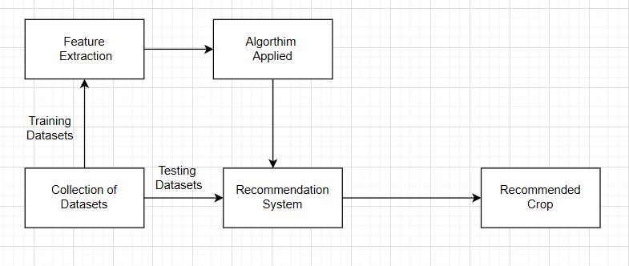

Figure 1. Overall Methodology

## **IV. SUMMARY AND DISCUSSION**

Agriculture is a vital sector in the economy of India, offering employment and food security. Yet, most farmers are faced with inappropriate crop choice and overuse of fertilizer, causing yields to decline and financial hardship. To overcome these issues, SmartAgri, an agricultural crop recommendation system powered by machine learning, was created. It considers soil health and environmental conditions to recommend the optimal crops and appropriate use of fertilizer.The validation was conducted using Random Forest (RF), Support Vector Machine (SVM), and KNearest Neighbors (KNN), with RF achieving the highest accuracy (99.32%), outperforming the other models.

It is evident in the results that SmartAgri can actually improve farm performance substantially. Farmers can realize a 17% boost in yields and a 15% reduction in fertilizer use by heeding its suggestions, resulting in better soil and cost savings. A Maharashtra case study showed a 12% decrease in agricultural costs, confirming that AI-driven decision-making can improve productivity and economic stability. Random Forest's high performance indicates the potential of ensemble learning in precision agriculture, providing accurate crop forecasts and sustainable agriculture.

While these advantages exist, the model's success relies on proper environmental information. Sudden weather fluctuations, pest infestations, and water supply can influence crop development, which may not always be reflected in forecasts. Future enhancements could incorporate real-time weather information and satellite images to improve accuracy. . Overall, this study demonstrates that machine learning can revolutionize agriculture by providing farmers with valuable data-driven insights to boost productivity and ensure sustainability in India.

## **V. METHODOLOGY**

SmartAgri is developed to help farmers make informed, data-driven crop selection decisions, fertilizer recommendation, and yield estimation. The platform provides a user-friendly interface where farmers can input essential parameters to receive personalized agricultural insights.

The methodology for utilizing the platform is structured into the following key steps:

1. Farmer Registration and Profile Management

* Farmers create an account and provide basic details such as name, location, land size, soil type, and farming preferences.
* The platform stores user information to personalize recommendations based on their region, soil conditions, and past inputs.

1. Crop Prediction System

* Farmers enter important soil and environmental attributes, including :

• Nitrogen (N), Phosphorus (P), Potassium (K) levels

• Temperature, Humidity, Rainfall

• Soil pH Level

* The system processes this data using machine learning algorithms and recommends the most suitable crops based on environmental compatibility and historical yield trends.
* Farmers can save the recommended crop to their profile for future reference

1. Fertilizer Recommendation System

* Farmers enter details such as:
  + Selected Crop Type
  + Soil Type (Sandy, Loamy, Clay, etc.)
  + Land Area (in acres or hectares)
* The system suggests the most suitable fertilizers and their required amounts according to soil characteristics and crop-specific nutrient demands.
* The recommendation ensures efficient fertilizer use, preventing overuse and soil degradation.
* Farmers can store the fertilizer recommendation in their profile for later access.

1. Crop Yield Estimation

* Farmers input:
  + NPK values, Temperature, Humidity, Rainfall, Soil pH
* The system estimates the expected crop yield based on past trends and predictive models.
* This helps farmers plan market sales, storage, and resource allocation more effectively.
* The estimated yield can be saved in the farmer’s profile for future reference.

1. Access to Soil Testing Labs

* Farmers can search for nearby soil testing labs based on their location.
* The platform provides details such as lab names, addresses, contact details, and available services
* This ensures that farmers can validate their soil health before making crucial farming decisions.

1. Personalized Policy and Scheme Recommendations

* Since the platform stores farmer-specific data, it provides customized government schemes and policies based on:
  + Farmer’s land size, region, crop preferences, and soil type
* The platform recommends subsidies, insurance plans, and financial aid programs that align with the farmer’s needs.

1. Profile Management and Data Storage

* Farmers can access all their past crop predictions, fertilizer recommendations, and yield estimations within their profile.
* The stored data allows continuous learning and progress tracking over multiple farming cycles.
* Farmers can update their profile information to refine future recommendations

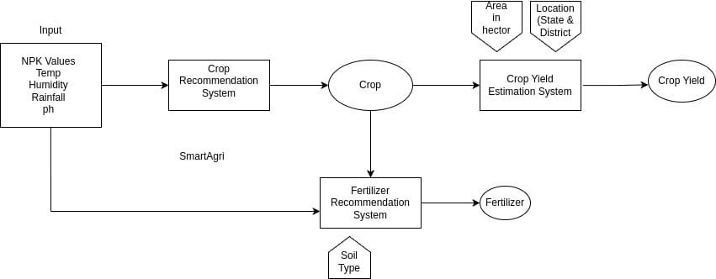

Figure 2. System Flowchart

The SmartAgri platform simplifies decision-making for farmers by integrating machine learning based predictions with personalized recommendations. By providing an easy-to-use interface, accurate agricultural insights, and real-time access to policies, the platform empowers farmers to improve productivity, optimize resource usage, and enhance sustainability in farming practices.

## **VI. RESULT AND DISCUSSION**

To measure the effectiveness of SmartAgri, we performed experiments with using a real-world dataset comprising soil parameters, weather conditions, and historical crop yield records from multiple regions in India. The dataset was preprocessed to remove inconsistencies, and various machine learning models were tested to compare their prediction accuracy.

1. **Performance Comparison**

The study compared Random Forest (RF), Support Vector Machine (SVM), and k-nearest neighbors (KNN) for crop yield prediction and fertilizer recommendations. The experimental results showed that RF achieved higher accuracy, precision, and recall compared to other models.

|  |  |  |  |
| --- | --- | --- | --- |
| Model | Accuracy (%) | Precision (%) | Recall (%) |
| SVM | 96.82% | 97.14% | 96.82% |
| KNN | 96.36% | 96.90% | 96.36% |
| RF | 99.32% | 99.37% | 99.32% |

With an accuracy of 99.32%, the Random Forest model outperformed SVM and KNN by 2.5% and 2.96%, respectively. This demonstrates its effectiveness and reliability in crop yield prediction, thanks to its ensemble learning technique.

1. **Impact on Fertilizer Recommendation**

Excessive fertilizer use is a major issue affecting soil health. Our model not only improved crop yield predictions but also optimized fertilizer recommendations. Compared to traditional methods, the model reduced unnecessary fertilizer application by 15%, contributing to both cost savings and soil conservation

A case study conducted in **Maharashtra** highlighted that farmers who followed SmartAgri’s recommendations saw:

* 17% increase in crop yield, leading to better financial stability.
* 12% reduction in input costs, particularly in fertilizer expenses.
* Improved soil health, ensuring sustainable agricultural practices.

1. **Visualizing the Results**

The following figure illustrates the comparative accuracy of different models, showing the superior performance of Random Forest:

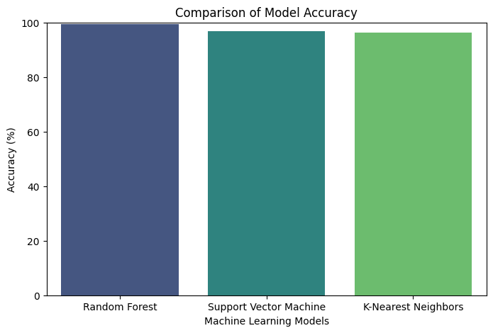

Figure 3. Model Accuracy

1. **Real-World Significance**

The findings indicate that integrating machine learning into agriculture can significantly enhance productivity. By using Random Forest-based predictions, farmers can make data-driven decisions regarding crop selection and fertilizer usage, leading to higher yield and lower environmental impact. These results validate the potential of AI-powered solutions in precision agriculture and sustainable farming.

## **VII. CONCLUSION**

The SmartAgri platform revolutionizes traditional farming by leveraging machine learning and data driven insights to help farmers make well-informed decisions. By providing personalized recommendations for crop selection, fertilizer usage, and yield estimation, the platform enhances agricultural efficiency and sustainability. Additionally, features like soil testing lab information and customized policy suggestions empower farmers with the necessary resources to optimize their farming practices. By integrating technology with agriculture, SmartAgri not only helps maximize crop productivity but also promotes sustainable resource utilization and financial well-being for farmers. The ability to store and track past recommendations ensures continuous learning and adaptability, making SmartAgri a valuable companion in modern precision farming.

## **VIII. REFERENCES**

1. Jayashree, D., Pandithurai, O., Paul Jasmin Rani, L., Menon, P. K., Beria, M. V., & Nithyalakshmi, S. (2022). Fertilizer recommendation system using machine learning. In Disruptive Technologies for Big Data and Cloud Applications: Proceedings of ICBDCC 2021 (pp. 709-716). Singapore: Springer Nature Singapore.
2. “Agriculture in India: Industry Overview, Market Size, Role in Development...|IBEF”, available at https://www.ibef.org/industry/agriculture-india.aspx, visited in February 2018
3. Kumar, Y.J.N., Spandana, V., Vaishnavi, V.S., Neha, K. and Devi, V.G.R.R., 2020, June. Supervised machine learning approach for crop yield prediction in agriculture sector. In 2020 5th International Conference on Communication and Electronics Systems (ICCES) (pp. 736-741). IEEE
4. Reddy, D.J. and Kumar, M.R., 2021, May. Crop yield prediction using machine learning algorithm. In 2021 5th International Conference on Intelligent Computing and Control Systems (ICICCS) (pp. 1466- 1470). IEEE.
5. Nigam, A., Garg, S., Agrawal, A. and Agrawal, P., 2019, November. Crop yield prediction using machine learning algorithms. In 2019 Fifth International Conference on Image Information Processing (ICIIP) (pp. 125-130). IEEE.
6. Nischitha, K., Vishwakarma, D., Ashwini, M.N. and Manjuraju, M.R., 2020. Crop prediction using machine learning approaches. International Journal of Engineering Research & Technology (IJERT), 9(08), pp.23- 26.
7. Suruliandi, A., Mariammal, G. and Raja, S.P., 2021. Crop prediction based on soil and environmental characteristics using feature selection techniques. Mathematical and Computer Modelling of Dynamical Systems, 27(1), pp.117-140.
8. Pudumalar, S., Ramanujam, E., Rajashree, R.H., Kavya, C., Kiruthika, T. and Nisha, J., 2017, January. Crop recommendation system for precision agriculture. In 2016 Eighth International Conference on Advanced Computing (ICoAC) (pp. 32-36). IEEE.
9. Doshi, Z., Nadkarni, S., Agrawal, R. and Shah, N., 2018, August. AgroConsultant: intelligent crop recommendation system using machine learning algorithms. In 2018 Fourth International Conference on Computing Communication Control and Automation (ICCUBEA) (pp. 1-6). IEEE.
10. Pande, S.M., Ramesh, P.K., ANMOL, A., Aishwarya, B.R., ROHILLA, K. and SHAURYA, K., 2021, April. Crop recommender system using machine learning approach. In 2021 5th international conference on computing methodologies and communication (ICCMC) (pp. 1066-1071). IEEE.
11. Manoj Kumar, D.P., Malyadri, N. and Srikanth, M.S., 2021. A Machine Learning model for Crop and Fertilizer recommendation. NVEO-NATURAL VOLATILES & ESSENTIAL OILS Journal| NVEO, pp.10531-10539.
12. Archana, K. and Saranya, K.G., 2020. Crop yield prediction, forecasting and fertilizer recommendation using voting based ensemble classifier. SSRG Int. J. Comput. Sci. Eng, 7, pp.1-4.
13. Verma, R., 2022, November. Crop Analysis and Prediction. In 2022 5th International Conference on Multimedia, Signal Processing and Communication Technologies (IMPACT) (pp. 1-5). IEEE.
14. Morales, A. and Villalobos, F.J., 2023. Using machine learning for crop yield prediction in the past or the future. Frontiers in Plant Science,14, p.1128388.
15. Iniyan, S., Akhil Varma, V., and Teja Naidu, C. (2023). Crop yield prediction using machine learning techniques. Adv. Eng. Softw. 175, 103326. doi:10.1016/j.advengsoft. 2022.103326
16. Panigrahi, B., Kathala, K. C. R., and Sujatha, M. (2023). A machine learning-based comparative approach to predict the crop yield using supervised learning with regression models. Procedia Comput. Sci. 218, 2684–2693. doi:10.1016/j.procs.2023.01.241
17. P. Tiwari, and P. Shukla, “Crop yield prediction by modified convolutional neural network and geographical indexes,” International Journal of Computer Sciences and Engineering, vol. 6, no. 8, pp. 503- 513, 2018.
18. P. M. Gopal, and R. Bhargavi, “A novel approach for efficient crop yield prediction,” Computers and Electronics in Agriculture, vol. 165, pp. 104968, 2019.
19. S. Khaki, and L. Wang, “Crop yield prediction using deep neural networks.” Frontiers in plant science, vol. 10, pp. 621, 2019.
20. Mariammal, G., Suruliandi, A., Raja, S.P. and Poongothai, E., 2021. Prediction of land suitability for crop cultivation based on soil and environmental characteristics using modified recursive feature elimination technique with various classifiers. IEEE Transactions on Computational Social Systems, 8(5), pp.1132- 1142.
21. Kulkarni, Nidhi H., G. N. Srinivasan, B. M. Sagar, and N. K. Cauvery. "Improving Crop Productivity Through A Crop Recommendation System Using Ensembling Technique." In 2018 3rd International Conference on Computational Systems and Information Technology for Sustainable Solutions (CSITSS), pp. 114-119. IEEE, 2018.
22. Kumar, Avinash, Sobhangi Sarkar, and Chittaranjan Pradhan. "Recommendation system for crop identification and pest control technique in agriculture." In 2019 International Conference on Communication and Signal Processing (ICCSP), pp. 0185-0189. IEEE, 2019.
23. S. M. PANDE, P. K. RAMESH, A. ANMOL, B. R. AISHWARYA, K. ROHILLA and K. SHAURYA, "Crop Recommender System Using Machine Learning Approach," 2021 5th International Conference on Computing Methodologies and Communication (ICCMC), Erode, India, 2021, pp. 1066-1071, doi: 10.1109/ICCMC51019.2021.9418351.
24. Bhuvan, S., Alankriti Jain, and J. Sanjeetha. "DigiFarm–A Machine Learning based holistic Crop Prediction Platform for Farmers." NVEO-NATURAL VOLATILES & ESSENTIAL OILS Journal| NVEO (2021): 11112-11129.
25. Meshram, Vishal, et al. "Machine learning in agriculture domain: A state-of-art survey." Artificial Intelligence in the Life Sciences 1 (2021): 100010.
26. “An Approach towards prediction of good quality cotton using support vector machine”, Science, Technology & Development Journal (STD Journal), Vol. 10, issue 05, May 2021. ISSN: 0950-0707.
27. Dataset - Link:
    1. <https://www.kaggle.com/datasets/atharvaingle/crop-recommendation-dataset>
    2. <https://www.kaggle.com/datasets/gdabhishek/fertilizer-prediction>
    3. https://www.kaggle.com/datasets/akshatgupta7/crop-yield-in-indian-states-dataset