DESIGN AND FABRICATION OF LOCKING PLIER MECHANISM INTEGRATED GRIPPER VISE SYSTEM

## R.Mohammed Farooq1,T.Varun Kumar2,P.Surya3,E.Bala kumar4 ,V.Vetri Vel ,A.Harikrishnan5

Department of Mechanical Engineering, P.A College of Engineering and Technology, Pollachi, Tamil Nadu, India – 6420021,2,3,4,5,6

**ABSTRACT:**

In order to improve the ability to hold things securely during machining, assembly, and other workshop operations, this project presents a hybrid gripping device that combines the solidity of a vise with the locking mechanism of pliers. Workpieces of different sizes and shapes can be accommodated by the design's durable and adjustable grip. The system provides a cost-effective solution for manufacturing and industrial applications while enhancing efficiency, usability, and portability. Its dependability in improving work stability and precision is confirmed by experimental study. By ensuring a solid hold and reducing slippage, the locking plier mechanism enhances safety while operating. The technology is easy to use and time-efficient due to its rapid one-handed operation. It provides long-lasting performance with little upkeep because it was made using sturdy materials. Because of its versatility, it may be integrated with automation and is appropriate for use in contemporary production processes. Future improvements might include sophisticated materials for increased durability and clever sensors for in-the-moment grip modifications.

.**Keywords**: Locking plier mechanism, Gripper Vise, Secure Clamping System,CAD design (CATIA V5)

**INTRODUCTION:**

The capacity to safely grasp and handle items of various sizes, shapes, and materials is crucial for effective and secure operations in both modern industrial and do-it-yourself contexts. For these tasks, traditional instruments like bench vises and locking pliers have long been employed; nevertheless, they frequently lack the flexibility and adaptability needed to efficiently handle a variety of workpieces. Although they offer a powerful clamping force, bench vises are usually fixed in place and have little adjustment. However, locking pliers may not deliver the stability and stiffness required for precise work.

This project focuses on the design and construction of an integrated gripper vise system with a locking plier mechanism in order to overcome these constraints. This creative tool offers a flexible way to hold workpieces firmly while machining, assembling, and performing other operations by fusing the stability and rigidity of a bench vise with the customizable gripping capabilities of locking pliers. The system is appropriate for a variety of applications, including DIY projects and woodworking and metalworking, because it has an adjustable mechanism that lets users adjust the gripping force according to the demands of the task and the properties of the workpiece.

To maximize the system's usability, robustness, and ergonomics, a comprehensive research approach, material selection, and the application of sophisticated CAD software (CATIA V5) were all part of the design process. Important parts were thoughtfully constructed to guarantee durability and usability, including the over-center cam locking mechanism, the C-channel base for structural support, and the lead screw for jaw adjustment. The manufactured gripper vise system performed exceptionally well in holding items securely throughout cutting, drilling, and assembly tasks when evaluated in a variety of applications.

This research demonstrates how locking plier mechanisms can be included into gripper vise systems to provide a dependable, flexible, and affordable answer to contemporary manufacturing and workshop requirements. This system offers a flexible tool that improves efficiency, security, and accuracy in a variety of industrial and residential contexts by fusing the stability of a vise with the tried-and-true functionality of locking pliers. Through automation, ergonomic improvements, and sophisticated materials, future innovations could significantly expand the system's capabilities and open the door for creative applications across a range of sectors.

# FLOW CHART:

**Material Selection**



**Designing Process**



**3-D Modelling**





**Fabrication Process**

**Result and Output**

**MATERIAL SELECTION AND COMPONENTS:**

The strength, durability, and low cost of the materials used to fabricate the gripper-vise system were taken into consideration. The C-channel (3 inches, 1.5 feet long) and steel plate (3 mm thick, 100 mm long) were made of mild steel because of its exceptional strength and machinability, which make it perfect for structural elements. Due to its stability and resistance to mechanical stress, a round steel bar of 200 mm in length and 8 mm in thickness was chosen. To ensure a firm and flexible grasp, components were joined and adjusted using bolts (3 inches) and thread screws (10 mm thick, 1.4 feet long). These components were selected to guarantee that the gripper-vise system is strong, long-lasting, and able to manage a variety of workpiece forms and sizes. Properties including hardness, stiffness, and wear resistance were also taken into account throughout the selection process to guarantee long-term performance in a range of industrial and application settings.

# COMPONENTS:

* “L” Section
* C-Channel
* Lead Screw
* Gripper
* Nuts and Bolts

**DESIGN OF VISE:**

Known for its compatibility with products from various brands, CATIA V5 offers a comprehensive set of tools for design and engineering tasks. With configurable bundles tailored to industry requirements, users can choose cost-effective solutions that meet their business needs. CATIA V5 Engineering Excellence expands its capabilities to include part design, sheet metal, assembly design, kinematics, and more, making it a comprehensive solution for mechanical projects. Additionally, the software supports collaborative engineering and multi-CAD compatibility, increasing its utility for professionals and businesses in a variety of sectors.

# COMPONENTS DESIGN:

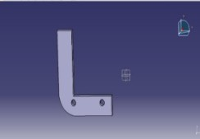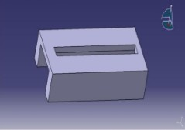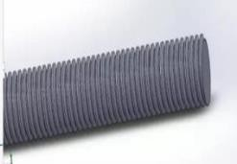

Fig1.”L”Section(Locking) Fig 2.C Channel(vise base) Fig 3.lead screw(jaw movement)

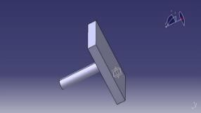

Fig 4.jaw(Gripper)

# \

# OVERALL DESIGN VIEW:

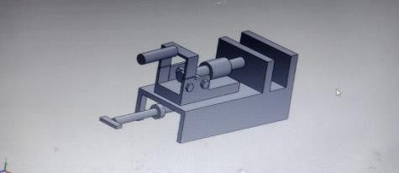

Fig 5.3D Vise Design Fig 6.2D Design

# LOCKING MECHANISM GRIPPER VISE:

## Introduction

Leveraging the robust and simple design principles of locking plier mechanisms, this project aims to develop a gripper vise system that offers dependable clamping and gripping functionality across a wide range of industrial applications. From careful design considerations to careful material selection and fabrication techniques, every aspect of the project is geared toward ensuring the resulting system meets stringent performance standards while prioritizing operator safety. The project's goal is to create a gripper vise system based on a locking plier mechanism that is appropriate for modern manufacturing needs, with an emphasis on dependability, versatility, and ease of use. In the end, this project reflects a thorough approach to technical innovation with the goal of producing a superior gripper vise system that can increase production and efficiency.

## Priciple:

The idea behind a gripper vise system based on a locking plier mechanism is to use leverage and mechanical advantage to hold workpieces securely in place. The basic idea for this mechanism is a moveable jaw that may be moved into different locations to suit a range of workpiece sizes. Squeezing the handle activates a locking mechanism that securely clamps the jaws onto the workpiece, giving the user a firm and reliable grip. The system's design minimizes slippage and guarantees accurate positioning by distributing the clamping force uniformly throughout the workpiece surface. Furthermore, the locking plier mechanism's simplicity improves dependability and usability, making it an efficient solution for grasping and gripping activities in many industrial contexts.

## Working Process:

A locking plier mechanism-based gripper vise system operates in a number of steps.First, the operator slides the movable jaw into the desired position by loosening the adjustment screw or knob to accommodate the workpiece's size. Squeezing the handle after the workpiece is in the correct position causes the jaws to close tightly around the workpiece and engages the locking mechanism. A clamping force is applied when the jaws close, securing the workpiece and avoiding slippage while it is being machined or assembled. The operator can reposition or adjust the pressure by using the release lever or button to release the locking mechanism if more adjustments are required.When the process is finished, the handle is released, which opens the jaws to remove the workpiece and disengages the locking mechanism. In order to prepare for the after workpiece, the gripper vise system is finally returned to its starting position. While the adjustable jaws offer versatility to accommodate varying workpiece sizes and shapes, the locking plier mechanism guarantees dependable and consistent clamping force throughout this process, enabling precise machining, assembly, or inspection operations.

## Clamping Mechanism:

The mechanism that enables the pliers to be securely locked into place is the over-center cam action. The pliers' cam mechanism moves past the center point when the handles are squeezed, producing a locking effect that secures the jaws in place without requiring constant handle pressure. By locking the jaws in place, this design guarantees that the pliers will hold onto objects firmly while offering stability and control for a variety of tasks. A crucial component of locking pliers is their over-center cam action, which gives them the ability to apply a strong and controlled clamping force, making them adaptable instruments for grasping, holding, and adjusting objects in a variety of settings.

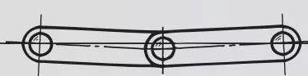Over centered clamped position

## Potential for Improvement Using Locking Plier Mechanism:

Enhancing gripping force, control, and usability is possible by incorporating a locking plier mechanism into gripper vise systems. By offering a more robust and dependable grip on items like pipes, rounded parts, and fasteners, locking pliers—which are renowned for their capacity to produce a sizable clamping force in a controlled manner—can enhance the overall functionality of gripper vise systems. Gripper vise systems can gain more gripping force, accurate clamping control, and increased versatility in securely gripping a variety of objects for extraction procedures and other applications by integrating the over-center cam action of locking pliers.

# RESULT:

Through successful design, fabrication, and testing, the Locking Plier Mechanism-Integrated Gripper Vise project showed outstanding performance in a range of applications. During operations like cutting, drilling, sanding, and assembly, the system successfully held workpieces of various sizes, shapes, and materials—such as foam, plastic, metal, and wood—in place. A firm and steady grip was made possible by the locking mechanism and adjustable jaws, which reduced slippage and guaranteed accurate placement. The sturdy design and dependable clamping mechanism of the gripper vise system guaranteed stability and accuracy throughout the machining and assembly procedures, producing results that were both professionand consistent. The project successfully addressed the limitations of traditional bench vises, offering a versatile, portable, and cost-effective solution for workpiece manipulation and holding tasks.

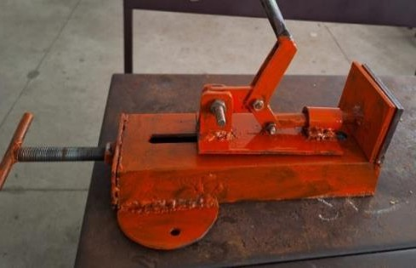

Fabricated Vise

# ADVANTAGES:

* Captures objects of many sizes and shapes, including irregular ones.
* Provides grip sizes that can be adjusted to fit different workpiece sizes.
* Makes one-handed operation quick and simple.
* Reduces slippage by offering a firm and stable grip on the workpiece.

# COMPARISION:

|  |  |
| --- | --- |
| **Traditional Bench Vise** | **Locking Plier Mechanism-Integrated Gripper**  **Vise** |
| Fixed jaw width limits the ability to hold workpieces of particular sizes and shapes.. | Extremely adaptable, able to hold a variety of irregular objects and shapes and sizes |
| requires adjusting screws or levers by hand, which can be laborious and time-consuming. | Easy clamping and releasing is made possible by its quick, one-handed operation and adjustable locking mechanism. |
| usually fixed to a workbench, which restricts flexibility and mobility. | Small and lightweight, it can be used in a variety of settings. |

**CONCLUSION:**

In conclusion, it would be difficult but worthwhile to develop a gripper vise system based on a locking plier mechanism. The key component of the system would be a sophisticated over-center cam latch mechanism that would give an extraordinarily strong and adjustable clamping force, similar to that of traditional Vise-Grip locking pliers. The gripper's long-lasting construction would be composed of high-strength materials such hardened steel with additional strengthening to withstand the high forces involved. If the user could accurately control the clamping force with an adjustment screw, the gripper could handle a wide range of object sizes and materials without causing damage. The powerful, adjustable grip of the locking plier gripper vise may be helpful in a variety of labs and workshops for activities such as holding parts steady for welding or machining, assisting with assembly and disassembly, and clamping test equipment in place. If this project is successful, the result will be an extremely strong, multipurpose clamping tool that combines the tried-and-true locking mechanism of traditional Vise-Grip pliers with a uniquely designed gripper vise system.

**REFERENCE:**

1. 1.Musibaudeen O. Idris1, Kehinde M. Adeleke2, Iliyasu K. Okediran, Tiamiyu I. Mohammed (2022) Design and Fabrication of a Modified Bench Vise for Comfortability and Productivity, 2714 2450, Adeleke University Journal of Engineering and Technology.
2. Chaudhry, Sufiyan and Kolhe, Hrishikesh and Darzi, Salman and Hiwarkar, Chirag and Kharde, Mukund, Design and Fabrication of Pneumatic Vice (2022). 4th International Conference on Communication & Information Processing.
3. Hemachandran.A.G.. Abishek.A.C., NawasShareef II, & Santhana Barathi.U. (2021). Motarized Bench Vice for Small Workshop. Research and Development in Machine Design.
4. P.Sivasankaran (2018) Design and Analysis of Modular Fixture for Machine Vice, N 2249-4219, International Journal of Industrial & Production Engineering & Technology.
5. Sandeep Kumar, Sunil Anand, Himanshu Tiwari, Gaurav Chamoli, Ashish Kukreti, Prince Kumar (2018), Design and Fabrication of Bench Vice and Toggle Screw Jack, International Journal of Machine Design and Manufacturing.
6. Anuchandranc.C, Praveenc.M, Karthikeyan.R(2017) Design and Fabrication of Automatic Machine Vice using Microcontroller,: 2321-0613, International Journal for Scientific Research & Development.
7. Mr. A.S. Kadam, Mr. T. V. Daundkar, Mr. S. R. Tanpure, Prof. V. V. Saidpatil (2016) Design and Modification of Bench Vice by Increasing the Degrees of Freedom, 2455-5703, GRD Journal for Engineering.
8. Mr. Shrikant M., Chougule Prof. D. B. Waghmare (2015) Design & Manufacturing of Components of Modified Bench Vise on Rapid Prototype, 2319 4847, International Journal of Application or Innovation in Engineering & Management.
9. Romel C. Dela Cruz (2015), Design and Development of Universal Holding Device for Bench Work Application, 2455-9024, International Research Journal of Advanced Engineering and Science.
10. J. U. Okoli, Tamuno Kurotamuno Jinyemiema (2007), Versatile Work Holding Device for Hole Drilling in Small-Scale Production Workshops. Advanced Materials Research.