**E – Waste Application**

***Sweeti Vijay Jawalkar1****, Computer Engineering, Zeal Polytechnic, Pune, India.*

***Shruti Gautam Khandagale2****, Computer Engineering, Zeal Polytechnic, Pune, India.*

***Sayali Gautam Khandagale 3****, Computer Engineering, Zeal Polytechnic, Pune, India.*

***Sakshi Dattatray Pandarkar4****, Computer Engineering, Zeal Polytechnic, Pune, India.*

***Prof. Megha S. Garud5****, Computer Engineering, Zeal Polytechnic, Pune, India.*

***Abstract:*** *In recent years, effective waste management has emerged as a critical challenge for urban environments due to rapid population growth and increased consumption. This research proposes a smart waste management system that leverages mobile technology to enhance community involvement and streamline waste reporting processes. The system enables users to capture and upload photographs of waste through a mobile application, with automatic geolocation tagging integrated at the time of image capture. This allows for real-time identification of waste accumulation sites, facilitating quicker response and efficient resource allocation by municipal authorities. The platform aims to bridge the communication gap between citizens and waste management services, encouraging civic responsibility and environmental awareness. Through this project, we demonstrate how combining image data with geospatial technology can contribute to a cleaner, more sustainable urban environment.*

***Keywords:*** *Waste Management, Smart City, Geolocation, Image-based Reporting, Mobile Application, Environmental Monitoring, Community Participation, Real-time Data, Sustainable Development, Urban Cleanliness, Citizen Engagement.*

1. **INTRODUCTION**

Proper waste management is a crucial component of sustainable urban development. With the rapid growth of cities and increasing population density, the challenge of managing solid waste has intensified, leading to environmental pollution, health hazards, and aesthetic degradation of public spaces. Traditional waste collection systems often lack the responsiveness and efficiency required to address these issues effectively, primarily due to delayed reporting and insufficient monitoring mechanisms. To address these limitations, this research presents a smart waste management solution that integrates mobile technology with geolocation services. The proposed system allows users to capture photographs of waste in their surroundings and upload them via a mobile application. Alongside the image, the user's location is automatically recorded using GPS technology. This real-time data is then transmitted to municipal authorities or waste management teams, enabling quicker identification, tracking, and disposal of waste materials. By encouraging community participation and leveraging everyday smartphone capabilities, this approach aims to enhance the accountability and effectiveness of urban waste management systems.

**2 OBJECTIVES**

The primary aim of this project is to develop a smart waste reporting system that enhances the efficiency of urban waste management through user participation and real-time data sharing. The specific objectives are:

1. **To design and develop a mobile application** :that allows users to capture and upload images of waste in public areas.
2. **To integrate geolocation services:** (GPS) into the application to automatically fetch and attach the user's location during photo capture.
3. **To enable real-time reporting of waste locations:** to concerned municipal or waste management authorities for faster response and action.
4. **To promote community engagement and awareness:** by involving citizens directly in the waste reporting process.
5. **To provide a centralized platform:** for storing, managing, and analyzing waste-related data to support better decision-making and resource allocation.
6. **To evaluate the effectiveness:** of the system in improving cleanliness, response time, and coordination between citizens and authorities.
7. **To utilize image data:** for potential future integration of AI-based classification of waste types (e.g., plastic, organic, hazardous), enabling smarter sorting and recycling processes.
8. **To reduce manual complaints and paperwork** :by providing a digital, user-friendly platform that streamlines communication between the public and waste management services..

**BACKGROUND:**

The Pune Metropolitan Region, including the rapidly developing locality of Pune, Maharashtra, grapples with the increasing complexities of municipal solid waste management. Traditional waste management systems often face challenges in effectively monitoring and responding to the widespread and often localized accumulation of waste. Reliance on scheduled collections and formal reporting mechanisms can lead to delays in addressing immediate waste disposal needs and may not capture the full extent of the issue across diverse urban and semi-urban landscapes.

Inefficient waste management not only detracts from the aesthetic appeal of communities but also poses significant risks to public health and the environment. Uncollected waste can become breeding grounds for disease vectors, contaminate water sources, and contribute to air pollution. Furthermore, the lack of real-time information on waste hotspots hinders the ability of municipal authorities to optimize resource allocation for collection, transportation, and processing.

The proliferation of smartphone technology and increasing digital literacy among citizens in regions like Pune present a unique opportunity to revolutionize waste management practices. By leveraging these readily available tools, it becomes possible to create more participatory and responsive systems. Mobile applications can empower citizens to become active stakeholders in maintaining the cleanliness of their surroundings by providing them with a direct channel to report and document instances of improper waste disposal.

This project recognizes the potential of citizen science and mobile technology to augment existing waste management infrastructure. By developing an application that integrates image capture and location tracking, we aim to create a dynamic and geographically precise dataset on waste accumulation within Pune. This data can provide valuable insights for local authorities, enabling them to make data-driven decisions, optimize collection routes, and respond more effectively to the needs of the community. Ultimately, this initiative seeks to contribute to a more sustainable and efficient waste management ecosystem in Pune and potentially serve as a model for other urban and semi-urban areas within the Pune Metropolitan Region facing similar challenges..

**3 LITERATURE SURVEY**

[1] The increasing volume of e-waste has raised serious concerns over its environmental and health impacts, especially in developing countries like India. The study titled "E-Waste Management and Challenges in India" outlines how the lack of awareness, informal recycling practices, and ineffective enforcement of regulations contribute to unsafe disposal of electronic waste. Informal workers dominate the sector, often handling hazardous components without protective measures. This paper emphasizes the need for structured regulation, integration of informal recyclers into the formal system, and public education programs to promote safe recycling practices and environmental responsibility.

[2] The 2023 research project “VISHODHANAM” E-Waste Handling Web Application" introduces a digital platform designed to simplify and streamline e-waste disposal. This application enables users to register e-waste items, schedule pickups, and learn about e-waste risks. It bridges the gap between consumers, recyclers, and governing bodies, providing a centralized system to manage electronic waste. Through features like request tracking, visual awareness modules, and categorization of devices, the application supports both sustainability goals and government policy execution for waste management

[3] Several supporting studies referenced in the VISHODHANAM paper highlight the role of emerging technologies in e-waste management. IoT-based systems are used to enable smart bins and real-time tracking of waste disposal. Predictive models have also been proposed for forecasting e-waste generation trends, aiding in better planning of collection and recycling. Moreover, case studies from Saudi Arabia and developed nations show how automation, awareness campaigns, and policy enforcement significantly enhance the efficiency of e-waste handling processes. These insights can guide the development and implementation of smart, scalable solutions tailored for India’s growing e-waste challenges.

**4 GAPS IDENTIFIED IN EXISTING SYSTEM**

Despite various efforts by municipal bodies and governments to maintain cleanliness and manage urban waste, several limitations still exist in the current systems. The key gaps identified are:

1. **Lack of Real-Time Reporting**: Traditional systems rely heavily on scheduled collection or manual reporting, which causes delays in addressing waste accumulation.
2. **Inefficient Complaint Mechanism**: Current reporting methods often involve physical complaints, phone calls, or online forms that are time-consuming and inconvenient for citizens.
3. **Limited Community Involvement**: Most existing systems do not actively involve the public in reporting waste, leading to reduced awareness and civic participation.
4. **Absence of Location Data**: Manual reports typically lack accurate location information, making it difficult for authorities to pinpoint the exact spot of waste disposal.
5. **Delayed Response by Authorities**: Without real-time alerts or proper tracking, authorities may not respond quickly, resulting in prolonged waste buildup and health hazards.
6. **Lack of Visual Evidence**: Most systems do not include image-based reporting, which limits the ability of authorities to assess the severity or nature of the waste before taking action.

**Solutions to Identified Gaps:**

The proposed system introduces a smart mobile application that allows users to report waste by capturing images and automatically tagging the location using GPS. This real-time, image-based reporting enhances communication between citizens and authorities, leading to quicker response times. The system also features a centralized dashboard for monitoring and analysis, encouraging community participation while enabling data-driven decision-making. Designed with scalability in mind, it supports future integration of AI for waste classification and ensures efficient, transparent, and environmentally conscious waste management.

1. **PROPOSED SYSTEM**
   1. **System Overview:**

The proposed waste management system is a mobile and web-based platform designed to streamline the reporting and handling of public waste issues. It leverages user input, image capture, and geolocation technologies to facilitate efficient communication between citizens and municipal authorities. The system consists of two main components: a **User Application** and an **Admin Dashboard**.

* 1. **Features:**

1. **Image Capture and Upload:**  
   Users can take real-time photos of waste using the mobile application and upload them directly through the platform.
2. **Automatic Location Detection:**  
   The app automatically fetches and tags the user's GPS location at the time of photo capture, helping authorities accurately locate waste.
3. **User-Friendlly Interface:**

Designed with simplicity in mind, the app ensures a smooth and intuitive user experience for all age groups.

1. **Real-Time Reporting:**  
    Waste reports are submitted instantly, ensuring that municipal teams receive alerts without delay.
2. **Status Tracking of Reports:**  
   Users can view the progress of their submitted reports, including acknowledgment and cleanup status.
3. **Centralized Admin Dashboard:**  
   Authorities have access to a web-based dashboard to monitor reports, view waste locations on a map, and manage cleanup tasks efficiently.
4. **Push Notifications and Alerts:**  
   Notify users about report updates, system announcements, or community cleanliness drives.
   1. **Modules:**

### **1. User Module**

#### **Register / Login**

Sign up or log in with email/phone

Store user info in Firebase or backend

#### **Capture Waste Photo**

* Open camera
* Take photo of waste
* Compress image (optional for faster upload)

#### **Fetch Location**

Auto-fetch location (latitude/longitude)

#### **Upload Report**

* Upload image + location + timestamp to Firebase/Database

#### **Notifications**

* Get notified when:
* Report is updated (e.g., marked as cleared)

### **2. Admin Module**

#### **Admin Login**

Only admin credentials can access this section

#### **View All Reports**

List of reports submitted by all users

Each entry shows:

1.Image

2.User info

3.Timestamp

4.Location

#### **Send Notification to User**

Notify user when status changes

* 1. **System Architecture:**

The architecture consists of a mobile app with two main modules (User & Admin) that interact with a cloud-based backend (e.g., Firebase). Users report waste by capturing images and location data, which is uploaded to the backend. Admins review reports, update their status, and communicate with users via notifications.

* 1. **Activity flow:**

Authentication → Report Creation → Auto Location Capture → Admin Review → Cleanup Task Assigned..

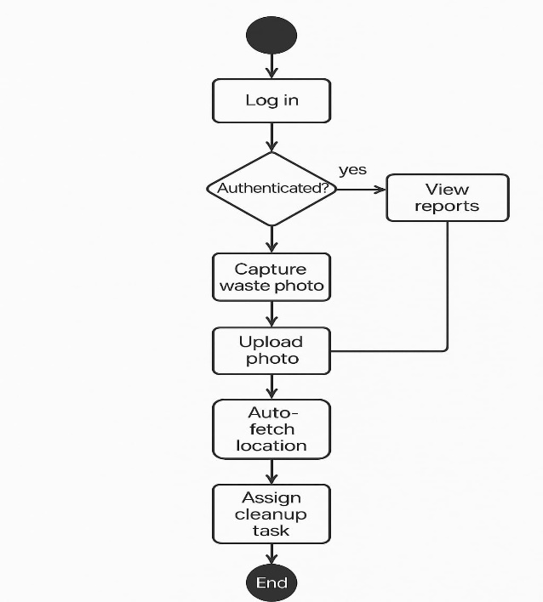

**Fig 1**. Activity diagram

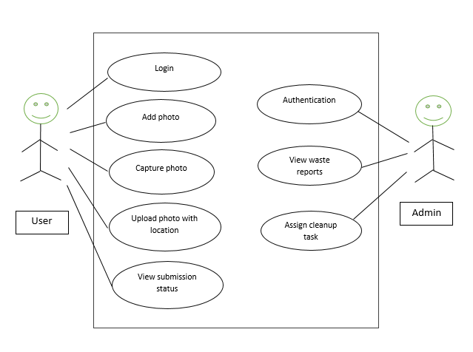

**Fig 2**. Use Case Diagram

1. **IMPLEMENTATION**

**6.1. Algorithm for Implementing a E-waste application:**

## **1. Authentication Algorithm**

Used for secure login and registration.

* **Firebase Authentication**
* **OAuth 2.0** (for social logins like Google, Facebook)
* **JWT (JSON Web Token)** for session management

## **2. GPS Location Fetching Algorithm**

Used to get the user’s current location.

* **Fused Location Provider API** (Google's algorithm combining GPS, Wi-Fi, and mobile network)

## **3. Image Uploading and Storage**

* Used when the user captures and uploads waste photos.
* **Multipart Upload Algorithm** (for sending images through HTTP)
* **Firebase Storage Upload Algorithm** (auto handles compression and storage)

## **4. Data Upload and Sync Algorithms**

* Ensures data (photo, location, etc.) is reliably sent to the server.
* **Retry with exponential backoff** (in case of network failure)
* **Offline data caching** with sync when internet is available (Room DB or SQLite)

## **5. Notification Handling Algorithm**

* Used to inform users when the admin updates the report status.
* **Firebase Cloud Messaging (FCM)** **algorithm**
* **Push Notification Queueing**

## **6. Status Update / Task Management Logic**

Used by admin to manage reports.

* **State Machine Algorithm** (**Pending** → In Progress → Cleared)
* **CRUD Operations** (Create, Read, Update, Delete)

## **7. Optional: Image Processing or AI (Advanced Feature)**

* If you want to analyze waste images (e.g., plastic, organic, etc.).

## **8. Sorting and Filtering Algorithms**

* Used when displaying reports to admin or user (e.g., sort by date, status, location).
* **Merge Sort / Quick Sort**
* **Filtering by parameters** (e.g., date range, location radius).

**6.2. Tools and Technology:**

### **1. Programming Language**

* **Java** or **Kotlin**  
  Used for developing the Android application frontend and logic.

### **2. Android Development Tools**

* **Android Studio**  
  The official IDE for Android app development.
* **Gradle**  
  Build automation tool used for managing dependencies and builds.

### **3. Backend / Database**

* **Firebase Database**
* Used to store user reports (photos, locations, status).
* **Firebase Storage**  
  Used to store uploaded waste images.
* **Firebase Authentication**  
  Handles user registration and login securely.

### **4. Location Services**

* **Google Play Services - Fused Location Provider**  
  Used for fetching accurate GPS location of the user.

### **5. Cloud & Hosting**

* **Firebase Cloud Functions**   
  For handling backend tasks like sending notifications, processing data.
* **Firebase Hosting**
* Can be used if you want to host admin panel or any web dashboard.

### **6. Push Notifications**

* **Firebase Cloud Messaging (FCM)**  
  Used to send notifications to users about cleanup status.

### **7. UI/UX Design**

* **XML (Android Layouts)**  
  For designing the user interface of the app.

### **8. Maps Integration**

* **Google Maps SDK**  
  To show waste locations on a map for admin or user view.

### **9. Image Handling**

* **Camera**  
  To allow users to take photos.

1. **CONCLUSION**

This waste management project successfully integrates user-friendly features to enhance the reporting and management of waste. By enabling users to capture and upload photographic evidence of waste along with automatically capturing their precise location, the system facilitates the submission of detailed and geographically accurate waste reports. This rich data empowers more efficient identification of problem areas and potentially faster response times from relevant authorities. Furthermore, the inclusion of features like viewing waste history and tracking issue status promotes user engagement and transparency in the waste management process. Ultimately, this project demonstrates the potential of leveraging mobile technology to create a more participatory and informed approach to waste management, contributing to cleaner and more sustainable communities.

1. **REFERENCES**

[1] VISHODHANAM E-waste Handling Web Application Prof. Mohammad Sajid Department of Computer Science and Engineering, Nagpur Institute of Technology Nagpur

[2] E-Waste Management and Challenges in India Dr. Vikas Kumar Associate Professor, S.D. College of Engineering and Technology, Muzaffarnagar (U.P)

[3] E-Waste Management: As a Challenge to Public Health in India Monika, Jugal Kishore Department of Community Medicine, Maulana Azad Medical College, New Delhi, India