

***e-ISSN: 2582-5208***

***Date: 16/04/2025***

***International Research Journal Of Modernization in Engineering Technology and Science***

(Peer-Reviewed, Open Access, Fully Refereed International Journal)

Ref: IRJMETS/Certificate/Volume 07/Issue 04/**70400149336**

**DOI : https://www.doi.org/10.56726/IRJMETS72982**



*This* *is to certify that author “****B Sai Shruthi****” with paper ID “****IRJMETS70400149336****” has published a paper entitled “BLOCKCHAIN-ENABLED SECURE AND AUDITABLE PRODUCT INFORMATION RETRIEVAL IN MULTI-CLOUD ENVIRONMENTS”* ***in International Research Journal Of Modernization In Engineering Technology And Science (IRJMETS), Volume 07, Issue 04, April 2025***

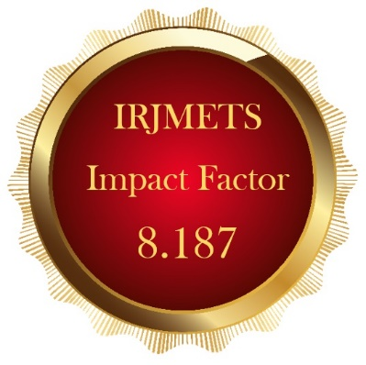



Editor in Chief

*We Wish For Your Better Future*

**www.irjmets.com**

