**LPG TRANSPORT TRACKING AND LEAKAGE DETECTION WITH ACCIDENT PREVENTION ALERT SYSTEM**

**Abstract:**

The LPG Transport Tracking and Leakage Detection with Accident Prevention Alert System offers a comprehensive solution for enhancing the safety and monitoring of LPG transportation. Powered by an Arduino microcontroller, the system integrates multiple sensors, including a gas sensor to detect leaks, a load cell to monitor cylinder weight, and a DHT11 for environmental conditions. In the event of a leak, the system triggers a buzzer alert and automatically sends notifications via GSM to pre-defined contacts. Real-time vehicle tracking is enabled through a GPS module, while an LCD display provides continuous updates on gas levels, weight, and location. This system ensures timely detection and response to hazards, significantly reducing risks and improving transport safety.

**Keywords:**

LPG transport, leakage detection, accident prevention, Arduino, GPS tracking, gas sensor

**Introduction:**

LPG transportation involves significant safety challenges due to the risks of gas leakage and potential accidents. To address these concerns, the LPG Transport Tracking and Leakage Detection with Accident Prevention Alert System is developed as an advanced safety mechanism. This system, powered by an Arduino microcontroller, integrates gas sensors for leak detection, a load cell to monitor cylinder weight, and a DHT11 sensor for environmental monitoring. Additionally, it features a GPS module for real-time tracking and a GSM module to send alerts during emergencies. With an LCD display providing continuous status updates and a buzzer for immediate alerts, this system ensures proactive hazard detection, timely response, and enhanced transport safety.

**Literature review:**

* **"Design and Development of IoT-Based LPG Leakage Detection and Monitoring System"**–*A.Kumar, R.Singh,et al.* This study presents an IoT-based framework for detecting LPG leaks in households and vehicles, with real-time alerts sent via GSM.
* **"An Intelligent Gas Leakage Detection System with Vehicle Tracking using GPS and GSM"**–*S.Sharma, P.Mishra*. The paper explores a system that integrates gas sensors and GPS modules to track the location of a vehicle during a gas leakage incident.
* **"Real-Time Vehicle Tracking and Accident Detection System using MEMS and GPS"**–*K.Rajasekar, T.Srinivasan*. This work highlights the use of MEMS sensors to detect vehicle accidents and send alerts through a GSM-based messaging system.
* **"IoT-Based LPG Weight and Leakage Monitoring System"** – *M. Gupta, L. Kumar*  
  The research focuses on the use of load cells for real-time gas weight monitoring and gas sensors for leakage detection, ensuring safety during transport.

**Existing model:**

Current systems for LPG transportation often rely on manual monitoring and basic gas detectors, lacking comprehensive features like real-time location tracking or automated alert mechanisms. They are inefficient in promptly detecting gas leaks or accidents, increasing the risk of hazardous incidents. Additionally, the absence of load monitoring leads to undetected unauthorized usage or potential leaks. This limited functionality makes these systems less reliable for ensuring transport safety.

**Proposed model:**

The proposed system integrates advanced technologies such as an Arduino-controlled platform with sensors for gas leakage detection, load monitoring, and environmental conditions. GPS and GSM modules enable real-time vehicle tracking and automated alerts in emergencies, significantly improving response time and safety. The inclusion of an LCD for system status display and a buzzer for immediate audio alerts creates a robust solution that addresses the limitations of existing methods.

**Block diagram:**

Arduino

GSM

Load Cell

GPS

LCD

Power Supply

Gas sensor

Buzzer

**Hardware components:**

* Arduino
* LCD
* Load Cell
* Gas Sensor
* Buzzer
* GPS Module
* GSM Module

**Software components:**

* Arduino IDE
* Embedded C

**Description:**

**Arduino:**

Arduino Uno is a very valuable addition in the electronics that consists of USB interface, 14 digital I/O pins, 6 analog pins, and Atmega328 microcontroller. It also supports serial communication using Tx and Rx pins.

There are many versions of Arduino boards introduced in the market like Arduino Uno, Arduino Due, Arduino Leonardo, Arduino Mega, however, most common versions are Arduino Uno and Arduino Mega. If you are planning to create a project relating to digital electronics, embedded system, robotics, or IoT, then using Arduino Uno would be the best, easy and most economical option.

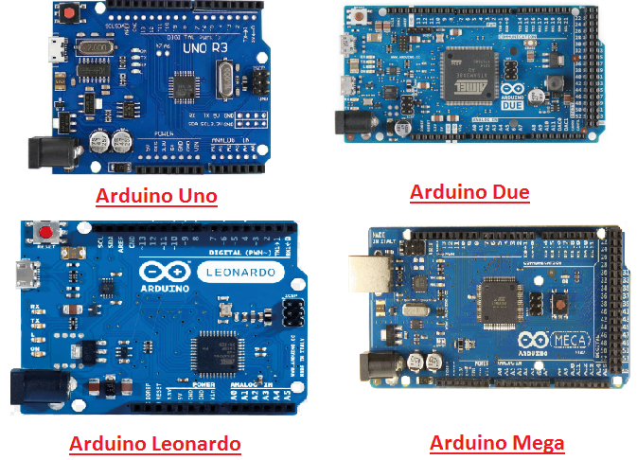

It is an open-source platform, means the boards and software are readily available and anyone can modify and optimize the boards for better functionality.

The software used for Arduino devices is called IDE (Integrated Development Environment) which is free to use and required some basic skills to learn it. It can be programmed using C and C++ language.

Some people get confused between **Microcontroller and Arduino**. While former is just an on system 40 pin chip that comes with a built-in microprocessor and later is a board that comes with the microcontroller in the base of the board, bootloader and allows easy access to input-output pins and makes uploading or burning of the program very easy.

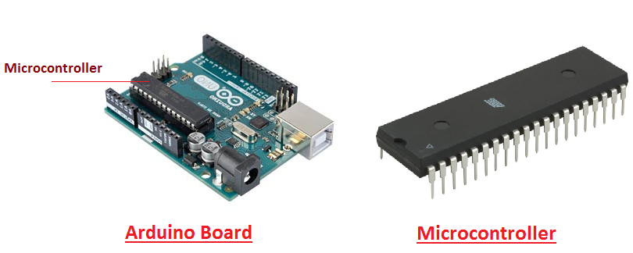

While learning microcontroller requires some expertise and skills.

Nevertheless, we can say every Arduino is basically a [microcontroller](https://www.theengineeringprojects.com/2018/03/introduction-to-microcontrollers.html) but not every microcontroller is an Arduino.

**Introduction to Arduino**

* **Arduino Uno** is a microcontroller board developed by Arduino.cc which is an open-source electronics platform mainly based on AVR microcontroller Atmega328.
* First Arduino project was started in Interaction Design Institute Ivrea in 2003 by David Cuartielles and Massimo Banzi with the intention of providing a cheap and flexible way to students and professional for controlling a number of devices in the real world.
* The current version of Arduino Uno comes with USB interface, 6 analog input pins, 14 I/O digital ports that are used to connect with external electronic circuits. Out of 14 I/O ports, 6 pins can be used for PWM output.
* It allows the designers to control and sense the external electronic devices in the real world

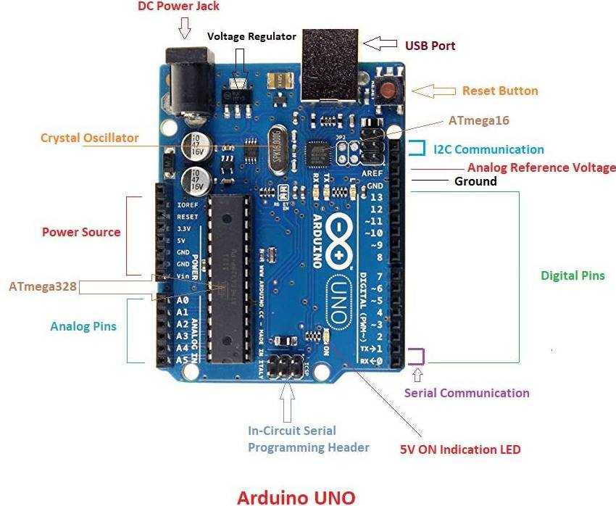

* This board comes with all the features required to run the controller and can be directly connected to the computer through USB cable that is used to transfer the code to the controller using IDE (Integrated Development Environment) software, mainly developed to program Arduino. IDE is equally compatible with Windows, MAC or Linux Systems, however, Windows is preferable to use. Programming languages like C and C++ are used in IDE.
* Apart from USB, battery or AC to DC adopter can also be used to power the board.
* Arduino Uno boards are quite similar to other boards in Arduino family in terms of use and functionality, however, Uno boards don’t come with FTDI USB to Serial driver chip.
* There are many versions of Uno boards available, however, Arduino Nano V3 and Arduino Uno are the most official versions that come with Atmega328 8-bit AVR Atmel microcontroller where RAM memory is 32KB.
* When nature and functionality of the task go complex, Mirco SD card can be added in the boards to make them store more information.

**Features of Arduino**

* Arduino Uno comes with USB interface i.e. USB port is added on the board to develop serial communication with the computer.
* [Atmega328](https://www.theengineeringprojects.com/2017/08/introduction-to-atmega328.html) microcontroller is placed on the board that comes with a number of features like timers, counters, interrupts, PWM, CPU, I/O pins and based on a 16MHz clock that helps in producing more frequency and number of instructions per cycle.

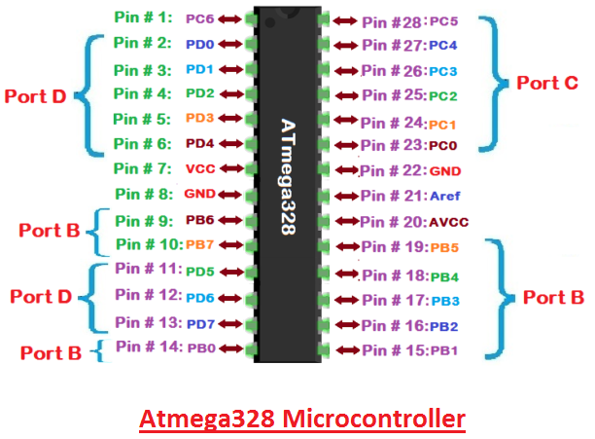

* It is an open source platform where anyone can modify and optimize the board based on the number of instructions and task they want to achieve.
* This board comes with a built-in regulation feature which keeps the voltage under control when the device is connected to the external device.
* Reset pin is added in the board that reset the whole board and takes the running program in the initial stage. This pin is useful when board hangs up in the middle of the running program; pushing this pin will clear everything up in the program and starts the program right from the beginning.
* There are 14 I/O digital and 6 analog pins incorporated in the board that allows the external connection with any circuit with the board. These pins provide the flexibility and ease of use to the external devices that can be connected through these pins. There is no hard and fast interface required to connect the devices to the board. Simply plug the external device into the pins of the board that are laid out on the board in the form of the header.
* The 6 analog pins are marked as A0 to A5 and come with a resolution of 10bits. These pins measure from 0 to 5V, however, they can be configured to the high range using analogReference() function and AREF pin.
* 13KB of flash memory is used to store the number of instructions in the form of code.
* Only 5 V is required to turn the board on, which can be achieved directly using USB port or external adopter, however, it can support external power source up to 12 V which can be regulated and limit to 5 V or 3.3 V based on the requirement of the project.

**Arduino Pinout**

* Arduino Uno is based on AVR microcontroller called Atmega328. This controller comes with 2KB SRAM, 32KB of flash memory, 1KB of EEPROM. Arduino Board comes with 14 digital pins and 6 analog pins. ON-chip ADC is used to sample these pins. A 16 MHz frequency crystal oscillator is equipped on the board. Following figure shows the pinout of the Arduino Uno Board

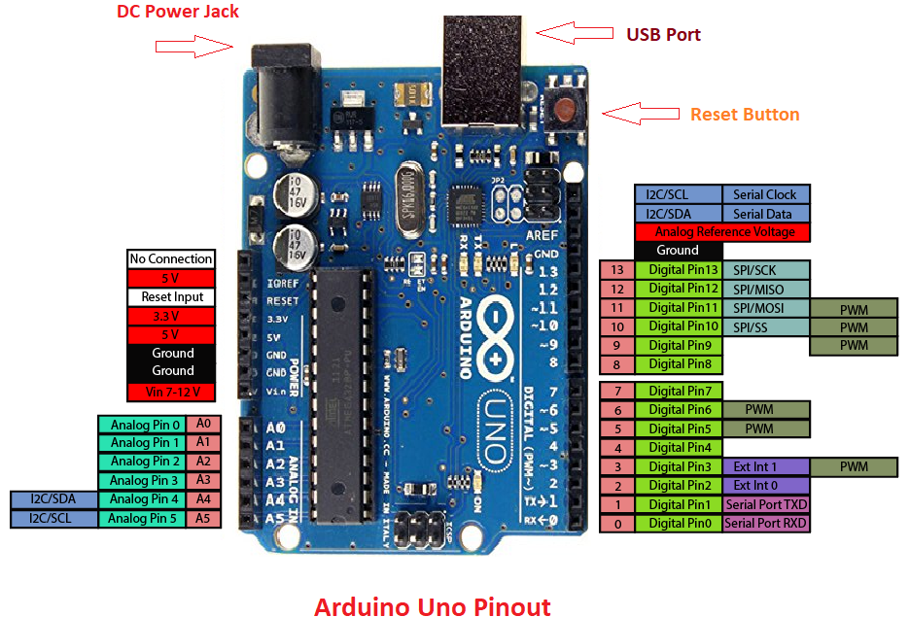

**Pin Description:**

There are several I/O digital and analog pins placed on the board which operates at 5V. These pins come with standard operating ratings ranging between 20mA to 40mA. Internal pull-up resistors are used in the board that limits the current exceeding from the given operating conditions. However, too much increase in current makes these resisters useless and damages the device.

**LED.** Arduino Uno comes with built-in LED which is connected through pin 13. Providing HIGH value to the pin will turn it ON and LOW will turn it OFF.

**Vin.** It is the input voltage provided to the Arduino Board. It is different than 5 V supplied through a USB port. This pin is used to supply voltage. If a voltage is provided through power jack, it can be accessed through this pin.

**5V.** This board comes with the ability to provide voltage regulation. 5V pin is used to provide output regulated voltage. The board is powered up using three ways i.e. USB, Vin pin of the board or DC power jack.

USB supports voltage around 5V while Vin and Power Jack support a voltage ranges between 7V to 20V. It is recommended to operate the board on 5V. It is important to note that, if a voltage is supplied through 5V or 3.3V pins, they result in bypassing the voltage regulation that can damage the board if voltage surpasses from its limit.

**GND.** These are ground pins. More than one ground pins are provided on the board which can be used as per requirement.

**Reset.** This pin is incorporated on the board which resets the program running on the board. Instead of physical reset on the board, IDE comes with a feature of resetting the board through programming.

**IOREF.** This pin is very useful for providing voltage reference to the board. A shield is used to read the voltage across this pin which then select the proper power source.

**PWM.** PWM is provided by 3, 5, 6,9,10, 11pins. These pins are configured to provide 8-bit output PWM.

**SPI.** It is known as Serial Peripheral Interface. Four pins 10(SS), 11(MOSI), 12(MISO), 13(SCK) provide SPI communication with the help of SPI library.

**AREF.** It is called Analog Reference. This pin is used for providing a reference voltage to the analog inputs.

**TWI.** It is called Two-wire Interface. TWI communication is accessed through Wire Library. A4 and A5 pins are used for this purpose.

**Serial Communication.** Serial communication is carried out through two pins called Pin 0 (Rx) and Pin 1 (Tx).

Rx pin is used to receive data while Tx pin is used to transmit data.

**External Interrupts.** Pin 2 and 3 are used for providing external interrupts. An interrupt is called by providing LOW or changing value.

### **Arduino Uno Technical Specifications**

|  |  |
| --- | --- |
| Microcontroller | [ATmega328P](https://components101.com/microcontrollers/atmega328p-pinout-features-datasheet) – 8 bit AVR family microcontroller |
| Operating Voltage | 5V |
| Recommended Input Voltage | 7-12V |
| Input Voltage Limits | 6-20V |
| Analog Input Pins | 6 (A0 – A5) |
| Digital I/O Pins | 14 (Out of which 6 provide PWM output) |
| DC Current on I/O Pins | 40 mA |
| DC Current on 3.3V Pin | 50 mA |
| Flash Memory | 32 KB (0.5 KB is used for Bootloader) |
| SRAM | 2 KB |
| EEPROM | 1 KB |
| Frequency (Clock Speed) | 16 MHz |

**Communication and Programming:**

Arduino Uno comes with an ability of interfacing with other other Arduino boards, microcontrollers and computer. The Atmega328 placed on the board provides serial communication using pins like Rx and Tx.

The Atmega16U2 incorporated on the board provides a pathway for serial communication using USB com drivers. Serial monitor is provided on the IDE software which is used to send or receive text data from the board. If LEDs placed on the Rx and Tx pins will flash, they indicate the transmission of data.

Arduino Uno is programmed using Arduino Software which a cross-platform application called IDE is written in Java. The AVR microcontroller Atmega328 laid out on the base comes with built-in boot loader that sets you free from using a separate burner to upload the program on the board.



**Applications:**

Arduino Uno comes with a wide range of applications. A larger number of people are using Arduino boards for developing sensors and instruments that are used in scientific research. Following are some main applications of the board.

* [Embedded System](https://www.theengineeringprojects.com/2016/10/what-is-embedded-systems.html)
* Security and Defense System
* Digital Electronics and Robotics
* Parking Lot Counter
* Weighing Machines
* Traffic Light Count Down Timer
* Medical Instrument
* Emergency Light for Railways
* Home Automation
* Industrial Automation

There are a lot of other microcontrollers available in the market that are more powerful and cheap as compared to Arduino board. So, why you prefer Arduino Uno?

Actually, Arduino comes with a big community that is developing and sharing the knowledge with a wide range of audience. Quick support is available pertaining to technical aspects of any electronic project. When you decide Arduino board over other controllers, you don’t need to arrange extra peripherals and devices as most of the functions are readily available on the board that makes your project economical in nature and free from a lot of technical expertise.

**LCD:**

LCD (Liquid Crystal Display) is the innovation utilized in scratch pad shows and other littler PCs. Like innovation for light-producing diode (LED) and gas-plasma, LCDs permit presentations to be a lot more slender than innovation for cathode beam tube (CRT). LCDs expend considerably less power than LED shows and gas shows since they work as opposed to emanating it on the guideline of blocking light.

A LCD is either made with a uninvolved lattice or a showcase network for dynamic framework show. Likewise alluded to as a meager film transistor (TFT) show is the dynamic framework LCD. The uninvolved LCD lattice has a matrix of conductors at every crossing point of the network with pixels. Two conductors on the lattice send a current to control the light for any pixel. A functioning framework has a transistor situated at every pixel crossing point, requiring less current to control the luminance of a pixel.

Some aloof network LCD's have double filtering, which implies they examine the matrix twice with current in the meantime as the first innovation took one sweep. Dynamic lattice, be that as it may, is as yet a higher innovation.

A 16x2 LCD show is an essential module that is generally utilized in various gadgets and circuits. These modules more than seven sections and other multi fragment LEDs are liked. The reasons being: LCDs are affordable; effectively programmable; have no restriction of showing exceptional and even custom characters (not at all like in seven fragments), movements, etc.

A 16x2 LCD implies 16 characters can be shown per line and 2 such lines exist. Each character is shown in a lattice of 5x7 pixels in this LCD. There are two registers in this LCD, in particular Command and Data.

The directions given to the LCD are put away by the order register. An order is a direction given to LCD to play out a predefined assignment, for example, introducing it, clearing its screen, setting the situation of the cursor, controlling presentation, and so forth. The information register will store the information that will be shown on the LCD. The information is the character's ASCII incentive to show on the LCD.

**Data/Signals/Execution of LCD**

Now that was all about the signals and the hardware. Let us come to data, signals and execution.

Two types of signals are accepted by LCD, one is data and one is control. The LCD module recognizes these signals from the RS pin status. By pulling the R / W pin high, data can now also be read from the LCD display. Once the E pin has been pulsed, the LCD display reads and executes data at the falling edge of the pulse, the same for the transmission case.

It takes 39-43μS for the LCD display to place a character or execute a command. It takes 1.53ms to 1.64ms except for clearing display and searching for cursor to the home position.

Any attempt to send data before this interval may result in failure in some devices to read data or execute the current data. Some devices compensate for the speed by storing some temporary registers with incoming data.

There are two RAMs for LCD displays, namely DDRAM and CGRAM. DDRAM registers the position in which the character would be displayed in the ASCII chart. Each DDRAM byte represents every single position on the display of the LCD.

The DDRAM information is read by the LCD controller and displayed on the LCD screen. CGRAM enables users to define their personalized characters. Address space is reserved for users for the first 16 ASCII characters.

Users can easily display their custom characters on the LCD screen after CGRAM has been set up to display characters.

**Images of LCD Display:-**

[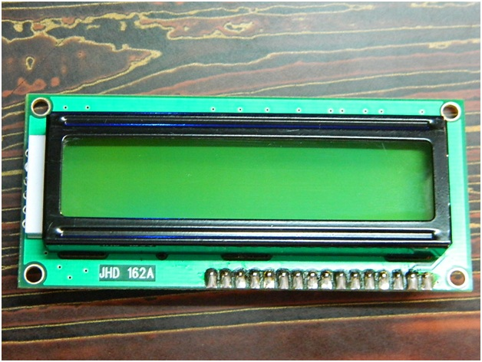](http://www.circuitstoday.com/wp-content/uploads/2012/02/LCD-Display-Front-Side.jpg)

**LCD – Front View**

[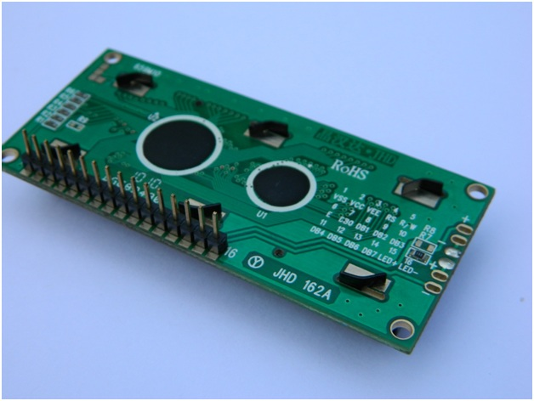](http://www.circuitstoday.com/wp-content/uploads/2012/02/lcd-display-back-side.jpg)

**LCD – Back View**

**Pin Diagram:**

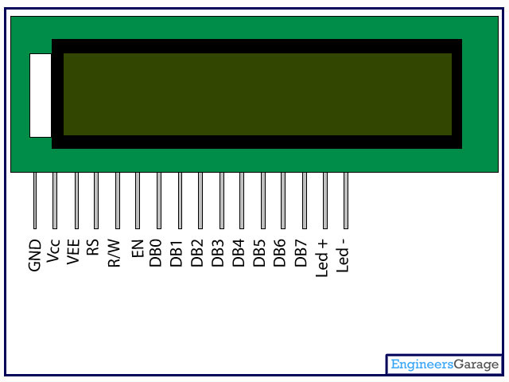

**Pin Description:**

|  |  |  |
| --- | --- | --- |
| Pin No | Function | Name |
| 1 | Ground (0V) | Ground |
| 2 | Supply voltage; 5V (4.7V – 5.3V) | Vcc |
| 3 | Contrast adjustment; through a variable resistor | VEE |
| 4 | Selects command register when low; and data register when high | Register Select |
| 5 | Low to write to the register; High to read from the register | Read/write |
| 6 | Sends data to data pins when a high to low pulse is given | Enable |
| 7 | 8-bit data pins | DB0 |
| 8 | DB1 |
| 9 | DB2 |
| 10 | DB3 |
| 11 | DB4 |
| 12 | DB5 |
| 13 | DB6 |
| 14 | DB7 |
| 15 | Backlight VCC (5V) | Led+ |
| 16 | Backlight Ground (0V) | Led- |

**RS (Register select)**

A 16X2 LCD has two order and information registers. The determination of the register is utilized to change starting with one register then onto the next. RS=0 for the register of directions, while RS=1 for the register of information.

**Command Register**

The guidelines given to the LCD are put away by the direction register. An order is a direction given to LCD to play out a predefined assignment, for example, instating it, clearing its screen, setting the situation of the cursor, controlling showcase, and so on. Order preparing happens in the direction register.

**Data Register:**

The information register will store the information that will be shown on the LCD. The information is the character's ASCII incentive to show on the LCD. It goes to the information register and is prepared there when we send information to the LCD. While choosing RS=1, the information register.

**Read and Write Mode of LCD:**

As stated, the LCD itself comprises of an interface IC. This interface IC can be perused or composed by the MCU. A large portion of the occasions we're simply going to keep in touch with the IC since perusing will make it increasingly perplexing and situations like that are exceptionally uncommon.Information such as cursor position, status completion interrupts, etc. can be read if necessary.

**LCD Commands:**

There are some preset commands in the LCD that we need to send to the LCD via some microcontroller. The following are some important command instructions:

|  |  |  |
| --- | --- | --- |
| **Sr. No.** | **Hex Code** | **Command to LCD instruction Register** |
| 1 | 01 | Clear display screen |
| 2 | 02 | Return home |
| 3 | 04 | Decrement cursor (shift cursor to left) |
| 4 | 06 | Increment cursor (shift cursor to right) |
| 5 | 05 | Shift display right |
| 6 | 07 | Shift display left |
| 7 | 08 | Display off, cursor off |
| 8 | 0A | Display off, cursor on |
| 9 | 0C | Display on, cursor off |
| 10 | 0E | Display on, cursor blinking |
| 11 | 0F | Display on, cursor blinking |
| 12 | 10 | Shift cursor position to left |
| 13 | 14 | Shift cursor position to right |
| 14 | 18 | Shift the entire display to the left |
| 15 | 1C | Shift the entire display to the right |
| 16 | 80 | Force cursor to beginning ( 1st line) |
| 17 | C0 | Force cursor to beginning ( 2nd line) |
| 18 | 38 | 2 lines and 5×7 matrix |

## Command codes for LCD

**Block Diagram of LCD Display:-**

**[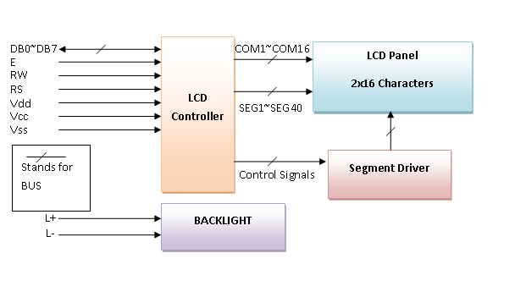](http://www.circuitstoday.com/wp-content/uploads/2012/02/LCD-Display-Block-Diagram.png)**

**Control and display commands**

|  |  |  |  |  |  |  |  |  |  |  |  |  |
| --- | --- | --- | --- | --- | --- | --- | --- | --- | --- | --- | --- | --- |
| **Instruction** | **Instruction Code** | | | | | | | | | | **Instruction Code Description** | **Execution time** |
| RS | R/W | DB7 | DB6 | DB5 | DB4 | DB3 | DB2 | DB1 | DB0 |
| Read Data From RAM | 1 | 1 | D7 | D6 | D5 | D4 | D3 | D2 | D1 | D0 | Read data from internal RAM | 1.53-1.64ms |
| Write data to RAM | 1 | 0 | D7 | D6 | D5 | D4 | D3 | D2 | D1 | D0 | Write data into internal RAM (DDRAM/CGRAM) | 1.53-1.64ms |
| Busy flag & Address | 0 | 1 | BF | AC6 | AC5 | AC4 | AC3 | AC2 | AC1 | AC0 | Busy flag (BF: 1→ LCD Busy) and contents of address counter in bits AC6-AC0. | 39 µs |
| Set DDRAM Address | 0 | 0 | 1 | AC6 | AC5 | AC4 | AC3 | AC2 | AC1 | AC0 | Set DDRAM address in address counter. | 39 µs |
| Set CGRAM Address | 0 | 0 | 0 | 1 | AC5 | AC4 | AC3 | AC2 | AC1 | AC0 | Set CGRAM Address in address counter. | 39 µs |
| Function Set | 0 | 0 | 0 | 0 | 1 | DL | N | F | X | X | Set interface data length (DL: 4bit/8bit), Numbers of display line (N: 1-line/2-line) display font type (F:0→ 5×8 dots, F:1→ 5×11 dots) | 39 µs |
| Cursor or Display Shift | 0 | 0 | 0 | 0 | 0 | 1 | S/C | R/L | X | X | Set cursor moving and display shift control bit, and the direction without changing DDRAM data | 39 µs |
| Display & Cursor On/Off | 0 | 0 | 0 | 0 | 0 | 0 | 1 | D | C | B | Set Display(D),Cursor(C) and cursor blink(b) on/off control | 39 µs |
| Entry Mode Set | 0 | 0 | 0 | 0 | 0 | 0 | 0 | 1 | I/D | SH | Assign cursor moving direction and enable shift entire display. | 0µs |
| Return Home | 0 | 0 | 0 | 0 | 0 | 0 | 0 | 0 | 1 | X | Set DDRAM Address to “00H” from AC and return cursor to its original position if shifted. | 43µs |
| Clear Display | 0 | 0 | 0 | 0 | 0 | 0 | 0 | 0 | 0 | 1 | Write “20H” to DDRAM and set DDRAM Address to “00H” from AC | 43µs |

**4-bit and 8-bit Mode of LCD:**

The LCD can work in two striking modes, the 4-bit mode and the 8-bit mode. We send the information snack through snack in 4 bit mode, first upper chomp, by then lower snack. For those of you who don't have the foggiest idea what a goody is: a chomp is a four-piece gathering, so a byte's lower four bits (D0-D3) are the lower snack, while a byte's upper four bits (D4-D7) are the higher snack. This enables us to send 8 bit data. This connects with us to send 8 bit data. Whereas in 8 bit mode we can send the 8-bit information truly in one stroke since we utilize all the 8 information lines. You need to get it now; yes 8-bit mode is quicker and immaculate than 4-bit mode. In any case, the fundamental shortcoming is that it needs 8 microcontroller-related information lines. This will result in our MCU coming up short on I/O pins, so 4-bit mode is extensively utilized. To set these modes, no control pins are used.

**Load Cell**

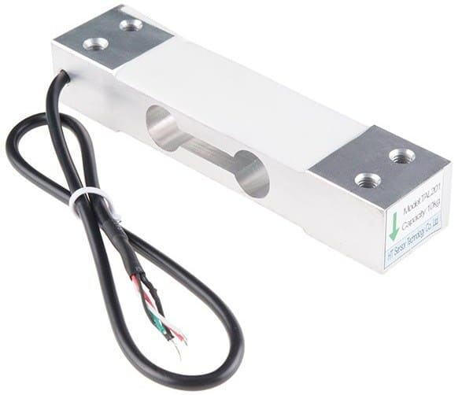

A **load cell** is a transducer that is used to create an electrical signal whose magnitude is directly proportional to the force being measured. It is basically a device that measures strain and then converts force into electric energy which serves as a measurement for scientists and workers. The strain measurement by load cells helps in maintaining the integrity of the unit under pressure and protects people and equipment nearby.

[Load cell](https://instrumentationtools.com/strain-gauge-load-cell/) is a sensor or a transducer that converts a load or force acting on it into an electronic signal. This electronic signal can be a voltage change, current change or frequency change depending on the type of load cell and circuitry used.

There are many different kinds of load cells.

**Resistive load cells** work on the principle of piezo-resistivity. When a load/force/stress is applied to the sensor, it changes its resistance. This change in resistance leads to a change in output voltage when a input voltage is applied.

**Capacitive load cells** work on the principle of change of capacitance which is the ability of a system to hold a certain amount of charge when a voltage is applied to it. For common parallel plate capacitors, the capacitance is directly proportional to the amount of overlap of the plates and the dielectric between the plates and inversely proportional to the gap between the plates.

**Load Cell Working Animation**  


**Wheatstone Bridge Circuit**

The four strain gauges are configured in a [Wheatstone Bridge](https://instrumentationtools.com/bridge-circuit-construction/) configuration with four separate resistors connected as shown in what is called a Wheatstone Bridge Network.

An excitation voltage – usually 10V is applied to one set of corners and the voltage difference is measured between the other two corners. At equilibrium with no applied load, the voltage output is zero or very close to zero when the four resistors are closely matched in value. That is why it is referred to as a balanced bridge circuit.

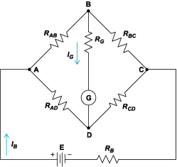

When the metallic member to which the [strain gauges](https://instrumentationtools.com/strain-gauge-load-cell/) are attached, is stressed by the application of a force, the resulting strain – leads to a change in resistance in one (or more) of the resistors. This change in resistance results in a change in output voltage. This small change in output voltage (usually about 20 mVolt of total change in response to full load) can be measured and digitized after careful amplification of the small milli-volt level signals to a higher amplitude 0-5V or 0-10V signal.

These load cells have been in use for many decades now, and can provide very accurate readings but require many tedious steps during the manufacturing process

There are **various load cell designs** in addition to bending beams. This includes for example:

* Load cells with column-shaped spring elements for high loads
* Hollow cylindrical load cells for very high loads
* Load cells with spring elements directly from the measuring bracket
* Ring torsion load cells
* Shear beam load cells
* Load cells with diaphragm spring element.

Top of Form

### **HX711 Load Cell Amplifier**

The Load Cell Amplifier is a small breakout board for the **HX711 IC** that allows you to easily read load cells to measure weight. By connecting the amplifier to your microcontroller you will be able to read the changes in the resistance of the load cell, and with some calibration, you’ll be able to get very accurate weight measurements.

The HX711 uses a two-wire interface (Clock and Data) for communication. Any microcontroller’s GPIO pins should work, and numerous libraries have been written, making it easy to read data from the HX711. Check the hookup guide below for more information. Load cells use a four-wire Wheatstone bridge configuration to connect to the HX711. These are commonly colored RED, BLK, WHT, GRN, and YLW. Each color corresponds to the conventional color coding of load cells:

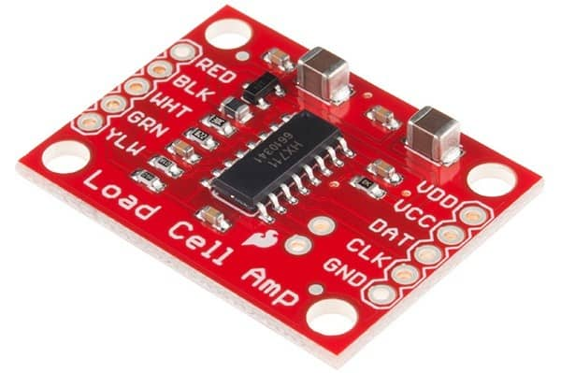

**Red (Excitation+ or VCC)  
Black (Excitation- or GND)  
White (Amplifier+, Signal+ or Output+)  
Green (A-, S- or O-)  
Yellow (Shield)**

### **Design & Consideration**

#### **Load Cell and HX711 Connection:**

[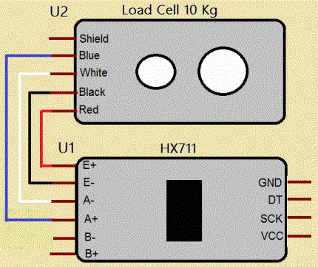](https://how2electronics.com/wp-content/uploads/2018/06/connections-between-Load-cell-and-HX711-module.gif)

|  |  |
| --- | --- |
| 1  2  3  4 | - RED Wire is connected to E+  - BLACK Wire is connected to E-  - WHITE Wire is connected to A-  - GREEN Wire is connected to A+ |

**Features**

* Two selectable differential input channels
* On-chip power supply regulator for load-cell and ADC analog power supply
* On-chip oscillator requiring no external component with optional external crystal
* On-chip power-on-reset
* Data Accuracy: 24 bit (24 bit analog-to-digital converter chip)
* Refresh Frequency : 10/80 Hz
* Operation voltage : 4.8 ~ 5.5V
* Operation current : 1.6mA
* Operation temperature range : -20 to +85?
* Dimension : 36 x 21 x 4mm

**Wiring**

|  |  |  |
| --- | --- | --- |
| **Label** | **Meaning** | **Connection** |
| E+ | Excitation + | Connect to RED wire of load cell |
| E- | Excitation – | Connect to BLACK wire of load cell |
| A- | Input A- | Connect to GREY wire of load cell |
| A+ | Input A+ | Connect to GREEN wire of load cell |
| B- | Input B- | Not used |
| B+ | Input B+ | Not used |
| GND | Ground | Connect to GND of system |
| DT | Data | Connect to digital pin |
| SCK | Serial Clock | Connect to digital pin |
| VCC | Power source | Connect to 5V of system |

Bottom of Form

**MQ135 Gas Sensor Module**

MQ-135 gas sensor can be implement to detect the smoke and other harmful gases. It has potential to detect different harmful gases, including NH3, NOx, alcohol, benzene, smoke and CO2. MQ135 gas sensor has high sensitivity to Ammonia, Sulfide and Benzene steam, also sensitive to smoke and other harmful gases. This Module makes use of the MQ-135 air quality detector and hazardous gas detector chip. Other circuit components such as the LM393 analog comparator chip on this module makes it easy to integrate this module into a project that can detect hazardous gases. The Module requires a 5V power supply and provides a digital Logic output (1 or 0) and an analog level output (0-4V). The digital logic output is LOW (0) when no gas is detected but goes HIGH (1) when hazardous gas concentration in the environment reaches the set threshold set via a potentiometer on the module. The analog level output provides an output voltage within the range of 0 to 4V based on the concentration of the hazardous gas in the environment; 0V for lowest concentration, 4V for maximum concentration.

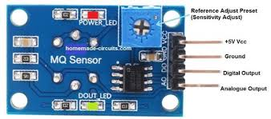 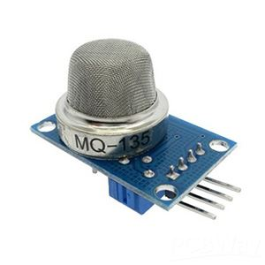

**Fig:** **Gas sensor MQ135**

This Module makes use of the MQ-135 air quality detector and hazardous gas detector chip. Other circuit components such as the LM393 analog comparator chip on this module makes it easy to integrate this module into a project that can detect hazardous gases. The Module requires a 5V power supply and provides a digital Logic output (1 or 0) and an analog level output (0-4V). The digital logic output is LOW (0) when no gas is detected but goes HIGH (1) when hazardous gas concentration in the environment reaches the set threshold set via a potentiometer on the module. The analog level output provides an output voltage within the range of 0 to 4V based on the concentration of the hazardous gas in the environment; 0V for 27 lowest concentration, 4V for maximum concentration. You can use it detects hazardous gases such as Ammonia, Nitrogen Oxide, Alcohol, Benzene, Smoke (Carbon Monoxide), Carbon Dioxide and other air contaminants in our DIY project. The MQ-135 device on this module uses a heating element. After initial power ON, please wait at least 20 Seconds before reading outputs to ensure data validity. The Sensitive material used in MQ135 gas sensor is SnO2. The conductivity of this material is lower in clean air. The sensor conductivity increases with the increasing concentration of target pollution gas. MQ135 can monitor different kinds of toxic gases such as sulphide, ammonia gas, benzene series steam and CO2. The detection range is 10-10,000 ppm with the voltage rate of about 5.0V±0.1V AC or DC The important features are long life span, low cost, simple driver circuit and good sensitivity to toxic gases. MQ 135 gas sensor is widely used in industrial gas alarm, portable gas detector and domestic gas alarm for monitoring CO2 in air. The amount of CO2 present in the atmosphere is 400.7 ppm according to which the sensor is calibrated.

.

**GPS:**

Global Positioning System (GPS) is a satellite-based system that uses satellites and ground stations to measure and compute its position on Earth.

GPS is also known as Navigation System with Time and Ranging (NAVSTAR) GPS.

GPS receiver needs to receive data from at least 4 satellites for accuracy purpose. GPS receiver does not transmit any information to the satellites.

This GPS receiver is used in many applications like smartphones, Cabs, Fleet management etc.

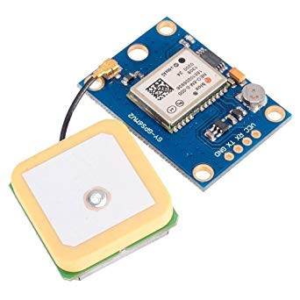

# **How GPS Works**

GPS receiver uses a constellation of satellites and ground stations to calculate accurate location wherever it is located.

These GPS satellites transmit information signal over radio frequency (1.1 to 1.5 GHz) to the receiver. With the help of this received information, a ground station or GPS module can compute its position and time.

# **How GPS Receiver Calculates its Position and Time**

GPS receiver receives information signals from GPS satellites and calculates its distance from satellites. This is done by measuring the time required for the signal to travel from satellite to the receiver.

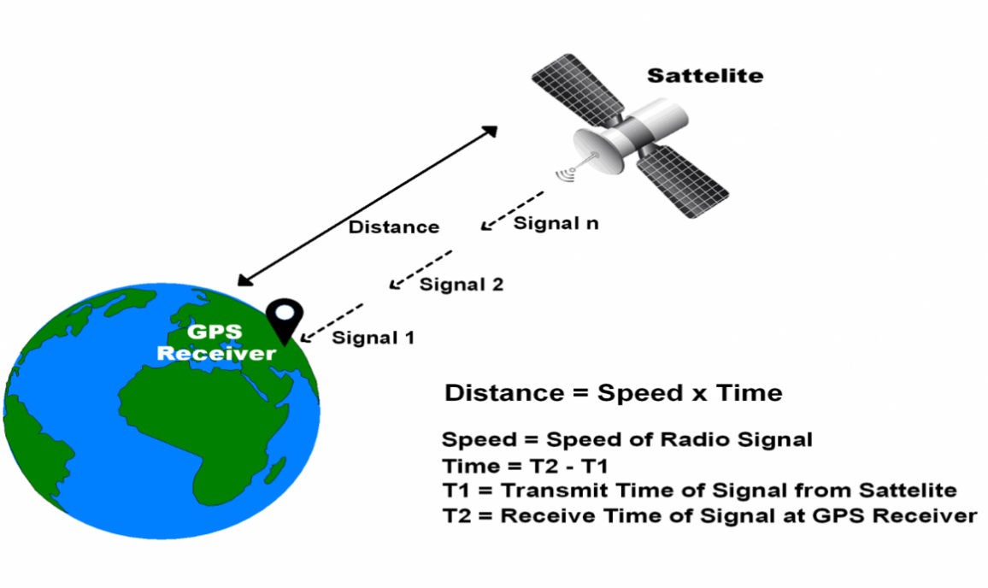

**GPS Distance Calculation**

\textbf{Distance = Speed x Time}

Where,

Speed = Speed of Radio signal which is approximately equal to the speed of light i.e.3*10^{8}

Time = Time required for a signal to travel from the satellite to the receiver.

By subtracting the sent time from the received time, we can determine the travel time.

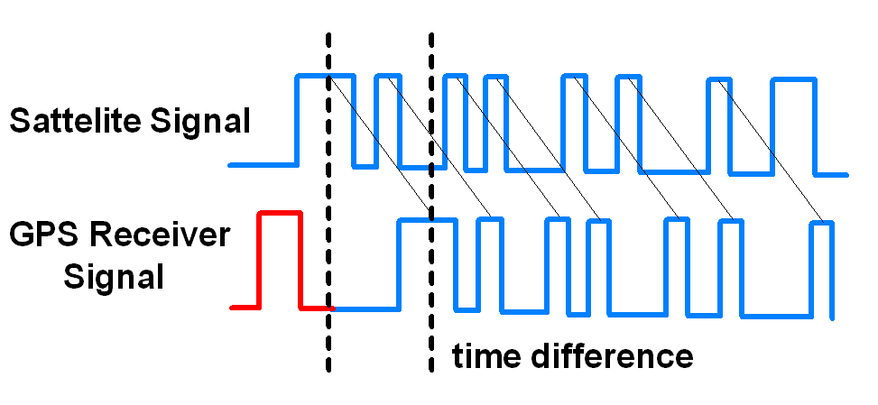

**GPS Signal Time Difference**

To determine distance, both the satellite and GPS receiver generate the same pseudocode signal at the same time.

The satellite transmits the pseudocode; which is received by the GPS receiver.

These two signals are compared and the difference between the signals is the travel time.

Now, if the receiver knows the distance from 3 or more satellites and their location (which is sent by the satellites), then it can calculate its location by using [Trilateration](http://electronics.howstuffworks.com/gadgets/travel/gps1.htm) method.

# [Trilateration](http://electronics.howstuffworks.com/gadgets/travel/gps1.htm): Trilateration is a mathematical technique used by a [global positioning system](https://www.lifewire.com/global-positioning-system-gps-1683311) (GPS) device to determine user position, speed, and elevation. By constantly receiving and analyzing radio signals from multiple GPS satellites and applying the geometry of circles, spheres, and triangles, a GPS device can calculate the precise distance or range to each satellite being tracked.

## How Trilateration Works

Trilateration is a sophisticated version of triangulation, though it does not use the measurement of angles in its calculations. Data from a single satellite provides a general location of a point within a large circular area on the Earth's surface. Adding data from a second satellite allows the GPS to narrow the specific location of that point down to a region where the two areas of satellite data overlap. Adding data from a third satellite provides an accurate position of the point on the Earth's surface.

All the GPS devices require three satellites for an accurate calculation of position. Data from a fourth satellite—or even more than four satellites—further enhance the precision of the point's location, and also allows factors such as elevation or, in the case of aircraft, altitude to also be calculated. GPS receivers routinely track four to seven satellites simultaneously and use trilateration to analyze the information.

# **GPS Module**

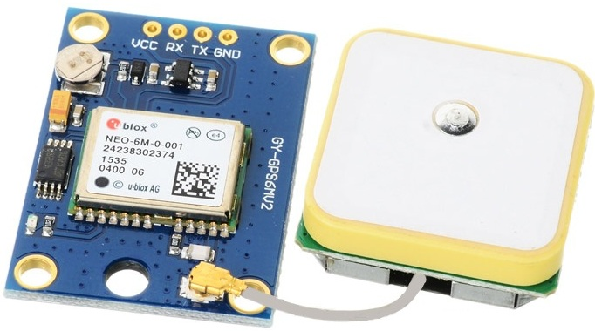

**GPS Receiver**

GPS receiver module gives output in standard (National Marine Electronics Association) NMEA string format. It provides output serially on Tx pin with default 9600 Baud rate.

This NMEA string output from GPS receiver contains different parameters separated by commas like longitude, latitude, altitude, time etc. Each string starts with ‘$’ and ends with carriage return/line feed sequence.

**E.g.**

$GPGGA,184237.000,1829.9639,N,07347.6174,E,1,05,2.1,607.1,M,-64.7,M,,0000*7D

$GPGSA,A,3,15,25,18,26,12,,,,,,,,5.3,2.1,4.8*36

$GPGSV,3,1,11,15,47,133,46,25,44,226,45,18,37,238,45,26,34,087,40*72

$GPGSV,3,2,11,12,27,184,45,24,02,164,26,29,58,349,,05,26,034,*7F

$GPGSV,3,3,11,21,25,303,,02,11,071,,22,01,228,*40

$GPRMC,184237.000,A,1829.9639,N,07347.6174,E,0.05,180.19,230514,,,A*64

**Pin Description**

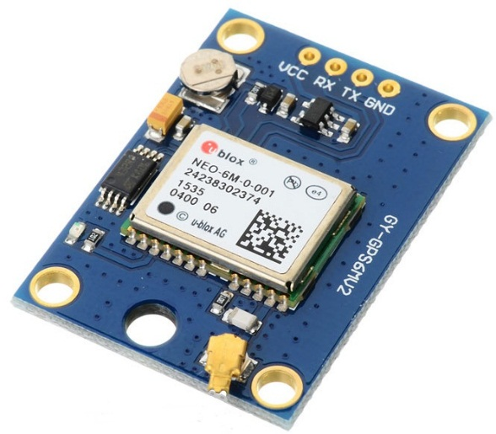

**GPS Receiver Module**

**VCC:** Power Supply 3.3 – 6 V

**GND:**Ground

**TX:**Transmit data serially which gives information about location, time etc.

**RX:**Receive Data serially. It is required when we want to configure GPS module.

# **Check GPS module**

Before Interfacing GPS module with PIC18F4550 microcontroller, we can check the output of GPS module. From that string, we can extract information like longitude, latitude, time which is helpful to find location and timing information.

To do this, connect this GPS module to the PC via USB to Serial converter or DB9 connector. Also, it is necessary to keep antenna of GPS module on proper location.

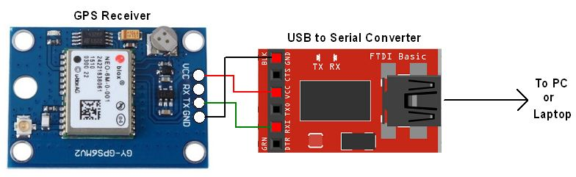

**GPS Serial Interface**

1. Now open any serial terminal e.g. Realterm, Hyper terminal, Putty etc. on PC/laptop.
2. Open the PORT with 9600 baud rate.
3. The terminal will show data coming from GPS receiver module.

The output data from GPS receiver module displaying on a serial terminal as follows.



In the above string, the NMEA string starting with “$GPGGA” is most popularly used. It provides us Time, Longitude, Latitude and Altitude along with directions. This information is helpful to find Time and Location.

**GSM**

GSM is a mobile communication modem; it is stands for global system for mobile communication (GSM). The idea of GSM was developed at Bell Laboratories in 1970.  It is widely used mobile communication system in the world. GSM is an open and digital cellular technology used for transmitting mobile voice and data services operates at the 850MHz, 900MHz, 1800MHz and 1900MHz frequency bands.

GSM system was developed as a digital system using time division multiple access (TDMA) technique for communication purpose. A GSM digitizes and reduces the data, then sends it down through a channel with two different streams of client data, each in its own particular time slot. The digital system has an ability to carry 64 kbps to 120 Mbps of data rates.

There are various cell sizes in a GSM system such as macro, micro, pico and umbrella cells. Each cell varies as per the implementation domain. There are five different cell sizes in a GSM network macro, micro, pico and umbrella cells. The coverage area of each cell varies according to the implementation environment.

### Time Division Multiple Access

TDMA technique relies on assigning different time slots to each user on the same frequency. It can easily adapt to data transmission and voice communication and can carry 64kbps to 120Mbps of data rate.

### GSM Architecture

A GSM network consists of the following components:

* **A Mobile Station:**  It is the mobile phone which consists of the transceiver, the display and the processor and is controlled by a SIM card operating over the network.
* **Base Station Subsystem:** It acts as an interface between the mobile station and the network subsystem. It consists of the Base Transceiver Station which contains the radio transceivers and handles the protocols for communication with mobiles. It also consists of the Base Station Controller which controls the Base Transceiver station and acts as a interface between the mobile station and mobile switching centre.
* **Network Subsystem:** It provides the basic network connection to the mobile stations. The basic part of the Network Subsystem is the Mobile Service Switching Centre which provides access to different networks like ISDN, PSTN etc. It also consists of the Home Location Register and the Visitor Location Register which provides the call routing and roaming capabilities of GSM. It also contains the Equipment Identity Register which maintains an account of all the mobile equipments wherein each mobile is identified by its own IMEI number. IMEI stands for International Mobile Equipment Identity.

### Features of GSM Module:

* Improved spectrum efficiency
* International roaming
* Compatibility with integrated services digital network (ISDN)
* Support for new services.
* SIM phonebook management
* Fixed dialing number (FDN)
* Real time clock with alarm management
* High-quality speech
* Uses encryption to make phone calls more secure
* Short message service (SMS)

The security strategies standardized for the GSM system make it the most secure telecommunications standard currently accessible. Although the confidentiality of a call and secrecy of the GSM subscriber is just ensured on the radio channel, this is a major step in achieving end-to- end security.

### GSM Modem

A GSM modem is a device which can be either a mobile phone or a modem device which can be used to make a computer or any other processor communicate over a network. A GSM modem requires a SIM card to be operated and operates over a network range subscribed by the network operator.  It can be connected to a computer through serial, USB or Bluetooth connection.

A GSM modem can also be a standard GSM mobile phone with the appropriate cable and software driver to connect to a serial port or USB port on your computer. GSM modem is usually preferable to a GSM mobile phone. The GSM modem has wide range of applications in transaction terminals, supply chain management, security applications, weather stations and GPRS mode remote data logging.

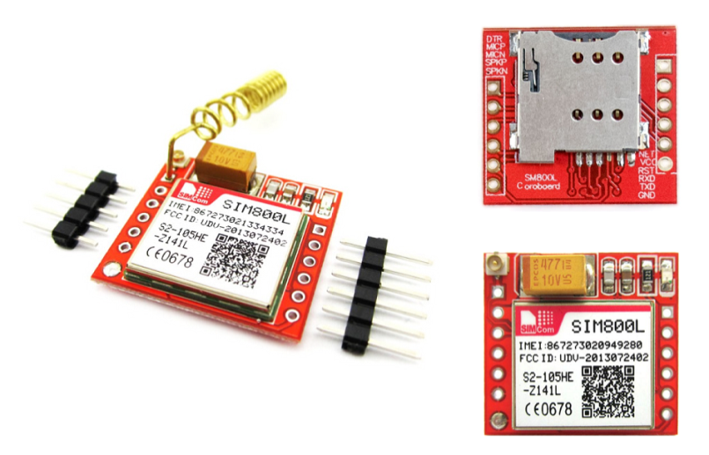

It requires a **SIM (Subscriber Identity Module)** card just like mobile phones to activate communication with the network. Also they have **IMEI** (International Mobile Equipment Identity) number similar to mobile phones for their identification. A GSM/GPRS MODEM can perform the following operations:

1.      Receive, send or delete SMS messages in a SIM.

2.      Read, add, search phonebook entries of the SIM.

3.      Make, Receive, or reject a voice call.

The MODEM needs **AT commands**, for interacting with processor or controller, which are communicated through serial communication. These commands are sent by the controller/processor. The MODEM sends back a result after it receives a command. Different AT commands supported by the MODEM can be sent by the processor/controller/computer to interact with the **GSM and GPRS cellular network**.

### **GSM Architecture**

The GSM architecture is divided into Radio Subsystem, Network and Switching Subsystem and the Operation Subsystem. The radio sub system consists of the Mobile Station and Base Station Subsystem.

The mobile station is generally the mobile phone which consists of a transceiver, display and a processor. Each handheld or portable mobile station consists of a unique identity stored in a module known as SIM (Subscriber Identity Chip). It is a small microchip which is inserted in the mobile phone and contains the database regarding the mobile station.

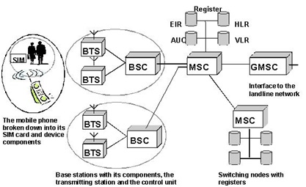

**Buzzer:**

A buzzer or beeper is an audio signaling device, which may be mechanical, electromechanical, or piezoelectric. Typical uses of buzzers and beepers include alarm devices, timers and confirmation of user input such as a mouse click or keystroke. Buzzer is an integrated structure of electronic transducers, DC power supply, widely used in computers, printers, copiers, alarms, electronic toys, automotive electronic equipment, telephones, timers and other electronic products for sound devices. Active buzzer 5V Rated power can be directly connected to a continuous sound, this section dedicated sensor expansion module and the board in combination, can complete a simple circuit design, to "plug and play.

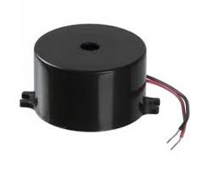

**Buzzer Pin Configuration**

|  |  |  |
| --- | --- | --- |
| **Pin Number** | **Pin Name** | **Description** |
| 1 | Positive | Identified by (+) symbol or longer terminal lead. Can be powered by 5V DC |
| 2 | Negative | Identified by short terminal lead. Typically connected to the ground of the circuit |

**Buzzer Features and Specifications**

* Rated Voltage: 6V DC
* Operating Voltage: 4-8V DC
* Rated current: <30mA
* Sound Type: Continuous Beep
* Resonant Frequency: ~2300 Hz
* Small and neat sealed package
* Breadboard and Perf board friendly

**How to use a Buzzer**

A **buzzer**is a small yet efficient component to add sound features to our project/system. It is very small and compact 2-pin structure hence can be easily used on [breadboard](https://components101.com/misc/breadboard-connections-uses-guide), Perf Board and even on PCBs which makes this a widely used component in most electronic applications.

There are two types are buzzers that are commonly available. The one shown here is a simple buzzer which when powered will make a Continuous Beeeeeeppp.... sound, the other type is called a readymade buzzer which will look bulkier than this and will produce a Beep. Beep. Beep. Sound due to the internal oscillating circuit present inside it. But, the one shown here is most widely used because it can be customized with help of other circuits to fit easily in our application.

This buzzer can be used by simply powering it using a DC power supply ranging from 4V to 9V. A simple 9V battery can also be used, but it is recommended to use a regulated +5V or +6V DC supply. The buzzer is normally associated with a switching circuit to turn ON or turn OFF the buzzer at required time and require interval.

**Applications of Buzzer**

* Alarming Circuits, where the user has to be alarmed about something
* Communication equipment’s
* Automobile electronics
* Portable equipment’s, due to its compact size

**EMBEDDED C**

Implanted C makes use of KEIL IDE programming. The framework program written in implanted C can be placed away in Microcontroller. The accompanying is a portion of the actual motives behind composing applications in C as opposed to get collectively. It is much less disturbing and much less tedious to write down in C then amassing. C is less traumatic to trade and refresh. You can utilize code available in capacity libraries. C code is compact to different microcontrollers with subsequent to 0 alteration. Genuine, installed C programming need nonstandard expansions to the C driver with a view to bolster charming components, as an example, settled point range catching, numerous unmistakable reminiscence banks, and fundamental I/O operations.

In 2008, the C Standards Committee prolonged the C data to deal with these problems via giving a normal well known to all executions to purchaser to contains numerous additives not handy in standard C, for example, settled factor wide variety catching, named address spaces, and vital I/O equipment tending to.

Installed C utilize the greater part of the grammar and semantics of wellknown C, e.G., number one() paintings, variable definition, facts type statement, contingent proclamations (if, switch. Case), circles (even as, for), capacities, exhibits and strings, structures and union, piece operations, macros, unions, and so on.

**Embedded systems programming**

Installed frameworks writing computer programs is not quite the same as creating applications on a desktop PCs. Key attributes of an implanted framework, when contrasted with PCs, are as per the following:

•Embedded gadgets have asset limitations (restricted ROM, constrained RAM, constrained stack space, less handling power)

•Components utilized as a part of installed framework and PCs are distinctive; implanted frameworks ordinarily utilizes littler, less power devouring segments. Inserted frameworks are more fixing to the equipment.

Two remarkable components of Embedded Programming are code speed and code estimate. Code speed is represented by the handling power, timing requirements, while code size is administered by accessible program memory and utilization of programming dialect. Objective of implanted framework writing computer programs is to get greatest elements in least space and least time.

Implanted frameworks are modified utilizing distinctive sort of dialects:

•Machine Code

•Low level dialect, i.e., get together

•High level dialect like C, C++, and Java and so on.

•Application level dialect like Visual Basic, scripts, Access, and so on..,

**Arduino IDE:**

The Arduino IDE software is a open source software, where we can have the example codes for the beginners. In the Present world there are lot of version in the Arduino IDE in which present usage is Version1.0.5. It is very easy to connect the PC with Arduino Board.

First we have to install the Arduino IDE software according to the below instructions:

* Insert the CD-ROM or PENDRIVE which Contains the software and then Copy the Setup File to your desired location.
* After Copying, now click on the setup you will see an window shown below
* 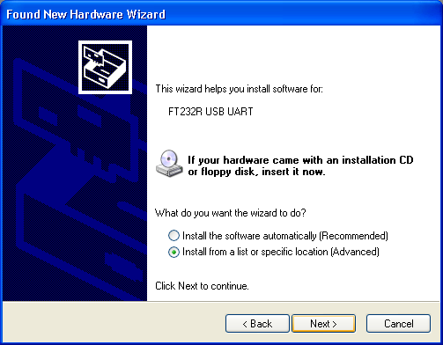Click On NO, not this time. Then after NEXT
* 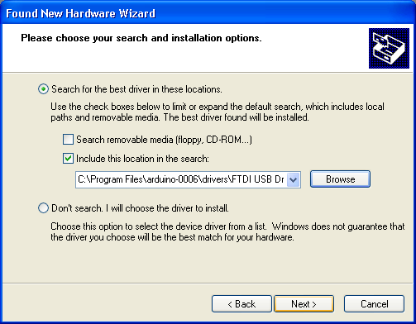Another Window opens –select Install from a list of specific location and NEXT
* Select “include this location in the search” and then click Browse option available in it
* Now it will Automatically check the USB driver and the software is installed click Finish

.

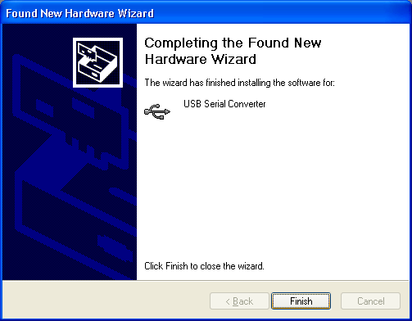

* Now click Finish, the Software will be downloaded.
* Now click on the Arduino IDE icon present on your Desktop. A window will appear like this.

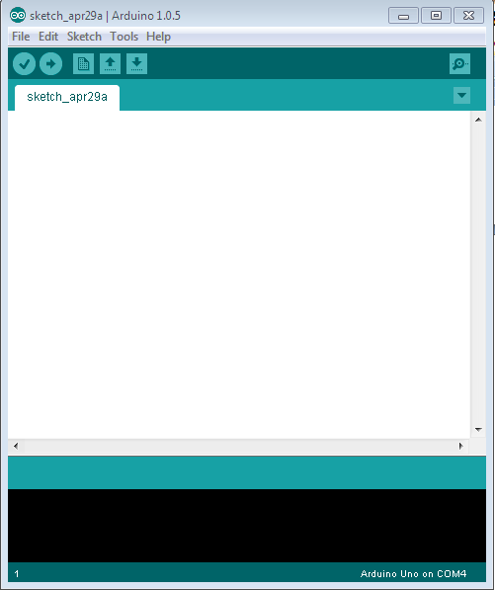

* For any sample programs, select FILE option🡪Examples.

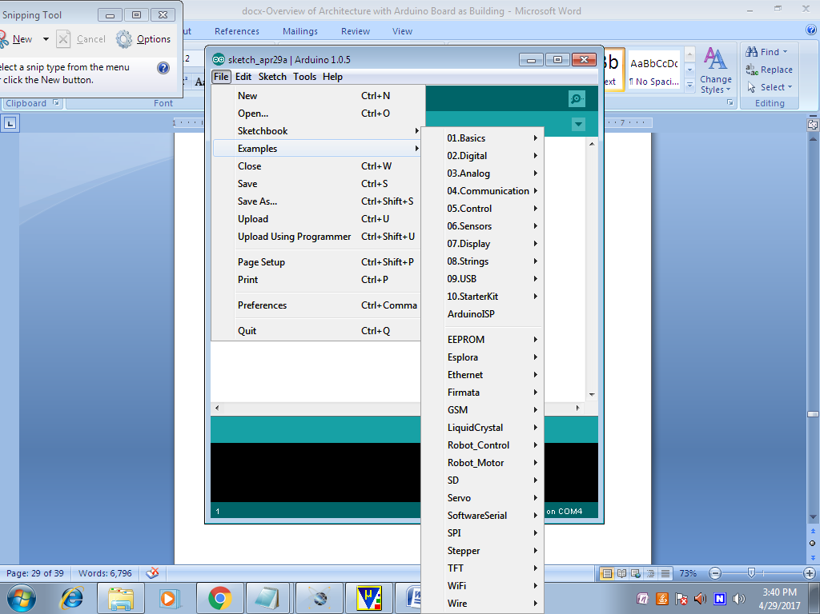

* After Entering the Sample Code in the file, it would look like this

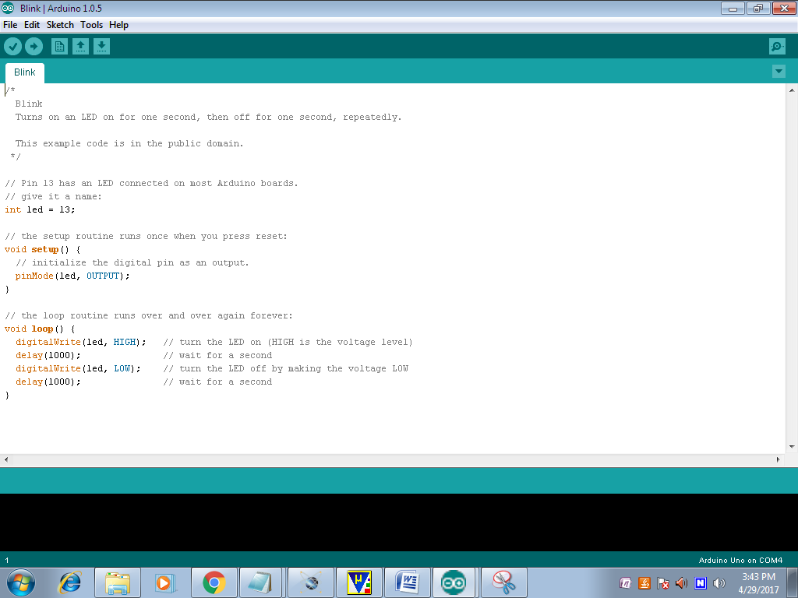

* Before Connecting we have to select which Board is used by the user, Basically UNO. By selecting TOOLS🡪Board🡪ARDUINO UNO

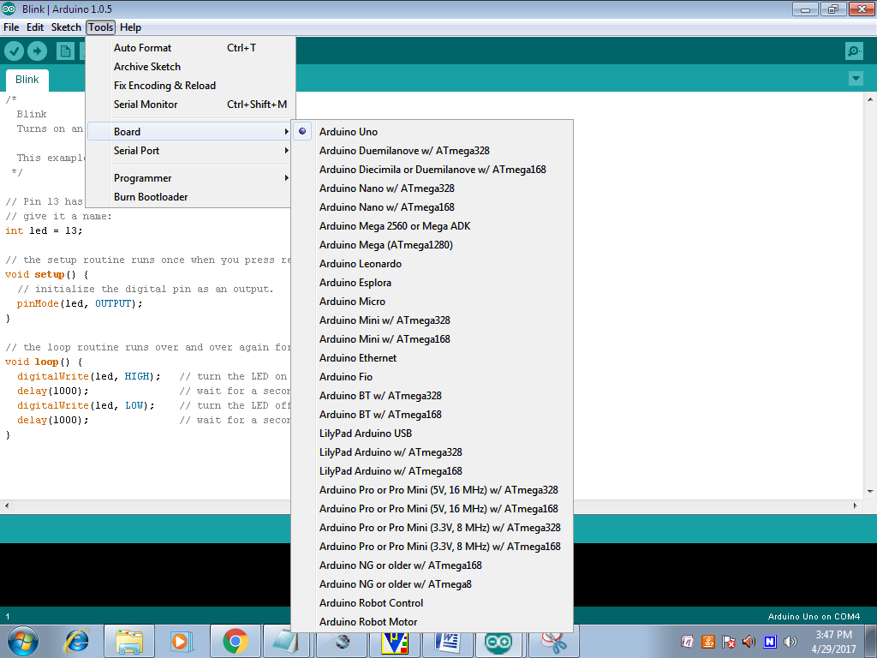

* Now to dump the in the board Connect the Arduino to the PC through the USB port available in it. Like this TOOLS🡪SERIAL PORT🡪COMM4,COMM8 etc;

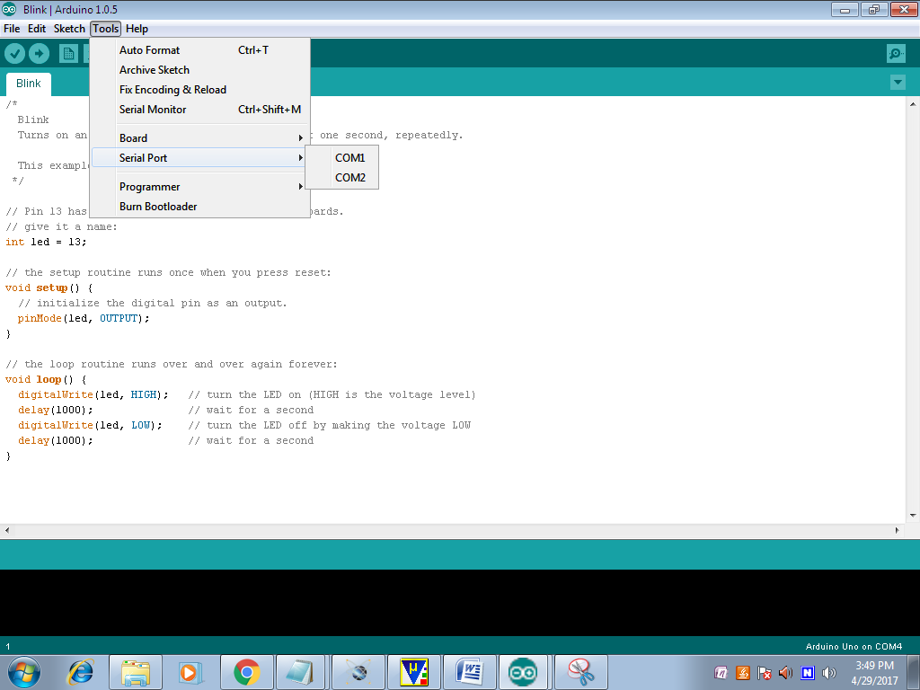

* To verify the written Program select COMPILE option available in the software ($√$).
* Now Connect the Board and select the COMM port and then UPLOAD the file in ARDUINO(🡪)
* To OPEN the Previous ARDUINO FILE selects $(↑)$ option.
* To enter new files select NEW option.
* To Save the Existing File, Click on the $(↓)$.
* To Send the Data Through Serial Monitor, Click on the (Ǫ).

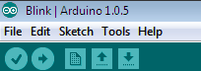

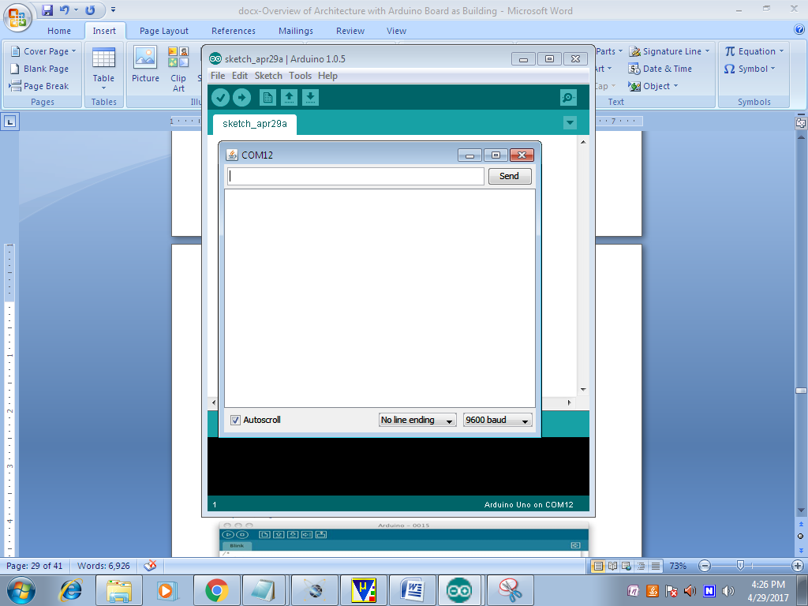

* Here we can see the Serial Data.

**Advantages:**

* Enhanced Safety
* Real-Time Monitoring
* Accident Prevention
* Environmental Protection
* Improved Operational Efficiency

**Applications:**

* LPG Transport Fleet Management
* Commercial LPG Delivery Services
* Public Safety and Emergency Services
* Industrial Gas Distribution

**Conclusion:**

In conclusion, the LPG Transport Tracking and Leakage Detection with Accident Prevention Alert System represents a significant advancement in the safe transportation of LPG. By integrating advanced technologies such as gas sensors, MEMS sensors, GPS, GSM, and load cells, the system provides a comprehensive solution to monitor the real-time status of LPG transport, detect potential leaks, and prevent accidents. The system not only enhances safety by providing immediate alerts in case of leakage or accidents but also improves operational efficiency through real-time tracking and data display. Additionally, the system contributes to environmental protection by minimizing the risks associated with gas leakage, while offering cost savings by reducing the chances of damage and regulatory fines. Its applications across various industries, including transportation, distribution, agriculture, and construction, demonstrate its scalability and versatility. Ultimately, this project highlights the importance of combining IoT, sensor technology, and communication systems to ensure the safe and efficient delivery of hazardous materials, providing a robust framework for future advancements in LPG transport safety.

**References:**

[1] **Kumar, A., & Singh, R. (2020).** "Design and Development of IoT-Based LPG Leakage Detection and Monitoring System." *International Journal of Computer Applications, 175*(7), 1-6.

[2] **Sharma, S., & Mishra, P. (2018).** "An Intelligent Gas Leakage Detection System with Vehicle Tracking using GPS and GSM." *Journal of Sensors and Actuators A: Physical, 282*, 15-24.

[3] **Rajasekar, K., & Srinivasan, T. (2019).** "Real-Time Vehicle Tracking and Accident Detection System using MEMS and GPS." *International Journal of Engineering Research and Applications, 9*(3), 35-40.

[4] **Gupta, M., & Kumar, L. (2021).** "IoT-Based LPG Weight and Leakage Monitoring System." *International Journal of Advanced Science and Technology, 29*(3), 1203-1212.