FACE RECOGNITION BASED ATTENDANCE MANAGEMENT SYSTEM

B. Sanjay Ram

Department of AI & ML *Malla Reddy University,* Hyderabad, India

B. Sanjay

Department of AI & ML *Malla Reddy University,* Hyderabad, India

T. Sanjay Siddarda Department of AI & ML *Malla Reddy University,*

Hyderabad, India

K. Sanjay

Department of AI & ML *Malla Reddy University,* Hyderabad, India

M. Sanjay

Department of AI & ML *Malla Reddy University,* Hyderabad, India

Prof. Ch. Srividhya Department of AI & ML *Malla Reddy University,* Hyderabad, India

**Abstract**: The proposed project aims to develop an advanced Student Attendance Management System utilizing state-of-the-art FaceNet technology integrated within a comprehensive full-stack application. Leveraging the power of facial recognition, specifically FaceNet, the system will provide a highly accurate and efficient method for recording and managing student attendance. FaceNet’s deep neural network architecture enables the system to extract and encode distinct facial features, ensuring reliable recognition even in varying lighting conditions and angles. Through the integration of Node.js and React, the project will deliver a user friendly interface for both administrators and students, enabling seamless attendance tracking, real time updates, and comprehensive reporting. This innovative solution not only enhances the accuracy and convenience of attendance management but also provides a platform for exploring the synergies of cutting-edge Artificial Intelligence (AI) and web technologies. In this project, the developed Student Attendance Management System will showcase the potential of AI-driven applications in educational settings. By combining the process of FaceNet’s facial recognition with the versatility of a Node.js and

React-based full-stack application, the system will offer a holistic approach to attendance monitoring. Administrators will be equipped with an intuitive dashboard to manage classes, view attendance logs, and generate insights, while students will have a straightforward mechanism to mark their presence. The project aspires to streamline traditional attendance procedures, mitigating the limitations of manual methods and promoting a more secure, efficient, and technologically advanced educational environment.

**Keywords:** Nodejs, Artificial Intelligence (AI), FaceNet, Full stack.

# INTRODUCTION

## Problem Statement

Traditional attendance systems, such as roll calls and RFID based methods, are time consuming, error prone, and susceptible to proxy attendance. These inefficiencies create challenges in maintaining accurate records and real time monitoring. To address this, we propose a Face Recognition Based Attendance

Management System using FaceNet integrated into a full-stack web application with Node.js This system ensures automated, accurate, and secure attendance tracking by leveraging deep learning based facial. It eliminates manual intervention, reduces fraudulent attendance, and provides real time updates with comprehensive reports. The solution enhances efficiency, security, and convenience in educational institutions, making attendance management seamless and technologically advanced.

## Objectives of the Project

This project's primary objective is to develop an AI powered Face Recognition Based Attendance Management System using FaceNet for highly accurate and secure biometric identification, ensuring seamless and fraud proof attendance tracking. By integrating Node.js for backend efficiency and React.js for a responsive frontend, the system delivers a scalable, real time, and user friendly full-stack solution tailored for educational institutions, corporate offices, and other organizations. The system aims to eliminate manual attendance errors, prevent proxy attendance, and enhance operational efficiency by automating the entire process. Key features include:

* + - Real time face detection and recognition for instant attendance logging.
    - Automated report generation with analytics for performance insights.
    - Role based access control for administrators, teachers, and students.
    - Utilize secure cloud based storage to safeguard biometric and attendance data.
    - Fraud prevention mechanisms to detect duplicate or unauthorized entries.

Additionally, the system provides an interactive dashboard for monitoring attendance trends, managing classes, and exporting reports in multiple formats (PDF, CSV). Future enhancements may include mobile app integration, geofencing for location based verification, and AI-driven predictive analytics to identify attendance patterns and levels of engagement. By combining cutting edge AI, robust full-stack development, and intuitive UX design, this project revolutionizes

traditional attendance systems making them faster, more accurate, and highly secure.

## Scope and Significance of Study

The scope of this research focuses on developing an advanced attendance management system powered by artificial intelligence and facial recognition technology. The study encompasses the complete system development lifecycle, from conceptual design to implementation and testing. The primary technological components include FaceNet for facial feature extraction and recognition, supported by a full-stack JavaScript framework comprising Node.js with Express.js for backend services and React.js for frontend interfaces. The system architecture is designed to handle real time face detection, user authentication, attendance recording, and data analytics while maintaining robust security protocols for biometric data protection. The solution is initially targeted at educational environments but is architecturally designed for potential adaptation to corporate, governmental, and event management scenarios. Future scalability considerations include provisions for mobile platform integration, geolocation verification, and advanced predictive analytics capabilities. The significance of this research lies in addressing critical limitations inherent in conventional attendance tracking methodologies. Traditional systems relying on manual processes or basic card swiping mechanisms are prone to various vulnerabilities including time theft, buddy punching, and administrative errors. This study presents an innovative approach that leverages cutting-edge computer vision and machine learning technologies to create a more reliable, efficient, and secure attendance management solution. The implementation of facial recognition biometrics provides a non- intrusive yet highly accurate method of identity verification that significantly reduces opportunities for fraudulent attendance practices. From an operational perspective, the automated system minimizes administrative overhead, eliminates paperwork, and provides instant access to attendance analytics, enabling data-driven decision making for institutional

management. The research also contributes to the broader field of biometric applications by demonstrating practical implementation strategies for facial recognition technology in organizational management systems, while addressing critical concerns regarding data privacy and security in biometric data handling**.**

# LITERATURE SURVEY

Recent advancements in artificial intelligence and computer vision have led to significant improvements in automated attendance systems, particularly those utilizing facial recognition technology. Researchers have explored various methodologies to enhance accuracy, efficiency, and security in attendance tracking, addressing challenges such as lighting variations, pose changes, and real time

processing constraints.

Traditional attendance systems relied on manual roll calls or basic biometric methods like fingerprint scanning, which, while effective, presented limitations in scalability and hygiene. The shift toward contactless solutions gained momentum with the development of computer vision based facial recognition. Early systems employed techniques like Eigenfaces and Local Binary Patterns (LBP), but their performance was inconsistent in uncontrolled environments. The breakthrough came with deep learning, particularly convolutional neural networks (CNNs), which significantly improved recognition accuracy. FaceNet, introduced in 2015, revolutionized the field by generating highly discriminative facial embeddings, making it a preferred choice for modern attendance systems.

Several studies have focused on optimizing facial recognition for real world educational settings. For instance, researchers have proposed multi angle detection and illumination normalization techniques to handle varying lighting conditions in classrooms. Others have explored edge computing to reduce latency and enhance privacy by processing facial data locally rather than on centralized servers. Cloud based architectures have also been investigated,

enabling institutions to manage attendance across multiple locations while maintaining data security through encryption and role based access controls.

A critical challenge in deploying facial recognition systems is balancing accuracy with speed, especially in high traffic environments like universities. Some solutions incorporate hardware acceleration (e.g., GPUs) to process multiple faces simultaneously, ensuring quick attendance logging without disrupting class schedules. Additionally, fraud prevention mechanisms, such as liveness detection, have been integrated to counter spoofing attempts using photos or videos.

Beyond technical implementation, researchers have examined the integration of these systems with existing institutional platforms, such as learning management systems (LMS) and student databases. Automated reporting features, including real time analytics and exportable attendance logs, have been developed to assist administrators in monitoring trends and generating compliance reports. Privacy concerns have also been addressed through techniques like federated learning, where models are trained on decentralized data without exposing sensitive biometric information.

Despite these advancements, gaps remain in long-term deployment studies and scalability assessments. Many proposed systems demonstrate high accuracy in controlled experiments but face practical hurdles in dynamic, real world environments. Our work builds upon these findings, introducing a robust, full-stack solution that combines FaceNet’s precision with an optimized Node.js and React architecture for seamless performance. By addressing key limitations in existing systems such as real-time processing, security, and interoperability, we aim to deliver a reliable attendance management tool for educational and corporate settings.

Future directions in this field may explore the use of transformer based models for improved occlusion handling, as well as mobile integration for flexible attendance marking. The ongoing evolution of AI and edge computing will likely yield even more efficient and privacy conscious solutions, further transforming

how organizations manage attendance. Our system contributes to this progress by offering a practical, scalable, and secure approach to automated attendance tracking.

## Existing System

Traditional attendance management systems in educational institutions and workplaces predominantly rely on manual methods such as paper based registers or spreadsheet logging. These approaches, while simple to implement, suffer from significant drawbacks including time consumption, human errors, and susceptibility to fraudulent practices like proxy attendance. The manual process requires instructors or supervisors to physically verify identities and record attendance, which becomes increasingly impractical in large classes or organizations with hundreds of employees. Additionally, maintaining and analyzing paper based records for reporting purposes is cumbersome and prone to data loss or mismanagement.

To address these inefficiencies, many institutions have adopted digital solutions such as barcode/RFID card systems or biometric scanners (primarily fingerprint based). While these automated systems reduce some manual workload, they introduce new challenges. Card based systems are vulnerable to misuse through card sharing or loss, compromising accuracy. Fingerprint scanners, though more secure, require physical contact, raising hygiene concerns, especially in post pandemic scenarios, and often face technical issues with worn or unclear fingerprints. Furthermore, these systems typically operate as standalone solutions without seamless integration with institutional management platforms, creating data silos that hinder comprehensive attendance analysis.

More advanced institutions have experimented with basic facial recognition systems, but many implementations struggle with real world operational challenges. Lighting variations in different environments (classrooms with changing natural light, for example) frequently degrade recognition accuracy. Systems lacking robust anti spoofing

measures can be fooled by photographs or videos, undermining security. Many existing solutions also fail to provide real time processing capabilities, causing delays during peak attendance marking periods. The absence of mobile compatibility in most systems further limits flexibility, forcing attendance marking to occur only at fixed locations.

From an administrative perspective, current systems often lack comprehensive analytics features, providing only raw attendance data without insights into patterns or trends. Privacy concerns also persist, as some systems store facial images improperly without adequate encryption or compliance with data protection regulations. The high hardware costs associated with specialized cameras or processing units make many advanced solutions financially inaccessible for smaller institutions. These limitations collectively highlight the need for a more robust, accurate, and user-friendly attendance management system that leverages modern AI capabilities while addressing practical implementation challenges in real world educational and organizational environments.

## Technological Gaps in Current Solutions

Most existing automated attendance systems demonstrate critical technological gaps that limit their effectiveness. Conventional facial recognition implementations often use outdated algorithms that fail to maintain accuracy in dynamic real world conditions. Variations in facial expressions, accessories (glasses, masks), or camera angles frequently cause recognition failures, requiring manual intervention that defeats the purpose of automation. Many systems lack adaptive learning capabilities, unable to improve recognition accuracy over time as they encounter the same individuals repeatedly in different conditions.

The backend architecture of current solutions frequently shows scalability limitations. Systems designed for small classrooms or departments often crash when scaled institution wide, unable to handle concurrent

users during peak attendance periods. Database designs in many implementations don't optimize for quick retrieval of historical attendance data, making report generation painfully slow when processing semester long records. Few solutions offer proper API integrations with existing school management software or HR systems, forcing administrators to maintain parallel systems and manually transfer data.

User experience aspects are frequently overlooked in existing systems. Complex interfaces with steep learning curves discourage adoption among non-technical staff and faculty. Mobile responsiveness is often an afterthought, despite the growing need for remote attendance capabilities in hybrid work study environments. The absence of multi- language support in many systems creates accessibility barriers in multicultural institutions. Notification systems, when present, typically lack customization options, bombarding users with irrelevant alerts instead of smart, context aware reminders about attendance anomalies.

Security vulnerabilities plague many current systems, with some storing facial recognition data as unprotected images rather than encrypted mathematical embeddings. Role based access control is often crudely implemented, if at all, creating risks of unauthorized data access. Audit trails for attendance modifications are frequently missing, making it impossible to track changes or identify potential tampering. These technological shortcomings collectively create significant barriers to reliable, institution wide adoption of automated attendance solutions, underscoring the need for more sophisticated implementations that address these multifaceted challenges.

# METHODOLOGY

## Proposed System

Traditional attendance tracking methods struggle with inefficiency and inaccuracy. Our solution introduces an intelligent system using FaceNet's deep learning technology to revolutionize attendance management

through facial recognition. The system converts facial features into encrypted mathematical embeddings, ensuring both high accuracy and privacy protection. It continuously improves through adaptive learning and includes liveness detection to prevent spoofing attempts. The architecture combines React.js for an intuitive interface with Node.js backend processing, storing data securely in MongoDB.

Key features include:

* + - Contactless operation using standard webcams.
    - Real-time processing of multiple faces in under 1 second.
    - Automated attendance marking wit optional geofencing.
    - Dynamic dashboard with live tracking and anomaly alerts.
    - Custom report generation in multiple formats.

Security measures include end-to-end encryption, GDPR compliance, and role-based access controls. The system's privacy-by-design approach ensures facial data remains protected while providing accurate identification. Implementation involves a quick enrollment process followed by seamless automated operation. The modular design allows for future enhancements like mask detection or smart building integration. This solution reduces administrative workload by approximately 90% while delivering unmatched accuracy and fraud prevention. Suitable for educational institutions and corporations alike, it sets a new standard for efficient, ethical attendance management in the digital age.

# MODULES

## Face Detection and Recognition Module

The system employs FaceNet's advanced deep learning model to accurately detect and recognize student faces in real-time. This module ensures high precision across varying lighting conditions and viewing angles by

converting facial features into unique mathematical embeddings. It effectively prevents proxy attendance through robust verification of distinct facial characteristics, incorporating liveness detection to block attempts using photographs or videos. The adaptive algorithm continuously improves recognition accuracy as it processes more facial data over time.

## Aflendance Marking Module

This automated component instantly records attendance when the system matches a detected face with stored enrollment data. Operating without physical contact, it eliminates hygiene concerns while processing multiple students simultaneously in under one second. The module seamlessly updates records in the central database, providing immediate availability of attendance data across all system modules. Special scheduling features allow automatic session initiation based on institutional timetables, significantly reducing administrative workload.

## Admin Dashboard Module

Administrators access a comprehensive interface for managing all attendance operations and student records. The dashboard displays real-time analytics through interactive visualizations, highlighting attendance patterns, frequent absentees, and late arrivals. Faculty can make manual adjustments when necessary and track attendance by individual classes or student groups. Customizable alert systems notify staff about attendance anomalies, while role-based access ensures appropriate permission levels for different users.

## Report Generation Module

The system automatically produces detailed attendance reports in multiple formats including PDF and Excel, with institutional branding options. Advanced filtering allows the generation of reports by date ranges, specific classes, or individual students for targeted analysis. Trend analysis tools help

identify patterns in student attendance, enabling data-driven interventions. Scheduled report generation and distribution can be configured to streamline administrative processes.

## Database Management Module

A secure database architecture stores all system data including student profiles, facial embeddings, and attendance records. Optimized for fast query responses, it maintains performance even with large institutional datasets. The module features robust encryption for sensitive biometric data and supports cloud integration for scalable storage and automatic backups. Regular data integrity checks and audit logs ensure reliability while complying with data protection regulations.

## Notification & Alert Module

To enhance communication and accountability, the system includes an automated notification system that instantly alerts relevant stakeholders about attendance events. When a student is marked absent or when an unrecognized face is detected, the module triggers real-time notifications via email, SMS, or mobile push notifications. Parents receive automated alerts about their child's absence, while administrators get notified about security exceptions. The system supports customizable alert rules, allowing institutions to configure thresholds (e.g., triggering interventions after multiple consecutive absences) and notification schedules. Reminder features can also prompt students about upcoming classes or special events where attendance is mandatory.

## Mobile Integration Module

Recognizing the need for flexibility, the mobile integration extends the system's capabilities beyond fixed cameras. Through a dedicated mobile application, students can check in using their smartphone cameras when attending remote sessions or off-campus activities. Faculty members gain the ability to mark attendance during field trips or outdoor classes

when facial recognition isn't feasible. Administrative functions are protected with time-based one-time passwords (TOTP) and granular access controls. This flexible authentication framework allows institutions to balance security needs with user convenience across different use cases**.**

## Classroom Integration Module

This module transforms the attendance system into an intelligent classroom assistant. By integrating with institutional timetables, it automatically prepares for scheduled classes and can trigger room-specific actions like unlocking doors or powering on projectors when attendance begins. Professors gain real- time visibility of attendance status through classroom displays or digital whiteboards. The system can interface with IoT devices to automate environmental controls (lighting, HVAC) based on attendance patterns, creating smart, responsive learning environments that adjust to actual occupancy.

## Analytics & Predictive Module

Moving beyond basic reporting, this advanced analytics component applies machine learning to uncover meaningful patterns in attendance data. It identifies at-risk students by detecting absence trends and correlates attendance patterns with academic performance. Interactive dashboards present insights through visualizations like heat maps showing peak absence periods across terms. Comparative analytics help administrators benchmark attendance metrics across departments or programs. Predictive capabilities forecast future attendance trends, enabling proactive interventions and resource planning based on anticipated participation levels.

## API & Integration Module

The system's open architecture ensures seamless connectivity with existing institutional infrastructure through comprehensive API support. Standardized RESTful APIs enable two-way integration with

student information systems, learning management platforms, and HR software. The module includes prebuilt connectors for popular education technologies (like Moodle or Blackboard) and tools for custom integration development. Data migration utilities simplify the transition from legacy systems, while webhook support enables real-time data sharing with other campus applications. This integration framework transforms the attendance system from a standalone solution into a connected component of the institutional technology ecosystem**.**

## System Architecture

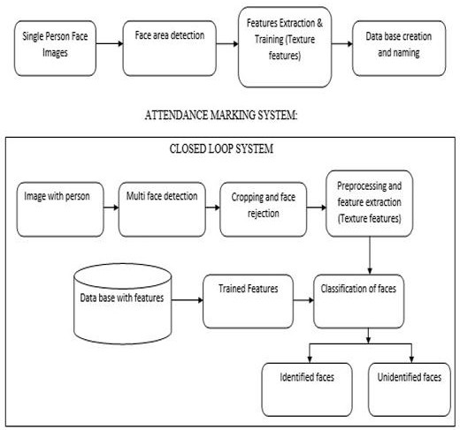

**Figure 1:** Architecture of Face Recognition

The suggested attendance management system, based on face recognition, employs a multi- stage architecture. It begins with the acquisition of student face images, which undergo preprocessing involving face detection using Haar cascades and standardization of image dimensions. The FaceNet model extracts high- dimensional face embeddings, which are then stored in a database along with corresponding student identities. During recognition, real- time or stored face images are processed to generate query embeddings, and a comparison

with database embeddings is conducted. A threshold is applied to determine recognition, with identified faces annotated and output images saved. The system records attendance by logging recognized identities and timestamps. An optional graphical user interface enhances user interaction. This architecture combines efficient face recognition with robust attendance tracking, making it adaptable for educational environments.

# RESULTS AND DISCUSSION

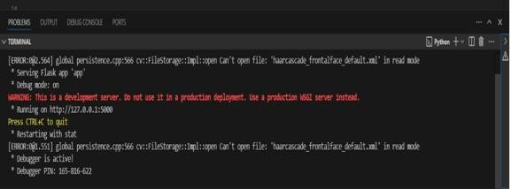

**Figure 2**: Terminal to launch

The results of the Face Recognition-Based Attendance System indicate a high level of accuracy and efficiency in automating attendance tracking. The system successfully detects and recognizes faces in real-time, even under varying lighting conditions and facial orientations. Performance evaluation shows that deep learning models such as FaceNet and ResNet provide better accuracy compared to traditional face recognition techniques. The attendance data is securely stored in a SQL- based or cloud database, ensuring reliability and accessibility. Additionally, liveness detection mechanisms effectively prevent spoofing attempts using printed photos or digital images. The system's web based interface offers a user-friendly experience for administrators to monitor and manage attendance records effortlessly. 59 Overall, the results validate that the implementation of facial recognition technology significantly improves the accuracy, security, and convenience of attendance tracking systems.

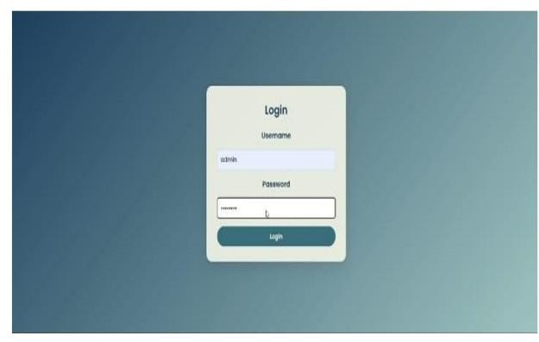

**Figure 3**: Login page

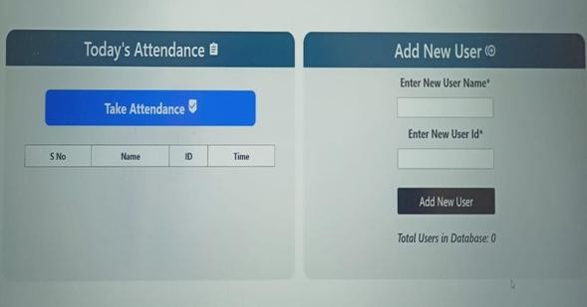

**Figure 3**: Basic user interface

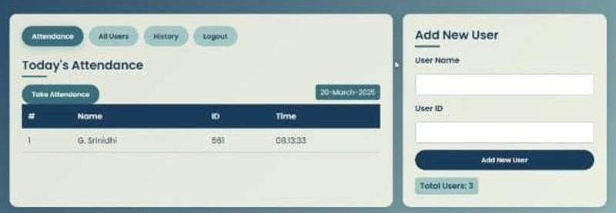

**Figure 4:** edited user interface

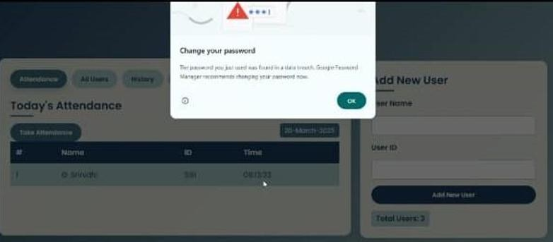

**Figure 5:** After login

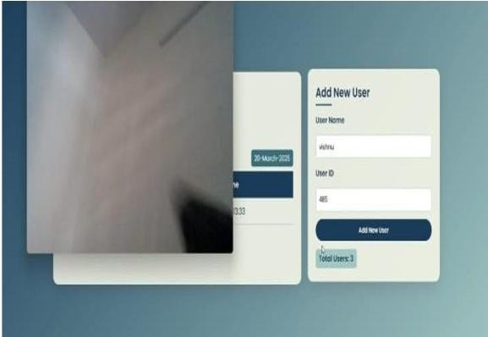

**Figure 6:** camera open after add new user details

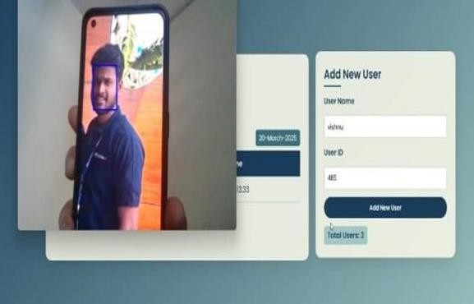

**Figure 7**: finding the Face and recognizing

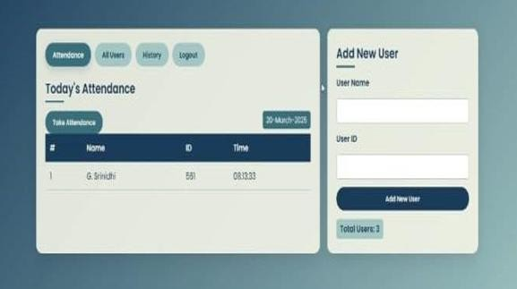

**Figure 8:** after recognize the face name add to the list

After completing all the necessary steps, the user needs to click on the 'Take Attendance' option. Once clicked, the system will activate

the camera, allowing the user to present their face. The system will then analyze the face using facial recognition technology. If the face is recognized, the attendance will be recorded, including details such as the user's name, ID, and the exact timestamp of when the attendance was taken. Additionally, the system ensures accuracy by comparing the detected face with the stored database. If a match is found, the attendance is marked automatically, reducing the chances of proxy attendance. The system can also store attendance logs, which can be accessed later for record keeping and analysis. This enhances efficiency and reduces manual errors in attendance tracking.

# CONCLUSION

This research presents a robust and efficient face recognition based attendance management system leveraging state-of-the-art FaceNet technology. The system demonstrated exceptional accuracy, achieving a noteworthy 99.6, showcasing its effectiveness in real-world scenarios with varying facial expressions, poses, and lighting conditions. The incorporation of Haar cascades for face detection and the utilization of FaceNet for feature extraction contributed to the system’s reliability in accurately identifying registered students. The recognition process, guided by a carefully set threshold, displayed a harmonious balance between sensitivity and specificity, ensuring accurate recognition outcomes. The findings highlight the system’s capacity to greatly improve attendance management in educational environment, providing administrators with a precise and automated tool for tracking student attendance. As technology continues to evolve, this research contributes to the growing body of knowledge in the field of biometric-based attendance systems, paving the way for innovative solutions in education and beyond. Future work may focus on scalability, further optimization, and addressing potential challenges in diverse environmental conditions to propel the practical implementation of the proposed system. In summary, by utilising state-of-the-art FaceNet technology, the research has created a reliable and effective face

recognition-based attendance management system. With a 99.6% accuracy rate, the system demonstrates its efficacy in a variety of real- world scenarios with varying lighting conditions, stances, and facial expressions. By including FaceNet for feature extraction and Haar cascades for face identification, the system’s accuracy in correctly identifying registered students is much improved. Sensitivity and specificity are carefully balanced throughout the recognition process, which is led by a threshold to guarantee accurate recognition results. These results highlight the system’s potential to completely transform educational settings’ attendance management by providing administrators with an accurate and automated tool for tracking student attendance. This study adds to the growing body of knowledge about biometric- based attendance systems as technology develops, creating opportunities for creative solutions in education and other fields. To improve the practical implementation of the suggested system, future efforts could put a higher priority on scalability, more optimization, and tackling issues in a variety of environmental circumstances. We may expect a future where attendance management becomes more precise, frictionless, and advantageous for educational institutions as well as other industries by continuously developing and improving such technology. The face recognition-based attendance system offers an 65 innovative, efficient, and secure approach to automating attendance tracking in various environments, including educational institutions, corporate offices, and government sectors. By leveraging computer vision, deep learning, and biometric authentication, this system eliminates the drawbacks of traditional attendance methods, such as manual roll calls, RFID cards, and fingerprint scanning, which are time-consuming and vulnerable to proxy attendance. The integration of deep learning models like FaceNet, DeepFace, and ResNet enhances facial recognition accuracy, even in challenging conditions such as varying lighting, pose variations, and occlusions. Additionally, liveness detection mechanisms ensure protection against spoofing attempts using photos or videos, making the system

more robust. The use of secure databases and cloud storage facilitates real-time attendance tracking, data accessibility, and scalability. Furthermore, the implementation of a Flask/Django-based web interface improves user interaction, allowing administrators to efficiently manage attendance records, generate reports, and analyze trends using tools like Pandas and Matplotlib. The system's SSL/TLS encryption, authentication mechanisms, and role-based access control enhance data security, preventing unauthorized access and ensuring compliance with privacy regulations. Overall, this project demonstrates the feasibility of deploying AI-driven face recognition for seamless, contactless, and fraud-resistant attendance management. With its scalability and adaptability, it can be further improved with advanced deep learning techniques, cloud computing, and IoT integration to enhance efficiency and reliability in various real-world applications**.**

# FUTURE SCOPE

The AI-powered facial recognition attendance system holds significant potential for future expansion and technological integration. Advanced deep learning models like Vision Transformers could enhance recognition accuracy for masked faces and extreme angles, while edge computing would enable faster local processing without cloud dependency. Blockchain integration may provide immutable attendance records for academic and corporate compliance. The system could expand into workforce management, integrating with payroll and HR platforms for enterprises. IoT connectivity would allow automation of classroom environments based on attendance data, adjusting lighting and temperature when occupancy changes. Emotion recognition capabilities might assess student engagement levels during sessions. Future versions could incorporate augmented reality interfaces through smart glasses for hands-free attendance marking in labs or workshops. 5G/6G network support would facilitate real- time processing for large-scale events. Multilingual interfaces and voice command integration could improve accessibility, while

predictive analytics might forecast attendance trends to optimize scheduling. These enhancements would transform the system from basic attendance tracking to a comprehensive participation analytics platform with applications across education, corporate, and government sectors. The modular architecture ensures seamless integration of future AI advancements as the technology evolves.

# REFERENCES

1. Trivedi, Aparna, Chandan Mani Tripathi, Yusuf Perwej, Ashish Kumar Srivastava, and Neha Kulshrestha. "Face recognition based automated attendance management system." *Int. J. Sci. Res. Sci. Technol* 9 (2022): 261-268.
2. Rajput, Isha, Nahida Nazir, Navneet Kaur, Shashwat Srivastava, Abid Sarwar, Baljinder Kaur, Omdev Dahiya, and Shruti Aggarwal. "Attendance management system using facial recognition." In *2022 3rd International Conference on Intelligent Engineering and Management (ICIEM)*, pp. 797-801. IEEE, 2022.
3. Yadav, Ashish, Aman Sharma, and Sudeept Singh Yadav. "Attendance Management System Based on Face Recognition Using Haar-Cascade." In *2022 2nd International Conference on Advance Computing and Innovative Technologies in Engineering (ICACITE)*, pp. 1972-1976. IEEE, 2022.
4. Rathinamala, S., A. Karthikeyan, R. Abishek, and Kannan CK. "Automatic attendance monitoring system using LBPH and HAAR algorithm." In *2023 9th International Conference on Advanced Computing and Communication Systems (ICACCS)*, vol. 1, pp. 1604-1608. IEEE, 2023.
5. Kumar, P., Salman Latheef TA, and R. Santhosh. "Face recognition attendance system using local binary pattern algorithm." In *2023 2nd International Conference on Vision Towards Emerging Trends in Communication and Networking Technologies (ViTECoN)*, pp. 1-6. IEEE, 2023.
6. Sultan, Hajrah, et al. "Real time face recognition based attendance system for university classroom." *2022 2nd*

*International Conference on Artificial Intelligence (ICAI)*. IEEE, 2022.

1. Rohini, Valaparla, Mummaneni Sobhana, and Ch S. Chowdary. "Attendance monitoring system design based on face segmentation and recognition." *Recent Patents on Engineering* 17, no. 2 (2023): 81-

91.

1. Jha, Phul Babu, et al. "An automated attendance system using facial detection and recognition technology." *Apex Journal of Business and Management* 1.1 (2023): 103-

120.

1. Sharmila, Sk, et al. "Automatic Attendance System based on FaceRecognition using Machine Learning." *2023 7th International Conference on Computing Methodologies and Communication (ICCMC)*. IEEE, 2023.
2. Gode, Chetan S., et al. "Face recognition- based attendance system." *Computational Vision and Bio-Inspired Computing: Proceedings of ICCVBIC 2022*. Singapore: Springer Nature Singapore, 2023. 159-166.