TITLE: Intelligent agriculture lighting system using IOT for optimized crop growth

Authors details:

Under the guidance of:

Neeti Yadhav (Guide)

9531834597

neeti20011996@gmail.com

Sanskrithi School Of Engineering

Team members:

Nimma mounika – 8309483363 – nimmamounika03@gmail.com – Sanskrithi School of Engineering.

Kotlapalli kavitha – 9014937794 – kotlapallikavitha@gmail.com – Sanskrithi School of Engineering.

Kallolu lavanya – 9398573144 – lavanya9384988kssss@gmail.com – Sanskrithi School of Engineering.

Rageri devisree – 9505667974 – devisreed288@gmail.com – Sanskrithi School of Engineering.

ABSTRACT:

By integrating IoT and sensor-based automation, the proposed system optimizes horticultural lighting and agricultural operations. A soil moisture sensor monitors soil conditions and activates the water pump when moisture levels are low. The pH sensor ensures optimal soil health by detecting pH variations, while the DHT11 sensor tracks environmental parameters like temperature and humidity. An LDR sensor detects nighttime conditions, triggering LED lights to support plant growth. The system utilizes an Arduino UNO and NodeMCU for control and data processing, with real-time updates displayed on an LCD. Additionally, GSM connectivity enables remote alerts for abnormal conditions. Relays manage the operation of water pumps and lighting, ensuring efficient resource utilization and reducing manual
intervention. This automated approach enhances plant growth, conserves energy, and improves overall agricultural productivity.

INTRODUCTION:

With the growing demand for efficient and sustainable agricultural practices, integrating IoT

and sensor-based automation has become essential for optimizing horticultural lighting andirrigation. Traditional farming methods often result in resource wastage, inconsistent plant

growth, and increased labor costs due to manual monitoring and control. The proposed system addresses these challenges by utilizing sensors to monitor soil moisture, pH levels, temperature, humidity, and light conditions. Automated water pumps and LED lighting ensure optimal plant growth while minimizing energy consumption. The Arduino UNO and NodeMCU serve as the central controllers, processing real-time data and displaying it on an LCD. Additionally, GSM connectivity provides remote alerts for abnormal conditions, enabling timely intervention. By automating key agricultural operations, this system enhances efficiency, reduces manual effort, and supports sustainable farming practices.

User interface
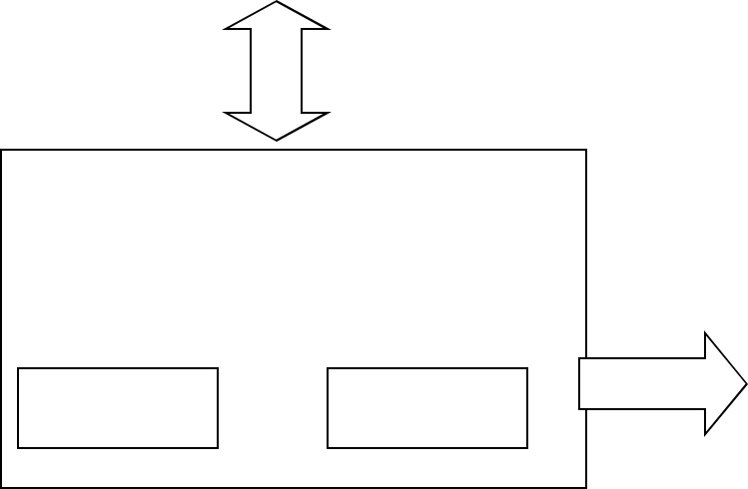

Embedded system
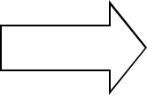

Software Hardware

Inputs

Output


Link to other systems

Fig: Overview of embedded system

PROPOSED SYSTEM:

Proposed IoT-based smart monitoring system automates aquaponics and hydroponics operations by integrating sensors and IoT technologies. Environmental parameters like water pH, temperature, humidity, and water levels are continuously monitored using sensors, with data displayed locally on an LCD and uploaded to ThingSpeak for remote tracking. Automated alerts via GSM and relay-controlled water pumps ensure real-time intervention and seamless nutrient circulation, enhancing efficiency and sustainability.

WORKING THEORY:

Block Diagram:
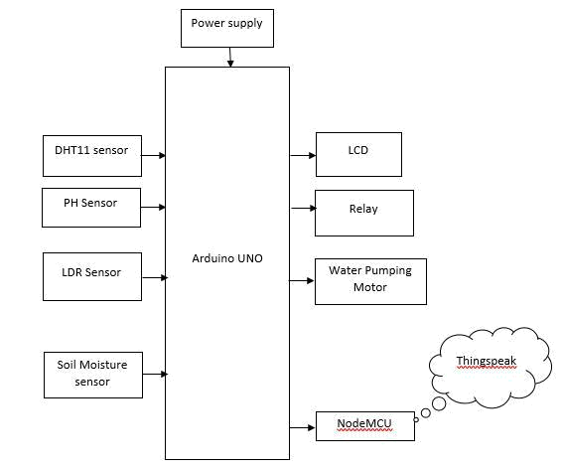

Power supply:

Power supply refers to the provision of electrical energy to devices, systems, or buildings. It's a crucial aspect of modern life, enabling the functioning of everything from homes and industries to technology and infrastructure.

Liquid Crystal Diode (LCD):

LCD (Liquid Crystal Display) is the innovation utilized in scratch pad shows and other littler PCs. Like innovation for light-producing diode (LED) and gas-plasma, LCDs permit presentations to be a lot slenderer than innovation for cathode beam tube (CRT). LCDs expend considerably less power than LED shows and gas shows since they work as opposed to emanating it on the guideline of blocking light.

Relay:

Most of the high-end industrial application devices have relays for their effective working. Relays are simple switches which are operated both

electrically and mechanically. Relays consist of an electromagnet and a set of contacts. The switching mechanism is carried out with the help of the electromagnet. There are also other operating principles for its working. But they differ according to their applications. Most of the devices have the application of relays.

Water pumping motor:

A water pumping motor is an electric motor that powers a water pump, used to lift or move water from one place to another. It's commonly used in:

- Irrigation systems

- Water supply systems

- Drainage systems

- Domestic water pumps

These motors help provide water for various applications, including agriculture, households, and industries.

NodeMCU(ThingSpeak):

NodeMCU is a popular Wi-Fi enabled microcontroller board based on the ESP8266 chip. It's often used for IoT (Internet of Things) projects, allowing devices to connect to the internet and send/receive data.

ThingSpeak is a cloud-based platform that allows users to collect, analyze, and visualize data from IoT devices. It's often used with NodeMCU and other microcontrollers to:

- Send sensor data to the cloud

- Monitor and analyze data remotely

- Trigger notifications or actions based on data

Arduino UNO:

Arduino Uno is a very valuable addition in the electronics that consists of USB interface, 14 digital I/O pins, 6 analog pins, and Atmega328 microcontroller. It also supports serial communication using Tx and Rx pins.

The Arduino microcontroller is an easy to use yet powerful single board computer that has gained considerable traction in the hobby and professional market. The Arduino is open-source, which means hardware is reasonably priced and development software is free. This guide is for students in ME 2011, or students anywhere who are confronting the Arduino for the first time. For advanced Arduino users, prowl the web; there are lots of resources. This is what the Arduino board looks like.
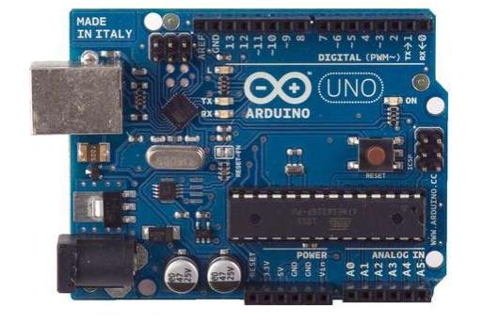

The Arduino programming language is a simplified version of C/C++. If you know C, programming the Arduino will be familiar. If you do not know C, no need to worry as only a few commands are needed to perform useful functions.

PH Sensor:

A pH sensor measures the acidity or alkalinity of a solution. It's used in:

- Water quality monitoring

- Laboratories

- Industrial processes
DHT11 Sensor:

The DHT11 is a digital temperature and humidity sensor. It's a popular, low-cost sensor used in various projects to measure:

- Temperature

- Humidity

It's often used with microcontrollers like Arduino or NodeMCU in applications such as:

- Weather stations

- Home automation

- Environmental monitoring

Easy to use and integrate, the DHT11 provides accurate readings for temperature and humidity.

LDR (Light Dependent Resistor) Sensor:

LDR (Light Dependent Resistor) sensor detects light levels. It changes resistance based on the amount of light it receives. Often used in:

- Automatic lighting systems

- Light-sensitive circuits

- Robotics

Simple and effective for detecting light changes!

Soil Moisture Sensor:

A soil moisture sensor measures the water content in soil. It's used in:

- Agriculture

- Gardening

- Irrigation systems
Helps monitor soil moisture levels, ensuring optimal watering and plant health!

Software Requirements:

EMBEDDED C:

Implanted C makes use of KEIL IDE programming. The framework program written in implanted C can be placed away in Microcontroller. The accompanying is a portion of the actual motives behind composing applications in C as opposed to get collectively. It is much less disturbing and much less tedious to write down in C then amassing. C is less traumatic to trade and refresh. You can utilize code available in capacity libraries. C code is compact to different microcontrollers with subsequent to 0 alteration. Genuine, installed C programming need nonstandard expansions to the C driver with a view to bolster charming components, as an example, settled point range catching, numerous unmistakable reminiscence banks, and fundamental I/O operations.

Arduino IDE:

The Arduino IDE software is a open source software, where we can have the example codes for the beginners. In the Present world there are lot of version in the Arduino IDE in which present usage is Version1.0.5. It is very easy to connect the PC with Arduino Board.
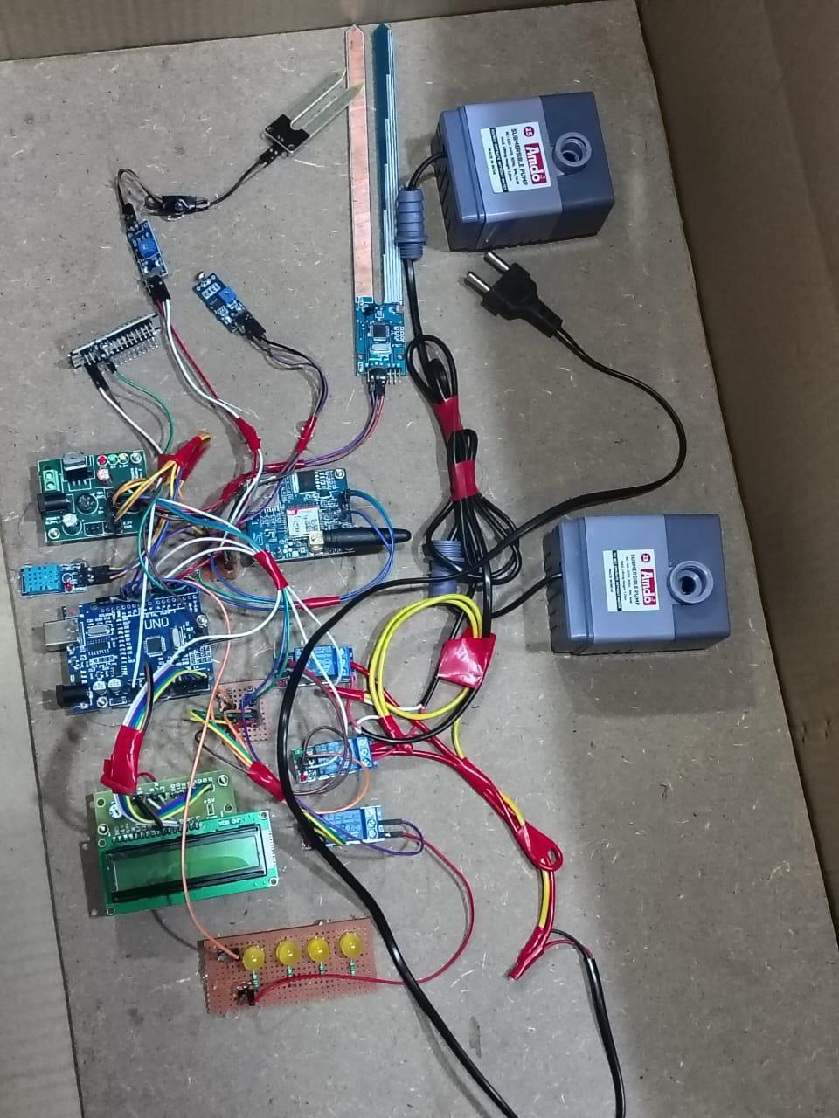

CONCLUSION:

In conclusion, the proposed IoT-based smart irrigation system efficiently automates plant monitoring and resource management. By leveraging real-time sensor data and automated control mechanisms, the system optimizes water and energy usage while ensuring optimal growth conditions. The integration of cloud-based monitoring further enhances accessibility and decision-making. Overall, this solution reduces manual effort, improves agricultural efficiency, and promotes sustainable farming practices.

