**“VOICE ENABLED HOME AUTOMATION SYSTEM”**

**Prof. Priyanka P. Narode1, Anirudh Satalgaon2, Harsh Deogadkar3,**

**Samrudhi Gadge4, Prashasti Sawale5**

1Assistant Professor, Department Of Computer Engineering P K Technical Campus, Pune India.

2,3,4,5Student,Department Of Computer Engineering, P K Technical Campus, Pune, India.

**ABSTRACT**

The ESP32 microcontroller is used in this project's Internet of Things-based home automation system to operate electrical appliances through manual switches and voice commands (Alexa, Google Assistant). Custom PCB designs are not required because the hardware setup includes an ESP32 and a 4-channel relay module. Sinric Pro is a cloud-based automation platform that enables internet-based control and remote operation through a free account. It supports up to three devices, with a fourth that can be manually controlled. The system offers a scalable and affordable smart home solution by seamlessly integrating with the Google Home and Amazon Alexa apps for voice-activated control. Wi-Fi connectivity, Arduino libraries, and Sinric Pro API keys for device configuration are essential elements.

Keywords: Voice control, ESP32, home automation, IoT, Alexa, Google Assistant, four-channel relay module, Sinric Pro, smart.

**INTRODUCTION**

The rapid advancement of Internet of Things (IoT) technology has revolutionized home automation, enabling users to control household appliances remotely through smartphones, voice commands, or manual switches. Traditional smart home systems often rely on expensive proprietary devices or dedicated smart speakers, limiting accessibility and flexibility. However, with the widespread availability of low cost microcontrollers like the ESP32, it is now possible to develop customizable and cost-effective automation solutions without relying on pre-built commercial products. The project demonstrates the implementation of a versatile home automation system that integrates voice control (Google Assistant and Alexa), manual switches, and remote access via a cloud-based platform. By utilizing the ESP32’s Wi-Fi capabilities along with a 4-channel relay module, the system eliminates the need for complex circuitry while maintaining scalability. The Sinric Pro cloud service facilitate seamless integration with popular voice assistants, allowing users to operate devices without additional smart speakers. Additionally, the inclusion of physical switches ensures functionality even during internet outages, enhancing reliability.

**1.1 MOTIVATION OF THE PROJECT**

The motivation behind this project stems from the Growing demand for affordable, flexible smart home solutions that improve on current systems limitations. Current smart home systems are often costly, proprietary, or require expensive smart speakers. This project overcomes these limitations by using an affordable ESP32 and relays to create a flexible automation system with multiple control options, free from brand restrictions. The system offers flexible control through voice commands (Google Assistant/Alexa), smartphone apps, or manual switches, maintaining operation even without internet. By adopting open-source technology, this solution eliminates restrictions while delivering reliable and scalable smart home automation.

* 1. **PROBLEM DEFINITION**

The increasing demand for convenient and accessible home automation highlights the limitations of traditional manual appliance control, which requires operating each device individually. This project addresses the need for a more efficient solution by developing an IoT-based home automation system that enables users to control appliances such as lights through voice commands using Google Assistant or Alexa on smartphones, eliminating the dependency on dedicated smart devices like Google Home or Echo Dot. In addition to voice control, the system supports manual operation through existing switchboards or push buttons, ensuring flexibility for all users. To further enhance automation, a sound sensor is integrated to activate a bulb upon detecting sound, and a PIR motion sensor turns on an LED when movement is detected—both actions being displayed on the serial monitor—thereby creating a smart, responsive, and user-friendly environment.

1. **LITERATURE SURVEY**

A voice-enabled home automation system using Bluetooth and Arduino allows for the control of home appliances via voice commands. Research shows that Bluetooth technology is used for short-range wireless communication between a smartphone (or voice recognition device) and an Arduino microcontroller. The Arduino, programmed to respond to specific commands, controls devices like lights, fans, and other appliances based on the user’s voice input. The system is widely favored due to its low cost, simple setup, and the open-source characteristics of Arduino. Voice commands are sent via Bluetooth, making the system suitable for short-range control within homes. This is particularly useful for enhancing accessibility, especially for people with physical disabilities, as it allows hands-free operation of devices. However, challenges such as voice recognition accuracy and the limited range of Bluetooth need to be addressed to improve performance. Despite these limitations, the system offers a cost-effective and user-friendly solution for smart home automation.

| **Author(s)** | **Title** | **Strength** | **Weakness** |
| --- | --- | --- | --- |
| **Aswathy K Cherin, H. Mercy (2024)** | IoT-Based Smart Home Automation Using Intelligent Sensors | Real-time control (232ms response) | Vulnerable to internet and privacy issues |
| **Sumit Kumar, Virender Kumar (2021)** | Voice-Controlled Home Automation Using Arduino | Efficient control, beneficial for elderly | Voice recognition issues in noisy environments |
| **B. Usha Rani, P. N.E. Naveen (2023)** | Automation of Home Appliances Using Bluetooth | Great for aged/handicapped users | Limited range of Bluetooth |
| **R. Krishnamoorthy, R. Thiagarajan** | IoT Voice Assisted Control Using NodeMCU | High accuracy (VASAP) | Limited flexibility in voice commands |
| **Kapil Upadhyay, Deepak Kumar** | Home Automation via Cloud | Remote control from anywhere | Connectivity and downtime issues |

1. **SYSTEM ARCHITECTURE**

**KEY COMPONENTS DESCRIPTION**

**• Mobile Phone**

Employed to transmit voice commands to the system through the voice recognition module. It serves as a user interface for managing devices from a distance.

**• Voice Recognition Module**

Receives voice commands from the mobile phone. It interprets voice inputs and sends the corresponding signals to the controller for further action.

**• Manual Switch**

Provides an alternative way to control the system manually, ensuring functionality in the absence of voice commands.

**• Sound Sensor**

Identifies sound signals (such as claps or other prompts) in the surroundings and transmits the input to the controller for examination

**• Controller**

Acts as the brain of the system. It processes inputs from the voice recognition module, PIR sensor, and sound sensor and sends commands to the relay module accordingly.

**• PIR Motion Sensor**

Senses motion in the environment. When motion is detected, it informs the controller to activate connected devices like LED lights.

**• Relay Module**

Receives control signals from the controller to switch electrical appliances (e.g., bulbs, fans) ON or OFF using external power.

**• External Power Supply**

Provides necessary power to the relay module and connected appliances.

**• Bulb and Fan**

Home appliances that are controlled automatically by the relay module based on inputs from the controller.

**• LED**

Utilized as a signal for detecting movement. Activates when motion is sensed through the PIR sensor.

**• Serial Monitor**

Displays the status and actions of the system, such as “Bulb ON,” “Motion Detected,” etc., for debugging and real-time monitoring.

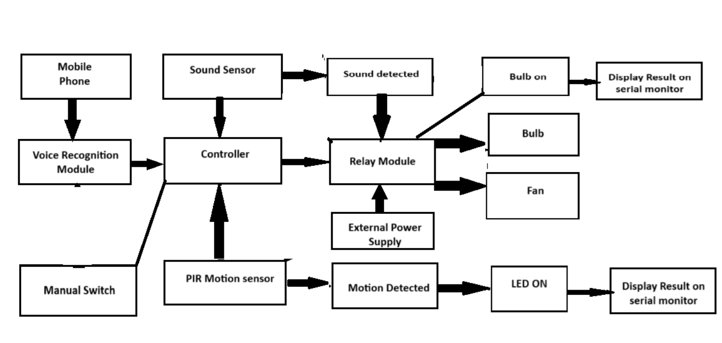

**Figure 1:** System Architecture

1. **MODULES**

**ESP32 :**

Think of the ESP32 as the brain of your smart-home setup. It’s a tiny microcontroller with built-in Wi-Fi and Bluetooth, so it can chat directly with the devices and the internet. When you speak to Google Assistant or Alexa, they turn your words into a command (often passing it along via IFTTT, Blynk, or MQTT), and the ESP32 picks it up. From there, it decides, “Okay, turn on the living room light” or “Kick on the fan,” and sends the signal out to the right relay or smart module. It’s fast, power-friendly, and there’s a giant community of makers online, so it’s a go-to choice for voice-controlled projects. You can even hook up sensors—like temperature or motion detectors—to make your system smarter and more efficient.

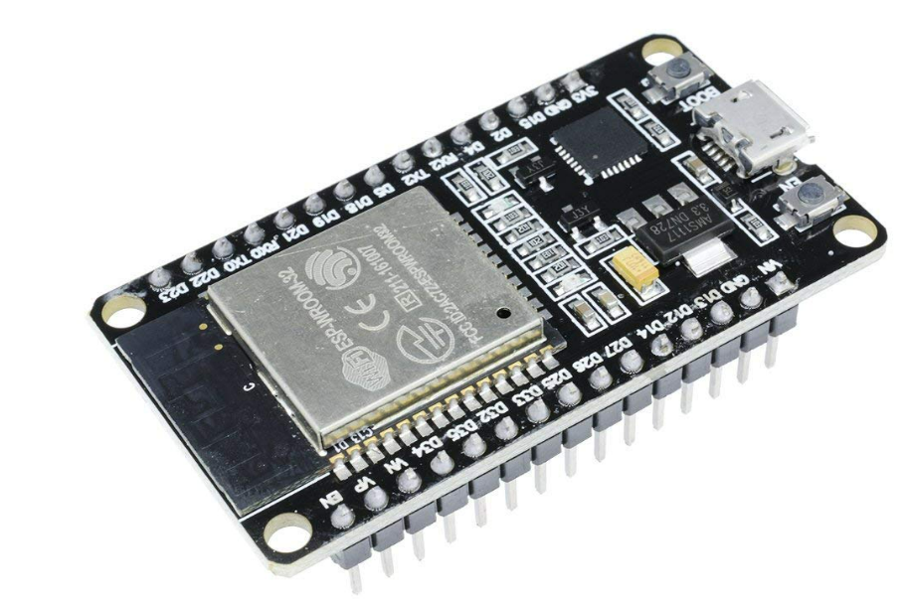

**4 Channel Relay Module :**

Imagine you have four high-power devices, say, a lamp, a motor, a solenoid valve, and a heater, but your microcontroller can only handle tiny currents. That’s where a 4-channel relay comes in. Each channel acts like a little switch: your Arduino (or PIC, or whatever controller you’re using) sends a low-power signal, and the relay switches the bigger voltage or current for you. You get four independent “big-muscle” switches that all play nicely with your digital electronics, perfect for running multiple gadgets safely in robotics or home automation.

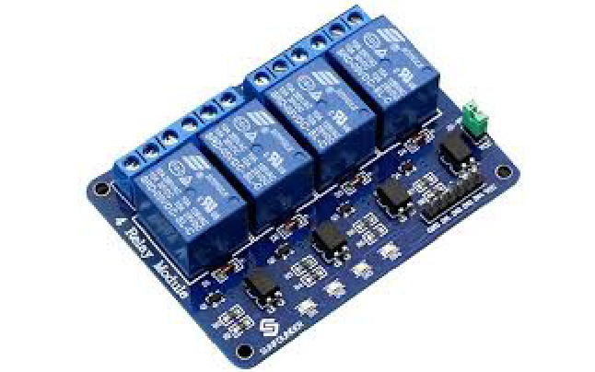

**PIR Motion Sensor :**

Ever notice how some lights turn on the moment you walk into a room? That’s a PIR (passive infrared) sensor at work. It “looks” for changes in the infrared light given off by warm bodies (like you!), and when it sees movement, it sends a signal.

Inside, it only has three pins:

·       **VCC**: Power in (usually 5 V DC)

·       **Output**: Where the “I observe motion!” signal is emitted (frequently connected via a resistor to ground)

·       **GND**: Return to the ground  
It’s a super-simple way to add motion detection to alarms, lights, or even your DIY security system.

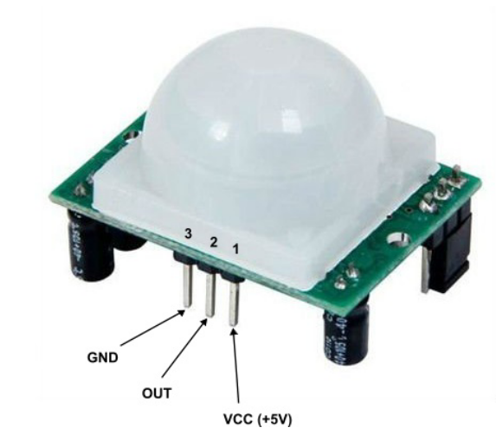

**Sound Sensor :**

A sound sensor module listens for noises around it anything from a clap to the rumble of traffic and turns them into an electrical signal your microcontroller can read. Inside you’ll find a small microphone, a little amplifier, and some buffering/peak‑detection circuitry. You can tweak how sensitive it is (so it ignores background hum but still catches a shout), then have your controller do something like flash an LED or trigger an alert as soon as it “hears” something above your set threshold. It’s a handy way to add audio awareness for switches, security setups, or monitoring systems.

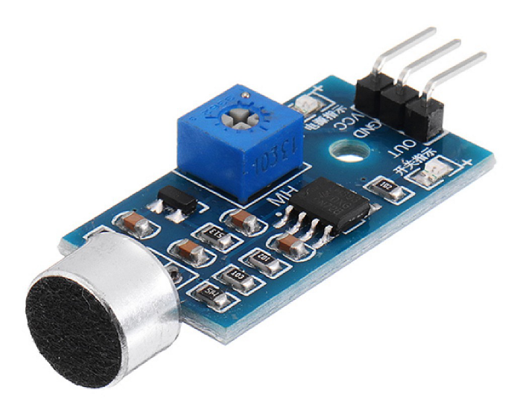

1. **OUTPUT**

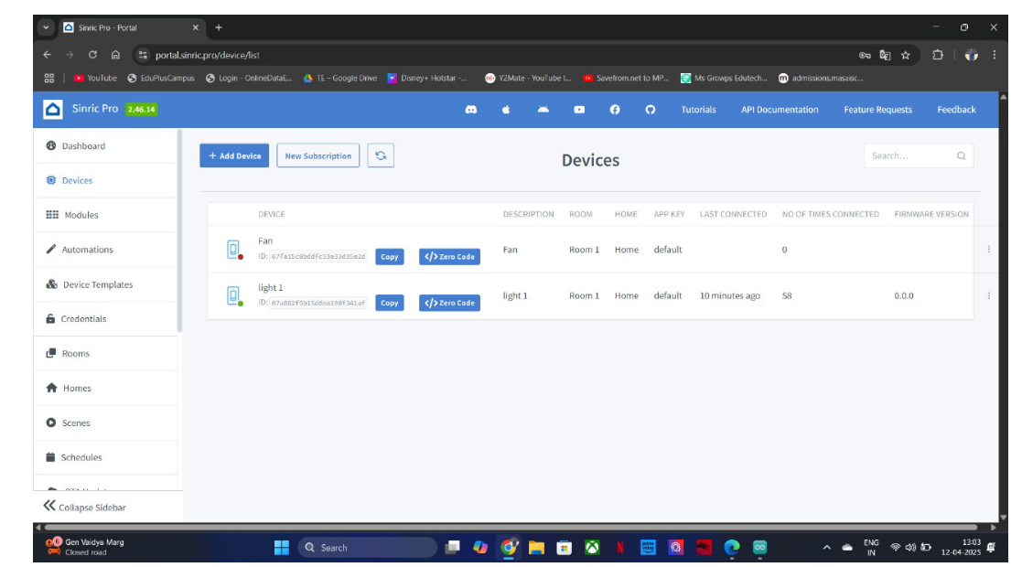

Figure 2.1: Sinric Pro Device Management screen showing two registered devices –

a fan and a light – along with their status, room, and connection details.

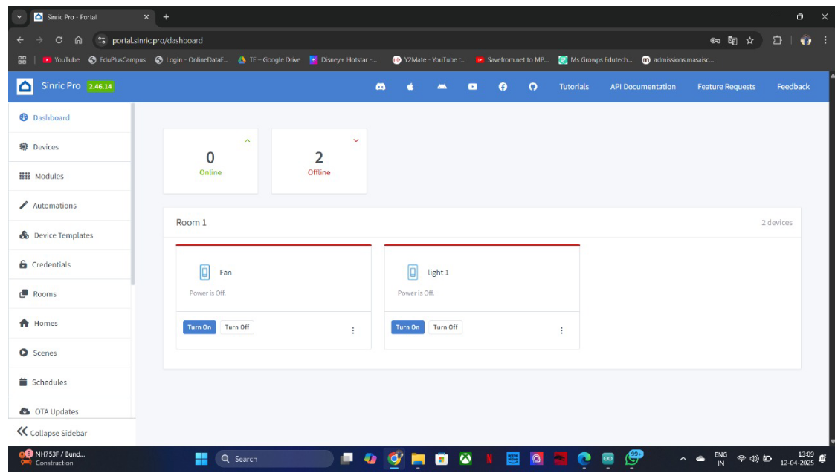

Figure 2.2: Sinric Pro Dashboard displaying the control panel for devices in Room

1. Both the fan and light are shown as offline, with available power toggle options.

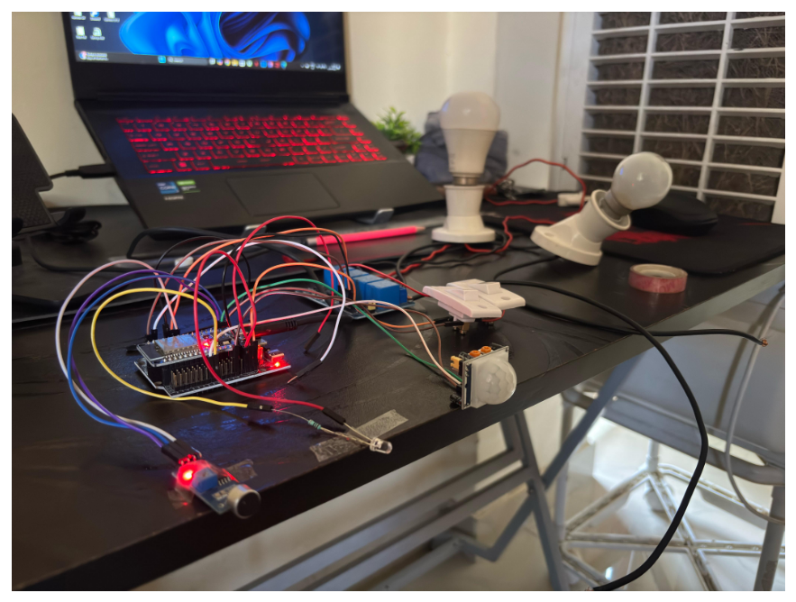

Figure 2.3: A calm silence fills the space—lights rest in standby, awaiting your

presence, your voice, or a whisper of sound to awaken them.

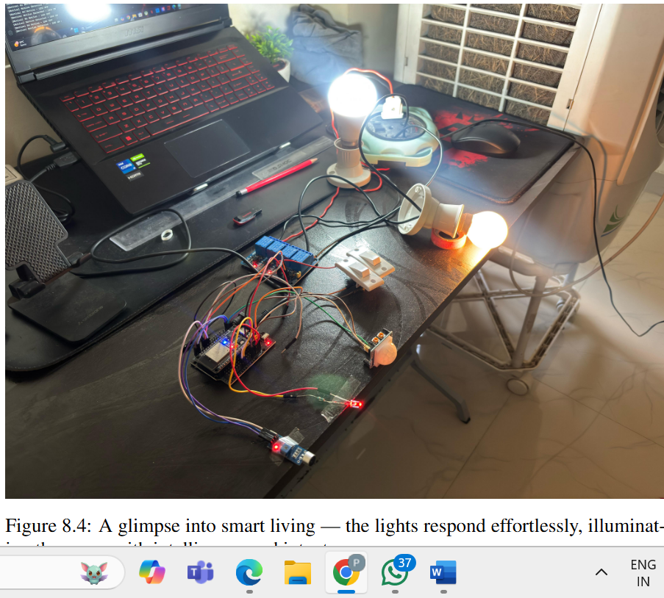

Figure 2.4: A glimpse into smart living — the lights respond effortlessly, illuminat-

ing the space with intelligence and intent.

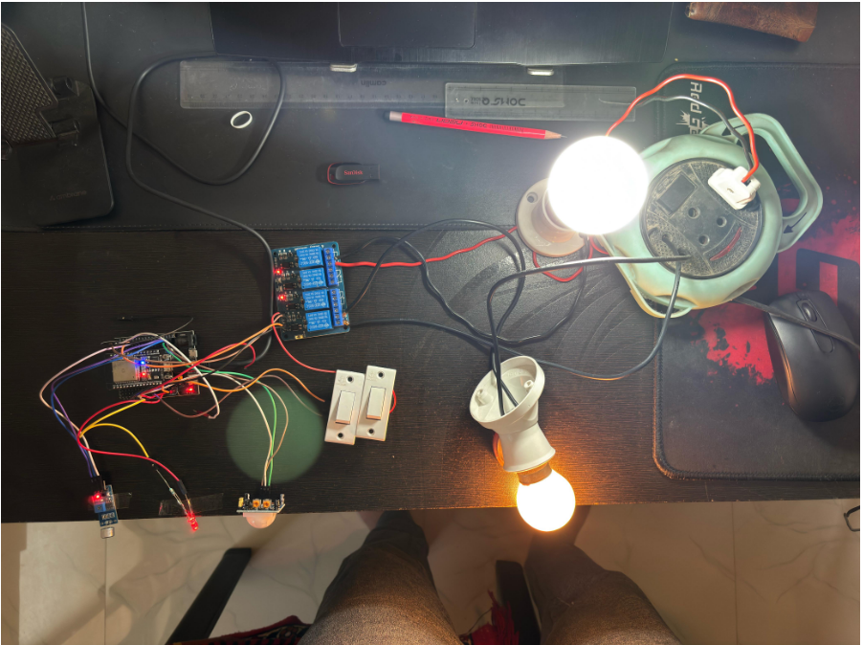

Figure 2.5: smart home awakened, casting light with purpose and precision.

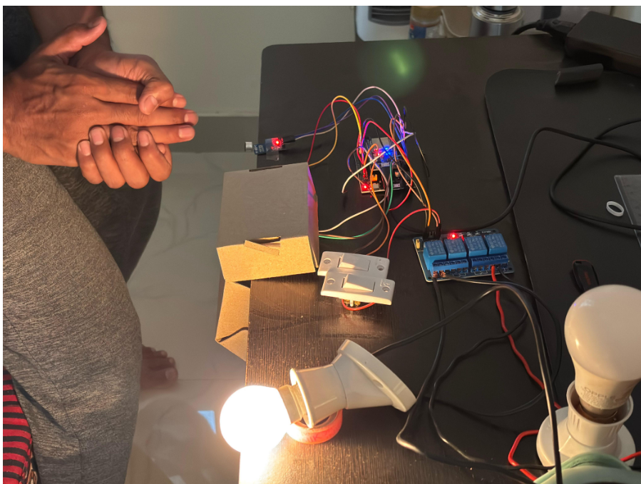

Figure 2.6: Lights awaken to sound—an instant, intelligent response to your environment.

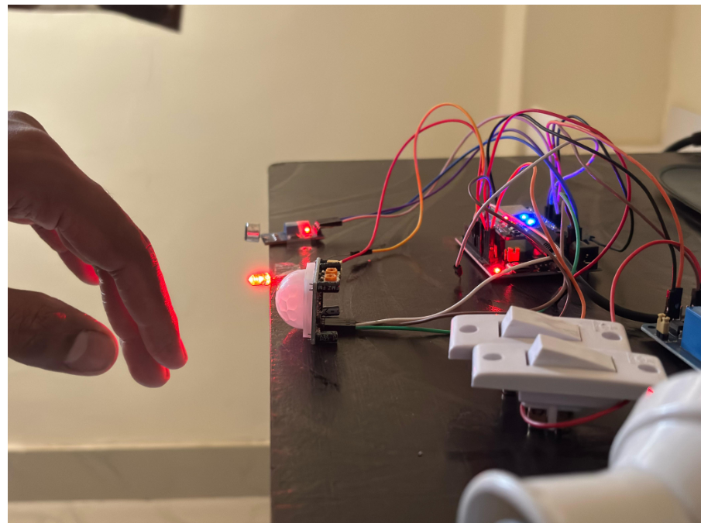

Figure 2.7: Motion sensed, LED illuminated.

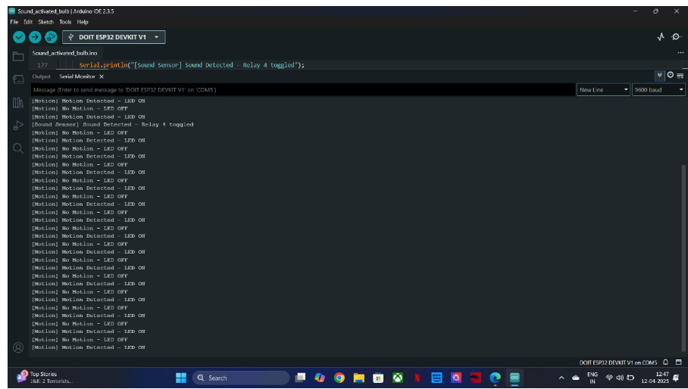

Figure 2.8: Lights activated instantly upon detecting motion, ensuring safety, aware-

ness, and seamless automation.

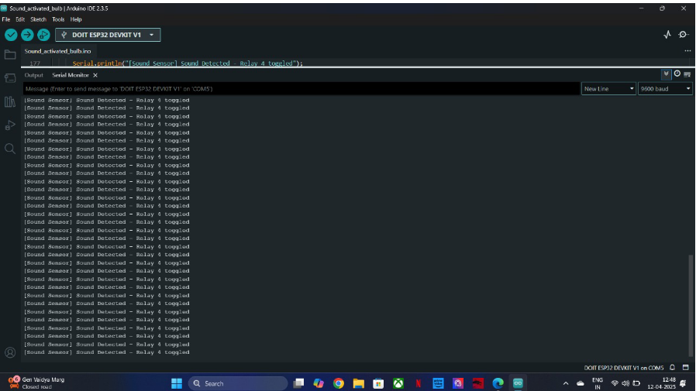

Figure 2.9: A sound in the surroundings triggers an intelligent light response, en-

hancing convenience and interactivity.

1. **CONCLUSION**

In this research, a voice-based home automation system was successfully developed using Arduino, integrating various modules such as the ESP32, PIR motion sensor, 4-channel relay module, and sound sensor. The system demonstrates how low-cost, open-source hardware and IoT technologies can be effectively combined to create a smart and convenient living environment.

The ESP32 module played a key role by enabling wireless communication and voice command execution via integration with voice assistants. The PIR sensor enhanced the system's functionality by enabling motion-based automation, while the sound sensor added a layer of voice-triggered control. The 4-channel relay module allowed for the simultaneous operation of multiple home appliances, ensuring practical and scalable automation.

Overall, the project was efficient, responsive, and user-friendly. It provides a strong foundation for future enhancements, such as mobile app integration, cloud-based data logging, to further improve smart home experiences.

1. **REFERENCES**

[1]. V. Tsankov, B. Evstatiev, and I. Valova, “Concept for an IoT-based Electronic System for Smart Home Automation,” in Proc. 2024 9th Int. Confon Energy Efficiency and Agricultural Engineering (EE&AE), Ruse, Bulgaria, 2024, pp. 1–5, doi:0.1109/EEAE60309.2024.10600500.

[2] S. Niranjana et al., “An IoT Based Real-Time Monitoring System for Viticulture to Minimize Energy Consumption,” in 2023 International Conference on Self Sustainable Artificial Intelligence Systems (ICSSAS), IEEE,2023.

[3] N. Solangi, A. Khan, M. F. Qureshi, N. Zaki, U. M. Qureshi and Z. Umair, “IoT Based Home Automation System: Security Challenges and Solutions,” in 2024 5th International Conference on Advancements in Computational Sciences (ICACS), IEEE, 2024.

[4] L. Vanitha, S. Sahoo, R.T. Prabu, et al., “Performance analysis of wide bandgap inorganic perovskite for indoor photovoltaics for IoT applications: simulation study,” Optical and Quantum Electronics, vol. 56, p1413, 2024. 10.1007/s11082-024-07336-0.

[5] K. Naik and S. Patel, “An open source smart home management system based on IoT,” Wireless Networks, vol. 29, pp.989–995, 2023

[6] A. Shewale, A. Mokhade, et al., “Efficient Techniques for Residential Appliances Scheduling in Smart Homes for Energy Management Using Multiple Knapsack Problem,” Arabian Journal for Science and Engineering 2023.