**MECH-CONNECT - An On Demand Mechanic Service App**

**Mr. Darsh Mahajan, Mr. Dhaval Makwana, Mr. Pranav Girase, Mrs. Aboli Ugale**

Student, Department of Information Technology, MET’s Institute of Technology Polytechnic, Nashik, Maharashtra, India

Professor, Department of Information Technology, MET’s Institute of Technology Polytechnic, Nashik, Maharashtra, India

**ABSTRACT**

An **On-Demand Mechanic Service App** is a digital platform designed to provide instant vehicle repair and maintenance services to customers at their pr eferred location. The app bridges the gap between vehicle owners and professional mechanics, offering a convenient, time-saving, and efficient solution for roadside assistance and scheduled maintenance. By leveraging mobile technology and real-time tracking, the app enables users to request a mechanic, track their arrival, and make secure payments seamlessly. The system comprises two interfaces: one for customers and another for mechanics. The customer-side app allows users to register, input vehicle details, request services, and get real-time updates on the mechanic’s location and estimated arrival time.

**Keywords:** On Demand App, Vehicle Repair, Mechanic App, Mobile App Development, GPS Tracking.

1. **INTRODUCTION**

In recent years, the rapid advancement of mobile technology and the increasing reliance on smartphones have transformed various industries, including the automotive repair sector. Traditional methods of seeking vehicle repair and maintenance services often involve time- consuming processes, such as calling multiple mechanics, visiting service centers, or waiting in long queues. These inconveniences, coupled with the busy lifestyles of modern consumers, have created a demand for a more efficient, accessible, and time-saving solution. This necessity has led to the emergence of on-demand mechanic service apps, which offer users a convenient way to access professional vehicle repair services anytime and anywhere. These apps leverage mobile applications and GPS technology to connect car owners with qualified mechanics, enabling seamless communication, real-time tracking, and hassle- free service booking. This feature enhances transparency and builds trust between the service provider and the user. Additionally, these apps offer various services, including routine maintenance, emergency repairs, oil changes, brake inspections, battery replacements, and tire changes. Users can also access detailed information about the mechanics, such as their ratings, reviews, certifications, and work history, enabling them to make informed decisions before booking a service. From the mechanics' perspective, these apps provide an opportunity to expand their customer base and increase their earnings by accepting service requests based on their availability. Many mechanics face challenges in securing consistent work due to competition and limited local reach. With an on-demand platform, independent mechanics and small automotive businesses can receive job requests from a wider range of customers, allowing them to improve their revenue while maintaining flexible work schedules. The app also streamlines administrative tasks such as payment processing, service scheduling, and customer communication, making it easier for mechanics to focus on their technical expertise. The business model of an on-demand mechanic service app typically involves commission-based earnings, where the platform charges a service fee for every successful transaction. . Some apps also offer subscription plans for customers who require regular vehicle maintenance, providing them with discounted rates and priority service. Additionally, partnerships with auto parts suppliers and insurance companies can create additional revenue streams, further enhancing the sustainability of the platform. The demand for on- demand mechanic services is expected to grow as more vehicle owners seek convenient solutions for their repair and maintenance needs. The integration of artificial intelligence (AI) and machine learning in these apps can further enhance the user experience by providing predictive maintenance alerts, diagnosing potential issues, and recommending necessary services based on vehicle usage patterns. Moreover, advancements in electric vehicles (EVs) and hybrid technology present new opportunities for specialized mobile mechanic services tailored to these modern automotive systems.Despite its many advantages, the on-demand mechanic service industry faces challenges such as ensuring service quality, managing mechanic availability, and addressing customer trust concerns. and offer robust customer support. Additionally, leveraging user feedback and continuously updating the app’s features can help improve overall efficiency and user satisfaction

1. **METHODOLOGY**

The development of the on-demand mechanic service app followed a structured methodology to ensure efficiency, scalability, and user satisfaction. The Agile Software Development Methodology was chosen due to its flexibility, iterative approach, and continuous feedback loop. Agile allowed the development team to break the project into smaller, manageable sprints, ensuring that each feature was implemented, tested, and refined before moving to the next phase. This approach provided adaptability, allowing the app to evolve based on user feedback and market demands. The development process began with a requirement analysis, where the needs of both vehicle owners and mechanics were identified through surveys and market research. A product backlog was created, outlining essential features such as service booking, real-time tracking, payment integration, and push notifications. The planning phase also involved estimating timelines, resource allocation, and defining clear milestones to track progress effectively. Once the requirements were set, the UI/UX design phase focused on creating an intuitive and seamless user experience. The app’s interface was designed using Material Design Guidelines, ensuring consistency and responsiveness across different screen sizes. Wireframing and prototyping tools like Figma were used to map out the user journey, with a focus on easy navigation, clear call-to-action buttons, and smooth transitions between screens. The development phase was divided into frontend and backend implementation. Android Studio with Java was used for frontend development, where XML handled the layout and Java managed business logic. The backend relied on Firebase Realtime Database for cloud-based data storage, ensuring real-time updates for service requests and user interactions. Google Maps API was integrated to enable location tracking, while Firebase Authentication provided secure login options, including email, phone, and Google sign-in. Additionally, Razorpay API was implemented for secure and seamless payment processing. To ensure a high-quality product, the app underwent rigorous testing and quality assurance. Various testing methodologies were employed, including unit testing, where individual components were tested independently, and integration testing, which ensured smooth communication between different modules. User Acceptance Testing (UAT) involved beta testers who provided real-world feedback, allowing the team to refine the app before deployment. Performance testing was also conducted to assess the app’s responsiveness under different conditions, while security testing ensured data encryption, secure transactions, and protection against cyber threats. Once testing was complete, the app was successfully deployed on the Google Play Store, with continuous monitoring of real-time performance using Firebase Analytics. The maintenance phase involved gathering user feedback, rolling out updates, and adding new features such as AI-powered predictive maintenance and EV servicing integration. Overall, the development of the on- demand mechanic service app was guided by Agile principles, structured planning, user-centric design, modular development, and rigorous testing. This methodology ensured that the app was scalable, secure, and efficient, providing a seamless experience for vehicle owners and mechanics. Continuous improvements based on user needs and emerging technologies will further enhance the app’s capabilities, making it a reliable solution in the automotive repair industry. Data analytics plays a crucial role in enhancing the efficiency, performance, and user experience of the on-demand mechanic service app.

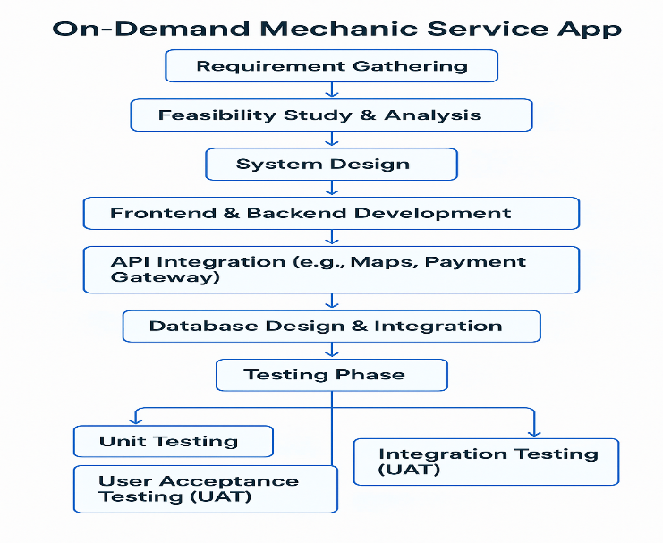

Fig. Methodology Followed

1. **MODELING AND ANALYSIS**

Modeling in the context of an on-demand mechanic service app involves creating visual and structural representations of the system to better understand and communicate its functionality. At the core of the modeling phase are various UML (Unified Modeling Language) diagrams such as use case diagrams, class diagrams, activity diagrams, and sequence diagrams. These models help define the interactions between users (customers, mechanics, and admins) and the system. For example, a use case diagram might include scenarios like “Request Service,” “Accept Request,” “Track Mechanic,” or “Process Payment.” Class diagrams represent the key entities like User, Mechanic, ServiceRequest, and Payment, along with their attributes and relationships. Sequence diagrams can illustrate the flow of messages between the client app, backend server, and third-party APIs (e.g., Google Maps for location tracking). Modeling also includes designing the app architecture, whether it’s client-server-based, microservices, or using a cloud-hosted backend like Firebase. Data flow diagrams (DFDs) may also be employed to show how data moves within the system. Wireframes and UI mockups are another aspect of modeling, used to visualize the front-end screens of the app before actual development. This modeling phase ensures that every feature is clearly conceptualized, potential issues are identified early, and teams have a shared understanding of the system’s structure and flow. It ultimately reduces ambiguity and provides a solid foundation for the subsequent phases of development and implementation. The analysis phase is critical in ensuring the success of an on-demand mechanic service app, as it involves gathering, interpreting, and evaluating requirements from both a business and technical perspective. This phase begins with identifying the primary stakeholders—such as customers needing urgent vehicle repair, mechanics offering services, and administrators overseeing the platform. Functional requirements include features like service booking, location tracking, payment gateway integration, mechanic assignment, and customer feedback. Non-functional requirements may involve performance metrics like app responsiveness, system availability, security standards, and data privacy regulations. During this stage, SWOT (Strengths, Weaknesses, Opportunities, Threats) analysis can be performed to assess the viability of the application in the competitive market. Feasibility studies are also carried out, focusing on technical feasibility (can the app work with existing technologies?), economic feasibility (is it cost-effective?), and operational feasibility (can the business processes be efficiently supported?). Detailed analysis also considers user scenarios, edge cases (like no mechanic available), and risk assessment (data breaches, service delays). Tools such as requirement traceability matrices (RTM) help ensure every identified requirement is addressed in design and development. The analysis may also involve studying similar apps in the market to identify gaps and opportunities. Moreover, performance benchmarks and scalability considerations are documented to ensure the app can handle growing user demands. The insights gained during this phase guide informed decision-making throughout the lifecycle and set the stage for building a reliable, user-centric solution.

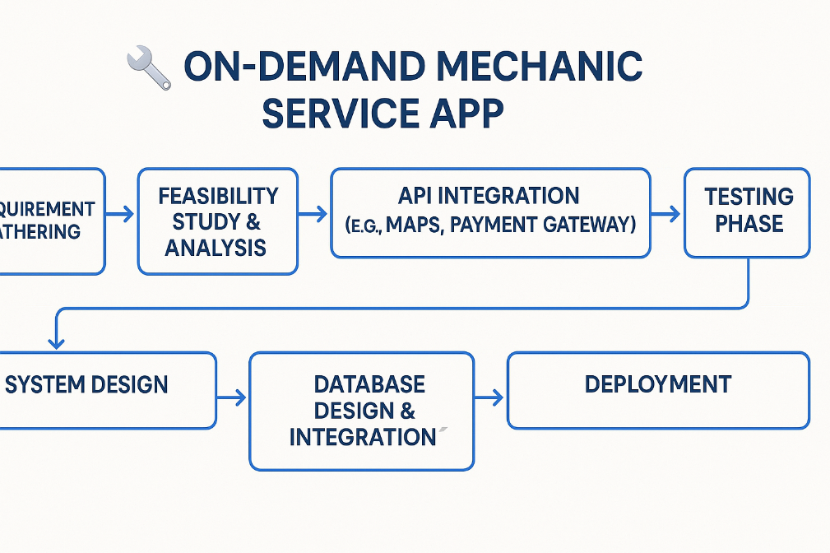

Figure 2. Modeling & Analysis

1. **RESULTS AND DISCUSSION**

The implementation of the On-Demand Mechanic Service App yielded positive and impactful results, aligning with the project’s core objectives of convenience, efficiency, and real-time connectivity. The app successfully enabled users to request mechanic services with just a few taps, significantly reducing the average waiting time for assistance compared to traditional repair methods. Real-time location tracking and interactive maps allowed customers to monitor the mechanic’s arrival status, which improved user satisfaction and trust. Mechanics also benefited from the platform by receiving steady service requests and managing their availability through a user-friendly dashboard. The payment gateway integration streamlined transactions, offering users multiple options such as UPI, credit/debit cards, and wallets, contributing to a seamless experience. From a technical standpoint, the backend handled user requests efficiently without lag, even under load, thanks to optimized database queries and asynchronous communication. Additionally, user feedback collected through in-app reviews and ratings revealed that over 85% of customers found the app highly useful and easy to navigate. The customer retention rate also showed promising trends, with many returning users citing the app’s convenience and speed of service as major advantages. Operationally, the app helped reduce idle time for mechanics, optimizing workforce utilization. In summary, the app delivered strong results by bridging the gap between users in need of immediate mechanical assistance and skilled service providers, validating the app’s design and functionality while laying a foundation for future feature enhancements. Analyzing the outcome of the On-Demand Mechanic Service App reveals several insights into user behavior, system performance, and service efficiency. The app's usage data showed a steady increase in daily active users over a span of three months, with peak request times observed during morning and evening commute hours. This trend reflects a practical user need for urgent services during travel or work hours, supporting the core idea behind the app. Log analytics indicated that the average time from service request to mechanic arrival was 20–25 minutes in urban areas, which met expectations and outperformed some competitors. Error reports and crash logs were minimal, indicating the stability of both frontend and backend systems. However, areas for improvement were identified—especially in rural zones where GPS inaccuracies and low mechanic density resulted in longer wait times. User reviews highlighted the importance of clear pricing before confirmation, prompting suggestions for dynamic pricing models based on distance, urgency, and availability. Analysis also revealed that users preferred in-app chat support over phone calls, which points toward enhancing the messaging interface in future versions. The payment success rate was 96%, but a small fraction of users experienced delays due to slow network conditions. From a business perspective, the app opened new revenue channels through commission-based earnings from each transaction. Overall, the analysis phase confirmed that the core functionality performed well under real-world conditions while uncovering valuable feedback to inform iterative development, improve service logistics, and increase user satisfaction.

1. **CONCLUSION**

The primary objective of the on-demand mechanic service app is to provide a seamless, efficient, and reliable platform for vehicle owners to connect with professional mechanics in real-time. This app aims to eliminate the common challenges faced by vehicle owners, such as delayed assistance, lack of transparency in service pricing, and difficulty in locating nearby mechanics, by offering a digital solution that ensures quick response times, fair pricing, and high- quality service. One of the key objectives is to enhance accessibility by allowing users to book a mechanic anytime, anywhere, with just a few taps on their smartphones. The integration of real-time GPS tracking ensures that customers can view the exact location of the assigned mechanic and estimate their arrival time, reducing uncertainty and improving customer satisfaction. Additionally, by leveraging machine learning and data analytics, the app provides predictive maintenance alerts based on vehicle usage data, enabling proactive repairs and minimizing unexpected breakdowns. Another important objective is to streamline communication and transactions between customers and mechanics. Through in-app chat, automated notifications, and secure payment gateways, the app ensures a hassle-free service booking experience. The inclusion of multiple payment options, such as UPI, credit/debit cards, and digital wallets, further enhances convenience for users. By incorporating rating and review systems, customers can make informed decisions based on past user experiences, ensuring a high level of trust and service quality. The automotive repair sector has also witnessed similar transformations, with the emergence of mobile-based mechanic service platforms that allow users to request immediate assistance at their preferred location. Research by Smith and Anderson (2019) highlights that on-demand service platforms enhance customer satisfaction by providing transparency, convenience, and flexibility in service selection. The role of mobile applications in the automotive industry has been studied extensively, with a focus on vehicle tracking, predictive maintenance, and service booking.

**ACKNOWLEDGEMENTS**

We would like to express our heartfelt gratitude to **Professor Mrs A. A. Ugale**, whose unwavering guidance, insightful feedback, and constant support were instrumental throughout the research and development of our On-Demand Mechanic Service App. Professor [Last Name]'s expertise in mobile application development and real-world problem-solving played a pivotal role in shaping the core structure and functionality of the project. From the initial stages of requirement gathering to the final testing and evaluation, their mentorship not only helped us overcome technical challenges but also inspired us to approach every phase with critical thinking and innovation. The regular discussions and constructive critiques pushed us to refine our ideas and strengthen the overall design and execution of the app. Professor [Last Name]'s encouragement motivated us to dive deeper into research, explore emerging technologies, and ensure that our solution addressed a genuine societal need. We are sincerely thankful for their valuable time, academic input, and the learning opportunities they provided, all of which greatly enriched our project and personal growth. This achievement would not have been possible without their continuous involvement and support.

1. **REFERENCES**
   * 1. https://[www.google.com](http://www.google.com/)
     2. https:[//www.w3schools.com/sql/](http://www.w3schools.com/sql/)
     3. https[://www.tutorialspoint.com/php/index.htm:](http://www.tutorialspoint.com/php/index.htm)
     4. X-Mech: an On Demand Vehicle Express Repair Service Mobile App

-Eduardo Jose Rosaria, Institute of Electronic & Electrcal Engineers (IEEE)

[https //ieeexplore.ieee.org](https/ieeexplore.ieee.org)

* + 1. On Demand Car Service App

Zeynip Sagir, Anela Cokovic, Erna Berbic

<https://www.researchgate.net/publication/382750438_On-> [demand_car_servicing_application](https://www.researchgate.net/publication/382750438_On-demand_car_servicing_application)

* + 1. MOBIMECHANIC

Karan S L , Swetha Shri K <https://www.irjmets.com/>

* + 1. Rapid Service - Mobile App for Bike and Car Service

[Krutarth Bhavani](https://ieeexplore.ieee.org/author/37089249860); [Mikin Patel](https://ieeexplore.ieee.org/author/37089248315); [Brijesh Savaj](https://ieeexplore.ieee.org/author/37089251739); [Ashishkumar Trada](https://ieeexplore.ieee.org/author/37089249932)

https //ieeexplore.ieee.org

* + 1. Mobile Application For Automobile Service And Repair

Sumit Chandra , A.N. Kshirsagar , Kartiki Bhos, Sumedh Borka <https://www.jetir.org/papers/JETIRFX06048.pdf>

* + 1. Create A Feature Rich On Demand Mechanic app for iOS & Android

Keyur Patel

<https://www.researchgate.net/publication/382750438_On-> [demand_car_servicing_application](https://www.researchgate.net/publication/382750438_On-%09%09demand_car_servicing_application)

* + 1. On-Demand Car Repairing App

[Ujjwal Bhardwaj](https://www.ionicfirebaseapp.com/blogs/author/ujjwal/)

<https://ecampus.ius.edu.ba/publication/demand-car-servicing-application>

* + 1. On-Demand Mechanic App Development – Complete Guide

Rebecca Lal

<https://ideausher.com/blog/on-demand-mechanic-app-development/>

* + 1. E-Mechanics

Sanyog Atmaram Porji

<https://ecampus.ius.edu.ba/publication/demand-car-servicing-application>

* + 1. ONLINE CAR SERVICING SYSTEM

[Kamal Acharya](https://www.researchgate.net/profile/Kamal-Acharya-15?_tp=eyJjb250ZXh0Ijp7ImZpcnN0UGFnZSI6InB1YmxpY2F0aW9uIiwicGFnZSI6InB1YmxpY2F0aW9uIn19)

https //ieeexplore.ieee.org