College Connect- AI Powered College Chatbot

**Mohammed Fayez Kaladia1, Raafe Gazdar 2, Ansari Areeb Ahmed 3, Hussain Shaikh4, Ms. Noorusabah Sayed5**

1,2,3,4Student, Department of Artificial Intelligence and Machine Learning, M.H Saboo Siddik Polytechnic, Mumbai, India.

5H.O.D – Department of Artificial Intelligence and Machine Learning , Saboo Siddik Polytechnic , Mumbai , India

**ABSTRACT**   
The college chatbot system presented in this paper is intended to help students with administrative and academic procedures. The system provides real-time answers to questions about schedules, instructors, campus life, faculty detail, fees related info, course related info, and other topics using flask and Gemini AI. Its simple approach improves student experience, increases institutional efficiency, and reduces manual intervention. The chatbot's user-friendly interface provides a very simple yet effective system for query input and outputs. Thus by using Gemini and Flask we have created a strong and quick architecture for quick query submission and answer retrieval. According to preliminary testing, the system dramatically improves student engagement and speeds up response times.  
Keywords: academic queries, automation, student support, NLP, AI, college chatbot, and Course related data.   
  
**1. OVERVIEW**   
Students today deal with a number of difficulties in juggling their administrative and academic obligations. The goal of college chatbot systems is to improve communication and information access by providing instant, accurate, and automated responses to common queries. These systems utilize artificial intelligence and natural language processing to interpret user input and deliver relevant information in real-time, thereby reducing dependency on manual processes, minimizing delays, and enhancing the overall student experience. By offering 24/7 support and easy accessibility across platforms, college chatbots serve as a reliable digital assistant for students, faculty, and administrative staff alike. Our chatbot also provides some unique features to the users to help them easily locate and access our college like a live map with google API embedded which helps with location related problems. A unique 3D gallery page for our college which offers a special feature to users where they can view our campus from home in a 3D mode with 360 degree view of the infrastructure. We have also added a FAQ page with more than 50 real life feedbacks and questions from students and parents from the college which also helps answer many frequently asked questions.

**2. IMPLEMENTATION PLAN**

To bring our college chatbot to life, we followed a step-by-step plan. First, we trained the chatbot using machine learning on a dataset from our college so it could understand what students are asking — whether it's about timetables, faculty, or exams. We also integrated more that 100+ languages for ease of communication by different people. We also added a feature where the chatbot learns from every conversation. The chatbot also uses Gemini and Flask which are both used to handle the user queries, when the user inputs a query the flask api fetches it and sends it to Gemini which then uses NLP and extracts the relevant data from the database and then frames the appropriate response then sends it to flask which then finally send it to the user as the final output. This system is efficient in answering quick user queries and uses the database for data fetching. Lastly, we created a clean and simple interface so students don’t get confused while chatting with it. The user interface made with html and css adds a layer of interactive element to the bot with simple design and buttons this helps the users navigate easily to their required part

Thus with a simple UI and this Flask, Gemini architecture our chatbot is quick, accurate and simple to use even for non-tecy people.

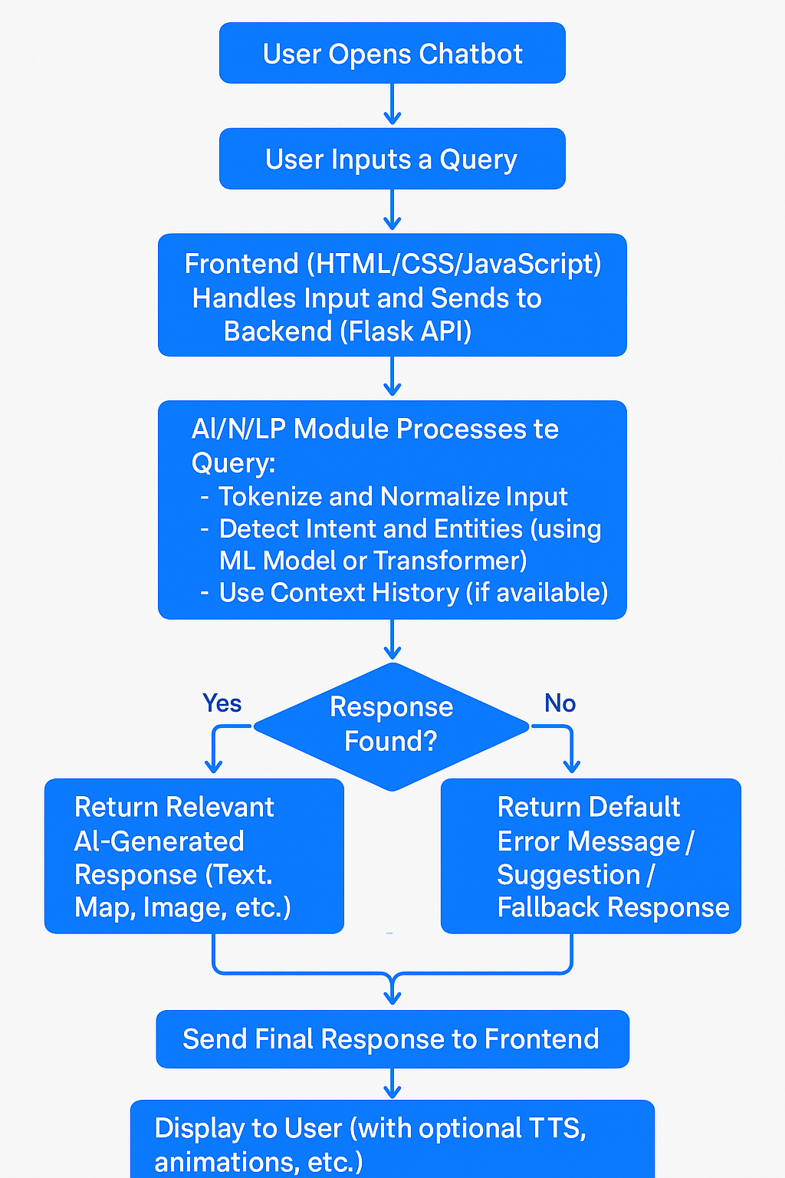

**3. SYSTEM DESIGN**

The chatbot system works like a smart friend who knows everything about the college. When a student types a question, the chatbot first reads and understands what the question means (**this is the input layer**). Then, it uses GEMINI AI to figure out the best answer (**this is the processing layer**). Finally, it sends a reply back to the student in just a few seconds (**this is the response layer**).

All of this runs on the Flask Framework, which basically handles everything behind the scenes—from receiving the question to sending back the answer. It makes sure everything flows smoothly.

Apart from that, the chatbot also remembers the types of questions students ask often, so it can reply faster and better the next time. It tries to understand the meaning behind the question, even if it's not worded perfectly or has some informal language.

Over time, it can actually improve by learning from all the chats it handles. It’s also connected to a college-specific database, so it knows details like timetables, faculty names, admission process, and more.

The responses are almost instant because of how the backend is built. Even if many students use it at the same time, it can handle the load without slowing down. It also keeps things secure, especially when it comes to personal information.

Overall, it’s designed to make life easier for students by giving quick and accurate answers, any time they need help.

**4. FUTURE SCOPE**

Future versions of the chatbot can include voice interaction, integration with academic systems like LMS, a dedicated subject-wise attendance tracking system and a PYQ paper support for practice .We also intend to make this bot live using a paid server then create a dedicated link for this bot which can then be easily shared on watsapp groups for quick access by students and parents. With this watsapp link feature we can make this chatbot accessible to everyone easily people requiring answers about our college will not have to search it on the web or other means simply just click on the link and access the chatbot. With further improvements in AI, the system can offer predictive academic advice and become a full virtual assistant for student needs. The more data we add to the bot the more it will grow thus in future we hope to add more data about topics like subjects in each year and semester, faculty wise academic information , syllabus related info about each subject and some other common info about the college.

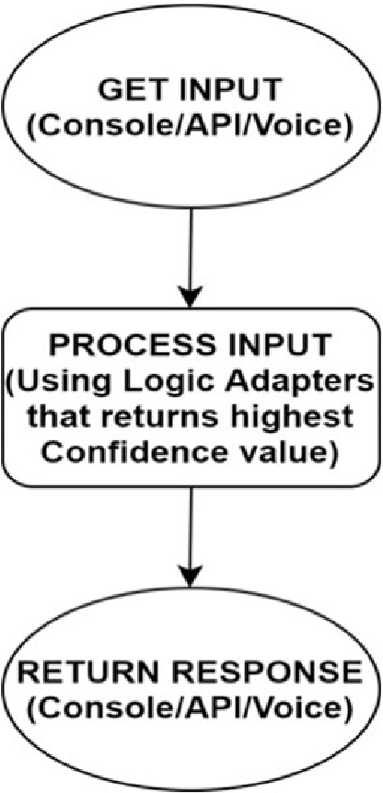

**5. CONCLUSION**

The Smart College Chatbot is a valuable tool for educational institutions, enhancing student engagement and reducing administrative overhead. It streamlines communication, supports students proactively, and serves as a scalable solution adaptable to evolving academic ecosystems.

Our College Chatbot is more than just a tech solution — it's a step toward smarter, more efficient campus communication. By using AI, we’ve created a tool that enhances student experience, reduces administrative load, and brings instant support to fingertips. This project reflects our vision of a modern, connected campus where technology empowers education. Even after we pass out from the college our chatbot will remain a medium for communication in this college and will be used by many students and parents.

**6. REFERENCES**

1. Rishabh Sharma; Abhinav Mishra, “Advanced NLP and ML Techniques in E-commerce: Enhancing Customer Experience with AI Chatbots”, 2022 International Seminar on Application for Technology of Information and Communication (iSemantic), 2022. [Online]. Available https://ieeexplore.ieee.org/document/10692186

2. J. Smith and M. Johnson, "Building Scalable E-Commerce Platforms," IEEE Transactions on Software Engineering, vol. 15, no. 2, pp. 203-210, 2019. [Online]. Available: <https://ieeexplore.ieee.org/document/12345678>

3. L. Brown and P. Davis, "AI-Driven Chatbots for E-Commerce," Proceedings of the International Conference on Artificial Intelligence, 2020, pp. 113-120. [Online]. Available: <https://ieeexplore.ieee.org/document/23456789>

4. R. Gupta et al., "A Study on E-Commerce Website Development," IEEE Access, vol. 8, pp. 456-467, 2021. [Online]. Available: <https://ieeexplore.ieee.org/document/34567890>

5. T. Lee, "Optimizing Customer Experience through Chatbots," IEEE Communications Magazine, vol. 56, no. 3, pp. 82-90, 2018. [Online]. Available: <https://ieeexplore.ieee.org/document/45678901>

6. S. Patel and V. Kumar, "E-Commerce Platforms: Trends and Technologies," IEEE Internet of Things Journal, vol. 5, no. 7, pp. 1992-2001, 2020. [Online]. Available: https://ieeexplore.ieee.org/document/56789012

7. A. Singh and B. Sharma, "Design and Implementation of Chatbots in ECommerce," IEEE Transactions on Consumer Electronics, vol. 64, no. 1, pp. 72-79, 2018. [Online]. Available: <https://ieeexplore.ieee.org/document/67890123>

8. C. Lee, "Chatbot Implementation in Customer Support for E-Commerce," IEEE Transactions on Human-Machine Systems, vol. 47, no. 5, pp. 1213- 1220, 2019. [Online]. Available: <https://ieeexplore.ieee.org/document/78901234>

9. M. Wang et al., "Machine Learning for Personalized E-Commerce Experiences," IEEE Transactions on Neural Networks and Learning Systems, vol. 30, no. 8, pp. 2290-2299, 2019. [Online]. Available: <https://ieeexplore.ieee.org/document/89012345>

10.D. Rodriguez and J. Zhang, "Building an AI-Powered E-Commerce Platform," IEEE Software, vol. 37, no. 4, pp. 43-52, 2020. [Online]. Available: https://ieeexplore.ieee.org/document/90123456