**Artificial Intelligence in Financial Services: Fraud Detection, Risk Management, and Algorithmic Trading.**

**Dr. Vikas Mahandule**, HOD, Assistant Professor, Department of Computer Application MIT Arts Commerce and Science College Alandi Pune India

**Dr. Priti Bharambe,** Assistant Professor, Department of Computer Application MIT Arts Commerce and Science College Alandi Pune India

**Ms. Sneha Patil,** Student, Department of Computer Application MIT Arts Commerce and Science College Alandi Pune India

**Ms. Komal Sarowar,** Student, Department of Computer Application MIT Arts Commerce and Science College Alandi Pune India

**Mr. Hrishikesh Gawande,** Student, Department of Computer Application MIT Arts Commerce and Science College Alandi Pune India

**Abstract**

The financial services industry has been transformed significantly with the introduction of artificial intelligence (AI), particularly in the case of fraud recognition, risk management and algorithmic trading. In this article, the conversion effect of AI is examined in three key areas: fraud detection, risk management and algorithmic trading. AI control systems use machine learning, natural language processing, data analysis processing, recognition of anomaly patterns, mitigating financial risks, and running your business with unprecedented speed and accuracy. Through case studies and recent progress, this paper shows how AI technology can redesign traditional financial models, improve formal compliance, and promote competitive advantage. The study also examines challenges related to AI adoption, such as data protection, model interpretability, and ethical concerns. Through a comprehensive analysis, this paper contributes to a deeper understanding of the current role of AI in the financial sector and future potential. When recognizing fraud, KI models such as neural networks and anomaly recognition algorithms improve accuracy by identifying subtle patterns and reducing false positive results. Risk management benefits from predictive analytics and AI-controlled credit valuations, allowing for a more accurate assessment of borrowers' risk and dynamic portfolio adjustments. Algorithm trading uses AI to analyze market trends, run high frequency businesses, and adapt strategies using reinforcement learning to go beyond traditional rule-based systems. However, there are challenges such as data security, regulatory hurdles, model transparency, and ethical concerns.

**Keywords:**

Artificial Intelligence, Financial Services, Fraud Detection, Risk Management, Algorithmic Trading, Machine Learning, Deep Learning, Financial Technology, Data Analytics.

1. **Introduction**

The financial services sector has consistently led the way in embracing innovative technologies aimed at enhancing efficiency, improving decision-making, and providing superior services to clients. Recently, the incorporation of Artificial Intelligence (AI) within this industry has transformed the operational landscape, data analysis, and response strategies of financial institutions. AI, which encompasses the replication of human cognitive functions by machines, particularly computer systems, is reshaping how these institutions manage intricate tasks such as fraud detection, risk assessment, and algorithmic trading. With the extensive digitization of financial services, organizations are now tasked with handling enormous amounts of data generated from transactions, customer interactions, market dynamics, and regulatory changes. Manually extracting valuable insights from this data is not only labor- intensive but also prone to errors. AI technologies, including machine learning, deep learning, natural language processing (NLP), and predictive analytics, provide robust solutions for analyzing large datasets, uncovering hidden trends, and enabling real-time, data-driven decision-making.

A key application of AI in finance is in the realm of fraud detection. As cyber threats grow more sophisticated, financial institutions face significant pressure to safeguard their customers against fraud and financial crimes. AI-driven fraud detection systems utilize real-time transaction monitoring, behavioral analysis, and anomaly detection to pinpoint suspicious activities with greater precision than traditional rule-based approaches. These systems continuously evolve, learning from new fraud patterns and enhancing their effectiveness over time. In the area of risk management, AI empowers institutions to foresee and address a variety of risks, including credit, market, operational, and compliance risks. By utilizing predictive models and data-driven simulations, financial firms can more accurately evaluate their risk exposure and make well-informed strategic choices. AI also supports stress testing and early warning systems, further bolstering risk management capabilities.

Fraud discovery, for illustration, now demands further than conventional rule- grounded pollutants due to the adding complication of cyber pitfalls and fiscal crimes. AI enables systems to descry unusual patterns and anomalies in real time, learning from data and conforming to new fraud tactics. also, in threat operation, AI provides advanced modeling capabilities that allow institutions to assess and respond to complex pitfalls more stoutly than ever ahead. In algorithmic trading, AI-powered systems can analyze 'extensive datasets and carry out trades' with rapid timing, surpassing conventional methods in unpredictable demands.

The financial services industry is experiencing a significant transformation propelled by swift progress in Artificial Intelligence (AI). Traditionally reliant on rule- grounded systems and mortal decision- timber, fiscal institutions now face growing pressure to borrow intelligent, data- driven results that can operate at scale and in real time. AI technologies particularly machine literacy, natural language processing, and advanced data analytics have begun to review the geography of fiscal services, especially in areas similar as fraud discovery, threat operation, and algorithmic trading. This exploration seeks to explore the evolving part of AI in these three key disciplines, examining how it enhances functional effectiveness, strengthens security, and reshapes strategic decision- making within fiscal institutions.

Grasping these dynamics 'is crucial not only for' academic discussion but also for financial interpreters, managers, and technology creators. As artificial intelligence progresses, its role in influencing the future of finance will become increasingly significant. Thus, this research adds to 'both theoretical and practical knowledge' by providing an extensive examination of how AI is re-evaluating fundamental financial processes and what that implies for the future of the industry.

**2. Artificial Intelligence in Fraud Detection**

Fraud remains a critical threat to financial institutions, resulting in annual losses amounting to billions of dollars. As financial transactions increasingly transition to digital platforms, the complexity and sophistication of fraud schemes have escalated. Traditional fraud detection methods, which depend on rule-based systems and manual monitoring, are no longer sufficient to tackle these evolving challenges. AI-driven fraud detection systems leverage machine learning (ML) and deep learning (DL) techniques to enhance and automate the detection process, providing substantial benefits over conventional approaches.

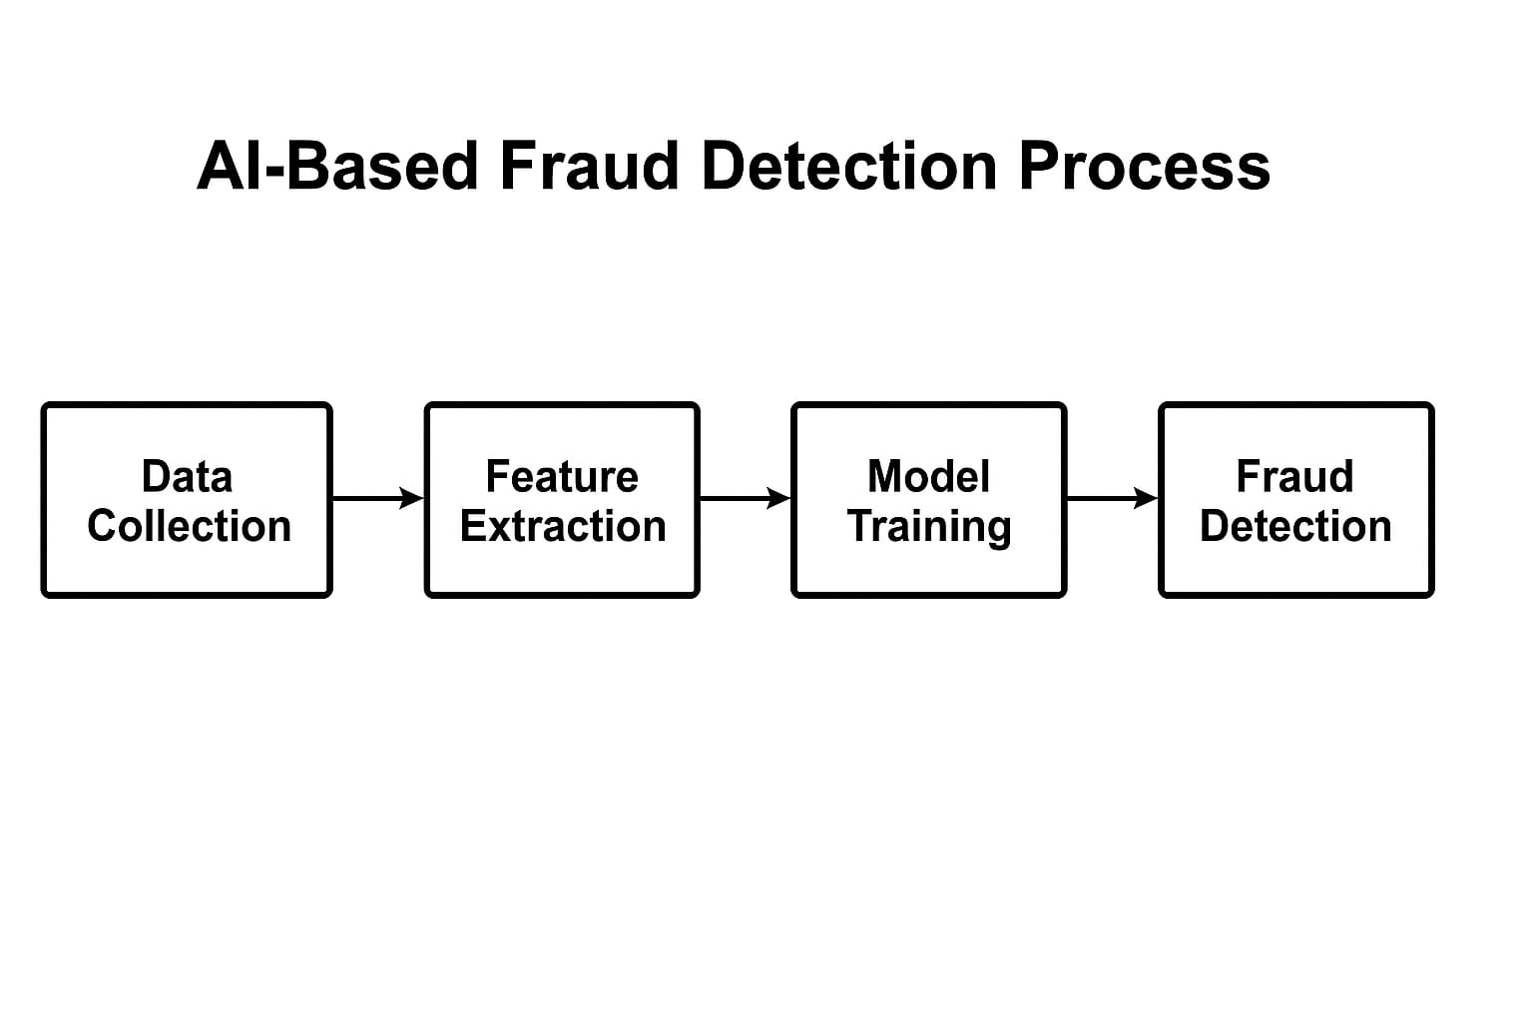

Fig 1: AI-Based Fraud Detection Process

**2.1 Mechanisms of AI in Fraud Detection**

AI algorithms process extensive volumes of transactional data in real time, pinpointing anomalies that diverge from typical behavior. These systems are capable of learning from historical data, adapting as they encounter new trends, fraudulent tactics, and shifts in customer behavior.

1. **Machine Learning (ML):** ML models are adept at recognizing unusual transaction patterns by continuously assimilating new data. For example, credit card fraud detection employs supervised learning algorithms, such as decision trees or random forests, to categorize transactions as either legitimate or fraudulent based on previously observed patterns.
2. **Deep Learning (DL):** Deep neural networks (DNNs) play a crucial role in fraud detection by uncovering complex, non-linear patterns within large datasets that traditional models often overlook. These networks can analyze substantial amounts of transaction data and detect subtle behavioral changes that may signal fraudulent activity.
3. **Natural Language Processing (NLP):** NLP enables systems to scrutinize unstructured text data, including customer communications or emails, to identify potential fraud indicators such as phishing attempts or suspicious inquiries.

**2.2 Advantages of AI in Fraud Detection**

1. AI can recognize fraudulent activities as they happen, empowering financial institutions to respond immediately and mitigate losses.
2. Adaptive Learning: In contrast to rule-based systems, AI possesses the ability to adjust to new and emerging threats.
3. This predictive ability allows institutions to take precautions rather than responding only after fraud. By determining normal standards of conduct, you can quickly recognize deviations that can indicate fraud.
4. This allows for quick decisions and minimizes delays in identifying and handling fraud attempts. Integration into several data sources.

**3. Artificial Intelligence in Risk Management**

Financial institutions face a range of risks, including market risk, credit risk, operational risk, and liquidity risk. Effectively managing these risks is crucial for ensuring the stability and profitability of these institutions. Traditional risk management approaches, which typically depend on historical data and basic statistical models, often struggle to address the intricate and evolving nature of financial markets. The implementation of AI technologies facilitates the creation of advanced, predictive risk management models capable of processing extensive real-time data, identifying potential risks, and assisting institutions in making proactive decisions.

**3.1 AI in Predictive Risk Management**

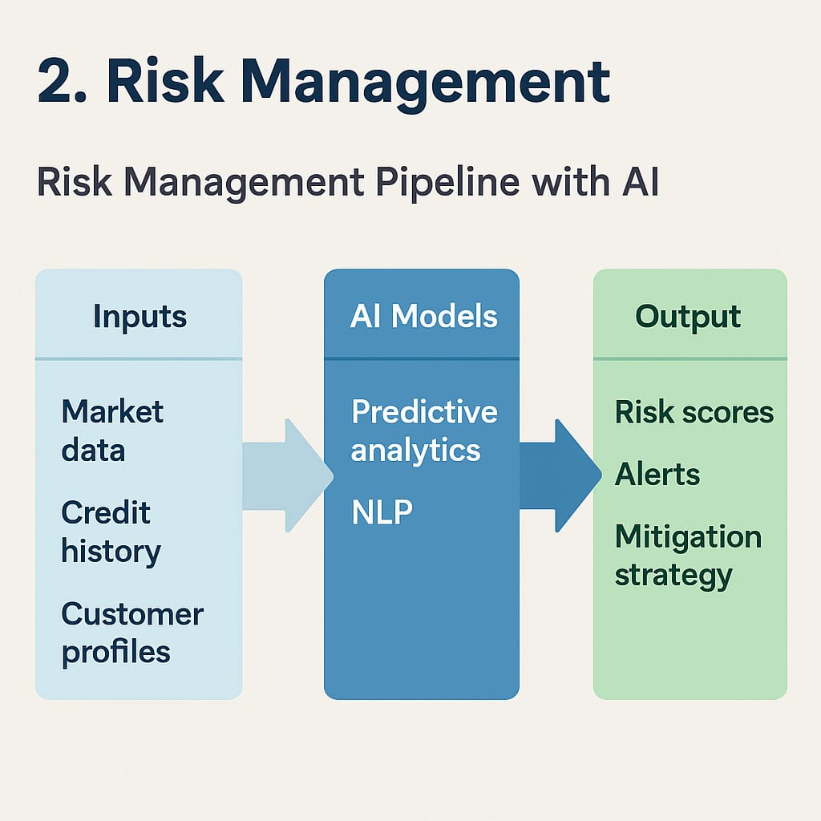

Fig 2: Risk Management Pipeline with AI

The Fig 2: “Risk Management Pipeline with AI” illustrates how artificial intelligence is integrated into risk assessment processes within financial institutions. It categorizes the workflow into three main stages—inputs, AI models, and output. By utilizing predictive analytics and natural language processing (NLP), the system analyzes market data, credit history, and customer profiles to generate risk scores, trigger alerts, and suggest mitigation strategies for informed decision-making.

1. **Credit Risk**: AI improves credit risk evaluation by examining alternative data sources, such as social media activity, transaction history, and mobile phone data, alongside conventional financial indicators. This approach leads to more precise credit scoring and diminishes dependence on outdated or incomplete information.
2. **Market and Liquidity Risk**: AI models can identify market trends, price fluctuations, and liquidity discrepancies by analyzing real-time market data. These models enable the early detection of potential market shifts or liquidity crises, allowing financial institutions to implement preventive strategies.
3. **Operational Risk:** AI aids in identifying anomalies in financial transactions, internal processes, and operational activities, thereby recognizing risks related to fraud, security breaches, or system failures. This capability fosters a more proactive approach to managing operational risks.

**3.2 Benefits of AI in Risk Management**

Artificial intelligence significantly enhances threat operation processes in fiscal services by enabling real- time analysis, prophetic capabilities, and robotization. Traditional threat operation systems frequently calculate on literal data and homemade oversight, which can delay responses to arising pitfalls. In discrepancy, AI technologies especially machine literacy (ML), natural language processing (NLP), and deep literacy — offer a visionary approach to relating and mollifying fiscal pitfalls.

1. **Real- Time Risk Assessment:** AI enables fiscal institutions to cover request conditions and client actions in real time. By assaying vast datasets continuously, AI systems can descry anomalies, oscillations, and patterns that may indicate credit, request, or functional pitfalls. This allows institutions to respond fleetly and help implicit losses.
2. **Prophetic Analytics:** Machine literacy models can read implicit threat scripts grounded on literal and real- time data. This prophetic capability improves decision- making by quantifying threat exposure and estimating the liability of adverse events, similar as loan defaults or request crashes.
3. **Functional threat Reduction:** By automating routine compliance and threat reporting tasks, AI reduces mortal error and ensures adherence to nonsupervisory norms. Robotic Process robotization (RPA) and AI- powered monitoring tools help institutions maintain functional integrity and inspection readiness.
4. **Improved Fraud Detection Integration:** Incorporating AI into threat operation fabrics allows flawless integration with fraud discovery systems. This binary- functionality enhances the institution’s capability to identify fraudulent conditioning that also pose fiscal or reputational threat.

**4. Artificial Intelligence in Algorithmic Trading**

Algorithmic trading involves the utilization of computer algorithms to automatically carry out trades based on established criteria. These algorithms are capable of processing extensive market data, recognizing trading opportunities, and executing trades in real-time. While traditional algorithmic trading primarily depended on straightforward rule-based strategies, the introduction of AI has significantly transformed the development, execution, and optimization of trading strategies.

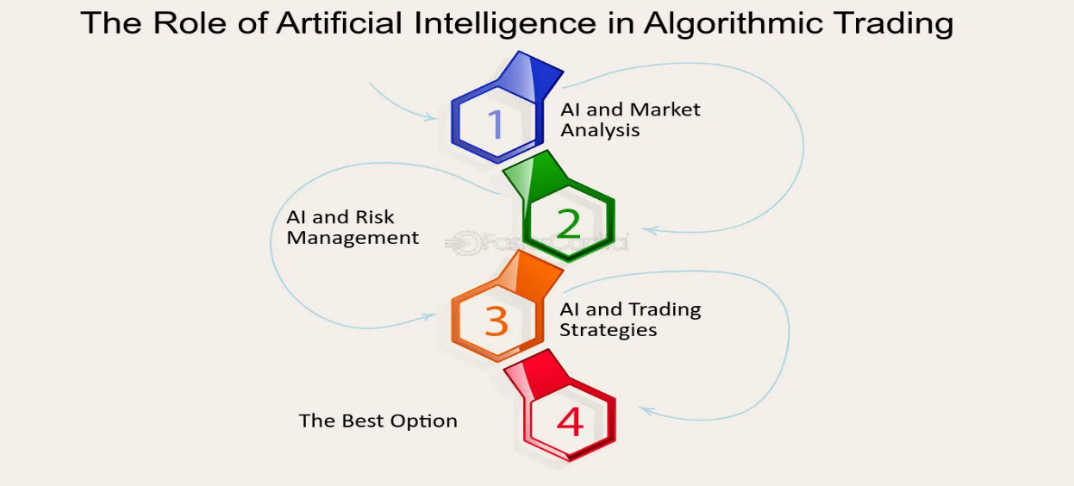

Fig 3: AI in Algorithmic Trading

The Fig 3: “The Role of Artificial Intelligence in Algorithmic Trading” illustrates the multi-stage integration of AI in the trading process. It begins with AI-driven market analysis, followed by risk management, the development of AI-based trading strategies, and finally selecting the best trading option. This process highlights how AI enhances speed, accuracy, and strategic decision-making in highly dynamic financial markets.

**4.1 AI in Algorithmic Trading**

AI-powered trading systems utilize machine learning, deep learning, and reinforcement learning methodologies to improve decision-making processes. These systems are designed to continuously learn from historical market data and adjust their strategies to accommodate new market conditions, thereby optimizing profitability and reducing risks.

1. **Machine Learning (ML):** AI models employ ML techniques to detect patterns within market data, including price fluctuations, trading volumes, and historical trends. This capability enables traders to forecast future market movements and execute trades at the most advantageous moments.
2. **Reinforcement Learning (RL):** A subset of machine literacy, underpinning literacy enables trading algorithms to learn through trial and error. The system enhances its trading strategies grounded on feedback from former trades, aiming for advanced returns over time.
3. **High-Frequency Trading (HFT):** AI plays a crucial role in high-frequency trading, where transactions occur in fractions of a second. AI models can analyze real-time data and execute thousands of trades per second, taking advantage of minor price discrepancies in the market.

**4.2 Benefits of AI in Algorithmic Trading**

1. Faster Decision-Making: AI enables real-time analysis of large volumes of market data, allowing trading systems to identify opportunities and execute trades within milliseconds.
2. Enhanced Accuracy and Precision: AI models consider multiple market indicators simultaneously, leading to more informed and accurate trading decisions compared to traditional rule-based systems.
3. Adaptive Strategy Optimization: Using machine learning and reinforcement learning, AI algorithms continuously learn from past trades and adjust strategies to changing market conditions.
4. High-Frequency Trading Efficiency: AI is crucial in high-frequency trading, where it executes large volumes of trades rapidly to capitalize on small price differences.
5. Risk Reduction: AI-powered systems can detect early signs of market volatility and automatically implement risk mitigation strategies, such as adjusting trade volume or pausing execution.

**5. Ethical and Regulatory Considerations**

As artificial intelligence becomes more prevalent in financial services, it is essential to consider the ethical and regulatory ramifications of its use. Key issues such as transparency, accountability, and fairness should be prioritized in any AI system, particularly in critical areas like fraud detection, risk assessment, and algorithmic trading. A significant advancement in this field is Explainable AI (XAI), which seeks to enhance the interpretability and comprehensibility of AI systems for both developers and users. By clarifying the decision-making processes, XAI fosters trust and facilitates better oversight, which is particularly vital in financial sectors where complex models may result in biased outcomes or systemic vulnerabilities. Moreover, adherence to data privacy regulations, including the General Data Protection Regulation (GDPR) in the European Union and global Anti-Money Laundering (AML) laws, is crucial. These regulations require financial institutions to safeguard personal data, ensure lawful processing, and maintain audit trails for automated decisions. Failure to comply can lead to legal repercussions and diminish public confidence in AI technologies. In summary, integrating ethical standards and regulatory compliance into the development and implementation of AI systems is not only a legal obligation but also a cornerstone for fostering sustainable innovation within financial services.

**6. Role of Artificial Intelligence in Financial Services**

The Impact of Artificial Intelligence on Financial Services

Artificial Intelligence (AI) is significantly transforming the financial services sector by providing innovative, rapid, and efficient solutions to intricate problems. Its applications range from optimizing operations to bolstering security, making AI an essential asset in various areas of finance.

**Primary Functions of AI in Financial Services:**

1. Customer Support: AI-driven chatbots and virtual assistants deliver immediate customer assistance, address inquiries, and provide tailored recommendations. Through Natural Language Processing (NLP), these technologies can effectively comprehend and respond to customer requirements.
2. Credit Assessment and Loan Management: AI enhances the evaluation of creditworthiness by utilizing both traditional and alternative data, leading to more precise loan approval processes. It accelerates the processing time and minimizes biases that are often found in manual underwriting practices.
3. Compliance with Regulations: AI technologies aid in compliance by automating the monitoring and reporting functions. These systems are capable of identifying violations, flagging suspicious activities, and ensuring compliance with regulations such as Anti-Money Laundering (AML) and the General Data Protection Regulation (GDPR).

**7. Integration and Future Prospects**

The incorporation of AI in fraud detection, risk management, and algorithmic trading demonstrates a larger movement within financial services: the shift towards intelligent, real-time, and automated systems. Financial organizations that successfully utilize AI obtain competitive benefits regarding efficiency, security, and decision-making precision.

Nonetheless, the extensive implementation of AI also brings about difficulties. These consist of ethical dilemmas, data privacy concerns, model comprehensibility, and algorithmic prejudice. Making certain that AI systems are open, responsible, and devoid of discriminatory actions is crucial for long-term viability and regulatory adherence.

Looking ahead, the role of AI in financial services is expected to grow exponentially. With advancements in quantum computing, edge AI, and explainable AI, future applications could unlock even deeper insights and innovations. Collaborative frameworks among Regulators, financial entities, and technology suppliers will be essential in navigating this swiftly changing landscape.

**8. Conclusion**

Artificial Intelligence (AI) is revolutionizing the financial services sector by enhancing efficiency, improving decision-making, and addressing key challenges in fraud detection, risk management, and algorithmic trading. Real-time data analysis, precise forecasting, and flexible trading strategies are made possible by artificial intelligence (AI), which makes use of technologies like natural language processing and machine learning.  
  
Despite its advantages, challenges such as data privacy, regulatory compliance, and algorithmic bias remain critical. Ensuring transparency, fairness, and ethical use of AI is essential for long-term success. With responsible implementation, AI can serve as a powerful tool to drive innovation, security, and sustainable growth in the financial industry.

**9. References**

1. Agrawal, A., & Bhatia, M. (2020). Machine learning for banking risk management. In 2020 International Conference on Data Engineering and Machine Learning (iCMLDE) (pp. 1–6). IEEE. <https://ieeexplore.ieee.org/document/9358214>
2. Brynjolfsson, E., & McAfee, A. (2017). Machine, Platform, Crowd: Harnessing Our Digital Future. W. W. Norton & Company.
3. Deloitte. (2020). AI and risk management: Revolutionizing the financial industry. Deloitte Insights.
4. Arner, D. W., Barberis, J., & Buckley, R. P. (2017). FinTech and RegTech: Impact on regulators and banks. Journal of Banking Regulation, 19(4), 1–14. <https://doi.org/10.1057/s41261-017-0038-3>
5. Bhat, M. A., & Gopalakrishna, D. (2022). Artificial intelligence in financial services: A critical analysis of opportunities and challenges. International Journal of Financial Studies, 10(3), 1–16. <https://doi.org/10.3390/ijfs10030052>
6. EY. (2021). How AI is transforming risk management in financial services. <https://www.ey.com/en_gl/financial-services/how-ai-is-transforming-risk-management>
7. Goodfellow, I., Bengio, Y., & Courville, A. (2016). Deep learning. MIT Press. <https://www.deeplearningbook.org>
8. IBM. (2021). AI in financial risk management. <https://www.ibm.com/blogs/ai-in-financial-risk-management>
9. Joseph, A., & Chakraborty, C. (2017). A review of machine learning for financial risk management. Risk Management, 19(3), 1–17. <https://doi.org/10.1057/rm.2017.2>
10. Lamba, H. S. (2018). Systematic trading: A novel approach to trading and investing systems design. Wiley.
11. Patil, D., Rane, N. L., & Rane, J. (2024). Artificial intelligence advancements in financial services include fraud detection, risk management, and algorithmic trading optimization. SSRN. <https://doi.org/10.2139/ssrn.5057412>
12. PwC. (2020). The power of artificial intelligence in risk and compliance. <https://www.pwc.com/gx/en/services/consulting/risk/power-of-ai-in-risk-and-compliance.html>
13. Roberts, S., Zhang, J., & Zohren, S. (2020). Algorithmic trading with deep learning. Financial Data Science Journal, 2(2), 25–39.
14. Ronanki, R., & Davenport, T. H. (2018). Artificial intelligence for the real world. Harvard Business Review, 96(1), 108–116. <https://hbr.org/2018/01/artificial-intelligence-for-the-real-world>