Iot based Human Health Monitoring System

Mr. U. S. Shirshetti (Guide)

Samiksha Bhosale (Member)Information Technology SVCP, Pune

**Abstract:** The Internet of Things (IoT) has revolutionized the healthcare industry by enabling real-time health monitoring and data-driven decision-making. This paper presents an IoT-based human health monitoring system designed to continuously track vital physiological parameters such as body temperature, heart rate, blood pressure, oxygen saturation (SpO2), and electrocardiogram (ECG) signals. The system integrates wearable sensors with microcontrollers and wireless communication modules to transmit data to a cloud-based platform, where it can be accessed by healthcare providers and patients in real time. Advanced analytics and alert mechanisms ensure early detection of abnormal conditions, enabling timely medical intervention. This approach enhances patient care, supports remote monitoring, and reduces the burden on traditional healthcare systems. The proposed system is cost-effective, scalable, and plays a vital role in preventive healthcare and chronic disease management. With the rapid advancements in technology and the increasing demand for efficient healthcare services, the integration of the Internet of Things (IoT) in the medical field has emerged as a transformative solution. This paper proposes an IoT- based human health monitoring system that enables real-time, continuous tracking of essential physiological parameters such as body temperature, heart rate, blood pressure, oxygen saturation (SpO₂), respiratory rate, and electrocardiogram (ECG) data.

***

# Keywords

Internet of things, ECG Monitoring, Smart Healthcare Mechanism, Patient Safety Planning, Pulse Oximeter, Cloud computing, Healthcare Automation.

# Introduction:

In recent years, the healthcare sector has witnessed a major transformation with the integration of emerging technologies, particularly the Internet of Things (IoT). IoT refers to a network of interconnected devices that collect, share, and analyze data through the internet. When applied to healthcare, IoT enables continuous monitoring, real-time data collection, and intelligent analysis of a patient’s physiological conditions without the need for constant physical presence in medical facilities.

Traditional health monitoring methods often require patients to visit clinics or hospitals for check-ups which can be time-consuming, expensive, and inaccessible for people living in rural or remote areas. Moreover, manual observation and delayed diagnosis may lead to critical situations, especially for elderly patients and those suffering from chronic illnesses.To address these limitations, IoT-based health monitoring systems offer a smart and efficient solution. By using wearable sensors connected to microcontrollers and cloud platforms, vital signs such as heart rate, temperature, blood pressure, oxygen saturation (SpO₂), and ECG can be continuously tracked and recorded. These readings are then transmitted wirelessly to a centralized server, where healthcare professionals or family members can access the data in real-time using a web or mobile application.This project aims to design and develop an IoT-based human health monitoring system that is cost-effective, user-friendly, and capable of providing accurate, real-time health insights to improve patient outcomes and support modern healthcare needs**.**

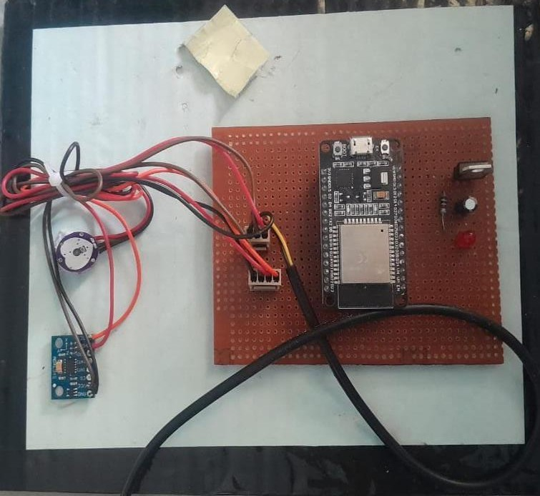

# Fig 1. IOT Health Monitoring System

1. **Literature Survey**

The application of IoT in healthcare has gained significant momentum in recent years, leading to the development of various smart health monitoring systems. G. Yang et al. (2014) introduced a wearable sensor-based system designed to monitor key physiological parameters such as ECG and body temperature, emphasizing the role of continuous monitoring in managing chronic diseases. Similarly, Patel and Wang (2010) developed a body area network (BAN) that collects patient health data and transmits it wirelessly to a centralized server. Their research highlighted challenges related to energy efficiency and data privacy in wearable health devices.

Parwekar (2016) explored cloud-assisted IoT systems that enhance remote diagnostics by providing scalable storage and advanced analytics capabilities. Suryadevara and Mukhopadhyay (2012) developed a smart home-based monitoring system for elderly care using wireless sensors, which enabled automatic and non-invasive tracking of health conditions. Additionally, industry whitepapers and World Health Organization (WHO) reports have emphasized the urgent need for remote healthcare solutions, particularly in rural and underserved regions, and in response to global health crises such as the COVID-19 pandemic.

# Background

The healthcare industry is undergoing a

technological transformation aimed at making medical services more efficient, accessible, and personalized. Traditional healthcare systems largely rely on face-to-face consultations and periodic checkups, which may not be sufficient for patients requiring continuous observation, such as those with chronic illnesses, the elderly, or individuals recovering from surgery. These limitations have driven the need for remote health monitoring solutions that allow real-time data acquisition and early detection of health anomalies.The Internet of Things (IoT) has emerged as a key enabler in bridging this gap between patients and healthcare providers. IoT refers to a network of interconnected devices capable of collecting and exchanging data through the internet. In the context of healthcare, IoT allows the integration of smart sensors, microcontrollers, and wireless communication technologies to monitor a patient's vital signs continuously and remotely. The data collected is transmitted to cloud platforms where it can be analyzed visualized, and accessed by authorized users such as doctors or caregivers. Various wearable technologies, such as smart bands, patches, and body sensor networks, have made it easier to capture physiological parameters like heart rate, body temperature, blood pressure, oxygen saturation (SpO₂), and ECG readings. When connected to IoT platforms, these sensors create a powerful system capable of alerting healthcare providers

oxygen saturation (SpO₂), and ECG readings. When connected to IoT platforms, these sensors create a powerful system capable of alerting healthcare providers in case of irregular health patterns. This not only facilitates timely medical intervention but also reduces the burden on healthcare facilities by minimizing unnecessary hospital visits. The background research and development in this area show a growing trend towards personalized and preventive healthcare solutions. However, challenges such as data accuracy, battery life, data privacy, and affordability still need to be addressed. The proposed system builds on this foundation, aiming to deliver a reliable, real-time, and cost-effective IoT-based health monitoring solution suitable for both individual and clinical use.

1. **Process Table**

|  |  |  |
| --- | --- | --- |
| Step No. | Action | Description |
| 1 | Collect Vital Health Data | Sensors measure parameters like heart rate, temperature, SpO₂, and blood pressure. |
| 2 | Process and Transmit Data | Microcontroller processes the data and sends it to the cloud via Wi-Fi or Bluetooth |
| 3 | Monitor and Analyze Data | Cloud platform stores, analyzes, and displays the data for real-time  monitoring. |
| 4 | Loop for Continuous Tracking | The system repeats the cycle continuously for ongoing health monitoring. |

1. **Methodology**
   1. **Data Collection and Transmission:**

Wearable biomedical sensors continuously measure vital signs such as heart rate, temperature, blood pressure, and SpO₂. The data is processed by a microcontroller and transmitted wirelessly to a cloud platform.

# Cloud Analysis and Monitoring:

The cloud stores and analyzes the data in real-time, visualizes it on dashboards or mobile apps, and sends alerts to healthcare providers if abnormal values are detected.

# Material Selection & Component Integration:

1. **Material Used**

**PCB (Printed Circuit Board)** – For connecting and mounting electronic components securely.

**Conductive Wires and Connectors** – For stable electrical connections between components.

# Integrated Components

* 1. Pulse Oximeter
  2. ESP 32
  3. Temperature Sensor
  4. PCB
  5. Fall-detection Sensor

1. **Prototype Development:** After finalizing the system design, we developed the IoT-based Human Health Monitoring prototype using biomedical sensors (e.g., heart rate, SpO₂, temperature), an ESP32 microcontroller for connectivity, and a cloud-based platform for data storage. Components were integrated with proper wiring, and initial programming was done to collect and transmit real-time health data.
2. **Testing & Improving Performance:** We conducted multiple testing cycles to evaluate the system’s accuracy, responsiveness, data reliability, and power efficiency. Sensor readings were validated against standard medical equipment. Iterative improvements were made to enhance sensor calibration, connectivity stability, and energy consumption.
3. **Processing & Optimizing Data:** Collected health data was processed using cloud-based analytics and local edge computing. This enabled real-time alerts, pattern recognition, and anomaly detection. Data visualization dashboards were optimized for clarity and actionable insights, aiding timely medical responses.
4. **Final Testing & Real-World Deployment:** We tested the system in real-life scenarios including home environments, clinics, and during light physical activity. Based on testing results, we refined user interface, improved data transmission reliability, and ensured the system's robustness for continuous monitoring. The solution was then optimized for real-world deployment, ensuring accuracy, usability, and remote accessibility.

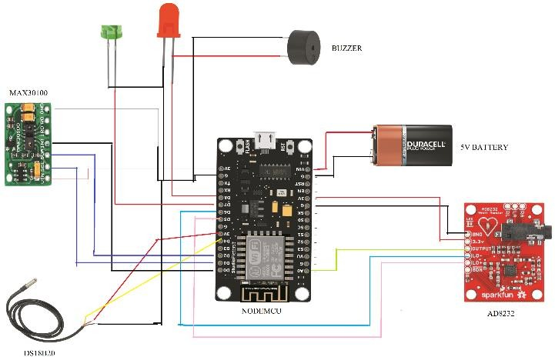

# Fig 2. Circuit diagram of Health Monitoring System

1. **Applications**
2. **Remote Patient Monitoring:** Continuous tracking of vital signs such as heart rate, blood oxygen, and temperature for elderly or chronically ill patients at home or in assisted living facilities.
3. **Hospital Patient Management:** Real-time monitoring of in-patient health data to support timely medical intervention and improve ICU efficiency.
4. **Occupational Health and Safety:** Monitoring workers in high-risk environments (e.g., factories, mines, or construction sites) to detect fatigue, heat stress, or other health anomalies early.
5. **Fitness and Wellness Tracking:** Supporting athletes and fitness enthusiasts with real-time feedback on physiological parameters during exercise or recovery.
6. **Rural and Remote Healthcare Access:** Extending medical monitoring to underserved areas where in-person healthcare access is limited, enabling telemedicine and remote diagnosis.
7. **Pandemic and Infectious Disease Control:** Screening individuals in public places quarantine zones to detect fever or irregular vitals, enabling proactive containment and medical response.

# Integration of Technology:

* + 1. **Adaptive Power Management:** Low-power modes and efficient data transmission protocols (like MQTT) extend battery life, making the system suitable for long-term, wearable use.

# Wireless Connectivity:

Seamless Wi-Fi and Bluetooth communication ensure uninterrupted data transfer to smartphones or cloud platforms, supporting remote access by healthcare professionals and caregivers.

**J. Challenges & Future Scope Challenges:**

1. Maintaining consistent and reliable readings despite variations in skin tone, movement, sweat, or ambient temperature.
2. Balancing real-time data acquisition with battery life in wearable or portable devices.
3. Ensuring stable data transmission in areas with weak or intermittent internet access.

# Future Scope:

* 1. **AI-Powered Predictive Analytics**

Integration of AI and machine learning to predict health anomalies before they occur, enabling early diagnosis and preventive care.

# Wearable Miniaturization

Development of ultra-small, flexible, and skin- friendly wearable sensors for continuous and unobtrusive monitoring.

# Blockchain for Data Security

Use of blockchain to ensure secure, tamper-proof health records, enabling safe sharing across hospitals and caregivers.

# Edge Computing Implementation

Real-time data processing at the device level to reduce latency and ensure faster health event responses.

# L. Conclusion

The development of our "IoT-Based Human Health Monitoring System" represents a transformative step toward smarter, proactive, and patient-centric healthcare. By integrating IoT technology with wearable sensors and cloud connectivity, we have created a system capable of continuously monitoring vital health parameters and providing real-time alerts, thereby reducing response time during critical health events. Our research and prototype development confirm the system’s feasibility in terms of technical implementation, affordability, and usability, making it a promising tool for individuals, caregivers, healthcare providers. Whether used in home settings, elder care, or remote health services, the solution enhances accessibility and reliability of medical monitoring. Through continuous improvement and interdisciplinary collaboration, our IoT- based system stands poised to revolutionize healthcare delivery, making it more efficient, scalable, and personalized for all.

# M. References

1. Kumar, P., Sharma, R., & Singh, M. (2021). *IoT-Based Health Monitoring System Using Wearable Sensors and Cloud Computing*. International Journal of Computer Applications, 183(40), 22–28.
2. Majumder, S., Deen, M. J., & Hossain, E. (2019). *Smart Health Monitoring Systems Using IoT and Wearable Sensors: A Review*. IEEE Sensors Journal, 19(14), 15357–15369.
3. Patel, S., Park, H., Bonato, P., Chan, L., & Rodgers, M. (2012). *A Review of Wearable Sensors and Systems with Application in Rehabilitation*. Journal of NeuroEngineering and Rehabilitation, 9(21), 1–17.
4. World Health Organization. (2020). mHealth: Use of Mobile Wireless Technologies for Public Health. Retrieved from [https://www.who.int/goe/publications/goe_m](https://www.who.int/goe/publications/goe_mhealth_web.pdf) [health_web.pdf](https://www.who.int/goe/publications/goe_mhealth_web.pdf)