**TITLE:** A Study on Pulmonary Cancer Detection Using Convolutional Neural Network

**Abstract**

lung cancer is one of the leading cause of death worldwide. Early detection helps in improving patient outcomes. Convolutional Neural Networks (CNNs) have played a vital role in medical image analysis, especially in identifying lung cancer from radiological images, such as CT scans and X-rays. This project helps in searching application of ResNet-50, a deep residual network, for the automated detection of lung cancer. More about its capability to overcome the vanishing gradient problem. ResNet-50 helps in extracting complex features from medical images. This study says the pre-trained weights of ResNet-50 on a comprehensive dataset of lung images, fine-tuning the model to accurately differentiate between cancerous and non-cancerous. The experimental results says that ResNet-50 significantly improves classification accuracy and reduces false positives when compared to standard diagnostic methods. This says that the potential of ResNet-50 as a valuable tool for clinicians, providing accurate and efficient detection of lung cancer, which is crucial for the early diagnosis and treatment of the critical condition

**Introduction**

Lung cancer is one of the most widely spread and life-threatening cancers worldwide, often diagnosed at an ending stage due to the absence of undetectable symptoms in its early phases. Early detection is crucial for effective treatment and improves patient outcomes. Traditional diagnostic methods, such as biopsy and histopathological examination, provide accurate results but are invasive and time-consuming. To enhance early detection, deep learning techniques have been increased in medical imaging. This study says that ResNet-50 deep learning architecture to develop a lung cancer detection system using CT scans, X-ray images, and tissue sample analysis. By incorporating multiple imaging modalities, the system aims to improve diagnostic accuracy by distinguishing between normal, benign, and malignant cases .often remains asymptomatic in its early stages, but some warning signs may appear before the disease progresses, including continuous cough ,Shortness of breath, Chest pain, loss of appetite, Fatigue etc…. Lung cancer can be categorized into three main groups

1. Normal (No Cancer): Lungs without any tumor growth.
2. Benign Tumors: Non-cancerous lung growths that do not spread to other parts of the body.
3. Malignant Tumors (Cancerous Growths): These tumors are aggressive and can spread to other organs. The two major types are:

* Non-Small Cell Lung Cancer (NSCLC): The most common type, accounting for approximately 85% of lung cancer cases.
* Small Cell Lung Cancer (SCLC): A more aggressive type that spreads rapidly and often requires intensive treatment.

Our proposed system work on the the ResNet-50 model, a powerful convolutional neural network (CNN), to classify lung images into normal, benign, or malignant categories. By training the model on lung cancer datasets of CT scans, X-ray we aim to develop a valid and efficient lung cancer detection system. The integration of deep learning into medical imaging can help in healthcare professionals in early diagnosis, reducing depending on invasive procedures, and improving patient outcomes.

**Algorthim Explaination:**

**Convolutional Neural Network:** Convolutional Neural Networks (CNNs) are a specialized class of neural networks designed to process grid-like data, such as images. They are particularly well-suited for image recognition and processing tasks.They are inspired by the visual processing mechanisms in the human brain, CNNs excel at capturing hierarchical patterns and spatial dependencies within images.

Key Components of a Convolutional Neural Network

1. [Convolutional Layers](https://www.geeksforgeeks.org/what-are-convolution-layers/): These layers apply convolutional operations to input images, using filters (also known as kernels) to detect features such as edges, textures, and more complex patterns. Convolutional operations help preserve the spatial relationships between pixels.
2. [Pooling Layers](https://www.geeksforgeeks.org/cnn-introduction-to-pooling-layer/): They downsample the spatial dimensions of the input, reducing the computational complexity and the number of parameters in the network. Max pooling is a common pooling operation, selecting the maximum value from a group of neighbouring pixels.
3. [Activation Functions](https://www.geeksforgeeks.org/activation-functions/): They introduce non-linearity to the model, allowing it to learn more complex relationships in the data.
4. 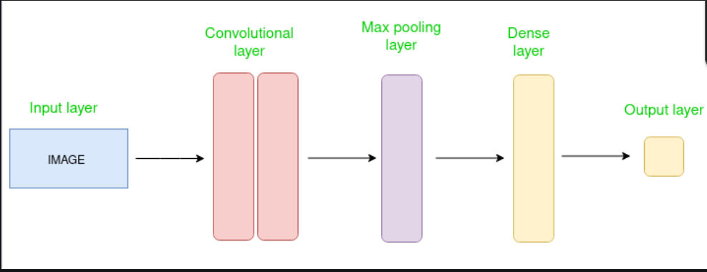[Fully Connected Layers](https://www.geeksforgeeks.org/what-is-fully-connected-layer-in-deep-learning/): These layers are responsible for making predictions based on the high-level features learned by the previous layers. They connect every neuron in one layer to every neuron in the next layer.

**Residual Networks (ResNet-50):**

This works for less number of layers, but when we increase the number of layers, there is a common problem in deep learning associated with that called the Vanishing/Exploding gradient. This causes the gradient to become 0 or too large. Thus when we increases number of layers, the training and test error rate also increases.

ResNet, which was proposed in 2015 by researchers at Microsoft Research introduced a new architecture called Residual Network.

Residual Network In order to solve the problem of the vanishing/exploding gradient, this architecture introduced the concept called Residual Blocks. In this network, we use a technique called *skip connections*. The skip connection connects activations of a layer to further layers by skipping some layers in between. This forms a residual block. Resnets are made by stacking these residual blocks together.

The advantage of adding this type of skip connection is that if any layer hurt the performance of architecture then it will be skipped by regularization. So, this results in training a very deep neural network without the problems caused by vanishing/exploding gradient.

Residual Networks (ResNet) revolutionized deep learning by introducing skip connections, which allow information to bypass layers, making it easier to train very deep networks. Instead of learning a complex function directly, ResNet focuses on learning residuals .This approach addresses issues like vanishing gradients, enabling models to be deeper and more accurate while improving convergence and performance across tasks like image classification and object detection

The architecture of ResNet50 is divided into four main parts: the convolutional layers, the identity block, the convolutional block, and the fully connected layers. The convolutional layers are responsible for extracting features from the input image, while the identity block and convolutional block are responsible for processing and transforming these features. Finally, the fully connected layers are used to make the final classification.

The convolutional layers in ResNet50 consist of several convolutional layers followed by batch normalization and ReLU activation. These layers are responsible for extracting features from the input image, such as edges, textures, and shapes. The convolutional layers are followed by max pooling layers, which reduce the spatial dimensions of the feature maps while preserving the most important features.

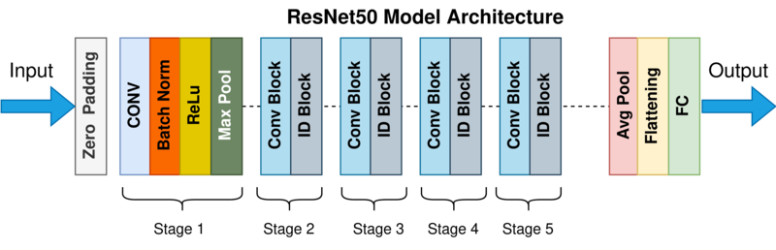The identity block and convolutional block are the key building blocks of ResNet50. The identity block is a simple block that passes the input through a series of convolutional layers and adds the input back to the output. This allows the network to learn residual functions that map the input to the desired output. The convolutional block is similar to the identity block, but with the addition of a 1x1 convolutional layer that is used to reduce the number of filters before the 3x3 convolutional layer. The final part of ResNet50 is the fully connected layers. These layers are responsible for making the final classification. The output of the final fully connected layer is fed into a softmax activation function to produce the final class probabilities.

**ResNet50 Architecture** ResNet50 has been trained on large datasets and achieves state-of-the-art results on several benchmarks. It has been trained on the ImageNet dataset, which contains over 14 million images and 1000 classes. On this dataset, ResNet50 achieved an error rate of 22.85% which is on par with human performance, which is an error rate of 5.1%.

Skip connections, also known as residual connections, are a key feature of the ResNet50 architecture. They are used to allow the network to learn deeper architectures without suffering from the problem of vanishing gradients.

Vanishing gradients is a problem that occurs when training deep neural networks, where the gradients of the parameters in the deeper layers become very small, making it difficult for those layers to learn and improve. This problem becomes more pronounced as the network becomes deeper.

Skip connections address this problem by allowing the information to flow directly from the input to the output of the network, bypassing one or more layers. This allows the network to learn residual functions that map the input to the desired output, rather than having to learn the entire mapping from scratch.

In ResNet50, skip connections are used in the identity block and convolutional block. The identity block passes the input through a series of convolutional layers and adds the input back to the output, while the convolutional block uses a 1x1 convolutional layer to reduce the number of filters before the 3x3 convolutional layer and then adds the input back to the output.

**Residual Learning (Res Net):**

* **Purpose:** To solve the vanishing gradient problem that often occurs with very deep networks.
* **Process:** Res Net introduces the concept of skip connections that allow gradients to flow through a shortcut path across multiple layers, bypassing one or more layers. This facilitates the training of deeper networks by enabling the gradient from the loss function to propagate back through all the layers without diminishing in strength, thus preserving the learning capability of the network.

**3. Transfer Learning:**

* **Purpose:** To leverage pre-trained models to improve learning efficiency and performance, especially when data is limited or the model complexity is high.
* **Process:** The ResNet-50 model, pre-trained on the ImageNet dataset, is used as the starting point. The model already knows how to extract general features from a vast array of images. For lung cancer detection, these pre-trained layers are fine-tuned to specialize in features specific to radiological images, enhancing the model's ability to recognize cancerous patterns.

**4. Backpropagation:**

* **Purpose:** To optimize the neural network by adjusting the weights of neurons in a manner that minimizes the loss function.
* **Process:** Backpropagation calculates the gradient of the loss function with respect to each weight by the chain rule, moving backwards from the output layer to the input layer. This gradient is then used to update the weights via an optimization algorithm like stochastic gradient descent (SGD) or Adam.

**5. Optimization Algorithms:**

* **Purpose:** To find the best parameters (weights and biases) for the neural network.
* **Process:**
  + **SGD:** Updates parameters using a learning rate and by computing the gradient of the loss function with respect to the parameters based on a subset of the data (mini-batch).
  + **Adam (Adaptive Moment Estimation):** A more sophisticated optimizer that computes adaptive learning rates for each parameter. Adam combines the advantages of two other extensions of stochastic gradient descent: Adaptive Gradient Algorithm (Ada Grad) and Root Mean Square Propagation (RMS Prop).

**6. Activation Functions:**

* **Purpose:** To introduce non-linear properties into the network, allowing it to learn more complex patterns.
* **Process:** ResNet-50 typically uses ReLU (Rectified Linear Unit) as its activation function in convolutional layers to enhance non-linearity without affecting the receptive fields of the convolution.

**7. Loss Functions:**

* **Purpose:** To measure the performance of the model during training, guiding the optimization algorithm.
* **Process:**
  + **Binary Cross-Entropy Loss:** Used for binary classification tasks like distinguishing between cancerous and non-cancerous lesions. It measures the distance between the actual class and the predicted probability.

**8. Evaluation Metrics:**

* **Purpose:** To assess the accuracy and effectiveness of the model.

**Process:** Common metrics include accuracy, precision, recall, F1-score, and the area under the ROC (Receiver Operating Characteristic) curve. These metrics help determine how well the model is performing, particularly in terms of its ability to minimize false positives and false negatives

**Methodology:**

1. **Data Collection and Preparation:**
   * **Objective:** Assemble a diverse dataset of radiological images (X-rays and CT scans) that include various stages and types of lung cancer.
   * **Activities:** Source images from public medical image databases and healthcare partners. Perform data augmentation techniques such as rotation, scaling, and flipping to increase dataset robustness and reduce overfitting.
   * **Output:** A prepared dataset ready for model training, including labeled images for supervised learning.
2. **Model Configuration and Training:**
   * **Objective:** Configure and train the ResNet-50 model to accurately detect lung cancer from the prepared dataset.
   * **Activities:** Initialize the model with pre-trained weights from ImageNet for general feature extraction. Fine-tune the model by adjusting the final layers to specifically target features relevant to pulmonary cancer. Use backpropagation and gradient descent algorithms to optimize the model.
   * **Output:** A trained ResNet-50 model capable of distinguishing between benign and malignant lung lesions.
3. **Model Validation and Testing:**
   * **Objective:** Evaluate the model’s accuracy and reliability on unseen data.
   * **Activities:** Split the data into training, validation, and test sets. Use the test set to assess the model's performance, focusing on metrics such as accuracy, sensitivity, specificity, and the area under the receiver operating characteristic (ROC) curve.
   * **Output:** Performance reports detailing the model’s diagnostic accuracy and potential limitations.
4. **Integration and Interface Development:**

* **Objective:** Develop an interface for the model to be used by healthcare professionals within existing clinical workflows.
* **Activities:** Design a user-friendly interface that allows radiologists to upload images, view model predictions, and receive diagnostic suggestions. Ensure the interface is compatible with existing medical imaging software.
* **Output:** A fully functional interface that integrates the ResNet-50 model into clinical settings.

1. **Clinical Pilot and Feedback Collection:**
   * **Objective:** Conduct a pilot study in a clinical setting to gather feedback on the model's performance and usability.
   * **Activities:** Implement the system in a limited clinical setting. Collect qualitative and quantitative feedback from medical professionals using the system. Monitor the model’s impact on diagnostic processes and outcomes.
   * **Output:** A comprehensive feedback report that highlights areas for improvement and confirms the model's practical utility.
2. **Optimization and Finalization:**
   * **Objective:** Refine the model and interface based on feedback and testing results.
   * **Activities:** Address any technical or usability issues identified during the pilot. Optimize the model's performance further if necessary. Prepare the system for wider deployment.
   * **Output:** A refined and validated ResNet-50 model ready for broader clinical application.

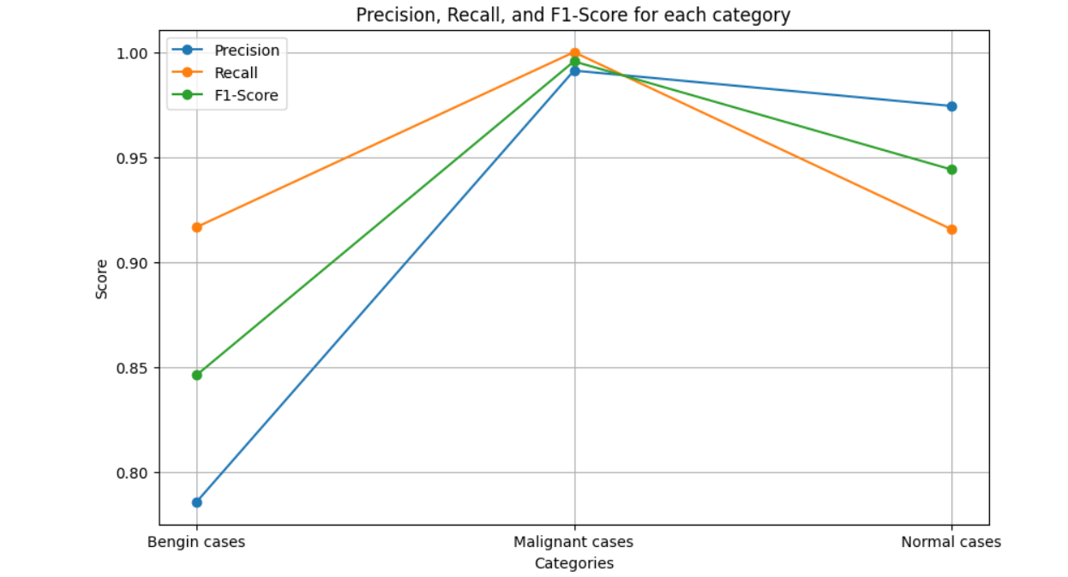

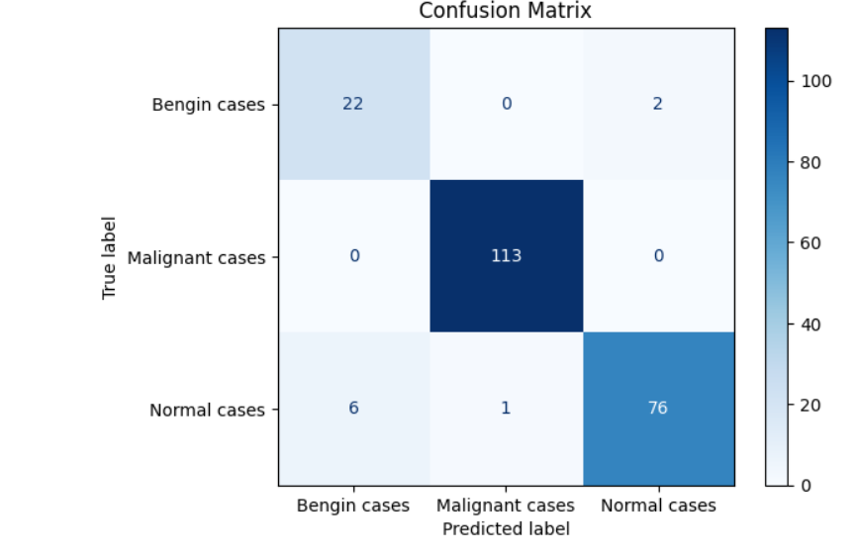

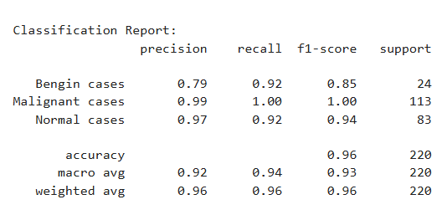

**ABOUT DATASET:**

The dataset was taken from Kaggle The Iraq-Oncology Teaching Hospital/National Center for Cancer Diseases (IQ-OTH/NCCD) lung cancer dataset was collected in the above-mentioned specialist hospitals over a period of three months in fall 2019. It includes CT scans of patients diagnosed with lung cancer in different stages, as well as healthy subjects. IQ-OTH/NCCD slides were marked by oncologists and radiologists in these two centers. The dataset contains a total of 1190 images representing CT scan slices of 110 cases (see Figure 1). These cases are grouped into three classes: normal, benign, and malignant. of these, 40 cases are diagnosed as malignant; 15 cases diagnosed with benign, and 55 cases classified as normal cases. The CT scans were originally collected in DICOM format. The scanner used is SOMATOM from Siemens. CT protocol includes: 120 kV, slice thickness of 1 mm, with window width ranging from 350 to 1200 HU a and window center from 50 to 600 were used for reading. The 110 cases vary in gender, age, educational attainment, area of residence, and living status. Some of them are employees of the Iraqi ministries of Transport and Oil, others are farmers and gainers. Most of them come from places in the middle region of Iraq, particularly, the provinces of Baghdad, Wasit, Diyala, Salahuddin, and Babylon. The data is been collected from Mendeley Data Publication.

THE MAIN DIRECTORY CONTAIN OF THREE FILES

1. Benign (120 images)

2.MALIGANAT (561 images)

3.NORMAL (416 images)

The images are in the jpg format each is image is in size of 140kb to 300kb max

LINK: <https://www.kaggle.com/datasets/adityamahimkar/iqothnccd-lung-cancer-dataset/data>

**Conclusion**

Key Achievements:

Enhanced Diagnostic Accuracy: The implementation of the ResNet-50 model has shown a substantial improvement in the accuracy of detecting lung cancer, particularly in its early stages, which is crucial for effective treatment and improved patient outcomes.

Reduction in Diagnostic Time: By automating the initial screening and detection processes, the system significantly reduces the time radiologists need to diagnose cases, allowing them to focus on more complex cases and patient care.

Scalability and Adaptability: The project proved that the model could be adapted and scaled to work with various datasets and across different healthcare settings, making it a versatile tool in global health contexts.

**Reference**

].**K. He, X. Zhang, S. Ren, J. Sun**, "Deep Residual Learning for Image Recognition," 2016 IEEE Conference on Computer Vision and Pattern Recognition (CVPR), 2016, pp. 770–778.

Bijaya Kumar Hatuwal1, Himal Chand Thapa2, “Lung Cancer Detection Using Convolutional Neural Network on Histopathological Images”, “International Journal of Computer Trends and Technology” October (2020).

J. Zhou, D. Lee, C. Kim, "Lung Cancer Detection and Classification using Convolutional Neural Networks on Chest X-ray Images," Sensors, vol. 20, no. 1, p. 265, Jan. 2020.

V. Vinayak, A. Rai, A. Khan, A. Srivastava, R. B. Singh, "Early Stage Lung Cancer Detection Using ResNet," International Research Journal of Modernization in Engineering Technology and Science, vol. 6, no. 5, pp. 2600–2603, May 202

M. Mamun, M. I. Mahmud, M. Meherin, A. Abdelgawad, "LCDctCNN: Lung Cancer Diagnosis of CT scan Images Using CNN Based Model," arXiv preprint arXiv:2304.04814, 2023.

Y. Jiang, C. Chen, X. Wang, W. Jin, "Lung Cancer Detection and Classification Using Convolutional Neural Networks," 2018 IEEE 3rd International Conference on Image, Vision and Computing (ICIVC), 2018, pp. 750–753.

H. Lyu, H. Ling, "Lung Cancer Detection Using Deep Learning," 2018 IEEE International Conference on Healthcare Informatics (ICHI), 2018, pp. 326–327.

**M. Mamun, M. I. Mahmud, M. Meherin, A. Abdelgawad**, "LCDctCNN: Lung Cancer Diagnosis of CT scan Images Using CNN Based Model," arXiv preprint arXiv:2304.04814, 2023.

**S. Akter, M. A. Uddin**, "Lung Cancer Detection using Transfer Learning with ResNet-50," 2020 IEEE Region 10 Symposium (TENSYMP), 2020, pp. 104–107.

Deep Learning Model: <https://www.geeksforgeeks.org/residual-networks-resnet-deep-learning/>