**Free Food Donate application**

1. **Nandini Moglappa Dhangar, Zeal Polytechnic, Pune, India.**
2. **Pratiksha Moglappa Dhangar, Zeal Polytechnic, Pune, India.**
3. **Priti Ambadas Karajkar, Zeal Polytechnic, Pune, India.**
4. **Kavita Rajeshwar Dhumale, Zeal Polytechnic, Pune, India.**
5. **Prof. Savita Biradar, Assistant Professor, Zeal Polytechnic, Pune, India.**

**Abstract:** The Free Food Donation App is an Android-based application developed using Java in Android Studio. Its main goal is to reduce food wastage and help needy people by connecting food donors with receivers. This app allows individuals, restaurants, or organizations to donate leftover or excess food, and enables hungry or underprivileged people to receive it. The app includes features like user registration, login, food donation form, food receiving form, food location map, history of donations/receipts, and contact/about sections. Donors can fill in food details, contact information, and location. Receivers can see available food and request it. The app also includes a simple dashboard for navigation. This project promotes social responsibility and helps in building a better community by sharing food with those in need. It provides an easy-to-use platform that encourages users to donate rather than waste food.

1. **Introduction:**

The Free Food Donation App is a project designed to help reduce hunger and prevent food wastage, with the goal of creating a hunger-free world. According to recent studies, around 1.3 billion tons of food is wasted globally every year, and nearly one-third of all food produced ends up as leftovers or waste. This app aims to reduce food wastage and make sure extra food reaches the people who need it most.

To achieve this, an Android-based mobile application has been developed using Android Studio and Java. This app allows any individual or organization to donate extra food easily through their smartphone. At the same time, people who are in need of food can send a request based on their requirements.

The only thing needed to use this app is a smartphone and an internet connection. Food wastage is a serious issue faced by many countries, including India, where studies show that up to 40% of food is wasted daily. This problem becomes even worse during weddings, festivals, and in hotels, where large amounts of food are thrown away.

On the other side, many children and families suffer from hunger and malnutrition every day. Although some NGOs are working hard to collect leftover food and distribute it to the poor, there is still a huge gap between food wastage and hunger. This app helps to bridge that gap by providing a digital platform where food can be shared, not wasted.

**2. Literature Survey**

**Title: Free food donate application (App)**

In recent years, many initiatives have been taken both in India and around the world to reduce food wastage and help people in need. One such initiative was a 2014 project in Aurangabad, India, which used location-based GIS and Google Web Services to create a smartphone-based food donation system. This system allowed users to donate food through a mobile app by entering basic details such as food type, quantity, and contact information. NGOs and social workers could then access this information and collect the food to deliver it to hungry people. The system also used GPS to track optimal routes from the donor's location to the nearest NGO, making food delivery faster and more efficient.

Another important research paper titled “Beyond Meal Sharing: Supporting Food Waste Reduction with ICTs” (2016) discussed how Information and Communication Technologies (ICT) can help reduce food waste at different levels of the supply chain. The paper emphasized that while people are becoming more aware of food waste, the role of ICT tools in solving this problem is still not fully utilized. The paper suggested that digital tools like mobile apps, smart tracking systems, and data analysis could help collect and redistribute excess food more effectively to needy families.

A more recent project, “Zero Hunger: Smart Food Donation System Using IoT” (2021), proposed an Android mobile application that includes two modules: one for users and another for NGOs. Users can post details of available food, including quantity, type, and location. NGOs can then assign volunteers to collect the food. The unique part of this system is the use of IoT devices by volunteers to check food quality before delivery. This system has been especially helpful in slum areas and low-income communities.

Another 2021 study, “Food Donation Application: Food Share”, introduced a mobile app where not just NGOs, but also individual needy people can register. This way, donors can choose to donate directly either to a registered NGO or to a person in need. This direct connection between donors and receivers makes the donation process more personal and effective.

These ideas have inspired our Free Food Donation App, which aims to combine the best features from both Indian and international projects. Our app is designed to:

* Support donors and receivers directly
* Work in both urban and rural areas
* Encourage social responsibility
* Reduce food waste
* Help fight hunger locally and globally

With technology growing rapidly in India and abroad, such mobile apps have the power to create a global impact by connecting people, reducing waste, and feeding the hungry with just a few taps on a smartphone.

**3. Problem Statement**

In recent years, food wastage has become a major global issue, especially in developing countries like India. Every day, tons of leftover or surplus food from homes, restaurants, hotels, parties, and social events are thrown away. According to studies, nearly one-third of all food produced globally goes to waste, while millions of people, including children, suffer from hunger and malnutrition.

There is a clear mismatch between the people who have extra food and those who need it. Many individuals and organizations want to donate food, but they do not have a proper platform to connect with people who are in need. On the other hand, poor and hungry people struggle to find food sources and may not know where or how to get help.

Although some NGOs and social groups are working to collect and distribute food, the process is often manual, unorganized, and limited. There is no efficient way to:

* Track available food donations in real-time
* Verify food safety and freshness
* Match donors and receivers based on location
* Maintain proper records of donations and distribution

This situation highlights the need for a technological solution that can bridge the gap between donors and receivers and make the process of donating and receiving food quick, reliable, and efficient.

The main problems can be summarized as:

* Lack of awareness among donors about how and where to donate food
* No common platform for food donors and needy people to connect
* Poor coordination between NGOs, volunteers, and donors
* Manual food collection and delivery processes causing delays and food spoilage
* Difficulty in tracking the impact and history of food donations

To solve this problem, the Free Food Donation App is developed using Android Studio and Java, which allows:

* Easy food donation through mobile phones
* Real-time location sharing and food listing
* Direct communication between donors, NGOs, and receivers
* Tracking and storing donation history
* Reducing food waste and hunger effectively

This app provides a digital platform for social good, where technology is used to ensure that no good food goes to waste and no one goes hungry.

**4. Proposed System**

The Free Food Donation App is a mobile-based application developed using Android Studio and Java, which helps to connect food donors and receivers quickly and easily. The system is designed to reduce food wastage and support needy people by making food donations more organized and efficient.

📱 Key Features of the Proposed System:

* User Registration/Login for both donors and receivers
* Food Donation Form where users can enter food details, quantity, and location
* Request Food Option for people or NGOs to find available donations
* Map Integration to view nearby food donations
* History Section to track past donations and requests
* Contact Us and About Us pages for information and support
* Logout and Session Management for secure access

👥 System Users:

* Donor – People or organizations who donate food
* Receiver – People or NGOs who request food
* Admin/NGO – Optional, for tracking and coordination

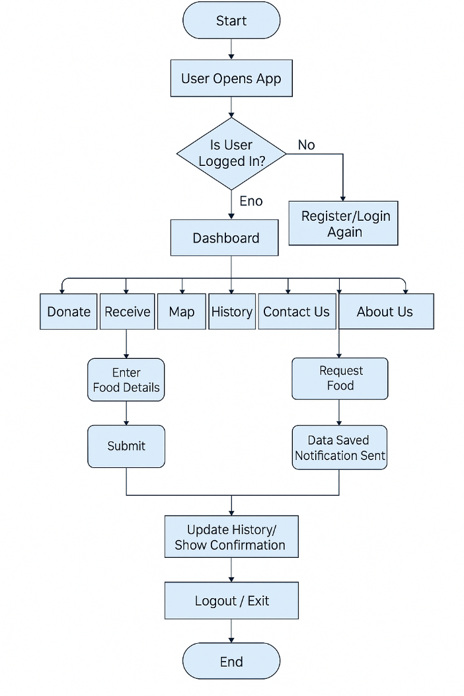

**5.**  **Possible solution**

To solve the problem of food wastage and hunger, we propose developing a mobile application that connects food donors with people in need. This Android-based app, developed using Android Studio and Java, provides a platform where individuals, hotels, restaurants, and event organizers can donate leftover or surplus food. At the same time, NGOs, volunteers, and needy people can request or receive food nearby.

💡 Key Solutions Offered by the App:

1. User-Friendly Interface
   * Simple login and registration system for both donors and receivers.
   * Easy navigation between features like Donate, Receive, Map, History, etc.
2. Real-Time Food Donations
   * Donors can upload food details (type, quantity, location, and contact).
   * Receivers and NGOs can view available food donations instantly.
3. Location-Based Services
   * Google Maps integration allows users to find or post donations nearby.
   * Helps reduce travel time and ensures food is delivered before spoilage.
4. History Tracking
   * Keeps records of past donations and received food entries.
   * Allows users to monitor their contributions and requests.
5. Notifications
   * Sends alerts to NGOs or nearby users when a new food donation is available.
   * Confirms successful submissions and delivery.
6. Awareness and Social Impact
   * Encourages a culture of sharing and reduces food wastage.
   * Builds a responsible community to support the fight against hunger.

**6. Project and scope**

The Free Food Donation App is an Android mobile application designed to reduce food wastage and help feed the hungry. The app creates a platform where food donors like individuals, restaurants, hotels, and event organizers can share leftover food with people who need it. It connects donors directly with receivers such as NGOs, volunteers, or poor families using a simple interface and location-based services.

This project uses Android Studio and is built with Java, making it efficient and compatible with most Android smartphones. The app allows users to register, donate food, receive food, view nearby food availability on a map, and track donation history. It aims to build a smart, responsible, and hunger-free society using the power of mobile technology.

### 🎯 **Scope of the Project**

The scope of the **Free Food Donation App** covers the following points:

1. **User Registration**
   * Both food donors and receivers can register and log in to the app securely.
2. **Food Donation System**
   * Donors can easily submit food details such as description, quantity, and pickup location.
3. **Food Request Feature**
   * Needy people or NGOs can browse and request available food based on location and availability.
4. **Map Integration**
   * Google Maps integration shows nearby donations and helps users find the shortest route.
5. **Donation History**
   * Users can view records of their past donations or received food.
6. **Notification and Alerts**
   * Users are notified about new donations or requests in their area.
7. **Simple UI/UX**
   * The app is designed with a simple and clean interface for easy usage by all age groups.
8. **Social Impact**
   * Helps reduce food waste, supports the hungry, and builds awareness about responsible food sharing.

Splash activity :

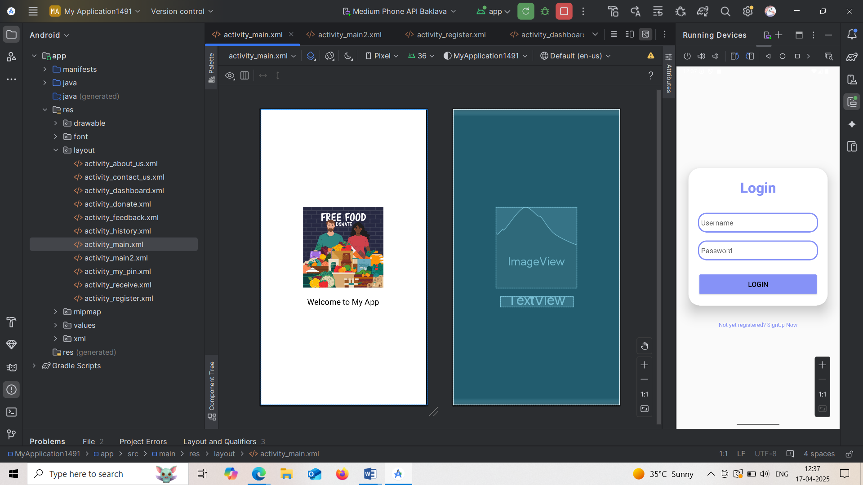

Login Screen :

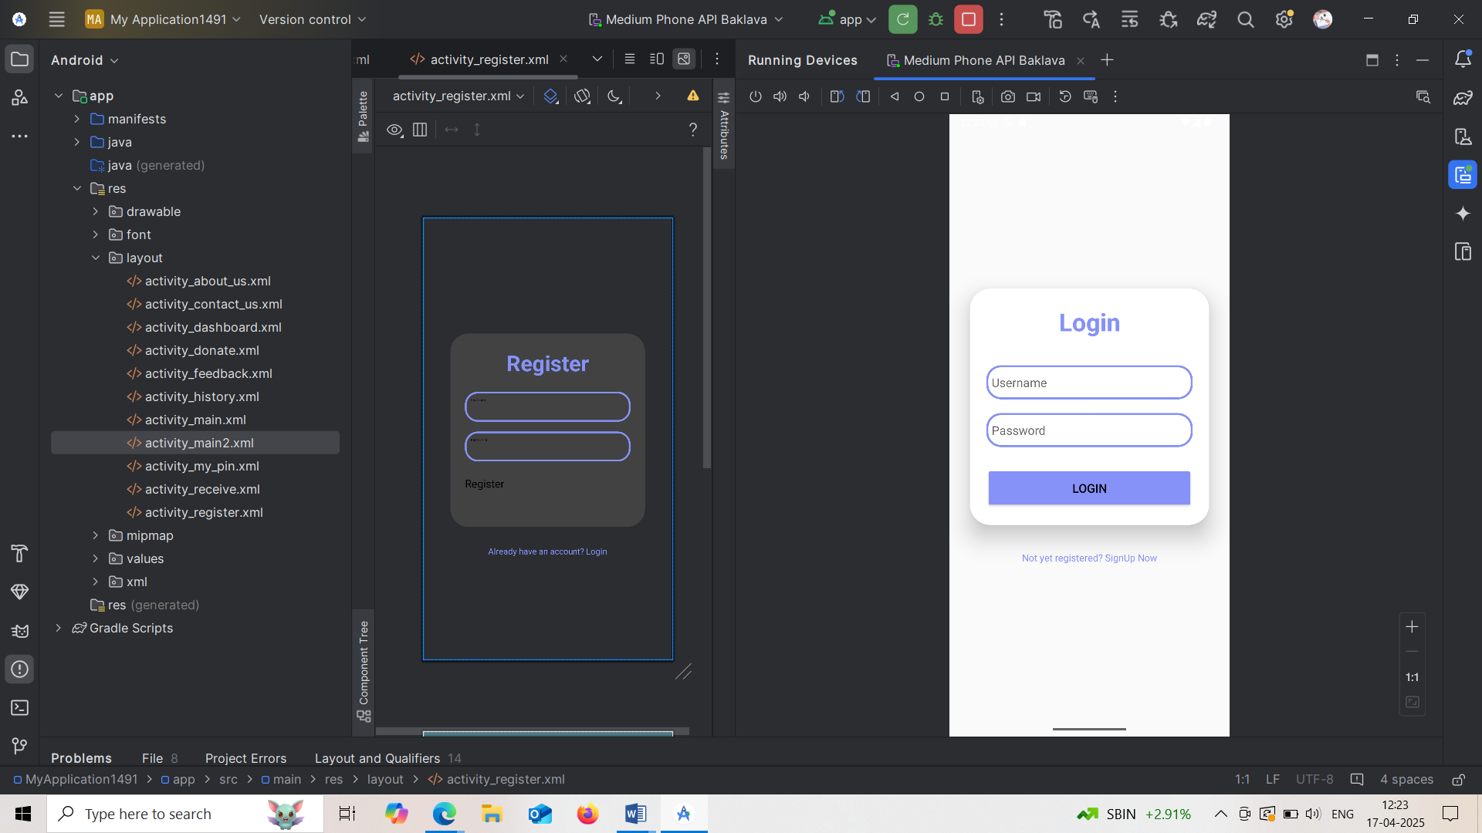

Register Screen :

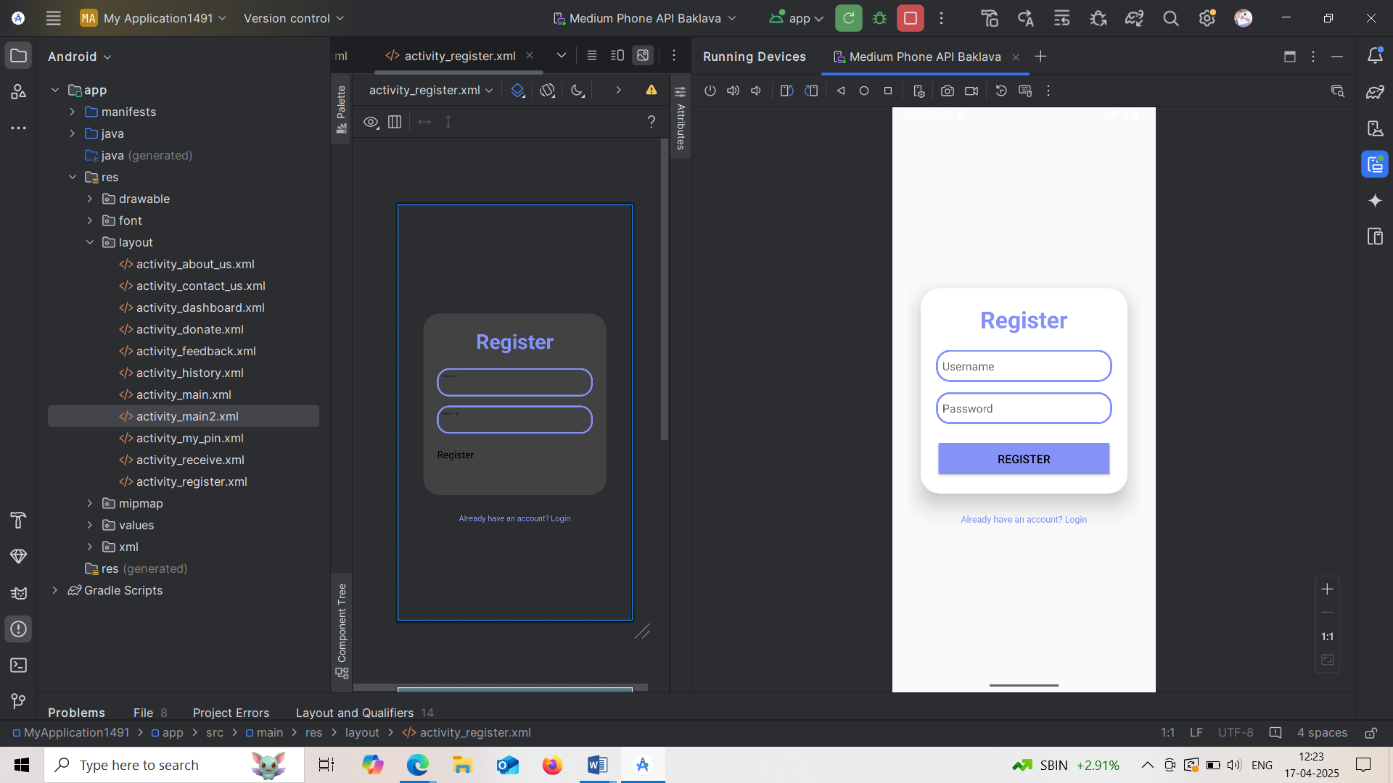

Dashboard screen:

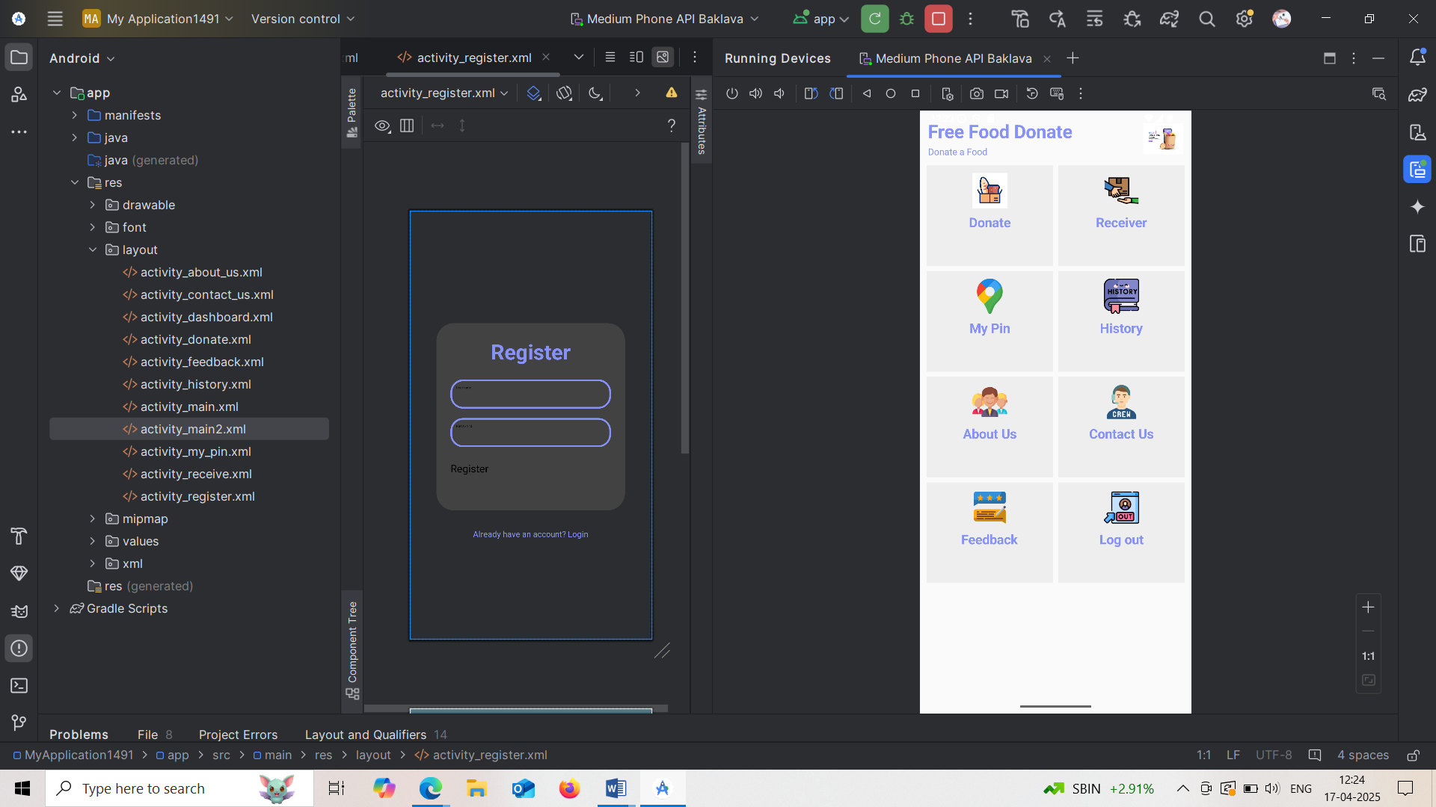

Donate screen :

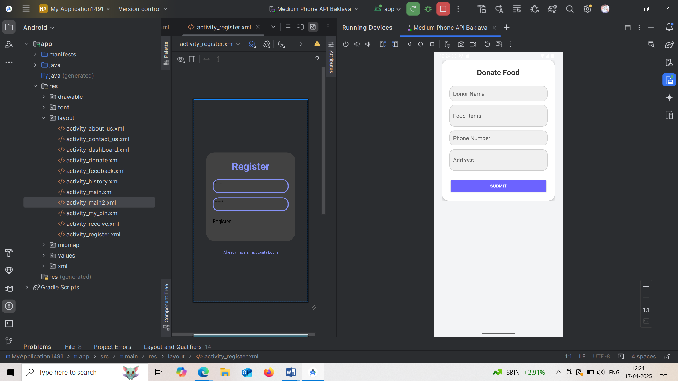

Receiver Screen :

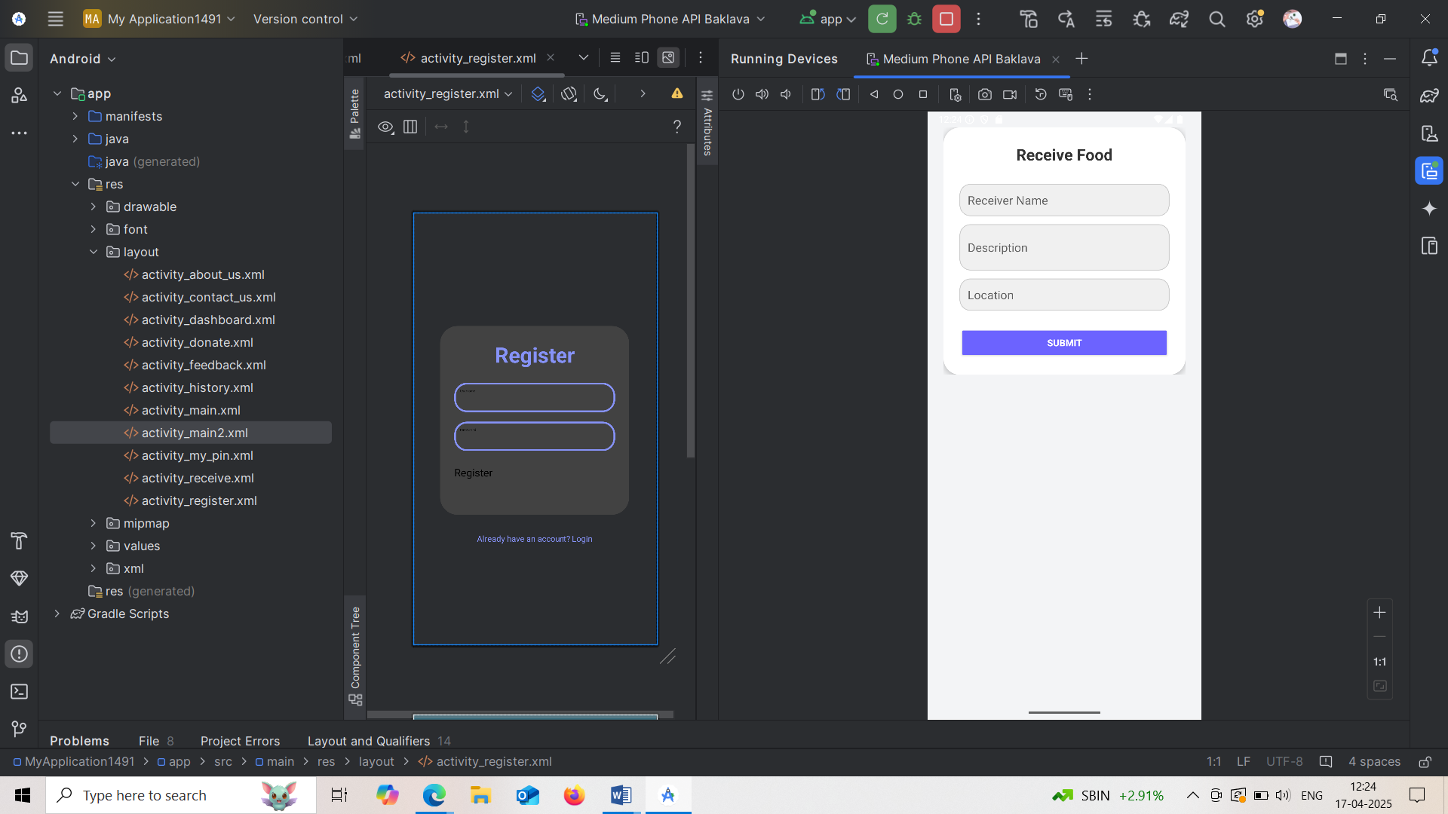

My Pin Screen :

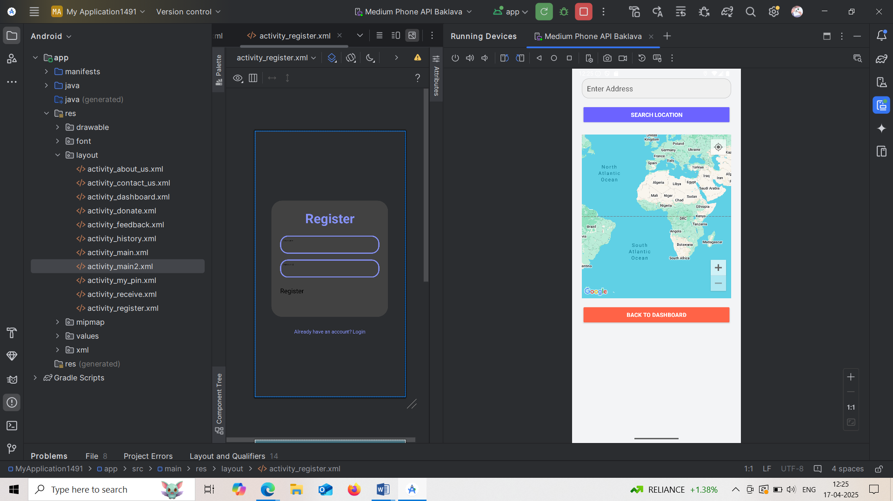

History Screen :

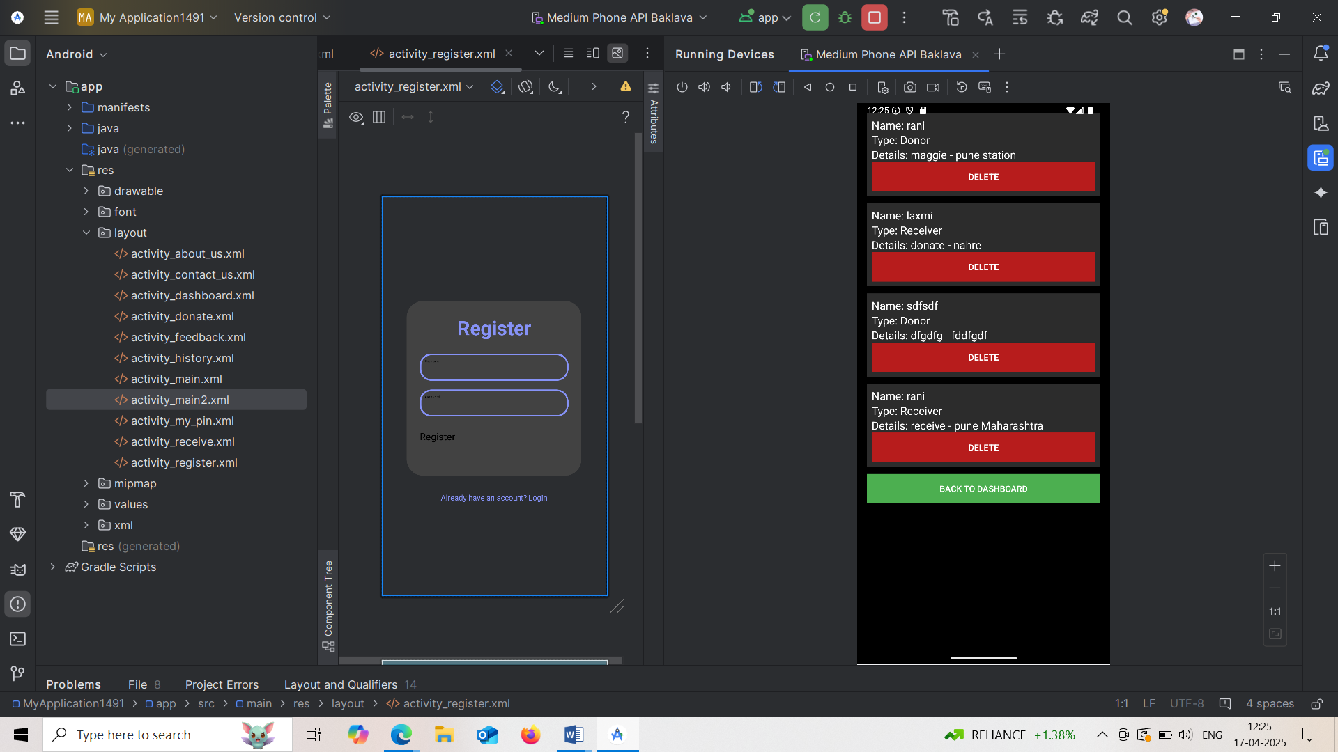

About us :

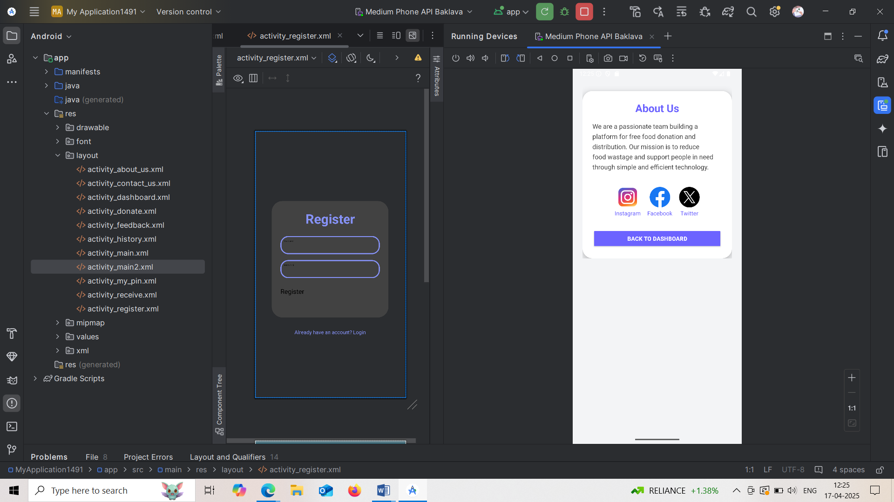

Contact us:

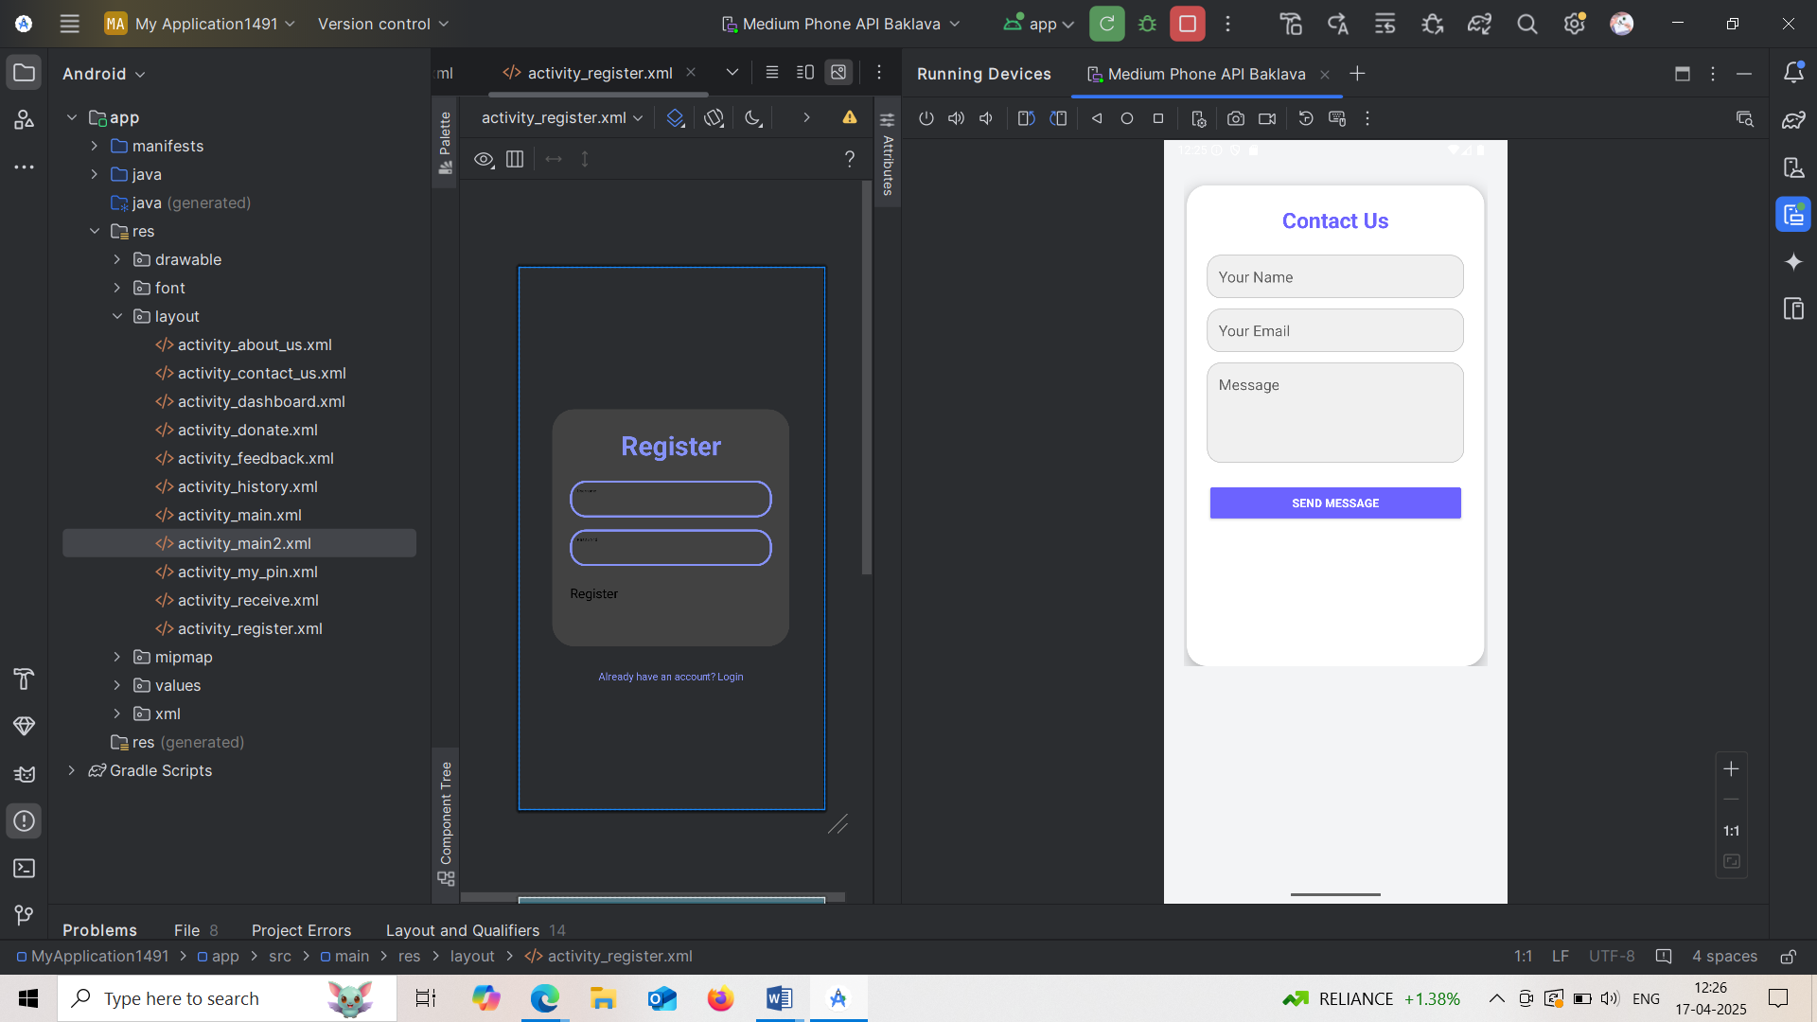

Feed Back Screen :

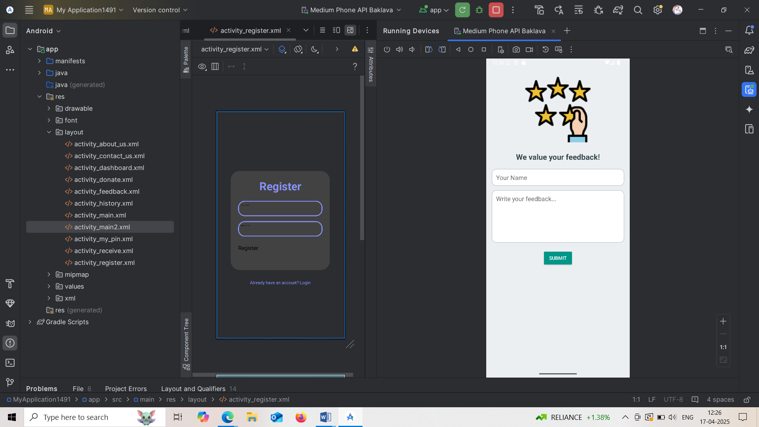

Logout the app.

**7. Critical Evaluation**

The Free Food Donation App is a very helpful and meaningful project that aims to reduce food wastage and feed the hungry. It uses mobile technology to create a connection between people who have extra food and those who need it. The app plays an important role in promoting social responsibility, especially in a country like India where a large amount of food is wasted daily, while many people go to bed hungry.

The application is easy to use, and its simple interface makes it suitable for all age groups. People can register on the app as either donors or receivers and can donate or request food based on their needs. The use of location-based services like Google Maps allows users to see nearby food donations, which saves time and ensures the food is delivered quickly before it spoils.

Even though the app has a good purpose and is very useful, there are a few limitations. One of the main problems is that it requires internet access and a smartphone to work. Many poor people who need food might not have access to these. Also, there is no proper system in the app to check the quality of the donated food, which can sometimes be unsafe to eat. Another issue is the need for public awareness. If not many people know about the app or use it, then its impact will be very small. Security of personal information is also important, as the app collects details like phone numbers and addresses, which should be properly protected to avoid misuse.

Despite these challenges, the app has great potential. It can be improved by adding new features like uploading food images, giving feedback on donations, and supporting multiple languages. An admin panel can also be added to monitor and verify the data submitted by users. With more promotion and NGO support, the app can become a strong solution to food wastage and hunger not only in India but around the world.

Overall, the Free Food Donation App is a valuable system that can bring positive change in society. With a few upgrades and more awareness, it can play a big role in creating a hunger-free community.

1. **Significance:**

The serve paper for a waste food donation application plays a vital role by establishing a comprehensive framework that ensures legal protection and regulatory compliance for food donors. It outlines operational procedures and safety protocols, which help to minimize risks associated with food handling and distribution. By facilitating collaboration between food donors and nonprofits, it fosters community engagement and enhances partnerships aimed at addressing food insecurity.

Moreover, the serve paper promotes resource efficiency by encouraging the diversion of edible food from landfills, contributing to environmental sustainability. It emphasizes transparency and accountability, allowing organizations to track donations and assess the impact of their efforts. Additionally, it can serve as a training tool, promoting best practices among staff and volunteers involved in food donation initiatives.

Ultimately, the serve paper not only supports the logistical aspects of food donation but also raises awareness about food waste and food insecurity, potentially influencing policy changes that bolster these efforts. Its significance lies in its ability to create a structured, safe, and effective system for food donations, benefiting both donors and those in need.

1. **Conclusion:-**

People uses of mobile phones for different function and the style is evolving year by year. The proposed applications must reduce food waste. There is a huge amount of food waste that take place in our everyday lives. As an alternative of throwing it away as garbage, it can be used to feed the homeless. Indicates the neighborhood where the most food is available and statistics on the amount of food available. It is a satisfactory individual benefit. Therefore, there can be no problem in using this effectiveness. Therefore, FTH mobile application has the ability to attract a wide variety of customers and hence is beneficial in solving the hunger problems and food waste around the world. The proposed software program aims to eliminate food waste and also fulfill numerous requirements including clothing, books, paraphernalia, etc. from clubs without money. Restaurants and bistros generate a large amount of food waste every day, as shown in the figure above. Instead of dumping scrap equivalents (which is usually the country of affairs), it could be used very effectively to care for the destitute. Likewise, cafes/bistros no longer need to repeat their maintenance because the van is equipped with the useful resources of corporate use. Be that as it may, feels a little more comfortable with this choice than with manually entering the food details. In any case, it is necessary to overcome certain obstacles that will allow you to make it a standard. However, for the meantime, this software program offers a realistic and powerful affiliation.

1. **Reference:**

* Ambika Nag and Vivek S. Agrawal, “Sustainable Food Waste Prevention Strategies to Achieve Food Security in India”, International Journal of Agriculture and Food Science Technology, vol. 4, pp.189 194, 2013.
* Ayesha Anzer, Hadeel A. Tabaza, and Wedad Ahmed, “A Food Wastage Reduction Mobile Application”, 6th International Conference on Future Internet of Things and Cloud Workshops (FiCloudW), 2018. 18) Jenil Shah, NamanTalati, Omkar Surve, and ShreyKyal, “Food Donation Portal”, International Journal for Scientific Research & Development, vol. 4, Issue 11, ISSN (online): 2321-0613, 2017. GEDRAG & ORGANISATIE REVIEW - ISSN:0921-5077
* Feed the Hunger (FTH)-An Android Application to Reduce Food Wastage Supriya R1 , Mehanaz Begum S 2 , Nivedhitha Bai K3 , Preethi S4 , Ragasriswathi M5 1Assistant Professor, Department of Information Technology, Tamilnadu, INDIA (Email id:supriyarajendran@gmail.com whatsapp no 88833 33144) 2 Student,Department of Information Technology, Tamilnadu,INDIA (Email id: mehnu98@gmail.com whatsapp no8248694696) 3 Student,Department of InformationTechnology, Tamilnadu,INDIA (Email id: nivedhithabai99@gmail.com whatsapp no 8778717159) 4 Student, Department of Information Technology, Tamilnadu,INDIA(Emailid:preethikeerthana1999@gmail.comwhatsappno79045955065Student,DepartmentofInformationTechnology,Tamilnadu,INDIA(Emailid:mrssswat77@gmail.com whatsapp no9080353724) (Corresponding author: SupriyaR Email id: supriyarajendran@gmail.com whatsappno 8883333144)
* Food for You (F4U) Mobile Charity Application Suraya Masrom1 , Abdullah Sani Abd. Rahman2 , Farah Norliyana Azahar3 , Nasiroh Omar4 1Faculty of Computer.

(IJARCET), April 2016.

, Food Wastage Reduction through Donation using M Approach: Helping Hands International Journal of Advanced Research in Computer Engineering & Technology (IJARCET), April 2016.

Online Food Reviews using Customer Ratings 2018.

A Kailas Platform Application for Canteen Food Ordering System” June 2020.

Mobile Crowd Sensing Services for Tinnitus Assessment, Therapy and Research, in 4th Intl Coon Mobile Services 2015.