**TITLE :** SMART AQUAPONICS AND HYDROPONICS MONITORING USING IOT

**AUTHORS DETAILS :**

**UNDER THE GUIDANCE OF:**

**DR .V.Annapurna, M.Tech, PH,D**

annapurna.v@sseptp.org

Sanskrithi School of Engineering, Puttaparthi

**TEAM MEMBERS :**

K.Chandra Sekhar 8074167729 – [chandrachandhu2004@gmail.com](mailto:chandrachandhu2004@gmail.com)

Sanskrithi School of Engineering Puttaparthi

G.Gopi Kiran 9374280962 – [ggopi21417@gmail.com](mailto:ggopi21417@gmail.com)

Sanskrithi School of Engineering Puttaparthi

P.Harsha Vardhan 8106644596 – pittaharsha1@gmail.com

Sanskrithi School of Engineering Puttaparthi

M.Ganesh Naik 9381018791 – ganeshnaik17956[@gmail.com](mailto:saikiranece66@gmail.com)

Sanskrithi School of Engineering Puttaparthi

**ABSTRACT :**

The "Smart Aquaponics and Hydroponics Monitoring System Using IoT" integrates advanced IoT technologies with sustainable farming techniques to optimize organic crop growth and fish farming through efficient resource management. The system employs an Arduino Mega 2560 microcontroller to monitor critical environmental parameters such as water pH, temperature, humidity, and tank water levels using sensors including the pH sensor, DHT11, temperature sensor, and ultrasonic sensor.

Data collected from these sensors is displayed on an LCD and uploaded to ThingSpeak via Node MCU for real-time remote monitoring. In case of abnormal conditions, the GSM module alerts users via text messages, enabling timely interventions. Three water pumping motors, controlled by relays, maintain continuous water circulation, ensuring the optimal transfer of nutrients between the aquaponic components.

This smart, automated system reduces the need for manual oversight, enhancing the efficiency and sustainability of aquaponics and hydroponics farming. With its user-friendly and scalable design, it serves as a practical solution for modern agricultural practices. The provided hardware kit ensures easy implementation without requiring external arrangements.

**INTRODUCTION :**

The "Smart Aquaponics and Hydroponics Monitoring System" introduces an innovative approach to modern farming by leveraging automation and IoT technologies. As aquaponics and hydroponics gain popularity for their resource-efficient and sustainable practices, managing critical environmental parameters becomes essential for maximizing productivity. This system addresses this need by automating key functions such as soil moisture regulation, water level maintenance, and pH balance monitoring. Equipped with advanced sensors like soil moisture, ultrasonic, pH, and DHT11, it ensures precise control of essential conditions. Real-time data visualization on an LCD and integration with the Thing Speak platform offer farmers actionable insights, while alerts through GSM enhance responsiveness to abnormalities. By employing Arduino UNO and relays for seamless operation, the system significantly reduces manual effort and promotes sustainable agricultural practices, making it a valuable tool for advancing smart farming technologies.

**PROPOSED SYSTEM :**

Traditional aquaponics and hydroponics systems rely heavily on manual monitoring and control of key parameters like water levels, pH, temperature, and soil moisture. While functional, these systems are labor-intensive and prone to human error, which can lead to inefficiencies, such as water wastage or suboptimal growth conditions. Additionally, the absence of real-time alerts and centralized data storage makes it difficult to detect and address issues promptly, potentially leading to significant losses.

**BLOCK DIAGRAM:**

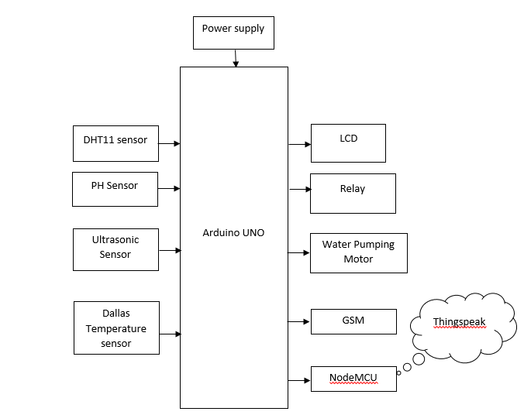

**HARDWARE REQUIREMENTS:**

* Arduino Mega 2560
* Ph Sensor
* DHT11
* Ultrasonic Sensor
* Temperature Sensor
* LCD
* Node MCU
* GSM Module
* Relay
* Water Pump

**SOFTWARE REQUIREMENTS:**

* Embedded

**WORKING THEORY :**

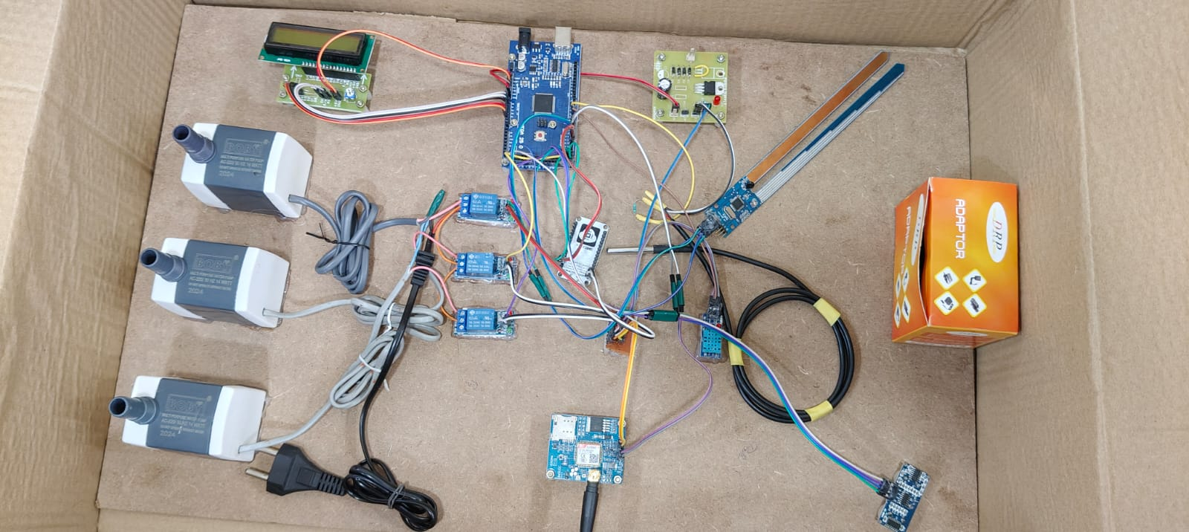

**Arduino Mega :**

The Arduino Mega is a versatile and powerful microcontroller board based on the ATmega2560 chip, designed for projects that require more input/output pins and greater memory capacity compared to the standard Arduino Uno. With 54 digital input/output pins, 16 analog inputs, and 4 hardware serial ports, the Arduino Mega is ideal for complex projects that demand a large number of sensors, actuators, and communication interfaces. It operates at a clock speed of 16 MHz and provides 256 KB of flash memory, allowing for more extensive code storage and execution. The board is compatible with most Arduino shields and modules, making it highly flexible for a variety of applications, from robotics to IoT projects. Its extensive I/O capabilities, combined with its open-source platform, make the Arduino Mega an excellent choice for advanced electronics and embedded system designs.

**LCD :**

An LCD (Liquid Crystal Display) is a flat-panel display technology that utilizes liquid crystals to modulate light and create images. It operates by placing liquid crystal material between two polarizing filters; when an electric current is applied, the orientation of the liquid crystals changes, allowing light to pass through or be blocked. This process enables the display of text, graphics, and videos with high clarity and energy efficiency. LCDs are widely used in various applications, from small screens in handheld devices to larger displays in televisions and computer monitors. They offer advantages such as thin form factors, low power consumption, and the ability to produce vibrant colors, making them a popular choice in both consumer electronics and industrial applications. Additionally, advancements in LCD technology, such as the introduction of LED backlighting and improved resolution, have enhanced their performance and visual quality, solidifying their presence in modern display technology.

**Ultrasonic sensor :**

An ultrasonic sensor is a device that measures the distance to an object or detects the level of a substance by emitting high-frequency sound waves and measuring the time it takes for the waves to bounce back. It operates on the principle of echolocation, similar to how bats use sound to navigate. When the sensor emits a pulse, it travels through the air until it hits an object, then reflects back to the sensor. The time taken for this reflection is used to calculate the distance between the sensor and the object. Ultrasonic sensors are widely used in applications such as distance measurement, object detection, and liquid level monitoring due to their accuracy, non-contact nature, and ability to function in a variety of environments.

**Ph sensor :**

A pH sensor is a device used to measure the acidity or alkalinity of a solution, expressed as a pH value on a scale from 0 to 14. It plays a crucial role in applications where maintaining the proper pH level is essential, such as in aquaponics, hydroponics, and water treatment systems. The sensor typically consists of a glass electrode and a reference electrode, which generate an electrical signal in response to the hydrogen ion concentration in the solution. This signal is then converted into a pH value. In an automated system, the pH sensor ensures optimal water quality by continuously monitoring the pH levels and triggering actions, such as activating a pump to adjust the water chemistry when the pH falls outside a specified range. This ensures a stable environment for plant growth and aquatic life, promoting healthy and efficient farming practices.

**GSM :**

GSM, or Global System for Mobile Communications, is a widely used digital mobile communication standard that enables mobile devices to connect to cellular networks for voice and data transmission. Originally developed in the 1980s in Europe, GSM has evolved to support various applications beyond voice calls, including SMS (Short Message Service), mobile internet access, and multimedia messaging. It operates on different frequency bands, allowing for global interoperability and seamless connectivity across different regions. GSM technology uses a time division multiple access (TDMA) technique, enabling multiple users to share the same frequency channel while maintaining clear communication. Its robustness and reliability have made it the backbone of mobile communications in many countries, facilitating remote monitoring and control in various applications, such as home automation, vehicle tracking, and emergency alert systems. With the advent of IoT, GSM continues to play a crucial role in enabling devices to communicate with each other and with centralized systems, enhancing connectivity and data exchange in smart applications

**Dallas Temperature sensor :**

The Dallas Temperature Sensor, commonly referred to as the **DS18B20**, is a widely used digital temperature sensor known for its precision and ease of use. It can measure temperatures in the range of -55°C to +125°C with a 0.5°C accuracy, making it ideal for a wide array of applications, including monitoring environmental conditions, medical systems, and automotive or industrial projects. The DS18B20 communicates over a 1-Wire bus, meaning it requires only one data line (plus ground) for communication, allowing for easy integration with microcontrollers like Arduino. Additionally, multiple DS18B20 sensors can be connected to a single data line, making it highly scalable for projects that require multiple temperature measurements. Its waterproof version further extends its utility for outdoor or harsh environment monitoring

**DHT11 Sensor :**

The DHT11 sensor is a widely used, low-cost sensor designed to measure temperature and humidity in various environmental conditions. It provides digital output, making it easy to interface with microcontrollers like Arduino. The sensor is capable of measuring temperatures within the range of 0 to 50°C with an accuracy of ±2°C, and humidity levels from 20% to 90% with an accuracy of ±5% RH. Due to its compact size and simplicity, the DHT11 is commonly used in applications such as weather monitoring systems, home automation, and agricultural projects. While it offers lower accuracy and precision compared to more advanced sensors, its affordability and ease of use make it a popular choice for many basic temperature and humidity monitoring tasks.

**NODE MCU :**

Node MCU is an open-source, low-cost development board based on the ESP8266 Wi-Fi module, designed for Internet of Things (IoT) applications. It features a microcontroller with built-in Wi-Fi capabilities, making it ideal for projects requiring wireless communication. With a simple and easy-to-use platform, Node MCU supports programming in the Arduino IDE, allowing developers to create and deploy IoT applications efficiently. The board includes digital and analog input/output pins, making it suitable for connecting various sensors and actuators. Its compact size and ability to interface with cloud platforms, such as ThingSpeak, make NodeMCU a popular choice for building smart devices and remote monitoring systems.

**RELAY :**

A relay is an electrically operated switch that allows a low-power signal to control a high-power circuit. It consists of an electromagnet, a set of contacts, and a spring mechanism. When an electric current flows through the electromagnet, it generates a magnetic field that pulls the contacts together or pushes them apart, depending on the relay's design. This action enables the relay to open or close the circuit, controlling the flow of electricity. Relays are commonly used in various applications, including automation systems, to control motors, lights, or other devices based on low-level control signals. They provide electrical isolation between the controlling and controlled circuits, ensuring safety and protecting sensitive components from high-voltage surges.

**BUZZER :**

A buzzer is a simple yet effective electronic component commonly used in alarm systems, indicating alerts, and signaling events through sound. Typically, buzzers can be classified into two types: active and passive. Active buzzers generate sound when voltage is applied, while passive buzzers require an external frequency to produce sound, allowing for more complex audio signals. In safety systems, such as gas leak detection or smoke alarms, buzzers play a critical role by providing audible alerts that prompt immediate action to mitigate potential dangers. They can be integrated with microcontrollers, like Arduino, to create automated safety solutions, enhancing user awareness in emergency situations. The loud and attention-grabbing nature of buzzers makes them an essential component in many electronic devices, ensuring important notifications are hard to miss.

**CONCLUSION :**

In conclusion, the "Smart Aquaponics and Hydroponics Monitoring System Using IoT" provides a comprehensive, efficient, and automated solution for optimizing sustainable farming practices. By integrating various sensors and IoT technologies, the system ensures the real-time monitoring of essential environmental parameters and facilitates timely intervention through GSM alerts. The automation of water circulation and nutrient management significantly reduces manual labor, enhancing the sustainability and productivity of both aquaponics and hydroponics systems. With its scalable design and ease of implementation, this system offers a practical and innovative approach to modern agriculture, promoting resource efficiency and improving crop and fish farming outcomes.