**Drawsiness Alert System**

**Snehal P. Jadhav1, Poonam K. Gunjal2, Snehal S. Gaikwad3, Rutuja V. Mhaske4**

1,2,3Diploma Student, Department of Computer Engineering, Shri Chhatrapati Shivaji Maharaj College of Engineering, Nepti, Ahmednagar, India

4Assistant Professor, Dept. of Computer Engineering, Shri Chhatrapati Shivaji Maharaj College of Engineering, Nepti, Ahmednagar, India

**ABSTRACT**

This document is a review report on the research conducted and the project made in the field of computer engineering to develop a system for driver drowsiness detection to prevent accidents from happening because of driver fatigue and sleepiness. The report proposed the results and solutions on the limited implementation of the various techniques that are introduced in the project. Whereas the implementation of the project give the real world idea of how the system works and what changes can be done in order to improve the utility of the overall system.

Furthermore, the paper states the overview of the observations made by the authors in order to help further optimization in the mentioned field to achieve the utility at a better efficiency for a safer road.

**1.INTRODUCTION**

This document is a review report on the research conducted and the project made in the field of computer engineering to develop a system for driver drowsiness detection to prevent accidents from happening because of driver fatigue and sleepiness. The report proposed the results and solutions on the limited implementation of the various techniques that are introduced in the project. Whereas the implementation of the project give the real world idea of how the system works and what changes can be done in order to improve the utility of the overall system.

Furthermore, the paper states the overview of the observations made by the authors in order to help further optimization in the mentioned field to achieve the utility at a better efficiency for a safer road. Thus, this tool extends beyond merely detecting drowsiness while driving, incorporating eye extraction and face recognition using dlib. This research is primarily focused on enhancing efforts to identify drowsiness in drivers under real driving conditions. The purpose of driver drowsiness detection systems is to aim to reduce these traffic incidents. The secondary data collected emphasizes previous studies on systems for detecting drowsiness, and various methods have been employed to recognize drowsiness or inattentive driving.

Keywords: Eye extraction, Dlib, Facial Extraction, Drowsiness, Machine Learning, EAR,

**2.PROBLEM STATEMENT**

**1.System Review**

This survey is done to comprehend the need and prerequisite of the general population,and to do as such, we went through different sites and applications and looked for the fundamental data. Based on these data, we made an audit that helped us get new thoughts and make different arrangements for our task. We reached the decision that there is a need of such application and felt that there is a decent extent of progress in this field too.

**2.Technology Used**

**PYTHON –**

Python is an interpreted, high-level, general-purpose programming language. Python's design philosophy emphasizes code readability with its notable use of significant whitespace. Its language constructs and object-oriented approach aim to help programmers write clear, logical code for small and large-scale projects. Python is dynamically typed AND supports multiple programming paradigms, including procedural, object-oriented, and functional programming.

**JUPYTER Lab –**

Project Jupyter is a nonprofit organization created to develop open-source software, open-standards, and services for interactive computing across dozens of programming languages.

**IMAGE PROCESSING –**

In computer science, digital image processing is the use of computer algorithms to perform image processing on digital images.

**MACHINE LEARNING –**

Machine learning is the scientific study of algorithms and statistical models that computer systems use in order to perform a specific task effectively without using explicit instructions, relying on patterns and inference instead. It is seen as a subset of artificial intelligence. Machine learning algorithms build a mathematical model based on sample data, known as "training data", in order to make predictions or decisions without being explicitly told.

**HUMAN PSYCHOLOGY WITH CURRENT TECHNOLOGY –**

Humans have always invented machines and devised techniques to ease and protect their lives, for mundane activities like traveling to work, or for more interesting purposes like aircraft travel. With the advancement in technology, modes of transportation kept on advancing and our dependency on it started increasing exponentially. It has greatly affected our lives as we know it. Now, we can travel to places at a pace that even our grandparents wouldn’t have thought possible. In modern times, almost everyone in this world uses some sort of transportation every day. Some people are rich enough to have their own vehicles while others use public transportation. However, there are some rules and codes of conduct for those who drive irrespective of their social status. One of them is staying alert and active while driving.

Neglecting our duties towards safer travel has enabled hundreds of thousands of tragedies to get associated with this wonderful invention every year. It may seem like a trivial thing to most folks but following rules and regulations on the road is of utmost importance. While on road, an automobile wields the most power and in irresponsible hands, it can be destructive and sometimes, that carelessness can harm lives even of the people on the road. One kind of carelessness is not admitting when we are too tired to drive. In order to monitor and prevent a destructive outcome from such negligence, many researchers have written research papers on driver drowsiness detection systems. But at times, some of the points and observations made by the system are not accurate enough. Hence, to provide data and another perspective on the problem at hand, in order to improve their implementations and to further optimize the solution, this project has been done.

**3. METHODOLOGY**

**Tools & Image Processing Methods**

**OpenCV:**

OpenCV (Open-Source Computer Vision) is the versatile tool for computer vision, featuring a wide array of modules that can assist with various computer vision challenges. However, perhaps the most beneficial aspect of OpenCV is its architecture and memory management.

It provides a framework for working with images and videos in any way desired, utilizing OpenCV without the hassle of allocating and reallocating memory for your images. The optimized capabilities of OpenCV make it suitable for real-time video and image processing.

The highly efficient image processing functions of OpenCV are employed by the author for real-time image handling of live video streams from the camera.

**Dlib:**

Dlib is a contemporary C toolkit that includes algorithms and tools for machine learning, facilitating the development of complex C++ software to address real-world challenges. It finds applications across a broad spectrum of fields in both industry and academia, such as robotics, embedded devices, mobile phones, and large-scale, high-performance computing environments. Dlib’s open-source licenses allow free use in any application. The author utilizes the open-source Dlib library for implementing CNN (Convolutional Neural Networks). The author applies highly optimized prediction functions and detectors of previously learned facial shapes to identify facial features.

**EAR (Eye Aspect Ratio):**

The numerator of this equation measures the distance between the vertical landmarks of the eye, while the denominator represents the distance between the horizontal reference points of the eye, with the denominator weighted accordingly since there is only one.The eye aspect ratio remains relatively constant when the eye is open, but it rapidly approaches zero when a blink occurs. When a person blinks, the aspect ratio of the eyes decreases significantly and nears zero. As illustrated in Figure 2, the eye aspect ratio remains constant, then swiftly drops to zero before rising again, indicating that a single blink has taken place.

**Face Recognition:**

The following sections outline the face recognition algorithms Eigenface, Fisherface, and Histogram of Local Binary Patterns (LBPH), along with their implementation in OpenCV. Local binary patterns were utilized as classifiers in computer vision as early as the 1990s by Li Wang [4]. The combination of LBP with histogram- oriented gradients was introduced in 2009, enhancing performance on certain datasets [5]. For feature coding, the image is divided into cells (4 x 4 pixels), using surrounding pixels in a clockwise or counterclockwise manner. The values are compared with the central ones, as depicted in Figure 6. The intensity or brightness value of each neighboring pixel is compared to that of the central pixel.

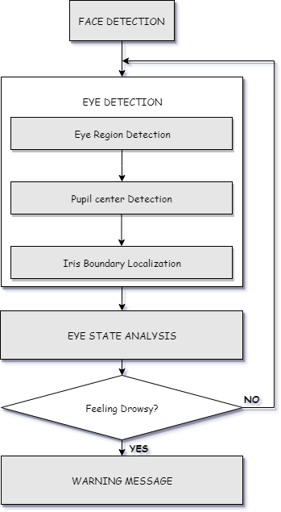

In our program we used Dlib, a pre-trained program trained on the HELEN dataset to detect human faces using the pre-defined 68 landmarks.

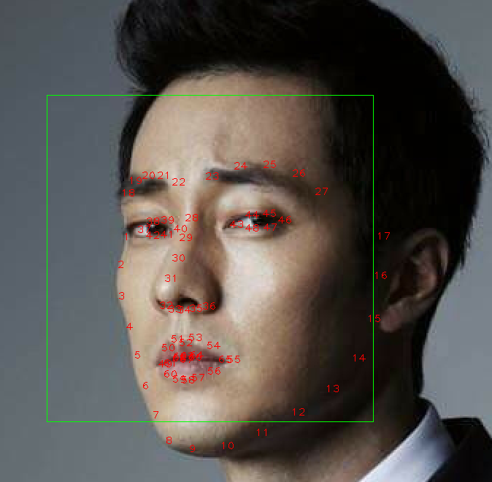

**Landmarked Image of a person by Dlib**

After passing our video feed to the dlib frame by frame, we are able to detect left eye and right eye features of the face**.**

Now, we drew contours around it using OpenCV.

Using Scipy’s Euclidean function, we calculated sum of both eyes’ aspect ratio which is the sum of 2 distinct vertical distances between the eyelids divided by its horizontal distance.

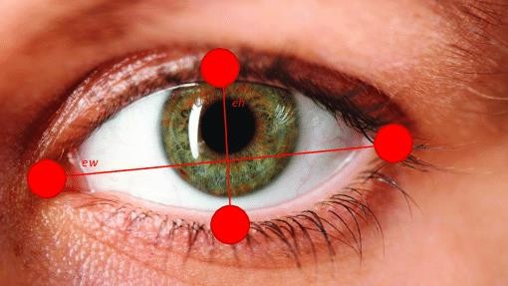

Eyes with horizontal and vertical distance marked for Eye Aspect Ratio calculation.

Now we check if the aspect ratio value is less than 0.25 (0.25 was chosen as a base case after some tests). If it is less an alarm is sounded and user is warned.

**Technology Stack**

* 1. Python:

Python is the basis of the program that we wrote. It utilizes many of the python libraries.

* 1. Libraries:
     + Numpy: Pre-requisite for Dlib
     + Scipy: Used for calculating Euclidean distance between the eyelids.
     + Playsound: Used for sounding the alarm
     + Dlib: This program is used to find the frontal human face and estimate its pose using 68 face landmarks.
     + Imutils: Convenient functions written for Opencv.
     + Opencv: Used to get the video stream from the webcam, etc

.

OS: Program is tested on Windows 10 build 1903 and PopOS 19.04

* 1. Laptop: Used to run our code.
  2. Webcam: Used to get the video feed.

**4.Future Scope**

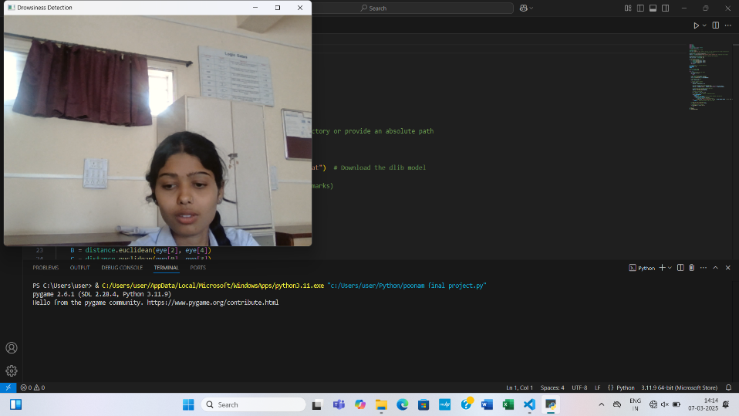

The model can be improved incrementally by using other parameters like blink rate, yawning, state of the car, etc. If all these parameters are used it can improve the accuracy by a lot.

We plan to further work on the project by adding a sensor to track the heart rate in order to prevent accidents caused due to sudden heart attacks to drivers.

Same model and techniques can be used for various other uses like Netflix and other streaming services can detect when the user is asleep and stop the video accordingly. It can also be used in application that prevents user from sleeping.

**5.Result**

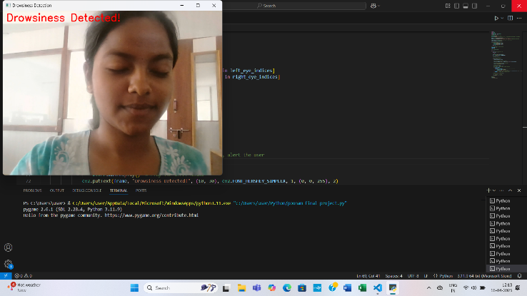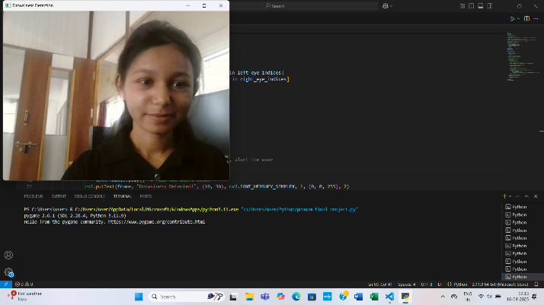

**6.Conclusion**

It completely meets the objectives and requirements of the system. The framework has achieved an unfaltering state where all the bugs have been disposed of. The framework cognizant clients who are familiar with the framework and comprehend it's focal points and the fact that it takes care of the issue of stressing out for individuals having fatigue-related issues to inform them about the drowsiness level while driving.

**7.Referances**

1. computationally efficient face detection; b. schlkopf-a. blake, s. romdhani, and p. torr.
2. use of the hough transformation to detect lines and curves in picture; r. duda and p. e. hart.
3. jain, “face detection in color images; r. l. hsu, m. abdel- mottaleb, and a. k. jain
4. pen/closed eye analysis for drowsiness detection p.r. tabrizi and r. a. zoroofi.
5. Jay D. Fuletra., “A Survey on Driver’s Drowsiness Detection Techniques” International Journal on

Recent and Innovation Trends in Computing and Communication ISSN: 2321-8169 Volume: 1 Issue: 11 2013

1. A Study of Heart Rate and Brain System Complexity and Their Interaction in Sleep-Deprived Subjects. Kokonozi A.K., Michail E.M., Chouvarda I.C., Maglaveras N.M. Bologna, Italy. : Computers in Cardiology, 2008
2. <http://dlib.net/face_landmark_detection_ex.cpp.html>