**SYSTEMATIC DESIGN AND ANALYSIS OF FLOW FIELD**

**SIVA JOTHI S1,**

1Assistant Professor, Department of Mechanical Engineering, Satyam College of Engineering and Technology, KanyaKumari, Tamilnadu, India.

**N NANTHINI2, R KARPPUKKARASI3, A MUTHU SELVA KUMAR4**

2, 3, 4 UG Scholars, Department of Aeronautical Engineering, Satyam College of Engineering and Technology, KanyaKumari, Tamilnadu, India.

**ABSTRACT**

The main aim of this project is to embed the engine in wing. So that the profile drag will be reduced and to determine the flow field of the wing. The idea behind the concepts is to fully integrate a propulsion system within a wing structure so that the aircraft takes full benefits of coupling of wing aerodynamics and the propulsion thrust stream. The objective of this study is to assess the feasibility of the EWP concept applied to large transport aircraft such as the Blended-Wing – Body aircraft. In this paper, some of early analysis and current status of the study are presented. In addition, other current activities of distributed propulsion under the RAC project are briefly discussed. We NACA 0012 Which is the airfoil and has a needed thickness. NACA 0012 airfoil is drawn using GAMBIT and then a cut for coefficient of lift, in FLUENT FOR Various angle of attack. And then a cut section is made in the trailing edge, it is analyzed for coefficient of lift. A graph is drawn between coefficients of lift Vs angle of attack, in comparison with experimental data. Later a jet is introduced in trailing edge, and it is analysed for various, and Vorticity magnitude is determined. Later in hot jet various jet temperatures is applied, for that, magnitude and temperature flow is analyzed.

**INTRODUCTION**

An aircraft is a machine that is able to fly by gaining support from the air,or, in general, the atmosphere of a planet. The atmosphere of a planet. It counters the force of gravity by using either static lift or by using the dynamic lift of an airfoil, or a few cases the downward thrust from jet engines. The human activity that surrounds aircraft is called aviation. Crewed aircraft are flown by an onboard pilot, but unmanned aerial vehicles may be remotely controlled or self- controlled by onboard computers. Aircraft may be different criteria, such as lift type, usage and others.

**1.1 Fixed Wing**

The forerunner of the fixed-wing aircraft is the kite. Whereas a fixed-wing aircraft relies on its forward speed to create airflow over the wings, a kite is tethered to the ground and relies on the wind blowing over its wings to provide lift. Kites were the first kind of aircraft to fly, and were invented in china around 500 BC. Much aerodynamic research was done with kites before test aircraft, wind tunnels, and computer modeling programs became available.

The first heavier-than- air craft capable of controlled free- flight were gliders. A glider designed by clayey out the first true manned, controlled flight in **1853.**Practical, powered, fixed-wing aircraft (the aeroplane or airplane) were invented by Wilbur and Orville Wright. Besides the method of propulsion. The most important wing characteristics are;

* Number of wings- monoplane, biplane, etc.
* Wing support- Braced or cantilever, rigid, or flexible.
* Wing plan form-including aspect ratio , angle of sweep , and any variations along the span ( including the important class of delta wings)
* Location of the horizontal stabilizer, if any.
* Dihedral angle-positive, zero, or negative.

A variable geometry aircraft can change its wing configuration during flight. A flying wing has no fuselage, though it may have small blisters or pods. The opposite of this is a lifting body, which has no wings, though it may have small stabilizing and control surfaces.

Wing –in-ground –effect vehicles may be considered as fixed-wing aircraft. They “fly” efficiently close to the surface of the ground or water, like conventional aircraft during takeoff. An example is the Russian ekranoplan (nicknamed the “Caspian sea monster”). Man –powered aircraft also rely on the ground effect to remain airborne with a minimal pilot power, but this is only because they are so underpowered –in fact, the airframe is capable of flying higher.

**1.2 Literature Survey**

Hyun D. Kim and John D. Saunders have made a study in embedded wing propulsion conceptual. In which they stated the idea behind the concept is to fully integrate a propulsion system within a wing structure so that the aircraft takes full benefits of coupling of wing aerodynamics and the propulsion thrust stream .The objective of this study is to assess the feasibility of the EWP concept applied to large transport aircraft such as the Blended-wing –body aircraft.

To study the feasibility of such concept, an 800 passenger Blended –Wing-Body (BWB) vehicles was chosen as a baseline configuration and was modified with the EWP concept.

Joseph A. Schetz, Jessica Walker performed their works on propulsion and aerodynamic performance evaluation of jet-wing distributed propulsion. Distributed propulsion is the idea of redistributing the thrust across the drag producing elements of a vehicle. Our configuration has a modest number of engines with part of the exhaust flow vented from thick training edges of the wings to cancel the local profile drag and the rest of the exhaust flow providing thrust to cancel the induce drag sections in transonic, viscous flow to

(1) Investigate the effect of jet wing on propulsion efficiency and the flow field

(2) Determine design changes for achieving efficient distributed propulsion, and

(3) Investigate the effect of jet – flaps with small jet deflection angles on aerodynamics parameters.

**1.3 Computational Fluid Dynamics**

Computational Fluid Dynamics is the use of computers and numerical techniques to solve problems involving fluid flow. CFD has been successfully applied in a hug number of areas. examples include: aero dynamics of aircraft and automobiles; Hydrodynamics of ships: heat transfer-heating and cooling of systems: fire and explosion hazards: hydrology: metrology, etc

**1.3.1 Basic Principles of CFD**

The approximation of a continuously varying quantity in terms of values at a finite number of points is called discretisation. The fundamental elements of any CFD Simulations are:

* The fluid continuum is discretized; i.e. field variables (u, v, w, p,) are approximated by their values at a finite numbers of nodes.
* The equations of motion are discretized: i.e. approximated in terms of values at the nodes.

Differential or integral equation Algebraic equation

(Continuum) (Discrete)

* The systems of algebraic equation are solved to give values at nodes. The main stages in a CFD study are :

1. Pre processing: problem formulation (governing equations and boundary condition) and construction of a computational mech.

2. Solving: numerical solution of a governing equation.

3. Post processing/results: plotting and analysis of results.

**1.3.2** Basic Elements of CFD

CFD codes are structure around the numerical algorithms that can tackle fluid flow problems. All CFD contain three main elements,

1. Pre Processor
2. solver
3. Post processor

**Pre Processor**

Pre processing consists of input of a flow problem to a CFD program by means of an operator user interface and the subsequent transformation of this input in to a form suitable for use by the solver. The user activities at the preprocessing stage involves,

* Definition of the geometry of the region of interest-computational domain.
* Grid generation-the sub division of the domain into a number of smaller, non-overlapping sub domains-a grid of cells.
* Selection of physical and chemical phenomena that need to be molded.
* Definition of the fluid properties.
* Specification of appropriate boundary conditions at cells, which coincide with or tough the domain boundary.

**Solver**

The numerical methods that forms the basics of the solver performs the following steps,

* Approximation of the unknown flow variable by means of simple functions.
* Discretisation by substation of the approximation into the governing flow equations and subsequent mathematical manipulations.
* Solution for the algebraic equation.

**Poster Processer**

As in pre processing a huge amount of development work had recently taken place in the post processing field. Owing to the increased popularity of engineering work stations, many of which have outstanding graphics capabilities, the leading CFD packages are now equipped with versatile data visualization tools. Those include,

* Domain geometry and grid display.
* Line shaded contour plots.
* View manipulation (Translation, rotation, scaling)
* Color postscript output.

**Numerical Modeling:**

**Laws Governing Fluid Motion:**

The laws governing fluid motion are (1) Conservation of mass; (2) Newton’s Laws of Motion (3) Conservation of Energy.

**Continuity Equation:**

The law of Conservation of Mass expressed in the form of a differential equation is called the continuity equation. If we consider a control volume, then the conservation of Mass can be interpreted as :the rate of mass leaving an elemental volume minus the mass entering the same volume is equal to the rate of change of mass in the control volume which is equal to the rate of change of density multiplied by the volume of element.

For unsteady flow, the continuity equation can be written as:

For steady flow, the above equation reduces to:

Where, V is the velocity and ρ is the Density.

**Momentum Equation:**

The physical principle involved in the momentum equation is the Newton’ Second Law of Motion according to which rate of change of momentum forces.

* The total rate of change of momentum is made of :
* Rate of change of momentum inside the control volume
* The difference between momentum flux leaving and entering (i.e.net flux) therefore in differential form momentum equation.

Where, ρ is the density ,P is the pressure acting, V is the velocity, u ,v, w is the velocity vectors , Fx, Fy, Fz is the viscous force and fx,fy,fz is the body force acting in the X-, Y-, and Z- axis respectively.

These equation shows a viscous flow and are also known as Navier- stokes equation.

For an in –viscid flow, the equation become:

Where, ρ is the density, P is the pressure acting, V is the velocity, u, v,

w is the velocity vectors acting in the X-,Y-, and Z- axis respectively.

These equations are known as Euler’s Equations.

**Energy Equation:**

The physical principle involved in the energy equation is that; Energy can neither be created nor be destroyed.

Therefore, Energy equation is given as;

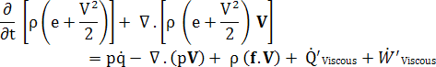

Where, ρ is the density, p is the pressure acting, v is the Velocity, e is the internal energy of the system, Q is the viscous heat source or sink, W is the viscous work done and F is the body force acting on the system.

The above equation is a partial differential equation which relates the flow field variables at a given point in space.

**RESULT AND DISCUSSION**

**Analysis of NACA 0012 Airfoil**

This analysis is performed on NACA-0012 airfoil. This is a four-digit airfoil which is most commonly used in solving problems in wind-tunnel.

**Problem Specification**

Various shapes of domains are used to compute the results and eventually, the domain shown in Fig.5, gave pretty good results.

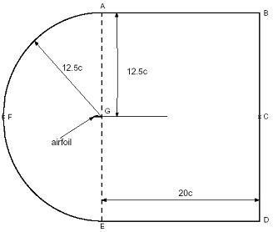

Fig.1 Domain Chosen for Analysis

For applying a pressure Far- field boundary condition, a closed and large domain is required compared to the airfoil. Thus, the length of the domain is chosen as 32.5c and width as 25c. Quad-type meshing element is preferred over the tri- type because it was proven that it can capture both the boundary layer and shock waves near the surface of the airfoil clearly when compared with other element types.

**Physical Properties**

The working fluid is considered to be air and the physical properties of air are tabulated as below in table:

|  |  |
| --- | --- |
| **Property** | **Values** |
| Material | Air |
| Flow model | Steady viscous flow |
| Mach number | 0.15 |
| Viscosity | 1.7894 e-05kg/m |
| Reference pressure | 0 |
| Density | 1.225kg/m^3 |
| Operating pressure | 101325 pa |

Table.1 Physical Properties

**BOUNDARY CONDITIONS**

The following boundary conditions were applied for the airfoil is shown in table.2

|  |  |
| --- | --- |
| Group Name | Type |
| Fairfield 1 | Velocity inlet |
| Fairfield 2 | Velocity inlet |
| Fairfield 3 | Pressure outlet |
| Airfoil | Wall |

Table.2 Boundary Types

*Inlet; the inlet is considered as a velocity inlet.

*Outlet; the outlet is considered as a special outlet.

*Wall; the airfoil is considered as a wall type boundary.

**ANALYSIS OF COLD JET**

CASE 1: in this analysis the jet velocity is applied as zero, with this the velocity magnitude, Vorticity magnitude and modified viscosity turbulence is show in below.

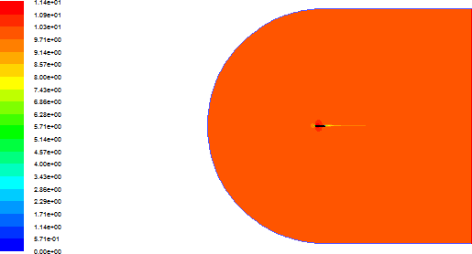

Fig1: Velocity Magnitude for Zero Jet Velocity.

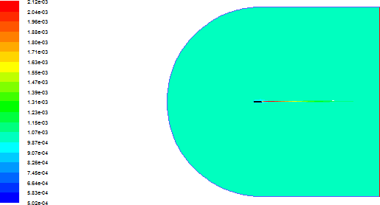

Fig2: Modified Turbulent Viscosity for Zero Jet Velocity.

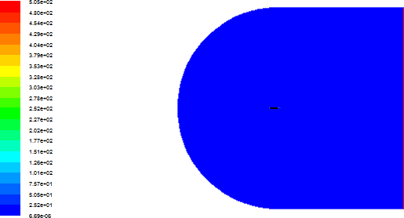

Fig3: Vorticity Magnitude for Zero Jet Velocity.

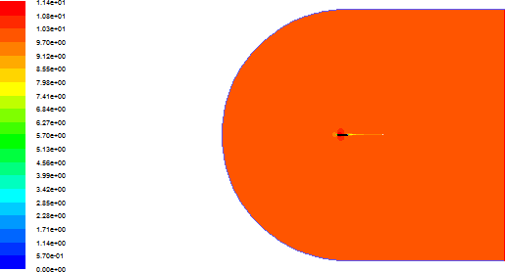

Fig4: Velocity Magnitude for Jet Velocity v = 5m/s

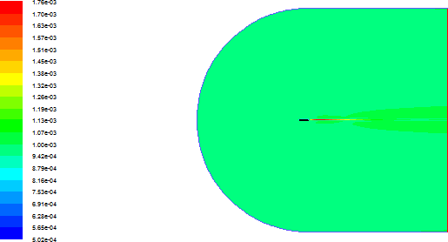

Fig5: Modified Turbulent Viscosity for Jet Velocity v =5 m/s

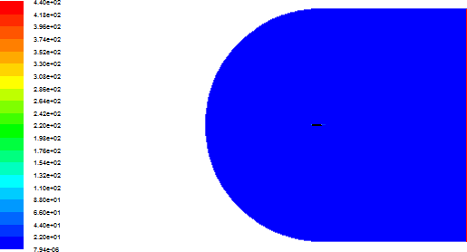

Fig6: Vorticity Magnitude for Jet Velocity v=5m/s.

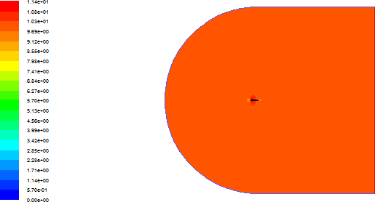

Fig7:Velocity Magnitude for Jet Velocity v = 10 m/s

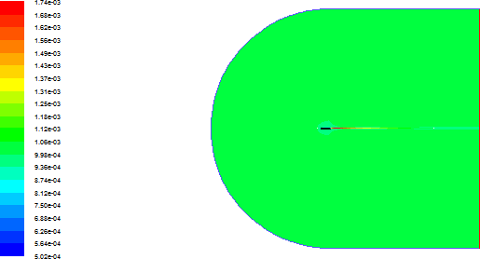

Fig8: Modified Turbulent Viscosity for Jet Velocity v =10 m/s

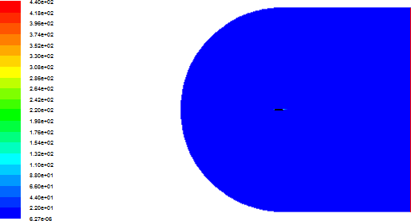

Fig9: Vorticity Magnitude for Jet Velocity v=10m/s.

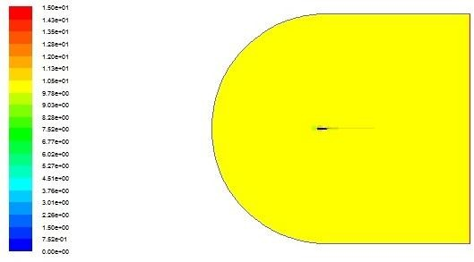

Fig10: Velocity Magnitude for Jet Velocity v = 15 m/s.

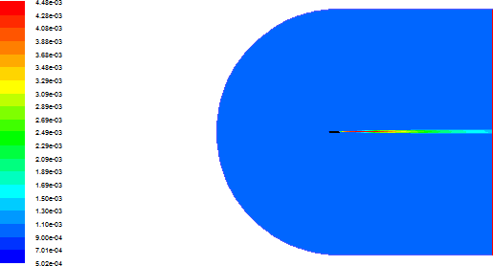

Fig11: Modified Turbulent Viscosity for Jet Velocity v =15 m/s

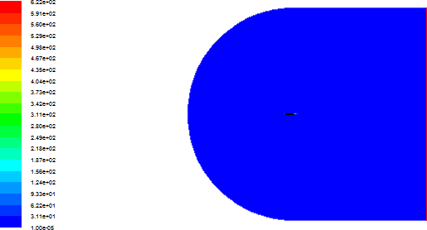

Fig12: Vorticity Magnitude for Jet Velocity v=15m/s.

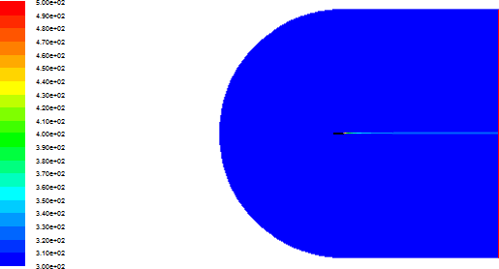

Fig13: Temperature for Jet T =500K.

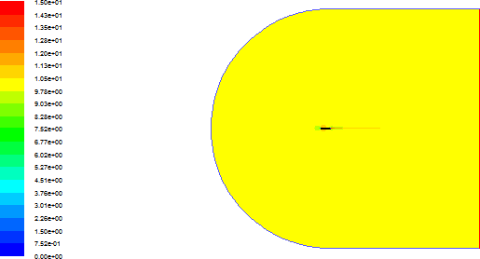

Fig14: Velocity Magnitude for Jet Temperature T=500 K.

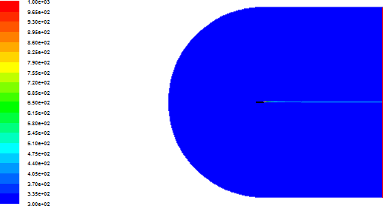

Fig15: Temperature for Jet Temperature T=1000K

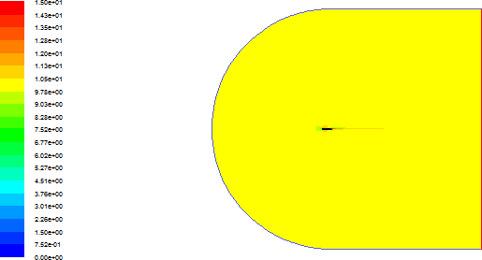

Fig16: Velocity Magnitude for Jet Temperature T=1000K.

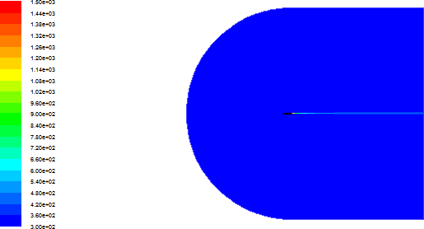

Fig17: Temperature for Jet Temperature T=1500 K.



Fig18: Velocity Magnitude for Jet Temperature T=1500 K.

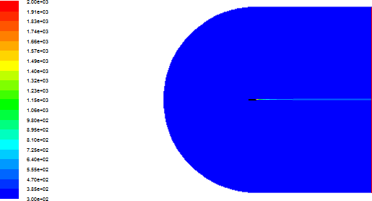

Fig19: Temperature for Jet Temperature T=2000K



Fig20: Velocity Magnitude for Jet Temperature T=2000 K.

Grid independence study shows the good results with experimental data.

First length variation gives fine mesh near the airfoil section. So the computational value satisfies the experimental value.

The assessment of turbulence models shows the comparison of various turbulence models for flow over an airfoil. The k-e models shows good performance to simulate the separated flow around aerofoil. The RNG k-e turbulence model performs better than standard k-e turbulence model. For further analysis are done by using RNG k-e turbulence model.

Validation of solver gives the good computational results. So the NACA-0012 airfoil is using for further flow analysis.

**CONCLUSION;**

In this project we analyzed the flow field of wing in which the engine of aircraft is embedded. Initially NACA 0012 is validated in FLUENT for various angle of attack. A graph is drawn between C1 VS e, using the result, in comparison with experimental data. NACA 0012 airfoil is cut at the trailing edge as cosine spacing. For cutted airfoil coefficient of lift is determined and a graph is drawn with angle of attack. A jet is fixed in the trailing edge in GAMBIT, and it is imported to FLUENT and analyzed for various jet velocities in cold jet. In this analysis velocity magnitude, modified turbulent viscosity, and Vorticity magnitude. In hot jet analysis, various jet temperature is applied, and velocity magnitude, temperature flow is determined as it has no effect on the flow.