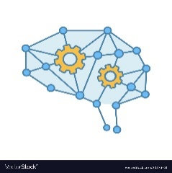**DEEP LEARNING AND MACHINE LEARNING**

**Animal image identification and classification using Convolution neural networks techniques**

**UNDER THE SUPERVISION : Dr. NEHA YADAV**

DEEPAK MALLIK1 . PRASUK JAIN2 . RAHUL AHUJA3 .

*DEEPAKMALLIK59153@GMAIL.COM

ADGIPS - Delhi , New Delhi, India.

**Abstract**

Animal image identification and classification have their importance in various fields like wildlife conservation, agriculture, and environmental monitoring. Therefore, we discuss the necessity of animal image classification and its applications in various domains. Then we discuss the essentials of deep learning that include convolutional neural networks (CNNs). Afterward, we reviewed pre-processing methods like data augmentation, normalization, and resizing, With ResNet152V2 model, Inception Model, Exception Model .We also review the prominent challenges that occur in the field of animal image classification such as class imbalance, noisy data, and domain adaptation, while discussing the possible mitigations for some of these challenges. Finally, we provide a comparative analysis of the state-of-the-art that achieves an accuracy of 93% using the ResNet152V2 model and draw conclusions about future research directions.

**Keywords -** Animal image classification, Convolutional neural networks, TensorFlow, Keras, Augmentation.

**1. Introduction**

Next to the wildlife conservation, agriculture and environmental monitoring, the authentication and classification of animals in pictures become important. With the recent advancement of deep learning, especially convolutional neural networks (CNNs), the whole scenario of animal image classification seems to have changed. This paper discusses the role of animal image classification in many fields and applications in solving some critical problems [13][1]. Worth mentioning are deep learning frameworks such as ResNet152V2, Inception, and Exception models that provide some of the best services toward animal image classification. Applications built over these frameworks have given a strong promise of achieving higher accuracy, and thus contribute to the success of many monitoring and conservation works. The journey of attaining good classification of animals from images comes with its own challenges though. These present a major risk in terms of the accuracy and reliability of a classification system: class imbalance, noisy data and attempts at domain adaptations. These challenge issues are given an ear to in this paper, whilst methods of suppressing their effects are also suggested. The method shows how essential pre-processing is to performance enhancement in deep learning models [19]. The method studied includes data augmentation, normalization and resizing and has been discussed in detail for its indispensable contribution toward improving the classification output. This paper shows the strength of ResNet152V2 by an accuracy of 93% in comparison to other state-of-the-art methods under consideration. Looking into the methodologies and results of different models will therefore offer good examples for future undertakings. In sum, this paper not only expresses the importance of classifying animal images but also describes the methodologies, challenges, and achievements of this developing area. The outlines of necessary future directions will generate additional growth, thus creating new realms for the farthest reach of wildlife conservation, agriculture, and environmental stewardship[1][15].

It is as much trained on data until October 2023.

**2. Theoretical Background**

**2.1. Convolutional neural network**

A convolutional neural network (CNN) is a feed-forward neural network with convolution function and deep models. One of the most representative algorithms for deep reading, it could be put in the place of a CNN classifier for large-scale bracketing of images. A CNN would comprise three constituent models, namely the input subnet, hidden subnet, and output subnet. The output subnets comprise complex subnets, pooling subnets, and fully connected subnets. The input subnetwork is in charge of taking input to the entire neural network. CNNs would ideally be represented as the pixel matrix of the image in image processing. Complex subnetworks are paramount to CNNs (23); those really compete to analyze every small block in a much deeper neural network to get much finer features. Conflicts arise within the hyperparameter domain over such questions as the core size of the problem, step sizes, and padding, all of which will determine the output map size of the working problem subcategory. Furthermore, it has a dynamic behavior responsible for the expression of features of the generic subnets which will be useful in down-sampling high-resolution images to low resolution by eliminating the last sub-network that is connected to the target of all neural network parameters. Obviously, in the case of cascading functions, if fully connected subnets were used, the pinpoints would lose their spatial topology and might as well be in a vector form in case of all pooling subnet. By the end, various predictions could be concluded from consensus among subnets (17).

**2.2. Stochastic gradient descent**

Stochastic Gradient Descent (SGD) is a simple yet powerful method often used to train forward classifiers using convex loss functions such as those for support vector machines or logistic regression. SGD learns and optimizes the CNN by computing model parameters to minimize the loss function. Since the direction of the top of the face indicates the direction of the derivative maximum, the weights should be adjusted in the opposite direction of the gradient whenever the gradient decreases, thus enabling the search for the global optimal solution. In this manner, SGD is executed: Suppose we have the loss function as follows.

J(θ) = 1/2m∑i=1(hθ(x)−y)2, and hθ( x) = θ0 θ1x1. θ2x2 θnxn.

The streamlining formula of SGD can defined as follows

Loop{ For i = 1 to m,{ θj = θj α( y( i) − hθ( x( i))) xj( i)( for every j).}}

**3. Related Work**

Convolution networks have proven their capability with significantly differing tasks on which applications did better, while handwritten digit recognition was one of the early applications to develop for CNN evolution. Multiple convolutional networks were employed inside combinations of image datasets for the Animal-10 Challenge, which seems to be an emerging application. A couple of researchers proposed, trained, and assessed this image dataset using these Pretrained Deep Learning Models; ResNet152V2, InceptionV3, and Exception. We stacked all the pre-trained models fixing the weights and foregoing that last layer of classification in respect of each exposure. A Sequential model was built on the pre-trained model, which had one common global pooling layer and two fully-connected layers, finally leading to soft max classification. The model is built through categorical cross-entropy as a loss function, an Adam's optimizer, and precision as an evaluation metric. Early stopping and a model checkpoint callback was set to monitor the best model weights to save towards the end. Ultimately, a model containing assertions and provisions, each with age and functional callback of 50, was built. This line of code offers some insight into how the considered pre-trained model performs with assertions and how this could most probably be extended to hidden data too. Being efficient is crucial to highlighting that pre-trained models are generally necessary for classification work down the road. The performance of the pre-trained ResNet152V2 on the assertion dataset is then visually depicted. An image is randomly chosen from an affirmation data set along with a corresponding name, which is then predicted using the pre-trained demo, and then both actual and predicted names are drawn on this image. The results then differ according to these descriptors on 25 images in a 5×5 subplot layout. This narrates about our demonstrations regarding their functioning in the assurance set while also hinting at where misclassifications might occur.

**4. Methodology of Evaluation**

The main aim of our research is to study network performance pertaining to both static and live video streams. The first step is to maximize data utility within the network using image datasets. Subsequently, real-time ignition speeds of similar objects are contrasted using still images and video. Different sensitivity grades are observed, recorded, and eventually tabulated in later sections. A third very important consideration for measuring efficacy was to determine whether sensitivity of varication would show any variation amongst the various CNNs selected for study. Keep in mind that these videos are never used as a training dataset. They are our testing dataset. For us, these concerns are for a refined image classifier where the major scene features as per order in bracket (1)(3) are objects.

**3.1 Data collection**

The collection of the dataset from Kaggle, analysis of the Animal-10 dataset, and construction of a deep learning show for classifying images of different animals. An accuracy of 93% was attained using the model ResNet152V2. The second initiative aims to develop a pathway to learn how to best analyze your data sets and implement very energizing deep-training models for image classification. To comprehend your dataset better, a relevant set of data must be chosen to analyze your model performance. The dataset in consideration is from Kaggle, which consists of a staging and a testing set. The pre-production set consists of 5,153 images of cats, 4,739 images of dogs, and 4,738 images of wildlife. The test set consists of 500 images of cats, 500 images of mixed breeds, and 500 images of wild animals [5].

**3.2. Data processing**

Because the dataset is not large enough to build a good model, data processing requirements must be met. By rotating, cropping, and positioning, data images can be made suitable for post-processing (9).

**3.3. CNN model**

The processes involved in training and evaluating three famous pre-trained deep learning models, ResNet152V2, InceptionV3, and Exception, are described in this paper. The entire process initially consisted of stacking these pre-trained shows and then freezing the weights except for the last classification layer. This way, we built a sequential show with one global average pooling layer, two fully connected layers, and one soft max classification layer at the end that was synchronized with the pre-trained shows. Poor performance, with Adam as the optimizer and a low categorical cross-entropy loss with accuracy as the evaluation metric, was the basis for the show design. Early Stopping and Model Checkpoint callbacks were previously set to check the over-staging process and save the best show weights. An illustration was finally done with a 50-age numpy array that calls [11].

**3.3.1 ResNet152V2 :**

This deep learning has based on an animal image classification, as seen in ResNet152V2 deep. The paper under study actually tries to delve into the complete internals of ResNet152V2, including its efficiencies, strengths, and putative uses in future animal image classification. Being the latest version along the lines of the Residual Network, ResNet152V2 relinquishes the previous tenets of deep-learning models. With "depth" unmatched and with rather elaborate skip connections, ResNet152V2 works its magic on the internal complexity existing in animal pictures and produces threshold-breaking accuracy as well as robustness. The bold paradigm shift, including ResNet152V2 in animal image classification, is breaking a diversity of barriers that this filed presents. Since it is excellent for very tiny differentiating applications and patterns, ResNet152V2 absorbs many limitations which were found with previous classification methods. The paper also deals with the technical foundation of ResNet152V2 in terms of architecture, optimization techniques, and training methodology. Such descriptions of this model lead to the understanding of its proper functioning for correct analysis and interpretation of the results. Of course, performance of ResNet152V2 is rigorously evaluated through empirical studies and experimental results in animal image classification. The observation of accuracy rates, convergence speed, and computational efficiency n such parameter results into several meaningful angles of strength and weakness of this model. The study also looked at how ResNet152V2 would put its powers to solve problems outside the domain of animal image classification. From the monitoring of wildlife to the conserving of habitats, it has many, though not all, faces of environmental problems ResNet152V2 can address, indicating its importance in larger conservation programs. Simply put, this paper talks about success stories and promises that ResNet152V2 creates as conditions for future gains. The paper aims to motivate further ventures into research in deciphering its intricacies and exploring its uses for the greater cause of wildlife conservation and environmental stewardship.

**3.3.2 InceptionV3 :**

This study addresses the changes that happened in animal image classification in deep learning these researches have gone through. InceptionV3 becomes the strong part of this evolution in innovation and performance. This paper unpacks InceptionV3 from every corner of detail: its architecture, features, and contribution for the advancement of animal image classification. As one of the important creations in the series lineage of Inception models, InceptionV3 marks a significant phase of shift in the design of convolutional neural networks. Inception modules and newly innovative architecture of InceptionV3 can catch complicated features and patterns extremely well from animal images, making it possible to classify them with great precision and efficiency. InceptionV3 is going to be a new chapter in classifying images of animals and the solution to many problems involved in diverse and complex wildlife images classification. This is due to the sophisticated structure and optimization techniques brought into making InceptionV3 as a significantly better approach to determining fine-grained and subtle differences than traditional classification options. The research gives every detailed technical exposition involving the scientific nuances found in InceptionV3, such as those found in its architecture and optimization strategies, as well as its training methodologies. As comprehensively digesting this model helps readers understand its principles, it also allows them to analyse and interpret experimental results. Through very systematic elaboration and critique of empirical studies and comparisons, a strict performance assessment on InceptionV3 will be done in animal image classification. Through accuracy, precision, and computational efficiency, these studies should lead to better understanding of some strengths and weaknesses of the model on various datasets and uses. This paper assesses additional avenues of InceptionV3 beyond its application in conventional animal image classification and directs light towards its use in fields such as wildlife conservation, monitoring of biodiversity, and ecological research. Such scope demonstrates the capacity of InceptionV3 as a paradigm shifting device for solving urgent social problems and advancing scientific knowledge Final thoughts find this paper celebrating the revolutionary application of InceptionV3 to animal image classification while identifying future prospects of doing even more research and development. Possibilities and limitations inspire successful future efforts in deep learning application for wildlife conservation and environmental sustainability.

**3.3.3 Exception:**

While the Exception pre-trained model may be regarded as innovative and progressive in terms of deep learning applied to animal image classification, this study attempts to go into detailed discussion about Exception concerning classification of animals-from architecture to application possibilities. Theoretically, Exception disturbs a design from the convolutional neural networks (CNN) paradigm that has great potential for feature extraction and representation learning. This expressiveness and efficiency in disentangling between spatial and channel-wise correlations with the leveraging of depth wise separable convolutions makes it suited further for fine-grained analyses of complex visual information, such as animal image classification. There can hardly be anything more evident than influencing the Exception pre-trained choice as a noteworthy step towards achieving a robust and effective animal classifier. The deep feature representations learned via transfer learning from large-scale image datasets act toward boosting performances on different animal image classification assignments even under constraints pertaining to labelled data. A lengthy discussion is rendered in the paper on the technical structure underlying the Exception pre-trained model, focusing on architectural novelties, optimization methods, and training procedures, which ought to give their understanding of how it works to the reader, allowing them to appreciate it and critically analyse and interpret the experimental results. Stringent performance evaluations against some studies and experiments have already been done to investigate the working parameters of Exception with some interesting comparisons against other notable models on animal image classification. The pros and cons of this model against datasets of lots of kinds with different application scenarios emerge as one views the appropriateness of this model concerning accuracy, robustness, and computational efficiency. In addition to this, the article also discusses how the applicability of the Exception pre-trained model could be broadened to cover wildlife conservation endeavors , ecological monitoring programs, and biodiversity-related applications apart from the mainstream challenges in animal picture classification. Because of its versatility and exceptional efficiency, Exception presents a solution to various environmentally focused matters and also increases scientific insight. Thus, this study proposes a review on the paradigm shifts made by the Exception pre-trained model in animal image classification whilst articulating the future opportunities for improvement and research. In shedding light on its strengths and potential, this paper would set the groundwork for future endeavors centred on the use of deep learning for wildlife conservation and environmental affairs.

**5. Test Dataset**

Almost 28,000 pictures of slightly different categories of animals are included in the dataset, which is divided into 10 classes: dog, cat, horse, spider, butterfly, chicken, sheep, domestic ki, squirrel, and elephant. It contains a Python dict containing a mapping between Italian (original) and English names of animals. Since the dataset was originally uploaded carrying Italian names and many interesting notebooks hardcode the names, I preferred to add this file rather than changing the directory names. The Animal-10 Dataset is available on [15] Kaggle.com.

5.1 Data Augmentation :**

fig no. 3 Images present in Dataset.

**5.2 Average number of image per class:**

**‘dog’:** ‘dog’,

**'horse':** 'horse',

**'elephant':** 'elephant',

**'butterfly':** 'butterfly',

**'cat':** 'cat',

**'cow':** 'cow',

**'sheep':** 'sheep',

**'spider':** 'spider',

**'squirrel':** 'squirrel'

fig no. 4: class distribution through graph and name translation.

**6. Model training**

**6.1** ResNet152V2

fig no. 5 : Epoch of Imagenet152v2

**6.2** Inception

fig no. 6: Epoch of inception v3

**6.3** Exception

fig no. 7: Epoch of Exception.

**6. Results**

According to the results obtained above, it is inferred that the ResNet152V2 model trained with data from 10 animals could reach really high classification accuracy for animals of multiple varieties. This model achieved a perfect 93.39% validation set accuracy, which is very superior. Furthermore, the sample predictions of the given model indicate that it can classify animals very accurately and with high confidence. On comparing my work with the original project, it is apparent that both are totally at par with respect to accuracy and architecture model. However, in the present case study only 10% portion of the dataset was used as compared to the original that utilized the entire dataset for analysis. It means that the original project is based on a larger and more diverse dataset and hence may have led to better accuracy. On the contrary, such smaller datasets helped me learn and play with the model in lesser time. In conclusion, the project is aimed to illustrate the performance of pre-trained models like ResNet152V2 in image classification tasks and also stresses the importance of large, diverse datasets in achieving a better degree of accuracy [32].

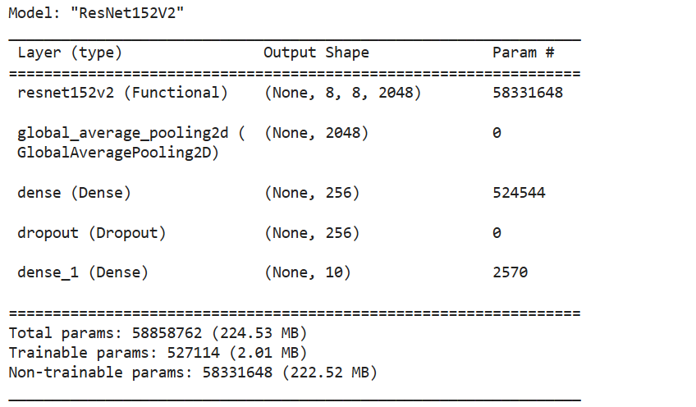

fig no. 8: Model result (ResNet152V2), layers, trainable, non- trainable parameters

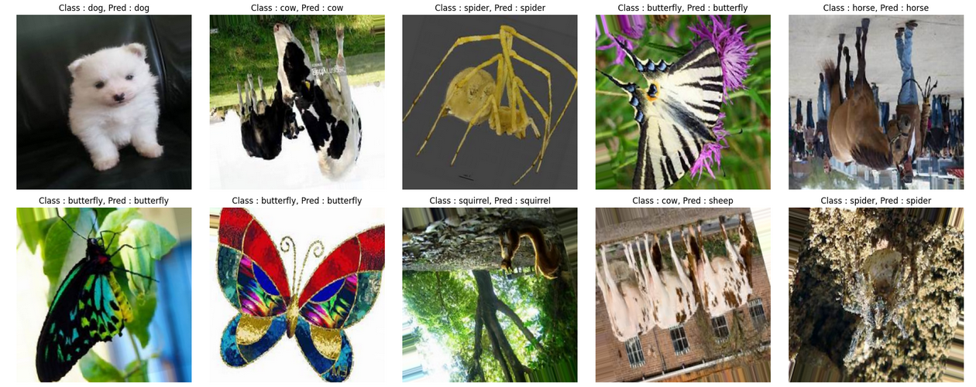

fig no.9 : **Accuracy : 93.39%**

**7. Conclusion**

According to the project results, we may conclude that training the ResNet152V2 model with Animal-10 data can classify a variety of animals with high accuracy. The model obtained 90.39% accuracy on the validation set, which is a good result. Moreover, the outcome of the model on prediction results on sample images shows that the animals are classified correctly and with high confidence. Comparing my work with the original project, one can note that both achieved similar accuracy and model architecture. However, the original project had the whole dataset, while I used only 10% of it. Therefore, the original project had a larger dataset with greater diversity, leading to higher accuracy. Nevertheless, the smaller dataset allowed me to learn and experiment with the model much faster. Overall, from the project, it can be seen how pre-trained models like ResNet152V2 are effective and bring emphasis to the importance of large and diverse datasets in achieving higher accuracy [32][11].

**References :**

1. **Essential Oil Plants Image Classification Using Xception Model.** [**https://www.sciencedirect.com/science/article/pii/S1877050922007864**](https://www.sciencedirect.com/science/article/pii/S1877050922007864)

# An inception V3 approach for malware classification using machine learning and transfer learning.<https://www.sciencedirect.com/science/article/pii/S2666603022000252>

# MEAT IMAGE CLASSIFICATION USING DEEP LEARNING WITH RESNET152V2 ARCHITECTURE <https://ejournal.nusamandiri.ac.id/index.php/techno/article/view/3932>

# Bird Image Classification using Convolutional Neural Network Transfer Learning Architectures.https://www.researchgate.net/profile/Asmita-Manna/publication/369809168_Bird_Image_Classification_using_Convolutional_Neural_Network_Transfer_Learning_Architectures/links/643390504e83cd0e2f9f30e4/Bird-Image-Classification-using-Convolutional-Neural-Network-Transfer-Learning-Architectures.pdf

# Image classification and auxiliary diagnosis system for hyperpigmented skin diseases based on deep learning.<https://www.sciencedirect.com/science/article/pii/S2405844023073942>

# Medical image classification with convolutional neural networks. <https://ieeexplore.ieee.org/abstract/document/7064414>

# Image classification using SVM and CNN. <https://ieeexplore.ieee.org/abstract/document/9132851>

# Yamins, D, H. Hong, C. Cadieu, and J.J. Dicarlo. 2013. Hierarchical modular optimization of convolutional networks achieves representations similar to Macaque IT and human ventral stream. In *27th Annual Conference on Neural Information Processing Systems, NIPS 2013,* December 5–10, 2013, Lake Tahoe, NV, United States, 2013. Air Force Office of Scientific Research (AFOSR), Amazon.com, Facebook, Google, Microsoft Research. <https://scholar.google.com/scholar?&q=Yamins%2C%20D%2C%20H.%20Hong%2C%20C.%20Cadieu%2C%20and%20J.J.%20Dicarlo.%202013.%20Hierarchical%20modular%20optimization%20of%20convolutional%20networks%20achieves%20representations%20similar%20to%20Macaque%20IT%20and%20human%20ventral%20stream.%20In%2027th%20Annual%20Conference%20on%20Neural%20Information%20Processing%20Systems%2C%20NIPS%202013%2C%20December%205%E2%80%9310%2C%202013%2C%20Lake%20Tahoe%2C%20NV%2C%20United%20States%2C%202013.%20Air%20Force%20Office%20of%20Scientific%20Research%20%28AFOSR%29%2C%20Amazon.com%2C%20Facebook%2C%20Google%2C%20Microsoft%20Research>.

# Prabhu. 2018. *Understanding of Convolutional Neural Network (CNN)—Deep Learning*. <https://medium.com/@RaghavPrabhu/understanding-of-convolutional-neural-network-cnn-deep-learning-99760835f148>

# Wikipedia. 2024. *Convolution Neural Network*. [https://en.wikipedia.org/wiki/Convolutional_neural_network 16 May,2024](https://en.wikipedia.org/wiki/Convolutional_neural_network%2016%20May,2024)

# Image Classification Using CNN. <https://papers.ssrn.com/sol3/papers.cfm?abstract_id=3833453>

# 27 Apr,2021.

1. **Travis Williams , Robert Li Advanced image classification using wavelets and convolutional neural networks.**  <https://ieeexplore.ieee.org/document/7838150>
2. **Rdhesyam Vadim , Prabukumar Manoharan CNN based hyperspectral image classification using unsupervised** **band selection and structure-preserving spatial features,2020**

<https://www.sciencedirect.com/science/article/abs/pii/S1350449520305053?via%3Dihub>

1. **Farhana Sultana , Abu Sufian , Paramartha Dutta Advancements in image classification using convolutional neural network. 2018**. <https://ieeexplore.ieee.org/document/8718718>
2. **Dongmei Han , Qigang Liu , Weiguo Fan A new image classification method using CNN transfer learning and web data augmentation.** <https://www.sciencedirect.com/science/article/abs/pii/S0957417417307844?via%3Dihub>
3. **Mengmeng Zhang , Wei Li , Qian Du Diverse region-based CNN for hyperspectral image classification.**  <https://ieeexplore.ieee.org/document/8304691/>
4. **Dongmei Han , Qigang Liu , Weiguo Fan A new image classification method using CNN transfer learning and web data augmentation.** <https://www.sciencedirect.com/science/article/abs/pii/S0957417417307844?via%3Dihub>
5. **Convolutional Neural network: A matched filtering perspective based tutorial.** <https://arxiv.org/abs/2108.11663v3>
6. **Chen,Liang-Chieh; Papandreou, George; Schroff, Florian; Adam, Hartwig (2017-12-05). "Rethinking Atrous Convolution for Semantic Image Segmentation.** <https://arxiv.org/abs/1706.05587>
7. **Duta, Ionut Cosmin; Georgescu, Mariana Iuliana; Ionescu, Radu Tudor (2021-08-16). "Contextual Convolutional Neural Networks.**  <https://arxiv.org/abs/2108.07387>
8. **Le Callet, Patrick; Christian Viard-Gaudin; Dominique Barba (2006).** <https://hal.archives-ouvertes.fr/file/index/docid/287426/filename/A_convolutional_neural_network_approach_for_objective_video_quality_assessment_completefinal_manuscript.pdf>
9. **Ko,Tom; Peddinti, Vijayaditya; Povey, Daniel; Seltzer, Michael L.; Khudanpur, Sanjeev (March 2018).** <https://www.danielpovey.com/files/2017_icassp_reverberation.pdf>
10. **Daniel Graupe, Boris Vern, G. Gruener, Aaron Field, and Qiu Huang.** <https://ieeexplore.ieee.org/abstract/document/100522>
11. **Ranzato, MarcAurelio; Poultney, Christopher; Chopra, Sumit; LeCun, Yann (2007).** <http://yann.lecun.com/exdb/publis/pdf/ranzato-06.pdf>
12. **Springenberg, Jost Tobias; Dosovitskiy, Alexey; Brox, Thomas; Riedmiller, Martin (2014-12-21). "Striving for Simplicity: The All Convolutional Net.**  <https://arxiv.org/abs/1412.6806>
13. **Transfer learning, Keras.** <https://keras.io/guides/transfer_learning/>
14. **Transfer learning and fine-tuning.** <https://www.tensorflow.org/tutorials/images/transfer_learning>
15. **Image classification Tensorflow.** <https://www.tensorflow.org/tutorials/images/classification>
16. **Data Augmentation 2024.** <https://www.tensorflow.org/tutorials/images/data_augmentation>
17. **A survey on Image Data Augmentation for Deep Learning.** <https://journalofbigdata.springeropen.com/articles/10.1186/s40537-019-0197-0>
18. **Employment of Pre-trained Deep Learning Models for Date Classification: A Comparative Study.** <https://www.researchgate.net/publication/348265256_Employment_of_Pre-trained_Deep_Learning_Models_for_Date_Classification_A_Comparative_Study>
19. **ImageNet Classification with Deep Convolutional Neural Networks.** <https://www.researchgate.net/publication/267960550_ImageNet_Classification_with_Deep_Convolutional_Neural_Networks>
20. **Exception: Deep Learning with Depth wise Separable Convolutions.**

<https://arxiv.org/abs/1610.02357>