Hand Gesture Controlled Industrial Robotic Vehicle

Sakshi Sonkusare[2]

Department of Electronics and Communication Engineering,

PCE , Nagpur

sakshisonkusare29@gmail.com

Rohit Meshram[3]

Department of Electronics and Communication Engineering,

PCE , Nagpur

meshramrohit736@gmail.com

Shital Gulhane[1]

Department of Electronics and Communication Engineering,

PCE , Nagpur

shitalgulhane35@gmail.com

# 

# Abstract:

Yash Meshram[4]

Department of Electronics and Communication Engineering,

PCE , Nagpur

yashmeshram22032004@gmail.com

Prof. S. I. Parihar[5]

Department of Electronics and Communication Engineering,

PCE , Nagpur

sunitaparihar1824@gmail.com

RF transmitter and an MPU6050 accelerometer-Gyroscope Sensor. It sends commands to the backward, left, and righ

The growing demand for automation and remote operation in industrial environments has accelerated the need for intuitive and reliable control systems for robotic vehicles. Conventional wired or manually operated control mechanisms often limit flexibility, efficiency, and operator safety, especially in hazardous or restricted areas. To address these limitations, this research proposes a Gesture-Controlled Industrial Robotic Vehicle that utilizes hand gesture recognition for seamless and contactless operation. The system is powered by an Arduino Nano microcontroller, integrated with an MPU6050 accelerometer-gyroscope sensor for real-time gesture detection, and an RF communication module for wireless command transmission. The robotic vehicle platform features DC motors controlled via an L298N motor driver, enabling forward, backward, left, and right motion based on predefined hand gestures. The paper details the system’s design, implementation, and operational testing, demonstrating its capability to enhance productivity and safety in industrial applications through an intuitive, gesture-based control interface.

*Key components of the system include L298N Motor Driver IC , MPU6050 Accelerometer & Gyroscope Sensor , H12 Encoder & Decoder IC .*

# Introduction

In today’s world, the robotics industry is experiencing the emergence of various trends aimed at enhancing the efficiency, accessibility, and accuracy of its systems. Technology has the potential to significantly simplify our lives, particularly when it allows for hands-free operation. In this context, we have developed a wireless, hand gesture-controlled robotic vehicle that operates based on hand movements. This project relies on wireless communication and utilizes an Arduino microcontroller. The software for the project was written using an integrated development environment (IDE). The system is Divided into two main sides : a transmitter and a receiver. The transmitter, mounted on a user’s glove, includes an

# Related Work

Several studies have contributed to the development of hand gesture-controlled industrial robotics, providing a solid foundation for the present work. The development of hand gesture-controlled robotics has seen significant advancements, as evidenced by various studies. Coronado et al. (2017) demonstrated wireless gesture control using analog accelerometers, while Vashisth and Sharma (2017) improved gesture detection with an ADXL335 accelerometer, albeit with limitations in scalability and range. Lavanya et al. (2017) Expand to image processing for enhanced precision, though this increased system complexity. Lodh et al. (2018) introduced a multifunctional Robocar that combined gesture, voice, and autonomous driving, but faced challenges in cost- effective replication. More recently, Pathan et al. (2022) integrated accelerometer-based input with image processing to enhance recognition accuracy. Collectively, these studies highlight the necessity for systems that balance accuracy, power efficiency, and simplicity, which the current research addresses by utilizing a lightweight architecture with Arduino Nano and RF modules, ensuring real-time responsiveness and reliability for applications in industrial automation and assistive technologies.

# Methodology

## Hardware Components

The Hand Gesture Control Industrial Vehicle is built around the following key hardware components:

**Arduino Nano**: The Arduino Nano is the microcontroller that serves as the brain of the hand gesture-controlled robotic vehicle.

**L298N Motor Driver IC** : The L298N Motor Driver IC is a dual H-Bridge motor driver used to control the speed and direction of DC motors. In the hand gesture-controlled robotic vehicle.

**MPU6050 Accelerometer-Gyroscope** : The MPU6050 is a 6- axis motion tracking device that combines a 3-axis accelerometer and a 3-axis gyroscope in a single chip. The accelerometer measures acceleration along the X, Y, and Z axes, allowing it to detect tilt, motion, and vibration caused by gravity or external forces. The

gyroscope measures angular velocity, which helps in tracking the rotation or orientation of the device.

**433 MHz Tx Module** : 433 MHz Transmitter Module Sends data wirelessly from the gesture controller glove & Convert digital signals gesture inputs into radio frequency signals. It Operates at 433 MHz, offering long-range and low-power transmission.

**433 MHz Rx Module** : Receives RF signals sent by the transmitter & Decodes the received signals and sends them to the Arduino Nano for processing. Also Ensures real-time control of the robotic vehicle based on hand gestures.

**H12E Encoder IC** : It is a 12 Bit encoder IC Convert Parallel data into serial data. The HT12E takes 4-bit parallel input data like gesture commands and encodes it into a serial format. This is necessary to transmit data efficiently via the RF transmitter.

**H12D Decoder IC** : HT12D is a 12-bit decoder IC that converts the serial data back into 4-bit parallel data. It is used in the receiver section of wireless systems. The IC receives the encoded serial data from the RF receiver module .

**Wheels** : It Provides Movement & Stability

**Power Supply**: Ensures reliable operation of all components.

* 1. **Circuit Operation:**

## Gesture Detection:

The MPU6050 accelerometer-gyroscope sensor captures real-time hand motion and tilt data along the X, Y, and Z axes, transmitting it to the Arduino Nano via the I2C protocol.

## Gesture Interpretation:

The Arduino Nano processes the sensor data and interprets specific gestures forward, backward, left, right, stop based on predefined threshold values.

## Signal Encoding:

The interpreted 4-bit command is passed to the HT12E Encoder IC, which converts it into a serial data stream for wireless transmission.

## Wireless Transmission:

The 433 MHz RF Transmitter wirelessly sends the encoded gesture data to the robotic vehicle’s receiver unit.

## Signal Decoding:

On the receiver side, the 433 MHz RF Receiver receives the data and passes it to the HT12D Decoder

IC, which recovers the original 4-bit gesture command.

### Motion Execution:

The receiving Arduino Nano interprets the decoded signal and controls the L298N Motor Driver IC, which drives the four BO DC motors to move the robot accordingly.

### Status Indication:

An LED indicator is included in the system to ensure proper functioning. It lights up when the system is powered on and actively receiving valid gesture commands, providing visual feedback of system activity.

## Circuit Diagram

The complete circuit diagram of the Hand Gesture Controlled Industrial Robotic Vehicle is illustrated in below diagram. The diagram shows the interconnection of all components with the, Arduino Nano ensuring synchronized operation for secure vehicle ignition and functionality.

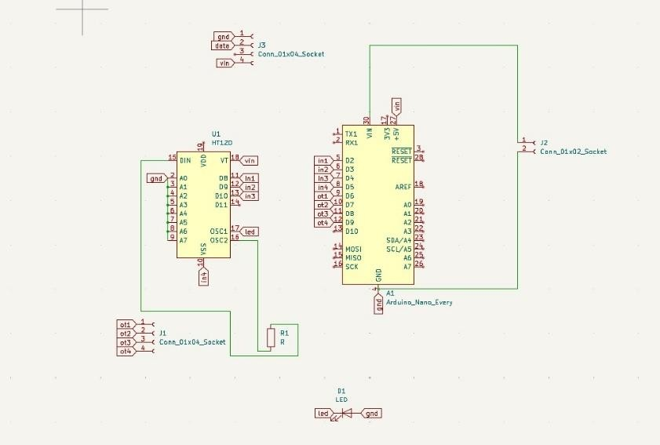

Fig a. Receiver Section

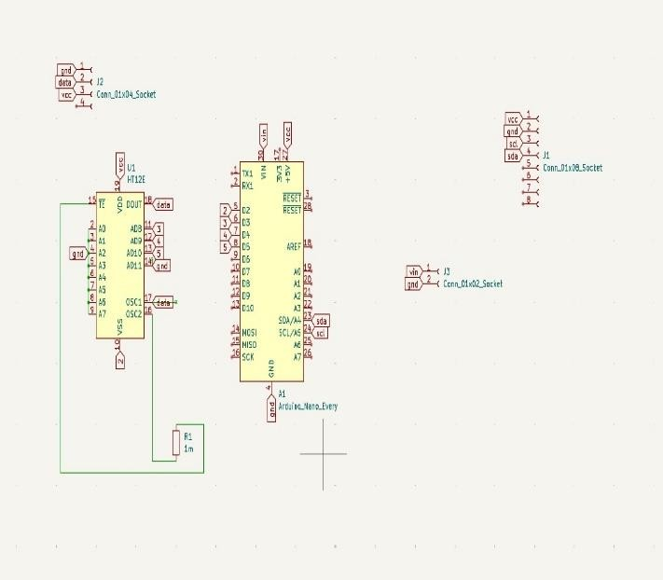

Fig b. Transmission Section

# System Workflow

The Hand Gesture Controlled Industrial Robotic Vehicle System follows a structured workflow to ensure secure and efficient operation:

## System Initialization

powering the system, both the transmitter and receiver Arduinos initialize the components .The MPU6050 accelerometer-gyroscope, HT12E encoder, IC RF modules, and L298N motor driver are activated. During startup, the MPU6050 undergoes baseline calibration to define a reference "neutral" hand position based on orientation and motion data.

## Gesture Input and Signal Conditioning

The user wears a transmitter module where the MPU6050 sensor captures real-time hand movement by detecting changes in acceleration and angular velocity across X, Y, and Z axes. The raw sensor data is filtered and processed to remove noise and ensure stable input signals to the Arduino Nano.

## Gesture Processing and Data Encoding

The Arduino Nano interprets the filtered sensor data and maps them to specific directional gestures for- rward, backward, left, right. These gesture commands are encoded into 4-bit digital data using the HT12E encoder IC, which prepares the data for RF transmission.

## Wireless Transmission :

The encoded signals are transmitted wirelessly via a 433 MHz RF transmitter module. The system suppo -

-rts a communication range of up to 50 meters in open in open environments, providing the user with flexible and untethered control over the robotic vehicle.

### Data Reception and Validation :

On the robotic vehicle side, the 433 MHz RF receiver receives the transmitted signals. The HT12D decoder IC decodes the 4-bit command and sends it to the receiver Arduino Nano. The microcontroller validates the data to ensure it matches predefined gesture commands and is free from transmission errors.

1. **Motor Control and Vehicle Movement** : Based on the interpreted gesture command, the

Arduino sends control signals to the L298N motor driver IC, which drives the BO motors accordingly.

The robot performs movements as follows:

Tilt forward → Move forward Tilt backward → Move backward Tilt left → Turn left

Tilt right → Turn right

### Failsafe Operation

If no data is received or an invalid gesture is detected,

the receiver triggers a stop command, ensuring the vehicle halts immediately for safety.



Start

Initialize MPU6050 and Arduino

Read Accelerometer & Gyroscope Data

Determine Gesture Forward

,Backward, Left ,Right

Encode Command using H12E

Transmit Signal Via RF Transmitter

Decode Command using H12D

Arduino Controls L298N Motor

Stop

# Results and Discussion

This section of Project summarizes the key findings from the implementation and testing of the Hand Gesture Controlled Industrial Robotic Vehicle .The performance testing of gesture recognition showed an average accuracy of over 90%, indicating that the system reliably interprets hand movements. In terms of operational efficiency, the robotic vehicle improved task execution speed and reduced physical strain. Notably, navigating an obstacle course took approximately 30% less time with gesture control compared to traditional methods. User feedback emphasized the intuitive nature of the control system, with participants finding it engaging and conducive to multitasking, thereby enhancing productivity. However, some limitations and challenges were identified, including sensitivity to environmental factors and variability in user control precision Future enhancements could focus on improving sensor calibration and incorporating adaptive algorithms .This

technology opens up several potential applications, such as remote control of robotic arms, automation in warehouses, and increased safety in hazardous environments.

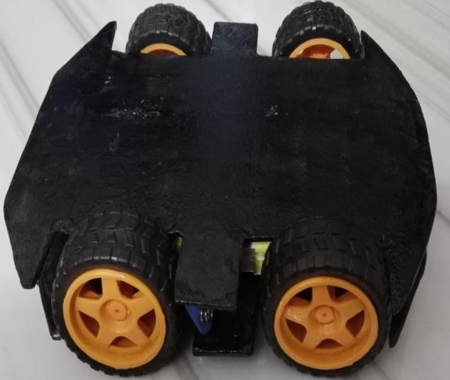

**Fig.1 Receiver Section of Hand Gesture Controlled Industrial Robotic Vehicle**

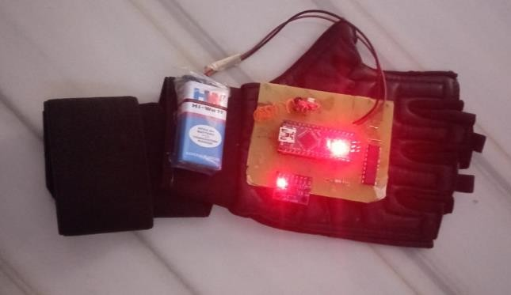

**Fig 2. Transmitter Section**

# Conclusion

The Hand Gesture-Controlled Robotic Vehicle demonstrates a significant advancement in intuitive human-machine interaction. By replacing traditional remote or joystick-based controls with gesture recognition using an accelerometer, the system offers a more natural and contactless method of operation. This approach enhances user experience and is particularly useful in scenarios where hands-free or remote operation is essential. With real-time responsiveness and reliable wireless communication, the system offers a practical and efficient solution for modern robotic applications, educational projects, and assistive technologies.

# References

1. D. Coronado, C. Lara, L. E. Mendoza, and M. R. Ronquillo, "Design and Implementation of a Robotic Vehicle Controlled by Hand Gestures for Surveillance

Applications," *Proc. IEEE Int. Conf. Ind. Technol.*, pp. 1565–1570, 2017.

1. V. Lavanya and A. R. Kumar, "Gesture Controlled Robot Using Accelerometer Sensor," *Int. J. Electron. Commun Computer Eng.*, vol. 8, no. 2017.

[3]A. Vashisth, R. Kumar, A. Kushwaha, and V. Tomar "Gesture Controlled Robot using Arduino and Accelerometer, Sensor," *Int.*

*J. Sci. Eng. Res.*, vol. 8, no. 4, pp. 1405–1409, Apr. 2017.

1. S. Kumar, R. Pandey, and A. Shukla, "Development Of Gesture Controlled Robot Using 3-Axis Accelerometer," *J. Control Instrum.*, vol. 8, no. 2, pp. 42–47, 2017.
2. P. L. Rani, A. Vamsi, and A. P. R. Kumar, "Hand Gesture Controlled Robot using Accelerometer Sensor for Industrial and Surveillance Applications," *Preprints*, 2019.
3. A. Lodh, D. Ghosh, and D. Ghosh, "Accelerometer and Arduino Based Gesture Controlled Robocar," *Int. J. Innov. Res. Sci. Eng. Technol.*, vol. 7, no. 8, pp. 9056–9062, Aug. 2018.
4. R. Prasanna, M. M. Ashwini, P. Sangeetha, and S. M. Fathima, "Wireless Gesture Controlled Robot for Military Application," Int.

J. Sci. Res. Eng. Trends, vol. 10, no. 1, pp. 10–15, 2024

1. S. Shruti, S. K. Verma, S. Singh, and T. Gupta, "Arduino Based Hand Gesture Controlled Robot," *Int. Res. J. Eng. Technol. (IRJET)*, vol. 9, no. 5, pp. 826–827, May 2022.
2. Wadaye , D., Nayak, Y., Yadav, V., Shelar, M., & Kulkarni, S. (2023b). Gesture-Controlled Surveillance Car. *International Journal for Research in Applied Science and Engi Tech*, *11*(4),1547- 1554. https://doi.org/10.22214/ijraset.2023.50402.