**TITLE :** IoT-Enabled Smart E-Healthcare System with Predictive Prescription Algorithm for Automatic Patient Monitoring and Treatment.

**AUTHORS DETAILS :**

**UNDER THE GUIDANCE OF:**

**B.Venkatesu, M.Tech**

[**venkatesu.b@sseptp.org**](mailto:venkatesu.b@sseptp.org)

Sanskrithi School of Engineering, Puttaparthi

**TEAM MEMBERS :**

J. Aravind Kumar 7386370248 – [sairamlights1256@gmail.com](mailto:sairamlights1256@gmail.com)

Sanskrithi School of Engineering Puttaparthi

D.Venugopal 6366152012 - [dharmavarapuvenugopal@gmail.com](mailto:dharmavarapuvenugopal@gmail.com)

Sanskrithi School of Engineering Puttaparthi

KVV. Sandeep Kumar 9505955366 – [21kf1a0428@sseptp.org](mailto:21kf1a0428@sseptp.org)

Sanskrithi School of Engineering Puttaparthi

G. Sai Kiran 6303692334 - [saikiranece66@gmail.com](mailto:saikiranece66@gmail.com)

Sanskrithi School of Engineering Puttaparthi

**ABSTRACT :**

This project presents an IoT-enabled Smart E- Healthcare System designed for continuous patient monitoring and predictive treatment using a combination of embedded system s and machine learning. The system utilizes an Arduino UNO integrated with a heartbeat sensor, respiratory sensor, pulse oximeter, and DS18B20 temperature sensor to collect real-time health data An LCD displays the readings locally, while data is processed using a Python-based predictive prescription algorithm that analyzes abnormal ties and suggests preliminary treatments or alerts caregivers. Powered by 5V and 12V adapters, the system ensures reliable operation and supports cloud integration for remote access. Th e collected data can also be stored for medical history analysis, enabling doctors to track patient progress over time. This intelligent system reduces the burden on medical staff, enhances diagnostic accuracy, and ensures timely medical interventions, especially in emergency scenarios. With scalability, portability, and real-time responsiveness, the proposed solution is ideal for smart hospitals, homecare, rural health centers and telemedicine applications, offering a step toward accessible and personalized healthcare.

**INTRODUCTION :**

The evolution of modern healthcare is increasingly being driven by the integration of smart technologies, especially the Internet of Things (IoT) and embedded system s. Traditional patient monitoring methods often rely heavily on manual observation and periodic checkups, which can result in delayed diagnosis and treatment, particularly in critical or remote scenarios. To overcome these limitations, this project proposes an IoT-enabled Smart E Health care System that provides continuous, real-time monitoring of vital health parameters and offers predictive prescription capabilities. The system incorporates multiple biomedical sensors, including a heartbeat sensor, respiratory sensor, pulse oximeter, and DS18B20 digital temperature sensor, all interfaced with an Arduino UNO microcontroller. These sensors collect accurate physiological data, which is then displayed on an LCD and transmitted for further ana lysis. A Python-based predictive algorithm processes this data to detect anomalies and provide preliminary treatment suggestions or emergency alerts. The system is powered using a regulated 5V power supply and 12V adapters, ensuring stable operation in diverse environments. Designed for both home and clinical use, this solution enhances healthcare delivery by supporting early diagnosis, reducing hospital visits, and enabling remote medical assistance making it highly effective for smart hospitals, rural health centers and telemedicine applications.

**PROPOSED SYSTEM :**

The proposed system is an IoT-enabled Smart E-Healthcare solution that integrates multiple biomedical sensors with an Arduino UNO to continuously monitor vital health parameters such as heart rate, respiratory rate, blood oxygen level (SpO2), and body temperature. The collected data is displayed in real time on an LCD and transmitted for processing using a Python-based predictive prescription algorithm, which intelligently analyzes the data to detect abnormalities and suggest preliminary treatments or alert caregivers. Unlike traditional systems, this solution goes beyond basic threshold-based alerts by incorporating intelligent decision-making for early diagnosis and proactive care. The system is powered by reliable 5V and 12V adapters, ensuring stable operation, and can be further integrated with cloud platforms for remote monitoring and data logging. Designed for scalability and ease of use, this smart healthcare system enhances patient care, reduces the need for frequent hospital visits, and provides timely interventions, making it ideal for use in homes, rural health centers, and smart hospitals

**BLOCK DIAGRAM:**

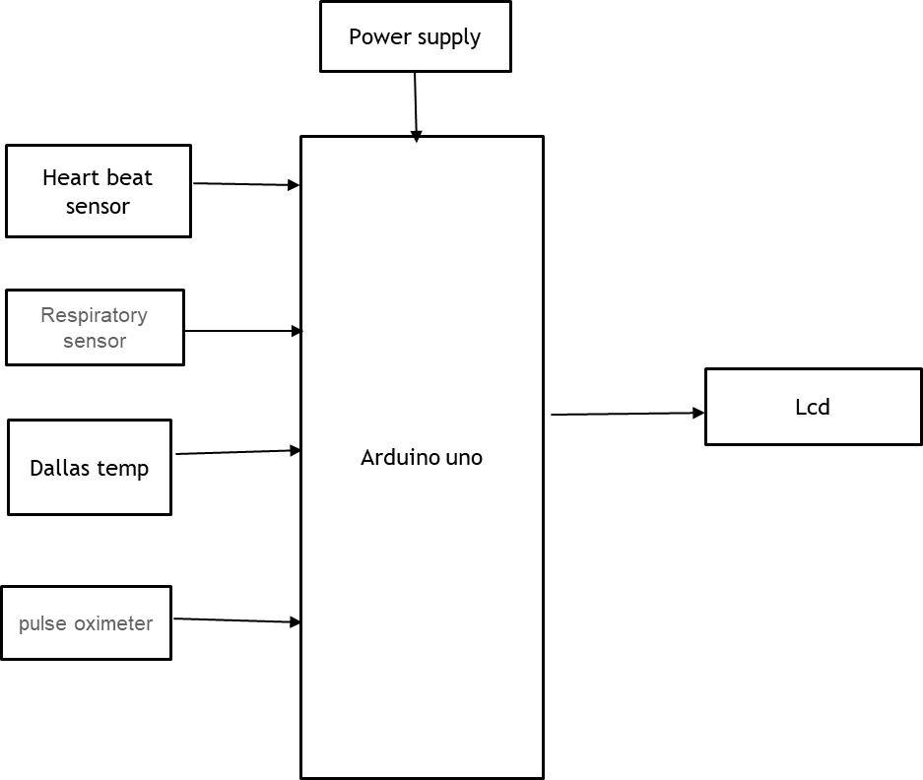

**HARDWARE REQUIREMENTS:**

* Arduino Uno
* Heartbeat sensor
* Dallas Temperature sensor
* Respiratory sensor
* Pulse oximeter
* LCD
* Power supply

**SOFTWARE REQUIREMENTS:**

* Embedded C
* Python

**WORKING THEORY :**

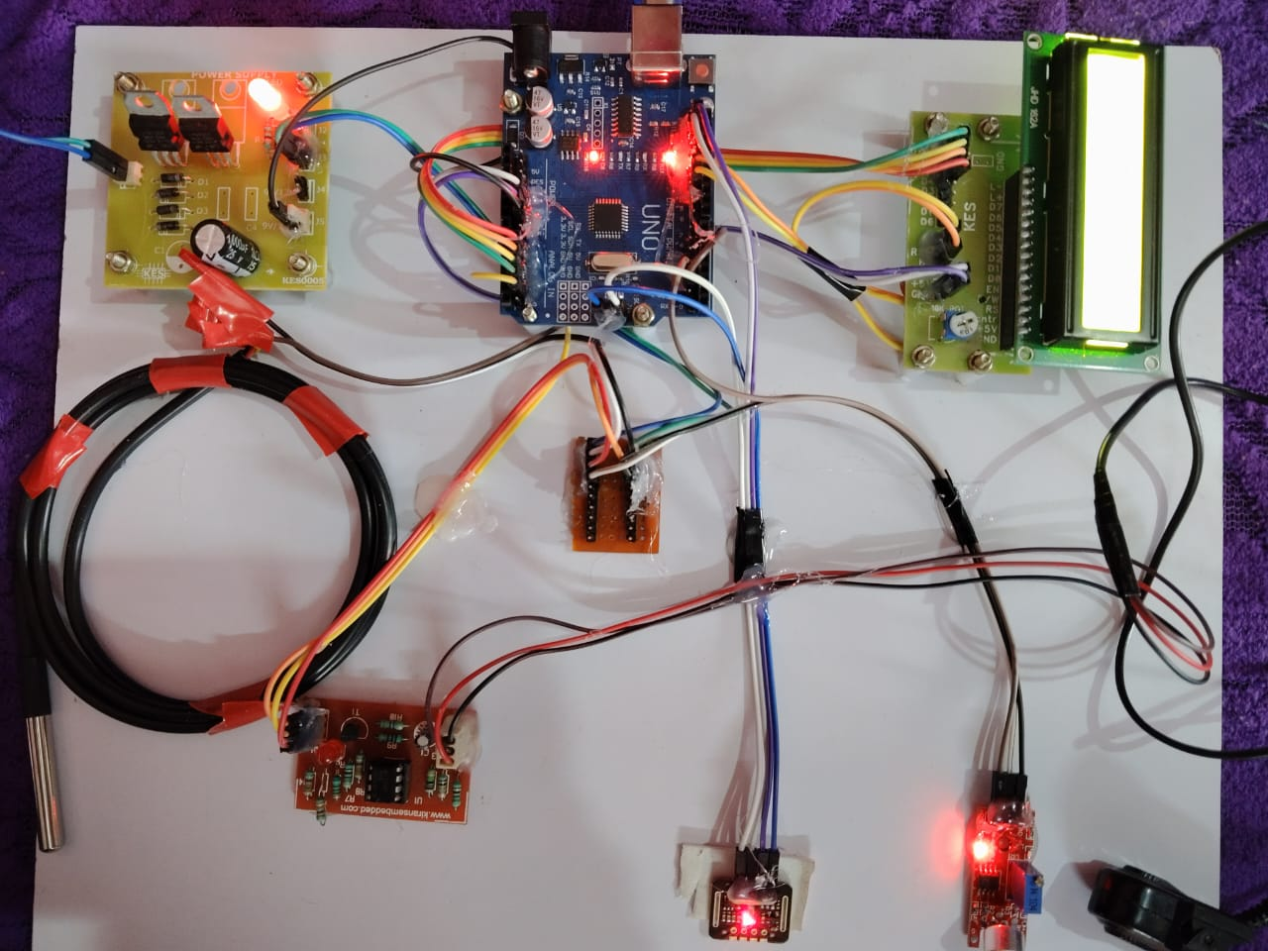

**Arduino UNO :**

The Arduino Uno is one of the most popular and widely used microcontroller boards in the Arduino family, ideal for both beginners and experienced engineers. Powered by the ATmega328P microchip, the board offers 14 digital input/output pins, 6 analog inputs, and a USB interface for easy programming. With 32 KB of flash memory, 2 KB of SRAM, and 1 KB of EEPROM, it provides enough resources for a wide range of basic to intermediate projects. The Uno is compatible with the Arduino IDE, which simplifies the programming process, making accessible to users with no prior experience in electronics. It also supports a wide variety of shields and modules, expanding its capabilities for IoT, robotics, and automation applications. Its versatility, ease of use, and low cost have made it a staple in the maker community, educational environments, and prototype development.

**LCD :**

An LCD (Liquid Crystal Display) is a flat-panel display technology that utilizes liquid crystals to modulate light and create images. It operates by placing liquid crystal material between two polarizing filters; when an electric current is applied, the orientation of the liquid crystals changes, allowing light to pass through or be blocked. This process enables the display of text, graphics, and videos with high clarity and energy efficiency. LCDs are widely used in various applications, from small screens in handheld devices to larger displays in televisions and computer monitors. They offer advantages such as thin form factors, low power consumption, and the ability to produce vibrant colors, making them a popular choice in both consumer electronics and industrial applications. Additionally, advancements in LCD technology, such as the introduction of LED backlighting and improved resolution, have enhanced their performance and visual quality, solidifying their presence in modern display technology.

**Heartbeat sensor :**

A heartbeat sensor, or pulse sensor, is an electronic device that measures the rate of heartbeats, typically by detecting changes in blood volume in a fingertip or other area of the body. These sensors commonly utilize photoplethysmography (PPG) to detect variations in light transmission or reflection through blood vessels, converting these changes into a digital signal representing the heartbeat.

**Respiratory sensor :**

Respiratory sensors are devices that monitor breathing patterns and related physiological parameters like airflow, humidity, and temperature. They play a crucial role in healthcare, allowing for real-time monitoring of respiratory health and early detection of potential problems, according to a study published on ScienceDirect.

**Pulse Oximeter :**

A pulse oximeter sensor is a medical device used to measure oxygen saturation (SpO2) levels in the blood and heart rate. It typically clips onto a fingertip or earlobe and uses light-emitting diodes (LEDs) to shine light through the skin. The sensor detects how much light is absorbed by oxygenated versus deoxygenated hemoglobin in the blood, calculating the percentage of oxygen saturation. Pulse oximeters are non-invasive and provide immediate readings, making them valuable for monitoring respiratory conditions, assessing the effectiveness of supplemental oxygen therapy, and monitoring patients during anesthesia or recovery. They are widely used in hospitals, clinics, and home healthcare settings due to their ease of use, portability, and ability to quickly detect changes in oxygen levels and heart rate.

**Dallas Temperature sensor :**

A Dallas temperature sensor, often referred to as a DS18B20 sensor, is a digital temperature sensor that uses the OneWire protocol for communication. It is manufactured by Maxim Integrated and is widely used for measuring temperature in various applications. The DS18B20 sensor provides accurate temperature readings with a resolution of up to 12 bits and can operate over a wide temperature range. One of its key features is its ability to interface with microcontrollers like Arduino using a single data wire, simplifying wiring and enabling multiple sensors to be connected on the same bus.

**CONCLUSION :**

In conclusion, the IoT-enabled Smart E-Healthcare System with a predictive prescription algorithm offers a reliable, real-time, and intelligent solution for continuous patient monitoring and early diagnosis. By integrating multiple biomedical sensors with an Arduino UNO and utilizing a Python-based algorithm, the system not only collects and displays vital health parameters but also provides smart analysis and treatment suggestions. It addresses the limitations of traditional healthcare systems by enabling remote monitoring, timely alerts, and proactive care, especially beneficial in rural areas and for elderly patients. The system’s cost-effectiveness, scalability, and adaptability make it a promising tool for improving healthcare accessibility, reducing hospital burden, and enhancing patient outcomes in both clinical and home environments.