**RETAIL INVENTORY FORECASTING USING MACHINE LEARNING**

Menaka A, Bhoomika K R, Swetha M, Devipriya D

## Abstract - In the contemporary landscape of retail and online commerce, the ability to accurately forecast sales is essential for optimizing inventory, improving strategic operations, and enhancing customer service. This research presents a machine learning-based solution for predicting monthly sales volumes by leveraging both historical sales transactions and product-level information. The proposed approach utilizes the XGBoost regression algorithm, trained on engineered features derived from temporal patterns and categorical attributes.The dataset incorporates multiple variables, including product category, brand, quantity sold, unit price, and transaction dates. Advanced feature engineering is conducted by extracting relevant time-based features—such as year, month, and day of the week—and by encoding categorical fields using label encoding. Distinct predictive models are developed for each combination of product category and season, thereby allowing for more fine-grained and context-aware forecasts. The effectiveness of these models is assessed using standard evaluation metrics, including Mean Absolute Error (MAE), Mean Squared Error (MSE), and R-squared (R²), all demonstrating high levels of accuracy.To ensure practical application, the forecasting system is deployed through a user-friendly Flask web interface, enabling users to select product categories and seasonal periods, initiate model training, and view future sales projections through interactive plots. All models and encoders are preserved using serialization techniques to facilitate reuse and efficient deployment.This intelligent forecasting tool offers a scalable and reliable solution for businesses seeking to anticipate demand trends, reduce inventory inefficiencies, and respond proactively to seasonal variations in consumer behavior.

## **1 INTRODUCTION**

In the current era of dynamic and highly competitive retail environments, the ability to accurately predict future sales has become a vital component of efficient business operations. Effective sales forecasting supports inventory control, resource allocation, and strategic decision-making, directly impacting profitability and customer satisfaction. However, conventional forecasting methods often struggle to capture the nonlinear dependencies and seasonal trends inherent in historical sales data, limiting their effectiveness in real-world scenarios.To overcome these challenges, this study introduces a machine learning-based forecasting framework utilizing the Extreme Gradient Boosting (XGBoost) regression algorithm. By incorporating a comprehensive set of features—including temporal indicators (year, month, day, weekday), product attributes (category, brand, season), pricing, and quantity sold—the model is capable of identifying complex patterns and delivering accurate sales predictions.Furthermore, to ensure ease of use and broader accessibility, the system is deployed through an interactive web interface built with the Flask framework. The application allows users to select specific product categories and seasonal contexts, initiate training of customized predictive models, evaluate model performance through metrics such as Mean Absolute Error (MAE), Mean Squared Error (MSE), and the coefficient of determination (R²), and visualize anticipated sales trends.This integrated approach not only streamlines the forecasting process but also translates raw transactional data into meaningful business insights, empowering organizations to make informed, data-driven decisions with seasonal precision.

**1.1 PROBLEM STATEMENT**

Accurate sales forecasting remains a significant challenge for retailers operating in today’s fast-paced and unpredictable market. The variability of consumer preferences, combined with seasonal fluctuations and product-specific demand patterns, often renders traditional forecasting techniques inadequate. These conventional approaches typically lack the sophistication required to capture intricate, nonlinear relationships within historical sales data, resulting in frequent inventory imbalances and suboptimal business decisions. Moreover, the absence of accessible, intelligent forecasting tools presents an additional barrier—particularly for users without technical expertise—hindering their ability to harness the full potential of data-driven strategies. Consequently, there is a critical need for a reliable and scalable forecasting system that not only incorporates advanced machine learning techniques but also offers a user-friendly interface. Such a solution would enable retailers to generate accurate sales predictions with seasonal and categorical sensitivity, ultimately supporting more informed, timely, and strategic decision-making.

**1.2 AIM AND OBJECTTIVE**

The principal aim of this study is to develop a smart and accessible sales forecasting system capable of delivering accurate and reliable predictions by analyzing historical sales records, product classifications, and seasonal influences. By employing sophisticated machine learning methodologies, specifically the XGBoost regression algorithm, the model is designed to detect intricate trends and dependencies in sales data driven by temporal and product-specific variables. In parallel, the project emphasizes usability and real-world applicability through the development of a Flask-based web application, which allows users to select relevant parameters—such as product category and seasonal period—train specialized models, and visualize projected sales trends. This integrated solution is intended to assist retailers and business stakeholders in making informed, data-driven decisions regarding inventory control, promotional planning, and resource distribution, ultimately contributing to enhanced operational efficiency and improved customer satisfaction.

**1.3 SCOPE OF THE PROJECT**

TThe scope of this project extends beyond its current capabilities, offering significant potential for future enhancements through the integration of advanced deep learning models such as Long Short-Term Memory (LSTM) networks, which are well-suited for capturing temporal dependencies and identifying long-range patterns in sales data. Incorporating additional external data sources—such as prevailing market dynamics, competitor pricing strategies, and consumer sentiment from social media—could further refine the accuracy and relevance of forecasts. Moreover, the development of a feature-rich analytical dashboard with interactive visualizations, role-specific access controls, and cross-platform mobile support would increase the system’s utility and user engagement. These prospective advancements would collectively evolve the solution into a sophisticated, intelligent sales advisory tool adaptable across various industry domains.

**2 LITERATURE SURVEY**

Their work demonstrated the effectiveness of gradient boosting in solving complex regression and classification tasks, making XGBoost a preferred choice for time series forecasting and large-scale data modeling. Géron provides practical insights into implementing machine learning models using Python-based libraries in his book Hands-On Machine Learning with Scikit-Learn, Keras, and TensorFlow [2]. His comprehensive explanations of preprocessing, model training, and evaluation techniques offer valuable guidance for building end-to-end predictive systems. Similarly, Raschka and Mirjalili further strengthen the understanding of machine learning concepts in Python Machine Learning, which emphasizes modern practices for developing intelligent applications using Python, including model optimization and deployment strategies [3].

A significant contribution to this domain is the work by Pedregosa et al., who developed Scikit-learn, a robust and user-friendly machine learning library in Python [4]. Their research outlines the library’s modular architecture and its suite of algorithms for classification, regression, clustering, and dimensionality reduction, all of which are essential components in building reliable forecasting solutions. The official XGBoost documentation provided by Microsoft Learn further serves as a comprehensive resource for understanding the practical implementation and parameter tuning of the algorithm in real-world scenarios [5].

To support web-based deployment, the Flask framework is employed, with its official documentation offering detailed guidelines for building lightweight and scalable web applications [6]. Flask’s flexibility and simplicity make it a popular choice for integrating machine learning models into user-facing applications. Additionally, the Pandas library provides essential tools for data manipulation and analysis, enabling efficient handling of large datasets with diverse features [7]. For interactive development and experimentation, Jupyter Notebook, an open-source project by Project Jupyter, plays a critical role by offering an intuitive environment for writing, testing, and visualizing code and results in real time [8].

**3 RIFML ALGORITHMS**

XGBoost, short for Extreme Gradient Boosting, is a powerful and scalable machine learning algorithm based on gradient boosting framework. It is widely used for regression, classification, and ranking tasks due to its high performance and speed. XGBoost builds an ensemble of decision trees sequentially, where each new tree tries to correct the errors made by the previous ones. One of its key advantages is regularization (L1 and L2), which helps in preventing overfitting and makes the model more generalizable. Additionally, XGBoost supports parallel processing, handles missing data internally, and offers flexibility through various hyperparameters, making it highly efficient and suitable for large datasets. Its ability to automatically handle interactions between variables and capture non-linear relationships has made it a favorite in data science competitions and real-world applications alike.

3.1 Algorithm for objective function

XGBoost tries to minimize the following regularized objective function:

L(ϕ)=∑i=1nl(yi,y^i(t))+∑k=1tΩ(fk)\mathcal{L}(\phi) = \sum\_{i=1}^{n} l(y\_i, \hat{y}\_i^{(t)}) + \sum\_{k=1}^{t} \Omega(f\_k)L(ϕ)=i=1∑n​l(yi​,y^​i(t)​)+k=1∑t​Ω(fk​)

Where:

lll is the loss function (e.g., squared error for regression).

y^i(t)\hat{y}\_i^{(t)}y^​i(t)​ is the prediction of the ithi^{th}ith data point at iteration ttt.

fkf\_kfk​ is the kthk^{th}kth decision tree.

Ω(f)\Omega(f)Ω(f) is the regularization term:

Ω(f)=γT+12λ∑j=1Twj2\Omega(f) = \gamma T + \frac{1}{2} \lambda \sum\_{j=1}^{T} w\_j^2Ω(f)=γT+21​λj=1∑T​wj2​

Where:

TTT is the number of leaves.

wjw\_jwj​ is the weight of leaf jjj.

γ\gammaγ and λ\lambdaλ are regularization parameters

3.2 Additive Training Strategy

Predictions are updated as:

y^i(t)=y^i(t−1)+ft(xi)\hat{y}\_i^{(t)} = \hat{y}\_i^{(t-1)} + f\_t(x\_i)y^​i(t)​=y^​i(t−1)​+ft​(xi​)

Each new tree ftf\_tft​ is added to correct the previous prediction errors.

3.3 Second-Order Taylor Approximation

To make optimization easier, the loss function is approximated using a second-order Taylor expansion:

L(t)≈∑i=1n[gift(xi)+12hift(xi)2]+Ω(ft)\mathcal{L}^{(t)} \approx \sum\_{i=1}^{n} \left[ g\_i f\_t(x\_i) + \frac{1}{2} h\_i f\_t(x\_i)^2 \right] + \Omega(f\_t)L(t)≈i=1∑n​[gi​ft​(xi​)+21​hi​ft​(xi​)2]+Ω(ft​)

Where:

gi=∂l(yi,y^i)∂y^ig\_i = \frac{\partial l(y\_i, \hat{y}\_i)}{\partial \hat{y}\_i}gi​=∂y^​i​∂l(yi​,y^​i​)​ (first-order gradient)

hi=∂2l(yi,y^i)∂y^i2h\_i = \frac{\partial^2 l(y\_i, \hat{y}\_i)}{\partial \hat{y}\_i^2}hi​=∂y^​i2​∂2l(yi​,y^​i​)​ (second-order gradient)

3.4 Gain (Split Evaluation)

The gain from splitting a node is given by:

Gain=12[GL2HL+λ+GR2HR+λ−(GL+GR)2HL+HR+λ]−γ\text{Gain} = \frac{1}{2} \left[ \frac{G\_L^2}{H\_L + \lambda} + \frac{G\_R^2}{H\_R + \lambda} - \frac{(G\_L + G\_R)^2}{H\_L + H\_R + \lambda} \right] - \gammaGain=21​[HL​+λGL2​​+HR​+λGR2​​−HL​+HR​+λ(GL​+GR​)2​]−γ

Where:

GL,GRG\_L, G\_RGL​,GR​: sum of gradients for left and right splits.

HL,HRH\_L, H\_RHL​,HR​: sum of Hessians (second derivatives) for left and right splits.

This formula helps in deciding where to split the tree to get the most benefit.

3.4 Leaf Weight Calculation

The optimal weight wjw\_jwj​ for a leaf node is:

wj=−GjHj+λw\_j = -\frac{G\_j}{H\_j + \lambda}wj​=−Hj​+λGj​​

Where:

GjG\_jGj​: sum of gradients for samples in the leaf.

HjH\_jHj​: sum of Hessians for samples in the leaf.

3.5 Algorithm Steps

(a) Initialize products  
(b) Receive User Input (seasons)  
(c) Preprocess Data:  
(d) Apply Machine Learning Model  
(e) Check for prediction  
(f)Predict & Display Results   
(h) Store in search history  
(i) Allow Updates via Admin Panel  
(j) Exit or Loop Until User Ends Session

3.6 Displaying prediction

Once the product is predicted, the system displays: precticted values and also in graphical visualization.

**4 RIFML FLOWCHART**

The Fig. 4.1 illustrates the ML-Based Retail inventory forecasting process,

**Dataset:**The foundation of the system begins with the dataset, which comprises historical sales records containing key features such as product information, dates, quantities sold, and prices.

**Dataset Collection:**This data is gathered from various transactional sources, ensuring comprehensive coverage across different time periods, seasons, and product categories.

**Data Preprocessing:**In this phase, the raw data is cleaned and transformed to remove inconsistencies, handle missing values, and convert formats. This step ensures that the dataset is consistent and ready for analysis.

**Model Training/Testing:**The cleaned data is then used to train and evaluate machine learning models. The dataset is typically split into training and testing sets to measure performance on unseen data.

**Model Selection:**Various algorithms are considered, and the most suitable model—in this case, XGBoost—is selected based on its ability to handle non-linear patterns, feature importance, and high predictive power.

**Feature Extraction:**Once the data is saved the system ends the session the user can either return to the home page or exit the system, all diagnostic data is securely stored and available for future analysis.

**Model Validation:**To ensure the model’s robustness and generalization capabilities, it undergoes rigorous validation using metrics such as Mean Absolute Error (MAE), Mean Squared Error (MSE), and R-squared (R²).

**Model Deployment:**Once validated, the model is deployed through a web-based interface built with Flask, allowing end-users to interact with the system in real time.

**Predictions:**The final step involves generating sales predictions based on user input parameters. The system outputs forecasted values for upcoming months, supporting data-driven business decisions.

Dataset

Dataset Collection

Data Preprocessing

Feature Extraction

Model Selection

Model Training/ Testing

Model Validation

Model Deployment

Predictions

Fig. 1: RIFML flowchart

.

**5 RESULT AND DISCUSSION**

The comprehensive analysis of sales data uncovers seasonal peaks, product-specific performance, and regional variations that emphasize the importance of adaptive strategies across markets. High-performing products and regions reflect targeted success, while under-performing areas highlight opportunities for focused marketing and operational improvements. Trends in online versus offline sales, along with sales team performance and marketing ROI, further inform strategic decision-making. Incorporating customer feedback, optimizing logistics, and aligning promotional efforts with consumer behavior will enhance future forecasting accuracy and overall business agility.

**5.1 RESULT**.

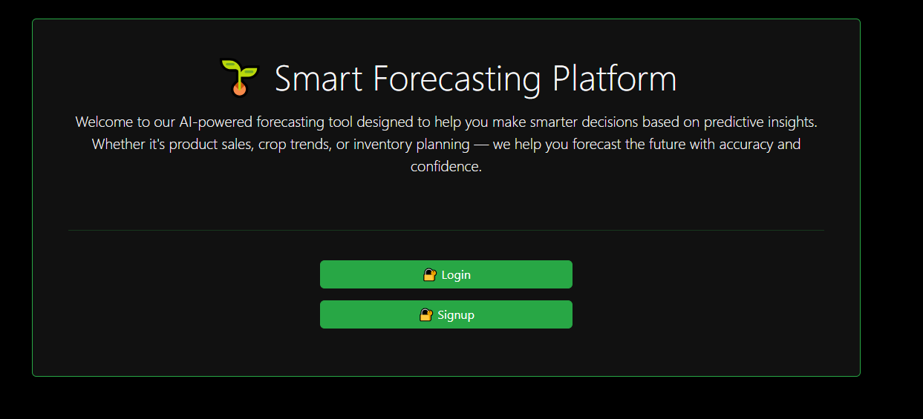

Fig. 1 : Landing Page.

In Fig. 1The Smart Forecasting Platform introduces users to a visually appealing and intuitively designed landing page that reflects the system’s commitment to accessible and intelligent forecasting solutions. Emphasizing usability, the interface adopts a sleek dark-themed aesthetic complemented by vibrant green buttons for “Login” and “Signup,” each accompanied by a lock icon symbolizing secure access. Positioned prominently at the top is a message highlighting the platform’s mission to empower users with AI-driven predictive insights for smarter, data-informed decision-making. Whether aimed at sales projections, agricultural forecasting, or inventory optimization, the platform serves as a centralized entry point where users can either access their accounts or register to begin leveraging its powerful forecasting capabilities with ease and confidence.

### Fig. 2 : Register Page

In Fig. 2,The Smart Forecasting Platform incorporates a secure authentication framework with distinct access levels for users and administrators. Users can register or log in to access personalized forecasting tools, while administrators utilize a dedicated login to oversee system operations and manage data. This dual-access structure upholds data security and ensures efficient role-based functionality across forecasting domains.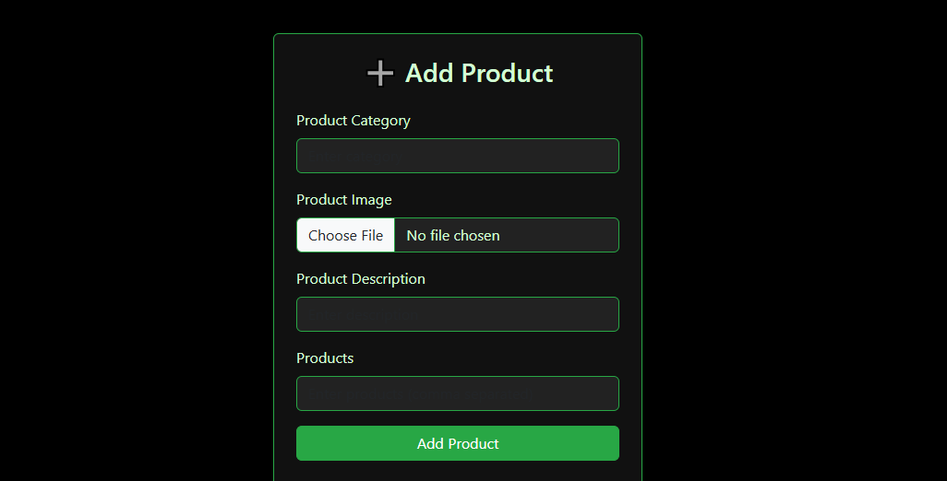

Fig. 3 : Add product

In Fig. 3,The admin panel of the Smart Forecasting Platform features a dedicated product management section that enables administrators to seamlessly add and organize product data. By entering details like category, description, image, and item list, admins ensure accurate and structured input for forecasting models. This streamlined interface supports efficient data handling, enhancing the platform’s predictive capabilities for sales and inventory planning.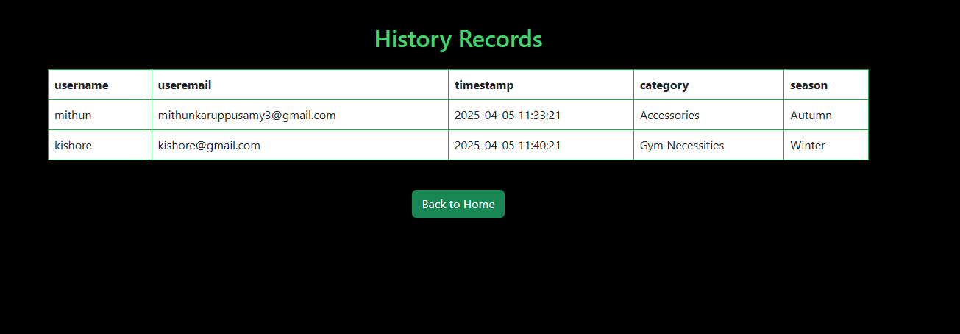

Fig. 4 :History records

In Fig. 4, The history records module within the admin panel of the Smart Forecasting Platform serves as a comprehensive log for tracking user interactions tied to forecasting activities. It presents a structured table detailing each user's name, email, activity timestamp, chosen product category, and season of analysis. This logging mechanism not only promotes transparency and accountability but also aids in assessing platform engagement and refining forecasting processes. A convenient “Back to Home” button enhances navigation, allowing administrators to return swiftly to the main dashboard after reviewing historical data.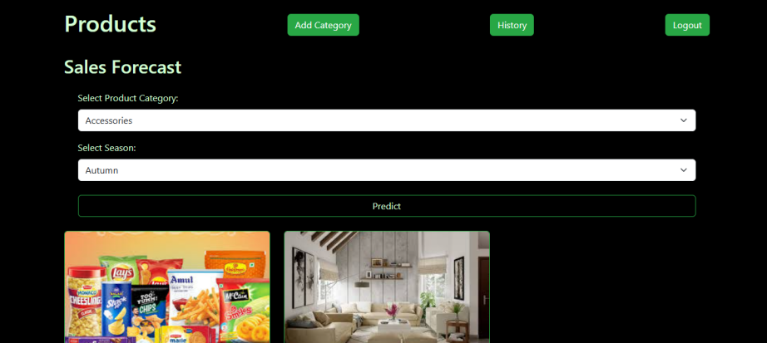

Fig. 5 : Sales forecasting page.

In Fig. 5, The sales forecast interface in the admin panel of the Smart Forecasting Platform enables administrators to generate demand predictions by selecting specific product categories and seasons. Using dropdown menus for easy input, the system applies machine learning models to forecast sales trends, offering visual outputs such as product images to highlight anticipated high-demand items. This functionality supports strategic planning by aligning inventory and marketing efforts with seasonal demand patterns. Additionally, quick-access buttons for category management, history logs, and logout functions enhance usability and administrative efficiency.

Fig. 6 : User login page.

In Fig. 6, The login system of the Smart Forecasting Platform offers a secure and streamlined gateway for both users and administrators. Users can authenticate using their email and password, while new users are guided to the registration page via a clear “Register” link. A separate link directs administrators to their exclusive login portal, ensuring role-based access to appropriate dashboards. With its minimalistic design, the interface prioritizes usability and security, efficiently routing users based on their access privileges.

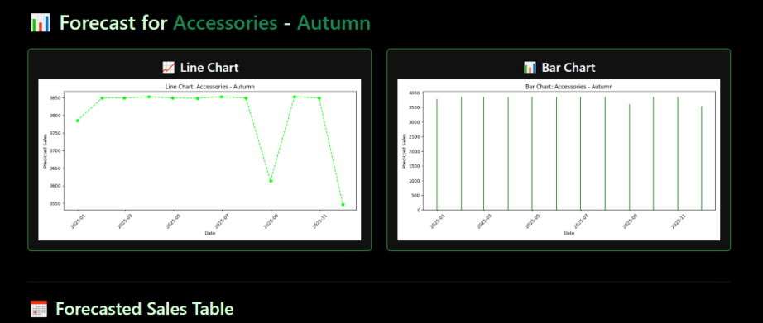

Fig. 7 : Graphical visualization.

In Fig. 7, The forecasting module of the Smart Forecasting Platform presents predictive insights for product categories, such as Accessories in the Autumn season, through dynamic visualizations. It features both line and bar charts that illustrate forecasted sales across a timeline, allowing users to observe patterns, peaks, and potential declines in demand. These visuals, driven by machine learning algorithms, offer a comparative and trend-focused view of projected sales, supporting strategic decisions in marketing and inventory control. Automatically generated based on input data and selected filters, the interactive charts enhance analytical clarity for seasonal business planning.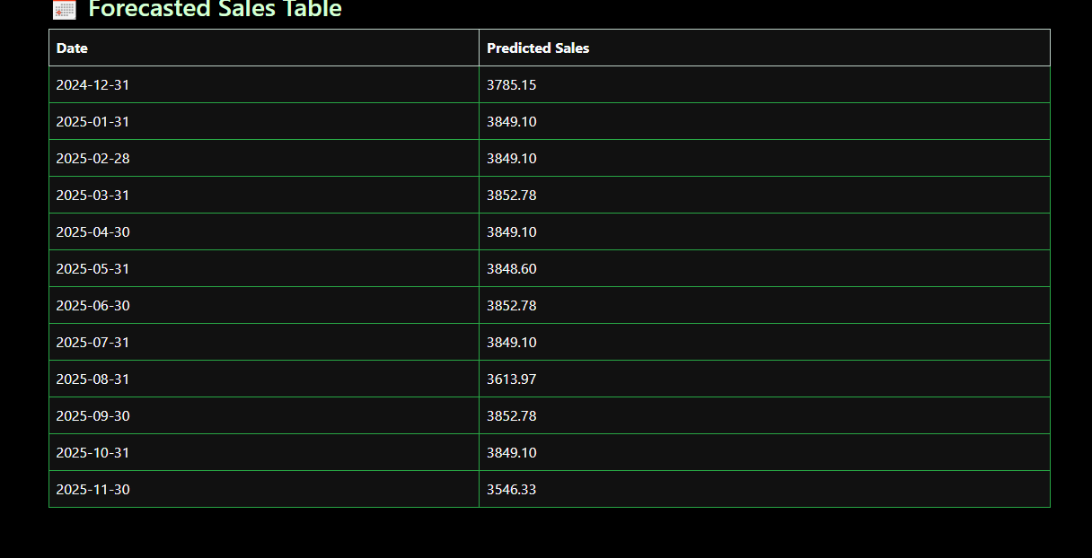

Fig. 8 : Forecasted sales table.

In Fig. 8, The forecasted sales table utilizes five years of historical data to train a time-series prediction model that captures seasonal variations and long-term sales trends. By identifying recurring patterns and fluctuations, the model—likely powered by algorithms such as XGBoost—projects future monthly sales with a high degree of accuracy. This predictive process includes thorough data preprocessing and pattern recognition, enabling precise insights into expected performance. The resulting forecasts, presented in a structured table format, empower businesses to make proactive decisions regarding inventory, marketing strategies, and resource planning.

**5.2 CONCLUSIONS**

In conclusion, the implementation of machine learning, particularly the XGBoost algorithm, has demonstrated a substantial improvement in the precision and reliability of sales forecasting models. Through comprehensive feature engineering and the transformation of categorical variables, the system effectively captures intricate patterns associated with time-based trends, product segmentation, and seasonal dynamics. The integration of this predictive model into a Flask-powered web interface enhances usability by enabling seamless interaction and on-demand forecasting capabilities. This intelligent framework equips businesses with actionable insights, facilitating more informed planning and resource allocation. Moreover, the scalability and adaptability of the solution make it well-suited for evolving retail landscapes, positioning it as a valuable asset for data-driven strategic decision-making.

**REFERENCE**

|  |
| --- |
| [1] T. Chen and C. Guestrin, "XGBoost: A scalable tree boosting system," in Proceedings of the 22nd ACM SIGKDD International Conference on Knowledge Discovery and Data Mining, San Francisco, CA, USA, 2016, pp. 785–794. doi: 10.1145/2939672.2939785.  [2] A. Géron, Hands-On Machine Learning with Scikit-Learn, Keras, and TensorFlow, 2nd ed. Sebastopol, CA, USA: O’Reilly Media, 2019.  [3] S. Raschka and V. Mirjalili, Python Machine Learning, 3rd ed. Birmingham, UK: Packt Publishing, 2019.  [4] F. Pedregosa, G. Varoquaux, A. Gramfort et al., "Scikit-learn: Machine learning in Python," Journal of Machine Learning Research, vol. 12, pp. 2825–2830, 2011.  [5] Microsoft Learn, "XGBoost Documentation – A comprehensive guide to using XGBoost for regression and classification tasks." [Online]. Available: [https://learn.microsoft.com](https://learn.microsoft.com" \t "_new)  [6]Flask Documentation, "Official documentation for the Flask web framework." [Online]. Available: [https://flask.palletsprojects.com/](https://flask.palletsprojects.com/" \t "_new)  [7] Pandas Development Team, Pandas: Powerful Python data analysis toolkit, 2020. [Online]. Available: [https://pandas.pydata.org/](https://pandas.pydata.org/" \t "_new)  [8] Jupyter Notebook, Project Jupyter. [Online]. Available: [https://jupyter.org/](https://jupyter.org/" \t "_new)  [9] I. Goodfellow, Y. Bengio, and A. Courville, Deep Learning. Cambridge, MA, USA: MIT Press, 2016.​[My Great Learning+1AI Summer+1](https://www.mygreatlearning.com/blog/top-machine-learning-books/?utm_source=chatgpt.com" \t "_blank)  [10] K. P. Murphy, Machine Learning: A Probabilistic Perspective. Cambridge, MA, USA: MIT Press, 2012.​[letsfindcourse.com+3Learn R, Python & Data Science Online+3My Great Learning+3](https://www.datacamp.com/blog/the-15-best-data-machine-learning-books-to-read-in-2022?utm_source=chatgpt.com" \t "_blank)  [11] T. Hastie, R. Tibshirani, and J. Friedman, The Elements of Statistical Learning: Data Mining, Inference, and Prediction, 2nd ed. New York, NY, USA: Springer, 2009.  [12] C. M. Bishop, Pattern Recognition and Machine Learning. New York, NY, USA: Springer, 2006.  [13] A. Burkov, The Hundred-Page Machine Learning Book. Québec City, QC, Canada: Andriy Burkov, 2019.​[Expect Technical Staffing+3My Great Learning+3techstrot.com+3](https://www.mygreatlearning.com/blog/top-machine-learning-books/?utm_source=chatgpt.com" \t "_blank)  [14] S. Shalev-Shwartz and S. Ben-David, Understanding Machine Learning: From Theory to Algorithms. Cambridge, UK: Cambridge University Press, 2014  [15] A. C. Müller and S. Guido, Introduction to Machine Learning with Python: A Guide for Data Scientists. Sebastopol, CA, USA: O’Reilly Media, 2016.  [16]D. Barber, Bayesian Reasoning and Machine Learning. Cambridge, UK: Cambridge University Press, 2012.​[Data Science Dojo+1Hackr.io+1](https://datasciencedojo.com/blog/machine-learning-books/?utm_source=chatgpt.com" \t "_blank)  [17] F. Chollet, Deep Learning with Python, 2nd ed. Shelter Island, NY, USA: Manning Publications, 2021.  [18] D. Conway and J. M. White, Machine Learning for Hackers: Case Studies and Algorithms to Get You Started. Sebastopol, CA, USA: O’Reilly Media, 2012  [19] T. M. Mitchell, Machine Learning. New York, NY, USA: McGraw-Hill, 1997.  [20] D. Barber, Bayesian Reasoning and Machine Learning. Cambridge, UK: Cambridge University Press, 2012.  [21] D. Koller and N. Friedman, Probabilistic Graphical Models: Principles and Techniques. Cambridge, MA, USA: MIT Press, 2009.  [22] Y. Bengio, A. Courville, and P. Vincent, "Representation Learning: A Review and New Perspectives," arXiv preprint arXiv:1206.5538, 2012.   1. A. Vaswani et al., "Attention Is All You Need," in Advances in Neural Information Processing Systems, vol. 30, 2017. |

1. A. Vaswani et al., "Attention Is All You Need," in Advances in Neural Information Processing Systems, vol. 30, 2017.
2. I. Goodfellow et al., "Generative Adversarial Nets," in Advances in Neural Information Processing Systems, vol. 27, 2014.
3. C. M. Bishop, Neural Networks for Pattern Recognition. Oxford, UK: Oxford University Press, 1995.
4. D. Conway and J. M. White, Machine Learning for Hackers: Case Studies and Algorithms to Get You Started. Sebastopol, CA, USA: O’Reilly Media, 2012.
5. J. Hearty, Advanced Machine Learning with Python. Birmingham, UK: Packt Publishing, 2016.
6. E. Stevens, L. Antiga, and T. Viehmann, Deep Learning with PyTorch. Shelter Island, NY, USA: Manning Publications, 2020.[Data Science Dojo](https://datasciencedojo.com/blog/machine-learning-books/?utm_source=chatgpt.com" \t "_blank)
7. P. Warden and D. Situnayake, TinyML: Machine Learning with TensorFlow Lite on Arduino and Ultra-Low-Power Microcontrollers. Sebastopol, CA, USA: O’Reilly Media, 2019.
8. T. Hastie, R. Tibshirani, and J. Friedman, The Elements of Statistical Learning: Data Mining, Inference, and Prediction, 2nd ed. New York, NY, USA: Springer, 2009.
9. U. von Luxburg and B. Schölkopf, "Statistical Learning Theory: Models, Concepts, and Results," arXiv preprint arXiv:0810.4752, 2008. [Online]. Available: [https://arxiv.org/abs/0810.4752](https://arxiv.org/abs/0810.4752" \t "_new)
10. R. McElreath, Statistical Rethinking: A Bayesian Course with Examples in R and Stan, 2nd ed. Boca Raton, FL, USA: CRC Press, 2020.
11. C. C. Aggarwal, Neural Networks and Deep Learning: A Textbook. Cham, Switzerland: Springer, 2018.