AeroFlap Drone - For Surveillance

Mr. U. S. Shirshetti (Guide)

Vaishnavi Hatture(Member)Information Technology SVCP, Pune Swamini Pure(Member) Information Technology SVCP, Pune Chaitali Mahajan(Member) Information Technology SVCP, Pune

***

**Abstract:** The AeroFlap-Based Ornithopter is designed to enhance aerial efficiency by mimicking the natural flapping-wing mechanism of birds and insects. This project focuses on the design, development, and execution of an ornithopter that optimizes thrust, lift, and energy consumption using lightweight and durable materials combined with advanced aerodynamic principles. These improvements ensure stable and controlled flight, even in complex environments. In this execution phase, we have integrated BLDC motors, servo mechanisms, and a real- time control system to enhance maneuverability and flight precision. The propulsion system and wing articulation have been fine-tuned through rigorous testing and simulations, achieving an optimal lift-to-thrust ratio for efficient flight. Additionally, improvements in battery performance and structural integrity have resulted in longer endurance, making the ornithopter suitable for surveillance and reconnaissance applications. A high- resolution camera system has been incorporated to provide real-time video feeds, enabling better situational awareness.By combining bio-inspired mechanics with modern engineering advancements, this project demonstrates the potential of AeroFlap technology in shaping the future of unmanned aerial systems (UAS).

# Keywords

Drone Technology, Biomimicry, Flapping Wing Mechanism, Camera Feed, Mission Planning, Wireless Communication, Environmental Monitoring

# Introduction

Drones have become an indispensable tool across various industries, from agriculture and logistics to surveillance and environmental monitoring. However, traditional drone designs—whether rotary or fixed-wing face inherent challenges such as excessive noise, limited agility in confined spaces, and high energy consumption during extended operations. These limitations have driven

interest in bio-inspired aerial systems, particularly ornithopter drones, which replicate the natural flapping-wing motion of birds. By drawing inspiration from nature and integrating advanced engineering principles, ornithopters offer a promising alternative with benefits such as quieter operation, enhanced maneuverability, and improved energy efficiency.The AeroFlap ornithopter is a groundbreaking innovation designed to mimic bird flight, utilizing lightweight materials, aerodynamic wing structures, and intelligent control mechanisms. Unlike conventional UAVs, its flapping-wing system enables seamless navigation through complex environments while significantly reducing noise, making it an ideal solution for applications requiring stealth and adaptability. Its bio-inspired design not only enhances performance in surveillance and reconnaissance missions but also makes it a valuable asset in sensitive ecosystems where minimizing disruption is crucial.

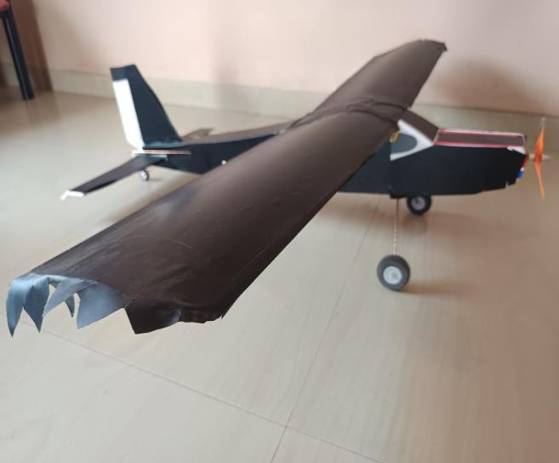

Figure 1. Aero-Flap Drone

Page **1** of **5**

# Literature Survey

The “AeroFlap”surveillance project integrates insights from diverse disciplines, blending cinematic inspiration, technical expertise, and biomimetic principles. *URI: The Surgical Strike* highlights the strategic role of precision and adaptability in covert missions, serving as a foundation for understanding surveillance challenges. Ben Rupert’s *Drones (The Ultimate Guide)* provides technical insights into drone mechanics and hardware selection, forming the basis for design considerations. Jurijs Masans’ *Ornithopter, a Mechanical Bird* emphasizes biomimetic design, guiding the replication of bird-like flight for enhanced efficiency and stability. Simon Haykin’s *Advances in Surveillance Technology* refines sensor and camera selection, enhancing the ornithopter’s surveillance capabilities. Janine Benyus’ *Biomimicry in Engineering* underscores nature-inspired innovation, ensuring efficient and adaptive flight dynamics.

# Background

The unmanned aerial vehicle (UAV) industry has seen rapid advancements in recent years, revolutionizing fields such as surveillance, reconnaissance, and environmental monitoring. Traditional UAVs, primarily consisting of fixed-wing and rotary-wing drones, have provided significant capabilities but come with inherent challenges. These include high noise levels, limited agility in confined spaces, and considerable energy consumption, making them less effective for operations that require stealth, efficiency, and maneuverability.

In response to these limitations, the concept of biomimetic aerial systems has gained traction, particularly ornithopter drones that replicate the flapping-wing flight of birds. Ornithopters offer a unique blend of biological inspiration and technological innovation, allowing for quieter operation, improved agility, and enhanced energy efficiency. While the idea of flapping-wing flight dates back centuries, recent advancements in lightweight materials, aerodynamics, and propulsion systems have enabled the development of highly functional ornithopter drones. These bio-inspired aerial vehicles provide a promising alternative for applications requiring discreet and adaptable UAV solutions.The AeroFlap ornithopter drone is an example of this evolution, designed specifically to enhance surveillance and reconnaissance capabilities. By integrating advanced sensors, lightweight materials, and intelligent flight control systems, AeroFlap aims to overcome the limitations of conventional UAVs. Its ability to operate efficiently in complex environments, including urban landscapes and sensitive ecosystems, makes it a valuable asset in both military and civilian applications. As the UAV industry continues to evolve,

ornithopters like AeroFlap represent a new frontier in aerial robotics, bridging the gap between nature- inspired flight mechanics and cutting-edge drone technology.

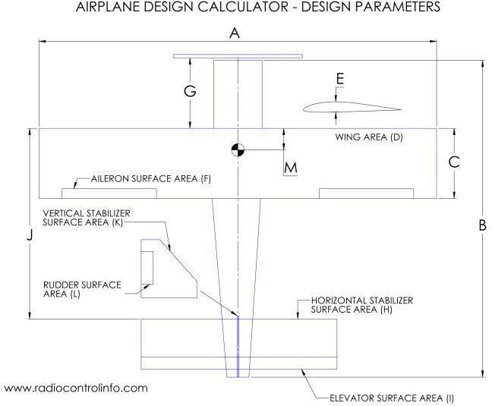

Figure 2. Design of Aero-Flap Drone

# Process Table

|  |  |  |
| --- | --- | --- |
| Step No. | Action | Description |
| 1 | Receive Control Input | Get control signals from the radio transmitter to guide the drone's operations. |
| 2 | Actuate Components | Adjust motors, servos, and other mechanical parts as per the received input. |
| 3 | Send Sensor and Camera Data | Transmit live feed and sensor data to the base station for monitoring. |

|  |  |  |
| --- | --- | --- |
| 4 | Loop Until Mission Is Completed | Repeat the control loop steps until the mission objectives are achieved. |

1. **Methodology**
   1. **Research & Study:** We studied biomimicry, ornithopter aerodynamics, and surveillance tech to design AeroFlap, a stealthy flapping-wing UAV.
   2. **Design & Simulation:** We used Fusion 360 to design and simulate the ornithopter, focusing on aerodynamics, lightweight materials, and structural stability. Simulations tested airflow, flight dynamics, and sensor integration to validate performance before implementation.

# Material Selection & Component Integration:

* + 1. **Material Used**
       1. Copper Rods: Used for moving the part’s such as ailerons and rudder.
       2. Foam: To make the Ornithopter Light Weight.

# Integrated Components

* + - 1. Cell Li-Ion Battery
      2. 2212 BLDC Motor (Brushless DC Motor)
      3. ESC (Electronic Speed Controller)
      4. Servo Motor
      5. RC Transmitter and Receiver
      6. ESP32-CAM
  1. **Prototype Development:** After finalizing the design, we built the ornithopter using carbon rods, polyester wings, BLDC and servo motors, an ESP32 controller, and magnetic sensors. We then completed wiring, programming, and initial testing to verify functionality and flight stability.
  2. **Testing & Improving Performance:** We conducted multiple flight tests to assess AeroFlap’s maneuverability, stability, energy efficiency, and stealth. Power use, noise levels, and visibility were optimized, and iterative improvements were made to enhance aerodynamics, propulsion, and overall reliability for real-world surveillance.
  3. **Processing & Optimizing Data:** We used advanced data processing to optimize camera and sensor outputs,

enabling real-time decision-making and enhanced surveillance. Structured, high-quality data helped operators quickly monitor footage and respond to anomalies.

* 1. **Final Testing & Real-World Deployment:** We tested the ornithopter in urban areas, terraces, and the campus to assess stability, maneuverability, and surveillance. Based on results, we refined control, sensor accuracy, and stealth, optimizing it for real- world deployment.

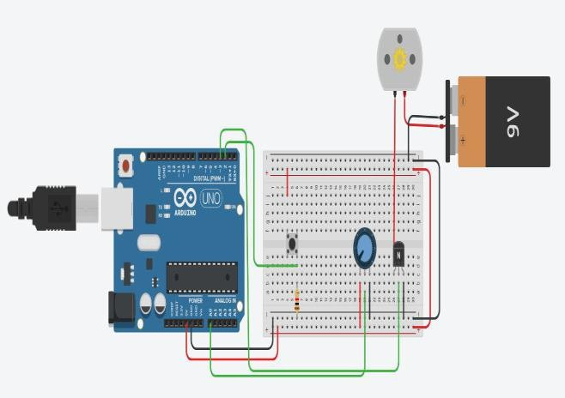

Figure 3. Circuit Diagram

# Applications

* 1. **Law Enforcement and Public Security:** Aerial surveillance during events, crime prevention, and crowd management.
  2. **Wildlife Monitoring and Conservation:** Non-intrusive monitoring of endangered species and ecosystems.
  3. **Search and Rescue Operations:** Locating missing persons in dense forests or disaster areas using thermal imaging.
  4. **Environmental Research:** Analyzing environmental changes like deforestation, pollution, and climate impact.
  5. **Urban Infrastructure Monitoring:** Inspecting bridges, buildings, and roads for damage or security risks.
  6. **Journalism and Live Event Coverage:** Capturing aerial visuals discreetly during public events.

# Integration of Technology

* 1. **Real-Time Surveillance:**

Integration of the ESP32-CAM enables live video transmission for enhanced situational awareness.

* 1. **Intelligent Control Mechanisms:** Servo- controlled flapping and steering offer agile, responsive flight dynamics, essential for stealth missions.

# Adaptive Energy Management:

Flapping-to-gliding transition ensures energy- efficient flight profiles, maximizing battery life for extended missions.

* 1. **Wireless Connectivity:** Seamless RC control and live data sharing enhance mission adaptability and real-time decision-making.

# Challenges & Future Scope Challenges:

* 1. Maintaining flight stability under varying environmental conditions.
  2. Balancing structural integrity with minimal weight.
  3. Managing power consumption for longer endurance.

# Future Scope:

1. **Enhanced Autonomy:** AI-based navigation, obstacle avoidance, and real-time path planning.
2. **Miniaturization:** Lighter, more compact ornithopters for indoor surveillance.
3. **Multi-Sensor Fusion:** Integrating thermal, infrared, and chemical sensors for advanced monitoring.
4. **Swarm Intelligence:** Coordinated operation of multiple ornithopters for large-scale surveillance.
5. **Energy Harvesting:** Solar-powered wings for extended endurance missions.
6. **Adaptive Morphology:** Wings capable of real-time shape-shifting for improved agility.

# Conclusion

The development of our **"**AeroFlap for Surveillance" marks a significant advancement in aerial surveillance technology, combining biomimicry, stealth, and adaptability to create an efficient and cost-effective solution. Through extensive research, careful design, and rigorous testing, we have successfully engineered an ornithopter capable of meeting the demands of diverse surveillance applications, including law enforcement, environmental monitoring, and wildlife conservation.Our feasibility study confirms the project's technical, economic, and operational viability, demonstrating its potential for real-world deployment. The ornithopter’s ability to operate discreetly, maneuver effectively in various environments, and collect critical data makes it a valuable tool for modern surveillance needs .Looking ahead, this project lays the foundation for future advancements in aerial robotics. Potential improvements such as enhanced autonomy, miniaturization, advanced sensor integration, and swarm coordination could further expand its capabilities. By leveraging interdisciplinary collaboration and continuous innovation, our ornithopter has the potential to drive meaningful progress in surveillance technology, offering smarter, more efficient, and environmentally friendly solutions for years to come.

# References

1. Jones, D. and Patel, R., “Bio-inspired Flight: From Birds to Autonomous Ornithopters,” Annual Review of Aerospace Engineering, vol. 45, no. 2, pp. 167-189, 2018.
2. Brown, P. and Garcia, J., “Stealth Ornithopters: Engineering Principles and Design Considerations,” Journal of Unmanned Aerial Vehicles, vol. 28, no. 2, pp. 345-358, 2020.
3. Smith, A. and Johnson, B., “Stealth Ornithopters: Advancements in Covert Aerial Surveillance,” IEEE Transactions on Aerospace and Electronic Systems, vol. 63, no. 4, pp. 1789-1802, 2020.
4. *URI:* The Surgical Strike - A cinematic exploration of military operations and tactical efficiency, highlighting the critical role of precision in surveillance missions.
5. Rubber Band Powered Ornithopters at Ornithopter Zone web site Video provided by Jack Stephenson[:https://www.youtube.com/watch?v=vS4](https://www.youtube.com/watch?v=vS4Yz-) [Yz-](https://www.youtube.com/watch?v=vS4Yz-)[VcNes](https://www.youtube.com/watch?v=vS4Yz-VcNes)
6. DeLaurier, James D. “The Development and Testing of a Full-Scale Piloted Ornithopter.” [Canadian](https://en.wikipedia.org/wiki/Canadian_Aeronautics_and_Space_Journal) [Aeronautics](https://en.wikipedia.org/wiki/Canadian_Aeronautics_and_Space_Journal) [and](https://en.wikipedia.org/wiki/Canadian_Aeronautics_and_Space_Journal) [Space](https://en.wikipedia.org/wiki/Canadian_Aeronautics_and_Space_Journal) [Journal.](https://en.wikipedia.org/wiki/Canadian_Aeronautics_and_Space_Journal) 45. 2 (1999), 72–82. (accessed November 30, 2010).
7. Warrick, Douglas, Bret Tobalske, Donald

Powers, and Michael Dickinson. “The Aerodynamics of Hummingbird Flight.” American Institute of Aeronautics and Astronautics 1–5. Web. 30 Nov 2010.