**A STUDY ON IMPACT OF RECRUITMENT AND SELECTION PROCESS**

KATHIRVEL G1, VETRIPRABHU T2,

1 MBA Student, School of Arts, Humanities and Management, Jeppiaar University, Chennai, India.

2Assistant Professor, School of Arts, Humanities and Management, Jeppiaar University, Chennai, India.

1 [appukathirvel04@gmail.com](mailto:appukathirvel04@gmail.com)

2 [vetriprabhu.coo@gmail.com](mailto:vetriprabhu.coo@gmail.com)

**ABSTRACT**

Organization's enlisting prepare which includes enlistment of candidates and Enlistment and Choice is a hypothetical concept which alludes to an choice from reasonable candidates for employments inside an organization. Enrollment and Determination points at giving the required number of talented representatives to the organization to keep the going concern of the commerce. Enlistment is the prepare of finding candidates for the empty position and empowering them to apply for it whereas on the other hand; Choice is the act of choosing the best candidate from the pool of candidates and advertising them the job.

**INTRODUCTION**

Recruitment and choice are fundamentally to human asset administration, guaranteeing the distinguishing proof and enlisting of qualified people for organizational victory. These forms include characterizing work prerequisites, publicizing positions and choosing the most reasonable candidates. The consistent integration of enrollment and determination is significant for securing the best fit workers and maintaining a strategic distance from incorrect choices in hiring

**SELECTION**:

• Preliminary meet

• Screening of Applications

• Employment test

• Conducting interviews

• Final selection

**IMPACT OF ENROLMENT AND DETERMINATION PROCESS:**

1. Great and productive enrolment and determination prepare moreover spares you cash since a handle that rapidly moves along takes less time and is more productive.

2. An set up enlisting and determination prepare can offer assistance to guarantee the enlisting handle is both reasonable and straightforward and works.

3. These will unavoidably lower the chance of legitimate activities against the company or organization.

4. An productive enrolment and determination prepare will guarantee that you contract the right specialist.

5. The right sort of enlisting and choice handle too makes a difference the company spare time on preparing by contracting the right labour

6. With the right enrolment and choice prepare the right individual, with the right abilities, will be prepared to begin work by requiring negligible preparing.

7. An Compelling selecting and determination prepare leads to way better company comes about.

8. Viable enrolment and choice prepare makes strides and increments efficiency in a company or organization.

9. Great and viable enlistment and choice handle increments the quality of items and service.

**REVIEW OF WRITING:**

Sania Usmani (2010): The greatest imperative results and tips expressed in this outline came from looking at three investigates related to the circumstance of the enlistment prepare and determination in the work environment subjective, quantitative and exploratory point of view of substantial allure and social crave.

UFOMA (2015): Inquire about has set up a relationship between the enlistment and determination hones of an organization and its execution. Companies that have strong enrollment plans perform way better since they enlist qualified people who are learned in zones of ability and who fit appropriately into the organization’s structure. Viable enlistment and determination are related with results like diminished turnover and tall worker inspiration, expanded money related execution, and improved inventiveness.

Somnath Chaudhuri, Niranjan Beam (2018): Geographic data frameworks (GIS) give data that can be valuable over numerous disciplines. One of these disciplines is the travel and neighborliness industry. GIS Applications in the Tourism and Neighborliness Industry is a imperative academic distribution that investigates the applications of GIS to the relaxation travel industry, particularly the significance of GIS in trip arranging, online bookings, and location-based administrations.

Purcell (2016): Enrollment drives allow organizations get to expansive pool of people with shifted aptitudes and capabilities. The victory of enterprise is to a great extent subordinate on the appropriate choice of people that give the best fit for different parts inside the organization the choice of talented and learned representatives comes about in items and administrations of a higher quality, which lead to expanded deals.

Neeraj (2012): Agreeing to the writing, there is a useful relationship between staff choice and organization. There is a solid connect between selecting and choice and add up to trade advancement, for illustration. The moment step in the labor arranging and securing handle in choice. It is the prepare of selecting the best candidate for the work based on the organization's needs. Determination forms change per industry, based on the mission and competitiveness of the industry. Each determination strategy has two results: chosen and not selected

**OBJCECTIVES**:

**Primary objective:**

To consider on a affecting of enrolment and choice process

**Secondary goals:**

1. Improving Manager Branding: Improve the organization's notoriety as alluring put to work through a proficient and locks in enlistment process.

2. Making strides Candidate Experience: Ensure a smooth and aware enlisting handle to take off a positive impression on all candidates, notwithstanding of determination outcome.

3. Creating Ability Pipeline: Build a database of potential candidates for future contracting needs, indeed if they’re not chosen immediately

4. Decreasing Time-to-Hire: Streamline the contracting prepare to fill opportunities rapidly without compromising on quality.

5. Empowering Inner Mobility: Promote inside enrolment and improvement openings, expanding representative inspiration and loyalty.

6. Supporting Progression Planning: Identify and select people with administration potential to get ready for future organizational needs.

7. Making strides Workforce Planning: Use information from enrolment patterns to way better estimate staffing needs and aptitudes gaps.

8. Empowering Advancement in HR Practices: Implement modern apparatuses and methodologies in enlistment (e.g., AI, social media) to upgrade adequacy and remain competitive.

**DATA ANALYSIS AND INTERPRETATION**

**TABLE INDICATING THE RECRUITMENT PROCESS AT THE COMPANY EFFECTIVELY IDENTIFIES QUALITY CANDIDATES.**

|  |  |  |  |
| --- | --- | --- | --- |
| **Category** | **Frequency** | **Percentage (%)** | **Cumulative Percent** |
| **Strongly Disagree** | **1** | **1.2** | **1.2** |
| **Disagree** | **3** | **3.5** | **4.7** |
| **Neutral** | **18** | **21.2** | **25.9** |
| **Agree** | **38** | **44.7** | **70.6** |
| **Strongly Agree** | **25** | **29.4** | **100.0** |
| **Total** | **85** | **100.0** |  |

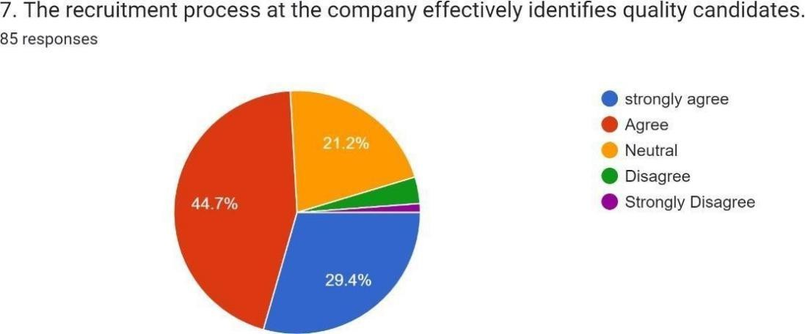

**INTERPRETATION:**

From the provided table, it is interpreted that 29.4% strongly agree, 44.7% agree, 21.2% are neutral, 3.5% disagree, and 1.2% strongly disagree.

**INFERENCE:**

The majority of respondents (44.7%) that the recruitment process at the company effectively identifies quality candidates as agreed.

**TABLE INDICATING THE RECRUITMENT AND SELECTION PROCESS AT THE COMPANY IS TRANSPARENT AND UNBIASED.**

|  |  |  |  |
| --- | --- | --- | --- |
| **Category** | **Frequency** | **Percentage (%)** | **Cumulative Percent** |
| **Strongly Disagree** | **1** | **1.2** | **1.2** |
| **Disagree** | **9** | **10.6** | **11.8** |
| **Neutral** | **20** | **23.5** | **35.3** |
| **Agree** | **38** | **44.7** | **80.0** |
| **Strongly Agree** | **17** | **20.0** | **100.0** |
| **Total** | **85** | **100.0** |  |

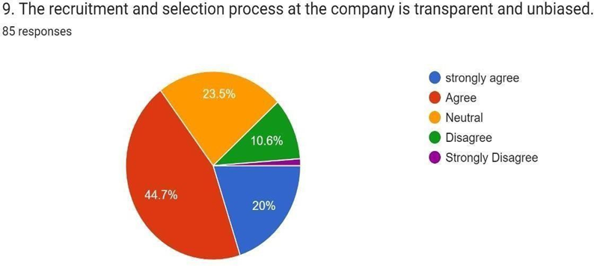

**INTERPRETATION:**

From the above table, it is evident that 20% of the respondents strongly agree, 44.7% agree, 23.5% are neutral, 10.6% disagree, and 1.2% strongly disagree.

**INFERENCE**:

The majority of respondents (44.7%) agreed that the recruitment and selection process at company is transparent and unbiased as agreed

**TABLE INDICATING EMPLOYEES HIRED THROUGH THIS PROCESS EXHIBIT A HIGH LEVEL OF JOB SATISFACTION.**

|  |  |  |  |
| --- | --- | --- | --- |
| **Category** | **Frequency** | **Percentage (%)** | **Cumulative Percent** |
| **Strongly Disagree** | **1** | **1.2** | **1.2** |
| **Disagree** | **5** | **5.9** | **7.1** |
| **Neutral** | **18** | **21.2** | **28.2** |
| **Agree** | **46** | **54.1** | **82.4** |
| **Strongly Agree** | **15** | **17.6** | **100.0** |
| **Total** | **85** | **100.0** |  |

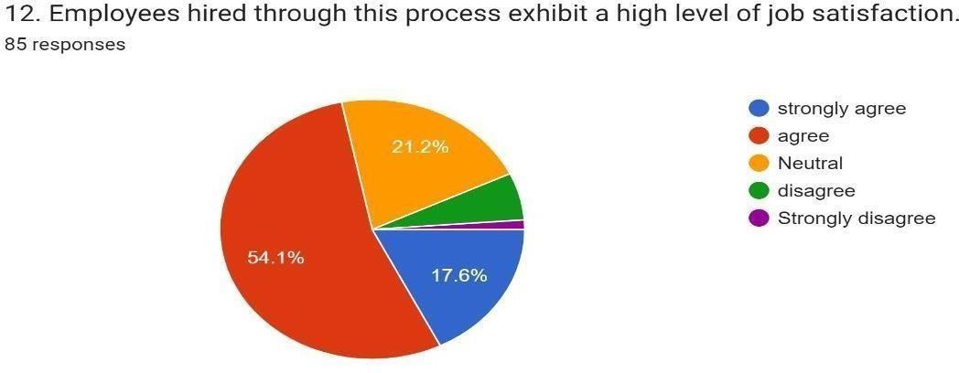

**INTERPRETATION**:

The table indicates that 17.6% strongly agree, 54.1% agree, 21.2% are neutral, 5.9% disagree, and 1.2% strongly disagree.

**INFERENCE**:

The majority of respondents (54.1%) that employees hired through this process exhibit a high level of job satisfaction as agreed

**REFERENCES**

Adam, J. (1963): Towards an understanding of disparity. Diary of Anomalous and Social Brain research, 67, 422-436. Adams, S.J. (1965): Disparity in social trade. Berkowitz (Ed.), Propels in exploratory social brain research (Vol. 2, pp.267-299).

Modern York: Scholarly Press. Agarwal, N., & Thit, M. (2003): Human asset issues, challenges and techniques in the Indian program industry. Universal Diary of Human Asset Administration, 3 (3), 249- 264.

Agarwala, T. (2003): Imaginative human asset hones and organizational commitment: An experimental examination. Universal Diary of Human Asset Administration, 14 (2), 175-197.

Ainsworth, M., & Smith, N. (1993): Making it happen: Overseeing execution at work. Sydney: Prentice Lobby.

Alexander, S., & Ruderman, M. (1987): The part of procedural and distributive equity in organizational conduct. Social Equity Inquire about, Alexander, S., Sinclair, R.R., & Tetrick, L.E. (1995): The part of organizational equity in characterizing and keeping up the business relationship. Tetrick & J. Barling (Eds.), Changing work relations: Behavioural and social viewpoints. Washington D.C.: American Mental Affiliation.

**BOOK**

* The Art of the Recruiter Message by Jonathan Kidder
* The Executive Recruiter's Playbook by William J Sheweloff
* Top Talent Sourcing Tools for Recruiters by Jonathan Kidder