DEVELOPMENT OF A CONCEPTUAL MODEL ON ADOPTION OF 3D PRINTING TECHNOLOGIES IN INDIAN CONSTRUCTION INDUSTRIES

*Aswin V 1, Sindhu Vaardini U2*

*1M.E Construction Management Student, Department of Civil Engineering, Kumaraguru College of Technology, Coimbatore, Tamil Nadu, India.*

*2Professor [PG], Department of Civil Engineering, Kumaraguru College of Technology, Coimbatore, Tamil Nadu. India.*

[aswinvenkat750@gmail.com](mailto:aswinvenkat750@gmail.com), [sindhuvaardini.u.ce@kct.ac.in](mailto:sindhuvaardini.u.ce@kct.ac.in)

***ABSTRACT*** *This study explores the integration of 3D printing technology in the Indian construction industry, emphasizing its transformative potential for enhancing efficiency, reducing material waste, and improving design flexibility. Despite its advantages, the adoption rate remains slow due to various technological, organizational, regulatory, and environmental barriers. Using the Technology- Organization-Environment-Policy (TOEP) framework, this research identifies the factors influencing 3D printing adoption by analyzing survey responses from industry professionals. The study aims to develop a conceptual model that addresses these challenges, fostering an environment where 3D printing can be more readily integrated. By examining case studies, the research evaluates the performance of 3D printing relative to traditional methods, underscoring the benefits and limitations of this innovative approach in the Indian context. The findings aim to support a strategic shift towards sustainable and efficient construction practices in India, potentially setting a model for global adoption in similar markets.*

***Keywords:*** *3D printing, Technology- Organization-Environment-Policy (TOEP), survey responses, traditional methods,* *Technology Acceptance Model (TAM),* *Structural Equation Modelling (SEM)*

**INTRODUCTION**

3D printing technology is transforming the construction industry by enabling faster execution, reducing material waste, and offering sustainable design solutions. In India, where construction is vital to economic growth, 3D printing has the potential to revolutionize traditional methods, yet adoption remains slow due to technological, organizational, and regulatory barriers. Also known as additive manufacturing, 3D printing constructs structures layer by layer, offering benefits like design flexibility, waste reduction, and seamless integration with Building Information Modelling (BIM). Its applications range from architectural modelling to full-scale building production and heritage restoration. Despite advantages such as improved safety and reduced environmental impact, challenges like high costs, limited materials, and lack of standardization hinder widespread adoption. To analyse these barriers, adoption models like the Technology Acceptance Model (TAM) and Diffusion of Innovation (DOI) provide insights, while the Technology-Organization-Environment-Policy (TOEP) framework helps assess adoption at the firm level. This study aims to develop a conceptual model using Structural Equation Modelling (SEM) and compare conventional and 3D-printed construction methods through case studies. The findings will help Indian construction firms embrace 3D printing, enhancing efficiency, sustainability, and competitiveness.

**LITERATURE REVIEW**

1. **3D Printing in Construction**

3D printing has emerged as a transformative technology in the construction industry, offering innovative solutions to long-standing challenges. Initially, it was utilized for creating architectural prototypes and scaled models (Buswell et al. 2008; Smith et al. 2012). However, advancements in material science and automation have enabled the fabrication of full-scale building components and even entire structures (Lim et al. 2012; Perkins and Skitmore 2015). Several notable projects have demonstrated the potential of 3D printing in construction, such as the development of contour crafting techniques by Khoshnevis (2014) and the implementation of robotic arm-based printing systems (Keating et al. 2017).

Among the key benefits of 3D printing in construction is its ability to produce highly complex and customized designs with minimal waste and reduced labour costs (Wu, Wang, and Wang 2016). Unlike traditional prefabrication methods, 3D printing does not require extensive formwork or molds, making it particularly advantageous for non-standardized designs (Perkins and Skitmore 2015). Additionally, it offers enhanced precision and automation, which contribute to faster construction timelines and increased safety by minimizing on-site human intervention (Hager, Golonka, and Putanowicz 2016).

Despite these benefits, the widespread adoption of 3D printing in construction remains slow. Challenges such as material limitations, regulatory barriers, and high initial investment costs have hindered its mainstream acceptance (Smith et al. 2012; Wu, Wang, and Wang 2016). Furthermore, three primary 3D printing technologies have gained prominence in the construction industry: contour crafting, extrusion-based concrete printing, and powder-based D-shape technology (Lim et al. 2011; Dini 2017). Each of these technologies has distinct advantages and constraints, which influence their applicability in different construction scenarios.

1. **Factors Influencing Adoption of 3D Printing Technology**

**2.1 Technological Readiness**

The readiness of 3D printing technology for construction applications has been a critical factor in its adoption. Bak (2003) emphasized that while 3D printing offers substantial cost and time advantages, its practical implementation is hindered by insufficient knowledge about process limitations and material performance. Concrete remains the dominant material used in construction 3D printing, owing to its strength and durability (Bos et al. 2016). However, challenges such as achieving optimal moisture content and ensuring structural integrity in layered printing must be addressed before large-scale adoption can occur.

Recent advancements in steel 3D printing have expanded the possibilities for using the technology in infrastructure projects. MX3D’s successful creation of a 3D-printed steel bridge in Amsterdam exemplifies the potential of additive manufacturing for complex structural applications (The Economist 2015). For 3D printing to be commercially viable, materials must meet industry standards for strength, durability, and cost-effectiveness (Labonnote et al. 2016).

**2.2. Effectiveness of 3D Printing**

The effectiveness of 3D printing in construction is evaluated based on cost, quality, time efficiency, and sustainability. Wu, Wang, and Wang (2016) highlighted the cost sensitivity of the construction industry, emphasizing the need for a thorough cost-benefit analysis before adopting new technologies. While 3D printing has the potential to lower construction costs in the long run, its initial investment and design complexities can be significant barriers (Perkins and Skitmore 2015).

Quality improvements in construction through automation have been a key driver of 3D printing adoption (Veda 2013). Unlike conventional construction methods, which are prone to human error and inconsistencies, 3D printing ensures greater precision and standardization (Labonnote et al. 2016). Additionally, the ability to rapidly prototype and iterate designs can reduce project delays and enhance overall efficiency (Buswell et al. 2008).

Sustainability is another crucial factor influencing the adoption of 3D printing technology. The method significantly reduces material waste, minimizes the need for extensive transportation, and decreases construction-related emissions (Haymond 2008; Johnson and Collins 2017). As a result, it aligns well with the growing demand for eco-friendly construction practices.

**2.3. Organizational Support**

Successful adoption of 3D printing technology in construction requires strong organizational commitment. Sargent, Hyland, and Sawang (2012) argued that top management involvement is crucial for facilitating technological change within firms. Resistance to change and skepticism among stakeholders can impede adoption unless companies actively invest in training and capacity building (Hayes 2007).

The availability of skilled labour for operating 3D printing equipment is another consideration. As with any emerging technology, a shortage of trained professionals can slow down implementation (Negahban, Baecher, and Skibniewski 2012). Case studies demonstrating the practical benefits of 3D-printed buildings can help overcome these barriers by showcasing the technology’s real-world advantages and cost savings (Sargent, Hyland, and Sawang 2012).

**2.4. Policy and Regulatory Considerations**

The transition from conventional to innovative construction methods necessitates regulatory support. Arora et al. (2014) identified the lack of clear guidelines and standards as a major barrier to adopting 3D printing technology. Similarly, Zhao et al. (2017) highlighted the risks associated with inadequate expertise and policy frameworks in emerging construction technologies.

Currently, building codes and regulations in many countries do not account for 3D-printed structures, leading to challenges in obtaining approvals and certifications (Strauss 2013). Standardized policies and regulatory reforms are essential to facilitate the safe and efficient integration of 3D printing in the construction industry (Smith 2012). Moreover, liability concerns regarding the performance and durability of 3D-printed components must be addressed through contractual clarity and risk-sharing mechanisms (Johnson and Collins 2017).In addition to regulatory considerations, issues related to maintenance and end-of-life deconstruction of 3D-printed buildings require attention. Unlike traditional construction methods, which follow well-established demolition and recycling processes, 3D-printed structures may pose new challenges in terms of material reuse and waste management (Haymond 2008).

Overall, while 3D printing holds immense potential for revolutionizing the construction industry, its adoption depends on overcoming technological, organizational, and regulatory hurdles. Future research should focus on developing standardized materials, optimizing cost-effectiveness, and establishing comprehensive regulatory frameworks to support the technology’s integration into mainstream construction practices.

Based on the literature review, a total of 32 factors influence in adoption of the 3D printing technology in the construction industry are identified and categorized into four groupings, as shown in Table 1. These four factor groupings are interconnected and do not function independently. Therefore, a conceptual framework (Figure 1) has been developed to illustrate their interactions, leading to the formulation of four hypotheses.

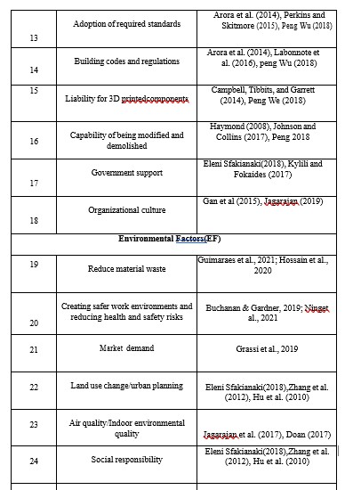Hypothesis 1: Technological factors positively influence the Efficiency of 3D Printing.

Hypothesis 2: organizational factors positively influence the Efficiency of 3D Printing.

Hypothesis 3: Policy and regulatory factors positively influence the Efficiency of 3D Printing.

Hypothesis 4: Environmental factors positively influence the Efficiency of 3D Printing.

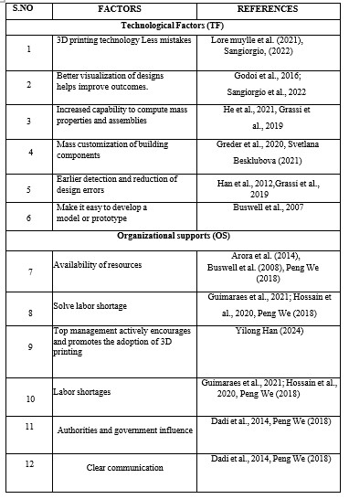**Table 1 Factors Identified Based on Literature**

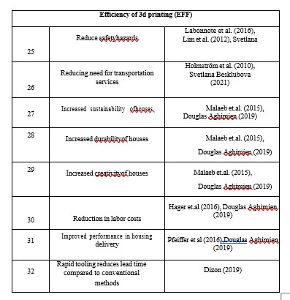

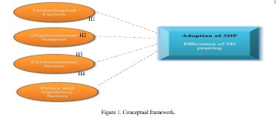

Figure 1. Conceptual framework.

**METHODOLOGY**

There searches design is shown in Figure 2 A comprehensive literature review was conducted to identify factors influencing the adoption of 3D printing technology in the Indian construction industry. The identified factors were categorized based on expert insights gathered from five senior managers with extensive industry experience. These experts provided feedback to refine the factor list and validate its relevance to the Indian construction sector. Their inputs also helped in revising the survey questionnaire to ensure clarity and accuracy.

An online questionnaire survey was conducted to achieve the research objectives. The survey link was circulated via email and LinkedIn, accompanied by an explanatory letter detailing the study's purpose and the researchers' contact information. Respondents were encouraged to participate and were given the option to seek further clarification if needed. The questionnaire included demographic profiling of respondents and a Likert scale-based evaluation (1 = very low to 5 = very high) of the factors influencing 3D printing adoption in the Indian construction industry. The five-point scale was chosen based on its widespread use in construction management studies for ease of response.

The study targeted professionals across various sectors of the Indian construction industry. Due to the absence of a defined sampling frame, a non-probability sampling method was adopted. Snowball sampling was used to recruit participants, leading to the collection of 105 complete survey responses. The demographic distribution of respondents included professionals from different age groups, job roles, and industry sectors, ensuring a diverse dataset.

For data analysis, a one-sample t-test was conducted to determine whether the identified factors significantly influenced the adoption of 3D printing. The factors were then ranked based on their mean scores. Structural Equation Modelling (SEM) was employed to validate the conceptual model by assessing the relationships between factor groupings and their interactions. Given the study’s sample size and data characteristics, Partial Least Squares SEM (PLS-SEM) was chosen as the most suitable approach. The SEM analysis consisted of a measurement model to evaluate factor relationships and a structural model to test the proposed hypotheses. By integrating literature review insights, survey data, and statistical analysis, this research provides a validated conceptual model that can serve as a guideline for industry stakeholders aiming to adopt 3D printing in Indian construction.

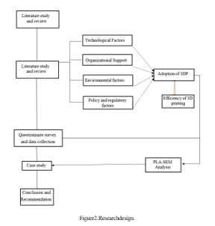Figure 2. Research design.

**DATA COLLECTION AND ANALYSIS**

From the prepared questionnaire 126 responses were recorded and using the collected data conceptional framework has been developed tests include, Cronbach alpha test has been carried out.

**Table 2 Table Showing Respondents Nature of Project**



**Table 3 Table Showing Respondents Designation**



**Table 4 Table Showing Working Experience**

**Table 5 Reliability Inference**



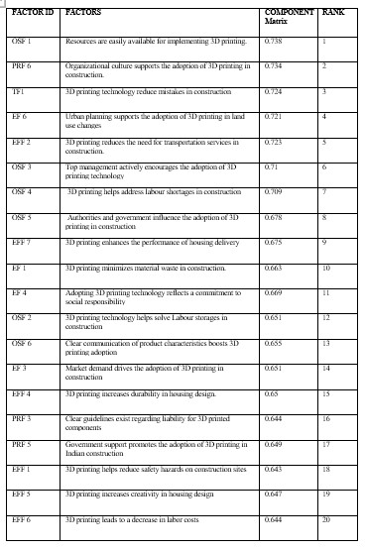**Table 6 Ranking for independent factors**

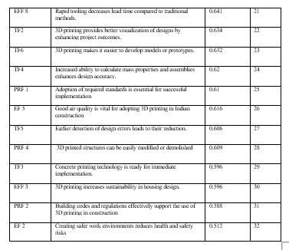

The data reveals that commercial buildings (30.2%) and infrastructure & heavy construction (25.4%) dominate the Indian construction industry, followed by residential buildings (24.6%) and industrial construction (15.1%), presenting significant opportunities for integrating 3D printing technologies into large-scale projects where speed, cost efficiency, and sustainability are critical. The study also highlights the distribution of key stakeholders, with Project Managers (31.7%) and Site Engineers (23.0%) playing major roles in project execution and on-site management, while Consultants (12.7%), Contractors (11.9%), and Clients (10.3%) influence decision-making, planning, and execution. The workforce experience distribution indicates a strong presence of mid-level (5.1-10 years, 25.4%) and highly experienced professionals (more than 10 years, 25.4%), along with early-career professionals (1-3 years, 28.6%). The Kaiser-Meyer-Olkin (KMO) value of 0.818 confirms the data's suitability for factor analysis, with Bartlett’s Test of Sphericity (p < 0.001) further validating its appropriateness. Among the technological factors, better visualization of designs (0.775) and easier model or prototype development (0.763) emerge as critical, reducing errors and improving design accuracy. The Relative Importance Index (RII), used to rank influencing factors, identifies the top five drivers of 3D printing adoption: strong organizational culture (0.734), reduced construction mistakes (0.724), minimized transportation needs (0.723), urban planning support (0.721), and top management encouragement (0.710). These findings emphasize that fostering an innovation-driven culture, improving accuracy, enhancing cost efficiency, leveraging urban planning policies, and securing leadership support are essential for accelerating 3D printing adoption in Indian construction industries.

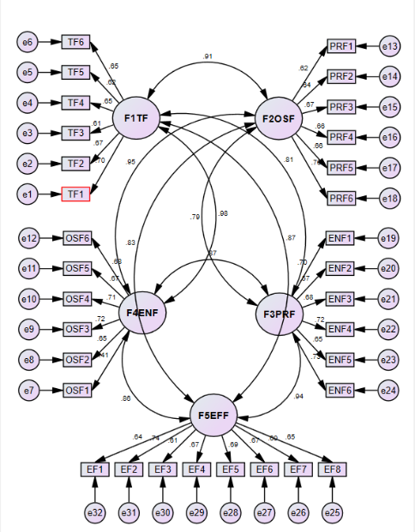**MODEL FIT**

Figure 3. Path Model

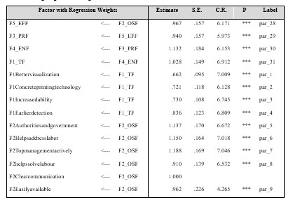**Table 7 Table Showing Regression Weights of Various Factors**

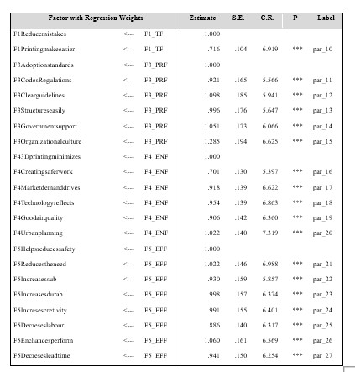**Table 4.23 Model Fit Summary**

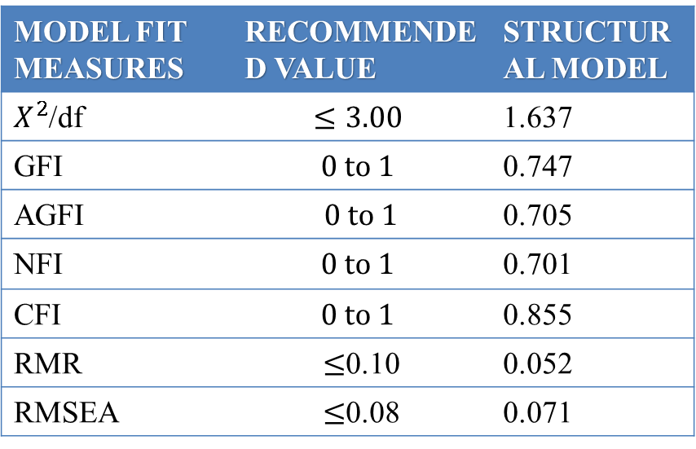

**RESULTS AND DISCUSSIONS**

The construction industry has evolved with technological advancements like 3D printing, which enhances efficiency, sustainability, and cost-effectiveness by reducing material waste, increasing design flexibility, and minimizing manual labour. The adoption of 3D printing in construction is driven by automation, cost-effectiveness, material efficiency, and sustainability, with government policies further promoting its integration. A quantitative analysis using statistical techniques confirms that economic feasibility, regulatory support, and technological accessibility strongly influence adoption rates, particularly among firms prioritizing innovation. To explore interrelations, a Structural Equation Model (SEM) was developed, showing that technological readiness mediates economic viability and adoption intention, while regulatory support enhances adoption likelihood by reducing legal barriers. Case studies comparing conventional and 3D printing methods reveal that 3D printing significantly reduces construction time, material waste, and long-term costs while offering environmental benefits through optimized resource utilization. Despite high initial investments, its scalability and transformative potential make it a promising technology for future construction. Further research could explore integrating AI, robotics, and IoT for greater automation, assessing the long-term durability of 3D-printed structures, analysing socio-economic impacts, developing sustainable materials, and conducting comparative studies across different regulatory environments to facilitate global implementation.

**REFERENCES:**

1. Aghimien, D. et al. (2019). Making a Case for 3D Printing for Housing Delivery in South Africa.
2. Allouzi, R. et al. (2020). Conventional Construction and 3D Printing: A Comparison Study on Material Cost in Jordan.
3. Beltagui, A. et al. (2019). The Role of 3D Printing and Open Design on Adoption of Socially Sustainable Supply Chain Innovation. https://doi.org/10.1016/j.ijpe.2019.07.035
4. Besklubova, S. et al. (2019). Factors Affecting 3D Printing Technology Adaptation in Construction.
5. Buchanan, C. et al. (2018). Metal 3D Printing in Construction: A Review of Methods, Research, Applications, Opportunities, and Challenges. <https://doi.org/10.1016/j.engstruct.2018.11.045>
6. Buswell, R. et al. (2007). Freeform Construction: Mega-scale Rapid Manufacturing for Construction. <http://dx.doi.org/10.1016/j.autcon.2006.05.002>
7. Chang, R. et al. (2020). Critical Success Factors for Implementing 3D Printing Technology in Construction Projects.
8. Dadi, G. et al. (2014). Performance of 3D Computers and 3D Printed Models as a Fundamental Means for Spatial Engineering Information Visualization. <http://dx.doi.org/10.1139/cjce-2014-0019>
9. Davidson, C. et al. (2013). Innovation in Construction Before the Curtain Goes Up. <http://dx.doi.org/10.1108/CI-02-2013-0007>
10. De Schutter, G. et al. (2018). Cement and Concrete Research. <https://doi.org/10.1016/j.cemconres.2018.06.001>
11. Dizon, R. et al. (2019). Three-Dimensional-Printed Molds and Materials for Injection Molding and Rapid Tooling Applications. <https://doi.org/10.1557/mrc.2019.147>
12. El-Sayegh, S. et al. (2020). A Critical Review of 3D Printing in Construction: Benefits, Challenges, and Risks.
13. Gemmel, P. et al. (2019). Technology Readiness and Adoption of 3D-Printing in the Construction Industry.
14. Godoi, F. et al. (2016). 3D Printing Technologies Applied for Food Design: Status and Prospects. <http://dx.doi.org/10.1016/j.jfoodeng.2016.01.025>
15. Grassi, G. et al. (2021). Fabrication and Durability Testing of a 3D Printed Façade for Desert Climates. <https://doi.org/10.1016/j.addma.2019.05.023>
16. Greder, K. et al. (2020). Design in 3D: A Computational Fashion Design Protocol. <https://doi.org/10.1108/IJCST-07-2019-0110>
17. Guimarães, A. S. et al. (2021). Advanced Manufacturing in Civil Engineering. <https://doi.org/10.3390/en14154474>
18. Han, N. et al. (2011). Collision Detection of Building Facility Pipes and Ducts Based on BIM Technology. <http://dx.doi.org/10.4028/www.scientific.net/AMR.346.312>
19. Han, Y. et al. (2024). Unpacking the Dynamics of 3-D Concrete Printing Adoption.
20. Hatoum, M. et al. (2022). Determining Decision-Making Factors for Technology Adoption in the Construction Industry.
21. He, R. et al. (2021). BIM-enabled Computerized Design and Digital Fabrication of Industrialized Buildings. <https://doi.org/10.1016/j.jclepro.2020.123505>
22. Hossain, M. et al. (2023). A Review of 3D Printing in Construction and Its Impact on the Labor Market. <http://dx.doi.org/10.3390/su12208492>
23. Latif, E. et al. (2022). The Feasibility of 3D Printing Technology as a New Construction Method for Houses in Saudi Arabia.
24. Ma, J. et al. (2019). Environmentally Sustainable Management of 3D Printing Network. <https://doi.org/10.1007/s12541-019-00280-0>
25. Ning, X. et al. (2021). 3D Printing in Construction: Current Status, Implementation Hindrances, and Development Agenda. https://doi.org/10.1155/2021/6665333