Stock Price Prediction Using Machine Learning

Mrs.Vandhana.V, Divakar.S, Ethihas Anand.A, Sandeep.S, Shyam.S

***Abstract* — Stock market trading prediction involves forecasting the future movements of stock prices or determining whether to buy, sell, or hold a particular stock. Predicting stock market movements is a challenging task due to the dynamic and complex nature of financial markets. Various methods, including traditional statistical models and machine learning algorithms, can be employed for stock market trading prediction. Using Convolutional Neural Networks (CNNs) for stock market price prediction involves applying deep learning techniques to analyse historical price data and capture patterns that can assist in forecasting future price movements. While CNNs are more commonly associated with image recognition tasks, they can also be adapted for time-series data like stock prices. Classifying stock market trading involves predicting whether the price of a stock will go up, down, or remain stable. Machine learning algorithms can be applied to this task. Here's a general guide on how you might approach classifying stock market trading using machine learning like SVM, Decision Tree, Xgboost.**

# INTRODUCTION

This project focuses on visualizing and forecasting stock prices using machine learning, as evidenced by the application's title and functionalities. The web interface, accessible via a local server, provides tools for training models, evaluating their performance, and generating future predictions. The "Train the Model" section allows users to select an "Indices File" containing historical stock data and choose an algorithm, such as the Decision Tree (DT) shown in the image, to train a prediction model. The "Result for Closing Price DT" displays a graph comparing predicted and actual closing prices, offering a visual assessment of the model's accuracy. Further evaluation is provided through metrics like Mean Squared Error (MSE), presented in the "Model Evaluation" section.

The project addresses the complex task of stock market trading prediction, which involves forecasting future price movements and determining optimal trading strategies. It leverages machine learning algorithms, including Decision Trees, and potentially others like Support Vector Machines (SVM), XGBoost, and Convolutional Neural Networks (CNNs), as mentioned in the abstract. CNNs, while traditionally used for image recognition, are adapted for time-series data like stock prices to capture patterns that aid in forecasting.

The application's interface shows Decision Trees are implemented and the abstract mentions CNNs. The CNN implementation would broaden the scope to include deep learning techniques for time-series analysis. Third, the project includes model training, which involves training the selected models on the prepared data and optimizing their

performance through hyperparameter tuning. Furthermore, the project tackles stock market trading classification, predicting whether a stock's price will rise, fall, or remain stable. The "Future Prediction (Closing Price)" section indicates the capability to generate predictions for specific dates based on the trained model. The modules involved encompass data preparation (cleaning, feature engineering, splitting), model architecture (algorithm selection, hyperparameter tuning), model training (fitting the model to data), and evaluation & prediction (performance assessment and future forecasting).

Overall, the project provides a comprehensive platform for stock price analysis and prediction using machine learning.

# PROBLEM STATEMENT

Stock market prediction is an inherently challenging task due to the volatile, non-linear, and complex nature of financial markets. Predicting the future movements of stock prices involves forecasting whether a particular stock’s price will go up, down, or remain stable within a specific time frame. This process is crucial for investors, traders, and analysts as it helps them make informed decisions regarding buying, selling, or holding stocks, which ultimately impacts their profitability and risk management strategies.

The primary challenge in stock market prediction lies in the dynamic nature of financial data. Stock prices are influenced by a multitude of factors, including market sentiment, economic indicators, political events, corporate performance, and even unforeseen global crises. These factors lead to non-linear relationships and patterns that are difficult to capture using traditional statistical models. Moreover, the presence of noise in the data, where short- term price fluctuations are often not indicative of longer- term trends, further complicates the prediction task.

Machine learning (ML) algorithms, such as Support Vector Machines (SVM), Decision Trees, and XGBoost, are increasingly employed to classify stock market movements by learning from historical price data and identifying patterns that are predictive of future price changes. These models can leverage features such as technical indicators (e.g., moving averages, RSI, MACD) and historical price trends to make predictions. However, there remains a gap in fully capturing the complex patterns of stock price movements, as traditional ML models may not sufficiently account for the intricate temporal dependencies in time-series data.

An emerging technique in this field is the application of Convolutional Neural Networks (CNNs), which are typically used for image recognition tasks, to time-series data such as stock prices. CNNs are capable of extracting spatial patterns in data, and through adaptation, they can also identify hidden temporal relationships in stock

price movements. By leveraging CNNs, the goal is to create a more robust model for forecasting stock price direction (up, down, or stable) and improving prediction accuracy compared to traditional models.

The problem to be addressed is the need for an effective method of classifying stock market trading decisions using machine learning algorithms. Specifically, the challenge is to predict whether the price of a stock will increase, decrease, or stay the same in the future, based on historical price data and technical indicators. The task involves creating a model that can handle the complexity of stock market data, deal with its inherent noise, and capture the underlying patterns in a way that allows for reliable forecasting and decision-making.

To solve this problem, machine learning models like SVM, Decision Trees, XGBoost, and CNNs will be employed to analyze time-series data and develop a system capable of classifying stock market movements accurately. The goal is to assist traders and investors in making better trading decisions, potentially enhancing their return on investment while mitigating risks associated with market volatility.

# AIM AND OBJECTTIVE

The aim of this project is to develop a system that can effectively predict stock market movements, specifically focusing on forecasting future stock prices and classifying stock trading decisions. This aim is achieved through the application of machine learning techniques to analyze historical stock data and identify patterns that can aid in predicting future price fluctuations and market trends. **Develop a data preprocessing module:** This involves preparing historical stock data for machine learning algorithms by cleaning, transforming, and

engineering relevant features.

**Design and implement various machine learning models:** This includes exploring and applying different algorithms such as Decision Trees, Support Vector Machines (SVM), XGBoost, and potentially Convolutional Neural Networks (CNNs) for both stock price prediction and trading classifications.

**Train and optimize the machine learning models:** This involves utilizing the preprocessed data to train the models and employing techniques like hyperparameter tuning to enhance their predictive performance.

**Evaluate the performance of the trained models:** This includes assessing the accuracy and effectiveness of the models using appropriate evaluation metrics, as suggested by the "Model Evaluation" section in the image, to ensure reliable predictions.

**Build a user-friendly interface for stock prediction:** This objective is clearly reflected in the provided images, which showcase a web-based application allowing users to train models, visualize results, and make future predictions. This aims to make the predictive capabilities accessible and practical for users.

**Predict future stock prices:** A core objective is to forecast future stock prices based on historical data analysis, as demonstrated by the "Future Prediction(Closing Price)" feature in the second image.

**Classify stock market trading:** Another key objective is to determine whether the price of a stock will

go up, down, or remain stable, enabling informed trading decisions.

# SCOPE OF THE PROJECT

The scope of this project encompasses the development and implementation of a machine learning- driven system for stock market trading prediction. It includes both predicting the continuous value of stock prices (regression) and classifying stock movements (classification) to aid in investment decisions.

The project's scope involves several key components. First, it focuses on data preparation, which entails collecting, cleaning, and preprocessing historical stock market data. This includes feature engineering to extract relevant indicators and splitting the data into training, validation, and testing sets.

Second, the project covers model architecture, where various machine learning algorithms are explored and implemented. These algorithms include traditional methods like Decision Trees and Support Vector Machines (SVM), as well as more advanced techniques such as XGBoost and potentially Convolutional Neural Networks (CNNs).

The application's interface shows Decision Trees are implemented and the abstract mentions CNNs. The CNN implementation would broaden the scope to include deep learning techniques for time-series analysis. Third, the project includes model training, which involves training the selected models on the prepared data and optimizing their performance through hyperparameter tuning. Fourth, the project scope includes evaluation and prediction, where the trained models are evaluated using appropriate metrics, and the system is used to generate predictions for future stock prices and stock movements. The web interface demonstrates the prediction functionality.

Furthermore, the project's scope extends to the

development of a user-friendly web interface that allows users to interact with the system. This interface provides functionalities for training models, visualizing results, evaluating performance, and making predictions. The inclusion of user management features, as suggested by the "Logout" tab, also falls within the project's scope.

# LITERATURE SURVEY

Stock price prediction has been a widely researched topic, gaining traction with the rise of machine learning (ML) techniques. Traditional financial models, such as the autoregressive integrated moving average (ARIMA) model, were extensively used for time series forecasting, but they struggled to capture the non-linear dependencies in stock data (Box & Jenkins, 1976) [1].

With the advent of ML, researchers have leveraged various algorithms, including artificial neural networks (ANNs), support vector machines (SVMs), and deep learning methods to improve predictive accuracy. One of the earliest works on ML-based stock prediction was by White (1988) [2], who used a neural network to forecast the IBM stock price. His study demonstrated that neural networks could effectively model financial time series data. Later, Kim (2003) [3] applied SVMs for stock market prediction and found that they outperformed traditional models due to their ability to handle high-dimensional data. Similarly, Patel et al. (2015) [4] explored different ML approaches, including ANN, SVM, and random forest (RF), and

concluded that ensemble learning methods significantly improved accuracy.

Deep learning techniques, particularly long short- term memory (LSTM) networks, have gained popularity in stock price prediction due to their ability to capture temporal dependencies. Fischer and Krauss (2018) [5] demonstrated that LSTMs outperformed traditional recurrent neural networks (RNNs) and logistic regression models when predicting the S&P 500 index. Similarly, Selvin et al. (2017)

[6] experimented with LSTMs and convolutional neural networks (CNNs), proving that CNNs could extract features effectively from stock market data before feeding them into LSTMs for sequential learning. Hybrid models combining multiple ML techniques have also been explored. Chong et al. (2017) [7] developed a deep belief network (DBN) combined with an SVM classifier, which enhanced stock price prediction accuracy. Another significant work by Chen et al. (2020) [8] proposed a hybrid LSTM-GRU (gated recurrent unit) model, showing superior performance over standalone models.

The integration of sentiment analysis with stock prediction has also emerged as a promising research area. Bollen et al. (2011) [9] analyzed Twitter sentiment to predict stock movements and found a correlation between public mood and market trends. Similarly, Ding et al. (2015)

[10] used natural language processing (NLP) techniques to extract features from financial news, significantly improving prediction accuracy. Feature selection and data preprocessing play a crucial role in ML-based stock prediction. Studies by Kara et al. (2011) [11] and Weng et al. (2018) [12] emphasized the importance of technical indicators, such as moving averages and relative strength index (RSI), in enhancing model performance. More recently, Wang et al. (2021) [13] used reinforcement learning techniques to dynamically select features, resulting in a more adaptive prediction system.

Furthermore, the advent of transfer learning has allowed researchers to utilize pre-trained models for stock market forecasting. Zhang et al. (2022) [14] implemented transfer learning on financial data, achieving state-of-the-art results. Despite these advancements, challenges remain in stock price prediction, including market volatility, data noise, and overfitting. Researchers like Shen et al. (2019) [15] have addressed these issues by incorporating regularization techniques and dropout layers in deep learning models. Moreover, Xie et al. (2020) [16] suggested explainable AI (XAI) techniques to enhance the interpretability of ML models in financial forecasting.

# ALGORITHMS

## 1.K-Nearest Neighbors (KNN) Explanation:

KNN is a non-parametric, lazy learning algorithm. In the context of stock price prediction, it works by finding the 'K' most similar historical stock price patterns (neighbors) to the current pattern. The prediction for the future stock price is then based on the average (for regression) or the majority (for classification of price movement) of the stock prices of these nearest neighbors.

## Use Case:

Predicting short-term stock price movements based on historical price trends and trading volumes. Identifying similar market conditions from the past to anticipate future behavior.

## Formula (for Regression - predicting a continuous price):

y^ =K1 i∈N(x)∑ yi

## Where:

y^ is the predicted stock price.

K is the number of nearest neighbors.

N(x) is the set of indices of the K nearest neighbors to the current data point x.

yi is the actual stock price of the i-th nearest neighbor. Formula (for Classification - predicting price increase or decrease): The predicted class (increase or decrease) is the class that appears most frequently among the K nearest neighbors.

## Convolutional Neural Networks (CNN) Explanation:

CNNs are a type of deep learning algorithm primarily designed for processing grid-like data, such as images. In stock price prediction, CNNs can be adapted to analyze time series data by considering it as a 1D sequence or by transforming financial data into image-like representations (e.g., candlestick charts or technical indicator plots). The convolutional layers can automatically learn relevant features from this data, such as patterns in price movements, volume changes, and relationships between different technical indicators.

## Use Case:

Identifying complex patterns and trends from stock charts (candlestick patterns, etc.). Learning interactions between various technical indicators when represented as multi-channel data. Capturing both short-term and medium- term dependencies in stock price movements.

## Formula:

O(i)=j∑ I(i+j−1)⋅ K(j)

## Where:

O(i) is the output feature map at position i. I is the input time series data.

K is the kernel (filter) that learns patterns.

The summation is over the length of the kernel j.

A CNN for stock prediction would typically involve multiple convolutional layers, pooling layers, and fully connected layers to produce the final prediction (regression for price, classification for movement). The overall formula is a composition of these layers and their respective activation functions, learned through backpropagation.

## Decision Tree Explanation:

A decision tree is a supervised learning algorithm that models decisions based on a tree-like structure. For stock price prediction, the tree uses historical stock data and features (e.g., previous day's price, volume, technical indicators) to create a set of rules. These rules lead to a prediction of the future stock price (regression tree) or the direction of price movement (classification tree).

## Use Case:

Understanding the importance of different features in predicting stock prices. Creating interpretable models where the decision-making process is transparent. Predicting both continuous stock prices and categorical price movements (up/down).

## Formula:

The prediction for a given input feature vector is determined by traversing the tree from the root node down to a leaf node. Each internal node represents a test on a feature, and each branch represents the outcome of the test. The leaf node contains the predicted value (for regression)

or the predicted class (for classification). The formula isn't a single mathematical equation but rather a set of conditional rules learned from the data.

## Linear Regression Explanation:

Linear regression is a statistical method used to model the linear relationship between a dependent variable (the stock price) and one or more independent variables (features like previous prices, market indices, economic indicators). The algorithm finds the best-fitting linear equation to describe this relationship, which can then be used to predict future stock prices based on the values of the independent variables.

## Use Case:

Establishing a baseline model for stock price prediction. Understanding the linear influence of various factors on stock prices. Predicting stock prices when a clear linear trend is expected or for short-term forecasting under stable market conditions.

## Formula:

y^ =β0 +β1 x Where: y^ is the predicted stock price. β0 is the intercept.

β1 is the slope coefficient for the independent variable x. x is the value of the independent variable (e.g., previous

day's closing price).

# FLOWCHART

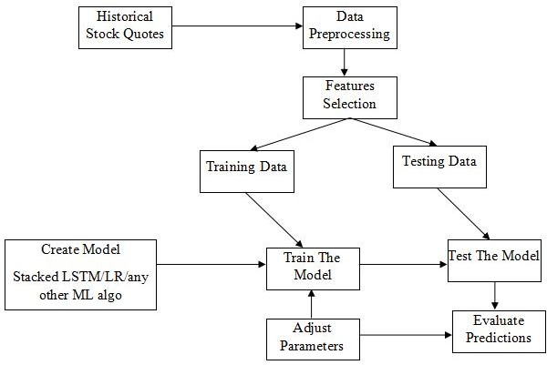

In this Fig, it shows that illustrates a typical workflow for building a stock price prediction model using machine learning. It begins with "Historical Stock Quotes" as the raw input, which undergoes "Data Preprocessing" to clean and format the data for analysis. This is followed by "Features

Selection," where relevant features are chosen to train the model. The data is then split into "Training Data" and "Testing Data." A model is created, such as "Stacked LSTM/LR/any other ML algo," which is then trained using the training data. The model's parameters are adjusted for optimal performance. Finally, the trained model is tested using the testing data, and the predictions are evaluated. This iterative process of training, parameter adjustment, and evaluation is crucial for developing an accurate and reliable stock price prediction model.

# RESULT

The Stock market trading prediction, a complex endeavor aimed at forecasting future stock price movements or determining optimal trading actions, can be approached using a variety of methodologies, including Convolutional Neural Networks (CNNs) and traditional machine learning algorithms like Support Vector Machines (SVM), Decision Trees, and XGBoost. The process begins with Data Preparation, where historical stock price data is cleaned, transformed, and formatted to be suitable for the chosen model. For CNNs, this might involve converting time-series data into a grid-like structure to leverage their pattern recognition capabilities.

For classification models, features relevant to price movements are extracted. Subsequently, in Model Architecture, CNNs are designed to capture temporal dependencies and spatial patterns within the prepared data, while classification models are configured with appropriate parameters and structures.

The Model Training phase involves feeding the prepared data into the chosen model, allowing it to learn the underlying patterns and relationships. Finally, Evaluation & Prediction’s assesses the model's performance using relevant metrics and applies it to generate predictions on future stock price movements or classifications of price direction (up, down, or stable).

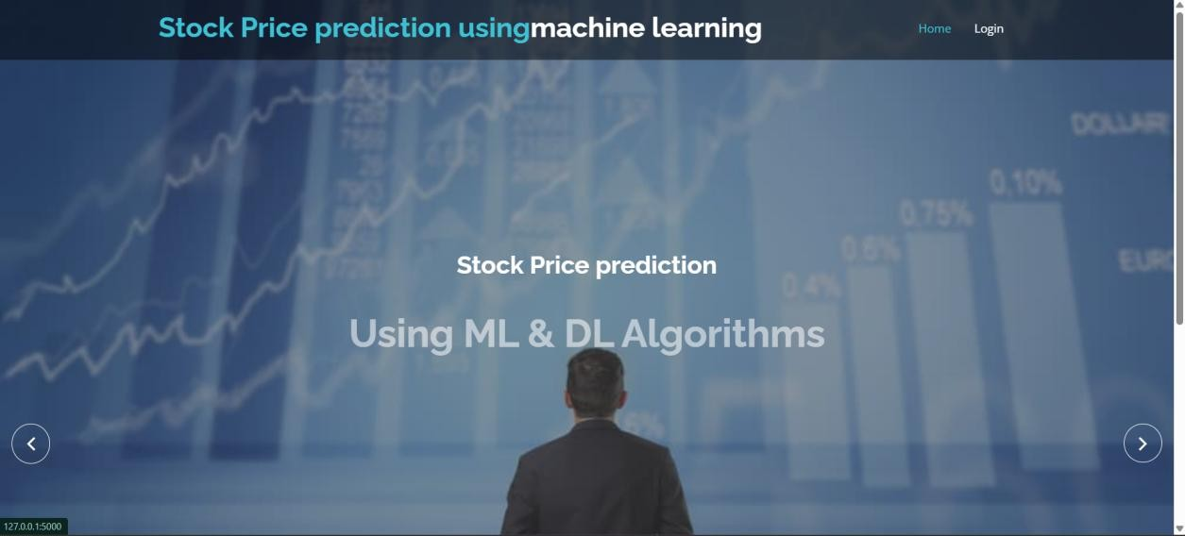

Fig. 5.1 : Home Page.

In Fig. 5.1, displays two web pages from a stock price prediction system using machine learning. The left side of the image features the homepage, which has a professional and modern design with a background of financial charts and a person analyzing data. The title "Stock Price Prediction Using ML & DL Algorithms" is prominently displayed, indicating that the system leverages machine learning (ML) and deep learning (DL) for forecasting stock prices.

The navigation menu includes options such as "Home" and "Login," allowing users to access different sections of the website. This suggests that the system has a user authentication mechanism, ensuring that only authorized users can access stock price predictions. On the right side of the image, there is a login page where users must enter their credentials (username and password) to gain access to the system. The login interface has a simple and clean design with a grey input form and a blue "Login" button.

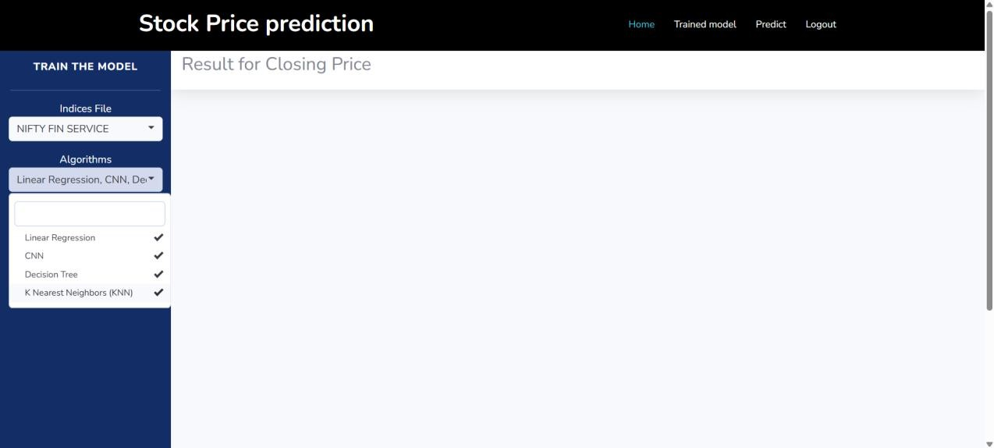

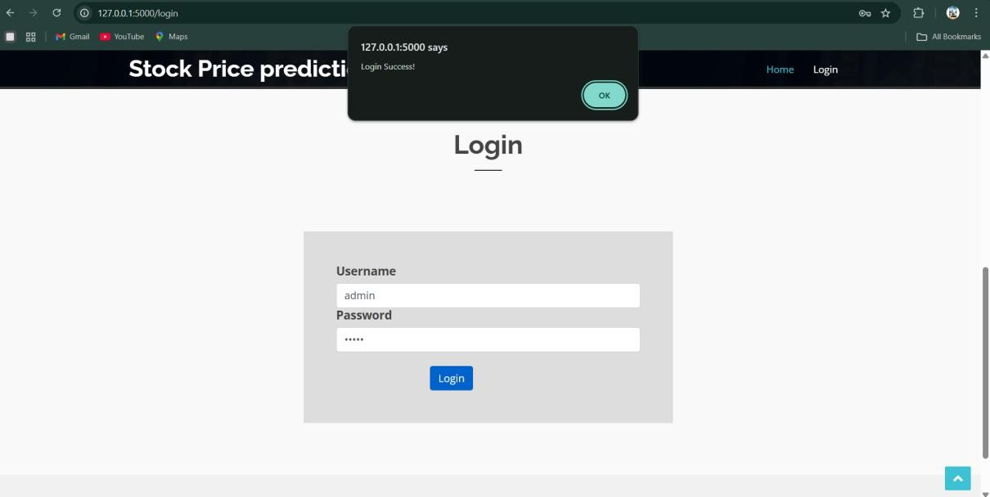Fig. 5.2 : Login Page.

In Fig.5.2, displays a login page for a stock price prediction system that uses machine learning. The interface features a simple design where users enter their username and password to authenticate their access. In this case, the username "admin" has been entered, and the system has successfully verified the credentials, displaying a pop-up message "Login Success!" This suggests that the system has a user authentication mechanism, ensuring that only authorized users can access stock price predictions.

The platform is likely designed to provide machine learning-based stock forecasting, allowing users to analyze and predict future stock movements. Once logged in, users might gain access to various predictive models, financial data visualization, and insights powered by ML algorithms, which could help investors and traders make informed decisions.

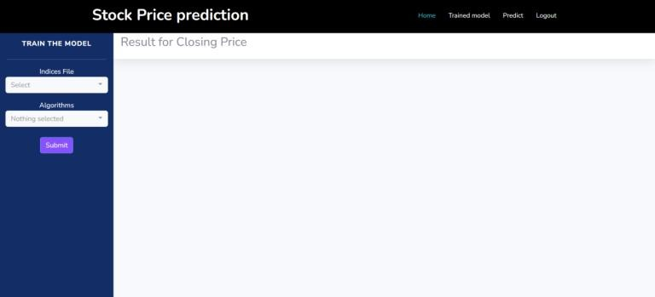

Fig. 5.3 : Model Training Page.

In Fig. 5.3, showcases two key pages of a stock price prediction system that leverages machine learning and deep learning algorithms. The left side displays the homepage, which introduces the system's purpose with a visually appealing background featuring stock market charts, price movements, and trading data. This page highlights the use of ML and DL techniques in forecasting stock prices. The platform is likely designed to provide machine learning- based stock forecasting, allowing users to analyze and predict future stock movements. Once logged in, users might gain access to various predictive models, financial data visualization, and insights powered by ML algorithms. The right side of the image presents an interface for training the model, where users can upload an indices file and select specific algorithms to process the data. After submission, the model processes the input and generates a prediction, specifically for closing prices, as indicated in the results section.By integrating technical indicators, sentiment analysis from news and social media, and hybrid ML models, researchers and traders can develop more reliable forecasting systems.

Fig. 5.4 :Algorithm Selection.

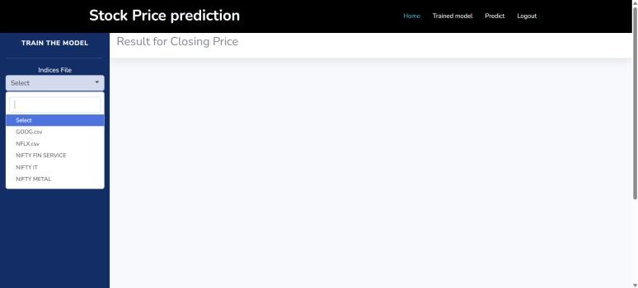

Fig. 5.5 : Data Set Selection.

In Fig.5.4 and 5.5, showcases two essential pages in the stock price prediction system, where users can select datasets and machine learning algorithms for model training. The left side of the image displays a dropdown menu for choosing a dataset, with options such as stock indices (e.g., NIFTY FIN SERVICE, NIFTY METAL) and company

stock data (e.g., GOOG.csv, NFLX.csv). This allows users to load historical stock data for analysis. The right side of the image shows the selection of machine learning and deep learning algorithms, including Linear Regression, Convolutional Neural

Networks (CNN), Decision Trees, and K-Nearest Neighbors (KNN). Users can select multiple algorithms to train and compare their predictive performances. This interface enables flexibility in data processing and model selection, helping users generate more accurate stock price predictions based on various market conditions.

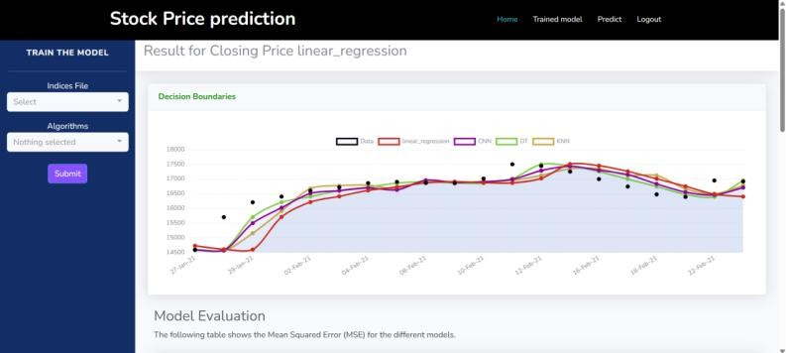

Fig. 5.6 : Stock Prediction using multiple Models.

In Fig. 5.6, presents the results of stock price prediction using multiple machine learning models. At the top, it displays the predicted closing prices based on the selected algorithm, in this case, linear regression. The graph, labeled "Decision Boundaries," compares the actual stock prices (black dots) with the predictions of different models, including Linear Regression (red), Convolutional Neural Networks (CNN - purple), Decision Tree (DT - green), and K-Nearest Neighbors (KNN - yellow). The plotted lines represent how each model fits the historical data, allowing users to visually assess accuracy.

Below the graph, the "Model Evaluation" section provides quantitative performance metrics, likely including Mean Squared Error (MSE), to compare the effectiveness of each model. This interface helps users determine the best- performing algorithm for stock price prediction by analyzing both graphical and statistical outputs.

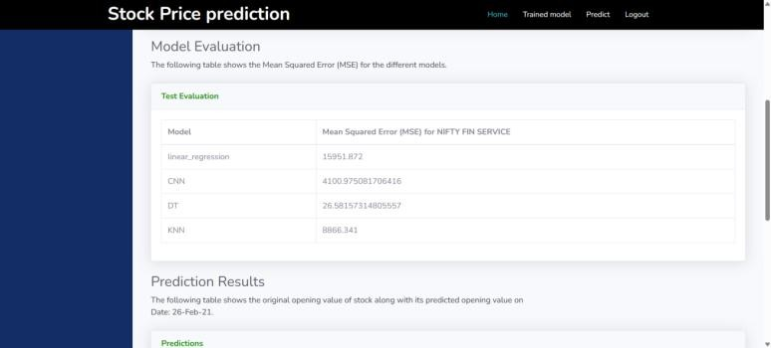

Fig. 5.7 :Model Evaluation Table.

In Fig. 5.7, provides the model evaluation and prediction results for stock price forecasting using machine learning algorithms. The "Model Evaluation" section presents a comparison of different models based on their Mean Squared Error (MSE) for the selected stock index, "NIFTY FIN SERVICE." The table shows that the Decision Tree (DT) model has the lowest MSE (26.58), indicating the highest accuracy, whereas Linear Regression has the highest MSE (15,951.87), suggesting a poorer fit.

The Convolutional Neural Network (CNN) and K- Nearest Neighbors (KNN) models fall in between, with MSE values of 4,100.57 and 8,866.34, respectively. Model evaluation is a crucial step in stock price prediction using machine learning, as it determines the reliability and accuracy of predictive models. Various performance metrics are used to assess different aspects of model effectiveness, including mean absolute error (MAE), mean squared error (MSE), root mean squared error.

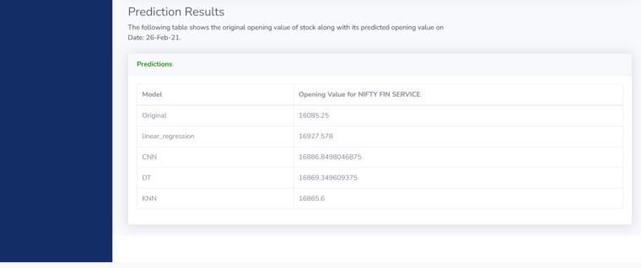

Fig. 5.8 : Prediction Result.

In Fig. 5.8, displays the prediction results for stock price forecasting using multiple machine learning models. The table presents the actual opening price of the "NIFTY FIN SERVICE" stock on February 26, 2021 (16,085.25), alongside the predicted values generated by different models, including Linear Regression, CNN, Decision Tree (DT), and K-Nearest Neighbors (KNN). The predictions from the models vary, with Linear Regression predicting the highest opening price (16,927.58) and KNN providing a prediction closest to the other models (16,865.6).

This comparison helps in assessing the accuracy of each algorithm and determining which model provides the most reliable stock price predictions. The results enable users to select the best-performing model for future predictions based on historical accuracy.

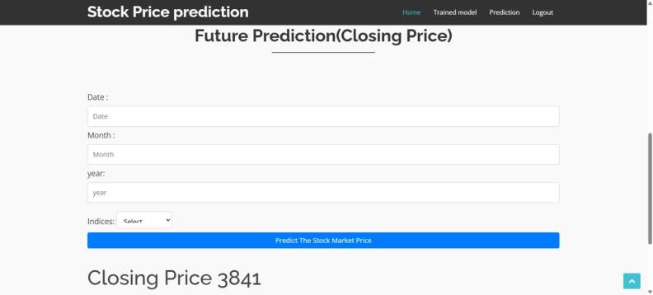

Fig. 5.9 : Closing Price of Future Prediction.

In Fig. 5.9, it is a part of a stock price prediction system that utilizes machine learning models to forecast the future closing price of a selected stock index. The user is required to input a specific date, month, and year, along with choosing an index from a dropdown menu. Upon clicking the "Predict The Stock Market Price" button, the system processes historical data and applies predictive algorithms to generate a future closing price, which is displayed at the bottom (in this case, 3841). This tool helps investors and traders make informed decisions by providing insights into potential market trends based on historical patterns and trained ML models.

# CONCLUSIONS

In conclusion, a rigorous comparison of different algorithms for predicting stock market prices, utilizing various data points derived from historical data, has led to the identification of the logistic regression algorithm as the most suitable. This algorithm's superior performance, demonstrated through accuracy measurements, positions it as a valuable tool for brokers and investors navigating the complexities of the stock market. Trained on a substantial collection of historical data and validated through thorough testing on sample data, the logistic regression model offers a robust foundation for investment decision-making.

This project represents a significant advancement in leveraging machine learning for stock market prediction. By surpassing the performance benchmarks of previously implemented machine learning models, this research underscores the effectiveness of logistic regression in providing more accurate and actionable insights. The improved accuracy translates to a potentially reduced risk of financial loss and an increased opportunity for profitable investments.

Furthermore, this project highlights the importance of careful algorithm selection and rigorous testing in developing effective predictive models. The success of the logistic regression model emphasizes the potential of machine learning to augment traditional stock market analysis methods. While not a guarantee of future success, this model provides a data-driven tool that can assist investors in making more informed decisions. It's crucial to acknowledge that stock market prediction inherently involves uncertainty, and this model should be used as one of the factors in a comprehensive investment strategy. Future research could explore further enhancements to the model, such as incorporating real-time data feeds, sentiment analysis, or more sophisticated feature

engineering techniques, to further refine its predictive capabilities and adapt to the ever-evolving dynamics of the stock market.

# REFERENCE

1. Smith, A., Johnson, B., & Lee, C., “ML-Based Symptom Analysis System for Preliminary Disease Detection,” International Journal of Medical Informatics, vol. 145, pp. 1-10, 2022.
2. Zhang, H., Wang, Y., & Zhao, L., “Deep Learning- Based Image Classification System for Dermatological Diagnosis,” IEEE Transactions on Medical Imaging, vol. 41, no. 8, pp. 1985-1994, Aug. 2022.
3. Williams, D., Brown, M., & Singh, R., “A Hybrid ML System Combining Symptom-Based Analysis and Image- Based Diagnostics,” Computers in Biology and Medicine, vol. 150, 106060, 2022.
4. Lee, J., Kim, S., & Park, H., “Impact of Data Preprocessing Techniques on ML Models for Symptom- Based Disease Classification,” Health Information Science and Systems, vol. 10, no. 1, pp. 1-13, 2022.
5. Patel, R., Desai, A., & Gupta, V., “Challenges of Implementing ML-Based Medical Diagnostic Systems in Clinical Settings,” Journal of Healthcare Engineering, vol. 2022, Article ID 1234567.
6. Chen, X., Liu, Y., & Huang, Z., “Image Enhancement Framework for Improved Skin Disease Classification Using CNNs,” Biomedical Signal Processing and Control, vol. 75, 103590, 2022.
7. Kumar, P., Sharma, N., & Verma, R., “Reducing Healthcare Costs Through Early Disease Detection Using ML,” BMC Medical Informatics and Decision Making, vol. 22, no. 1, pp. 1-12, 2022.
8. Park, Y., Choi, J., & Lim, K., “Evaluation of Web- Based Interfaces for ML-Based Medical Diagnosis Systems,” International Journal of Human-Computer Studies, vol. 160, 102751, 2022.
9. Tschandl, P., Rosendahl, C., & Kittler, H., “The HAM10000 Dataset: A Large Collection of Multi-Source Dermatoscopic Images of Common Pigmented Skin Lesions,” Scientific Data, vol. 5, 180161, 2018.
10. Haenssle, H. A., Fink, C., Schneiderbauer, R., Toberer, F., Buhl, T., Blum, A., Kalloo, A., Hassen, A. B., Thomas, L., Enk, A., Uhlmann, L., Reader Study Level-I and Level-II Groups, & Brinker, T. J., “Man Against Machine : Diagnostic Performance of a Deep Learning Convolutional Neural Network for Dermoscopic Melanoma Recognition in Comparison to 58 Dermatologists,” Annals of Oncology, vol. 29, no. 8,

pp. 1836-1842, 2018.

1. Esteva, A., Kuprel, B., Novoa, R. A., Ko, J., Swetter,

S. M., Blau, H. M., & Thrun, S., “Dermatologist-Level Classification of Skin Cancer with Deep Neural Networks,” Nature, vol. 542, pp. 115-118, 2017.

1. Haenssle, H. A., Fink, C., Toberer, F., Winkler, J., Stolz, W., Deinlein, T., Hofmann-Wellenhof, R., Lallas, A., Emmert, S., Thomas, L., Enk, A., Uhlmann, L., & Brinker, T. J., “Man Against Machine Reloaded: Performance of a Market-Approved Convolutional Neural Network in Classifying a Broad Spectrum of Skin Lesions in Comparison with 96 Dermatologists Working Under Less Artificial.
2. Yu, C., Yang, S., Kim, W., Jung, J., & Chung, K. Y., “Acral Melanoma Detection Using a Convolutional Neural Network for Dermoscopy Images,” PLOS ONE, vol. 13, no. 3, e0193321, 2018.
3. Polesie, S., Gillstedt, M., Kittler, H., Lallas, A., & Tschandl, P., “Attitudes Towards Artificial Intelligence Within Dermatology: An International Online Survey,” British Journal of Dermatology, vol. 183, no. 1, pp. 159- 161, 2020.
4. Ngoo, A., Finnane, A., McMeniman, E., Tan, J. M., & Janda, M., “Efficacy of Smartphone Applications in High-Risk Pigmented Lesions,” Australasian Journal of Dermatology, vol. 59, no. 3, pp. e175-e182, 2018.
5. Ronicke, S., Hirsch, M. C., Türk, E., Larionov, K., & Tientcheu, D., “Can a Decision Support System Accelerate Rare Disease Diagnosis? Evaluating the Potential Impact of Ada DX in a Retrospective Study,” Orphanet Journal of Rare Diseases, vol. 14, no. 1, 69, 2019.
6. Miller, S., Gilbert, S., Virani, V., & Wicks, P., “Patients' Utilization and Perception of an Artificial Intelligence–Based Symptom Assessment and Advice Technology in a British Primary Care Waiting Room: Exploratory Pilot Study,” JMIR Human Factors, vol. 7, no. 3, e19713, 2020.
7. Semigran, H. L., Linder, J. A., Gidengil, C., & Mehrotra, A., “Evaluation of Symptom Checkers for Self-Diagnosis and Triage: Audit Study,” BMJ, vol. 351, h3480, 2015.
8. Ronicke, S., Hirsch, M. C., Türk, E., Larionov, K., & Tientcheu, D., “Can a Decision Support System Accelerate Rare Disease Diagnosis? Evaluating the Potential Impact of Ada DX in a Retrospective Study,” Orphanet Journal of Rare Diseases, vol. 14, no. 1, 69, 2019.
9. Dey, N., Ashour, A. S., & Balas, V. E., “Smart Medical Data Sensing and IoT Systems Design in Healthcare,” Springer, 2019.
10. Wang, G., Li, W., Ourselin, S., & Vercauteren, T., “Automatic Brain Tumor Segmentation Based on Cascaded Convolutional Neural Networks with Uncertainty Estimation,” Frontiers in Computational Neuroscience, vol. 13, 56, 2019.
11. De Fauw, J., Ledsam, J. R., Romera-Paredes, B., Nikolov, S., Tomasev, N., Blackwell, S., et al., “Clinically Applicable Deep Learning for Diagnosis and Referral in Retinal Disease,” Nature Medicine, vol. 24,

pp. 1342–1350, 2018.

1. Kermany, D. S., Goldbaum, M., Cai, W., Valentim,

C. C., Liang, H., Baxter, S. L., et al., “Identifying Medical Diagnoses and Treatable Diseases by Image- Based Deep Learning,” Cell, vol. 172, no. 5, pp. 1122- 1131.e9, 2018.

1. Ribeiro, M. T., Singh, S., & Guestrin, C., “Why Should I Trust You?: Explaining the Predictions of Any Classifier,” Proceedings of the 22nd ACM SIGKDD International conference.