# Virtual Dressing Room

# Prof. Tejal Panmand*1Yashvi Borkar*2 ,

# Gayatri Kadu*3, Samiksha Wagh*4, Juee Sanas*5,

*1,2,3,4,5Computer Engineering, Zeal Polytechnic , Zeal Institute,

Pune, Maharashtra, India.

# ABSTRACT

Communication is a highly necessary part of society. It is said that Man is a Social animal, and for that to be true an effective communication is highly necessary. Likewise during the Stone Age, communication was done through drawings etc. and as we evolved, society evolved script, languages which ultimately contributed to the development of society. As time passed, globalization began and languages spread, languages were then grouped as verbal and non-verbal. Those people who travelled and were unable to speak a foreign language used non-verbal media to convey meaning in other countries. But Non Verbal languages are not restricted to that only but also the sole means for People with Hearing and Speaking Disabilities (here onwards referred to as PWHSD) to interact without the need of any tools. And being small percent of the consensus they are usually neglected or not even considered in general. Although they are a small percent but far from being negligible proportion.

In order to be able to talk with them remembering that it is not possible for all to learn another new sign language to communicate with them, to enable virtual communication with them we have created a model which can assist PWHSD individuals to communicate with people and also enable other people to understand them. To do this we have utilized a MediaPipe model that can recognize sign language in real time. With the size of dataset we have, the accuracy of the model is quite good. We have developed a Working Website where one can practice and learn Sign Language and also utilize our Machine Learning Model to create further applications.

**Keywords**: Communication, Globalization, Verbal and non-verbal media, Virtual communication.

# INTRODUCTION

The process of sending information from one place, individual, or audience to another is called communication. Its three components consist of the speaker, message in transmission, and listener. It can be termed successful only when the intended message of the speaker has been received and understood by the audience. It can be classified into the following categories: formal and informal communication, oral (face-to-face and across distance), written, non-verbal, grapevine, feedback, visual, and active listening.

Communication is an inherent part of human interaction, but for deaf and dumb individuals, it can be very challenging. Sign language is a way through which deaf and dumb people can interact with each other and others, but it is not commonly understood by the majority of people. This can result in communication barriers that are hard to break. In a bid to solve this problem, we have come up with a technology-based solution that interprets sign language movements into English, which enables deaf and dumb people to communicate with those who can speak and hear more conveniently.

Our project seeks to minimize the communication barrier by establishing a learning platform where ordinary individuals can learn American Sign Language (ASL), which is among the most common sign languages in the US. With the use of the MediaPipe hand gesture recognition API, our real-time ASL recognition system can be trained on a webcam-created dataset, making it easier for people to learn ASL and easing communication between deaf and hearing people. Although more research is needed in this field, we think that our project is a valuable step towards the dismantling of communication barriers that exist between people who have hearing and speech disabilities.

# LITERATURE REVIEW

**Benalcázar et al. [1] (2017)** introduced a gesture recognition method using the Myo armband, which captures muscle activity to classify hand gestures. Their machine learning-based model achieved a notable classification accuracy of 90% on a dataset comprising 10 gestures, highlighting the effectiveness of electromyographic signals for gesture recognition.

**Limitation**: **Benalcázar et al. [1] (2017)** presented a gesture recognition system using the Myo armband, which measures muscle activity for gesture classification. While the system showed promising accuracy, a major limitation is its reliance on specific hardware—the Myo armband—which is not widely available or affordable, thus limiting accessibility and practical adoption. Furthermore, the dataset used consisted of only 10 hand gestures, which severely restricts the range of communication and reduces the system's applicability in real-world scenarios where a broader vocabulary is essential.

**Eslami et al. [2] (2018)** developed SignCol, an open-source platform designed for the collection and labeling of sign language gestures. This tool plays a crucial role in dataset creation, thereby aiding researchers in developing and evaluating new sign language recognition systems.

**Limitation**: **Eslami et al. [2] (2018)** developed SignCol, a tool that facilitates the recording and labeling of custom sign language gestures for dataset creation. However, its functionality is limited to data collection only—it does not include any integrated recognition or classification system. This means that while it aids in the development of sign language databases, it still requires additional tools and algorithms for gesture recognition. Additionally, the quality and consistency of the recorded data heavily depend on the user's recording methods and environmental conditions.

**Kabir et al. [3] (2019)** proposed a web browser extension for biometric authentication using keystroke dynamics. Although unrelated to gesture recognition directly, it underscores the versatility of machine learning in user behavior analysis and identity verification, which can be conceptually linked to gesture pattern recognition.

**Limitation**: **Kabir et al. [3] (2019)** introduced a keystroke dynamics-based authentication system for Google Chrome. Although the system achieved high accuracy in identifying users based on typing rhythm, it is not directly relevant to gesture or sign language recognition. The focus on text input and biometric authentication limits its application to PWHSD or any communication involving non-verbal or visual mediums, making it unrelated to the core goal of sign language interpretation.

**Shrenika and Bala [4] (n.d.)** proposed a template matching-based sign language recognition system that compares user input with predefined gesture templates. Achieving an accuracy of 93.5% on a dataset of 50 gestures, their work emphasizes the reliability of pattern recognition for static gesture classification.

**Limitation**: **Shrenika and Bala [4] (n.d.)** proposed a template matching-based approach for sign language recognition. While the method is straightforward and effective for simple scenarios, it lacks robustness in varied environments. The accuracy of template matching drops significantly when there are changes in lighting, hand orientation, background, or camera angle. Moreover, the system does not scale well for larger gesture vocabularies or dynamic gestures, making it less suitable for practical use cases that involve continuous signing.

**Manandhar et al. [5] (n.d.)** developed a hand gesture vocalizer that converts recognized gestures into synthesized speech. With an accuracy of 85%, this system provides an essential step toward real-time communication support for PWHSD by bridging the gap between sign and spoken language.

**Limitation: Manandhar et al. [5] (n.d**.) developed a hand gesture vocalizer aimed at converting hand gestures into spoken words. Though innovative, the system supports only a limited set of 10 gestures, which severely constrains communication possibilities. Additionally, with an accuracy of 85%, the system may struggle to perform reliably in real-time scenarios or with users who have slight variations in gesture formation, limiting its effectiveness for everyday use among PWHSD.

1. **OBJECTIVE**

The aims of Sign Language Recognition are threefold and aim to bring the Deaf and non-Deaf world closer together to foster increased integration and understanding. Among the principal aims is examining the linguistic and cultural importance of sign language with a focus that it is more than a form of gestures, but a distinct language with a grammar, syntax, and significant cultural importance for the Deaf community. Yet another essential goal is to explore recognition and acceptance by governments, educational institutions, and society as a whole of sign language. This encompasses knowing about its historical struggle for acceptance and current lobbying efforts for parity status with the spoken languages. Another area of research for the discipline is evaluating the quick evolution in recognition technology, especially driven by machine learning and artificial intelligence. These technologies are challenged by real-time translation and the ability to capture the context of gestures accurately. Sign language recognition also seeks to investigate the practical applications of these technologies in areas such as healthcare, education, and government, where they can make a big difference in communication accessibility for Deaf people. Finally, the potential of the future for sign language recognition is probed with technology advancements like wearable technology and artificial intelligence-based technology, which guarantee to minimize the barriers to communication even further and create a society that is inclusive.

# PROPOSED SYSTEM

The system proposed for sign language recognition seeks to overcome the shortcomings of current systems by combining cutting-edge technologies and overcoming some of the main challenges like accuracy, environmental dependency, and the absence of contextual awareness. The system is meant to provide more stable and accessible communication for Deaf and Hard of Hearing people. The system proposed would include the following major components:

**Multimodal Data Capture:** Intermingling vision-based devices (e.g., cameras) with wearable equipment (e.g., motion sensors or smart gloves) to enhance accuracy in recognizing gestures. Through this, elaborate hand movement and non-manual markers like head movement and facial expressions are caught, which play a crucial role in proper interpretation.

**Advanced Machine Learning Algorithms:** Using deep learning methods, such as Convolutional Neural Networks (CNNs) for extracting spatial features and Long Short-Term Memory Networks (LSTMs) for grasping sequences of gestures in time. These models will be trained on large and varied datasets, allowing the system to identify intricate signs and accommodate various users' styles.

**Context-Aware Recognition:** Increasing the system's intelligence through the incorporation of features like facial expressions, head movements, and body posture. As most signs are context-dependent, this feature provides more accurate and natural interpretation of signed expressions or sentences.

**Real-Time Translation and Feedback:** Making sure that the system is able to identify and translate signs into oral or written language in real-time, with negligible latency. This will enable easier interaction between Deaf people and non-signers in daily settings such as classrooms, hospitals, or public services.

**Cross-Language and Multilingual Support:** Developing the system to accommodate various sign languages (e.g., ASL, ISL, BSL) to promote greater applicability. This aspect has the potential to bridge communication across regional and linguistic divides in the global Deaf community.

**User-Friendly Interface and Accessibility:** Designing an accessible and user-friendly interface that enables people of all technical backgrounds to simply use the system. This would involve features such as customizable options, voice output, text translation, and learning and practice feedback loops for sign language.

* **Algorithm’s :**

1. **Initialize System:**
   * + Install camera and wearable devices (sensors, gloves).
     + Configure sensors to track hand movements, gestures, and non-manual markers (head

movements, facial expressions).

* + - Set the system default languages (e.g., ASL, ISL, BSL).

1. **Capture Multimodal Data:**
   * + Stream video frames from the camera continuously to identify hand gestures.
     + Stream sensor data from wearable devices to track accurate hand movements and

locations.

* + - Stream facial expressions and head movements simultaneously using the camera to capture context.

1. **Preprocessing:**

* Video Preprocessing: Apply image processing techniques to extract hand region

from video frames (e.g., background subtraction, skin detection).

* Sensor Data Processing: Normalize data from wearable devices (e.g., sensor

values for hand movement).

* Facial Expression Detection: Use facial recognition techniques to extract

emotional expressions or sign-related features.

1. **Gesture Detection and Feature Extraction:**

* Hand Gesture Recognition: Extract features like hand shape, position, and movement using a Convolutional Neural Network (CNN) for real-time gesture recognition.
* Contextual Features Extraction: Extract contextual features from the captured facial expressions, head movements, and body posture using Facial Landmark Detection and Pose Estimation techniques.

1. **Context-Aware Gesture Recognition:**
   * + Fuse hand gesture features with contextual features (head movements, facial expressions) via a Long Short-Term Memory Network (LSTM) or Transformer-based models to identify the meaning of the sign in context.
     + Analyze the order of the gestures and merge the context (e.g., if the hand gesture is asking a question, it can shift depending on the head movement or facial expression).
2. **Real-Time Translation:**

* After detecting the gesture, translate it into the corresponding word/phrase within a sign language dictionary.
* In case the target language is text, display the translation on screen.
* In case the target language is speech, render the text-to-speech using Text-to-Speech (TTS) synthesis.

1. **Multilingual Support**
   * + If the system is meant for more than one sign language (e.g., ASL, BSL), the signed sign should be translated to the appropriate language dictionary depending on user input or system setup.
     + Translate language if needed (e.g., from ASL to BSL).
2. **User Feedback:**
   * + Print out the translated text or utter the translated sentence to the user.
     + Offer live feedback to the user when a gesture is properly recognized, and request a retake
     + if the recognition is not successful (e.g., "Repeat the sign").
3. **End System:**
   * + Monitor and update the recognition system continuously.
     + Stop the video stream and sensor data capture when the user ceases signing.

# ARCHITECTURE DIAGRAM

The diagram depicts a sign‑language learning app where users log in, trigger real‑time gesture detection with a personalized ML model, and have each recognized sign stored in Firebase. A Dashboard component then pulls this data to build ProgressData—tracking practiced signs and total practice time—which is displayed back to the user as a clear progress report. Below is a detailed explanation of each step:

1. **User.login(email, password) → HomePage**  
   Authenticates the user, sets signedIn = true, and redirects them to the HomePage upon success.
2. **HomePage.display()**  
   Renders project information and navigation controls (e.g. buttons to start signing or view the dashboard).
3. **User.performSign() → Sign Detection.startDetection()**  
   When the user opts to practice, the Sign Detection module initializes the webcam and begins capturing live frames.
4. **Sign Detection ← Firebase Storage Bucket.retrieveModel(user)**  
   Loads the user‑specific trained ML model file from Cloud Storage so that gestures can be recognized in real time.
5. **Sign Detection.startDetection() → displayImage(image)**  
   Processes each video frame through the model, then overlays and shows the predicted sign on the screen for immediate feedback.
6. **Sign Detection.storeData(data) → Firebase DB.storeData(data)**  
   Packages each recognized sign (e.g. sign name, timestamp) into a data object and pushes it to the Firebase database.
7. **Dashboard.getProgress() → Firebase DB.retrieveData(user)**  
   When the user opens their dashboard, it queries the database for all stored practice records belonging to that user.
8. **Firebase DB.retrieveData(user) → ProgressData**  
   The raw records are wrapped into a ProgressData object, which holds a list of PracticedSign entries and total practice time.
9. **ProgressData.getPracticedSigns() & getPracticeTime()**  
   Provide the dashboard with the list of each sign practiced (and their frequencies) plus overall minutes spent.
10. **PracticedSign.incrementFrequency()**  
    Each time a given sign is recognized again, its frequency counter is bumped, enabling the dashboard to show which signs you’ve practiced most.
11. **Dashboard → User**  
    Finally, the dashboard displays charts or tables of sign frequencies and total practice time—giving the user a clear, up‑to‑date view of their progress.

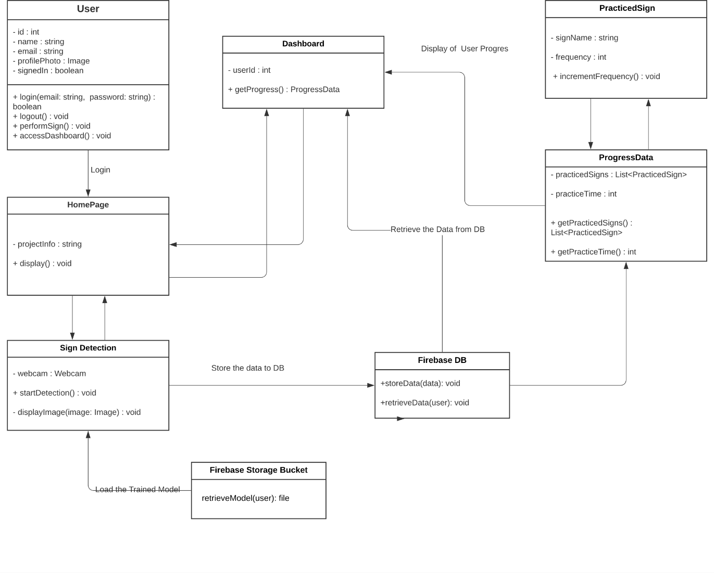

**Fig.3.4 Architecture diagram**

# USE-CASE DIAGRAM OF USER

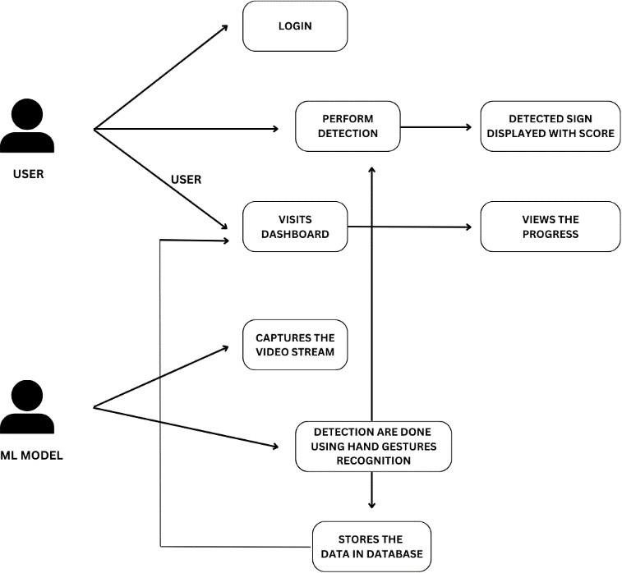

**Fig.3.3 Use case diagram**

This image shows a Use Case Diagram for a Sign Language Recognition System.

**Key Points:**

1. **Real-time Gesture Recognition:** The user logs in, performs hand gestures which are captured by the ML model via video stream, recognized, and displayed with a score for feedback.
2. **Progress Tracking:** Recognized gestures are stored in a database, and users can visit the dashboard to view their practice history and progress.
3. **IMPLEMENTATION OF WORK**

The implementation of a Sign Language Recognition System can be broken down into four distinct phases: Data Collection & Preprocessing, Model Training, System Development, and Deployment & Testing. Each phase plays a crucial role in ensuring the accuracy, efficiency, and usability of the system.

**Welcome Page**

This is the first part our website which comes every time if the user hasn’t register into this website or has been logout from this website. On every button the hovering has been done means every time whenever the take the cursor to the button automatically the button will be filled with the defined color

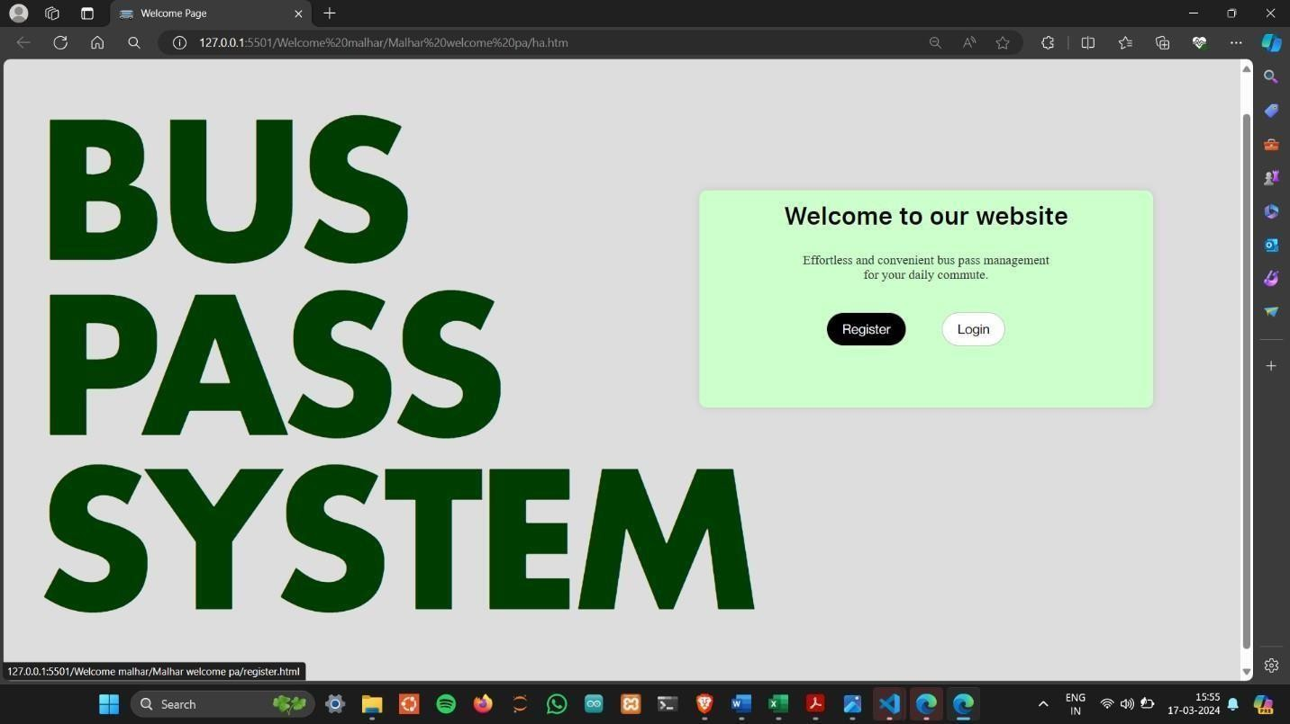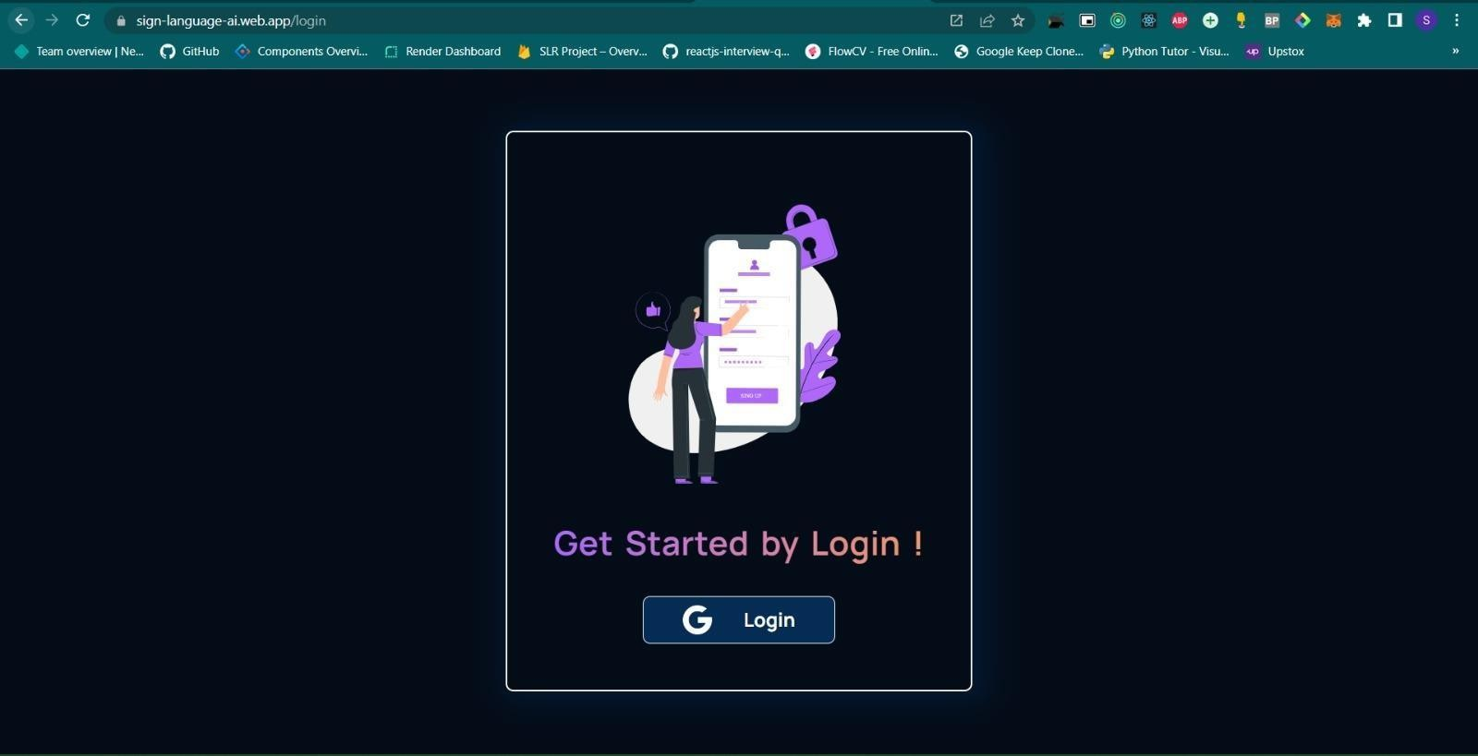

Home Page

The Home Page of the Sign Language Recognition System is the primary user entry point, offering a neat, intuitive, and user-friendly interface. Upon accessing the home page, the user is welcomed with a message that describes briefly the purpose of the system—enabling communication through sign language recognition.

At the top of the page, there is a navigation bar with links to major sections like About, How It Works, FAQ, and Contact. The body of the page has a prominent "Start Recognition" button through which users can directly start the sign language recognition process. Under this button, there is an interactive live camera display, allowing the user to view their hand movements in real time as the system interprets them. There is also a tutorial button that takes the user to a step-by-step tutorial on how to use the system efficiently, particularly for first-time users who are not familiar with sign language or the site.

While the user makes gestures in front of the camera, the identified sign is shown on the screen in real-time as text. In case text-to-speech capability is enabled, the system also speaks out the identified sign so that it is readable for deaf users. The bottom part of the page shows a history section where all previously identified signs are listed for reference.

For additional help, a Help or Support page can be accessed easily, offering troubleshooting instructions and details regarding system features. The page is responsive in design, which guarantees it will function without problems on desktops or mobile devices, with an easy and accessible interface for everyone. The entire design is minimalist in nature, prioritizing ease of use while guaranteeing that the main functionality—sign language recognition—is kept central and intuitive.

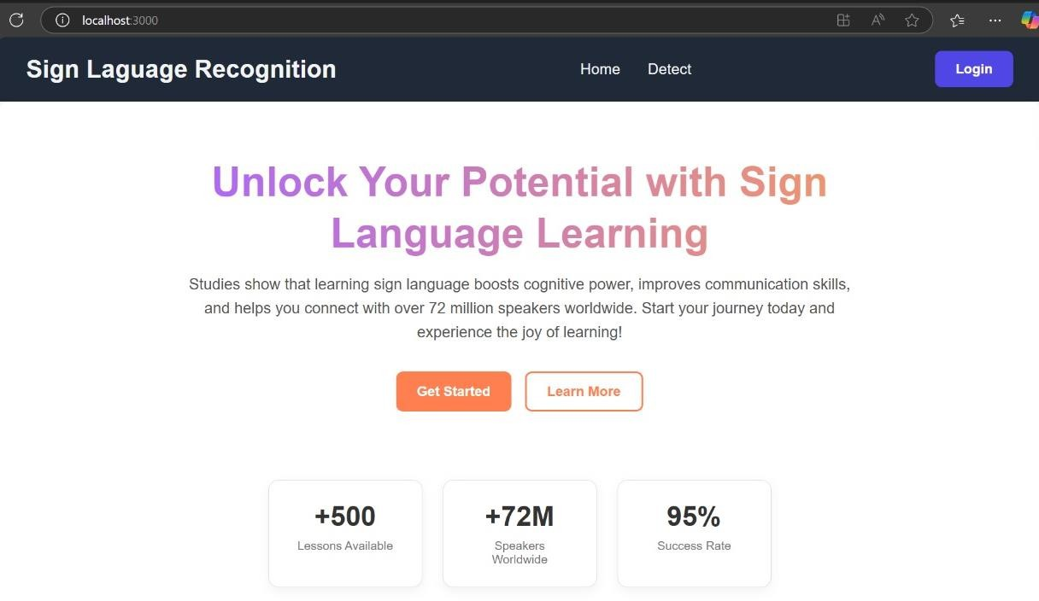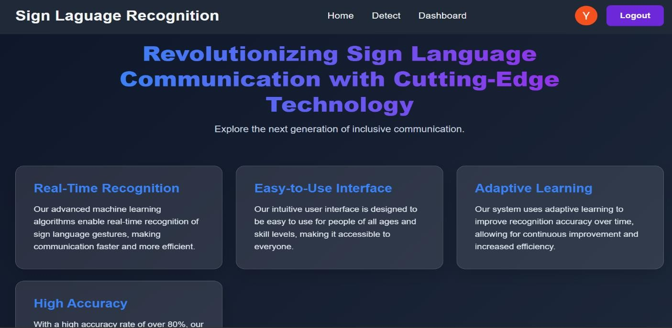

# 

# Detection page

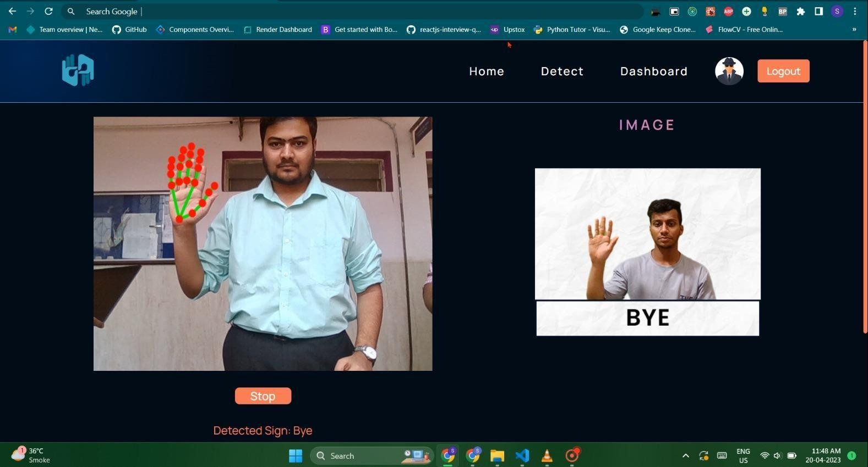

**Meaning:**

The word **"bye"** is a common casual way to say **goodbye** or **see you later**.

ASL Gesture Description:

* Hold up your **dominant hand**, palm facing forward.
* Open all fingers (like a wave).
* **Move your fingers together and apart** a couple of times — like you're waving..

Notes:

* This sign is typically informal.
* For a more formal farewell, sometimes a more structured sign is used, but the wave is perfectly fine in most social settings.

# Dash Board

# 

Sign Language Recognition dashboard is an interactive visual unit aimed at providing increased user involvement and monitoring learning progress. It acts as a central point for users to follow up on their activity and performance as they practice different sign language gestures.

The dashboard features several dynamic panels. The "Time Spent By You" graph shows the cumulative time a user has spent using the system on particular dates, enabling them to assess their consistency and commitment over time. The "Top Users" leaderboard lists the most active users, promoting healthy competition and motivation through a game-like experience.

Another important feature is the "Most Practiced Signs" table that highlights the signs practiced most often by the user, presenting insights into usage patterns and assisting in identifying areas of possible need for additional practice. The "Quote of the Day" page also gives motivational and culturally stimulating quotes to encourage users and emphasize the importance of learning sign language

.

# IX.CONCLUSION

In conclusion, this project that recognizes and teaches sign language is a valuable resource for individuals seeking to learn or improve their communication skills in sign language. The integration of the model with the webpage's Detections tab enables students to practice and learn sign language independently without the need for a sign language tutor. Furthermore, the project's interactive and attractive platform encourages users to explore the page further, making the learning experience more enjoyable and engaging. The project's future scope includes incorporating a larger database, user submissions, and educational partnerships to improve user experience and sign language education. Its continued development has potential to impact the field and provide exciting opportunities for learning and practicing sign language.

# X. FUTURE SCOPE

In Future Scope of the Sign Language Recognition System There is great scope for the Sign Language Recognition System to evolve and increase its usability, accuracy, and availability across various sectors. One of the major areas for improvement is gesture recognition accuracy with the inclusion of more sophisticated deep learning models like transformers and hybrid neural networks. These models have the potential to enhance real-time recognition, particularly for dynamic or complex gestures involving continuous hand motion.Another major future advancement is multilingual support for sign languages. Most recognition systems currently support a particular sign language, for example, ASL (American Sign Language) or ISL (Indian Sign Language). In the future, the system is capable of being trained in more than one sign language, enabling interaction between people of different linguistic background. Also, gesture-to-speech can be supplemented with natural language processing (NLP) to give more precise sentence structure rather than the recognition of single signs in isolation..

# XI.REFERENCES

1. M. E. Benalcázar, A. G. Jaramillo, J. A. Zea, A. Páez, and V. H. Andaluz, “Hand Gesture Recognition Using Machine Learning and the Myo Armband,” in 2017 25th European Signal Processing Conference (EUSIPCO), 2017, pp. 1339–1343.
2. M. Eslami, M. Karami, S. Tabarestani, and F. Torkamani-Azar, “SignCol: Open-Source Software for Collecting Sign Language Gestures,” in 2018 26th Iranian Conference on Electrical Engineering (ICEE), 2018, pp. 1–6.
3. Kabir, M. N., Tayan, O., Alginahi, Y., Hasan, M. M., & Rahman, M. A. (2019). On the development of a web extension for text authentication on Google Chrome. In 2019 International Conference on Electrical, Computer and Communication Engineering (ECCE) (pp. 1-4). IEEE.
4. Shrenika, S., & Bala, M. M. (n.d.). Sign language recognition using template matching technique. Institute of Aeronautical Engineering, Hyderabad, Telangana, India.
5. Manandhar, S., Bajracharya, S., Karki, S., & Jha, A. K. (n.d.). SCITECH Nepal, Vol. 14, No. 1 Hand Gesture Vocalizer for Dumb and Deaf People