Hand Gesture Recognition And Voice Conversion For Deaf And Dumb

V.Tarun Sri   
School of Engineering   
MallaReddy UniversityHyderabad, India  
2111cs020587@mallareddyuniversity.ac.in

CH.Trupti  
School of Engineering  
MallaReddy UniversityHyderabad,India  
2111cs020590@mallareddyuniversity.ac.inJ.Tharuni  
School of Engineering   
MallaReddy UniversityHyderabad, India  
2111cs020588@mallareddyuniversity.ac.in

B.Uday kiran  
School of Engineering  
MallaReddy UniversityHyderabad,India  
2111cs020591@mallareddyuniversity.ac.in G.Thejashwini  
School of Engineering   
MallaReddy UniversityHyderabad, India  
2111cs020589@mallareddyuniversity.ac.in

Dr.Sujit Das  
School of Engineering  
MallaReddy UniversityHyderabad,India

*Abstract*— To further develop correspondence between hard of hearing quiet people and hearing individuals, Sign Language Recognition (SLR) plans to make an interpretation of gesture based communication into text or voice. In spite of having a huge cultural impact, this action is in any case exceptionally troublesome because of its multifaceted nature and extensive variety of hand signals. Existing SLR methods use grouping models in view of hand-made qualities to address communication via gestures developments. By and by, it is trying to assemble reliable highlights that can acclimate to the extensive variety of hand movements. We recommend a special 3D convolutional neural network (CNN) to handle this issue. This network automatically extracts discriminative spatial-temporal characteristics from the raw video stream without the need for any previous information, eliminating creating features. To improve performance, the 3D CNN is fed several channels of video feeds that include colour, depth, and trajectory information as well as body joint locations and depth clues. We illustrate the proposed model's superiority to the conventional methods based on hand-crafted features by validating it on a real dataset acquired using Microsoft Kinect.

*Keywords*— Hand Gesture Recognition, Voice Conversion, Sign Language Recognition (SLR), Convolutional Neural Networks (CNNs), Text-to-Speech (TTS), Gesture Classification,

# Introduction

Technology has significantly shaped human civilization, improving daily life through AI, machine learning, robotics, and IoT. Despite these advancements, the needs of differently-abled individuals, especially the deaf and mute, remain underexplored. Communication is essential, yet those with speech and hearing impairments face challenges as sign language is not universally understood, creating a societal communication gap. This often leads to exclusion in social and professional settings. Hand Gesture Recognition and Voice Conversion (HGRVC) systems offer a promising solution by interpreting hand gestures and converting them into text or voice. This technology bridges the communication gap, enabling seamless interaction between deaf-mute individuals and the broader population. By facilitating real-time translation, HGRVC systems empower differently-abled individuals to express themselves effectively, fostering inclusivity and social participation.The deaf-mute community faces challenges in communicating with those who do not understand sign language, making everyday interactions difficult. Traditional methods like writing or using interpreters are often inconvenient. To solve this, AI and computer vision-based hand gesture recognition systems can automatically translate sign language into text or speech, promoting inclusivity and independent communication.The Hand Gesture Recognition and Voice Conversion (HGRVC) system captures, processes, and interprets hand gestures using computer vision and deep learning. It detects gestures via a camera, pre-processes images to improve clarity, extracts key features, classifies gestures using machine learning models like CNNs, and converts them into text or voice output. This system bridges the communication gap for deaf-mute individuals, enabling real-time, efficient interaction with a user-friendly interface. While it enhances inclusivity, challenges include gesture complexity, individual variations, high computational demands, dataset limitations, and the need for future integration with AR or brain-computer interfaces for improved functionality.

# Literature Review

Sign Language Recognition (SLR) aims to bridge the communication gap between hearing-impaired and hearing individuals by converting sign language into text or speech. Traditional SLR methods rely on handcrafted feature extraction, which struggles with variations in gestures, lighting, and background noise. To overcome these limitations, we propose a **3D Convolutional Neural Network (3D CNN)** that learns spatial-temporal features directly from raw video sequences, improving recognition accuracy and efficiency.[1] By incorporating multi-modal data like RGB frames, depth maps, and motion trajectories, our model enhances robustness across different signers and environments. Validated using a real-world dataset from Microsoft Kinect, the proposed system outperforms traditional methods, offering a scalable and effective solution for real-time sign language recognition. Future improvements will focus on expanding language support and optimizing real-time deployment.This advancement in SLR fosters seamless communication, promoting inclusivity and accessibility for the hearing-impaired community in daily interactions.[2]Sign Language Recognition (SLR) has gained significant attention as an assistive technology to bridge the communication gap for individuals with hearing and speech impairments. Traditional methods such as sign language, lip reading, and written communication are not universally understood, often leading to misunderstandings and social isolation.[3] Vision-based and sensor-based approaches have been explored to automate sign language translation, with deep learning techniques like Convolutional Neural Networks (CNNs) offering promising results. These models can analyze hand gestures, facial expressions, and movement patterns to convert them into text or speech, improving accessibility for deaf and mute individuals.[4] Despite its advantages, existing SLR systems face several challenges. They often rely on high-quality images and controlled environments for accurate recognition, making them less effective in real-world scenarios with poor lighting or background noise. Variability in gestures, influenced by cultural differences and personal styles, further complicates recognition accuracy. [5]Moreover, real-time processing of hand gestures requires significant computational power, limiting deployment on low-end devices. While CNN-based systems reduce dependence on human interpreters, they still require extensive datasets for training and frequent updates to improve accuracy. Additionally, these models primarily focus on visual recognition, making them less inclusive for individuals with both hearing and visual impairments.

# Methodology

**A.Existing System:**

Communication plays a vital role in human interaction, yet individuals with hearing and speech impairments face significant challenges in expressing themselves effectively. Deaf and mute individuals primarily rely on sign language, a system of hand gestures, facial expressions, and body movements. However, since sign language is not universally understood, communication barriers exist between them and the larger society. Lip reading is another alternative, but it is often inaccurate due to similarities in lip movements across different words. These limitations result in misinterpretations, social isolation, and difficulties in professional and daily life interactions.

Over the years, several assistive technologies have been developed to address these challenges, including hearing aids, text-to-speech software, and mobile applications for sign language translation. While these solutions provide some relief, they have notable drawbacks such as high costs, dependence on the internet, and the need for intermediaries. As a result, many individuals with speech and hearing impairments continue to struggle with effective communication.To tackle these issues, deep learning and computer vision-based approaches have been introduced. Convolutional Neural Networks (CNNs) have been applied to recognize sign language gestures, facial expressions, and visual cues, translating them into readable text. These systems rely on image processing techniques to detect and classify gestures, allowing real-time communication without human interpreters. The CNN model is trained on datasets containing various sign language symbols, enabling accurate recognition and conversion of hand gestures into meaningful text.

**B.Proposed System:**

The proposed system focuses on recognizing hand gestures and converting them into text and speech, enhancing communication for individuals with hearing and speech impairments. Unlike traditional methods that rely on skin tone, texture, or external devices, this system uses convolutional neural networks (CNNs) to analyze hand gestures based on form properties, ensuring robustness across different lighting conditions and user variations. The methodology involves capturing hand movements via a webcam, processing them through a trained CNN model, and mapping the recognized gestures to corresponding words. A natural language generation module refines sentence structure, and a text-to-speech (TTS) module provides voice output for seamless communication.

Data acquisition and preprocessing play a vital role in improving recognition accuracy by converting images into binary or grayscale formats, removing background noise, and extracting key features. The CNN model is trained to classify various gestures, enabling real-time processing and efficient text generation. The system's advantages include high accuracy, real-time translation, and adaptability to different sign languages. Unlike sensor-based solutions, it is non-intrusive, cost-effective, and easily accessible via a webcam.

This technology has applications beyond sign language translation, including human-computer interaction, virtual reality, and assistive communication tools. Despite challenges like computational demands and variations in individual signing styles, future improvements could enhance efficiency, expand gesture recognition, and integrate additional features such as facial expression analysis.

**C.Modules:**

The hand gesture recognition system consists of several key modules that work together to capture, process, classify, and convert hand gestures into meaningful outputs.

**1. Upload a Dataset of Hand Gestures**

The first step involves collecting and uploading a dataset containing various hand gestures. This dataset is essential for training the model to recognize different gestures under different lighting conditions, orientations, and backgrounds.

**2. Prepare the Dataset**

Preprocessing the dataset improves recognition accuracy by normalizing image sizes, applying data augmentation techniques like rotation and flipping, and removing unnecessary noise or background artifacts.

**3. Model Development**

A convolutional neural network (CNN) is developed and trained to recognize hand gestures..

**4. CNN Gesture Training Images**

The CNN model is trained using the preprocessed dataset.

**5. Webcam-Based Recognition of Sign Language**

The system captures live hand movements, preprocesses frames, and classifies gestures using the trained model, displaying the recognized output on the screen.

**6. Webcam Picture Extraction**

To improve accuracy, the system extracts and processes frames from the webcam feed, ensuring only high-quality images are used for classification.

**7. Image Conversion and Background Removal**

To enhance gesture visibility, images are converted into binary or grayscale format8. Feature Extraction from Images

**9. Audio Playback and Recognition**

The final module converts recognized gestures into spoken language using text-to-speech (TTS) technology.

# Architecture

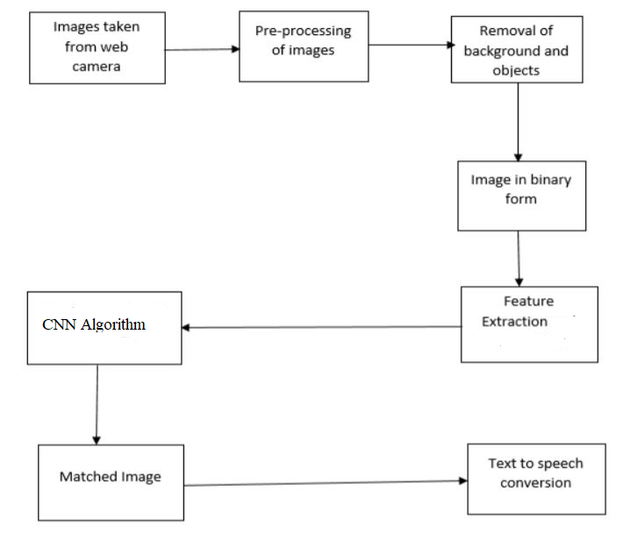fig 4.1 System Architecture

This flowchart represents the process of hand gesture recognition using a CNN-based algorithm.

1. **Images Taken from Webcam** – The system captures hand gesture images using a webcam.
2. **Preprocessing of Images** – The captured images undergo resizing, normalization, and noise reduction to enhance quality.
3. **Removal of Background and Objects** – Background elements are eliminated using segmentation techniques to isolate the hand gesture.
4. **Image in Binary Form** – The preprocessed image is converted into a binary format for better feature extraction.
5. **Feature Extraction** – Key features such as edges, contours, and shapes are extracted using image processing techniques.
6. **CNN Algorithm** – A Convolutional Neural Network (CNN) classifies the gesture by matching it with trained gesture patterns.
7. **Matched Image** – The system determines the best-matching gesture from the database.
8. **Text-to-Speech Conversion** – The recognized gesture is converted into speech output, making it accessible for communication.

The sequence diagram illustrates the workflow of a **hand gesture recognition system** using a **Convolutional Neural Network (CNN)**. The system consists of four main components: **User, Dataset, Application, and System**, each playing a crucial role in the recognition process. The process begins with importing necessary libraries, followed by uploading a dataset containing images of hand gestures. Once the dataset is uploaded, the system proceeds with model generation, where a CNN architecture is defined and trained using the provided data. After training, the system evaluates its accuracy to ensure reliable performance.Once the model is trained, the **webcam is activated** to capture real-time hand gestures. The user inputs a gesture, which is then processed by the CNN model. The system extracts relevant features, matches them with trained patterns, and classifies the gesture. Finally, the recognized gesture is displayed, and in some implementations, it can be converted into speech using text-to-speech synthesis. This structured approach ensures accurate and efficient hand gesture recognition, facilitating interaction between humans and machines in various applications such as sign language interpretation, human-computer interaction, and accessibility solutions.

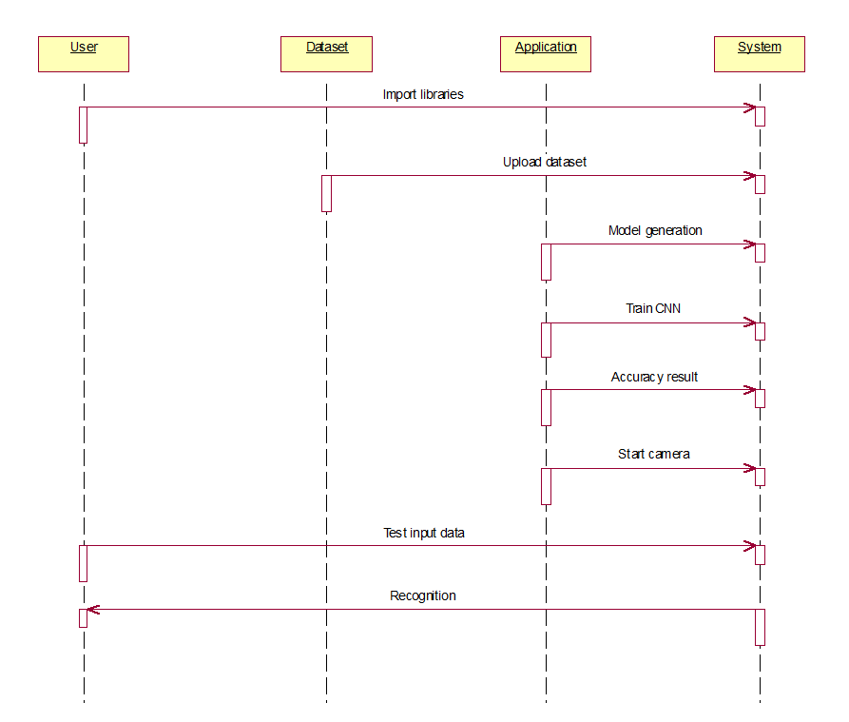fig 4.2 Sequence Diagram

# Experimental Results

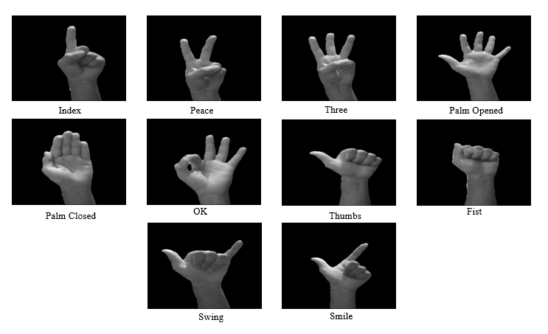fig 5.1 Sample input

The image displays a set of hand gestures used for recognition in a gesture-based system. Each gesture represents a unique hand sign, which can be used for applications such as sign language recognition, human-computer interaction, or gesture-based control systems. The gestures include **Index, Peace, Three, Palm Opened, Palm Closed, OK, Thumbs, Fist, Swing, and Smile**, each depicting a different hand posture against a black background. These variations in hand positions help in training Convolutional Neural Networks(CNNs) for accurate classification in hand gesture recognition systems.

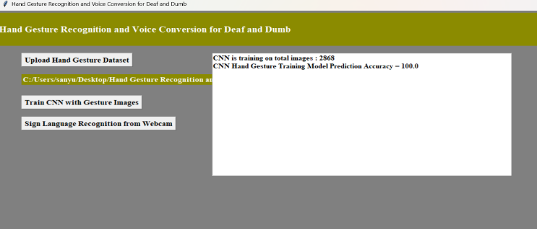fig 5.2 Dataset Loading and Acccuracy

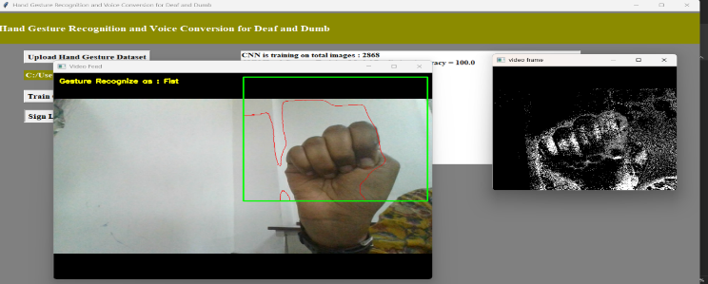

Fig 5.3 Sample Output1

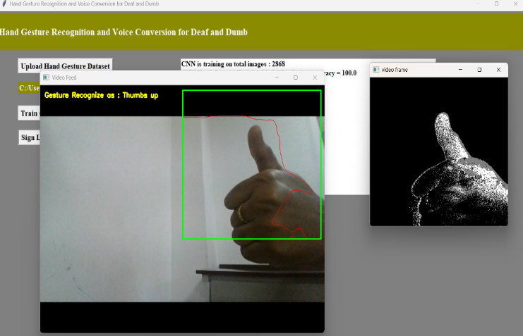

Fig 5.4 Sample Output2

# References

[1]**Ying Wu & Thomas S. Huang**, *"Vision-Based Gesture Recognition: A Review,"* Lecture Notes in Computer Science, Vol. 1739, 1999.

[2]**Richard Watson**, *"A Survey of Gesture Recognition Techniques,"* Technical Report TCD-CS-93-11, Trinity College Dublin, 1993.

[3]**H. Zhou & T.S. Huang**, *"Tracking Articulated Hand Motion with Eigen Dynamics Analysis,"* Proc. Int. Conference on Computer Vision, 2003.

[4]**B. Stenger et al.**, *"Model-Based 3D Tracking of an Articulated Hand,"* British Machine Vision Conference, 2001.

[5]**Thad Starner & Alex Pentland**, *"Real-Time American Sign Language Recognition Using Hidden Markov Models,"* MIT Media Lab, 1995.

[6] **Lars Bretzner, Ivan Laptev, Tony Lindeberg**, *"Hand Gesture Recognition Using Multiscale Color Features,"* Int. Conf. on Automatic Face and Gesture Recognition, 2002.