**Bioremediation of Plastic Pollution: Exploring the Potential of Plastic Degrading Bacteria**

**Praveena Gupta, Assistant Professor, Department of Biosciences, Shri Cloth Market Institute of Professional Studies, Indore**

**Dr.Smruti Sohani, Professor, Institute of Agriculture Science, SAGE University, Indore**

**Abstract**

Plastic pollution has grown to be one of the most urgent environmental demanding situations globally, with thousands and thousands of heaps of plastic waste collecting in landfills, oceans, and terrestrial ecosystems. The gradual degradation of plastics because of their resistance to natural procedures poses a large risk to biodiversity and human health. Recently, studies have shifted closer to locating biological solutions to mitigate plastic waste, with a focal point on plastic-degrading microorganism. These microorganisms have shown promise in breaking down various plastic polymers, together with polyethylene, polypropylene, and polystyrene, through enzymatic techniques. The general techniques in preventing plastic waste as landfill, incineration, recycling are considered less effective as they launch a few hazardous materials to the environment. Thus, the best approach is wanted to triumph over this problem. Biodegradation is an enzymatic degradation concerning a few microorganisms which includes bacteria. This approach can be used to prevent the plastic waste problem. Plastic waste biodegradation took place via numerous steps, together with biodeterioration, depolymerisation, and assimilation. Within this process, microorganism will secrete many enzymes on the way to degrade and convert plastic polymers into microbial biomass and gases. Thus, this process has fewer even no facet outcomes.

Keywords: Bacteria, Biodegradation, Plastic polymers, Plastic waste, Enzymes.

Introduction The indiscriminate human exploitation of natural resources has generated unheard of disturbances in nature through the introduction of the poisonous chemical substances at a faster rate. Among the maximum pollutants brought to the environment are being the artificial plastic fabric which is a man- made polymer. In the 12 months 1869 the first plastic polymer, celluloid, was produced through John Hyatt for the replacement for ivory [1]. In the remaining fifty years, plastic materials have grown to grow to be crucial in all aspects of human endeavours as a result of their durability, high power and coffee value. Hence, global plastic manufacturing has tripled within the final twenty 5 years [2]. However, a majority of the anticipated eight.3 billion plastics produced up to now are single-use convenience products which have ended up discarded in our natural environments [3]. Plastics incorporate of an extensive variety of lengthy-chain polymeric substances, extracted from the fossil gasoline assets with numerous programs in every day-lifestyles and enterprise. The synthesis of these polymers is basically involves strategies, considered one of that's addition polymerisation of carbon double bonds to form the carbon-chain polymers [4]. The manufacturing of polymers consisting of polyethylene, polybutene and polypropylene accounting for more than 60% of total plastic manufacturing is primarily based on the polymerisation reaction. The different method is a condensation response between a carboxylic acid and an alcohol/amine institution to form either a polyamide or polyester. Synthetic plastics are classified into most important businesses viz., thermoplastics and thermosets based on their response to reheating. Thermoplastics are plastic polymers which can be modified upon reheating while thermosets face up to recodification [5] upon heating. Thermoplastics are acrylonitrile butadiene styrene (ABS), polyamide, polyethylene (PE), polyimide (PI), poly-methyl methacrylate (PMMA), polypropylene (PP), polystyrene (PS), polytetrafluoroethylene (PFE), polyvinyl chloride (PVC), and polyvinylidene chloride (PVDC) [6,7] and the thermosets encompass acrylic resins, epoxy resins, polyester, polyethylene terephthalate (PET), polyurethane (PU), silicone and vinyl resins [8,9]. Estimates at the production of different forms of plastics has proven that polyethylene (PE) is produced in huge scale (ninety nine.6 million metric ton) when as compared to the opposite sorts of plastics (Plastic Europe, 2019) (Fig. 1). Production of various varieties of plastic Source: Plastic Europe, 2019 PU polyethylene terephthalate (PETE) with seventy three. Four million metric ton observed through polypropylene (PP) (fifty five.9 million metric ton), polyvinyl chloride (PVC) (44.3 million metric ton) and the least produced plastic is poly lactic acid (PLC) with 2.1 million metric ton. The maximum normally used plastics are PE, PET, PP, PS, PVC and polyurethane (PUR), among which PE, PETE and PP accounting for more than 50% of the total production. The bodily association of the polymer chains in low density polyethylene and lower content material of vinylidene defects that have been shown to be at once correlated with oxidization of the polymer makes it more biodegradable. [11]

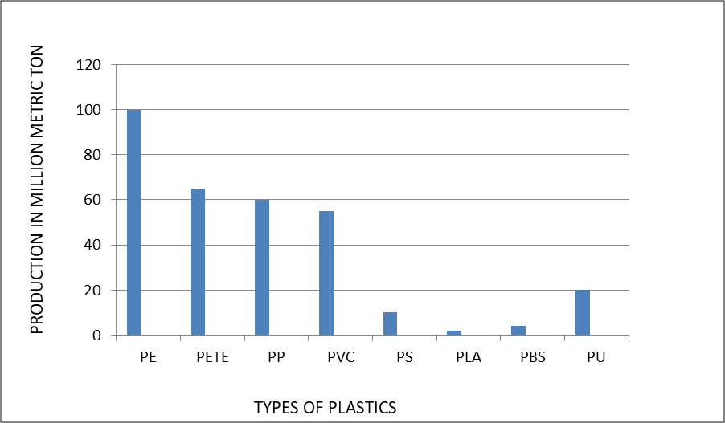

**Figure 1**

**Production of different varieties of plastics**

Recent studies within the discipline of separating and characterizing plastic degrading microorganism from soil collected from industrial dumping grounds have made large strides. Researchers have employed diverse methodologies which includes metagenomic evaluation, microbial culturing and molecular techniques to identify and represent bacterial traces able to degrading plastics. Advancements of genome sequencing technology have facilitated the identity of key genes and enzymes concerned in plastic degradation pathways .Additionally, efforts had been made to optimize conditions for boosting the performance of plastic degradation through theses microorganism together with the identity of appropriate boom substrates and environmental factors.

Plastics are man-made long chain polymeric devices. Synthetic polymers began to replacement herbal substances in nearly each place extra than 1/2 a century in the past and in recent times plastics have emerge as an vital part of our existence. With time, the steadiness and durability of plastics were stepped forward constantly, and for this reason these organizations of materials are considered as a synonym for materials which might be proof against many environmental affects

**DEGRADATION OF PLASTIC**

Plastic degradation is breakdown of complicated polymer into less complicated monomers that is depending on several factors, which include availability of a substrate, surface characteristics, morphology, and molecular weight of the polymers. Plastic degradation involves various treatments of bodily, chemical and organic elements. Physical factors contain warmth and radiations, chemical factors include acids and alkalis and organic factors are the use of microorganisms and insects. Depending upon the nature of the reactive agents, polymer degradation has been labeled as picture-oxidative degradation, thermal degradation, ozone-caused degradation, mechano-chemical degradation, catalytic degradation, and biodegradation. Biodegradation includes microorganisms inclusive of microorganism, fungi and actinomycetes appearing on plastic compounds and utilise them as a carbon and strength source.

**BIOLOGICAL DEGRADATION OF PLASTICS**

Biological components encompass microorganisms which can be omnipresent inside the biosphere, and they play an important position inside the upkeep of many environmental strategies, as they have got advanced over millennia to mineralise unique compounds along with toxic chemicals. The most essential function of the microbes on this planet is their potential to decompose the organic rely and recycle the number one elements (carbon (C), oxygen (O), and nitrogen (N)) that make up all living structures. The position of microorganism could be very essential for plastic degradation. Different styles of microbes degrade specific businesses of plastics. Microorganisms which include microorganism, fungi and actinomycetes degrade both herbal and artificial plastics. The richness of microbes able to degrade polythene is to date restricted to 17 genera of bacteria and nine genera of fungi. Works on low density polyethylene (LDPE) discovered that bacterial isolates of Bacillus and fungal isolate of Aspergillus sp. have been the highest degraders.

**Bacteria**

Bacteria are widely known to be the driving pressure of the earth’s nutrient as they're brings about the transformation and nutrient cycling thru the environment. Their position in decomposition ensures that carbon and nutrients are liberated from exceptional complex polymers. Studies have proven that the capability of bacteria to degrade plastic is based totally on their natural ability to degrade lengthy-chained fatty acids. Pseudomonas is the most outstanding and studied bacterial genus with regards to plastic polymer degradation. Biofilm formation has been cited to play a significant position inside the bacterial decomposition of plastics, as it promotes the adherence of the colonies to the plastic floor as well as their staying power. Similarly, the isolates of microorganism observed to be concerned in plastic degradation are Bacillus megaterium, Pseudomonas sp., and Azotobacter sp. Bacillus brevis.

**Actinomycetes**

Actinomycetes shape a diverse group of filamentous microorganism available in one of kind environments with many biotechnological applications in bioremediation, remedy, and food industries. Actinomycetes together with the Streptomyces agencies, Rhodococcus ruber, Actinomadura sp., and the Thermoactinomyces species were proven to possess sizeable plastic biodegradative potentials. Actinomycetes located to degrade polylactic acid (PLA), PCL and Polybutylene succinate (PBS) inclusive of Amycolatopsis sp., Saccharothrix.

**STEPS INVOLVED IN PLASTIC BIODEGRADATION**

Microbes ruin down specific compounds into less complicated bureaucracy through biochemical transformation. The biodegradation of plastic polymers may be discovered thru an alteration inside the physical residences of the polymers specifically via the reduction in the molecular weight, loss of mechanical power and change in plastic surface houses .The different biochemical degradative pathways worried in plastic biodegradation may be categorised into biodeterioration, biofragmentation, assimilation and mineralisation, all of those approaches are achieved thru various enzymatic activities and bond cleavage . The biodeterioration manner is the first step initiated to colonies microbes at the polymer surface with the main objective of decreasing the resistance and sturdiness of the plastic substances

Biofragmentation is a depolymerisation step entails the motion of extracellular enzymes, and free radicals generated by means of the microbes act upon the bio-deteriorated plastic polymers into smaller units that bring about the reduction in polymer molecular weight and oxidation of the decrease weight molecules. Assimilation is the system wherein the lower molecular weight compounds produced for the duration of biofragmentation are transported into the microbe's cytoplasm. A biofragmented product Octadecane has been shown to be taken up by way of Pseudomonas sp. DG17. Mineralisation procedure includes a sequence of enzymatic reactions within the cellular leading to the whole degradation of the polymer into oxidized metabolites which includes carbon dioxide (CO2), nitrogen (N2), methane (CH4), and water vapour (H2O). When Oxygen is to be had, cardio microorganisms are in general answerable for the destruction of complicated substances, yielding microbial biomass, Carbon dioxide, and water as the very last merchandise anaerobic consortia of microorganisms are accountable for polymer deterioration under anoxic situations. The microbial biomass, Carbon dioxide, methane and water are the number one merchandise under methanogenic (anaerobic) conditions (e.g. Landfills/compost) (Fig. 2).

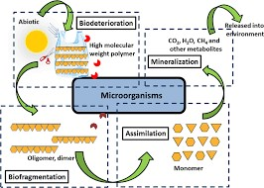

**Figure 2**

**A General mechanism of plastic degradation**

**MICROBIAL ENZYMES INVOLVED IN DEGRADATION OF PLASTIC**

The microbial enzymes concerned in plastic degradation had been classified into extracellular and intracellular enzymes. However, the most studied organization many of the is the extracellular enzymes which possess better reactivity efficiency of forming oxidative to hydrolytic functionality. They are basically worried within the depolymerisation of the long carbon chains of the plastic polymers to a aggregate of oligomers, dimers and monomers as illustrated underneath.

Hydrolytic cleavage Plastic

Plastic Polymer+ Microbial Enzyme Monomers

**FACTORS AFFECTING MICROBIAL BIODEGRADATION OF PLASTICS**

Microbial biodegradation of plastic polymers is stricken by a extensive variety of factors primarily based at the characteristics of polymer, environmental components and chemical factors which mainly feature to facilitate next microbial movement by way of increasing the floor region, hydrophobicity and also reducing the molecular weight.

**CONCLUSION**

The present paper highlights the vastest research at the biodegradation of plastic through microbes along with bacteria, fungi and actinomycetes. A ray of mild becomes thrown on the roles of various microbial enzymes worried. Based on the current literature, it can be deduced that the records on extraordinary microbes with plastic degrading potentials had been based on pure way of life isolates. This sincerely demonstrates that the high range of microorganisms throughout distinct herbal habitats has no longer been appreciably exploited. Hydrolytic enzymes are especially chargeable for the degradation of plastic polymer as discovered through maximum of the researchers. Most importantly, the process of isolation of microbial species that possess those plastic degrading enzymes desires to be standardized. It is likewise believed that the application of various microorganisms as a consortium will cause greater performance in plastic degradation because of the synergism among the microbes and their enzymes. The degradation of plastic the use of microorganisms is green, beneficial and price powerful for plastic waste management. However, there are no reports on any sensible software of microbes for plastic degradation at subject conditions. Hence, greater studies on this region of research may be taken up to develop a package deal for powerful biodegradation tactics on a industrial scale.

**REFERENCE**

[1] Morris P.J. (1998) ‘A popular records of the science and era of huge molecules’, Journal of Chemical Education, Vol .65.

[2] A Feil, T Pretz, Editor, “Plastic Waste and Recycling”, Elsevier, Amsterdam, (2020).

[3] Nielsen T.D., Hasselbalch J., Holmberg K. And Stripple J. (2020) ‘Politics and the plastic crisis: A assessment for the duration of the plastic life cycle’, Energy and Environment, Vol. 9, pp. 360.

[4] A.I. Ma’adeed, I. Krupa, Editors, “Springer Series on Polymer and Composite Materials”, Springer, (2016).

[5] Ayodeji A., Bhagwat P., S. Singh, Pillai S. (2021) ‘Plastic biodegradation: Frontline microbes and their enzymes’, Science of The Total Environment, Vol. 759, pp. 143536.

[6] Li D., Zhou L., Wang X., He L., Yang X.(2019) ‘ Effect of crystallinity of polyethylene with exclusive densities on breakdown power and conductance property’, Innovations in Microbiology and Biotechnology, Vol. 4, pp. 1746.

[7] Makhlouf A., Satha H., Frihi D., Gherib S., Seguela R.(2021) ‘ Optimization of the crystallinity of polypropylene submicronic-talc composites: the function of filler ratio and cooling price’, Express Polym Lett, Vol. 10, pp., 234–247.

[8] Jog J.P. (1995) ‘Crystallization of Polyethylene terephthalate’, Journal of Macromolecular Science Part C, Vol .35, pp. 531–553.

[9] S Ray, R.P.Cooney, M. Kutz, Editor, “Thermal degradation of polymer and polymer composites”, Handbook of Environmental Degradation of Materials, Elsevier, Amsterdam, (2018).

[10] Barlaz M.A., Ham R.K. And Schaefer, D.M. (1989) ‘Mass-stability evaluation of anaerobically decomposed refuse’, Journal of Environmental Engineering, Vol. 115, pp. 1088–1102.

[11] Mohanan N., Montazer Z., Sharma P.K., Levin D.B. (2020) ‘Microbial and Enzymatic Degradation of Synthetic plastic’, Frontiers in Microbiology, Vol.11, pp. 1-22