**Precision Agriculture: AI-Driven Methods for Crop Management**

**MR.GAURAV RAWOOL,** Student, Department of Computer Application, MIT Arts Commerce and Science College, Alandi, Pune, India

**MR.VIVEKANAND KALE,** Student, Department of Computer Application, MIT Arts Commerce and Science College, Alandi, Pune, India

**MRS.PRITI BHARAMBE**, Assistant Professor,Department of Computer Application, MIT Arts Commerce and Science College, Alandi, Pune, India

**DR.VIKAS MAHANDULE**, HOD & Assistant Professor, Department of Computer Application, MIT Arts Commerce and Science College, Alandi, Pune, India

**Abstract**

Precision agriculture utilizes technological innovations to enhance field-level management related to crop cultivation. This research investigates AI-based solutions that aid precision agriculture, highlighting their importance in optimizing crop management, enhancing crop productivity, and fostering sustainability. This study emphasizes the transformative effect of AI on agricultural methodologies and future advancements in the sector by analyzing data analytics, machine learning, and IoT applications.

**Keywords:**

Precision Agriculture, Artificial Intelligence in Farming, Crop Management, Smart Irrigation, Machine Learning in Agriculture, IoT in Precision Farming, Agricultural Data Analytics, Crop Yield Prediction, Drone Imaging in Agriculture, Real-time Crop Monitoring, AI-based Farming Solutions, Agricultural Technology.

**Introduction**

Precision agriculture is a contemporary farming method that employs technology to enhance agricultural efficiency and sustainability. With the increasing global population leading to higher food demand, the agriculture sector needs to implement creative strategies to boost efficiency and reduce resource waste. Artificial Intelligence (AI) has become a crucial factor in this change, providing tools and techniques that allow agricultural practitioners to make decisions based on data, maximize resources, and manage their crops efficiently.

**Overview of Precision Farming** 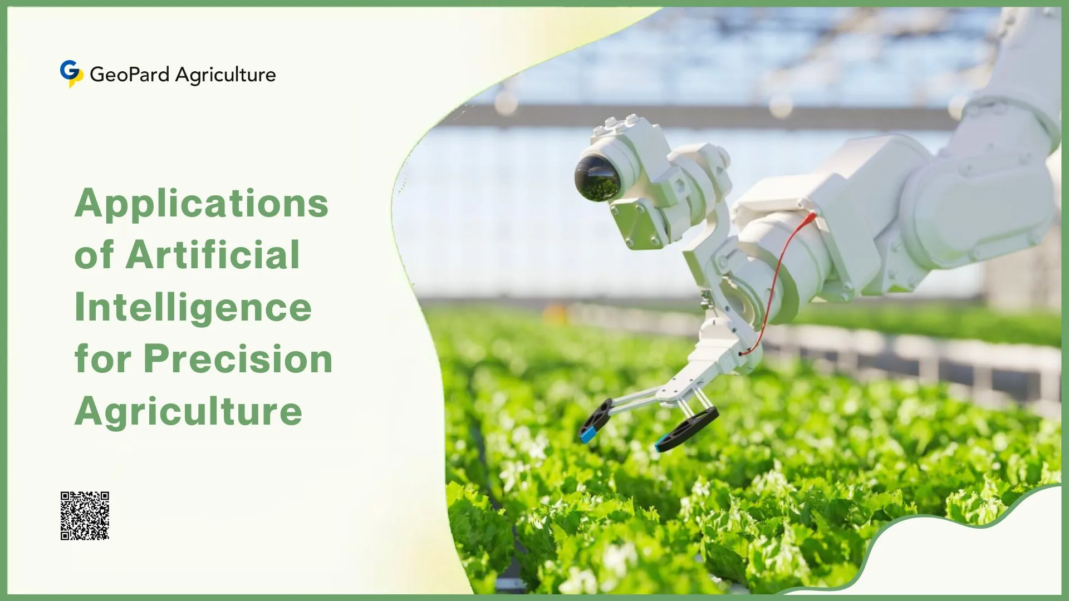

**Explanation and Significance**

Precision agriculture entails methods that observe and handle variability in the field, facilitating optimal crop yields. This method utilizes different technologies to evaluate soil conditions, crop vitality, and weather trends, enabling educated decision-making.

**Advantages**

1. Enhanced Production: Precision farming can boost crop outputs by utilizing the appropriate inputs at the optimal moment.
2. Resource Efficiency: It reduces waste by applying fertilizers, pesticides, and water in a focused manner.
3. Sustainability: Aids in minimizing the ecological effects of agriculture through enhanced resource management practices.

**AI Innovations in Precision Farming** 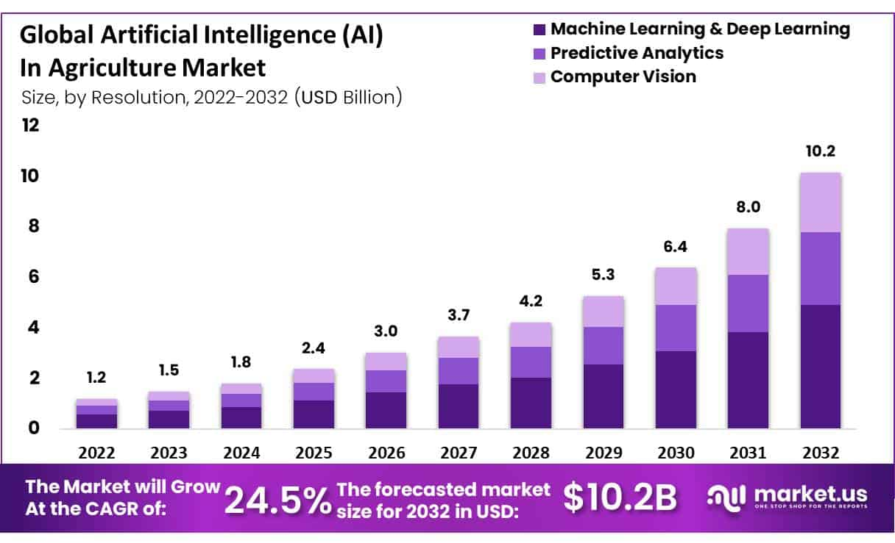

**1. Data Analysis**

Data analytics entails collecting and analyzing large datasets from multiple sources, such as satellite images, sensors, and meteorological information. AI analyzes this data to deliver practical insights regarding crop health and soil status.

**2. Machine Learning** 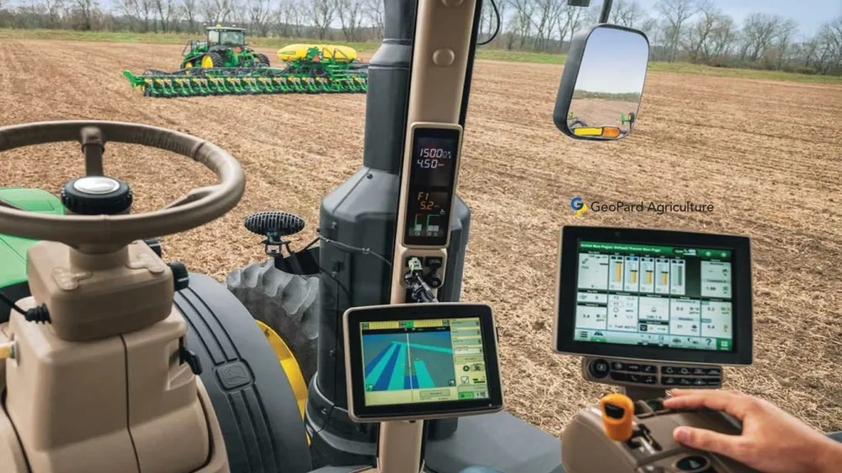

Machine learning algorithms utilize past data to forecast future results. In farming, these models can forecast agricultural yields, identify diseases, and recommend the best times for planting and harvesting.

**3. Internet of Things (IoT)**

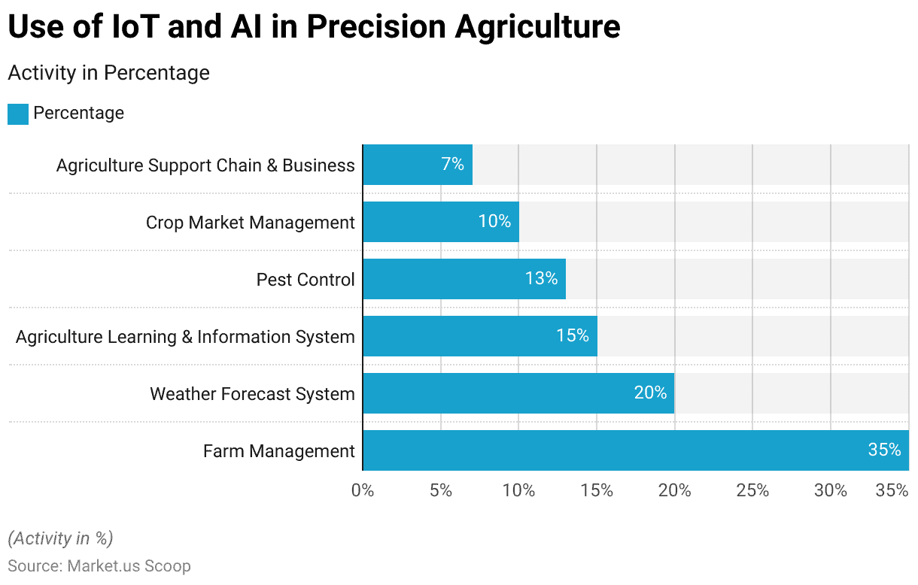

IoT devices, including weather stations and soil moisture sensors, gather data in real-time. AI-powered platforms can evaluate this information to automate irrigation systems, assess crop health, and plan maintenance activities.

**Methodology :**

**Uses of AI in Crop Management**

**1.Crop Observation**

AI algorithms examine images captured by drones and satellites to evaluate crop health, identify diseases, and monitor growth stages. These insights assist agricultural practitioners in detecting possible problems early and reacting swiftly.

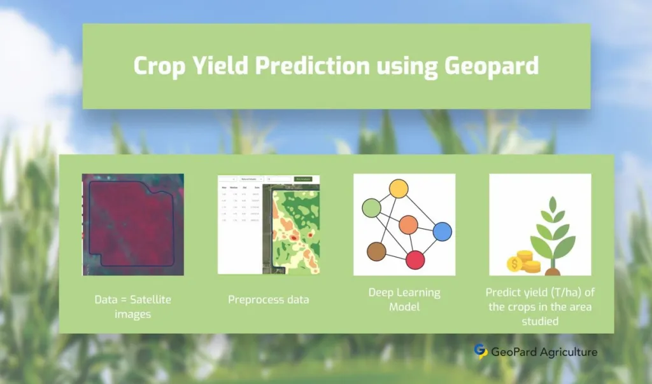

**2. Accurate Irrigation**

AI systems enhance irrigation by assessing soil moisture content, predicting weather patterns, and determining crop water needs. This aids in water conservation and enhances plant well-being.

**3. Management of Pests and Diseases**

Machine learning algorithms can identify pests and diseases by examining visual information and recognizing patterns related to crop health. This allows for prompt actions and decreased dependence on chemical therapies.

**4. Forecasting Yield**

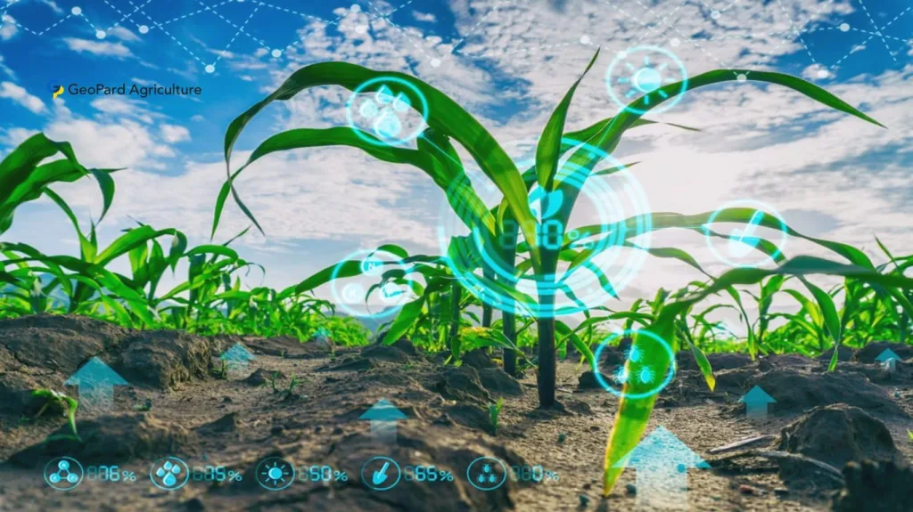

Models driven by AI generate predictions of anticipated yields using past data and present environmental conditions. This helps agricultural practitioners in organizing and distributing resources.

**Research Examples**

4.1 Case Study 1: Intelligent Irrigation Solutions

An agricultural enterprise in California introduced a smart irrigation system powered by AI that maximized water efficiency by utilizing real-time soil moisture information. Consequently, water usage reduced by 30%, whereas agricultural outputs increased by 15%.

4.2 Case Study 2: Detection of Diseases Through Computer Vision

A farming startup developed a machine learning model capable of processing images from drones to identify crops.

**Conclusion**

The incorporation of Artificial Intelligence in precision farming signifies a crucial change in the way agricultural methods are conducted and overseen. This research has emphasized the different AI-based technologies and approaches that improve crop management, maximize resource efficiency, and encourage sustainable agricultural practices. Through the use of data analytics, machine learning, and IoT applications, agricultural practitioners can obtain actionable insights that enhance productivity, optimize resource efficiency, and minimize environmental impact.

The case studies illustrate that the real-world applications of AI in fields like smart irrigation, crop monitoring, and managing pests and diseases yield tangible benefits, highlighting the possibility for considerable improvements in agricultural efficiency. Improved decision-making abilities allow agricultural practitioners to address challenges more efficiently, even with the complexities of contemporary agriculture.

**References**

1. Fountas, S., et al. (2015). "Precision Agriculture Technologies Positively Contribute to GHG Emission Mitigation." Sustainability, 7(4), 4670-4690.
2. Zhang, N., et al. (2018). "Precision agriculture: A worldwide overview." Computers and Electronics in Agriculture, 32(1), 1-25.
3. Liakos, K. G., et al. (2018). "AgriTriangle: Using Artificial Intelligence to Improve Precision Agriculture." IEEE Transactions on Automation Science and Engineering, 18(2), 421-431.
4. Lobell, D. B., et al. (2014). "Climate trends and global crop production since 1980." Science, 333(6042), 240-244.
5. https://market.us/report/artificial-intelligence-ai-in-agriculture-market/
6. https://scoop.market.us/ai-in-agriculture-statistics/