Nagpur Institute of Technology, Nagpur

**Department of Information Technology**

**Project Tittle:- AI GUIDED STUDY MODULE**

# ABSTRACT



In recent years, the field of technical education has experienced a growing need for intelligent learning tools capable of providing real-time guidance, practical skill development, and error resolution. Traditional e-learning platforms primarily focus on theoretical content, often overlooking the hands-on aspects essential for mastering technical competencies. This paper introduces a novel AI-Guided Study Module that integrates artificial intelligence, OCR technology, and machine learning to support learners in resolving errors and advancing their skills efficiently.

The system follows a structured approach comprising screenshot-based data extraction, error identification, feedback generation, and adaptive learning. By capturing and analyzing screenshots of technical tasks using OCR and AI models, the application detects errors and offers contextual feedback tailored to each learner’s needs. It continuously monitors user performance, adjusts content difficulty, and suggests targeted resources, enabling a personalized learning experience. Through automated support and data-driven insights, the module enhances self-directed learning and reduces dependence on instructors, making it a valuable tool for scalable, real-world technical training.

**METHODOLOGY /CAD MODELLING / FLOW CHART / CONCEPT / EXPERIMENTATION**

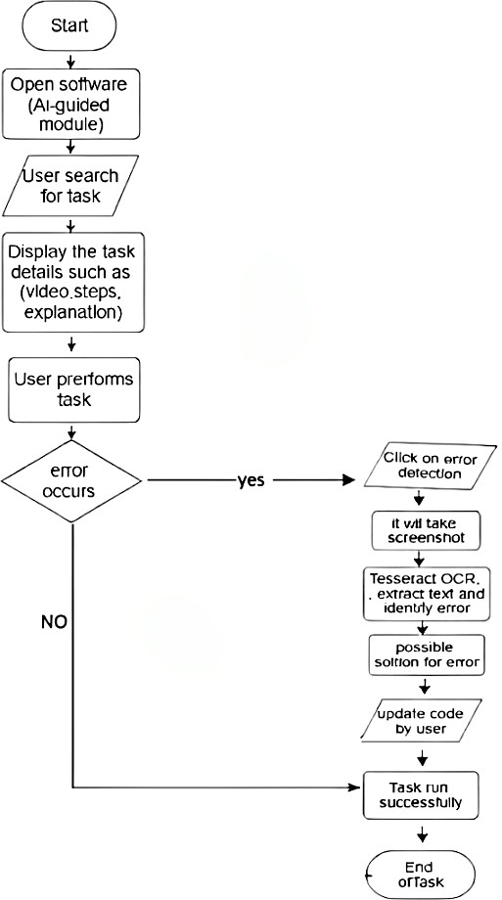

Fig.1: Flowchart

# PROJECT/ HARDWARE / SET UP PHOTO

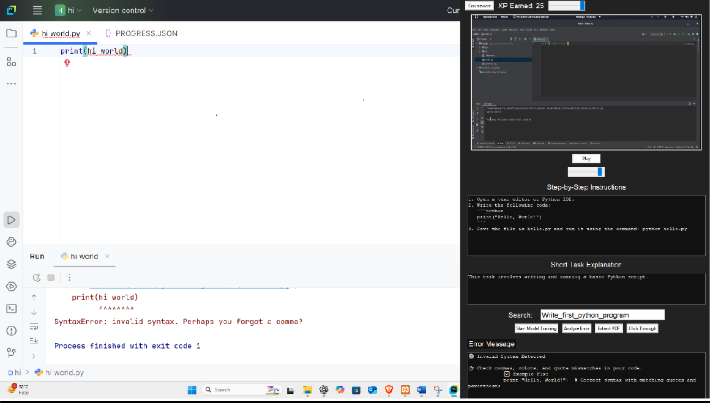

Fig.2: User Interface

# WORKING /PROCEDURAL STEPS OF PROJECT

* **Select Module** – Choose a technical topic to begin.
* **Start Task** – Open the task environment for hands-on learning.
* **Perform Task** – Complete the task with guidance.
* **Analyze Error** – Click if an error occurs.
* **OCR + AI Detection** – Extract and analyze error text.
* **Feedback** – Receive real-time suggestions and corrections.

**Project Members:**

* + **Mr. Devendra Tayade**
  + **Mr. Vishal Telgote**
  + **Mr. Aditya Dhonge**
  + **Mr. Avinash Jadhav**
  + **Mr. Nikesh Shahare**

**PROBLEM STATEMENT**

* Difficulty in identifying unknown errors during technical tasks.
* Lack of real-time feedback and automated error detection.
* High dependence on instructors for troubleshooting.
* No personalized or adaptive learning paths.
* Limited tracking of performance and learning progress.
* Gap between theoretical learning and practical application.

# AIM & OBJECTIVES OF PROJECT

* **Aim:** To build an AI-based learning system that provides real-time feedback and personalized guidance for technical skill development.
  + **Objectives:** Detect and analyze errors using OCR and AI.
  + Provide instant and accurate feedback to learners.
  + Adapt learning paths based on user performance.
  + Reduce reliance on human instructors.
  + Track progress and improve hands-on learning.

# APPLICATION / IMPLEMENTATION AREA

* + Technical education and skill-based learning platforms.
  + Self-paced learning environments with minimal instructor support.
  + Coding bootcamps and online training modules.
  + Institutions aiming to improve practical understanding of programming.
  + Error analysis and feedback systems for students and developers.
  + Real-time support tools for hands-on software training.

# ADVANTAGES OF PROJECT

* + Allows users to share their technical errors and learning issues.
  + Processes user inputs (like screenshots or code) to detect and classify mistakes.
  + Uses intelligent AI and machine learning techniques to suggest accurate solutions.
  + Provides real-time feedback, reducing learning delays.
  + Enhances self-learning by minimizing dependence on instructors.
  + Adapts content dynamically based on learner progress and error patterns.

# RESULT & DISCUSSION

The result of the proposed AI-Guided Learning system will be the detection of specific technical errors along with the level of accuracy in identifying and correcting them. The analysis is performed using an AI-driven process that considers various factors such as the learner’s past mistakes, learning speed, and task complexity. The insights generated will help learners improve their problem-solving skills and assist mentors or instructors in providing targeted guidance with high precision.

**Session 2024- 2025**