ASVAT: AUTOMATED CUSTOMER SERVICE AUTOMATION

# Vedant D. Bhele¹, Sujal S. Bhosale², Tanmay M. Ghanekar³, Azad G. Jadhav⁴, Prof. Tejal S. Panmand⁵

1,2,3,4,5Computer `, Zeal Polytechnic, Pune, Maharashtra, India.

# ABSTRACT

In today’s competitive business environment, the need for comprehensive customer communication platforms has become more apparent. While many platforms focus on customer interaction, they often lack crucial features such as AI-driven automation, task management, and product showcasing. This literature survey reviews existing research on customer service platforms and their shortcomings in these areas, proposing a new system that integrates AI-driven customer service, task automation, and product promotion into a single, unified platform. The proposed system aims to address the gaps left by current solutions by enhancing both internal workflows and customer-facing operation.

**Keywords: -** Technology growth , Automation , Efficiency , Customer service transformation , AI-powered chatbot , Task management , Multi-channel support , Streamlined operations , Reduced manual workload , Customer satisfaction , Operational efficiency

# INTRODUCTION

Customer communication tools have become indispensable for businesses looking to streamline their operations and improve customer satisfaction. However, existing platforms often focus on specific features, such as live chat or ticketing, and neglect essential business processes like internal task management and product showcasing. As businesses grow, the need for platforms that not only communicate with customers but also automate internal workflows and integrate product promotions becomes critical.

This literature survey explores the evolution of customer communication platforms and identifies the shortcomings of existing solutions. The survey also introduces a proposed platform that integrates AI-driven automation, task management, and product showcasing, providing businesses with a more comprehensive solution to meet both external and internal needs.

**Objectives:** The primary objectives of this study are:

**Evaluation of Current Platforms**: To assess the capabilities and limitations ofexisting customer communicationplatforms.

**Identification of Gaps**: To identify criticalgaps in task automation, AI-powered customer service, and product showcasing.

**Proposed Solution**: To introduce a new platformthat integrates AI-driven automation and task management with product showcasing functionalities.

**Efficiency and User Satisfaction**: To evaluate how AI-driven automation can improve efficiency in customer interactions and streamline internal processes.

## Current Market Needs and Problems:

Businesses today face several challenges when it comes to choosing the right customer communication platform. While these tools often provide essential services, such as chat or ticketing, they lack comprehensive solutions for managing internal tasks and promoting products. Key market needs that remain unmet by current platforms include:

**Task Automation**: Many platforms offer limited or no internal task automation. Businesses need systems that can efficientlymanage customer queries, automate internalworkflows, and streamline task delegation across teams.

**Product Showcasing**: Existing platformsfocus primarily on communication, leaving product showcasing to other marketing or e-commerce platforms. This separation creates inefficiencies in how businesses promote their products while interacting with customers.

**AI Integration**: Many platforms either lack AI capabilities or offer only basic chatbot functions. More advanced AI- driven customer service systems can handlecomplex queries, automate supportprocesses, and reduce human intervention, which is essential for scalability and efficiency.

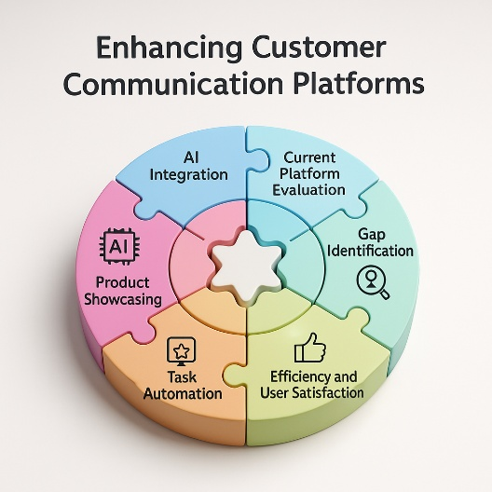

## Background:

Studies have consistently highlighted the importance of AI and automation in customer service. With advancements in machine learning and natural language processing, businesses can

now leverage AI to improve their customer support and automate internal processes. However, most current platforms fail to integrate these technologies fully. The lack of task automation and product showcasing capabilities further widens the gap between what businesses need and what platforms offer.

Research by Johnson et al. (2019) shows that AI-driven chatbots can handle a significant portion of customer queries autonomously, reducing the need for human intervention by up to 40%. Similarly, studies on task automation suggest that automated workflows can improve business efficiency by 30% (Brown & Williams, 2020). These findings highlight the critical need for platforms that integrate AI, task automation, and product showcasing into a single solution.

# LITERATURE SURVEY

This literature review examines the existing research on customer communication platforms, AI-driven automation, and task management.

**AI in Customer Service**: In their study, Johnson et al. (2019) explored the impact of AI-powered chatbots on customer service platforms. They found that AI significantly reduces response times and improves customer satisfaction by automating repetitive tasks. The study concluded that AI integration could reduce the need for human support by 40%, making it an essential tool for businesses looking to scale their customerservice efforts.

**Task Automation**: Brown and Williams (2020) investigated the role of task automation in improving internal workflows within businesses. Their research showed that automating task delegation and issue tracking can reduce operational bottlenecks and improve productivity by 30%. This studyunderscores the need for customer communication platforms to offer integrated task automation solutions. Link to study.

**Product Showcasing**: According to Smithand Doe (2022), integrating product showcasing into customer communication platforms can significantly enhance customerengagement and conversion rates. Their research found that businesses using platforms with integrated product promotion tools saw a 15% increase in conversions, as customers could browse and interact with products directly during customer service interactions. Link to study.

## How the Project Fills This Gap:

The proposed system fills several critical gaps identified in the literature by integrating AI-driven customer service, task automation, and product showcasing into a single, unified platform. Specifically:

**AI-Powered Automation**: The proposed platformincludes an advanced AI chatbot capable of handling complex queries,creating support tickets, and automating task delegation. By reducing human intervention, businesses can scale their customer support operations efficiently.

**Task Automation**: This platform features robust task management tools that allow businesses to assign and track tasks, automate internal workflows, and streamline customer support processes. These tools address the inefficiencies of current platforms, which often lackintegrated task automation capabilities.

**Product Showcasing**: Unlike existing communication tools that separate customer service from product promotion, this platform enables businesses to showcase their products directly during customer interactions. Customers can browse product catalogs and engage with offerings while receiving support, which increases engagement and conversion rates.

# PROPOSED SYSTEM

The proposed system is a comprehensive platform designed to meet the needs of businesses seeking to enhance both customer interactions and internal workflows. Key features include:

**AI-Powered Chatbot**: Capable of resolving complex customer queries, offering product recommendations, and automating support ticket creation.

**Task Management**: A robust task management system that automates the assignment and tracking of internal tasks, ensuring that both customer issues and internal workflows are handled efficiently.

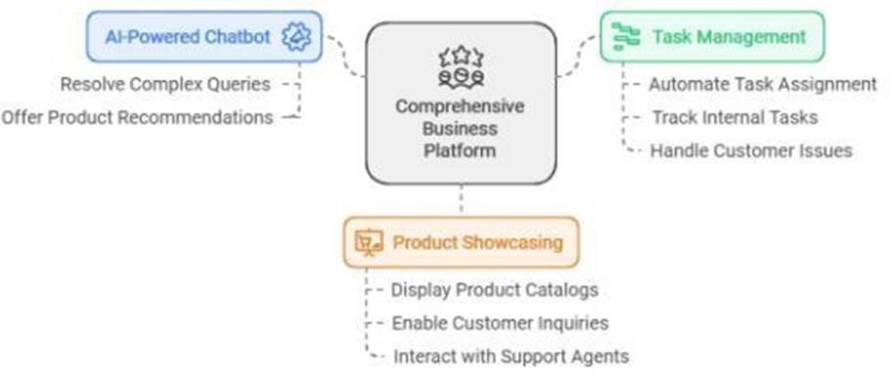**Product Showcasing**: Allows businesses to displaytheir products directly withinthe platform, enabling customers to explore product catalogs and make inquiries while interacting with customer support agents.

## Scope:

The scope of this project extends beyond traditional communication tools by offering an all-in-one solution that integrates customer service, task management, and product showcasing. This system is designed for businesses that require comprehensive tools to manage both external customer interactions and internal operations. The platform will be scalable, making it suitable for businesses of all sizes, from small enterprises to large corporations.

# FEATURES AND WORKING

User Features:

1.Customer Voicebot: The customer dashboard features an integrated AI voice bot, powered by the Gemini API, designed to assist users in resolving issues efficiently. If a customer encounters a problem with a product, the voice bot provides step-by-step guidance to help identify and address the issue. Leveraging advanced AI capabilities, it enhances user experience by offering quick and intelligent support through voice interaction. This feature ensures timely assistance and significantly reduces the need for manual support intervention.

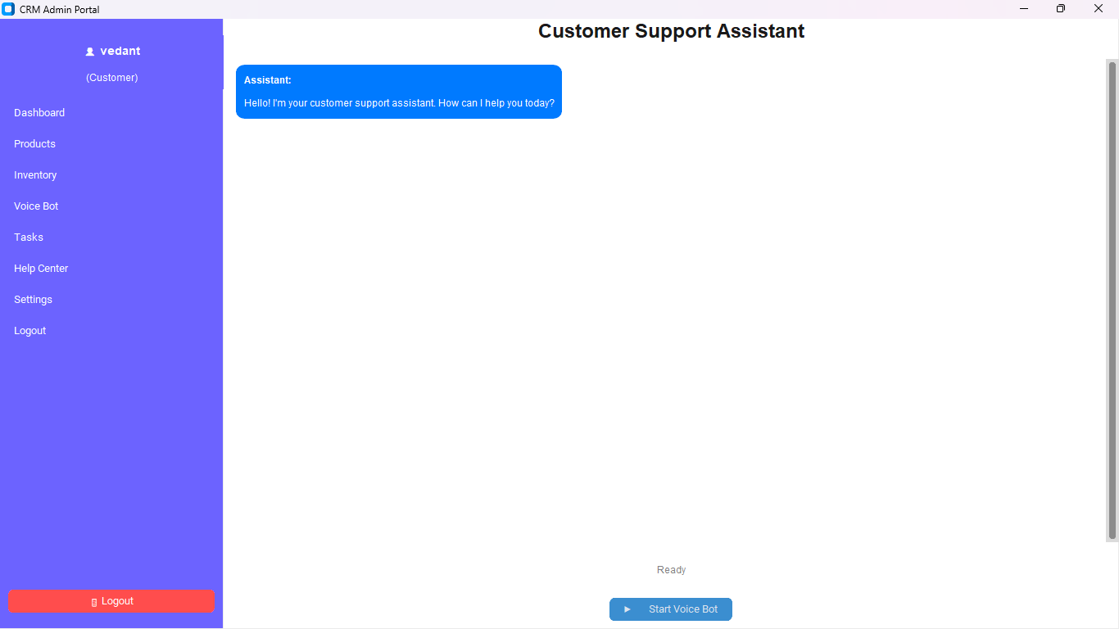

# Employee Features:

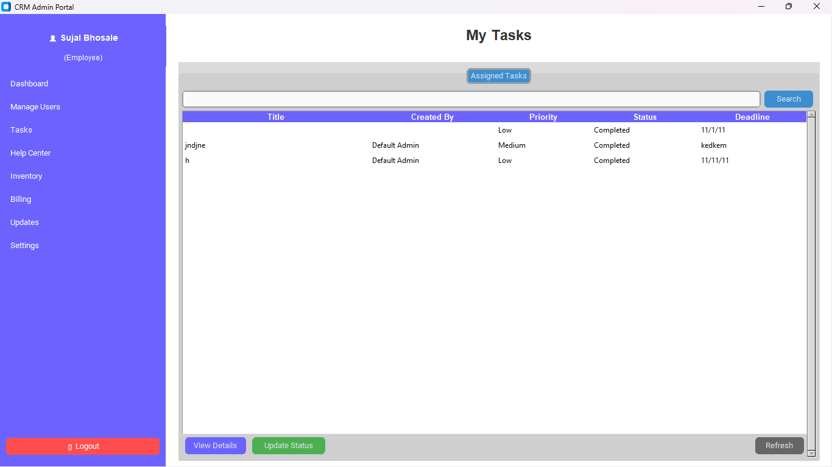The Task Management module enables users to create tasks by providing a description and uploading relevant images. Once submitted, the task is sent to the administrator, who can assign it to a specific employee through the admin console. The admin dashboard displays the task status categorized as Pending, Assigned, and Completed for effective tracking. As the employee progresses and marks the task as completed, the status is updated in real-time on both the admin and user dashboards, providing clear visibility of task progress and resolution.

## Admin Features:

1.Notice Board: The admin panel includes a Notice section that allows administrators to create and publish important announcements for all employees or selected individuals. Notices can be related to holidays, meetings, guest visits, or any other organizational updates. These notices are instantly visible on the employee dashboard, ensuring timely and effective communication. This feature helps keep all employees informed and aligned with company activities.

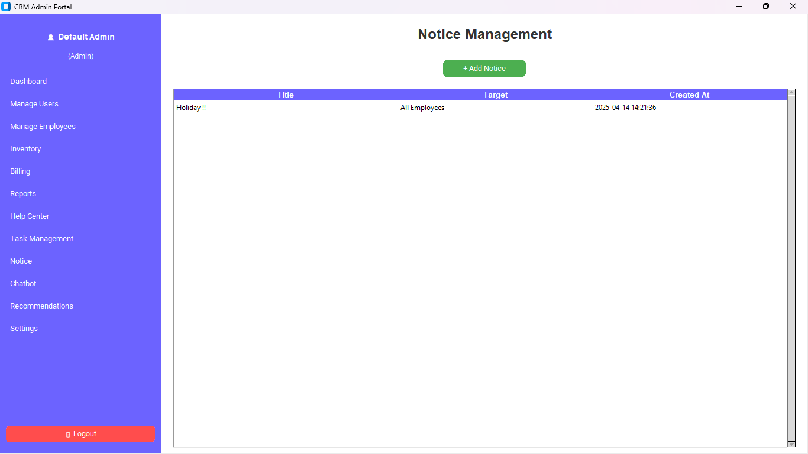

2.Billing System: The billing system is designed to automatically generate a professional PDF invoice that includes the company logo and authorized signature. To create a bill, the user must first select the customer, followed by the billing date, which is automatically set to the current date but can be manually changed if needed. The user then selects the product and specifies the quantity. Once the details are entered, the system generates a well-formatted PDF invoice for download or printing.

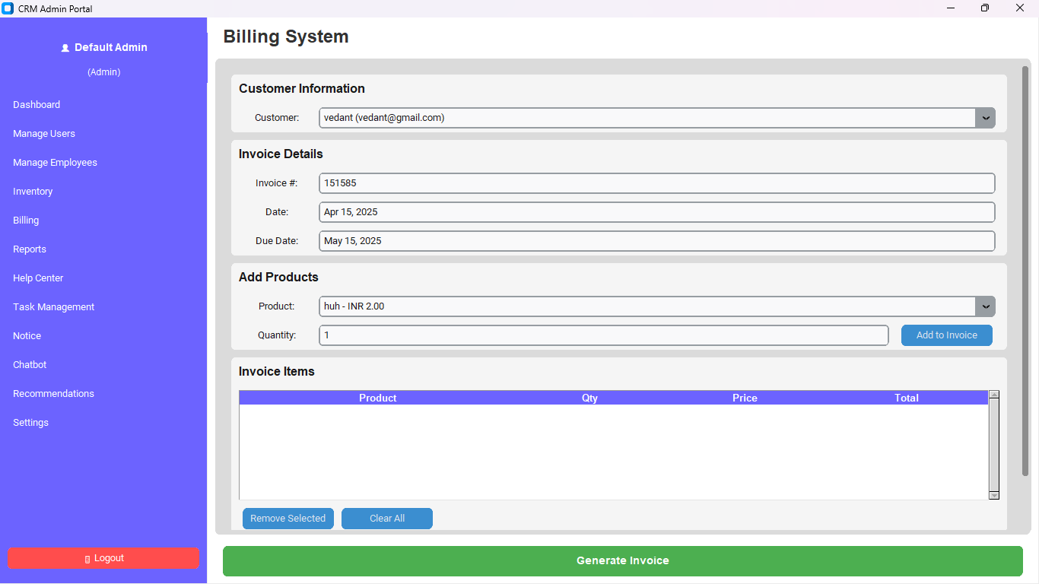

3.Product Management: The Product Management module allows administrators to add new products along with relevant details such as name, description, price, and availability. Once added, these products are displayed on the user side in a clean, card-style layout. Users can view product information in read-only mode, ensuring data integrity and preventing unauthorized edits. This feature provides a clear and organized presentation of products for easy browsing.

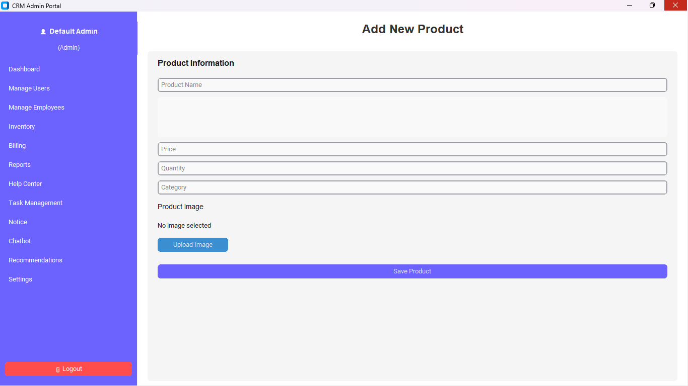

## 4.Admin Chat Bot: The admin panel includes an AI-powered chatbot designed to streamline operations through intelligent automation. This chatbot can efficiently handle various modules such as Task Management, Product Management, Billing System, Report Generation, and Employee Management—all through simple conversational commands. By interacting with the chatbot, administrators can perform actions like creating tasks, managing products, generating bills, and retrieving reports without navigating through multiple interfaces. This feature enhances productivity and simplifies administrative processes through seamless, AI-driven assistance.

## 

## PROPOSED SYSTEM:

* 1. **System Overview**: ASVAT – Automatic Customer Service is a web-based CRM system designed to enhance customer support, streamline employee task management, and simplify administrative control. It allows users, employees, and administrators to interact through dedicated role-based dashboards. The system aims to automate service requests, complaint management, billing, and reporting processes, offering a complete solution for businesses seeking efficient customer relationship management.
  2. **Key Features:** The system offers several powerful features to improve functionality and productivity. The Help Center enables customers to raise complaints and service requests**.** Task Assignment helps admins delegate responsibilities to employees, who can track and complete their tasks efficiently. Repair Management organizes service issues and their resolutions, while the Billing System automates the creation and handling of invoices. A built-in ChatBot provides users with quick responses and basic support. Each role has access to a tailored Dashboard, ensuring a personalized and relevant experience.
  3. **System Architecture:** ASVAT is built using a modular architecture that separates front-end and back-end operations. The client-side interface provides responsive and user-friendly access to users, employees, and admins. On the server side, a relational database handles user data, complaints, tasks, inventory, and billing information. Each role interacts with the system independently while remaining connected through shared data, ensuring real-time updates and smooth operations.
  4. **Modules:** The system is divided into three major modules. The User Module allows general users to access product details, raise complaints, chat with the bot, and track their service requests. The Employee Module includes task management tools, access to user data, billing entries, and inventory tracking. The Admin Module grants full system control, enabling administrators to manage users, assign tasks, monitor reports, configure settings, and oversee the overall functioning of the platform.
  5. **Data Flow:** The flow of data in ASVAT begins when a user submits a request or complaint. This data is stored in the system and directed to the appropriate employee based on task allocation by the admin. Employees then take action, update the task status, and process billing if necessary. The admin can view all updates and generate reports. This seamless data flow ensures coordination among all roles and guarantees that no request goes unanswered.
  6. **Integration:** ASVAT integrates several system components to deliver a seamless user experience. The chatbot and voice assistant allow for interactive communication. Secure authentication ensures that only authorized users can access their respective dashboards. Notifications keep users updated about their requests, while employees receive task reminders. The system is also capable of integrating with third-party APIs for future enhancements like payment gateways or analytics tools.
  7. **Expected Outcomes:** By implementing ASVAT, businesses can expect improved efficiency in handling customer interactions, faster resolution of service requests, and reduced workload for employees. The system’s structure enhances transparency, coordination, and data accuracy. It helps organizations maintain better records, improves customer satisfaction, and ensures that all internal processes are streamlined for higher productivity.
  8. **System Requirements:** ASVAT is a web-based platform and can run on any modern browser. It is built using technologies such as Python, Firebase, Tkinter, Customtkinter, and Fpdf. For full functionality, it requires hosting on a server with PHP and database support. Since it is platform-independent, it can be accessed on both desktop and mobile browsers, making it convenient and flexible for all users.
  9. 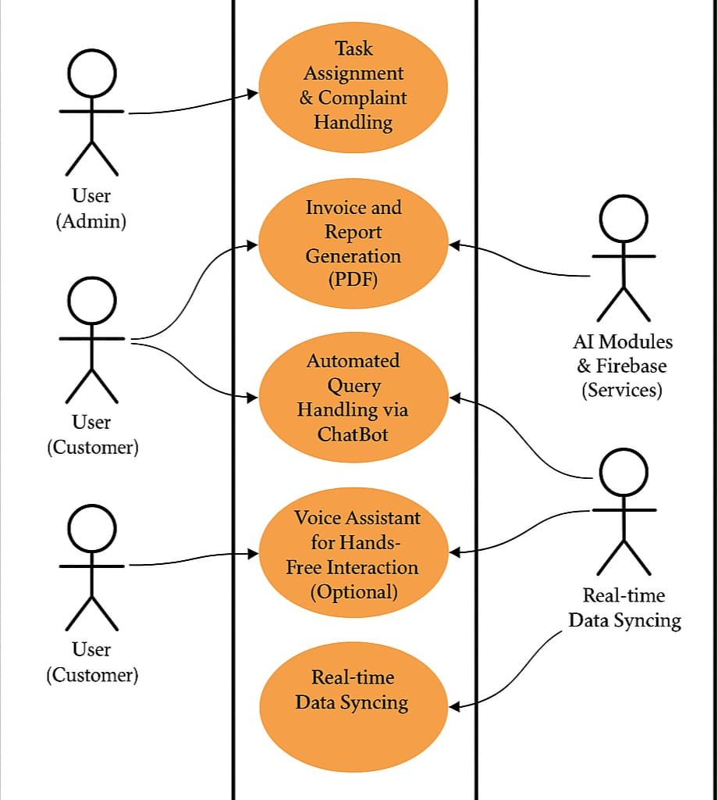

Fig. Use Case Diagram- **ASVAT**

# CONCLUSION

Current customer communication platforms offer valuable tools but often fall short in integrating task automation, AI- driven customer support, and product showcasing. The proposed system bridges these gaps by offering a unified solution that enhances both internal workflows and customer- facing interactions. By incorporating AI automation and product promotion, this platform stands as a comprehensive solution for businesses looking to improve their ustomer service and streamline internal operations

# REFERENCES

1. Implementing Project Oriented Customer Service.
2. Project Remedies Inc. [http://www.projectremedies.com](http://www.projectremedies.com/)
3. Edson Coutinho Da Silva. Customer Experience.
4. A Framework to create and deliver Value to Customers
5. https:/[/www.researchgate.net/publication/354170670](http://www.researchgate.net/publication/354170670)
6. Prof. dr hab. Anna Dabrowska & Prof. dr hab. Mirostawa Janos’-Kresto, The importance of customer experience for service enterprise