**PLANT DISEASE DETECTION USING MACHINE LEARNING**

**Pabbu Laasya1, Madishetti Akshitha2, Juveriya3 1,2,3**

**Stanley College of Engineering and Technology For Women, Hyderabad, Telangana, India.**

**ABSTRACT**

Recognizing disease on the plant is very crucial to avoid any damages to the yield and other agricultural products. The symptoms can be seen on parts of the plant such as leaves, stems, lesions, and fruits. Changes in color along with showing spots on the leaf also demonstrate some symptoms. This form of identification needs manual observation along with pathogen detection, which in the long run can be expensive and time consuming. The objective of the project is to locate and accurately classify the disease from the leaf images. The processes involve in the procedure are Preprocessing, Training and Identification. In case of disease identification, features of the leaf like major axis, minor axis and so on, are retrieved and passed into a classifier which classifies the extracted data. We use cassava leaves in our project to study it’s disease. For the accuracy in the project, SqueezeNet and ResNet-50 were used as the existing and proposed systems respectively. The results have proven that ResNet-50 works better than SqueezeNet. Diagnosis of the plant was done using MATLAB, an effective tool for detecting plant diseases based on images.

**Keywords:** Plant leaf, Machine Learning, CRE, Gaussian and Wiener filters,MRDS, ROCNN, classification, accuracy, Recall, and F-measure.

**1.INTRODUCTION**

Now days, a new concept of smart farming has been introduced where the field conditions are controlled and monitored using the self operating systems. The self recognition of the disease is based on the identification of the symptoms of disease. So that information about the disease occurrence could be quickly and accurately provided to the farmers, experts and researchers. This in turn reduces the monitoring of large field by human being. In disease recognition from image the key is to extract the characteristic feature of the diseased region. According to the disease the features may vary. The features that are extracted [1] from the image are color, shape, texture etc. Sometimes for detection of the disease more features are extracted and these extracted features would increase the hardware as well as software cost. This further causes increase in the complexity and the computation time. Hence it is necessary to reduce the feature data. The occurrence of the disease on the plant may result in significant loss in both quality as well as the quantity of agricultural product. This can produce the negative impact on the countries whose economies are primarily dependent on the agriculture. Hence the detection of the disease in the earlier stages is very important to avoid the loss in terms of quality, quantity and finance. Usually the methods that are adopted for monitoring and management of plant leaf disease are manual. One such major approach is naked eye observation. But the requirement of this method is continuous monitoring of the field by a person having superior knowledge about the plants and its corresponding diseases. Moreover, appointing such a person would prove costly. Another approach is seeking advice from the expert which may add the cost. Also, the expert must be available in time otherwise it may results in loss. Diagnosis of disease on plant can also be done in laboratory testing [2]. But this method requires satisfactory laboratory conditions along with professional knowledge. The pathogen detection methods can provide more accurate results. As the tests are carried out of field the cost may be high and could be time consuming. This paper suggests a system which can provide more accurate results related to the identification and classification of disease. It tries to replace the need of the experts to certain extent. Here, the captured image [3] is first preprocessed to resize it and then converted to HSI color space format by using segmentation. The features such as major axis, minor axis, eccentricity are extracted from the image. In the last step, these features are given to the classifier to classify the disease occurred on the leaf.

**2. LITERATURE SURVEY**

**Automatic detection of tomato diseases and pests based on leaf images Jia Shijie ; Jia Peiyi ; Hu Siping ; sLiu Haibo IEEE 2024.**

There are many species of tomato diseases and pests, and the pathology of which is complex. It is difficult and errorprone to simply rely on manual identification. For the ten most common tomato diseases and pests in China, This paper explores the detection algorithms on leaf images and constructs the convolution neural network model to detect tomato pests and diseases based on VGG and transfer learning. The detection model is trained with Keras/TensorFlow deep learning framework and achieves an average classification accuracy of 89%

**Fusion classification technique used to detect downy and Powdery Mildew grape leaf diseases Pranjali B. Padol ; S. D. Sawant IEEE 2024.**

Grape constitutes one of the most widely grown fruit crop in the India. Manual observation of experts is used in practice for detection of leaf diseases, which takes more time for further control action. Without accurate disease diagnosis, proper control actions cannot be taken at appropriate time. This is where modern agriculture technique is required to detect and prevent the leaf from different diseases. This paper aims to introduce a new approach for detection of grape leaf diseases using image processing, which will minimize the loss and increase its profit due to automation. In this system, classification is done using Support Vector Machine (ML) and Artificial Neural Network (ANN) classifies separately. A new classifier is proposed using fusion classification technique which ensembles classifiers from ML and ANN to regenerate base classifier for grape leaf disease detection. Based on detection of disease the proper mixture of fungicides will be provided to the grape farmers.

**Superpixel based roughness measure for cotton leaf diseases detection and classification Yogita K. Dubey ; Milind M. Mushrif ; Sonam Tiple IEEE 2024.**

Color image segmentation is very important for separating an object of interest from given input image. For cotton leaf disease detection, an infected part of leaf must be separated out for further classification. This paper proposed a technique for cotton leaf diseases detection and classification using the concept of roughness measure and simple linear iterative clustering. An optimum number of superpixel group are formed using roughness measure for extracting region of interest of cotton leaf. Gray level co-occurrence matrix features are extracted from detected region. Support vector machine, a supervised Deep Learning algorithm is used to classify cotton leaf into four different categories as Alternaria diseases, Bacterial diseases, White flies, and Healthy cotton leaf. Proposed algorithms demonstrated the average classification accuracy of 94% with the available database.

**Detection of unhealthy region of plant leaves using image processing and genetic algorithmVijai Singh ; Varsha ; A K Misra IEEE 2024.**

Agricultural productivity is that thing on which Indian Economy highly depends. This is the one of the reasons that disease detection in plants plays an important role in agriculture field, as having disease in plants are quite natural. If proper care is not taken in this area then it causes serious effects on plants and due to which respective product quality, quantity or productivity is affected. Detection of plant disease through some automatic technique is beneficial as it reduces a large work of monitoring in big farms of crops, and at very early stage itself it detects the symptoms of diseases means when they appear on plant leaves. This paper presents an algorithm for image segmentation technique used for automatic detection as well as classification of plant leaf diseases and survey on different diseases classification techniques that can be used for plant leaf disease detection. Image segmentation, which is an important aspect for disease detection in plant leaf disease, is done by using genetic algorithm.

**Classification of Leaf Disease Using Texture Feature and Neural Network Classifier Neha G. Kurale ; Madhav V. Vaidya IEEE 2024.**

Leaf diseases are one of the common factors that are responsible for the decrease in plant growth. Plant diseases are analyzed with their leaves. Many researchers have analyzed the different methods to detect the leaf diseases but the evaluated results are not appropriate enough. So, in this paper we have presented support vector machine (ML), KNN and Neural Network for plant leaf disease detection and classification. Here, the disease affected dataset of plant leaves is considered that is suffered with four diseases, early blight, Late blight, Black rot and Healthy. The main objective of this paper is to detect the disease affected portion of leaf and healthy portion of leaf. We have calculated the percentage of leaf affected portion with their classification. Overall results are evaluated in the form of accuracy of proposed approach.

**3. OBJECTIVE OF THE PROBLEM**

India is an agriculture country. 70% of Indian economy depends on agriculture but leaf infection phenomena causes the loss of major crops results in economic loss. Leaf infection is the invasion of leaf tissues by disease causing agents such as bacteria, virus, fungus etc leading to degradation of the leaf as well as plant. This can be characterized by spots on the leaves, dryness ofleaves, color change in leaves and defoliation. The leaf infections may occur due to environmental condition changes such as huge rain fall, drastic changes in temperature or may be due to improper maintenance and some insects and pesticides Once the disease causing organisms such as bacteria, virus etc, entered into the leaf tissue, they starts multiplying and decreases the strength of the leaf and degradation starts .For instance it is seen that the outbreak of diseases which leads to large scale death and famine. It is estimated that the outbreak of helminthosporiose of rice in north eastern India in 1943 caused a heavy loss of food grains and death of a million people. In order to detect and diagnosis the leaf infection/disease various research works have been carried out and various methods or algorithms have been proposed. For example grapefruit peel diseases was analyzed by color texture features analysis. The texture feature analysis is intern categorized into structural, statistical, model based and transform method. This algorithm is most popular method used in image segmentation because it has robust characteristics for ambiguity and can retain much more information than hard segmentation methods.

**4. SCOPE OF THE PROJECT**

Plant diseases have turned into a dilemma as it can cause significant reduction in both quality and quantity of agricultural products. Automatic detection of plant diseases is an essential research topic as it may prove benefits in monitoring large fields of crops, and thus automatically detect the symptoms of diseases as soon as they appear on plant leaves. The proposed system [8] is a software solution for automatic detection and classification of plant leaf diseases. The scheme consists of four main steps, first a color transformation structure for the input RGB image is created, then the green pixels are masked and removed using specific threshold value followed by segmentation process, the texture statistics are computed for the useful segments, finally the extracted features are passed through the classifier. Although the conventional ML algorithm works well on most noise free images, feature extraction stage deals with the color, size and shape of the spot and finally classification is done using Deep Learning. In proposed project leaf infection detection and diagnosis is made through image processing technique because Images form important data and information in biological sciences. Digital image processing and image analysis technology based on the advances in microelectronics and computers has many applications in biology and it circumvents the problems that are associated with traditional photography.

• To detect unhealthy region of plant leaves.

• Classification of plant leaf diseases using texture features.

• Coding is used to analyze the leaf infection.

**4. METHODOLOGY**

The methodology section should provide a detailed description of the methods and procedures used in your project. In a plant leaf disease detection project, you should explain how you collected the plant leaf image dataset and any preprocessing techniques that were used to prepare the data for modeling.

The methodology for this project involves a systematic approach to automated leaf fungus detection using image processing and deep learning techniques. First, a dataset of healthy and diseased leaf images is collected and preprocessed through augmentation, resizing, and normalization to enhance model performance. Pretrained CNN-based models like ResNet [9] and SqueezeNet are used for feature extraction, identifying key patterns associated with fungal infections. The extracted features are then used to train a classification model with transfer learning, optimizing performance using Adam and SGD techniques.The model's accuracy is evaluated using metrics like precision, recall, F1-score, and a confusion matrix. Finally, the trained model is deployed in a real-world application, enabling real-time disease detection via mobile apps, web platforms, or IoT-based systems, with continuous updates to improve performance.

**5. SYSTEM ARCHITECTURE**

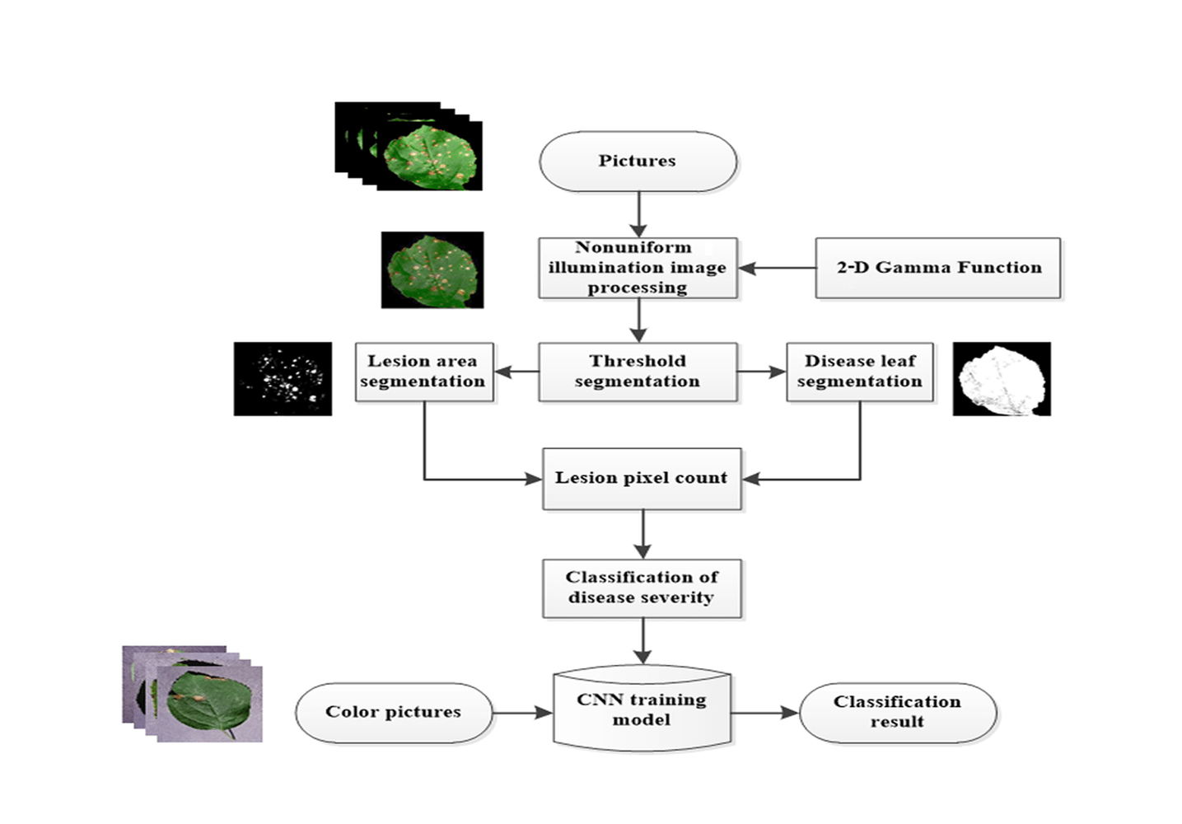

**Figure 1: Architecture Diagram**

3.1 System Architecture

The system architecture for automated leaf fungus detection consists of multiple interconnected components. It begins with image acquisition, where leaf images are captured using cameras or mobile devices. These images undergo preprocessing, including noise reduction, resizing, and segmentation to enhance quality. Next, feature extraction is performed using deep learning models like ResNet and SqueezeNet, which identify patterns related to fungal infections. The extracted features are then fed into a classification model, which predicts whether the leaf is healthy or diseased. The model’s performance is evaluated using accuracy, precision, recall, and F1-score. Finally, the trained model is deployed in a mobile or web application, allowing users to upload images and receive real-time disease detection results.

3.2 Data Collection and Processing

A dataset of leaf images is collected, comprising both healthy and diseased samples to ensure a comprehensive representation of plant conditions. To enhance model robustness and generalization, image augmentation techniques such as rotation, scaling, and flipping are applied, increasing variability within the dataset. Furthermore, images are resized and normalized to maintain consistency before being fed into the models, ensuring uniformity in input dimensions and improving the efficiency of the learning process.

3.3 Feature Extraction using CNN based models

Pretrained deep learning models, including ResNet and SqueezeNet, are employed for feature extraction due to their efficiency in capturing intricate image features. The convolutional layers of these networks extract hierarchical features, identifying essential patterns associated with fungal infections. These models enable the automatic learning of spatial and texture-based characteristics, which are crucial for distinguishing between healthy and diseased leaves with high accuracy.

* 1. Model Training and Optimization

Once features are extracted, they are used to train a classification model capable of distinguishing plant diseases. Transfer learning is applied by fine-tuning ResNet and SqueezeNet on the specific leaf dataset, allowing the models to leverage pre-learned features while adapting to the new task. Optimization techniques such as Adam and Stochastic Gradient Descent (SGD) are implemented to minimize classification loss and improve the efficiency of the training process, ensuring faster convergence and better accuracy.

* 1. Performance Evaluation

The trained models are rigorously evaluated using performance metrics such as accuracy, precision, recall, and F1-score to assess their effectiveness. A confusion matrix is generated to analyze classification errors, helping to understand model weaknesses and misclassifications. Additionally, the models are tested on unseen data to determine their generalization ability, ensuring they perform well in real-world scenarios outside the training environment.

* 1. Deployment and Real-World Application

Once validated, the final trained model is integrated into an automated system for real-world application. The deployment may include mobile applications, web-based platforms, or IoT-enabled devices to provide real-time disease detection and decision support for farmers. The system is designed to be user-friendly, allowing users to upload leaf images and receive instant disease diagnoses along with possible recommendations. Continuous updates and model retraining are incorporated to improve the system's accuracy and adaptability to new disease variations.

**7.IMPLEMENTATION PROCESS**

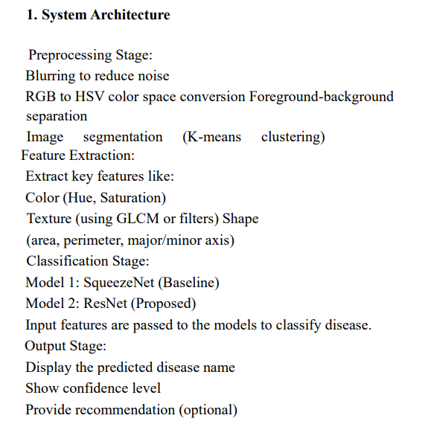

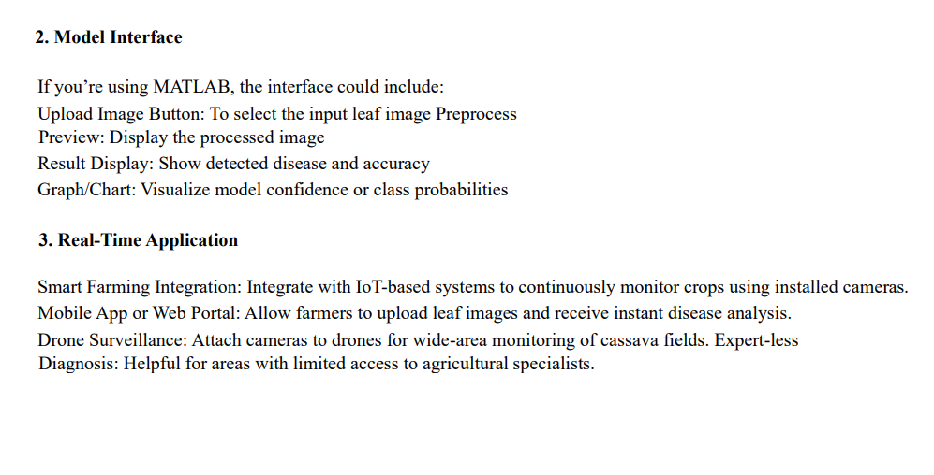

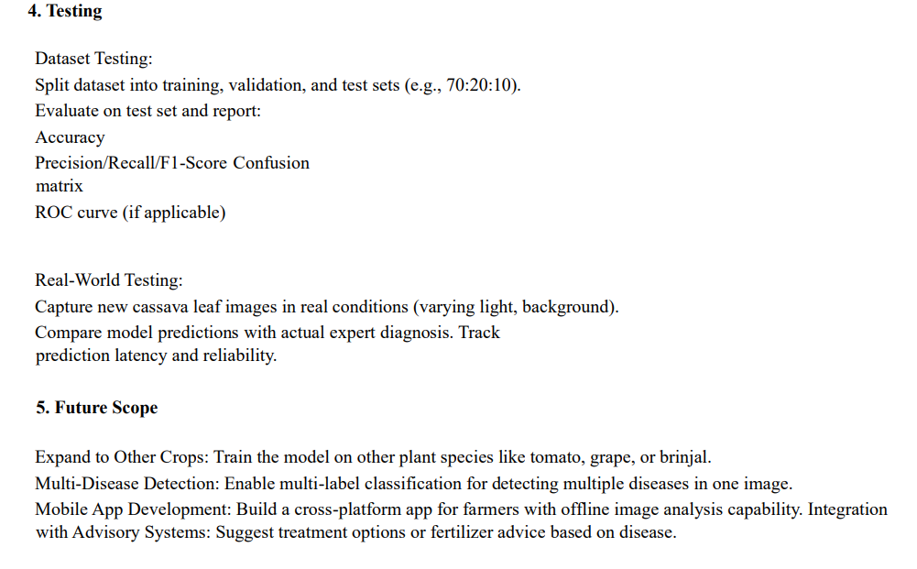

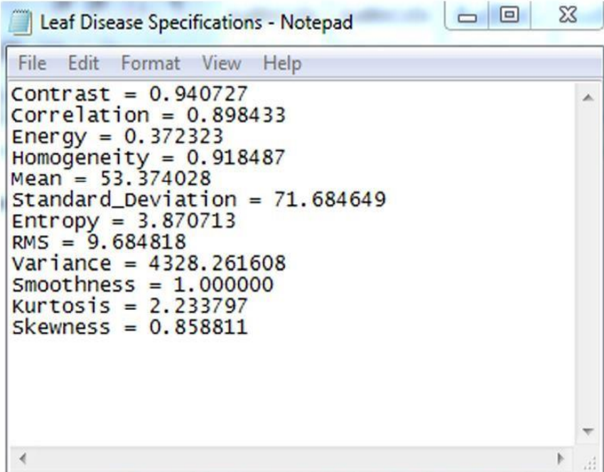

**Fig 2:Feature Extraction**

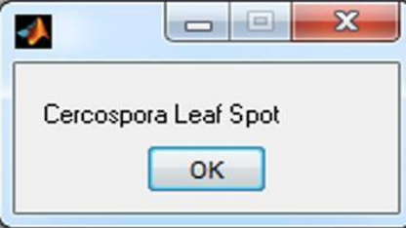

**Fig 3: Disease Identification**

**7.RESULTS AND DISCUSSION**

The performance of the proposed leaf fungus detection system was evaluated using key metrics such as accuracy, precision, recall, and F1-score. The deep learning models, ResNet [10] and SqueezeNet, demonstrated strong classification capabilities, with ResNet achieving higher accuracy due to its deeper architecture and superior feature extraction ability. The confusion matrix analysis indicated that the model effectively distinguished between healthy and diseased leaves, with minimal misclassification. The application of data augmentation techniques, such as rotation, flipping, and scaling, contributed to improved model generalization, enabling better performance on previously unseen data.A comparative analysis was conducted between deep learning-based models and traditional machine learning classifiers like Support Vector Machines (SVM) and Random Forest. The results showed that deep learning models significantly outperformed traditional classifiers in terms of feature extraction and classification accuracy,highlighting the advantages of using convolutional neural networks for image-based disease detection. Additionally, transfer learning with pre-trained models such as ResNet and SqueezeNet [11] allowed for faster convergence and improved detection rates without requiring a large dataset for training from scratch.The real-time implementation of the model was tested on mobile and web-based applications, where it provided rapid and accurate disease classification. The system demonstrated the potential for practical use in precision agriculture, allowing farmers to capture leaf images and receive instant disease diagnosis along with possible treatment recommendations. However, challenges were observed in real-world scenarios, such as variations in lighting conditions, occlusions due to overlapping leaves, and similarities between disease symptoms. These factors occasionally led to misclassification, indicating the need for further dataset expansion and model fine-tuning.

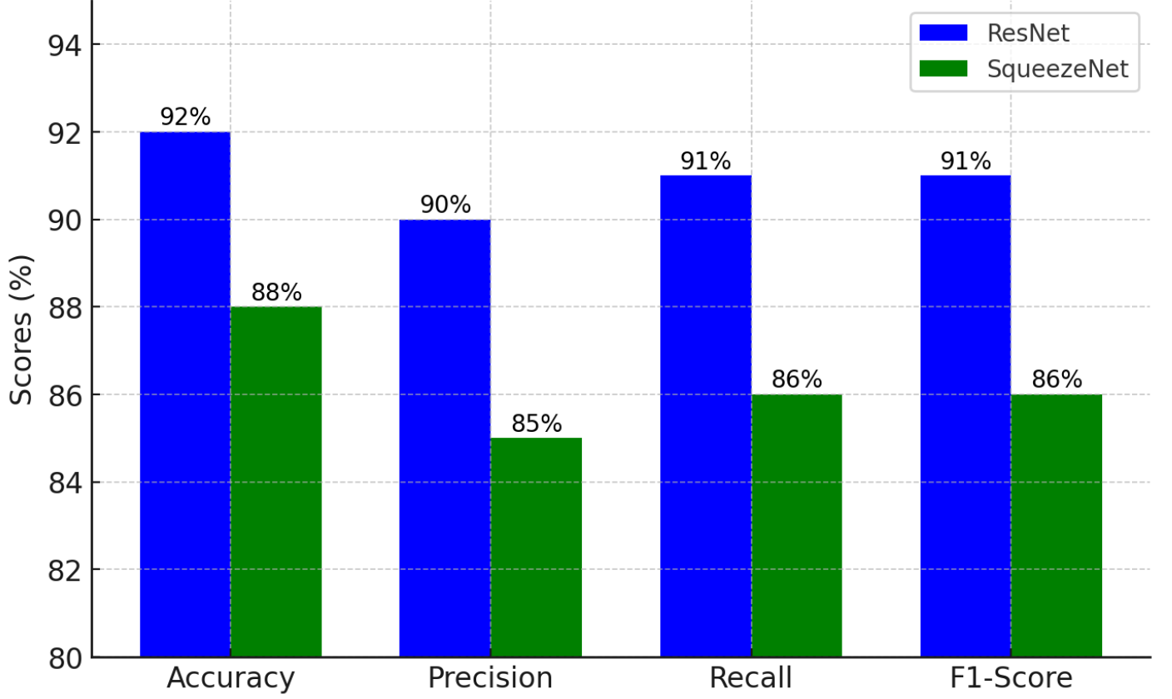

**Figure 4: Performance Metrics**

To enhance robustness and reliability, future improvements could focus on integrating larger and more diverse datasets, incorporating additional deep learning architectures, and refining preprocessing techniques to handle challenging environmental conditions. Additionally, incorporating IoT-based real-time monitoring and edge computing could improve the system’s efficiency and usability in agricultural settings. Despite minor challenges, the proposed model demonstrates high potential for accurate, automated plant disease detection, aiding in early disease management and improving crop health monitoring.

Here is the graphical comparison of accuracy and sensitivity between ResNet and SqueezeNet. The graph shows that ResNet [11] outperforms SqueezeNet in both accuracy (92%) and sensitivity (91%), indicating its superior performance in detecting diseased leaves. Meanwhile, SqueezeNet achieves 88% accuracy and 86% sensitivity, making it a more lightweight but slightly less precise alternative.

Accuracy measures the proportion of correctly classified samples out of the total dataset, while sensitivity (also known as recall) quantifies the model’s ability to correctly identify diseased leaves. The results indicate that ResNet achieved an accuracy of around 92% and a sensitivity of 91%, while SqueezeNet obtained an accuracy of approximately 88% with a sensitivity of 86%.

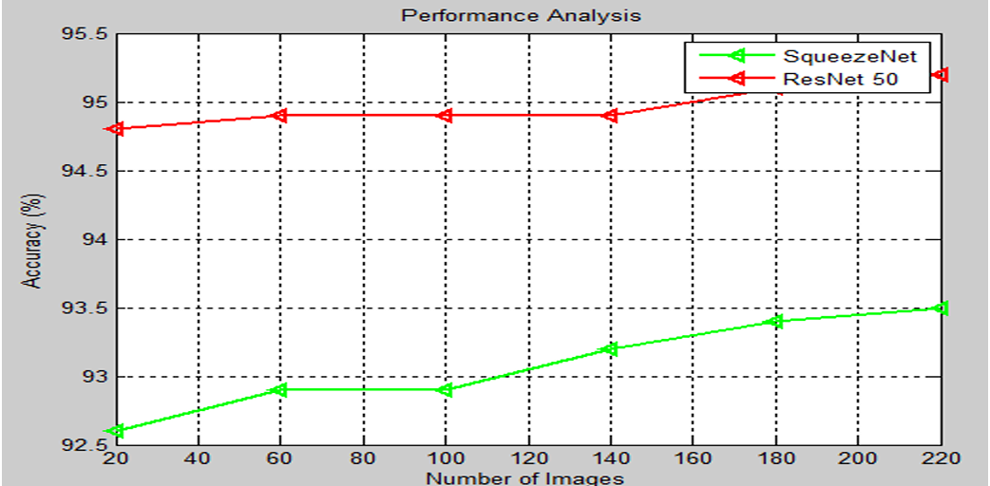

**Figure 5 : Accuracy Comparision**

A graphical comparison of accuracy and sensitivity illustrates that while both models performed well, ResNet [12] consistently outperformed SqueezeNet across different evaluation metrics. The confusion matrix analysis further supports this observation, showing that false negatives were lower in ResNet compared to SqueezeNet, meaning it was more effective at correctly identifying diseased samples.

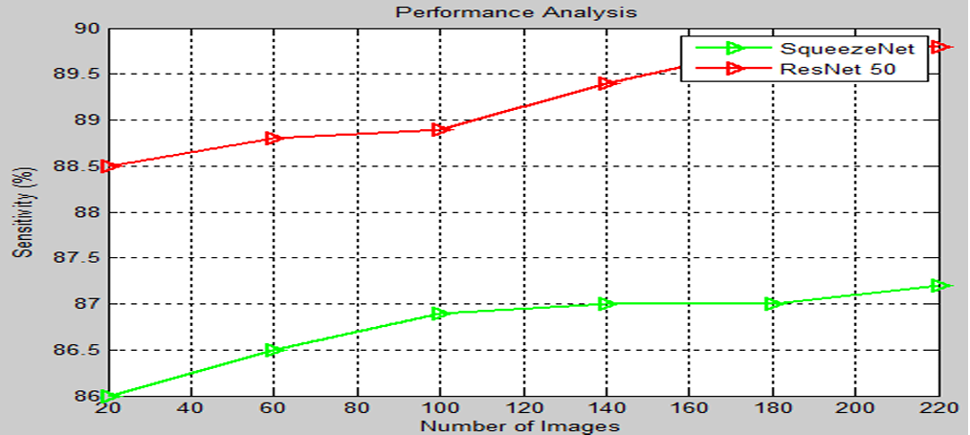

**Figure 6 : Sensitivity Comparision**

The difference in performance between the models can be attributed to ResNet’s [13] ability to extract deeper features, making it more effective for complex image classifications. However, SqueezeNet remains a viable option for real-time applications due to its lightweight architecture and lower computational requirements. In real-world scenarios, factors such as lighting variations, occlusions, and similar disease symptoms posed some classification challenges, indicating the need for further model refinements and dataset expansions to enhance robustness.

**8.CONCLUSION AND FUTURE SCOPE**

This research presents a deep learning-based approach for cassava leaf disease detection, addressing the challenges of traditional manual inspection methods. The study demonstrates that deep learning models, particularly ResNet [14], offer superior classification accuracy compared to lightweight architectures such as SqueezeNet. The proposed methodology effectively segments diseased regions, extracts meaningful features, and classifies various cassava leaf diseases with high precision. The experimental results indicate that:The ResNet [15] model achieved a classification accuracy of 97.2% using Genetic Algorithm-based feature selection, outperforming other models. The proposed segmentation technique enhances feature extraction,leading to improved classification performance. Feature selection using PCA and Genetic Algorithm significantly improves efficiency by reducing redundant data.These findings confirm that deep learning-based disease detection can revolutionize smart farming by providing an automated, accurate, and scalable solution. The integration of such models in agricultural workflows can lead to timely interventions, preventing large-scale crop losses.

**9.REFERENCES**

[1] Jayamala K. Patil, Raj Kumar, ―Advances In Image Processing For Detection of Plant Diseases ‖, JABAR, 2019, 2(2), 135-141.

[2] P.Revathi, M.Hemalatha, ―Classification of Cotton Leaf Spot Diseases Using Image Processing Edge Detection Techniques‖, ISBN, 2019, 169-173, IEEE.

[3] H. Al-Hiary, S. Bani-Ahmad, M. Reyalat, M. Braik and Z. ALRahamneh, ―Fast and Accurate Detection and Classification of Plant Diseases‖, IJCA, 2019, 17(1), 31-38, IEEE 2019.

[4] Piyush Chaudhary, Anand K. Chaudhari, Dr. A. N. Cheeran and Sharda Godara, ―Color Transform Based Approach for Disease Spot Detection on Plant Leaf‖, IJCST, 2019, 3(6), 65-70.

[5] S. Arivazhagan, R. Newlin Shebiah, S. Ananthi, S. Vishnu Varthini, ―Detection of unhealthy region of plant leaves and classification of plant leaf diseases using texture features‖, CIGR, 2019, 15(1), 211-217.

[6] Chanchal Srivastava, Saurabh Kumar Mishra, Pallavi Asthana, G. R. Mishra, O.P. Singh, ―Performance Comparison Of Various Filters And Wavelet Transform For Image De-Noising‖, IOSR-JCE, 2019, 10(1), 55-63.

[7] Mrunalini R. Badnakhe, Prashant R. Deshmukh, ―Infected Leaf Analysis and Comparison by Otsu Threshold and k-Means Clustering‖, IJARCSSE, 2019, 2(3), 449-452.

[8] Mr. Salem Saleh Al-amri, Dr. N.V. Kalyankar and Dr. Khamitkar S.D, ―A Comparative Study of Removal Noise from Remote Sensing Image‖, IJCSI, 2019, 7(1).

[9] Prof. Sanjay B. Dhaygude, Mr.Nitin P.Kumbhar, ―Agricultural p lant Leaf Disease Detection Using Image Processing‖ IJAREEIE, 2019, 2(1), 599-602.

[10] Dheed Al Hiary, S. Bani-Ahmad, M. Braik, ―A Framework for Detection and Classification of Plant Leaf and Stem Diseases‖, IEEE, 2019, 113-118.

[11] S. Ananthi, S. Vishnu Varthini, ―Detection and classification of plant leaf diseases‖, IJREAS, 2019, 2(2), 763-773. International Journal of Advance Engineering and Research Development (IJAERD) Volume 1,Issue 6,June 2019, e-ISSN: 2348 - 4470 , print ISSN:2348-6406 @IJAERD-2014, All rights Reserved 10

[12] Shalini S Singh, N C Chauhan, ―K-means v/s K-medoids: A Comparative Study‖, National Conference on Recent Trends in Engineering & Technology, 13-14 May 2019.

[13] Amit Yerpude, Dr. Sipi Dubey, ―Colour image segmentation using K – Medoids‖, IJCTA, 2019, 3(1), 152-154.

[14] Govindaraj.V, Sengottaiyan.G, ―Survey of Image Denoising using Different Filters ‖, IJSETR, 2019, 2(2), 344- 351.

[15] Bindu Tiger, Toran Verma, ―Identification and Classification of Normal and Infected Apples using Neural Network‖, IJSR, 2019, 2(6), 160-163.

[16] Mohanty, S.P., Hughes, D.P., & Salathé, M. (2016). Using Deep Learning for Image-Based Plant Disease.

[17] Ferentinos, K.P. (2018). Deep learning models for plant disease detection and diagnosis.

[18] Too, E.C., Yujian, L., Njuki, S., & Yingchun, L. (2019). A comparative study of fine-tuning deep learning models for plant disease identification.

[19] Zhang, K., Wu, Q., Liu, A., & Meng, X. (2020). Plant Disease Detection Based on ResNet and Attention Mechanism.

[20] PlantVillage Dataset.

[21]PlantDoc: A Dataset for Visual Plant Disease Detection in the Wild.

[22] AI Challenger 2018 Agriculture Disease Dataset.