# Virtual Dressing Room

# Prof. Megha Garud*1, Vivek Dumbre*2 ,

# Shambhuraje Jagtap*3,Sahil Tagunde*4, Parth Waikar*5,

*1,2,3,4,5Computer Engineering, Zeal Polytechnic , Zeal Institute,

Pune, Maharashtra, India.

# ABSTRACT

A virtual dressing room is a modern technology that allows people to try on clothes digitally, without physically wearing them. This innovative concept has become increasingly popular with online shopping, as it helps customers see how outfits will look on them before making a purchase. Using augmented reality (AR) and artificial intelligence (AI), virtual dressing rooms create a personalized shopping experience. Customers can upload their photos or create digital avatars that reflect their body shape and size, enabling them to visualize how different styles, colors, and fits would look on them. This not only makes shopping more convenient but also reduces the number of returns, as shoppers can make better choices about what will suit them. Additionally, virtual dressing rooms can provide personalized recommendations based on user preferences, making it easier for shoppers to discover new styles. The technology is continually improving, with advanced algorithms offering realistic representations of how clothes fit and move. Furthermore, virtual dressing rooms promote inclusivity by catering to diverse body types and personal styles, ensuring everyone can find outfits that fit and flatter them. As retailers adopt this technology, it promises to enhance the online shopping experience, making it more enjoyable and efficient. In essence, virtual dressing rooms are transforming the way people shop for clothes, blending technology and fashion to create a seamless experience.

**Keywords**: Augmented Reality (AR), Personalization, Inclusivity, Convenience.

# INTRODUCTION

Virtual dressing rooms are revolutionizing the online shopping experience, providing customers with an innovative way to try on clothes digitally. By using augmented reality (AR) and artificial intelligence (AI), these virtual fitting rooms allow users to upload their photos or create digital avatars that replicate their body shape and size. This technology enables shoppers to see how clothes will look on them before making a purchase, removing the uncertainty of buying without trying on items in person. It enhances convenience and saves time, as customers can visualize how different styles, colors, and sizes will fit their bodies without ever leaving home. One of the most significant benefits of virtual dressing rooms is the reduction in returns. By allowing customers to try on clothing virtually, they can make more informed decisions about what to buy, which reduces the chances of ordering items that don’t fit or look as expected. This also helps brands and retailers by lowering the costs associated with returns and improving customer satisfaction. Furthermore, this technology promotes inclusivity, catering to diverse body types and personal styles. Virtual fitting rooms can adapt to various body shapes, allowing individuals to see how garments will look on them, regardless of size or shape, making the shopping experience more inclusive for all. As the technology evolves, virtual dressing rooms have the potential to transform the online shopping landscape. Retailers are continually improving the accuracy of fit, making the virtual try-on experience more lifelike with better body measurement capabilities and enhanced garment rendering. Additionally, the rise of AI can offer personalized suggestions based on customers' previous shopping behaviors, adding another layer of convenience and customization. The integration of virtual fitting rooms into online retail promises to make shopping more engaging, enjoyable, and tailored to individual needs, while also making it more sustainable by reducing returns and waste.

# LITERATURE REVIEW

**Prof. Puneeth, Ullas , Sri Dharshan (2022),** This is a system design in In real-time to develop an application known as Virtual Visualization of Cloth Fitting that allow the user tries virtually with any cloth, get properly fit his/her body measurement which helps easy way out on online shopping without feel left anything. The system features functionalities like perfect body part selection, image scaling etc based on big data for advanced processing such as blending and torso detection which is done suitable to state of the art fashion. Its primary goal is to find an accurate body extraction in noisy images. For the first part, we use a novel segmentation method dominated by colors to extract the torso for resizing and fitting of clothing onto an user.[1].

**Limitation**:The proposed virtual dressing system faces several challenges that could impact its overall performance. One major issue is the potential for inaccuracies in body measurement extraction, as different poses and angles can distort the fit. Complicated backgrounds may make body extraction more difficult, while variations in lighting could interfere with accurate color detection and segmentation. The system may also have difficulty accommodating the wide range of human body shapes, leading to poor fit outcomes for some users. Additionally, real-time processing demands, especially when dealing with high-resolution images, could negatively affect system performance. If the user interface is not intuitive, usability might suffer, making navigation more difficult for users. Another concern is the system's ability to accurately represent the various textures and designs of different clothing materials in the virtual environment. Reliance on tools like OpenCV and NumPy introduces the risk of disruptions if these libraries encounter issues. Privacy concerns regarding the uploading of personal images may also deter potential users. Finally, the system's limited training dataset could fail to generalize effectively across diverse populations, further limiting its efficacy. [1].

**In [2] RNS Institute of Technology “Bengaluru”(2014),** Research is conducted to overcome the barriers of regular shop purchase and online clothing system problems by employing virtual trial room implemented with Augmented reality (AR)and artificial intelligence(AI). With this, the company can do away with physical fitting rooms and it enhances a shopper's online experience by giving them an alternative to literally testing out how clothes look.occreateElementID(8990,sd*,sd). It is based on Python algorithms for machine learning and deep learning, with tools including OpenCV for image processing (used to extract hand data from the web camera) and MediaPipe API which handles hand tracking. The app combines anthropometric data generation, cloth realistic modeling and intuitive body motion based GUI to provide users with a more engaging experience than just trying on clothes. The procedure comprises image capture, pre-processing of the images, extracting features from the processed images and populating a database to achieve photo-realistic fitting and sizing. This is the idea behind a virtual trial room, which personalizes and makes for an immersive shopping experience by adjusting cloth models dynamically to user's body.

**Limitation** :Virtual trial rooms face several challenges that could hinder their overall effectiveness. For one, accurate body measurements may be affected by differences in user posture and varying camera angles. Moreover, because the technology relies heavily on augmented reality and AI, it might not perform smoothly on low-end devices. Another issue lies in its difficulty accommodating a wide range of body types, which could restrict its usefulness for certain users. Lastly, concerns about data privacy—particularly regarding the storage of personal measurements—could discourage people from fully embracing the system. .[2].

**Aladdin Masri, Muhannad Al-Jabi (2019),**In this paper, Aladdin Masri, Muhannad Al-Jabi (2019), author proposes virtual dressing room application with the help of Microsoft Kinect sensor. Authors approach is mainly based on extraction of the user from video stream, alignment of models and also skin color detection. Author used modules for locations of the joints for positioning, scaling, and rotating for aligning the 2D cloth models with the user. We then apply skin colour detection on video to handle the unwanted occlusions of the user and the model. Then the model is overlaid on the user in real-time. Problem is just the Alignment of the user and the cloth models with precise position, scale, rotation and ordering. One of the important steps of the problem is the detection of the user and the body parts. In literature, various approaches are suggested that include body part detection,

skeletal tracking, and posture estimation and superimposing it onto a virtual environment in the user interface. The project is developed in the real time, C# programming environment for Kinect hacking application. Also, Kinect driver's middleware is used for some basic functions and for the tracking process along with Microsoft Kinect [3].

**Limitation** : There are many limitations of virtual dressing room applications that may hinder its effectiveness. For example, the measurement taken by the body can be done in a particular posture of the user and thus the calibration of the Kinect may not effectively put on the garment on the user. Other drawbacks are the necessity of hardware or software. Here it is the Kinect and thus the system will only work with users with this technology. Besides, user interaction may need to be learned after some period of usage and therefore may not be intuitive with all customers. Apart from that, the differences in garment physics and mechanics are probably not well captured, which would impact the overall feel of the virtual try-on experience. Collection and storage of personal body measurements may evoke privacy concerns among users who might thus shy away from the application. Lastly, issues such as latency or processing mayntervene with the user experience, and frustration may result. [3].

**Prof. T.SubaNachiyar ,C.CarolinGifta (2022)** The virtual fitting room platform aims to improve the online and in-store shopping experience by letting people try on garments virtually, alleviate time and accessibility issues that accompany traditional fitting rooms. This solution allows the user to upload pictures, enter body measurements, and watch how they would look in the garment using a 3D model with full rotation for an almost realistic view of the apparel from all sides. It entails features, such as a voice assistant that guides the user through a process, an accuracy matcher to predict a range of fit levels, and various categories of clothing. This method provide a 3D user-friendly experience because it has eliminated some of the problems often encountered while using. [4] .

**Limitation** :The virtual fitting room system presents several limitations that may affect user experience. Firstly, the reliance on accurate body measurements can lead to discrepancies if users input incorrect data, compromising fit accuracy. Additionally, the requirement for clear and properly aligned photos can be challenging for users, potentially resulting in unsatisfactory visualizations. The voice assistant feature, while helpful, may not always accurately interpret user commands, causing frustration. Moreover, the system's performance may be hindered by technical issues such as software bugs or connectivity problems. Users may also experience a lack of tactile feedback, missing the physical sensation of trying on garments. Lastly, the application may not cater to all body types, virtualtry-onexperience.[4]

1. **OBJECTIVE**

The objective of a virtual dressing room is to improve online shopping by allowing customers to try on clothes digitally. This technology helps users see how garments fit and look on them, reducing returns due to sizing or style issues. It also aims to promote inclusivity by accommodating various body shapes and sizes. Additionally, virtual dressing rooms provide personalized recommendations based on user preferences, creating a convenient and enjoyable shopping experience that blends technology with fashion. Another key goal is to personalize the shopping experience, offering tailored recommendations based on user preferences and past purchases. Ultimately, the objective is to create a convenient, engaging, and satisfying shopping environment that combines the best of technology and fashion.

.

# PROPOSED SYSTEM

The proposed system is a **virtual fashion store with integrated firewall protection**, designed to provide users with a secure and immersive online shopping experience. This system not only ensures smooth navigation and feature-rich shopping but also prioritizes user data security and privacy using firewall implementation techniques. Below are the detailed features and components of the proposed system:

**Use Authentication and Access Control**

The system includes dedicated login and signup pages (login.html and signup.html) to authenticate users securely. Input validation techniques and secure form handling are applied to prevent unauthorized access. This layer of authentication acts as the first line of defense in protecting user data and managing access rights across the application.

**Product Browsing and Filtering**

Users can browse a wide range of fashion items through a visually appealing interface. The products.html and ProductDetails.html pages display item details such as name, image, price, and description, allowing customers to make informed choices. Efficient navigation and sorting options are provided for a better shopping experience.

**Virtual Try-On Feature**

The system stands out with an innovative **virtual try-on module**, implemented in main.py, where users can activate their webcams to try clothing virtually. This feature leverages computer vision to overlay clothing items onto the user's live video feed, helping them visualize how a product looks on them before purchase. This adds a futuristic and interactive touch to the traditional e-commerce model.

**Smart Cart and Smooth Checkout**

The system provides a seamless cart and checkout experience through the checkout.html page. Users can review their orders, see the total amount, and get confirmation of order placement. A clean and minimal design helps users complete their transactions efficiently without distractions.

**Backend Integration and Processing**

The backend, primarily coded in Python (main.py), handles webcam initialization, data processing, and interaction between front-end and virtual dressing logic. It also manages user session handling, enhances interaction with products, and can be further extended to store purchase history and user preferences.

**Firewall and Security Mechanisms**

As part of the system’s core architecture, a firewall configuration is implemented to prevent unauthorized access, SQL injection, and DDoS attacks. The firewall ensures only verified requests are allowed through, protecting both server resources and sensitive customer information. IP filtering, port blocking, and access control lists (ACLs) are part of the firewall rules applied to this system.

**Responsive Design and Device Compatibility**

The entire system is built with responsive design principles, using HTML and CSS to ensure compatibility across different devices, including desktops, tablets, and smartphones. Google Fonts and animation libraries (e.g., Bodymovin) are also used to enhance the UI aesthetics.

**Scalability and Future Scope**

The modular architecture of this system allows easy scalability. Future enhancements can include AI-driven recommendation engines, integration with payment gateways, and advanced biometric security measures. The virtual try-on feature can also be extended to support multiple outfits and AR-based dressing.

* **Algorithm’s :**

1. **User Interface**:

1. User Interaction (Frontend)1. User visits the website (index.html).

2. User browses the product listing (products.html).

3. User selects a product to view more details (ProductDetails.html).

4. User can:

a. Add the product to cart.

b. Continue browsing.

5. User clicks the cart icon to review selected items (cartPage.html).

6. User proceeds to checkout (checkout.html).

1. **User Authentication**:

1. If user is not logged in:

a. Redirect to login page (login.html).

b. User can create an account via signup.html.

2. On successful login:

a. Store session/authentication info.

b. Redirect to checkout.

1. **Checkout Process**:

1. Collect shipping and payment information.

2. Verify input fields (client-side or server-side).

3. Submit order details to backend (main.py or other backend script).

4. Show confirmation page/message.

1. **Backend Logic (main.py):**

1. Handle form submissions (e.g., login, signup, order checkout).

2. Read/write user/product/order data from/to files or a database.

3. Perform authentication checks.

4. Return responses to the frontend (possibly using Flask or similar).

# ARCHITECTURE DIAGRAM

This flowchart illustrates the **workflow of a Virtual Dressing Room System**, which allows users to try on virtual clothes using image processing and pose estimation. The system follows a step-by-step approach to capture user input, detect their pose, overlay virtual clothing, and display the modified image. Below is a detailed explanation of each step:

1. **Start**
   * The process begins when the user initiates the virtual dressing system.
2. **Load Product Images**
   * The system loads images of virtual clothing (e.g., shirts) stored in a directory (Resources/Shirts).
   * These images will later be used to overlay on the user's detected body.
3. **Capture User Input**
   * The system captures the user's image or video using **OpenCV**.
   * This allows the system to process the user’s real-time pose for further analysis.
4. **Detect User Pose**
   * The captured image/video is analyzed using **MediaPipe Pose Estimation**, a machine-learning model that detects key body points.
   * This helps in accurately positioning the virtual clothing on the user’s body.
5. **Overlay Virtual Clothing**
   * Once the user's pose is detected, the system overlays the selected virtual clothing onto the detected pose.
   * This step ensures that the clothing aligns correctly with the user's body.
6. **Display Modified Image in UI**
   * The processed image with the overlaid virtual clothing is displayed on the user interface (UI).
   * The user can view how the selected clothing looks on them.
7. **User Can Switch Clothing**
   * The user has the option to try on different clothing items by selecting from the available options.
   * The system will update the overlay dynamically without needing to recapture the image.
8. **Optionally Save/Share Image**
   * If the user is satisfied with the virtual try-on, they can **save** the image or **share** it with others.
9. **End**
   * 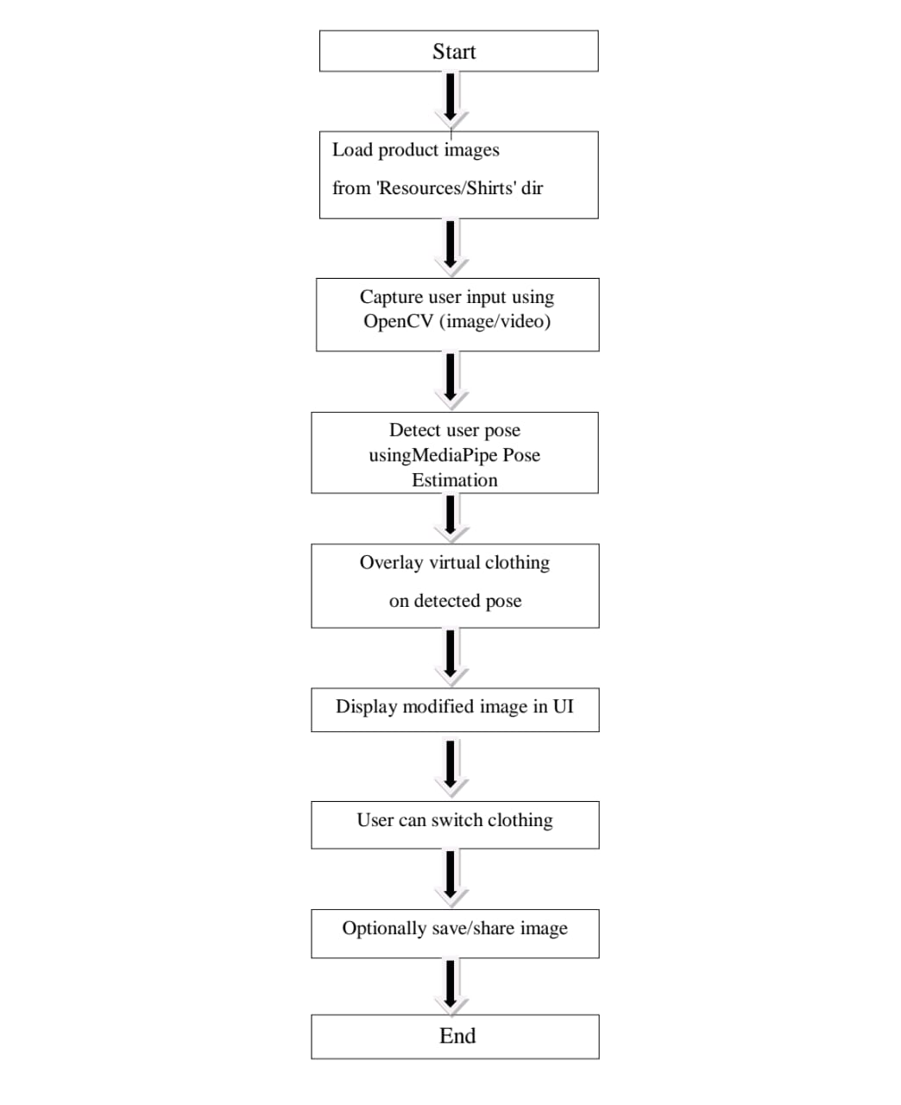The process is completed

(Figure 1: Architecture diagram of Virtual Dressing Room )

# USE-CASE DIAGRAM OF USER

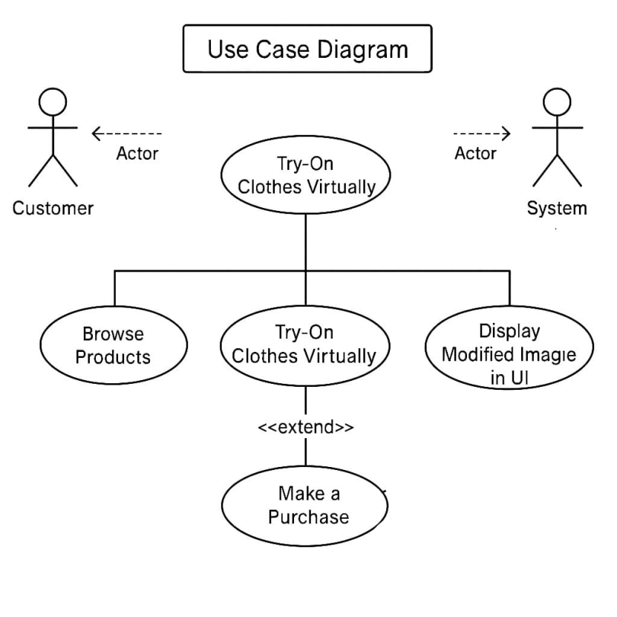

(Figure2: Use-case diagram for user)

This image shows a Use-Case Diagram for a Virtual Dressing Room system.

**Key Points:**

**Actors:**

* Customer: The user who interacts with the system.
* System: The virtual dressing room platform.

**Use Cases:**

* Browse Products: The customer can view available clothes.
* Try On Clothes Virtually: Main use-case where the customer uses the virtual feature to try clothes.
* Display Modified Image in UI: The system shows how the clothes look on the customer.
* Make a Purchase: The customer can buy the selected clothes. (This is an extension of the virtual try-on)

# USE-CASE DIAGRAM OF ADMIN

Edit Details

Login / Sign up

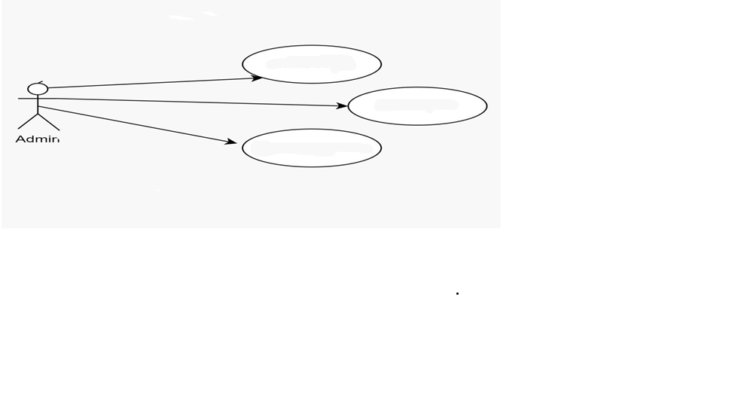

Admin

Change try on cloth

This Use-Case Diagram represents the Admin functionalities in a Virtual Dressing Room system. The admin is shown as the main actor who interacts with various system use cases to manage and maintain the platform effectively.

The first function the admin can perform is Login or Sign up, which is required to access the system securely. Once logged in, the admin gains access to other administrative features. This ensures that only authorized personnel can make changes within the system.

The other two key functionalities include Editing Details and Changing Try-on Clothes. Editing details may involve updating user info, product descriptions, or system settings. Changing try-on clothes refers to managing the virtual clothing items users can try—such as adding new clothes or removing old ones. These actions help keep the platform updated and user-friendly.

**VIII. IMPLEMENTATION OF WORK**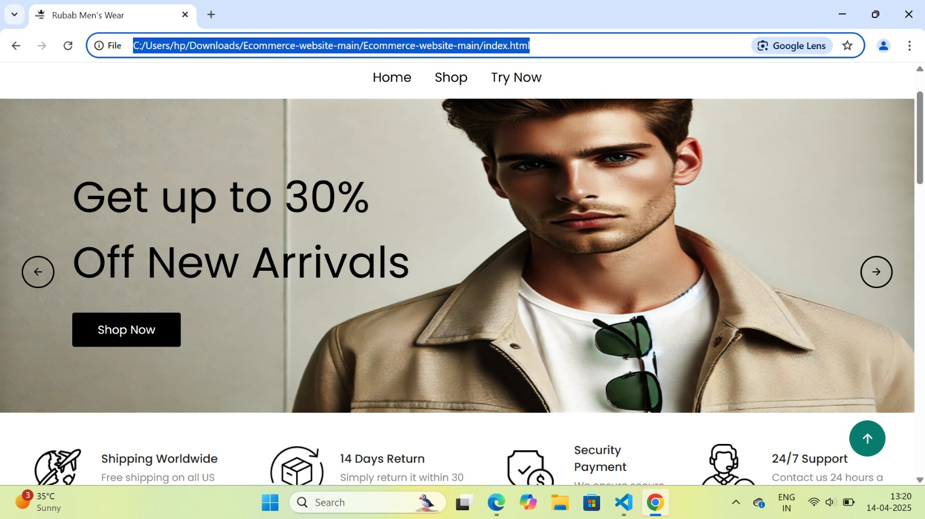

# HOME PAGE

This is the homepage of an e-commerce website called "RUBAB Men's Wear", currently running on a local server. It features a clean design with navigation links like Home, Shop, and a "Try Now" button, which indicates the presence of a virtual dressing room feature. The banner promotes a 30% discount on new arrivals and includes a call-to-action button. For your project, the “Try Now” section can allow users to virtually try clothes using a photo or live camera, enhancing the online shopping experience by combining fashion with interactive technology.

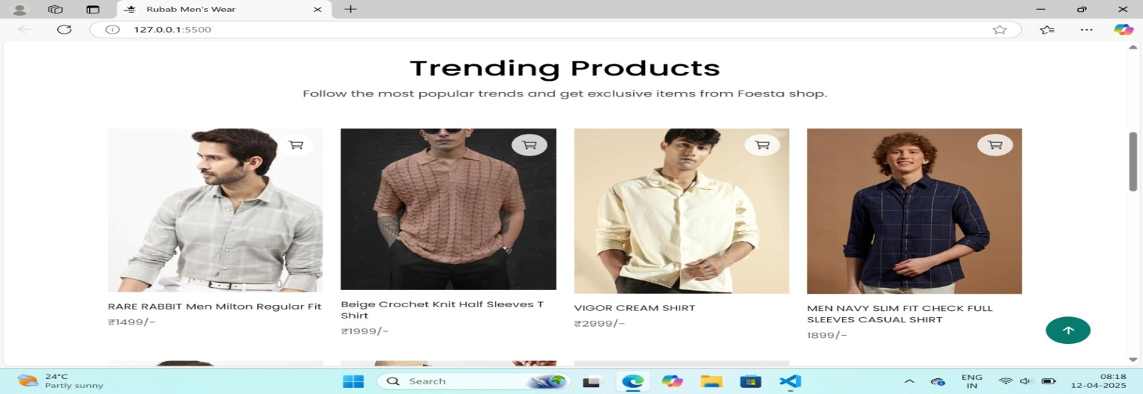

TRENDING PRODUCTS

This section of the RUBAB Men's Wear website showcases Trending Products, featuring a clean and modern layout of popular men’s shirts. Each product is displayed with a high-quality image, name, and price, along with a cart icon for easy purchase. The products include a mix of casual and stylish options, ranging from ₹1499 to ₹2999.

For your virtual dressing room project, this section can be enhanced by adding a “Try Virtually” option beside each item. This would allow users to preview how the shirt looks on them using a live camera or uploaded photo, improving their shopping experience and increasing confidence in their purchase decisions.

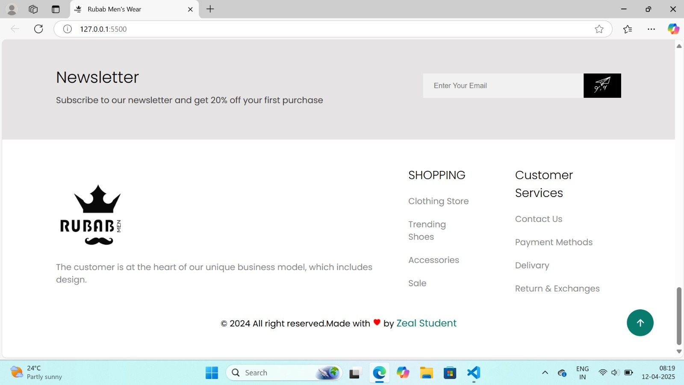

# VDR BASE

# This image showcases the footer section of the Virtual Dressing Room project website, designed for an online men’s clothing store named "RUBAB Men". The section includes a newsletter subscription prompt offering a 20% discount on the first purchase, enhancing user engagement. The footer also displays the brand logo and slogan emphasizing customer-centric design. It provides quick navigation links under "Shopping" and "Customer Services" for easy access to product categories and support options. The bottom line gives credit to the creator, showing the site is made with dedication by a Zeal Student in 2024.

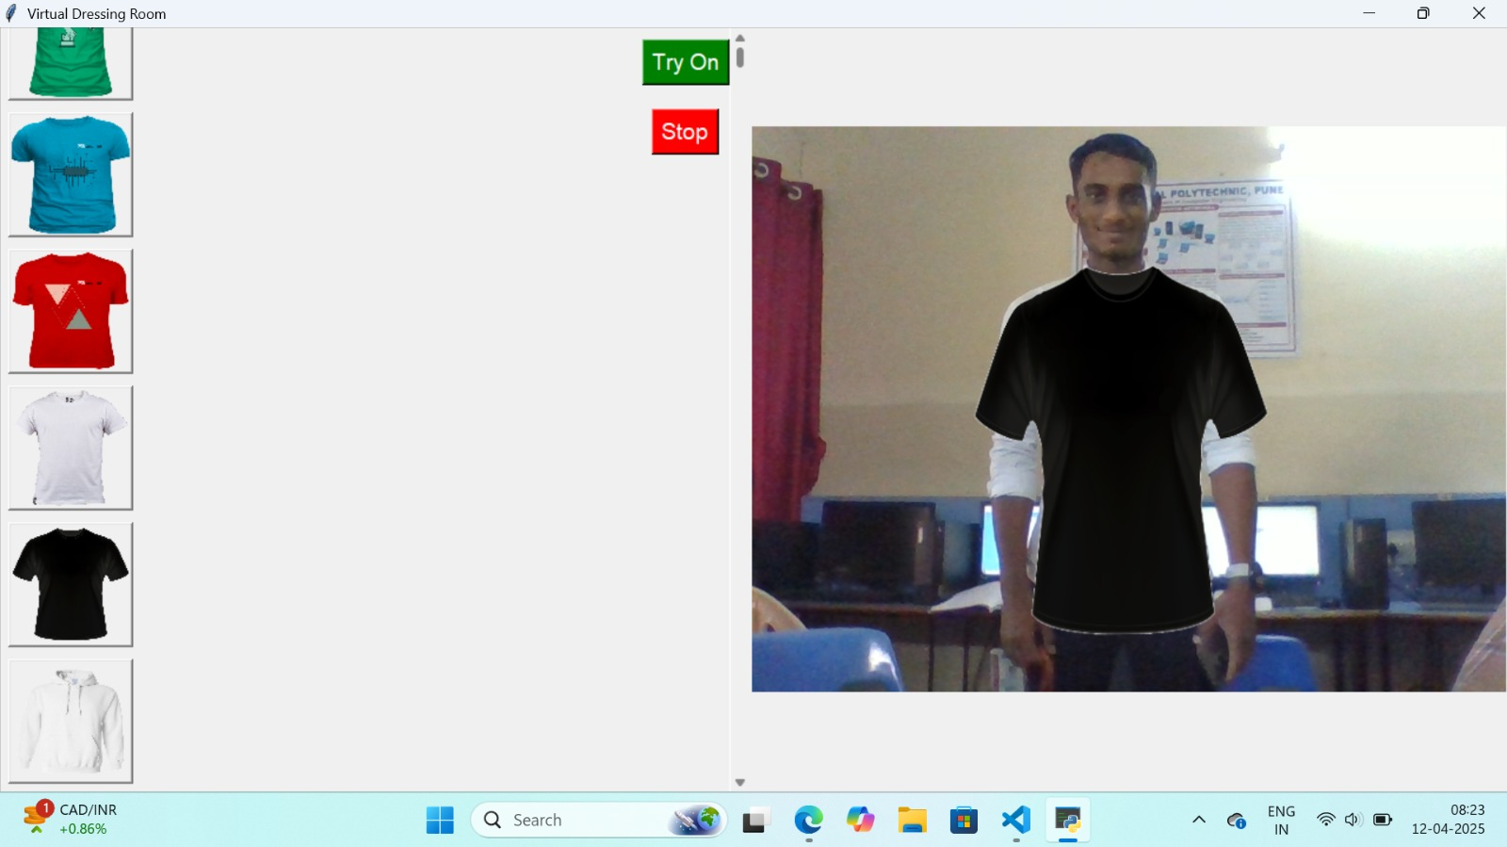

TRY-IT-ON

This image represents the core interface of the Virtual Dressing Room project, where users can select a clothing item from a panel and instantly "try it on" using augmented reality. The right section displays a live webcam feed overlaying the selected shirt onto the user’s body, simulating how the garment would look in real life. Simple "Try On" and "Stop" buttons allow for easy interaction. This feature provides a practical and engaging way to enhance online shopping by allowing users to virtually visualize products before purchasing.

# IX.CONCLUSION

In conclusion, the virtual dressing room represents a revolution in the online shopping experience, blending technology and fashion to meet the demands of today’s consumers Using augmented reality and machine learning, design this enables users to visualize clothes in individual avatars, greatly increasing fitting accuracy, payback rate Minimizing and the interactive nature of the platform does not seem to provide them with use not only engages but also encourages informed purchasing decisions through personalized recommendations and social engagement features

As technology improves, future developments, such as multi-sensory experiences and sustainable fashion designs, promise to further enhance the user journey By differentiating flesh controlling between the floor and the digital retail space, the virtual interior not only facilitates but meets modern standards of personalization and sustainability Ultimately, this new solution is set to redefine how consumer.

# X. FUTURE SCOPE

1.Improved Accuracy: In the future, body measurements and fit prediction can be made more accurate using AI and 3D body scanning.

2. Augmented Reality (AR): AR can be used to allow users to try clothes in real-time using their phone or webcam.

3. Mobile App Integration: The virtual dressing room can be developed into a mobile app for easier access anytime, anywhere.

4. More Clothing Options: The system can support more brands and styles, so users have a wider variety to choose from.

5. Personalized Suggestions: AI can recommend clothes based on the user’s style, body type, or past choices. 6. E-Commerce Integration: It can be linked with shopping websites to allow direct purchase after trying clothes virtually.

7. Virtual Fabric Feel: Future tech may allow users to feel the texture or weight of clothes virtually using haptic technology.

8. Social Sharing: Users can share their virtual try-ons with friends for opinions before buying.

# XI.REFERENCES

* Prof. Puneeth , Ullas M, TamannaFirdous, Sudarshan BG, Sri Dharshan, (A NOVEL APPROACH OF VIRTUAL VISUALIZATION OF CLOTH FITTING) College Of Engineering Mandya, India.Maharaja Institute Of Technology Mysore, Karnataka, India.Visvesvaraya Technological University, Belagavi, India. e-ISSN: 2582-5208 (2022) [1].
* Dayasagar A S, Kushal S, Sudeep Gowda C K, Sudharshan L, Jagadeesh B N RNS Institute of Technology Bengaluru (Virtual Trial Room Application). ISSN: 2456-3315 (2014) [2].
* Aladdin Masri, Muhannad Al-Jabi, “Virtual Dressing Room Application”, 978-

1-5386-7942-5/19/$31.00 ©2019IEEE. [3]

* R.Subhiksha, C.CarolinGifta, Prof: T.SubaNachiyar Department of Computer Science and Engineering, Velammal College of Engineering and Technology (A Proposed Hedonic model for Virtual Fitting room) ISSN 2582-7421 (2022) [4].