**ARDUINO BASED SMART PARKING SYSTEM**

Dr. V S Sandeep Kumar Reddy, Mr. K.Ashok ,Mr k.Sai kumar ,Ms A.Asha Bhavani, Ms.A.Nikhitha

Department ofElectricalEngineering, Assistant Professor, ANITS ,Visakhapatnam, India

Department of Electrical Engineering, B.tech final year, ANITS , Visakhapatnam, India

Department of Electrical Engineering, B.tech final year, ANITS Visakhapatnam, India

Department of Electrical Engineering, B.tech final year, ANITS, Visakhapatnam, India

Department of Electrical Engineering, B.tech final year, ANITS ,Visakhapatnam ,India

# **ABSTRACT**

This concept proposes a comprehensive smart parking system that uses Arduino and sensor technologies to properly manage parking spaces, resulting in greatly reduced congestion and wait times. The system has innovative features like automatic door opening and closing, automated receipt creation, and real-time parking availability monitoring. By expediting the parking procedure, it hopes to reduce labour expenses, fuel consumption, and pollution in metropolitan areas, thereby improving inhabitants' overall quality of life and creating a more sustainable urban environment. With the potential integration of mobile applications, customers will be able to easily discover and reserve parking spaces, further optimising their parking experience and contributing to more efficient urban infrastructure. This innovative solution has the potential to transform urban parking management, making cities more livable, navigable, and environmentally friendly, while also improving the economic viability of parking services. By adopting this smart parking system, cities can move towards a more intelligent, responsive, and citizen-centric approach to urban planning, setting a precedent for future smart city initiatives and fostering a better quality of life for residents and visitors alike.

1. **Introduction**

A smart parking system comprehensively addresses a multitude of pivotal challenges, including congestion management through guided parking allocation, optimising space utilisation via data-driven insights, providing real-time parking information for informed decision-making, implementing efficient payment systems for seamless transactions, ensuring accessibility and safety through designated features and surveillance, mitigating environmental impact by reducing parking times. By integrating with urban infrastructure for enhanced mobility, scaling to accommodate growing demands, safeguarding sensitive user data through robust security measures, and prioritising user experience through intuitive interfaces, mobile integration, and personalised services, thus streamlining parking operations, reducing frustration, and improving overall quality of life, while also contributing to a more sustainable, efficient, and technologically advanced urban eco system

1. **COMPONENTS**

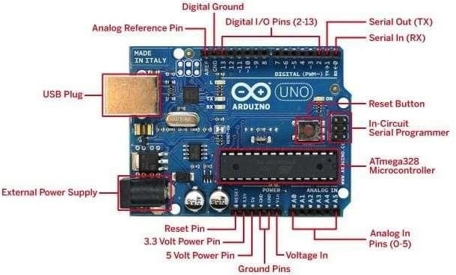**ARDUINO**

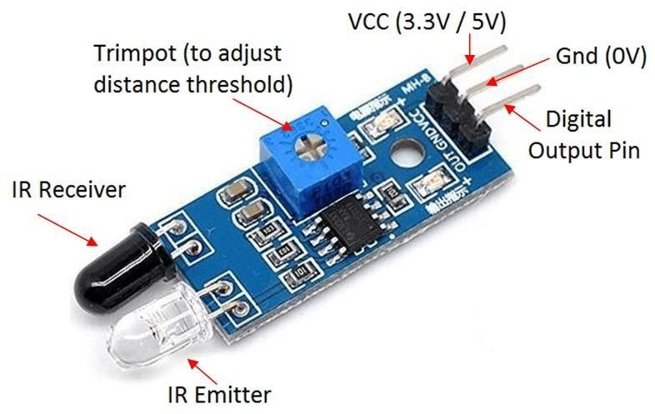In a Smart Parking System, Arduino serves as the central nervous system, leveraging its sophisticated microcontroller capabilities to intricately detect vehicle presence through IR sensors, accurately determine parking slot availability, and dynamically control displays and notifications, thereby orchestrating a highly efficient, automated, and user-centric parking experience that is distinguished by real-time updates, optimized space utilization, enhanced convenience, and streamlined operations, ultimately transforming the parking paradigm by providing a seamless, intelligent, and technologically advanced solution that caters to the evolving needs of urban mobility, smart city initiatives, and sustainable development, while also offering a scalable, adaptable, and cost-effective platform for integration with emerging technologies and innovative applications.

**IR SENSOR**

IR sensors in a Smart Parking System function as pivotal components, leveraging infrared technology to accurately detect vehicle presence and determine parking slot occupancy with exceptional precision and reliability, sending instantaneous and dependable signals to Arduino for real-time processing, thereby facilitating efficient parking management, optimizing space utilization, reducing congestion, alleviating traffic flow, and providing actionable data that enables informed decision-making, streamlined operations, enhanced user experience, and data-driven insights, ultimately contributing to a more organized, intelligent, technologically advanced, and user-centric parking infrastructure that seamlessly integrates with urban mobility solutions and smart city initiatives.

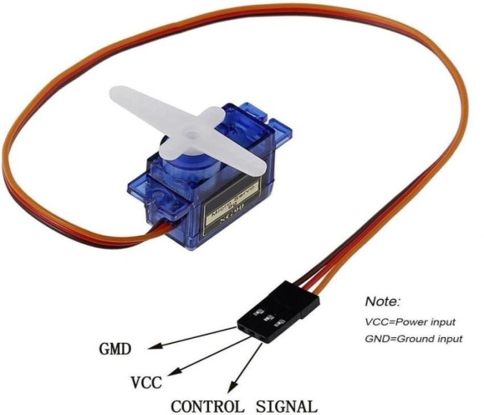**SERVO MOTOR**

In order to improve security, efficiency, and automation in parking management, streamline the overall parking experience, and provide a seamless interface between the parking infrastructure and users, servo motors are crucial actuators that precisely control barrier gates or entry/exit points and regulate parking slot access with accurate and reliable motion control. They also enable accurate and reliable operation, reduce manual intervention, improve overall system performance, and increase safety, all of which contribute to a more complex, intelligent, and user-friendly parking ecosystem that maximises traffic flow and minimises congestion.

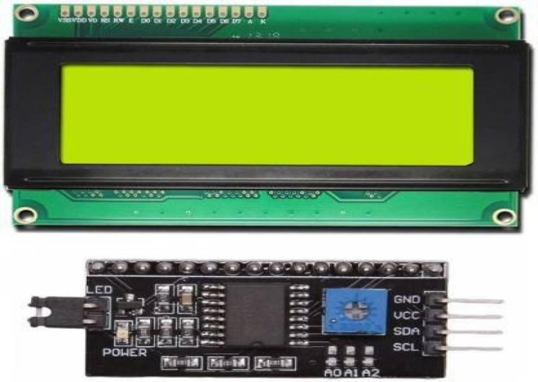**LCD DISPLAY**

Utilising its seamless integration with the Arduino board via the I2C interface to ensure streamlined communication, reduced pin usage, and increased system reliability, a 16x2 I2C LCD display is a highly versatile and essential component of smart parking systems. It serves as a clear and concise visual interface to display a wide array of crucial information, such as parking slot availability, welcome messages, system status updates, parking instructions, and more. This ultimately contributes to a more technologically advanced, intuitive, and user-friendly parking ecosystem that maximises traffic flow, minimises congestion, and improves the overall parking experience.

**GSM MODULE**

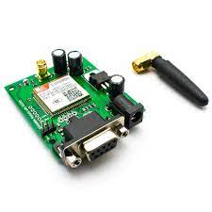

A GSM module plays a pivotal role in smart parking systems, facilitating seamless cellular communication to send and receive SMS notifications, provide real-time updates on parking slot availability, enable remote monitoring and control, and offer a range of value-added services, thereby expanding the system's capabilities, enhancing user experience through timely and efficient information exchange, and allowing users to receive updates on parking availability, reservation confirmations, and payment reminders, while also enabling system administrators to remotely monitor system performance, receive alerts, and optimize parking operations, ultimately contributing to a more connected, intelligent, and user-centric parking ecosystem that leverages the power of cellular communication to streamline parking management and improve overall efficiency.

1. **METHODOLOGY**

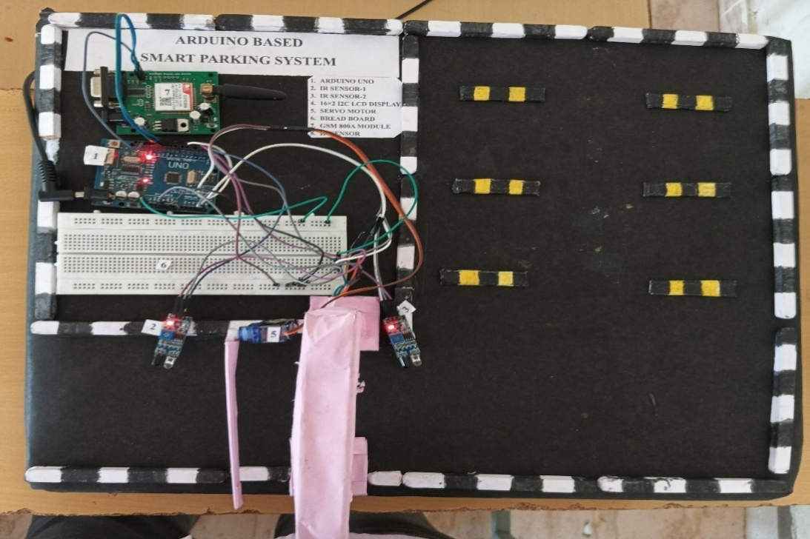

A smart parking system's methodology encompasses a comprehensive and multifaceted approach, commencing with the strategic installation of sensors to accurately detect vehicle presence and occupancy, followed by the seamless collection and processing of data from various sources, which is then utilized to display real-time parking slot availability information, automate gate control, and send timely notifications to users, while also facilitating remote monitoring, enabling data-driven decision-making through advanced analytics, and providing valuable insights into parking patterns and trends, ultimately yielding a more efficient, user-friendly, and optimized parking experience that minimizes congestion, reduces parking search times, maximizes convenience, and enhances overall urban mobility, while also offering opportunities for future integration with emerging technologies and innovative applications, such as autonomous vehicles, smart city initiatives, and sustainable urban planning.

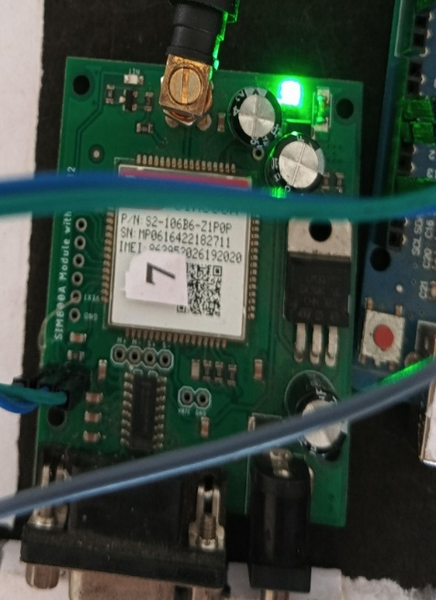

A smart parking system's GSM module is an essential component that makes real-time communication possible. It makes it possible for automated SMS alerts to be sent to users about a wide range of important information, such as parking slot availability, entry and exit notifications, payment reminders, system updates, and other important details. This ensures that customers have a hassle-free, informed, and user-centric parking experience. Additionally, parking administrators are empowered to remotely monitor and manage parking facilities, optimise parking operations, streamline maintenance, and make data-driven decisions, which ultimately leads to increased user satisfaction, less traffic, increased safety, and a notable increase in the system's overall efficiency and effectiveness. Additionally, it contributes to a more sustainable and technologically advanced urban infrastructure.

1. **CONCLUSION AND FUTURESCOPE**

**Conclusion**

With its innovative approach to parking management, the Arduino-based smart parking system with infrared sensors transforms the urban parking landscape by optimising space utilisation, drastically reducing congestion, easing traffic flow, and improving driver convenience. Its flexibility, scalability, and affordability make it a desirable and practical choice for cities all over the world, allowing them to solve parking issues, boost urban mobility, and improve the general standard of living for both locals and tourists.   
With so many interesting developments in the works, the future of Arduino-based smart parking systems is full of possibilities and promise. These include:   
Improved Sensor Technologies: Parking management will be further optimised by next-generation sensors that are more accurate, dependable, and long-lasting, allowing for more accurate car monitoring and detection. Integration with Autonomous cars: Parking will be transformed by a smooth integration with autonomous cars, which will allow for automated and effective parking solutions that require less human involvement. Digital platforms and mobile apps: Easy-to-use digital platforms and mobile applications will deliver real-time parking information, facilitate payment and reservation services, and provide tailored parking suggestions.Data Analytics and Urban Planning: Advanced data analytics will provide valuable insights into parking patterns, trends, and preferences, enabling data-driven decision-making and informed urban planning that optimizes parking infrastructure and urban mobility.These developments will not only further revolutionize parking management but also contribute to the creation of more sustainable, livable, and technologically advanced cities, ultimately enhancing the quality of life for residents, visitors, and the environment.

## **REFERENCES**

1. ThanhNam Pham1, Ming-Fong Tsai1, Duc BingNguyen1, Chyi-Ren Dow1 and Der-Jiunn Deng2.“ACloud-Based Smart-ParkingSystem Basedon Internet-of-ThingsTechnologies”.IEEE Access, volume 3, pp. 1581 – 1591, september 2015.
2. M.FengshengYang,AndroidApplicationDevelopmentRevelation,ChinaMachinePress,2010.
3. YanfengGengandChristosG. Cassandras.“A NewSmartParking System Based onOptimal Resource Allocation and Reservations”. IEEE Transaction on Intelligent Transportation Systems , volume 14, pp. 1129 -1139, April 2013.
4. CuiShiyao,Wu Ming,LiuChen, Rong Na . “TheResearch and Implement of theIntelligent Parking Reservation Management System Based on ZigBee Technology”. MeasuringTechnologyand Mechatronics Automation (ICMTMA) , pp. 741-744, January2014.
5. K.Ashokkumar a, Baron Sam ,R.Arshadprabhu , Britto. "Cloud Based Intelligent Transport System". Procedia Computer Science, volume 50, pp. 58-63, 2015.
6. Z.Ji,I.Ganchev,M.O'Droma,andX.Zhang,``Acloud-basedintelligentcarparkingservices for smart cities,'' in Proc. 31st URSI General Assembly Sci. Symp.(URSI GASS), Aug. 2014.
7. Hamada R.H.AI-Absi,PatrickSebastian ,”Vision-Based Automated Parking System ”in 10th International Conference on Information science,2010
8. Sarfraz nawaz, Christos Efstratiou, Celia Mascolo,“Parksense: A smartphone based sensing systemforonstreetparking”inCambridgeuniversityInternationalJournalofComputerApplications (0975 – 8887) Volume 169 – No.1, July2017 18
9. B.K.KonstantinosDomdouzisandC.Anuba.,“Anexperimentalstudyoftheeffectsofdifferent medium onthe performance ofrfidsystem,”vol.21.AdvancedEngineeringInformatics, 2011.
10. K.Finkenzeller,FundamentalsandApplicationsinContactlessSmartCardsandIdentification. John Wiley and Sons Ltd, 2003.