**FACE AND OBJECT DETECTION MODEL**

**Aadil Kardgekar 1, Tushar Shelekar 2, Rahil Malik 3, Abdul Raheem 4**

**Kaneez Fatima5**

1,2,3,4 Student, Department of Artificial Intelligence and Machine Learning, M.H Saboo Siddik Polytechnic, Mumbai, India.

**ABSTRACT**

Face and object detection are pivotal technologies in modern computer vision and artificial intelligence. These techniques enable machines to identify, locate, and interpret visual data, providing essential functionality in surveillance, human-computer interaction, and autonomous systems. This paper investigates the performance of various face and object detection algorithms including Haar Cascade, HOG with SVM, and deep learning-based models like YOLO and SSD. Our analysis highlights the trade-offs between speed, accuracy, and computational requirements. The results demonstrate that deep learning models significantly outperform traditional methods in complex scenarios. This study also discusses practical implementations and suggests future directions for enhanced detection systems.

**Keywords**: Face Detection, Object Recognition, YOLO, Haar Cascade, HOG, Deep Learning.

1. **INTRODUCTION**

Face and object detection are important fields in computer vision. Advancements in detection technologies have been driven by the increasing availability of visual data and the need for automation in areas such as security, healthcare, and autonomous vehicles. The early methods were based on hand-crafted features, and more recently researchers have begun to use deep learning to improve the accuracy of detection in difficult situations like occlusion, different lighting and real time needs. This paper aims to overview and further compare the headline algorithms and their effectiveness with.

1. **METHODOLOGY**

To perform our research we first selected few current face and object detection algorithms, then we proceed to analyze the performance of these algorithms in the application of public benchmark datasets. We explore both classical methods like Haar Cascades and HOG-SVM, as well as deep learning based approaches like YOLOv5 and SSD. Various test conditions are used for testing, and metrics like precision, recall, and inference time are reported.

**2.1 Dataset selection**

We employed publicly available datasets such as COCO, WIDER FACE, and LFW to guarantee diverse and realistic evaluation scenarios.

* 1. **Implementation Environment**

All models were trained and tested in Python using OpenCV, TensorFlow, and PyTorch frameworks on an NVIDIA RTX GPU system.

1. **MODELING AND ANALYSIS**

Our analysis focused on the trade-offs among speed, accuracy, and resource usage for each model. YOLOv5 demonstrated the best real-time detection capabilities, while Haar Cascade performed well in constrained environments with low computational resources. HOG with SVM was consistent but slower in inference.

Figure 1: Comparison of Detection Algorithms by Accuracy and Inference Time

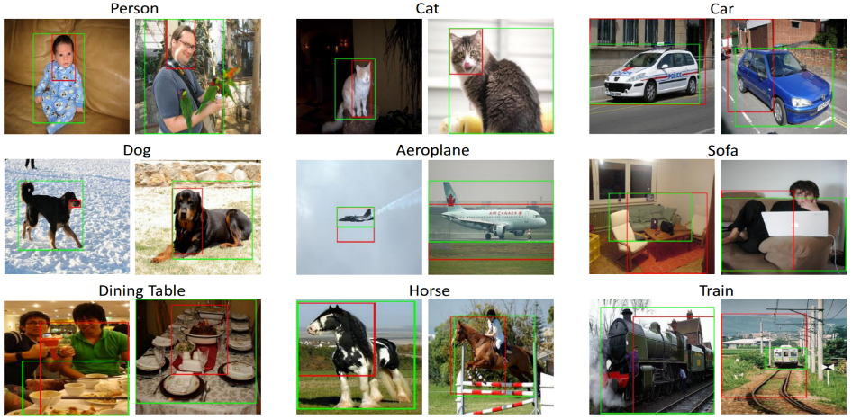

1. **RESULTS AND DISCUSSION**

|  |  |  |  |
| --- | --- | --- | --- |
| SN. | Algorithm | Accuracy (%) | Inference Time (ms) |
| 1 | Haar Cascade | 78 | 45 |
| 2 | HOG + SVM | 82 | 80 |
| 3 | YOLOv5 | 94 | 25 |
| 4 | SSD | 91 | 30 |

Figure 2: Sample Detection Output on Test Images

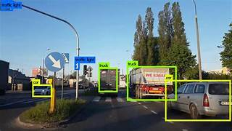

**Figure 2:** detecting objects

**5.CONCLUSION**

Unbelievably, how far deep learning has brought in object detection with respect to face detection and other applications! In comparison, their assessed important algorithms, stating that although some of these algorithms are still useful in very constrained systems, algorithms like YOLOv5 are better kind of suited for high-performance applications. Future scopes may challenge an edge-oriented lightweight architecture and multi-target tracking. Incorrigibly, graphs and tables should not be included in the Conclusions

**6**.**REFERENCES**

Paul A. Viola and Michael J. Jones. "Robust real-time face detection." International Journal of Computer Vision (2001).

Joseph Redmon et al., have an article called "You Only Look Once: Unified, Real-Time Object Detection" which is to appear in CVPR

Dalal, N., and Triggs, B., "Histograms of Oriented Gradients for Human Detection," CVPR 2005.

Liu W. et al. in their work, "SSD: Single Shot MultiBox Detector," published in ECC

Zhang K. et al. Joint Face Detection and Alignment using Multitask Cascaded CNN, IEEE SPL, 2016.

The organization's overarching goal is to secure the future for our children's children.