LEVERAGING SAP FOR SUSTAINABLE SUPPLY CHAIN MANAGEMENT

Mr. S. Manikandan¹, Dr. R. Kandavel²,

¹MBA Students School of Arts, Humanities and Management , Jeppiaar University, Chennai, india.

²Associate Professer & Research Supervisor, School of Arts, Humanities and Management, Jeppiaar University, Chennai, india.

¹[manikandankumarsdsam@gmail.com,](mailto:manikandankumarsdsam@gmail.com)

²[krkandavel@gmail.com,](mailto:krkandavel@gmail.com)

# Abstract:

In today’s dynamic and competitive business environment, efficient supply chain management (SCM) is vital for organizational success. This study explores the role of SAP Enterprise Resource Planning (ERP) systems in enhancing the effectiveness of supply chain operations. SAP ERP integrates various business functions, providing real-time data access, improved coordination, and streamlined processes across procurement, production, inventory, and logistics. The objective of this research is to analyze how SAP ERP contributes to operational efficiency, cost reduction, and better decision-making in supply chains. By reviewing literature, collecting both primary and secondary data, and analyzing real-world applications, this study identifies the significant impact of SAP ERP in creating a more agile and responsive supply chain. The findings highlight that SAP ERP not only supports better resource planning but also plays a crucial role in building sustainable and resilient supply chain networks.

# Introduction:

In today’s fast-paced and competitive business environment, organizations must optimize their supply chain operations to ensure efficiency, cost-effectiveness, and resilience. SAP ERP (Enterprise Resource Planning) has emerged as a powerful tool that integrates various supply chain functions, including procurement, inventory management, production planning, and logistics, into a unified system. By leveraging real-time data, automation, and predictive analytics, SAP ERP enhances decision-making, reduces operational risks, and improves overall supply chain visibility. This study explores the role of SAP ERP in streamlining supply chain processes, its impact on organizational performance, and the challenges and best practices associated with its

implementation. Understanding how SAP ERP transforms supply chain management can help businesses achieve greater efficiency, sustainability, and a competitive edge in the global market.

# Review of Litrature:

Several researchers and industry experts have emphasized the growing role of SAP ERP systems in enhancing supply chain management (SCM). According to Knolmayer et al. (2002), SAP's Advanced Planning and Optimization (APO) tools offer advanced functionalities for demand forecasting, production planning, and inventory optimization, contributing to more synchronized supply chain operations.Orłowska (2023) highlights that SAP ERP software supports logistics subsystems by automating routine tasks and improving data visibility, which are crucial for effective supply chain coordination. Similarly, Forbes (2024) notes that modern ERP systems, including SAP, have evolved with integrated AI and analytics capabilities, enabling faster and more accurate decision-making across supply chains.

A study by SAPinsider (2023) found that companies using SAP ERP reported increased operational efficiency and improved supplier relationships due to the system's real-time data integration. Furthermore, research by the International Journal of Supply Chain Management emphasizes the adaptability of SAP ERP in diverse industries, underlining its scalability and customization as key factors in supply chain optimization.

# Objectives of the study:

* To analyze the role of SAP ERP in optimizing supply chain processes – Examine how SAP ERP integrates various supply chain functions, including procurement, inventory management, production planning, and logistics.
* To evaluate the impact of SAP ERP on supply chain efficiency and cost reduction – Assess how real-time data, automation, and predictive analytics contribute to improved decision- making, reduced lead times, and lower operational costs.

# Significance of the study:

* Enhancing Supply Chain Efficiency – This study highlights how SAP ERP optimizes supply chain processes by integrating procurement, production, inventory, and distribution, leading to improved efficiency and reduced operational bottlenecks.
* Cost Reduction and Profitability – Understanding SAP ERP’s role in automating workflows, reducing wastage, and minimizing operational costs helps organizations achieve better financial performance.

# Hypotheses of the Study:

Here are two hypotheses for the study on leveraging SAP ERP for supply chain management:

* H1: Implementation of SAP ERP significantly improves the efficiency of supply chain operations.Explanation: This hypothesis assumes that organizations using SAP ERP experience better coordination, reduced lead times, and improved resource utilization across their supply chain.
* H2: Integration of SAP ERP enhances real-time decision-making in supply chain management.

Explanation: This suggests that SAP ERP systems enable faster and more informed decisions through real-time data access, resulting in more agile and responsive supply chain strategies.

# Research Methodology:

This study employs a qualitative and quantitative research approach to analyze the role of SAP ERP in supply chain management. Primary data will be collected through surveys and interviews with supply chain professionals, ERP consultants, and industry experts to understand the practical challenges and benefits of SAP ERP implementation. Secondary data will be gathered from academic journals, case studies, and industry reports to provide a theoretical foundation. A comparative analysis of organizations that have successfully implemented SAP ERP versus those that have faced difficulties will help identify best practices. The study will also use data analytics tools to assess key performance indicators (KPIs) such as inventory efficiency, cost reduction, and supply chain visibility. This mixed-methods approach ensures a comprehensive understanding of SAP ERP’s impact on modern supply chain operations.

# Primary data:

* **Surveys and Questionnaires:** Conducted with supply chain managers, ERP consultants, and business executives to understand their experiences with SAP ERP implementation.
* **Interviews**: One-on-one discussions with industry experts to gain insights into the challenges and benefits of SAP ERP in supply chain management.

# Secondary data:

* **Academic Journals and Research Papers**: Studies on SAP ERP’s role in supply chain optimization, technology integration, and operational efficiency.
* **Industry Reports and Whitepapers:** Insights from SAP reports, consulting firms (e.g., Deloitte, Gartner), and market research studies on ERP adoption trends.

**Data Analysis and Interpretation**

**Data Analysis:**

|  |  |
| --- | --- |
| Opinion | Percentage |
| Top Management Decision | 26 |
| Branch Manager Level | 16 |
| Both | 58 |
| Total | 100 |

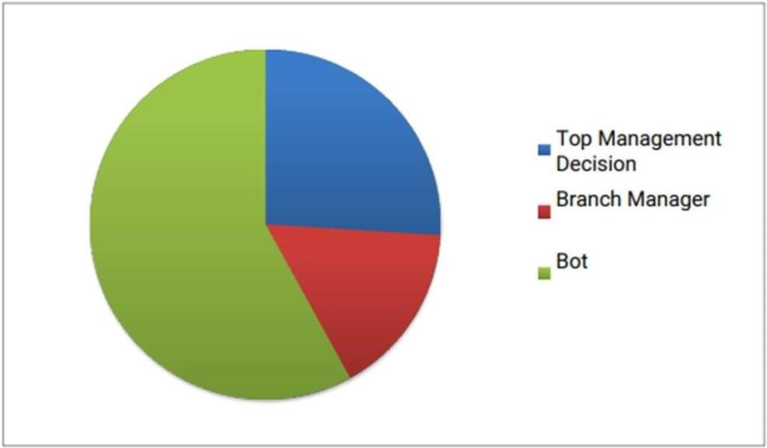

**INTERPRETATION**

About 58% of implementation of new Supply Chain Process is done with the mutual understanding in between management of the company and branch head. 26% implementation is done on the direction of top management and 16% of implementation is done on the direction of branch manager.

**How long you are working in the organization?**

|  |  |
| --- | --- |
| Opinion | Percentage |
| 0 – 2 Years | 6 |
| 2 – 5 Years | 16 |
| 5 – 10 Years | 30 |
| More than 10 Years | 48 |
| Total | 100 |

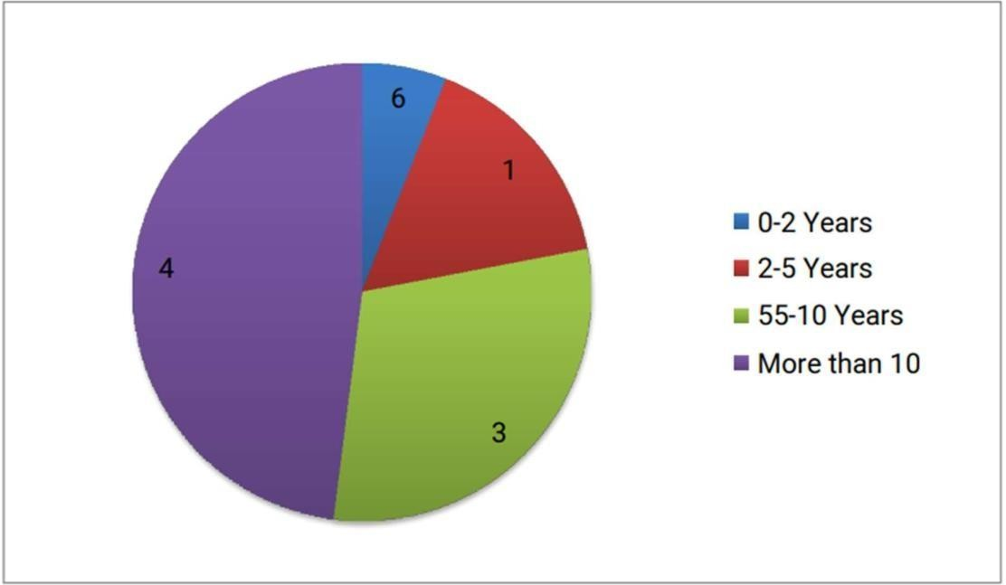

**INTERPRETATION**

From the chart that 24 employees are working for more than 10 years. Even no. of employees working between 5-10 years are 15. This shows that the operation management process in Apollo Tyres Industry is very smooth and most of the employees are regular follows the organization rules and regulations. This indicates that employee are satisfied and their respondent were interviewed and it was found that employee to know while they are continuing in their company for more than 10 year and followed that they are overall satisfied.

# Findings:

* **Improved Supply Chain Visibility and Efficiency:**

SAP ERP provides real-time tracking of inventory, procurement, and logistics, ensuring better coordination and reducing supply chain disruptions.

# Cost Reduction and Resource Optimization:

Automation and predictive analytics in SAP ERP help businesses minimize operational costs, reduce waste, and improve resource utilization.

# Challenges in Implementation and User Adoption:

High costs, system complexity, and resistance to change are common challenges organizations face when implementing SAP ERP, requiring proper training and change management strategies.

# Integration with Emerging Technologies Enhances Performance:

The integration of SAP ERP with AI, IoT, and blockchain improves demand forecasting, supplier collaboration, and real-time supply chain monitoring, enhancing overall efficiency.

# Conclusion:

SAP ERP plays a critical role in modern supply chain management by integrating key business processes, improving efficiency, and enhancing decision-making through real-time data analytics. It enables organizations to achieve better supply chain visibility, cost reduction, and resource optimization. Despite its advantages, challenges such as high implementation costs, system complexity, and user resistance must be addressed through effective change management and training. Furthermore, the integration of emerging technologies like AI, IoT, and blockchain enhances SAP ERP’s capabilities, making supply chains more agile and resilient. By leveraging SAP ERP effectively, and drive long-term supply chain sustainability.

# Bibliography and Refferences:

1. Monk, E., & Wagner, B. (2012). Concepts in Enterprise Resource Planning (4th ed.). Cengage Learning.
2. Chopra, S., & Meindl, P. (2021). Supply Chain Management: Strategy, Planning, and Operation (8th ed.). Pearson.
3. Davenport, T. H. (1998). Putting the Enterprise into the Enterprise System. Harvard Business Review, 76(4), 121-131.
4. SAP SE. (2023). SAP ERP and Supply Chain Management: Enabling Digital Transformation. Retrieved from [www.sap.com](http://www.sap.com/)
5. Kumar, S., & Hillegersberg, J. (2020). ERP Implementation in Supply Chains: Benefits and Challenges. Journal of Enterprise Information Management, 33(3), 567-589.

# Journals and Research papers:

1. "Supply Chain Management Based on SAP Systems: Architecture and Planning Processes" Authors: Gerhard Knolmayer, Peter Mertens, Alexander Zeier

Publication: ResearchGate

1. "Enhancing Supply Chain Management Efficiency with SAP Solutions" Author: [Author Name Not Provided]

Publication: SSRN Electronic Journal

1. "SAP ERP as a Tool for Managing Logistics systems of an Enterprise" Author: Małgorzata Orłowska

Publication: ResearchGate

1. "Designing a Cognitive Supply Chain Platform Using SAP ERP " Author: [Author Name Not Provided]

Publication: International Journal of Supply Chain Management

# Web Resources:

1. "The Impact Of Modern ERP And SCM Systems In Manufacturing" Source: Forbes

Link: [https://www.forbes.com/sites/moorinsights/2024/07/10/the-impact-of-modern-erp-and-](https://www.forbes.com/sites/moorinsights/2024/07/10/the-impact-of-modern-erp-and-scm-systems-in-manufacturing/) [scm-systems-in-manufacturing/](https://www.forbes.com/sites/moorinsights/2024/07/10/the-impact-of-modern-erp-and-scm-systems-in-manufacturing/)

1. "Why 'SAP' Stands Out in Supply Chain Management" Source: Ben Gordon

Link: [https://bengordonpalmbeach.com/2024/05/why-sap-stands-out-in-supply-chain-](https://bengordonpalmbeach.com/2024/05/why-sap-stands-out-in-supply-chain-management/) [management/](https://bengordonpalmbeach.com/2024/05/why-sap-stands-out-in-supply-chain-management/)

1. "Manufacturing's Hidden Risk Will Be Outdated SAP Systems" Source: SupplyChainBrain

Link: [https://www.supplychainbrain.com/blogs/1-think-tank/post/40159-manufacturings-hidden-](https://www.supplychainbrain.com/blogs/1-think-tank/post/40159-manufacturings-hidden-risk-will-be-outdated-sap-systems) [risk-will-be-outdated-sap-systems](https://www.supplychainbrain.com/blogs/1-think-tank/post/40159-manufacturings-hidden-risk-will-be-outdated-sap-systems)