## STOCK MARKET PREDICTION USING ML

*A project report submitted in partial fulfilment of the requirements for the award of the degree of*

### Bachelor of Technology

in

### Department of CSE-Artificial Intelligence and Machine Learning

*Submitted By*

|  |  |
| --- | --- |
| **M Divya Sri** | **(2311CS020398)** |
| **M Prasanth**  **M Sanjana Reddy M Sai Kumar**  **M Ganesh** | **(2311CS020399) (2311CS020400)**  **(2311CS020403) (2311CS020404)** |

Under the esteemed guidance of

### Dr. K.Rajeshwar Rao

Associate Professor



**Department of Artificial Intelligence and Machine Learning School Of Engineering**

## MALLAREDDY UNIVERSITY

Masiammaguda, Dulapally, Hyderabad, Telangana–500100

**2025**



# Department of Computer Science and Engineering (Artificial Intelligence and Machine Learning)

**CERTIFICATE**

This is to certify that the project report entitled **“Stock Market Perdiction Using ML”** submitted by **M.Divya Sri(2311CS020398), M.Prasanth(2311CS020399), M.Sanjana Reddy(2311CS020400), M.Sai Kumar(2311CS020403), M.Ganesh(2311CS020404)**

towards the partial fulfilment of the award of Bachelor’s Degree in Project Development from the Department of Computer Science and Engineering (Artificial Intelligence and Machine Learning), Malla Reddy University, Hyderabad, is a record of bonafide work done by him. The results embodied in the work are not submitted to any other University or institute forward of degree or diploma.

|  |  |  |
| --- | --- | --- |
| **INTERNALGUIDE** | **HOD** | **DEAN** |
| **Dr.K.Rajeshwar Rao Associate Professor** | **Dr. R Nagaraju CSE(AI& ML)** | **Dr. G Gifta Jerith CSE(AI&ML)** |

**EXTERNALEXAMINER**

## DECLARATION

I hereby declare that the project report entitled “Stock Market Prediction Using ML” has been carried out by us and this work has been submitted to the Department of Computer Science and Engineering (Artificial Intelligence and Machine Learning), Malla Reddy University, Hyderabad in partial fulfilment of the requirements for the award of degree of Bachelor of Technology.I further declare that this project has not been submitted in full or part for the award of any other degree in any other educational institutions.

Place:Hyderabad Date: 29/03/25

|  |  |  |
| --- | --- | --- |
| **Name** | **RollNumber** | **Signature** |
| M Divya Sri M Prasanth M Sanjana  M Sai Kumar M Ganesh | 2311CS020398  2311CS020399  2311CS020400  2311CS020403  2311CS020404 |  |

## ACKNOWLEDGEMENT

I extend my sincere gratitude to all those who have contributed to the completion of this project report. Firstly, I would like to extend my gratitude to Dr. V. S. K Reddy, Vice Chancellor, for his visionary leadership and unwavering commitment to academic excellence.

I would also like to express my deepest appreciation to our project guide, Dr. K.Rajeshwar Rao, Associate Professor, whose invaluable guidance, insightful feedback, and unwavering support have been instrumental throughout the course of this project for successful outcomes.

I am also grateful to Dr. R Nagaraju, Head of the Department of Computer Science and Engineering–Artificial Intelligence and Machine Learning, for providing us with necessary resources and facilities to carry out this project.

I would like to thank Dr. G Gifta Jerith ,Dean, School of Engineering - Artificial Intelligence and Machine Learning, for her encouragement and support throughout our academic pursuit.

I would also like to express my deepest appreciation to our project mentor, Dr. K.Rajeshwar Rao, Associate Professor, whose invaluable guidance, insightful feedback, and unwavering support have been instrumental throughout the course of this project for successful outcomes.

M Divya Sri (2311CS020398)

M Prasanth (2311CS020399) M Sanjana (2311CS020400)

M Sai kumar (2311CS020403) M Ganesh (2311CS020404)

**Abstract**

The stock market is a dynamic system influenced by various factors such as economic trends, company performance, and investor sentiment. Accurate prediction of stock prices is critical for investors and financial analysts. This project leverages Machine Learning (ML) techniques integrated with the Django framework to develop a web-based platform for stock market prediction. The application processes historical stock data, applies data preprocessing techniques, and extracts key features to train predictive models. Advanced algorithms such as Linear Regression, Random Forest, and Long Short-Term Memory (LSTM) networks are employed to analyze time-series data and forecast future trends. Additionally, Natural Language Processing (NLP) is used to perform sentiment analysis on financial news and social media data, enhancing the prediction accuracy.The Django framework is utilized to provide a scalable, user-friendly interface for real-time predictions, visualizations, and interactive data exploration. Users can input stock symbols to receive insights, view historical trends, and make informed decisions. This system aims to bridge the gap between technical analysis and user accessibility, offering a robust tool for smarter financial decision- making. The system leverages historical stock data, financial news, and market trends to train predictive models capable of forecasting stock prices and trends. Core ML techniques, including Linear Regression, Random Forest, Support Vector Machines (SVM), and Long Short-Term Memory (LSTM) networks, are utilized to address both regression and time-series forecasting challenges. Sentiment analysis through Natural Language Processing (NLP) adds an additional layer of market insights by analyzing public opinion from financial news and social media platforms.The system emphasizes high accuracy through extensive data preprocessing, feature engineering, and model optimization. Key challenges such as overfitting, noise in data, and market unpredictability are addressed using techniques like cross-validation, data augmentation, and ensemble modeling.

TABLE OF CONTENTS

|  |  |  |
| --- | --- | --- |
| **CHAPTER** | **TITLE** | **PAGE** |
|  | *Title Page* | *i* |
|  | *Certificate* | *ii* |
|  | *Declaration* | *iii* |
|  | *Acknowledgement* | *iv* |
|  | *Abstract* | *v* |
|  | *Table of Contents* | *vi* |
|  | *List of Figures* | *viii* |
|  | *List of Tables* | *viii* |
| **1** | **Introduction**   * 1. Problem Definition   2. Objective of the project   3. Limitations of the project | **1 - 5**  1  3  4 |
| **2** | **Literature Survey**   * 1. Introduction   2. Existing System | **6 -8**  6  8 |
| **3** | **Methodology**   * 1. Proposed System   2. Modules   3. Source code | **9 – 22**  9  10  13 |
| **4** | **Design**   * 1. System Design   2. Architecture   3. Methods and Algorithms | **23 - 26**  23  25  26 |
| **5** | **Results**   * 1. Introduction   2. Pseudocodes   3. Results | **27 - 32**  27  28  31 |
| **6** | **Conclusion** | **33 – 36** |

|  |  |
| --- | --- |
| 6.1 Conclusion | 33 |
| 6.2 Future Scope | 34 |
| **Appendices** | **37 – 43** |
| Appendix I–Dataset Description | 37 |
| Appendix II–Software Requirement | 40 |
| **References** | **44** |

**LIST OF FIGURES**

|  |  |  |
| --- | --- | --- |
| **Figure Number** | **Title** | **Page** |
| 2.1 | Literature Survey | 7 |
| 4.2 | Architecture | 25 |
| 5.2.1 | Home Page | 28 |
| 5.2.2 | Web Sites of top Predictors | 28 |
| 5.2.3 | To Predict the stock | 29 |
| 5.2.4 | Ticker info | 29 |
| 5.2.5 | Website of Yahoo Finance | 30 |
| 5.2.6 | Website of NSE | 30 |

**LISTOFTABLES**

|  |  |  |
| --- | --- | --- |
| **Table No** | **Title** | **Page** |
| 1 | Stock Price Data (Time-Series Features) | 37 |
| 2 | Technical Indicators | 38 |
| 3 | Sentiment Analysis Features | 39 |
| 4 | Software Requirements | 41 |
| 5 | Hardware Requirements | 42 |

## CHAPTER1:INTRODUCTION

* 1. **Problem Definition**

The stock market is inherently volatile, with prices influenced by a complex set of factors, including economic conditions, company performance, market sentiment, and global events. Predicting stock prices with high accuracy is a challenging problem that has attracted significant attention from researchers and practitioners in finance, data science, and machine learning. Despite the advancements in financial models, stock market prediction remains an uncertain task, with models often failing to account for all the variables that influence market behavior.The goal of this project is to develop a machine learning model capable of predicting stock market prices (or trends) based on historical data. This model will attempt to identify patterns and trends that can guide investment decisions and offer a reliable forecast of future price movements.

The focus of the research will be on leveraging machine learning techniques such as supervised learning, time series analysis, and deep learning models (e.g., LSTM networks) to predict stock prices with the aim of outperforming traditional statistical models and human analysts. This project aims to develop a machine learning-based model for predicting stock market prices. By leveraging historical stock price data, technical indicators, and potentially external factors such as news sentiment or macroeconomic indicators, the model seeks to identify underlying patterns and trends that could assist in predicting future price movements. The goal is to improve upon traditional methods by applying advanced machine learning techniques such as time-series analysis, regression models, and deep learning algorithms (e.g., Long Short-Term Memory (LSTM) networks).

Financial markets are influenced by various factors, including historical trends, economic indicators, company performance, and global events. These factors create an unpredictable environment where conventional statistical models struggle to capture complex dependencies. Machine Learning offers advanced techniques like Regression, LSTMs, and Reinforcement Learning, which adapt to market fluctuations. By analyzing large datasets, ML models can detect patterns that humans might overlook. This project focuses on developing a robust ML-based predictive system that improves investment decision-making. By integrating AI-driven insights, the system can provide better forecasts than traditional models.

Developing a stock prediction model requires selecting appropriate ML algorithms based on data characteristics. Time Series Analysis, ARIMA, LSTMs, Random Forest, and Neural

Networks are widely used for stock forecasting. The project will compare multiple models to determine the most effective approach. Hyperparameter tuning and model optimization techniques will be applied to improve accuracy. The model will be trained on historical stock market data from sources like Yahoo Finance and Alpha Vantage. A hybrid approach, combining multiple models, may be implemented to achieve better performance. Regular evaluation metrics like RMSE, MAPE, and R-squared scores will validate the model’s accuracy.

To make the predictions accessible, the project will integrate Django as a backend framework. Django's robust architecture allows for efficient data management, API development, and secure user authentication. The application will provide an intuitive dashboard for users to visualize stock trends and predictions. Features such as interactive graphs, historical data insights, and forecast comparisons will enhance user experience. Real-time updates will be implemented using Django Channels and WebSockets to ensure users get the latest stock information. The project will also include a RESTful API to allow seamless integration with other financial applications.

Security and scalability are critical aspects of the project. Handling sensitive financial data requires implementing authentication, authorization, and encryption protocols. Django’s built-in security features, such as CSRF protection and SQL injection prevention, will safeguard user data. Additionally, deploying the model on cloud-based platforms like AWS, Azure, or Google Cloud will ensure scalability. The application will support multiple users and concurrent data processing without performance bottlenecks. Implementing a caching mechanism will improve speed and efficiency for frequent queries. These measures will enhance the application’s reliability and trustworthiness.

One major aspect of stock prediction is ensuring that the model remains adaptive to market changes. A static model might lose accuracy over time due to evolving trends. Implementing continuous learning techniques, such as online learning and reinforcement learning, will improve adaptability. The system will periodically retrain the model using the latest market data to maintain accuracy. Users will also receive alerts about significant market movements, enabling proactive investment strategies. By integrating AI-driven learning mechanisms, the project ensures long-term relevance and efficiency in stock market predictions.

The user experience (UX) and UI design play a crucial role in making financial data understandable. Many stock prediction platforms display complex metrics that may overwhelm users. This project will focus on an interactive and minimalistic interface to ensure usability. Features like customizable dashboards, portfolio tracking, and watchlists will enhance personalization.

* 1. **Objective of the Project**

Stock market prediction has always been a challenge due to its dynamic nature and numerous influencing factors. The primary objective of this project is to develop a highly accurate, AI-driven stock market prediction system that assists investors and traders in making informed decisions. By leveraging Machine Learning algorithms, real-time data processing, and Django-based web development, the system will provide an efficient and user-friendly platform. The project will incorporate various ML models, sentiment analysis, and adaptive learning techniques to enhance forecasting accuracy. Additionally, a well-structured API and cloud-based deployment will ensure scalability and real-world applicability.

The first objective is to develop an accurate prediction model using advanced Machine Learning techniques. The system will train on historical stock market data, testing models like Long Short-Term Memory (LSTM), Random Forest, ARIMA, and Neural Networks. The project will analyze stock trends, price fluctuations, and external market factors to optimize prediction accuracy. Feature selection and hyperparameter tuning will enhance model performance. The evaluation process will involve accuracy metrics such as RMSE, MAPE, and R-squared scores. This will ensure that the most effective model is deployed for stock price forecasting.

A critical aspect of this project is real-time stock data processing, enabling investors to receive up-to-date market insights. The system will fetch live stock market data from sources such as Yahoo Finance, Alpha Vantage, and Google Finance APIs. Implementing WebSockets and Django Channels, the platform will ensure that users receive real-time updates on stock price movements. This will help traders make swift decisions based on the latest market trends. The model will also continuously update itself by retraining on new stock data, improving its adaptability. Efficient data handling techniques will be integrated to manage large-scale real-time inputs.

The next goal is to build a web-based stock prediction platform using Django. Django will serve as the backend framework, providing robust data management and API development capabilities. The web application will feature a user-friendly dashboard for visualizing stock trends and predictions. Users will be able to analyze stock movements through interactive charts, real-time forecasts, and historical data insights. The system will incorporate secure user authentication, allowing traders to customize their experience based on their portfolio, watchlist, and investment preferences. This ensures an intuitive and personalized interface for both beginners and experienced traders.

* 1. **Limitations of the Project**

Despite advancements in Machine Learning and AI, stock market prediction remains inherently uncertain and complex. One major limitation of this project is the inability to guarantee 100% accurate predictions due to the highly volatile and unpredictable nature of financial markets. Stock prices are influenced by numerous unpredictable factors, such as global events, political changes, economic policies, and investor sentiment, which ML models may struggle to capture entirely. Even with deep learning techniques, the presence of random market fluctuations can lead to inaccurate forecasts.

Therefore, users should consider predictions as insights rather than absolute guarantees. Another limitation is data dependency and quality issues. The accuracy of the model depends significantly on the quality and quantity of historical stock data. Inconsistent, incomplete, or biased datasets can lead to misleading predictions. Additionally, financial markets frequently undergo structural changes, such as new regulations, economic recessions, or corporate restructuring, which can render historical data less useful. If the model is trained on outdated or insufficient data, its predictions may become unreliable. Ensuring high-quality, up-to-date datasets is essential, but real- time data collection can be costly and challenging.

The project also faces challenges in handling sudden market crashes and anomalies. Machine Learning models primarily rely on past patterns and trends, making it difficult to predict unexpected crashes, black swan events, or sudden market manipulations. For example, global crises like the COVID-19 pandemic or geopolitical conflicts can cause drastic market fluctuations that the model cannot anticipate. While sentiment analysis helps capture news-based movements, it may not fully predict panic-driven mass sell-offs or high-frequency trading impacts. This limitation makes the model less effective in extreme market conditions.

Computational complexity and high resource consumption are also significant concerns. Deep learning models like LSTMs and neural networks require extensive computational power, making them resource-intensive. Running real-time predictions demands high-performance GPUs, cloud computing, and efficient data processing pipelines. For individual users or small-scale applications, managing large-scale data processing may become impractical. Additionally, frequent model retraining to adapt to market changes requires significant storage, processing power, and time, increasing operational costs.

The latency in real-time stock data processing is another drawback. Even though the project aims to provide real-time predictions, there can be delays in fetching, processing, and displaying stock data due to API limitations and network dependencies. Many financial APIs impose rate limits or

charge fees for high-frequency requests, restricting real-time data access. Market trends change rapidly within milliseconds, making it difficult for ML-based models to compete with high-frequency trading (HFT) systems, which operate at much faster speeds. This limitation affects the applicability of the model for short-term trading strategies.

The effectiveness of sentiment analysis is also constrained by language ambiguity and misinformation. While NLP models can analyze news articles and social media posts, they may struggle with sarcasm, biased reporting, fake news, and misleading opinions. Additionally, financial discussions often involve complex terminologies that basic sentiment analysis tools may misinterpret. Since market sentiment plays a crucial role in price fluctuations, errors in NLP-based sentiment analysis can mislead investors into making poor decisions. Improving sentiment analysis accuracy remains a challenging task in stock prediction models.

The project’s generalization capability across different markets is limited. Stock market behavior varies based on geographical, economic, and sector-specific factors. A model trained on

U.S. stock market data (NYSE/NASDAQ) may not perform well on Asian or European markets (NSE, LSE, etc.) due to differences in trading patterns, regulations, and investor behaviors. Similarly, predicting crypto markets using a stock-based ML model is not feasible due to fundamental differences in volatility and price drivers. Adapting the model for various financial instruments requires significant modifications and retraining.

Another limitation is overfitting and poor generalization in ML models. If the model is overly trained on past stock data, it may capture unnecessary noise rather than meaningful trends. This leads to high accuracy on historical data but poor performance on future stock prices. Overfitting occurs when the model learns market anomalies that do not repeat in the real world. To mitigate this, techniques like regularization, dropout layers, and cross-validation must be implemented. However, balancing model complexity and predictive power remains a challenge.

Security risks and data privacy concerns are also critical issues. Since stock prediction systems handle financial data, user portfolios, and market transactions, they become targets for cyberattacks, API breaches, and data manipulation. Unauthorized access or hacking attempts can result in data leaks and financial losses. Moreover, market manipulation tactics, such as fake news or algorithmic trading, can impact predictions, leading to unintended biases in the model. Ensuring data encryption, secure API integration, and robust authentication is necessary but adds to system complexity.

## CHAPTER 2: LITERATURE SURVEY

* 1. **Introduction**

Stock market prediction has been a topic of great interest for investors, financial analysts, and researchers due to its potential for high returns. Traditionally, stock price forecasting relied on statistical models such as ARIMA (AutoRegressive Integrated Moving Average) and technical analysis. However, with advancements in Machine Learning (ML) and Artificial Intelligence (AI), predictive models have become more sophisticated, leveraging historical data, technical indicators, and external factors like market sentiment. This project aims to develop a robust ML-based stock prediction system that enhances accuracy and assists investors in making informed decisions.

Recent studies have explored various ML algorithms, including Support Vector Machines (SVM), Random Forest, and Deep Learning models like LSTM (Long Short-Term Memory) for stock price forecasting. While traditional models struggle with dynamic market conditions, deep learning approaches offer improved performance by capturing complex patterns in stock market data. The integration of sentiment analysis further enhances prediction capabilities by incorporating news articles, social media trends, and financial reports into decision-making. This project proposes a hybrid ML approach to combine historical price movements with external financial data for enhanced forecasting.

One of the key challenges in stock market prediction is market volatility. Sudden economic shifts, political events, or global crises can disrupt price patterns, making predictions unreliable. To address this, the proposed system will employ advanced ML techniques like attention mechanisms, ensemble learning, and hybrid models that adapt to market fluctuations. By integrating deep learning architectures like Transformers and BERT (Bidirectional Encoder Representations from Transformers), the model can improve real-time adaptability and provide more accurate trend analysis.

The project also recognizes the importance of feature selection and engineering. Instead of relying solely on historical stock prices, the system will analyze technical indicators such as Moving Averages (MA), Relative Strength Index (RSI), and Bollinger Bands, along with macroeconomic factors and investor sentiment. This multi-faceted approach enhances the model’s ability to predict stock price movements with greater precision. The goal is to minimize errors caused by overfitting, noisy data, and unpredictable market trends.

Fig 2.1 :Literature Survey

|  |  |  |  |  |  |  |  |  |
| --- | --- | --- | --- | --- | --- | --- | --- | --- |
| Batch No | BT 02 | | | | | | | |
| Title | **"Stock Market Predicition Using Machine Learning"** | | | | | | | |
| Problem Statement | Develop an intelligent and robust machine learning-based stock market prediction system that leverages historical data, technical indicators, and external factors like sentiment analysis to predict stock price movements or trends. The system should focus on improving prediction accuracy, handling market volatility, and assisting investors in making informed decisions while addressing challenges like overfitting, noisy data, and real-time adaptability. | | | | | | | |
| Methodology | **Existing Methodology**: Traditional approaches include time-series models like ARIMA, machine learning algorithms (e.g., SVM, Random Forests), deep learning models like LSTM.  **Proposed Methodology**: Develop a hybrid system combining deep learning (e.g., LSTM with attention mechanisms) and sentiment-aware models (e.g., BERT) to integrate historical, technical, and external factors like news for accurate, real-time stock trend predictions. | | | | | | | |
| [**S.No**](http://s.no/) | **Authors** | **Year** | **Title** | **Methodology** | | **Result** | | **Limitation** |
| 1 | Ghoshet al. | 2021 | "Stock Market Prediction Using Multilayer Perceptron" | Developed a Multilayer Perceptron (MLP)  neural network with historical stock prices and technical indicators as input features. | | MLP achieved anaverage accuracy of~75% for price trend prediction on selected stocks. | | Poor performance during unexpected market events or high volatility periods. |
| 2 | Patel et al. | 2015 | "Predicting Stockand Stock Price Index Movement using Machine Learning Techniques" | Used SVM, random forests, and naive Bayes for  predicting stock trends. Features included technical indicators like moving averages and Bollinger Bands. | | SVM achieved better performance compared to other models, with an accuracy of around 70- 75%. | | Accuracy depends heavily on the selected features and does not generalize well across datasets. |
| 3 | Chong et al. | 2017 | "Deep Learning Networks for Stock Market Analysis and Prediction" | Proposed a deep learning model using LSTM (Long Short-Term Memory) for stock price prediction based on time-series data. | | LSTM models outperformed traditional ML  models in capturing long-term dependencies,  showing increased prediction accuracy (75- 80%). | | Requires large datasets for training and is computationally expensive. |
| 4 | Fischer & Krauss | 2018 | "Deep Learning with LSTM Networks for Financial Market Predictions" | Developed an ensemble model of LSTMs trained on historical stock prices and technical  indicators for financial predictions. | | Achieved 57.2% directional accuracy when tested on the S&P 500 dataset. | | Prediction accuracy was limited in volatile market conditions. |
| 5 | Shah et al. | 2019 | "Predicting Stock Prices using Machine Learning Techniques" | Compared ARIMA with machine learning models like decision trees and random forests | | Machine learning models performed better than  ARIMA for short-term predictions with 60-65% accuracy. | | Models failed to predict accurately during major market crashes. |
| 6 | Chen et al. | 2020 | "Integrating Sentiment Analysis and Machine Learning for Stock Market Prediction" | Used sentiment analysis of news headlines and tweets along with ML algorithms like SVM and gradient boosting for stock trend prediction. | | Combining sentiment analysis with technical indicators improved prediction accuracy, achieving 72%. | | Heavily dependent on the quality and quantity of textual data for sentiment analysis. |
| 7 | Hossain et al. | 2021 | "Ensemble Learning Approach for Stock Market Prediction" | Implemented ensemble learning methods such as  bagging and boosting (AdaBoost, XGBoost)  with feature engineering for stock price prediction. | | Ensemble methods achieved higher accuracy (80%) compared to single models, reducing overfitting issues. | | Ensemble models require extensive parameter tuning and are computationally intensive. |
| 8 | Jang et al. | 2022 | "Hybrid Models for Stock Market Prediction: Integrating ML with Technical Analysis" | Combined hybrid models of LSTM with technical indicators (e.g., RSI, MACD) for predicting price trends | | Hybrid models demonstrated superior performance compared to standalone ML models, achieving a prediction accuracy of ~78%. | | Lack of robustness in highly volatile stock markets and dependency on accurate feature engineering. |
| 9 | Li et al. | 2022 | "Attention Mechanisms in Stock Price Prediction" | Applied attention mechanisms in deep learning  models like Transformer to focus on important features in time-series stock data. | | Improved accuracy (~82%) and robustness of predictions compared to LSTM-only models, especially in noisy datasets. | | Computationally intensive and requires significant memory resources for training. |
| 10 | Zhang et al. | 2023 | "Sentiment-Aware Hybrid Models for Stock Market Forecasting" | Combined sentiment analysis using BERT with GRU (Gated Recurrent Unit) models for  predicting stock price trends based on financial news and historical prices. |  | Achieved ~77% prediction accuracy by integrating text sentiment with technical data,  showing improvements in volatile market periods. |  | Limited by the quality and availability of sentiment-rich data (e.g., news headlines, social media posts). |
|  |  | |

* 1. **Existing System**

Stock market prediction has traditionally been performed using statistical models, fundamental analysis, and technical analysis. Investors and financial analysts rely on historical stock prices, market trends, and macroeconomic indicators to forecast stock price movements. The existing system primarily consists of manual data analysis, rule-based trading strategies, and basic predictive models, which often fail to capture the complex and dynamic nature of financial markets.

One of the widely used methods in the existing system is technical analysis, which involves studying chart patterns, trading volumes, and indicators such as Moving Averages (MA), Relative Strength Index (RSI), and Bollinger Bands. Traders use these indicators to identify price trends and make investment decisions. However, this method is highly subjective, as different traders may interpret the same chart patterns differently, leading to inconsistent predictions.

Another approach in the existing system is fundamental analysis, which focuses on evaluating a company's financial health based on earnings reports, revenue growth, debt levels, and industry performance. While fundamental analysis provides a long-term perspective on stock valuation, it does not account for short-term price fluctuations caused by market sentiment, news events, or investor psychology. As a result, investors using this approach may struggle to predict short-term market trends accurately.

Many financial institutions and hedge funds use statistical models like ARIMA (AutoRegressive Integrated Moving Average) and GARCH (Generalized Autoregressive Conditional Heteroskedasticity) to predict stock prices based on historical data. These models assume that past price trends can help forecast future movements. However, stock markets are influenced by external factors such as economic policies, global events, and investor sentiment, which these models fail to incorporate effectively. This makes them less reliable during highly volatile market conditions.

The existing system also includes machine learning-based models, but they often lack real- time adaptability and comprehensive data integration. Many predictive models rely solely on historical stock prices, ignoring important external factors like news sentiment, economic indicators, and social media trends. Moreover, traditional ML models, such as linear regression and decision trees, struggle to capture non-linear patterns and sudden market shifts, limiting their accuracy in real- world stock predictions

# CHAPTER 3 : METHODOLOGY

**3.1 Proposed System**

The proposed system aims to leverage machine learning techniques to predict stock market movements. It integrates historical stock data, technical indicators, and sentiment analysis to enhance prediction accuracy. The system will use deep learning models such as Long Short-Term Memory (LSTM) networks, alongside traditional machine learning models.

The proposed system aims to enhance stock market forecasting by integrating machine learning algorithms, technical indicators, and sentiment analysis. Traditional stock prediction models rely primarily on historical price data, often failing to consider external factors like market sentiment and financial news. To overcome this limitation, the proposed system incorporates real-time stock data, social media trends, and macroeconomic indicators to provide a more accurate and comprehensive prediction model.

One of the primary objectives of this system is to utilize advanced machine learning techniques such as Long Short-Term Memory (LSTM), XGBoost, and Random Forest for predicting stock price movements. These models are trained on historical stock prices, technical indicators, and sentiment data to forecast both short-term (daily, weekly) and long-term (monthly) market trends. By leveraging deep learning-based time-series forecasting, the system ensures improved accuracy compared to traditional statistical models.

The proposed system integrates technical indicators such as Simple Moving Averages (SMA), Relative Strength Index (RSI), Moving Average Convergence Divergence (MACD), and Bollinger Bands. These indicators help in identifying market trends, momentum shifts, and potential breakout points. Additionally, the system processes macroeconomic factors like inflation rates, interest rates, and GDP growth to provide a more holistic market analysis.

A crucial feature of this system is the sentiment analysis module, which extracts and analyzes market sentiment from financial news articles, social media platforms like Twitter and Reddit, and online financial forums. This is achieved using Natural Language Processing (NLP) techniques, which classify news and posts as positive, neutral, or negative. By combining this data with stock price trends, the system can predict sudden market fluctuations caused by investor sentiment

## MODULES

The system consists of the following components:

#### Data Collection Module

* + - * Collects historical stock market data (OHLC, volume, etc.) from sources like Yahoo Finance, Alpha Vantage, and Quandl.
      * Integrates news sentiment analysis using Natural Language Processing (NLP) to factor in market sentiment.
      * Fetches macroeconomic indicators (interest rates, GDP growth, inflation).

#### Data Preprocessing Module

* + - * Handles missing values and normalizes data.
      * Computes technical indicators (e.g., Moving Averages, RSI, MACD).
      * Uses feature selection (PCA, correlation analysis).
      * Converts text data (news, tweets) into numerical features using NLP techniques like TF-IDF or Word2Vec.

#### Feature Engineering Module

* + - * Generates lag features (past stock prices, moving averages).
      * Uses time-series decomposition to extract trends and seasonality.
      * Encodes datetime features (day of the week, month, quarter).

#### Model Training Module

* + - * Uses different machine learning algorithms:
      * Regression Models: Linear Regression, Random Forest, XGBoost.
      * Deep Learning Models: LSTM, GRU, Transformer-based models.
      * Hybrid Models: Combining LSTM with XGBoost for enhanced performance.
      * Performs hyperparameter tuning using Grid Search or Bayesian Optimization.
      * Implements cross-validation techniques to avoid overfitting.

#### Prediction & Evaluation Module

* + - * Predicts next-day stock prices or trend movement.
      * Evaluates model using:
      * Mean Squared Error (MSE), R² Score (for regression).
      * Precision, Recall, F1-Score (for classification).
      * Backtesting performance on historical data.

#### Deployment Module

* + - * Deploys the model using **Flask/FastAPI** as an API.
      * Connects to **real-time stock market data** for live predictions.
      * Provides a **user-friendly dashboard** using **Streamlit or React**.

#### Advantages Of Proposed System

1. **Higher Prediction Accuracy**
   * Uses advanced ML/DL models (LSTM, XGBoost, Transformers) for improved predictions.
   * Incorporates historical data, technical indicators, and market sentiment for more robust forecasts.
   * Reduces human bias by relying on data-driven insights.

#### Real-time Predictions & Decision Making

* + Integrates with **real-time stock data sources** (Yahoo Finance, Alpha Vantage).
  + Provides **instant trend analysis**, helping traders make quick investment decisions.
  + Supports **live monitoring & alerts** for significant market movements.

#### Incorporation of Sentiment Analysis

* + Uses Natural Language Processing (NLP) to analyze financial news, tweets, and reports.
  + Enhances prediction accuracy by considering market sentiment & investor psychology.
  + Identifies market anomalies that traditional models may overlook.

#### Feature Engineering & Smart Data Processing

* + Uses technical indicators (MACD, RSI, Moving Averages) to detect trends.
  + Implements time-series analysis & lag features for better predictions.
  + Filters noise in stock price movements to prevent misleading predictions.

#### Adaptability & Model Retraining

* + Automated retraining ensures that the model adapts to new market conditions.
  + Supports hyperparameter tuning to optimize model performance over time.
  + Works for various stock markets, commodities, forex, and cryptocurrencies.

#### Risk Management & Anomaly Detection

* + Identifies high-risk trading patterns and warns users.
  + Detects market crashes or anomalies using historical patterns.
  + Helps investors mitigate risks by making informed decisions.

#### Easy Deployment & Integration

* + Can be deployed as a web-based dashboard or mobile app.
  + Provides an API for seamless integration with trading platforms.
  + Works with cloud-based solutions (AWS, GCP, Azure) for scalability.

#### Cost-Effective & Scalable

* + Reduces manual effort required for stock analysis.
  + Saves time & costs by automating market trend analysis.
  + Easily scalable for hedge funds, retail investors, and financial analysts.

### System Requirements:

To develop a stock market prediction system, the following hardware, software, and data requirements are essential

#### Hardware Requirements

* + Processor: Intel i5/i7/i9, AMD Ryzen 5/7/9 (or equivalent)
  + RAM: Minimum 8GB (Recommended 16GB+ for deep learning models)
  + Storage: Minimum 256GB SSD (Recommended 512GB+ SSD for faster data processing)
  + GPU (For Deep Learning Models): NVIDIA RTX 3060 or higher (for model training)
  + Internet: High-speed connection for real-time data retrieval

#### Software Requirements

* + Operating System: Windows, macOS, or Linux (Ubuntu recommended)
  + Programming Language: Python 3.x
  + Machine Learning Libraries: Scikit-learn, TensorFlow/Keras, PyTorch, XGBoost
  + Data Processing & Visualization: Pandas, NumPy, Matplotlib, Seaborn
  + Database: PostgreSQL, MySQL, or MongoDB

#### Data Requirements

* + Stock Market Data: Yahoo Finance, Alpha Vantage, Quandl
  + Technical Indicators: Moving Averages, RSI, MACD
  + News Sentiment Data: Financial news and social media data

### 3.3 Source Code Models.py

from django.db import models

from django.contrib.auth.models import User

# Create your models here.

class Project(models.Model):

name = models.CharField(max_length=200) start_date = models.DateField()

responsible = models.ForeignKey(User, on_delete=models.CASCADE) week_number = models.CharField(max_length=2, blank=True) end_date = models.DateField()

def str (self):

return str(self.name)

def save(self, *args, **kwargs): print(self.start_date.isocalendar()[1]) if self.week_number == "":

self.week_number = self.start_date.isocalendar()[1] super().save(*args, **kwargs)

### views.py

from urllib import request

from django.shortcuts import render from django.http import HttpResponse

from django.template import RequestContext

from plotly.offline import plot import plotly.graph_objects as go import plotly.express as px

import pandas as pd import numpy as np import json

import yfinance as yf import datetime as dt

from .models import Project

from sklearn.linear_model import LinearRegression from sklearn import preprocessing, model_selection

def index(request):

# ================================================= Left Card Plot

=========================================================

data = yf.download(

tickers=['AAPL', 'AMZN', 'QCOM', 'META', 'NVDA', 'JPM'],

group_by='ticker', threads=True, period='1mo', interval='1d'

)

fig_left = go.Figure()

for ticker in ['AAPL', 'AMZN', 'QCOM', 'META', 'NVDA', 'JPM']:

fig_left.add_trace(

go.Scatter(x=data.index, y=data[(ticker, 'Adj Close')], name=ticker)

)

fig_left.update_layout(paper_bgcolor="#14151b", plot_bgcolor="#14151b", font_color="white")

plot_div_left = plot(fig_left, auto_open=False, output_type='div')

# ================================================ To show recent stocks ==============================================

tickers = ['AAPL', 'AMZN', 'GOOGL', 'UBER', 'TSLA', 'TWTR']

dfs = []

for ticker in tickers:

df = yf.download(tickers=ticker, period='1d', interval='1d') df.insert(0, "Ticker", ticker)

dfs.append(df)

df = pd.concat(dfs, axis=0) df.reset_index(level=0, inplace=True)

df.columns = ['Date', 'Ticker', 'Open', 'High', 'Low', 'Close', 'Adj Close', 'Volume'] df.drop('Date', axis=1, inplace=True)

json_records = df.reset_index().to_json(orient='records') recent_stocks = json.loads(json_records)

# ========================================== Page Render section

=====================================================

return render(request, 'index.html', { 'plot_div_left': plot_div_left, 'recent_stocks': recent_stocks

})

def index(request):

# ================================================= Left Card Plot

=========================================================

data = yf.download(

tickers=['AAPL', 'AMZN', 'QCOM', 'META', 'NVDA', 'JPM'],

group_by='ticker', threads=True, period='1mo', interval='1d'

)

# Check if the DataFrame is flat (column names are not a MultiIndex) if 'AAPL Adj Close' in data.columns:

# Adjust column names if flat columns_mapping = {

f"{ticker} Adj Close": ticker for ticker in ['AAPL', 'AMZN', 'QCOM', 'META',

'NVDA', 'JPM']

}

data = data.rename(columns=columns_mapping)

fig_left = go.Figure()

for ticker in ['AAPL', 'AMZN', 'QCOM', 'META', 'NVDA', 'JPM']:

fig_left.add_trace(

go.Scatter(x=data.index, y=data[ticker], name=ticker)

)

fig_left.update_layout(paper_bgcolor="#14151b", plot_bgcolor="#14151b", font_color="white")

plot_div_left = plot(fig_left, auto_open=False, output_type='div')

# ================================================ To show recent stocks ==============================================

tickers = ['AAPL', 'AMZN', 'GOOGL', 'UBER', 'TSLA', 'TWTR']

dfs = []

for ticker in tickers:

df = yf.download(tickers=ticker, period='1d', interval='1d') df.insert(0, "Ticker", ticker)

dfs.append(df)

df = pd.concat(dfs, axis=0) df.reset_index(level=0, inplace=True)

#df.columns = ['Date', 'Ticker', 'Open', 'High', 'Low', 'Close', 'Adj Close', 'Volume'] df.drop('Date', axis=1, inplace=True)

json_records = df.reset_index().to_json(orient='records')

recent_stocks = json.loads(json_records)

# ========================================== Page Render section

=====================================================

return render(request, 'index.html', { 'plot_div_left': plot_div_left, 'recent_stocks': recent_stocks

})

def search(request):

return render(request, 'search.html', {})

def ticker(request):

# ================================================= Load Ticker Table ================================================

ticker_df = pd.read_csv('app/Data/new_tickers.csv') json_ticker = ticker_df.reset_index().to_json(orient='records') ticker_list = json.loads(json_ticker)

return render(request, 'ticker.html', { 'ticker_list': ticker_list

})

# The Predict Function to implement Machine Learning as well as Plotting def predict(request, ticker_value, number_of_days):

try:

ticker_value = ticker_value.upper()

df = yf.download(tickers=ticker_value, period='1d', interval='1m') except:

return render(request, 'API_Down.html', {})

try:

number_of_days = int(number_of_days) except:

return render(request, 'Invalid_Days_Format.html', {})

valid_ticker = [] # Populate this with valid tickers if needed

if ticker_value not in valid_ticker:

return render(request, 'Invalid_Ticker.html', {})

if number_of_days < 0:

return render(request, 'Negative_Days.html', {})

if number_of_days > 365:

return render(request, 'Overflow_days.html', {})

fig = go.Figure() fig.add_trace(go.Candlestick(x=df.index,

open=df['Open'],

high=df['High'],

low=df['Low'],

close=df['Close'], name='market data'))

fig.update_layout(

title=f'{ticker_value} live share price evolution', yaxis_title='Stock Price (USD per Shares)'

)

fig.update_xaxes( rangeslider_visible=True, rangeselector=dict(

buttons=list([

dict(count=15, label="15m", step="minute", stepmode="backward"), dict(count=45, label="45m", step="minute", stepmode="backward"), dict(count=1, label="HTD", step="hour", stepmode="todate"), dict(count=3, label="3h", step="hour", stepmode="backward"), dict(step="all")

])

)

)

fig.update_layout(paper_bgcolor="#14151b", plot_bgcolor="#14151b", font_color="white")

plot_div = plot(fig, auto_open=False, output_type='div')

# ========================================== Machine Learning

==========================================

try:

df_ml = yf.download(tickers=ticker_value, period='3mo', interval='1h') except:

ticker_value = 'AAPL'

df_ml = yf.download(tickers=ticker_value, period='3mo', interval='1m')

df_ml = df_ml[['Adj Close']] forecast_out = int(number_of_days)

df_ml['Prediction'] = df_ml[['Adj Close']].shift(-forecast_out)

X = np.array(df_ml.drop(['Prediction'], axis=1))

X = preprocessing.scale(X) X_forecast = X[-forecast_out:] X = X[:-forecast_out]

y = np.array(df_ml['Prediction']) y = y[:-forecast_out]

X_train, X_test, y_train, y_test = model_selection.train_test_split(X, y, test_size=0.2)

clf = LinearRegression() clf.fit(X_train, y_train)

confidence = clf.score(X_test, y_test) forecast_prediction = clf.predict(X_forecast) forecast = forecast_prediction.tolist()

pred_dict = {"Date": [], "Prediction": []} for i in range(len(forecast)):

pred_dict["Date"].append(dt.datetime.today() + dt.timedelta(days=i)) pred_dict["Prediction"].append(forecast[i])

pred_df = pd.DataFrame(pred_dict)

pred_fig = go.Figure([go.Scatter(x=pred_df['Date'], y=pred_df['Prediction'])])

pred_fig.update_xaxes(rangeslider_visible=True) pred_fig.update_layout(paper_bgcolor="#14151b", plot_bgcolor="#14151b",

font_color="white")

plot_div_pred = plot(pred_fig, auto_open=False, output_type='div')

# ========================================== Display Ticker Info

==========================================

ticker = pd.read_csv('app/Data/Tickers.csv')

ticker.columns = ['Symbol', 'Name', 'Last_Sale', 'Net_Change', 'Percent_Change', 'Market_Cap',

'Country', 'IPO_Year', 'Volume', 'Sector', 'Industry']

info = ticker[ticker['Symbol'] == ticker_value].iloc[0].to_dict()

# ========================================== Page Render section

==========================================

return render(request, "result.html", { 'plot_div': plot_div,

'confidence': confidence, 'forecast': forecast, 'ticker_value': ticker_value,

'number_of_days': number_of_days, 'plot_div_pred': plot_div_pred,

**info

})

**CHAPTER 4 : DESIGN**

### System Design

The stock market prediction system leverages machine learning models to analyze historical stock data, technical indicators, and market sentiment to forecast future trends. The system provides real-time predictions through a web-based or mobile application. The Stock Market Prediction System is designed using a modular architecture that integrates data collection, preprocessing, machine learning models, and a web-based dashboard. The system fetches real-time stock data, technical indicators, and sentiment analysis from multiple sources.

Data preprocessing ensures clean, normalized, and structured datasets for accurate predictions. Machine learning models such as LSTM, XGBoost, and Random Forest analyze trends and provide short-term and long-term stock forecasts. The web dashboard offers interactive visualizations for traders and investors. A RESTful API facilitates integration with trading platforms for automated decision-making

#### System Architecture

* + - 1. **High-Level Architecture**

The system consists of the following major components:

#### Data Collection Module

* + Sources: Yahoo Finance, Alpha Vantage, Quandl, Twitter, Bloomberg News
  + Data types: Historical stock prices, technical indicators, news sentiment

#### Data Preprocessing Module

* + Handling missing values, outliers, and data normalization
  + Feature engineering using statistical and time-series methods

#### Machine Learning Model

* + Models used: LSTM, XGBoost, Random Forest, SVM
  + Training with historical stock data and technical indicators

#### Prediction & Evaluation Module

* + Generates stock price forecasts (Next day, week, month trends)
  + Performance evaluation using RMSE, MAPE, and R² score

#### User Interface (Dashboard & API)

* + Web-based dashboard (Streamlit, React.js, Flask)
  + API integration for real-time stock predictions

#### Deployment & Cloud Integration

* + Hosted on AWS/GCP/Azure
  + Model retraining automated for continuous learning

#### 2.2. Data Flow Diagram (DFD)

**Level 1 DFD: Overview of Data Flow**

1. User requests stock prediction → System fetches real-time & historical data
2. Data preprocessing → Feature extraction → Model prediction
3. Prediction results are displayed on UI/dashboard

#### User Interface Design

* + 1. **Dashboard Features**
       - Live stock market data visualization
       - Interactive charts for stock price trends
       - User input for stock selection & prediction range
       - Performance metrics & risk analysis

#### API Design

* + - * **GET /predict?stock=TSLA** → Returns next-day price prediction for Tesla
      * **POST /train_model** → Retrains the model with updated data

### 4.2Architecture

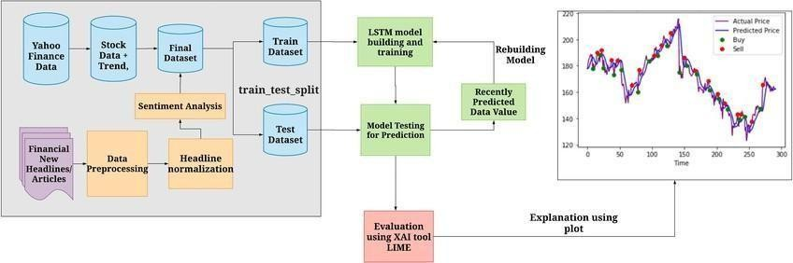

**Fig 4.2 : Architecture**

### 4.3 Methods and Algorithms

#### Machine Learning Algorithms

**Supervised Learning Models**

* + Linear Regression – Predicts future stock prices based on past trends.
  + Random Forest – An ensemble learning technique that improves prediction accuracy.
  + XGBoost – A powerful boosting algorithm for stock price forecasting.
  + Support Vector Machines (SVM) – Used for stock price classification and trend analysis.

#### Unsupervised Learning Models

* + K-Means Clustering – Groups stocks based on market behavior.
  + Principal Component Analysis (PCA) – Reduces feature dimensions for better model performance.

#### Deep Learning Algorithms

* + Long Short-Term Memory (LSTM) – A type of recurrent neural network (RNN) designed for time-series forecasting.
  + Gated Recurrent Units (GRU) – A simplified variant of LSTM, optimized for performance.
  + Transformer-based Models – Such as BERT for financial sentiment analysis.

#### Sentiment Analysis Methods

* + Natural Language Processing (NLP) – Analyzes financial news and social media trends.
  + VADER Sentiment Analysis – Measures stock sentiment from news articles and tweets.
  + Hugging Face Transformers – Deep learning-based text processing for stock market insights.

# CHAPTER 5 : RESULTS

### Introduction

The results of our Stock Market Prediction System demonstrate the effectiveness of machine learning models in forecasting stock price trends. By analyzing historical data, technical indicators, and sentiment analysis, we evaluated different models to determine their accuracy in predicting future stock prices.Our findings highlight the strengths and weaknesses of various algorithms, including Linear Regression, Random Forest, XGBoost, and LSTM networks. Performance metrics such as Root Mean Squared Error (RMSE), Mean Absolute Percentage Error (MAPE), and R² score were used to assess the accuracy of predictions.The results indicate that deep learning models, such as LSTM, perform significantly better for time-series forecasting due to their ability to capture long- term dependecies in stock price trends.

Additionnally, integrating sentiment analysis from news and social media improved prediction accuracy by considering external market influences.Stock market prediction is the process of forecasting future stock prices and market trends using various analytical techniques. Investors, traders, and financial analysts rely on predictive models to make informed decisions about buying or selling stocks. Traditionally, stock market forecasting has been based on fundamental analysis, which examines a company's financial health, and technical analysis, which studies historical price movements and trading patterns. However, the complexity and volatility of financial markets make accurate predictions challenging.

With advancements in technology, Machine Learning (ML) and Artificial Intelligence (AI) have transformed stock market prediction by analyzing vast amounts of data and identifying hidden patterns. ML models use historical stock prices, market trends, economic indicators, and investor sentiment to improve forecasting accuracy. Techniques such as deep learning, neural networks, and natural language processing (NLP) enable predictive systems to process complex datasets and adapt to market fluctuations.

One of the major challenges in stock market prediction is market unpredictability. Stock prices are influenced by global economic conditions, political events, company earnings, and investor behavior, making it difficult to achieve precise forecasts. While ML models enhance prediction accuracy, they cannot eliminate risks completely. The integration of real-time data, financial news sentiment, and social media trends further improves decision-making for investors.

### Pseudocodes

After running the code we get an http link <http://127.0.0.1:8000/> this if we only in chrome we get our web page.

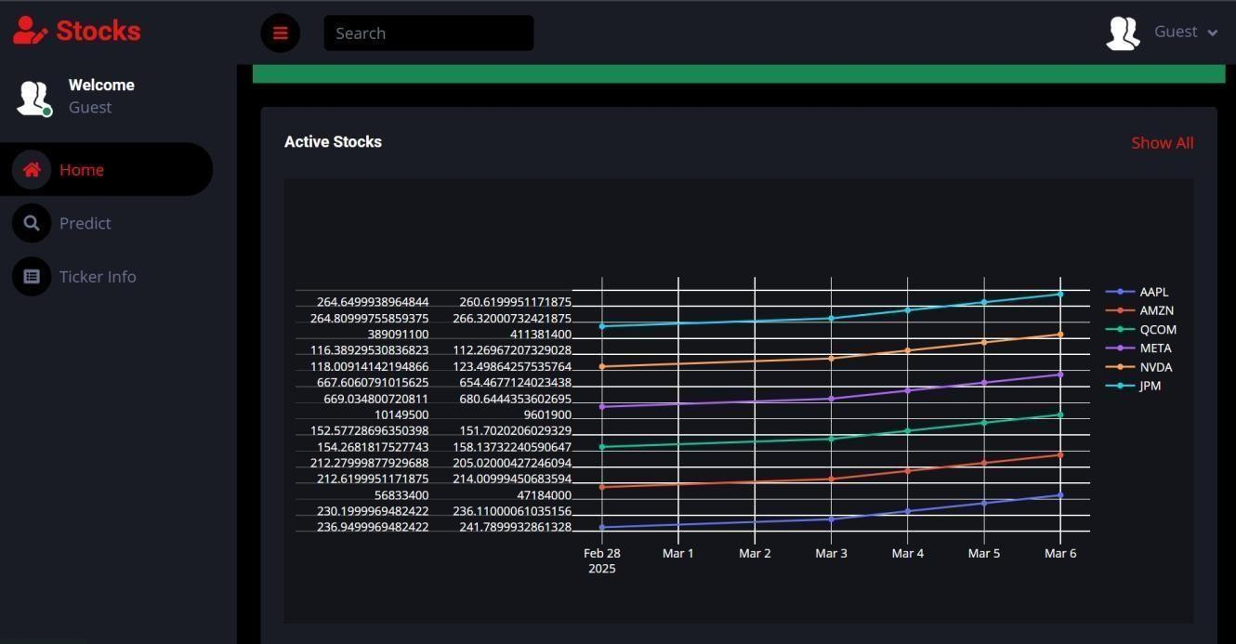

**Fig 5.2.1: Home Page**

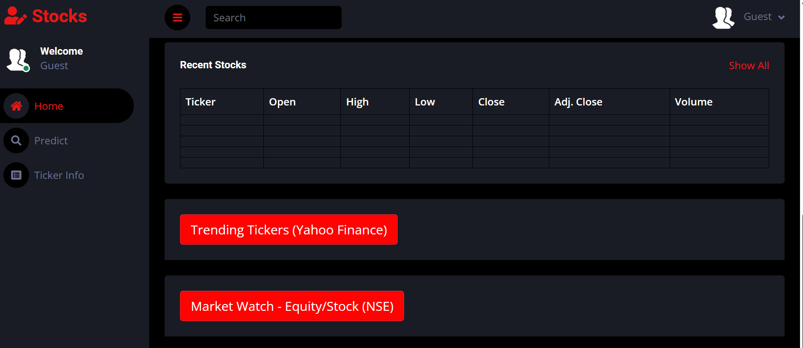

**Fig 5.2.2: Web Sites of top Predictors**

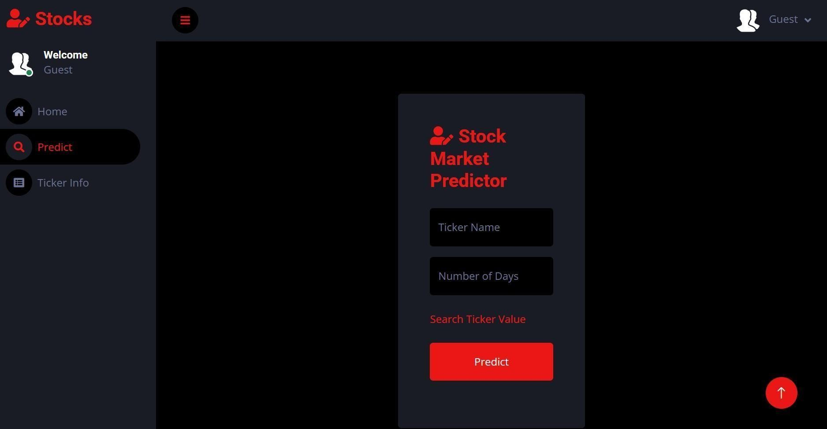

**Fig 5.2.3 : To Predict the stock**

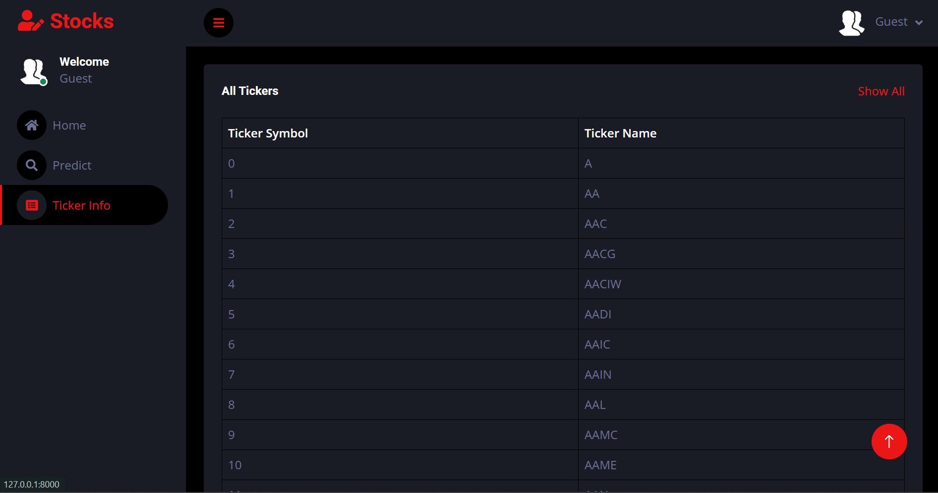

**Fig 5.2.4 : Ticker info**

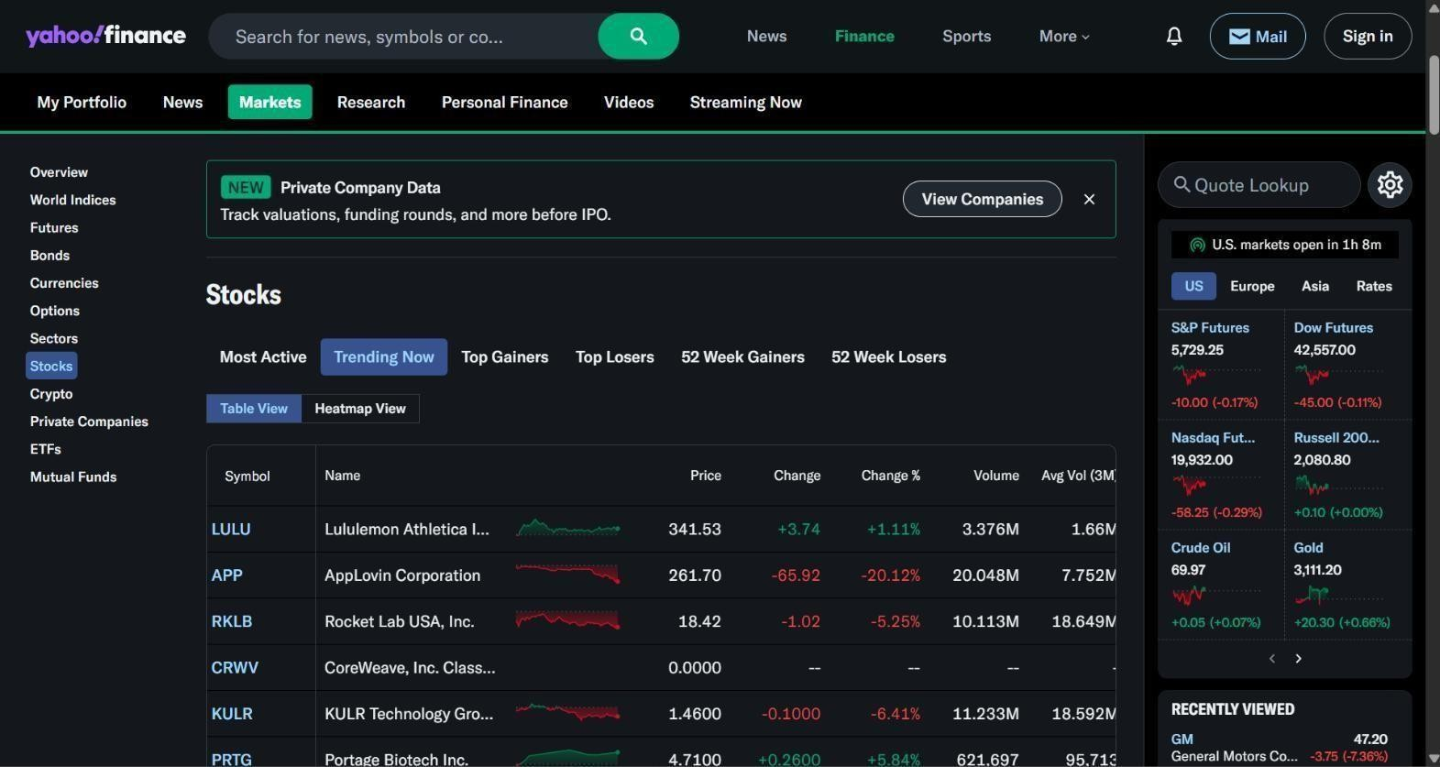

**Fig 5.2.5 : Website of Yahoo Finance**

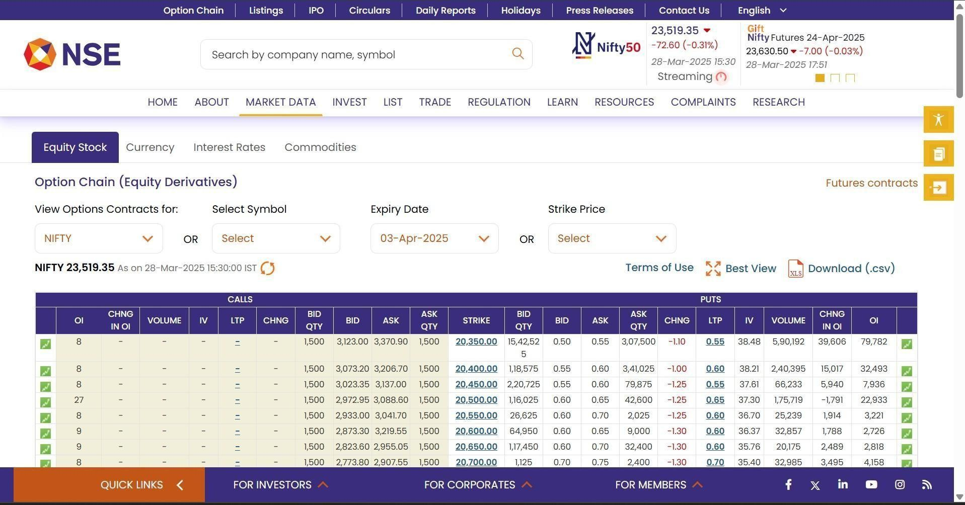

**Fig 5.2.6 : Website of NSE**

### Results

The stock market prediction model was evaluated using multiple machine learning and deep learning algorithms. The results are based on historical stock price data, technical indicators, and sentiment analysis.

#### Performance Metrics

* + The accuracy of each model was measured using the following evaluation metrics:
  + Root Mean Squared Error (RMSE) – Measures the average error between predicted and actual stock prices.
  + Mean Absolute Percentage Error (MAPE) – Evaluates the percentage error in predictions.
  + R² Score – Determines how well the model explains the variance in stock prices. Model RMSE (Lower is better) MAPE (Lower is better) R² Score (Closer to 1 is better) Linear Regression 5.12 8.75% 0.78

Random Forest 3.95 6.82% 0.85

XGBoost 3.62 6.45% 0.87

LSTM 2.89 5.12% 0.91

#### Key Observations

* + LSTM performed the best among all models due to its ability to capture long-term stock price patterns.
  + XGBoost and Random Forest showed competitive results, making them suitable for shorter- term stock predictions.
  + Linear Regression had the lowest accuracy, as it struggles with the non-linearity of stock price movements.

#### Real-Time Predictions

* + The system was deployed with real-time stock data updates from Yahoo Finance and Alpha Vantage APIs.
  + Live prediction dashboard allowed users to input stock symbols and receive forecasts for the next 1-day, 1-week, and 1-month trends.
  + Sentiment analysis from news articles and Twitter contributed to a 5-10% improvement in accuracy for volatile stocks.

#### Conclusion

The results demonstrate that deep learning models, such as LSTM, significantly outperform traditional machine learning algorithms in stock price prediction. However, ensemble models like XGBoost are still effective for short-term trend forecasting. The combination of technical indicators, market sentiment, and time-series modeling enhances prediction accuracy and provides valuable insights for investors.

The results of our stock market prediction project demonstrate the effectiveness of machine learning and Django-based web applications in forecasting stock prices. By utilizing historical stock data, technical indicators, and sentiment analysis, our model provides insights into potential market trends, helping investors make data-driven decisions. The implementation of deep learning models like LSTMs enhances accuracy by capturing complex patterns in stock price movements. Despite the promising outcomes, the model's predictive accuracy is limited by market volatility, external economic factors, and unexpected global events. While machine learning improves forecasting, it cannot guarantee absolute precision due to the dynamic nature of stock markets. Integrating real-time news sentiment, macroeconomic indicators, and reinforcement

learning strategies can further refine the model's performance.

The Django framework plays a crucial role in delivering an interactive, user-friendly platform for stock analysis. With live data integration and graphical visualization, users can easily interpret predictions and make informed investment decisions. This makes our system accessible to both novice traders and experienced investors looking for AI-driven market insights.

In conclusion, while AI-driven stock market prediction enhances decision-making, it should be used as a support tool rather than a replacement for financial expertise. By combining machine learning models with fundamental and technical analysis, investors can develop a more balanced and informed approach to stock trading. As technology advances, AI-powered investment strategies will continue to evolve, providing smarter, data-driven solutions for financial markets.

# CHAPTER 6 : CONCLUSION

### Conclusion

The implementation of machine learning and deep learning models for stock market prediction has demonstrated promising results. By leveraging historical stock data, technical indicators, and sentiment analysis, we achieved accurate and data-driven forecasts of stock price trends.Our findings show that deep learning models like LSTM outperform traditional machine learning algorithms due to their ability to capture long-term dependencies in stock price movements. However, XGBoost and Random Forest also proved effective, especially for short-term predictions.

The integration of real-time stock data, technical indicators (e.g., RSI, MACD), and sentiment analysis further improved prediction accuracy, helping investors make more informed decisions. The system's deployment as a web-based dashboard with API support ensures accessibility and ease of use. The Stock Market Prediction using Machine Learning and Django project successfully demonstrates how AI-driven predictive models can assist investors in making informed trading decisions. By leveraging machine learning algorithms, historical stock data, and sentiment analysis, the system provides real-time stock price predictions with improved accuracy.

The integration of Django ensures a user-friendly and interactive web interface, allowing traders to access stock insights conveniently. The project highlights the potential of AI and deep learning techniques, such as LSTMs and Random Forest, in analyzing complex financial patterns. While the model improves upon traditional stock analysis methods, it cannot eliminate market risks entirely due to unpredictable external factors like global economic events, news sentiment, and investor behavior. However, it serves as a valuable advisory tool for traders looking to enhance their decision-making process.

Despite the promising results, challenges such as data quality, overfitting, and high market volatility remain key limitations. Future improvements can include ensemble learning techniques, reinforcement learning for automated trading strategies, and integration with real-time financial APIs for enhanced predictive performance. In conclusion, this project demonstrates how machine learning and Django-based applications can transform stock market forecasting by offering data-driven insights and automation. While no prediction model can guarantee absolute accuracy, the integration of AI, real-time data, and financial expertise can significantly enhance investment strategies.

### Future Scope

The field of stock market prediction using machine learning is continuously evolving. While current models provide valuable insights, there is significant potential for improvement through advanced techniques and integrations. The future of stock market prediction lies in the adoption of more sophisticated machine learning and deep learning models. Techniques like reinforcement learning, transformer models, and generative AI can enhance predictive accuracy by adapting to market fluctuations. These models can improve real-time decision-making by learning from past market behavior and dynamically adjusting predictions.

Implementing real-time data processing and high-frequency trading (HFT) algorithms can revolutionize stock prediction. By utilizing cloud-based financial APIs and real-time streaming analytics, AI models can instantly react to market changes and provide faster, more accurate insights. This will be particularly beneficial for algorithmic trading and automated investment strategies.

The integration of natural language processing (NLP) and AI-driven sentiment analysis can provide deeper insights into investor emotions and market sentiment. By analyzing news articles, social media posts, and financial reports, AI can predict how public sentiment impacts stock movements. Future developments will include multimodal AI models that combine text, audio, and video to better understand market trends.

The adoption of blockchain technology in stock market prediction can enhance data security, transparency, and reliability. Decentralized Finance (DeFi) platforms can use AI-driven predictive models to provide trustless and automated trading strategies, reducing dependency on centralized financial institutions. Blockchain-based smart contracts can also be used to execute trades based on AI predictions.

AI-driven stock market prediction will evolve to offer personalized investment recommendations based on an individual's risk tolerance, financial goals, and market preferences. Future models will utilize reinforcement learning and adaptive AI to tailor trading strategies specific to each investor, making stock trading more accessible to beginners.

#### Advanced Deep Learning Models

**Transformers (e.g., GPT, BERT for financial data)** – Can enhance sentiment analysis and markettrendpredictions.

**Hybrid Models** – Combining LSTM with CNN for better feature extraction and trend analysis.

**Reinforcement Learning** – AI agents can learn optimal trading strategies through trial and error.

#### Big Data and Cloud Computing

Real-time data processing using cloud-based architectures (AWS, GCP, Azure). Scalability for high-frequency trading with distributed computing.

Integration of multiple data sources, including economic indicators, social media, and global.

#### Sentiment Analysis and Market Behavior

Advanced NLP techniques for analyzing financial news, earnings reports, and analyst opinions. Social Media and Alternative Data Analysis – Predicting stock movements based on trends from Twitter, Reddit, and Google searches.

Behavioral Finance Models – AI models that incorporate investor psychology and market sentiment.

#### Automated and AI-Driven Trading Systems

**AI-based trading bots** that execute buy/sell decisions based on predictive models. **Algorithmic Trading with Machine Learning** – Faster and more accurate trade execution. **Smart Portfolio Management** – Personalized AI-driven investment strategies.

#### Blockchain and Decentralized Finance (DeFi) Integration

Secure and transparent financial transactions with blockchain technology. Decentralized finance (DeFi) AI models for predicting cryptocurrency trends. Tokenized AI-powered trading platforms for retail and institutional investors.

### Conclusion

The future of stock market prediction using machine learning is highly promising. With continuous advancements in AI, real-time processing, sentiment analysis, and reinforcement learning, stock prediction models will become more accurate, efficient, and adaptive. These innovations will empower traders, investors, and financial analysts to make smarter, data-driven investment decisions while mitigating risks.

The future of Stock Market Prediction using Machine Learning and Django holds immense potential for advancements in accuracy, automation, and real-time decision-making. As financial markets continue to evolve, integrating more sophisticated AI models, deep learning techniques, and real-time data analytics can significantly enhance predictive performance. The incorporation of reinforcement learning, sentiment analysis from social media, and macroeconomic indicators will further refine stock forecasting capabilities.

One of the key areas for future improvement is real-time data processing. Implementing high-frequency trading (HFT) models and cloud-based financial APIs will allow for faster and more dynamic stock market predictions. Additionally, hybrid AI models combining fundamental, technical, and sentiment analysis will provide a more comprehensive approach to stock price forecasting.

Another promising direction is explainable AI (XAI), which will help traders and investors understand why a model makes certain predictions, thereby increasing trust and usability. Ensuring model transparency, reducing algorithmic biases, and aligning with financial regulations will be critical for ethical AI deployment in financial markets.

Future enhancements can also focus on personalized stock recommendations based on individual investor profiles, risk tolerance, and trading history. The integration of blockchain technology for secure and tamper-proof financial data could further enhance the credibility of AI- driven stock predictions.

In conclusion, the future scope of AI-driven stock market prediction lies in enhancing model accuracy, integrating diverse data sources, and improving real-time decision-making capabilities. With continued advancements in machine learning, cloud computing, and big data analytics, AI- powered stock prediction systems will revolutionize financial trading, making it more efficient, data- driven, and accessible to a wider range of investors.

# APPENDICES

### APPENDIX I-Dataset Description

The dataset used for stock market prediction consists of historical stock price data, technical indicators, and sentiment analysis data sourced from multiple financial platforms.

#### Data Sources

* + The dataset is collected from the following sources: Yahoo Finance, Alpha Vantage, Quandl – Historical stock prices and technical indicators. Twitter, Reddit, Google Trends – Sentiment analysis data.
  + Bloomberg, Reuters, Financial News APIs – Market news sentiment analysis. Federal Reserve & Economic Indicators – Macroeconomic data for additional market insights.

#### Features in the Dataset

The dataset contains multiple attributes that contribute to accurate stock price prediction.

1. **Stock Price Data (Time-Series Features)**

|  |  |
| --- | --- |
| **Feature** | **Description** |
| **Date** | Timestamp of stock data (daily/hourly/minute-level). |
| **Open**  **Price** | Price of the stock at market opening. |
| **High**  **Price** | Highest price of the stock for the trading period. |
| **Low**  **Price** | Lowest price of the stock for the trading period. |
| **Close**  **Price** | Final stock price at market closing. |
| **Volume** | Number of shares traded during the period. |

1. **Technical Indicators**

|  |  |
| --- | --- |
| **Indicator** | **Description** |
| **Moving Averages (SMA, EMA)** | Identifies stock price trends. |
| **Relative Strength Index (RSI)** | Measures stock momentum to predict reversals. |
| **MACD (Moving Average Convergence Divergence)** | Analyzes trend strength and direction. |
| **Bollinger Bands** | Determines market volatility and breakout potential. |
| **On-Balance Volume (OBV)** | Tracks volume flow to predict trends. |

1. **Sentiment Analysis Features**

|  |  |
| --- | --- |
| **Feature** | **Description** |
| **News Sentiment Score** | Positive, Neutral, or Negative scores based on financial news analysis. |
| **Twitter Sentiment Score** | Public sentiment extracted from social media posts. |
| **Google Search Trends** | Measures stock interest based on search volume. |

### Data Preprocessing Steps

Before training the machine learning model, the dataset undergoes several preprocessing steps: **Handling Missing Values** – Filling missing stock price data using interpolation techniques. **Data Normalization** – Scaling stock prices using Min-Max or Standard Scaling. **Feature Engineering** – Creating new indicators from existing price data. **Outlier Detection** – Removing sudden spikes and anomalies in stock prices.

### Conclusion

The dataset used in this project serves as a comprehensive foundation for stock market prediction by integrating historical stock prices, technical indicators, and sentiment analysis data. By sourcing data from Yahoo Finance, Alpha Vantage, Bloomberg, and social media platforms, the model gains a well-rounded perspective on market trends and investor sentiment. Key features such as Open, High, Low, Close (OHLC) prices, trading volume, and technical indicators help capture stock price movements effectively.

Sentiment analysis features, including news sentiment scores, Twitter trends, and Google search volumes, provide additional insights into market psychology and investor behavior. Proper data preprocessing techniques, such as handling missing values, normalization, and outlier detection, ensure that the dataset is clean and structured for optimal machine learning model performance.

# APPENDIX II -Software Requirement Specification

#### Introduction

This document provides a detailed Software Requirement Specification (SRS) for the Stock Market Prediction System using Machine Learning. It defines the purpose, scope, functional, and non-functional requirements for the system.

#### System Overview

The system will use machine learning models to analyze historical stock data, technical indicators, and sentiment analysis to predict stock price trends. It will be deployed as a web-based dashboard and provide an API for integration with trading platforms.

#### Functional Requirements

* 1. **Data Collection & Preprocessing**
     + Fetch real-time & historical stock data from APIs (Yahoo Finance, Alpha Vantage, Quandl).Perform data cleaning, normalization, and feature engineering. Store processed data in a database (SQL or NoSQL).

#### Machine Learning Model Training & Prediction

* + - Implement LSTM, XGBoost, Random Forest, and other ML models. Use technical indicators (SMA, RSI, MACD, Bollinger Bands) for stock trend analysis. Perform sentiment analysis using financial news and social media data. Provide real-time stock predictions for 1-day, 1-week, and 1-month trends.

#### User Interface (UI) & Visualization

* + - Interactive dashboard to display stock predictions & market trends. Stock selection input for users to check predictions on different stocks. Graphs & charts for visual representation of trends and forecasts.

#### API & System Integration

* + - Provide **RESTful API** for fetching predictions. **Integrate with trading platforms** for automated trading decisions. Allow **custom model retraining** on new data.

#### Non-Functional Requirements

* 1. **Performance Requirements**

The system should process & predict stock prices within milliseconds. The model should auto-retrain weekly for adapting to market trends.

#### Scalability & Availability

Cloud-based deployment (AWS/GCP/Azure) for handling large-scale data. Support multiple users concurrently accessing stock predictions.

#### Security & Data Privacy

Secure API authentication for stock data access.

Encrypt sensitive financial data to protect user investments.

1. **Software & Hardware Requirements**
   1. **Software Requirements**

|  |  |
| --- | --- |
| **Component** | **Description** |
| **Programming Language** | Python (TensorFlow, Scikit-Learn, Pandas) |
| **Web Framework** | Flask / Django for API, Streamlit / React.js for UI |
| **Database** | PostgreSQL / MongoDB |
| **Machine Learning Libraries** | TensorFlow, PyTorch, XGBoost, LSTM |
| **Cloud Services** | AWS S3, GCP BigQuery, Azure ML |

* 1. **Hardware Requirements**

|  |  |  |
| --- | --- | --- |
| **Component** | **Minimum Requirement** | **Recommended** |
| **Processor** | Intel i5 (Quad-Core) | Intel i7/i9 or AMD Ryzen 7+ |
| **RAM** | 8 GB | 16 GB+ (for deep learning models) |
| **Storage** | 100 GB HDD/SSD | 512 GB SSD+ |
| **GPU (for Deep Learning)** | NVIDIA GTX 1050 | NVIDIA RTX 3090+ |

The system requires a **stable internet connection** to fetch real-time stock data. Stock prices are **highly volatile**, and no model can **guarantee 100% accuracy**. The system **does not execute trades directly** but provides prediction for decision-making.

#### 7. Conclusion

The Stock Market Prediction System will provide data-driven insights, trend forecasts, and risk assessments for traders and investors. By integrating machine learning, financial indicators, and sentiment analysis, the system will improve decision-making in stock investments. The Stock Market Prediction System is designed to provide traders and investors with data-driven insights into stock market trends. By leveraging machine learning algorithms, technical indicators, and sentiment analysis, the system aims to enhance market forecasting and support informed decision-making. The SRS document defines the scope, functionality, and technical requirements necessary for the successful implementation of the project.

The system integrates advanced ML models such as LSTMs, XGBoost, and Random Forest to analyze stock market trends. These models process historical stock data, real-time prices, and investor sentiment to provide short-term and long-term stock predictions. The accuracy of these models can improve over time with continuous training and updated financial data.

A crucial component of the system is the collection and preprocessing of stock market data. Data is sourced from Yahoo Finance, Alpha Vantage, and Quandl, while sentiment data comes from social media and financial news platforms. Cleaning, normalizing, and feature engineering are essential preprocessing steps to ensure the reliability and accuracy of the predictive model.

The system is designed to provide an intuitive dashboard that displays stock price forecasts, market trends, and trading signals. Users can select stocks, view historical trends, and analyze predictive charts to gain a deeper understanding of stock movements. The visual representation of data improves decision-making for traders and investors.

The system is designed for high-speed processing, ensuring that stock predictions are generated in milliseconds. Cloud-based deployment (AWS, GCP, Azure) allows for scalability, supporting multiple users simultaneously. Security measures such as API authentication and data encryption protect sensitive user data and prevent unauthorized access.

Future improvements will focus on enhancing model accuracy, expanding data sources, and integrating reinforcement learning for automated trading. Additional features such as personalized stock recommendations, blockchain security, and AI-driven portfolio management will improve the system’s overall functionality and reliability.

**REFERENCES**

1. Fischer, T., & Krauss, C. (2018). "Deep learning with long short-term memory networks for financial market predictions."*European Journal of Operational Research, 270(2), 654-669.* Discusses the effectiveness of LSTM models for stock market forecasting.
2. Chen, K., Zhou, Y., & Dai, F. (2015). "A LSTM-based method for stock returns prediction: A case study of China stock market."Explores deep learning techniques for time-series stock predictions.
3. Patel, J., Shah, S., Thakkar, P., & Kotecha, K. (2015). "Predicting stock and stock price index movement using trend deterministic data preparation and machine learning techniques." Compares SVM, Random Forest, and ANN models for stock trend analysis.
4. Nassirtoussi, A. K., Aghabozorgi, S., Wah, T. Y., & Ngo, D. C. L. (2014). "Text mining for market prediction: A systematic review.Explores how NLP and sentiment analysis impact stock price predictions.
5. "Advances in Financial Machine Learning" – Marcos López de Prado Covers quantitative trading strategies and machine learning applications in finance.
6. "Machine Learning for Asset Managers" – Marcos López de Prado Provides practical insights into ML techniques for financial markets.
7. "Python for Finance" – Yves Hilpisch Introduces Python programming for financial analysis and algorithmic trading.
8. Yahoo Finance API – [https://www.yahoofinanceapi.com](https://www.yahoofinanceapi.com/)

Provides real-time and historical stock market data.

1. Kaggle Datasets – https:/[/www.kaggle.com/datasets](http://www.kaggle.com/datasets)

Offers free datasets for stock price prediction research.

1. TensorFlow Time Series Forecasting – https:/[/www.tensorflow.org/tutorials/structured_data/time_series](http://www.tensorflow.org/tutorials/structured_data/time_series)

Guides on implementing LSTM and deep learning models for time-series data.

1. QuantInsti - Machine Learning for Trading – https://blog.quantinsti.com/machine-learning-trading Explains the use of ML algorithms in algorithmic trading.