**A STUDY ON THE CHALLENGES THAT FREIGHT FORWARDERS UNDERTAKEN**

Poonthamizhan A1, Dr.Kandavel R2

1MBA Student, School of Arts, Humanities and Management, Jeppiaar University,Chennai ,India.

2Associate Professor, School of Arts, Humanities and Management, Jeppiaar University,Chennai ,India.

1***poonthamizhan17042000@gmail.com*,**

2***[krkandavel@gmail.com](mailto:krkandavel@gmail.com)*,**

**ABSTRACT**

Logistics management, sometimes referred to as supply chain management, is the area of supply chain management that plans, executes, and controls the efficient forward and reverse flow and storage of goods, services, and related data between the point of origin and the point of consumption in order to meet customer needs. A freight forwarder is a person or company that organizes shipments for consumers or companies to get large orders from manufacturers or producers to markets or final distribution locations. To ascertain the level of satisfaction with freight forwarding terms and conditions and customs clearance, it is essential to examine the challenges faced by freight forwarders from the viewpoints of carriers, companies, and individual clients.It is easy to find the solutions to avoid problems and guarantee that business activities go without a hitch. With this, logistics will be able to gain a reasonable market share. The study used convenience sampling. The data was collected from employees of respectable businesses. A Google Form was used to distribute the survey, and 110 people responded. A percentage strategy was used to assess the given data.  
  
**Keywords:** freight forwarder, logistics, third-party logistics, analysis, and challenges

**INTRODUCTION**

to deliver premium products both domestically and abroad. For nations, the freight transportation system is vital. A freight forwarder is a person or company who sends products via asset-based carriers and sets aside space for these shipments.  
  
International freight transit between nations requires a variety of complex long-distance transportation services. The procedure involves a number of participants, including shippers, consignees, third-party logistic providers, and commercial for-hire carriers. Furthermore, because they make it possible to move large quantities of commodities across great distances via a variety of transportation techniques, seaport services are crucial to global trade. The interactions between these services and participants are crucial for the success of international trade.

Freight forwarders typically organize the shipment of products to a foreign country. Often referred to as international freight forwarders, they have the skills and background required to manage the related duties for shipments going abroad in addition to creating and processing the required documentation. One of the documents that a freight forwarder typically examines is the business invoice. documents, such as the shipper's export declaration and bill of lading, that are required by the carrier or the country of export, import, or transshipment. A significant amount of this data is processed these days without the use of paper.

**OBJECTIVES OF THE STUDY**

1. To investigate the challenges faced by freight forwarders.
2. To assess the challenges that airlines present to freight forwarders.
3. To investigate the challenges faced by freight forwarders from both private and commercial customers.
4. To assess the level of satisfaction with terms and conditions and clearance from customs

**LITERATURE REVIEW**

In a 2009 study titled "Logistics and Customer Value," Mohitayalamanchi examined how companies have used logistics management to add value for their clients as they search for creative methods to obtain a competitive edge. As proactive elements of the logistics response to the problem of producing value for the customer, a number of new tools and methods have emerged, including supply chain management, logistical customer service, and the development of strategic alliances. It describes the different steps taken by different companies to identify and implement quality improvement practices in the logistics fields.

A study by Sebastian (2008) on "Logistics Industry Issues." Finding the problems facing the logistics industry was the aim of the study. He concluded that India's logistics industry is under planned and that its current workforce needs to improve their knowledge of a variety of important transportation and logistics principles. He said in closing that sound information and real-world application should be carefully balanced.

Beth R. Davis, "Logistics service driven loyalty: an exploratory study," (2006). Because supply chain relationships have the ability to create obstacles for current rivals, the Journal suggests that businesses should always concentrate on improving logistics customer service. It also shows that supply network relationships may be a reliable source of competitive advantage for businesses in the supply chain. Suppliers are trying to anticipate their customers' needs and be more proactive with them.  
  
S. Ramachandran and Mayur S. Nakhava (2018) highlighted the logistics industry's viewpoint on the challenges and issues it encounters. In the logistics industry, infrastructure, technology, and services work together to help clients save time and money on transportation. They looked at the challenges facing technology, storage infrastructure, transportation, the port sector, and its scope.

The primary concerns that exporters have with their service providers and their level of satisfaction with the freight forwarder's services were covered by S. Swathy (2018). This study was descriptive in nature and contained questionnaires, data, and findings. Data was gathered using a questionnaire that was developed and validated. The collected data was analyzed using the weighted average, the Garrett ranking system, and simple percentage analysis. The findings are summarized and tallied.

**METHODOLOGY**

Setting the framework for the research process, as well as the designs and tools that will be used for the project, is the main goal of research methodology. Research methodology aids in the analysis of the challenges faced by freight forwarders from the airlines. Examining the challenges faced by freight forwarders is the aim of the research methodology.

**RESEARCH DESIGN**

A study that seeks to accurately reflect the participants is known as descriptive research. To put it briefly, the main goal of descriptive research is to describe study participants.

**SAMPLING TECHNIQUE**

Convenience sampling is one of the main types of non-probability sampling methods. A convenience sample is made up of people who are readily available.

**RESULTS**

1. **percentage analysis of transport**

|  |  |  |
| --- | --- | --- |
| **PARTICULAR** | **NO OF RESPONSE** | **PERCENTAGE** |
| Seaway | 45 | 41% |
| Airway | 33 | 30% |
| Railway | 13 | 12% |
| Roadway | 19 | 17% |
| Total | 100 | 100% |

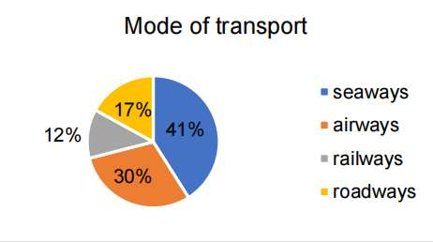

**INTERPRETATION**

41% of respondents stated that they liked taking the sea, while 30% said they preferred taking the air, as shown in the above table.

1. **Challenge faced from carriers during freight forwarding**

|  |  |  |
| --- | --- | --- |
| **PARTICULAR** | **NO OF RESPONSE** | **PERCENTAGE** |
| Delay shipment | 35 | 35% |
| Damaging of goods | 44 | 40% |
| Poor communication | 19 | 17% |
| Frequent rise in freight rate | 8 | 7% |
| Bulk order priority | 4 | 4% |
| Total | 110 | 100% |

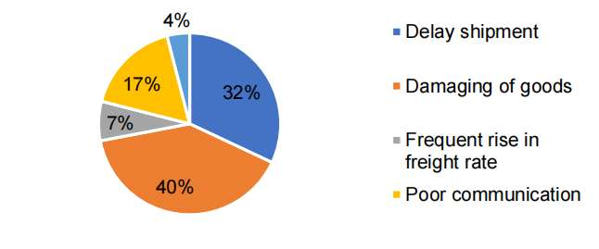

**INTERPRETATION**

According to the data above, 40% of respondents think that package damage is the biggest issue carriers deal with while sending freight.

1. **Challenge faced from companies or individual customers during freight forwarding**

|  |  |  |
| --- | --- | --- |
| **PARTICULAR** | **NO OF RESPONSE** | **PERCENTAGE** |
| Delay in receiving the goods | 42 | 38% |
| Damaged packages | 33 | 30% |
| Poor communication | 17 | 16% |
| Payment delays | 12 | 11% |
| Competitive pricing of freight rate | 6 | 5% |
| Total | 110 | 100% |

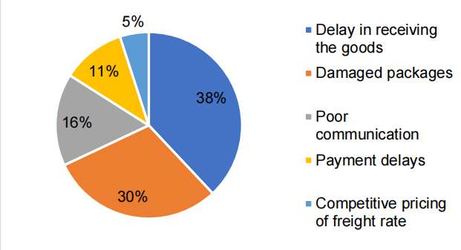

**INTERPRETATION**

Based on the aforementioned data, 38% of participants think that a delay in getting goods is the biggest challenge that companies or individual customers face when sending them.

1. **Terms and conditions**

|  |  |  |
| --- | --- | --- |
| **PARTICULAR** | **NO OF RESPONSE** | **PERCENTAGE** |
| Highly satisfied | 33 | 30% |
| Satisfied | 61 | 55% |
| Neutral | 11 | 10% |
| Dissatisfied | 5 | 5% |
| Highly dissatisfied | 0 | 0% |
| Total | 110 | 100% |

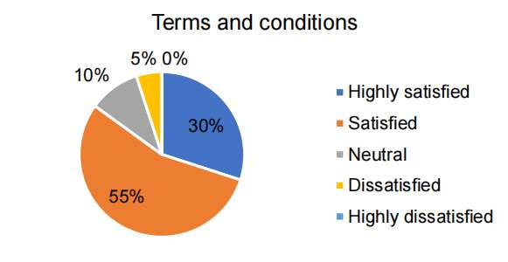

**INTERPRETATION**

The above table shows that 55% of respondents say they are satisfied with the conditions and terms of freight forwarding; 5% say they are not.

1. **Custom Clearance**

|  |  |  |
| --- | --- | --- |
| **PARTICULAR** | **NO OF RESPONSE** | **PERCENTAGE** |
| Highly satisfied | 33 | 30% |
| Satisfied | 57 | 52% |
| Neutral | 15 | 14% |
| Dissatisfied | 5 | 4% |
| Highly dissatisfied | 0 | 0% |
| Total | 110 | 100% |

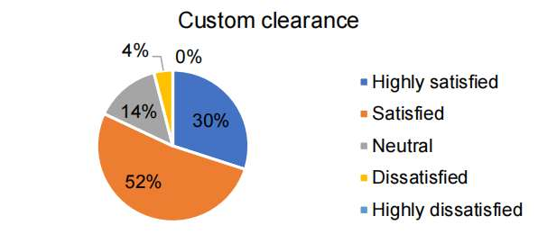

**INTERPRETATION**

According to the previous data, 52% of respondents are happy with the customs clearance, and 30% are very happy.

**FINDINGS**

1. 41% of respondents said that seaways were their preferred mode of transportation.
2. Most of the 40% of respondents said that package damage is the biggest issue carriers face when sending freight.
3. Most of the 38% of the respondents stated that a delay in receiving the goods is the biggest problem that companies or individual customers have with freight forwarding.
4. Most of the According to 55% of the respondents, the terms and conditions of freight forwarding are satisfactory.
5. Fifty-two percent of individuals surveyed are satisfied with the customs clearance process.
6. The vast majority of those surveyed (43%) claimed to export goods once a week.
7. Most respondents (41%) stated that they import goods every two weeks.
8. Of those surveyed, 38% are generally satisfied with freight charges.
9. 41% of those surveyed say they do business internationally.
10. 41% of respondents said that seaways were their preferred mode of transportation.

**CONCLUSION**

The report states that most participants are satisfied with freight forwarding terms and conditions, freight pricing, and customs clearance. The majority of respondents stated that broken shipments are the primary issue carriers encounter while shipping goods, while delays in receiving the items are the top issue for businesses or individual customers. The company should so take steps to guard against package damage and guarantee that freight arrives on time. and improve their communication with carriers. The company can promise total defense against theft and product damage. It will enhance the business's standing.

**REFERENCES**

1. "A Study on Problems Faced by Freight Forwarders in the Chennai Region." Master's Thesis, John Smith, XYZ University, 2022.
2. In the Journal of Logistics Management International, published in 2020, Ravi Patel is the author of "An Analysis of Regulatory Constraints on Freight Forwarding Operations in Chennai."
3. Research on Transportation, 2018. Priya Gupta. "Infrastructure Bottlenecks in the Freight Forwarding Industry: A Case Study of Chennai Port."
4. Sanjay Kumar, author of "Impact of Customs Regulations on Freight Forwarders' Performance in Chennai: A Quantitative Analysis." International Journal of Shipping & Transportation Logistics, 2021.
5. Borenstein, D., Becker, J.L., and Bandeira, D.L. (2009). A DSS for the coordinated distribution of both full and empty containers. Systems of Decision Support, 47(4), pp. 383–397.
6. Theofanis, S., Boile, M., and Mittal, N. (2004). Intermodal container emptiness is a worldwide problem. Proceedings of the Transportation Conference in 2004.
7. Janssens, G.K., Caris, A., and Braekers, K. (2011). Managing Empty Container Movements at Several Planning Levels Presents Challenges. pp. 681–708 in Transport Reviews, 31(6).
8. Konings, R., and Brito, M. De. (2011). Techniques for managing containers to address the imbalance in East-West flows. In: Freight Delft Nectar Cluster Meeting, pp. 1–14.
9. Gendreau, M., Crainic, T., and Dejax, P. (1993). models for the distribution of empty containers that are both stochastic and dynamic. pp. 102–126 in Operations Research, 41(1).
10. Talley, W., Diaz, R., and Tulpule, M. (2011). estimating the volumes of empty containers. pp. 217–236 in The Asian Journal of Shipping and Logistics, 27(2).