**INTELLIGENT AGENT BASED JOB SEARCH SYSTEM**

Guide : Prof . Mairaj Unisa Begum

Assistant Professor

School of Engineering

Computer Science-AI&ML

Malla Reddy University ,India.

| K.Siddartha | K.Sindhu Reddy | B.Sai Varun Reddy |
| --- | --- | --- |
| B-Tech | B-Tech | B-Tech |
| School of Engineering | School of Engineering | School of Engineering |
| Malla Reddy University | Malla Reddy University | Malla Reddy University |
| [2111cs020523@mallareddyuniversity.ac.in](mailto:2111cs020523@mallareddyuniversity.ac.in) | [2111cs020524@mallareddyuniversity.ac.in](mailto:2111cs020523@mallareddyuniversity.ac.in) | [2111cs020525@mallareddyuniversity.ac.in](mailto:2111cs020523@mallareddyuniversity.ac.in) |

| N.Sindhu | A.Harish | B.Siva Prasad |
| --- | --- | --- |
| B-Tech | B-Tech | B-Tech |
| School of Engineering | School of Engineering | School of Engineering |
| Malla Reddy University | Malla Reddy University | Malla Reddy University |
| [2111cs020526@mallareddyuniversity.ac.in](mailto:2111cs020523@mallareddyuniversity.ac.in) | [2111cs020527@mallareddyuniversity.ac.in](mailto:2111cs020523@mallareddyuniversity.ac.in) | [2111cs020528@mallareddyuniversity.ac.in](mailto:2111cs020523@mallareddyuniversity.ac.in) |

**1. ABSTRACT**

The Intelligent Agent-Based Job Search System is an AI-driven platform that revolutionizes the job search process by offering personalized, efficient, and accurate job matching using machine learning algorithms such as Random Forest, SVC, and KNN. Leveraging user profiles, skill sets, and historical job data, along with advanced natural language processing (NLP) to analyze job descriptions and resumes, the system provides precise recommendations through an intuitive interface featuring match percentages and real-time job listings. Its modular architecture supports scalability, multilingual expansion, and cross-industry integration,addressing key recruitment challenges like information overload and lack of personalization, while future enhancements aim to broaden its global usability and intelligence.

**Keywords:** *Intelligent Agent, Job search System, AI driven platform, Resume Analysis, Skill based matching*

**2. INTRODUCTION**

The evolving global job market presents significant challenges for both job seekers and employers, including information overload, lack of personalization, and inefficiencies in matching talent to opportunities. Traditional job platforms rely on static keyword-based systems that fail to understand nuanced candidate qualifications or employer needs, often overlooking transferable skills, soft skills, and evolving user preferences. Employers face time-consuming hiring processes and poor candidate matches despite existing Applicant Tracking Systems. To address these gaps, an Intelligent Agent-Based Job Search System offers a transformative solution by leveraging AI, machine learning, and NLP to deliver personalized, dynamic, and accurate job recommendations. This system acts as a virtual assistant for job seekers and a smart recruitment tool for employers, improving match quality, enhancing user satisfaction, and promoting equitable hiring practices.

**3. PROBLEM STATEMENT:**

The modern job market faces challenges due to fragmented platforms, overwhelming data, and lack of personalized matching. Traditional keyword-based systems often produce irrelevant results andinefficient recruitment. This disconnect affects both job seekers and employers. An AI-driven solution using NLP, ML, and intelligent agents is needed to provide personalized and efficient job recommendations.

**4. OBJECTIVE:**

The primary objective of this project is to develop an Intelligent Agent-Based Job Search System that leverages artificial intelligence to provide personalized job recommendations. The system aims to streamline the job search process for users by matching their skills, preferences, and career aspirations with suitable job opportunities. This platform intends to address inefficiencies in traditional job search methods by offering a more targeted, efficient, and user- friendly approach.

**Extract and Analyze User Profiles**:

Utilize advanced Natural Language Processing (NLP) techniques to extract skills, qualifications, and professional experiences from user-provided resumes or profiles . Accurately categorize user expertise to ensure precise matching with job requirements.

**Provide Personalized Job Recommendations:** Implement machine learning algorithms to match user profiles with job listings based on relevance and compatibility. Assign a match percentage to each job recommendation, helping users identify the best-suited opportunities quickly.

.**Centralize Job Listings**:

Aggregate job data from multiple sources, including company websites and job portals, to provide a comprehensive database of available positions. Regularly update listings to ensure users have access to the latest opportunities

**Enhance User Experience**:

Develop an intuitive and interactive user interface that allows users to: Upload resumes.View recommended job opportunities. Filter and search for specific roles. Provide additional job details such as job descriptions, required skills, location, and application deadlines.

**Simplify the Application Process**:

Include direct links to apply for jobs or enable in-platform application submission to save time and reduce manual effort.

**5. LITERATURE SURVEY**

This literature survey highlights the growing need for intelligent, AI-driven job search systems in response to the limitations of traditional keyword-based platforms, which often lack personalization and fail to understand user intent. It explores how recent advancements in Artificial Intelligence, Natural Language Processing (NLP), and Machine Learning (ML) have enabled the development of intelligent agents capable of delivering dynamic, context-aware job recommendations. The survey emphasizes the use of models like Random Forest, SVMs, and Neural Networks, along with NLP techniques for semantic analysis, to enhance matching accuracy and relevance. Additionally, it underscores the importance of real-time data integration, user behavior tracking, and soft skill consideration. The purpose of the survey is to identify existing research gaps, guide the selection of effective methodologies and technologies, and ensure the development of an innovative and efficient Intelligent Agent-Based Job Search System that adapts to the evolving job market while avoiding redundancy and supporting future research.

**6. EXISTING SYSTEM:**

Current job search platforms like LinkedIn, Indeed, and Glassdoor offer basic tools for job browsing and applications, primarily relying on keyword-based searches and filters. While some incorporate basic AI features like resume parsing and structured queries, they lack deep personalization and contextual understanding, often resulting in irrelevant job recommendations. These systems operate statically and struggle to adapt to user intent, market dynamics, or nuanced differences in roles. Despite the potential of advanced technologies like NLP and ML, most platforms underutilize them, failing to deliver intelligent, context-aware, and predictive job-matching experiences.

**7. PROPOSED SYSTEM:**

The proposed Intelligent Agent-Based Job Search System enhances traditional job platforms by integrating advanced AI, machine learning, and NLP to offer a personalized and efficient job search experience. Operating through a multi-agent framework, it includes agents for data collection, preprocessing, matching, and user interaction.The system semantically analyzes user skills and job descriptions to ensure accurate matches, uses algorithms like Random Forest and SVM for personalized recommendations, and continuously learns from user feedback. With real-time job listing updates via API integration, holistic profile analysis, and an intuitive user interface featuring dynamic filters and application tools, it streamlines the job discovery process and improves user engagement.

**8. DATASET DESCRIPTION:**

The dataset for the Intelligent Agent-Based Job Search System is designed to provide diverse job listings and user profiles for accurate job matching.

**Dataset Composition**

Job Listings: Includes job titles, descriptions, required skills, experience, location, and salary.

User Profiles: Contains user resume data (skills, work experience, education, and preferences).

**Data Sources**

User Contributions: Users upload resumes and input job preferences.

Job Portals: Data from LinkedIn, Indeed, Glassdoor, etc.

Skills & Industry Data: Information from platforms like Coursera and industry reports.

**Feature Extraction**

Job Descriptions: Extracts skills, categories, experience, and salary.

Resumes: Uses NLP models (NER, BERT) to match skills and job roles.

**Data Preprocessing**

Text Processing: Removes stopwords, tokenizes text, and standardizes titles.

Duplication: Removes duplicate job listings.

Standardization: Normalizes salary and location formats.

**Data Balancing & Augmentation**

Job Listing Augmentation: Adds synonyms and diversifies descriptions.

Resume Augmentation: Paraphrases resumes and recommends courses for skill gaps.

**Dataset Quality Assurance**

Human & Model Validation: Experts and models verify job-skill accuracy.

Bias Detection: Ensures diversity and complies with privacy laws (e.g., GDPR).

**Future Enhancements**

Real-Time Updates: Fetch new job listings dynamically.

Resume Enhancement: AI tools to optimize resumes for trending roles.

Multi-Language Support: Expands to support global users.

Skill Transfer Mapping: Identifies transferable skills for career shifts.

**9. ARCHITECTURE**

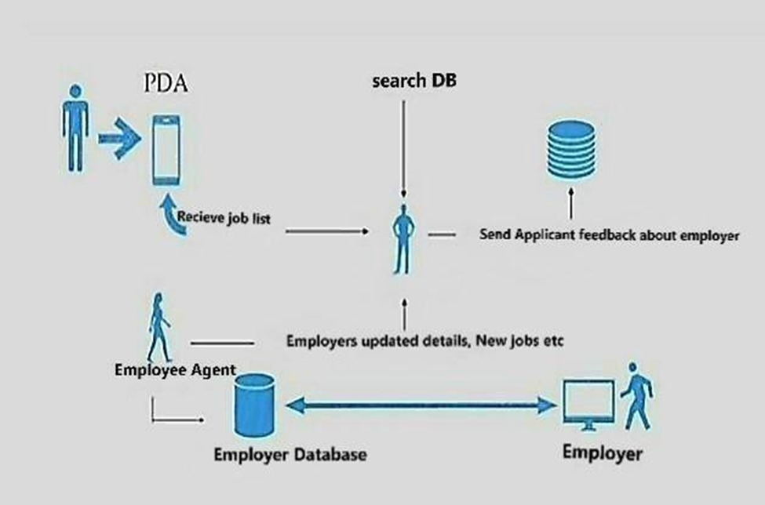

fig 9.1 architecture (from google)

**10. METHODOLOGY:**

**Resume Upload:** Users upload their resumes through a simple web or mobile interface.

**Resume Parsing:** The system extracts key information like skills, experience, and education using NLP.

**Job Matching:** Based on extracted data, a dynamic LinkedIn search URL is generated with relevant filters.

**Redirection:** Users are redirected to LinkedIn with real-time job listings matching their profile.

**Feedback Loop:** User interactions and feedback are stored temporarily to improve future recommendations while maintaining privacy.

**Notifications:** Users receive alerts for resume processing, errors, and successful job redirection.

**11. FLOWCHART:**

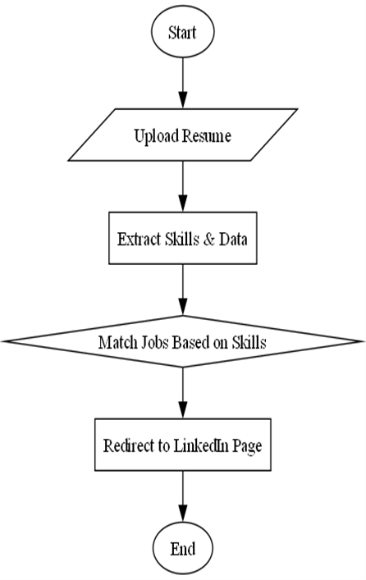

fig 11.1 flowchart (from google)

**12. ALGORITHMS:**

**Data Preprocessing**

Uses NLP, tokenization, and TF-IDF to clean and extract key data from resumes and job descriptions.

**Skill Extraction**

Extracts skills and qualifications using NER and maps them to a standard taxonomy.

**Job Matching**

Matches resumes with job postings using SVM, Random Forest, KNN, and Naive Bayes classifiers.

**Recommendation Engine**

Recommends jobs using Collaborative, Content-Based, and Hybrid Filtering approaches.

**LinkedIn Integration**

Fetches live job postings via Web Scraping and API Integration with LinkedIn**.**

**13. OUTPUT SCREENS:**



fig 13.1

Here first we need to upload our resume

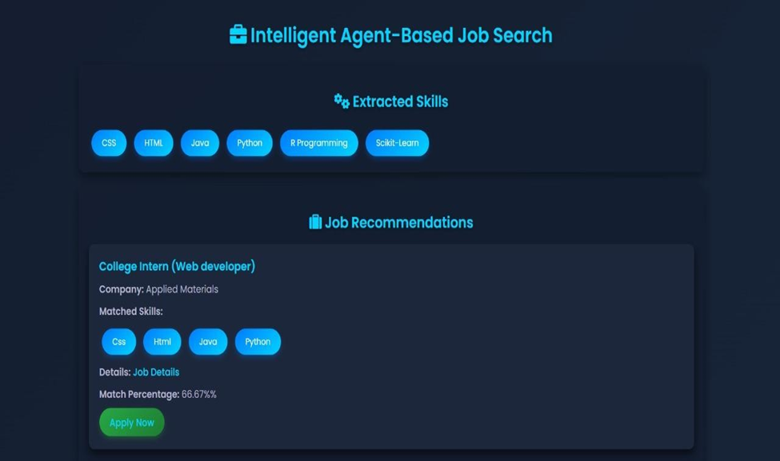

fig 13.2

then it will display all the matching jobs with the probability of getting the job to the user



fig 13.3

here we can apply for the job

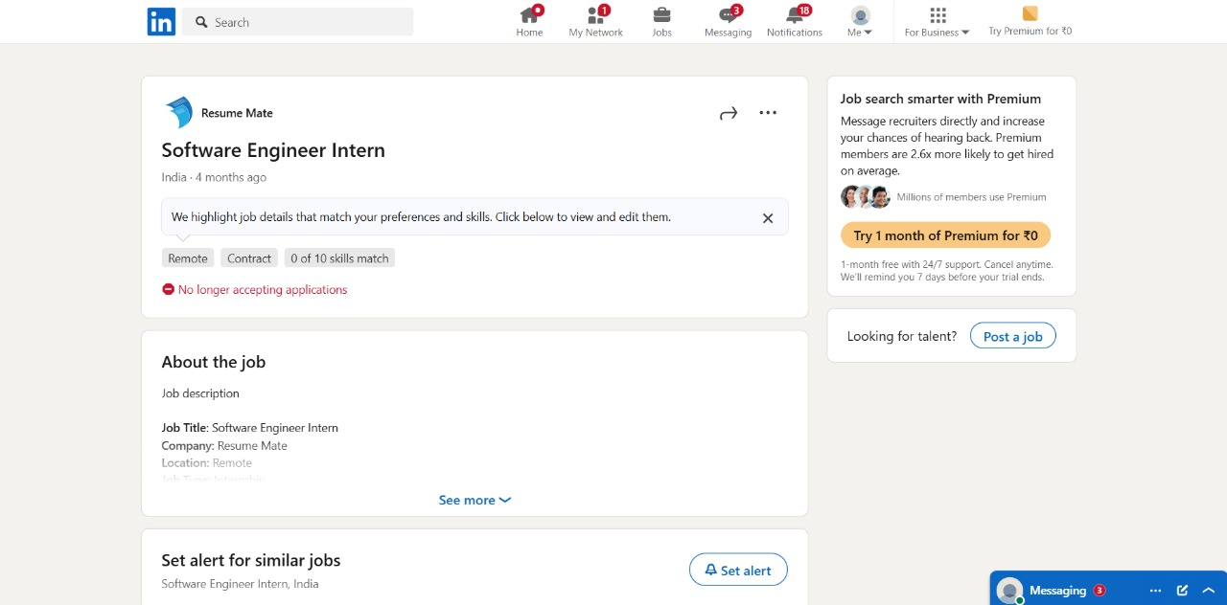

fig 13.4

after clicking apply button it will be redirected to the site where job is posted here it redirected to linkedin page.



fig 13.5

if the job is no more available then it will intimate us that the applications are closed for that specific job

**14. CONCLUSION.**

The Intelligent Agent-Based Job Searching System is an AI-driven platform that transforms job hunting by offering smart, personalized recommendations based on user skills, experience, and preferences. Unlike traditional keyword-based platforms, it uses machine learning and NLP to deeply analyze resumes and job listings for better matches. With features like real-time alerts, resume parsing, and scalable integration with job portals, it simplifies the search process for users while continuously learning and improving. Future upgrades include predictive insights, virtual career coaching, and secure blockchain-based verification, aiming to create a smarter, faster, and more inclusive job search experience.

**15. REFERENCES.**

<https://turcomat.org/index.php/turkbilmat/article/download/14128/10167/25175>

<https://www.ijesr.org/admin/uploads/Article%20%20pp%201658-1668_c.pdf>

Smart Job Recommender System Using AI and Machine Learning Techniques by N. Verma, A. Patel, and R. Kumar (2017)

<https://jespublication.com/uploads/2024-V15I9045.pdf>

Intelligent Agent-Based Systems for Employment Search by S.Yuvarani, S.Kalaivani,and V.Karthikeyan(2020).