AI Resume Builder

Uzzam Ansari#1, Ali Asgar#2 , Ahmed Raza Khan#3

,Maaviya Maktabay#4,Owais Mukri#5

*IT Department, 3rd Year*

*M.H. SABBOO SDDIK POLYTECHNIC*

*Mumbai , India*

[*reignscorp5@gmail.com*](mailto:reignscorp5@gmail.com)

[*aliasgardevjani@gmail.com*](mailto:aliasgardevjani@gmail.com)

[khan7323810@gmail.com](mailto:khan7323810@gmail.com)

[*maaviyakhateeb@gmail.com*](mailto:maaviyakhateeb@gmail.com)

[*owaishussain259@gmail.com*](mailto:owaishussain259@gmail.com)

***Abstract*— The AI Resume Builder is an intelligent web-based application designed to assist users in creating professional, tailored resumes with minimal effort. Leveraging Natural Language Processing (NLP) and machine learning algorithms, the system guides users through an intuitive interface, dynamically generating content suggestions and optimizing resume sections such as summaries, skills, experiences, and achievements. The tool ensures the final output adheres to industry standards and is customized for specific job roles or sectors. By automating the resume-building process, this AI-powered solution significantly enhances user efficiency, reduces errors, and increases the chances of job seekers securing interviews.**

***Keywords*— AI Resume Builder, Resume Optimization, Web Application, Smart Resume Assistant, Automated Resume Generation.**

1. FLOWCHART

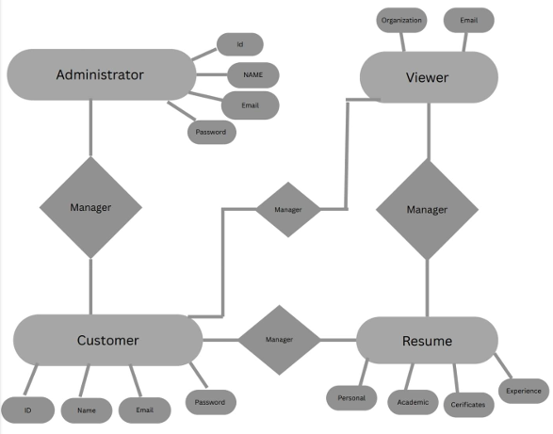

1. Introduction

An AI resume builder is a software application designed to simplify the process of creating a resume for individuals. The system leverages artificial intelligence to generate professional looking resumes efficiently. It offers an intuitive interface that helps users design resumes tailored to their qualifications and career goals without the hassle of manual formatting.

1. AI RESUME BUILDER APPLICATIONS

The following subsections discuss key applications of AI Resume Builder.

A. AI-Powered Resume Generation

B. Job Description Matching.

C. Grammar & Tone Enhancement

1. CHALLENGES AND FUTURE SCOPE

The future scope of an AI Resume Builder includes enhanced personalization with career path suggestions, advanced ATS optimization, and integration with job platforms for seamless applications. It could incorporate soft skills and personality insights, offer multilingual support for international resumes, and provide interview coaching. Future advancements may also include AI-driven design features for more customized resumes and the ability to suggest networking opportunities and referrals .

B. Model: Incremental Model

The incremental build model is a method of software development where the model is designed, implemented and tested incrementally (a little more is added each time) until the product is finished. It involves both development and maintenance. The product is defined as finished when it satisfies all its requirements. This model combines the elements of the waterfall model with the iterative philosophy of prototyping.

The product is decomposed into a number of components, each of which are designed and built separately (termed as builds). Each component is delivered to the client when it is complete. This allows partial utilization of product and avoids a long development time. It also creates a large initial capital outlay with the subsequent long wait avoided. This model of development also helps case the traumatic effect of introducing completely new system all at once

C. Model Implementation

As a systems analyst you need to be an expert in information technology (IT) solutions that are the best fit for the technical needs of your company or client. And to get the job in this field that's right for you, you need an excellent systems analyst resume. Systems analysts consult with users about their needs and stay on top of new technology products that could serve the company better. They write requirements and specifications for new systems and work with vendors and programmers to implement them. They also help to test new systems and train staff members in how to use them.

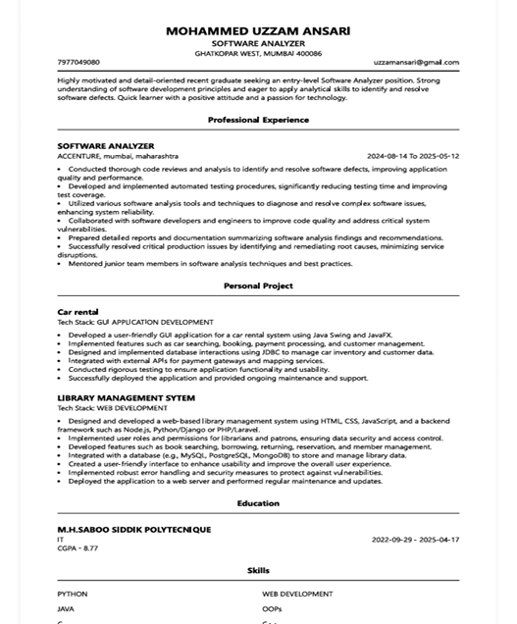

D. Figures

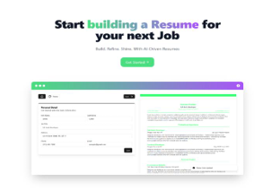

Fig 1. Example of AI Resume Builder (dashboard)

Fig 2. Example of Resume

1. *References*

Examples of reference items of different categories shown in the References section include:

example of a book:

[1] H. B. Aladi, "Automatic Resume Generator," Cloud-based Resume System, [Online].

[2] S. Biswas, "Stress-Free Resume Builder."

[3] S. Biswas, "Web Service for Online Resume Making."

[4] B. Kungwani, A. Manglani, N. Dembal, H. Hirani, and L. Sawlani, "Resume Manufacturer."

[5] FARIS Technology Institute, Ethiopia, "Resume/CV SystemSpam Detection."

[6] FARIS Technology Institute, "Resume Application."

[7] R. Gunkar, "Automated Resume Builder."

[8] A. Ayudhyay, "Geeks-for-Geeks Online Resume Builder."

[9] S. Biswas and M. Agar, "APP for CV Making."

1. Conclusions

In conclusion, the AI Resume Builder is a transformative tool that empowers job seekers to create optimized, professional resumes quickly and efficiently. By automating the process of formatting, keyword optimization, and tailoring resumes to specific roles or industries, it significantly reduces the time and effort traditionally required for resume creation. Its ability to enhance ATS compatibility, personalize content, and improve presentation ensures that resumes stand out both to automated systems and human recruiters.

Acknowledgment

This project titled “AI Resume Builder” is dedicated to

Revolutionizing the job application process by providing

an intelligent , efficient,and user friendly platform to help

individuals create optimized and professional resumes.

References

[1] H. B. Aladi, "Automatic Resume Generator," Cloud-based Resume System, [Online].

[2] S. Biswas, "Stress-Free Resume Builder."

[3] S. Biswas, "Web Service for Online Resume Making."

[4] B. Kungwani, A. Manglani, N. Dembal, H. Hirani, and L. Sawlani, "Resume Manufacturer."

[5] FARIS Technology Institute, Ethiopia, "Resume/CV SystemSpam Detection."

[6] FARIS Technology Institute, "Resume Application."

[7] R. Gunkar, "Automated Resume Builder."

[8] A. Ayudhyay, "Geeks-for-Geeks Online Resume Builder."

[9] S. Biswas and M. Agar, "APP for CV Making." Y. Gamil and A. A. Rahman, “IoT in Construction Projects,” International Journal of Construction Project Management, vol. 11, no. 2, pp. 103–123, 2019.

.

.