# Revolutionizing Healthcare web application

## Prof.Megha Garud*1 , Girish Thomare*2 , Saniket Bone*3,

## Pratik Kumkar*4, Karan Shelke*5

*1,2,3,4,5Computer Engineering, Zeal college of Polytechnic,

Pune, Maharashtra, India.

# ABSTRACT

The Revolutionizing Healthcare is a comprehensive software application developed to streamline and automate the operations of a hospital or medical facility. This project focuses on building an efficient, user-friendly, and secure system that manages critical hospital activities such as patient registration, appointment scheduling, doctor allocation, medical records maintenance, billing, and inventory control.

The main goal of the system is to reduce the complexity of manual processes and enhance the quality of healthcare services by leveraging digital solutions. It enables administrators, doctors, and staff to access and manage information quickly and accurately, ensuring improved decision-making and time management. The system also safeguards patient data through role-based access and secure storage.

# INTRODUCTION

In today’s fast-paced world, efficient management of healthcare services is essential to ensure high-quality patient care and smooth hospital operations. A Hospital Management System (HMS) plays a critical role in managing various aspects of hospital functioning including patient records, staff information, appointment scheduling, billing, and inventory management.

This project, titled **"Revolutionizing Healthcare"**, aims to develop a comprehensive software solution that simplifies and automates the day-to-day activities of a hospital. The system provides a user-friendly interface for both administrative staff and healthcare professionals, enabling seamless handling of patient information, doctor schedules, and medical reports. By digitizing and centralizing data, the system not only enhances operational efficiency but also ensures accuracy, security, and easy accessibility of medical records.

The primary objective of this project is to reduce manual workload, minimize errors, and offer a scalable solution that can adapt to different sizes and types of healthcare institutions. The system is designed with a focus on reliability, usability, and performance, making it a valuable tool for modern healthcare environments.

# LITERATURE REVIEW

## I In [1] Revolutionizing Healthcare: The Role of AI-Based Medical Expert Systems in Building a Better Future (IJRITCC, 2023):

**Authors:** Yash Wani, Vinay Gomashe, Shyam Kale, Varad Sardeshpande, Pratik Ugalmugale, Amruta Hingmire, Rushali A. Deshmukh

## Key Contributions:

• Developed an AI-based Medical Expert System that assists doctors in disease prediction and diagnosis.

• Integrated various machine learning algorithms including Multilayer Perceptron, CNN, SVM, and Fuzzy Classifiers for different diseases.

• Provides early detection support for diseases like heart disease, kidney issues, skin disorders, and diabetes.

## Limitations:

• Lacks real-time deployment in healthcare setups or mobile platforms.

• Data dependency: accuracy highly depends on training dataset quality.

**In [2] Revolutionizing Healthcare through Health Monitoring Applications with Wearable Biomedical Devices (IJRITCC, 2023):**

**Authors:** Sujata S. Alegavi, Bhushankumar Nemade, Vinayak Bharadi, Shiwani Gupta, Vidyadhari Singh, Archana Belge

## Key Contributions:

• Developed a wearable IoT-based health monitoring system using sensors (LM35, MAX30100, AD8232).

• Monitored real-time ECG, pulse rate, oxygen saturation, and temperature.

• Integrated with ESP32 and ThingSpeak cloud for remote data access and display via Android application.

## Limitations:

• Focus limited mainly to COVID-19 symptoms and basic vitals.

• Lacks advanced disease prediction or AI-based decision support.

• Minimal integration with hospital or professional medical systems.

## In [3] Design and Implementation of Online Advanced Hospital Management System Using Modern Technology (IJERT, 2019):

**Authors:** Rashmi Chaudhary

## Key Contributions:

• Developed a web-based hospital management system aimed at reducing paperwork and enhancing operational efficiency.

• Implemented modules for patient registration, appointment scheduling, staff management, and billing.

## Limitations:

• Does not incorporate advanced features like AI-driven diagnostics or predictive analytics.

• Limited scalability for larger hospital networks or multi-specialty institutions

# OBJECTIVE

1. **Streamline Patient Management**  
   To create a centralized system for managing patient data including personal information, medical history, current medications, insurance details, and emergency contacts.
2. **Efficient Appointment Scheduling**  
   To develop a scheduling system that allows hospital staff and patients to book, reschedule, or cancel appointments while automatically sending reminders and confirmations.
3. **Automate Medical Record Keeping**  
   To maintain accurate and secure medical records, including diagnoses, treatments, prescriptions, and lab results, ensuring easy access for healthcare providers.
4. **Optimize Billing and Payments**  
   To automate the billing process by generating invoices, tracking payment statuses, supporting various payment methods, and sending overdue reminders when necessary.
5. **Maintain Inventory Control**  
   To track hospital inventory including medicines, equipment, and supplies, ensuring sufficient stock levels and enabling timely reorders.
6. **Implement Process Automation**  
   To use flows, process builders, and validation rules to automate routine hospital operations like appointment reminders, billing updates, and follow-up scheduling.
7. **Enhance Reporting and Insights**  
   To generate detailed reports and dashboards that provide insights into patient visits, treatment outcomes, financial performance, and resource utilization.
8. **Improve User Experience with Lightning Components**  
   To develop custom Lightning Web Components and Visualforce pages for intuitive user interfaces, such as real-time dashboards, patient record viewers, and appointment booking systems.
9. **Support Real-Time Patient Engagement**  
   To integrate Einstein chatbots for providing instant assistance with FAQs, appointment bookings, billing queries, and navigation within hospital premises.

# PROPOSED SYSTEM

# 

(Figure 1: Proposed System Diagram)

The **Hospital Management System (HMS)** is designed to streamline and digitize the operations of a hospital by integrating various modules into a unified system. This system enhances the coordination between departments, ensures better patient care, and simplifies administrative processes.

**🧩 Key Components of the Proposed System**

1. **Reception/Registration Module**
   * Patients are registered by reception staff.
   * Patient details such as name, age, gender, and contact information are recorded.
   * Generates a unique patient ID for tracking.
2. **Appointment Management**
   * Patients can book appointments.
   * Reception confirms appointments based on doctor availability.
   * Appointment records are stored in the system.
3. **Consultation Module**
   * Doctors consult with patients based on appointments.
   * Diagnosis and prescriptions are recorded.
   * Medical records are updated after each consultation.
4. **Medical Records Management**
   * Centralized repository for all patient history and treatment details.
   * Doctors can review past records for better decision-making.
5. **Billing & Insurance**
   * Automated billing is generated post consultation.
   * Insurance status is verified and updated.
   * Payments are recorded (Cash/Card/Online).
6. **Feedback System**
   * After service, patients can provide feedback.
   * Ratings and comments help evaluate service quality.

**✅ Benefits of the Proposed System**

* 🔄 **Efficient Workflow** – Automates hospital operations from patient registration to billing.
* 💾 **Data Management** – All data is stored digitally for quick access and analysis.
* 🧑‍⚕️ **Improved Patient Care** – Doctors have access to complete medical history.
* 💰 **Transparent Billing** – Accurate billing reduces discrepancies.
* 📈 **Decision Support** – Admin can generate reports for better hospital management.

# FLOW CHART

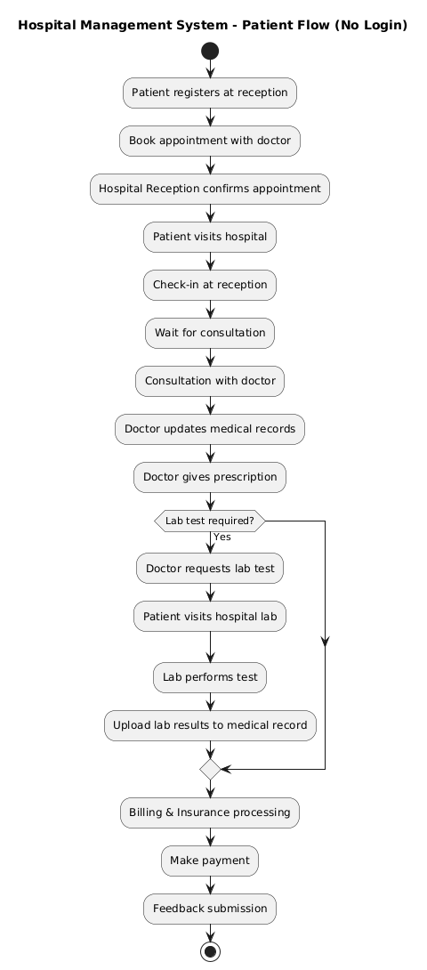

(Figure 2: Flow Chart Diagram)

# FEATURES AND WORKING

1. 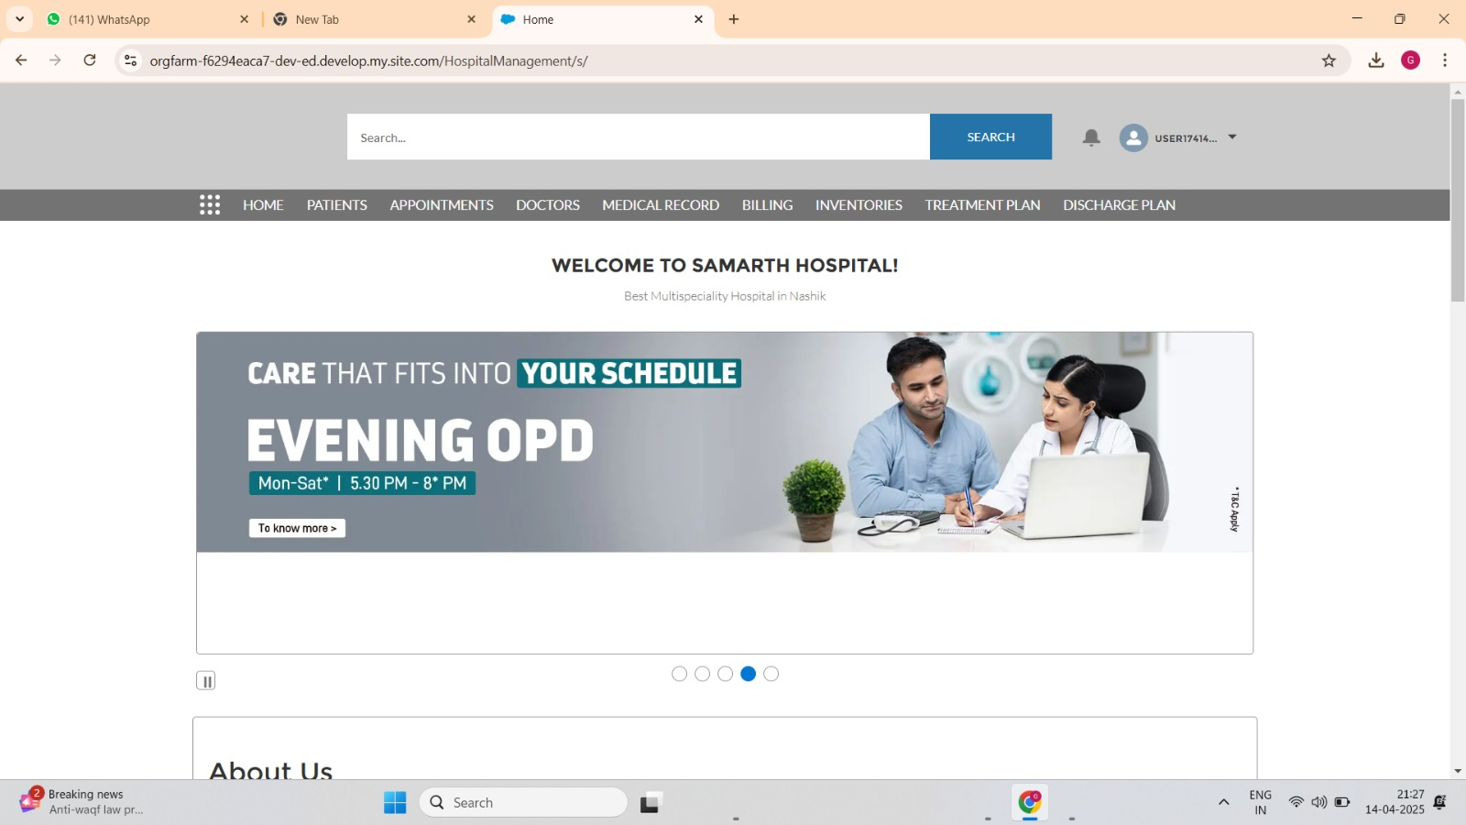The homepage of the Hospital Management System (HMS) web application serves as a centralized gateway for all stakeholders—patients, doctors, and hospital staff. It is designed with a user-friendly interface and intuitive navigation, enabling seamless access to various modules such as Patients, Appointments, Doctors, Medical Records, Billing, Inventories, Treatment Plan, and Discharge Plan.
2. The “Patient History” interface of the Hospital Management System (HMS) provides a consolidated and searchable list of all registered patients within the system. This module is designed to facilitate quick access to patient profiles and streamline administrative operations for healthcare providers.

Each entry in the list displays a unique Patient ID (e.g., PT-0001, PT-0007), which allows for precise identification and retrieval of patient records.

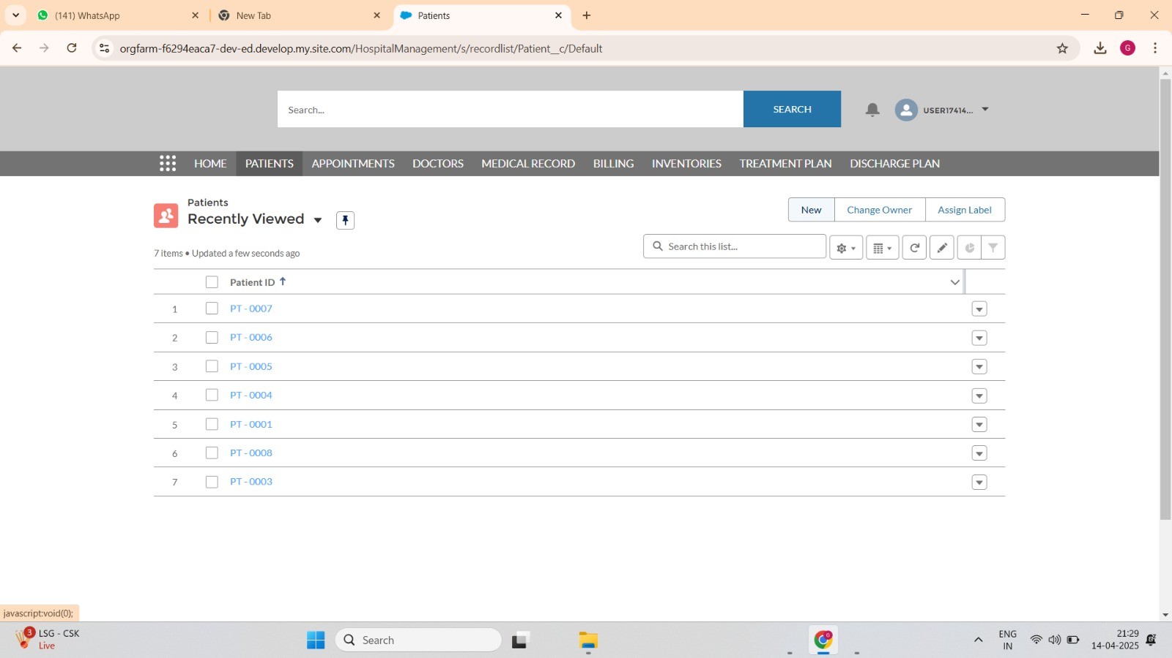

1. The “Patient Details” interface within the Hospital Management System (HMS) provides a structured and comprehensive view of individual patient profiles. Built on the Salesforce platform, this module ensures that all essential patient information is easily accessible and editable by authorized hospital staff.

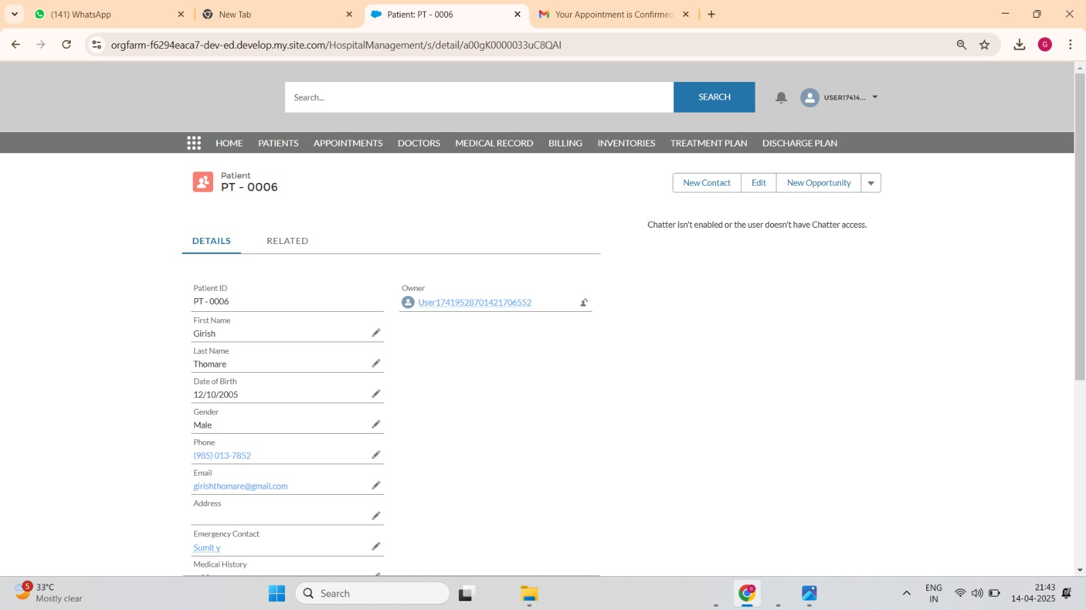

# The "New Appointment: Consultation" screen allows hospital staff to schedule a consultation for a patient. Users can search and select a patient, choose the date and time, set the appointment type, and update the status. The appointment is assigned to a senior doctor, and there are options to save or create another appointment easily.

# 

# This is the doctor dashboard which holds the doctor's information. It displays details such as Doctor ID, name, specialization, availability status, years of experience, and consultation fee. The dashboard also shows who created and last modified the record, which in this case is the Senior Doctor.

# 

# This is an appointment confirmation email that is automatically sent to the patient after the doctor confirms the appointment. It informs the patient about the successful scheduling of their consultation and provides the appointment date and time.

# 

# The appointment dashboard serves as a centralized platform for managing and viewing appointment information within the hospital system. It includes essential details such as appointment ID, patient reference, scheduled date and time, type of appointment, status, and the assigned doctor. Once an appointment is confirmed, it reflects accordingly in the system. This setup ensures streamlined scheduling, tracking, and communication between doctors and patients.

# The billing section in the hospital management system provides a streamlined interface to manage patient invoices. It includes key information such as the invoice ID, patient reference, associated appointment, billing date, total amount, payment status, and payment method. This section ensures accurate tracking of medical charges and facilitates efficient financial operations between the hospital and the patient.

# FUTURE SCOPE

The Hospital Management System (HMS) implemented in Salesforce lays a solid foundation for digital transformation in healthcare institutions. While the current system covers essential modules, several enhancements and expansions can be made in the future to further elevate its capabilities:

1. 🔗 Integration with Wearable and IoT Devices  
   The system can be enhanced to integrate with wearable health trackers and medical IoT devices, enabling real-time monitoring of patient vitals and automatic data logging into patient records.
2. 🤖 Advanced AI for Clinical Decision Support  
   Future iterations could incorporate AI/ML models to assist doctors in diagnosing illnesses, predicting patient readmission risks, and suggesting personalized treatment plans.
3. 📱 Mobile Application Development  
   A dedicated mobile app for both Android and iOS can be developed to allow patients to book appointments, view test results, communicate with doctors, and receive alerts and reminders on the go.
4. 🌐 Telemedicine Integration  
   Expand the platform to support video consultations, virtual waiting rooms, and e-prescriptions—especially useful for remote or rural patients.
5. 🧾 Insurance and Claims Automation  
   Incorporating insurance provider integrations can automate claims processing, eligibility checks, and coverage validations, reducing manual workload and errors.

# CONCLUSION

The Hospital Management System developed on the Salesforce platform successfully achieves its goal of streamlining and automating key hospital operations. By integrating core functionalities such as patient registration, appointment scheduling, billing, inventory management, and medical record handling, the system enhances both administrative efficiency and patient care quality.With the use of Salesforce tools like Flows, Validation Rules, Dashboards, Lightning Web Components (LWC), and automation features, the project not only simplifies complex hospital workflows but also ensures data accuracy, accessibility, and security. The inclusion of Einstein AI chatbots for patient engagement and dynamic dashboards for real-time insights reflects a forward-thinking approach in modern healthcare management.Overall, this system provides a scalable and customizable foundation for hospitals aiming to embrace digital transformation. As the healthcare industry evolves, the HMS can be further expanded with advanced technologies like AI-driven diagnostics, IoT integration, and mobile accessibility, making it a future-ready solution that adapts to the growing needs of both patients and healthcare providers.

# REFERENCES

1] Mr.Yash Wani1, Mr. Vinay Gomashe2, Mr. Shyam Kale3, Mr. Varad Sardeshpande4, Mr. Pratik Ugalmugale5, Mrs. Amruta Hingmire6, Mrs. Rushali A. Deshmukh7 , Revolutionizing Healthcare: The Role of AI-Based Medical Expert Systems in Building a Better Future ,Volume: 11 Issue: 9,22 September 2023

2] Sujata S. Alegavi1, Bhushankumar Nemade2, Vinayak Bharadi3, Shiwani Gupta4, Vidyadhari Singh5, Archana Belge6 , Revolutionizing Healthcare through Health Monitoring Applications with Wearable Biomedical Device.Volume: 11 Issue: 9s, 14 August 2023.

3] Rashmi Chaudhary1 , Design and implementation of online advanced hospital management system using modern technology , International Journal of Engineering Research & Technology (IJERT) ,Vol. 8 Issue 07, July-2019.