**"Pharmacological Approach to Lower Limb Superficial Varicosities with Bleeding and Skin Changes: A Case Report from South India"**

**SUHANA ANJUM1, M.NIHARIKA2 , A.AKHILA3, D.ABHINAYA4 CH.PRANAVI5 , G.VYSHNAVI6,**

**D.SHRAVAN KUMAR7**

**DEPARTMENT OF PHARMACY, VAAGESWARI COLLEGE OF PHARMACY, BESIDE LMD POLICE STATION, THIMMAPUR, KARIMNAGAR, TELANGANA.INDIA-505001**

**ABSTRACT**

**Background:** Varicose veins are a common venous disorder characterized by dilated, tortuous superficial veins, most commonly in the lower limbs due to chronic venous insufficiency. They frequently occur in individuals involved in prolonged standing or physical strain.

**Case Presentation**: A 35-year-old male presented with complaints of multiple tortuous swellings over the right leg, gradually progressing over the past year and associated with pain on walking. Clinical examination and Doppler imaging confirmed superficial varicosities and subcutaneous edema.

**Management**: Conservative pharmacological treatment with anti-inflammatory agents, antibiotics, antioxidants, proteolytic enzymes, and gastric protection was instituted. The patient showed symptomatic improvement.

**Conclusion**: Early detection and conservative treatment of varicose veins can effectively relieve symptoms and prevent progression. Doppler imaging remains the cornerstone in diagnosis. Patient education and lifestyle modification are essential adjuncts.

**Keywords:**

Varicose veins, superficial venous insufficiency, conservative treatment, Doppler ultrasound, lower limb venous disorder.

**INTRODUCTION**

Varicose veins are dilated, tortuous, subcutaneous veins, commonly occurring in the lower extremities, resulting from chronic venous insufficiency (CVI) due to valvular incompetence within the superficial venous system. They represent one of the most prevalent chronic vascular disorders globally, with an estimated prevalence ranging from 10–30% in adults, more common in women, though also significantly observed in men with occupational and lifestyle risk factors. The World Health Organization (WHO) classifies varicose veins as a form of peripheral venous disease, contributing substantially to morbidity and healthcare burden in both developed and developing nations. The pathophysiology of varicose veins primarily involves failure of venous valves, which are responsible for maintaining unidirectional blood flow from the peripheral to the central venous system against gravity. Incompetent valves lead to venous reflux, increased venous pressure, and subsequent venous wall dilatation. Over time, this results in venous hypertension, stasis, endothelial dysfunction, and tissue hypoxia, leading to a cascade of clinical manifestations. Patients often present with visible varicosities, heaviness in the legs, aching pain after prolonged standing, night cramps, skin changes such as hyperpigmentation or eczema, and in advanced stages, venous ulcers and spontaneous bleeding from superficial veins.

While the disease predominantly affects older individuals and women, there is a rising trend of younger men presenting with symptomatic varicosities, especially in urban settings, where occupational and lifestyle patterns involve prolonged standing, sedentary habits, and poor ergonomics. In this context, male patients in the 3rd or 4th decade of life, such as the one presented in this report, are increasingly being diagnosed with early-stage or moderate CVI, emphasizing the need for awareness and timely intervention. Doppler ultrasonography is the gold standard diagnostic modality for evaluating the venous system in suspected varicose veins. It enables visualization of the venous anatomy, valve competency, and the presence of any thrombotic occlusion.

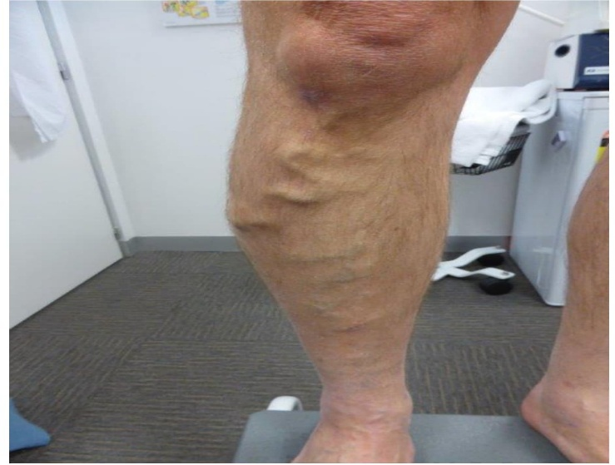

**Fig 1: depicts the varicose veins in lower extremities**

It also helps in distinguishing between superficial and deep venous involvement, guiding appropriate treatment strategies. Conservative treatment options include limb elevation, use of compression stockings, pharmacotherapy involving anti-inflammatory agents, vasoactive drugs, enzyme therapy, antioxidants, and patient counselling. In cases refractory to medical treatment or presenting with complications such as ulceration, sclerotherapy, radiofrequency ablation, or venous stripping surgery may be indicated.

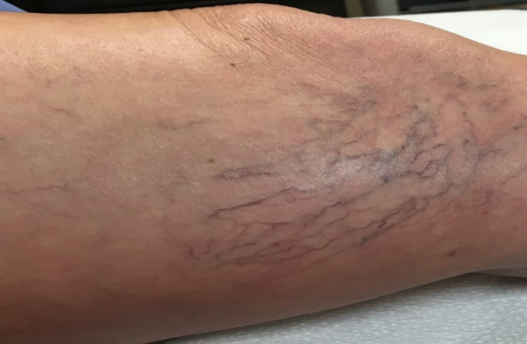

**Fig 2: shows the spider veins**

The current case report discusses the clinical evaluation and conservative medical management of a 35-year-old male presenting with symptomatic right lower limb varicose veins associated with bleeding and skin changes. The case underscores the importance of early Doppler screening, non-surgical therapeutic interventions, and lifestyle modifications. It also highlights the growing incidence of venous disorders in younger men exposed to occupational risk factors and the role of pharmacological agents including anti-inflammatory medications, proteolytic enzymes, and micronutrient support in symptom resolution and venous health restoration**.**

**CASE REPRESENTATION**

A 35-year-old male was admitted to the medicine department with complaints of multiple tortuous swellings over the right leg, progressively increasing over the last year. He reported pain on walking, skin discoloration, and a history of bleeding from the affected site approximately 15 days before admission. The patient also had a history of prolonged standing due to his occupation and admitted to amber chewing for the past year. Clinical Findings: Local Examination: Visible dilated, tortuous superficial veins on the medial and anterior aspect of the right leg, associated with mild subcutaneous edema and hyperpigmentation of the overlying skin. No active ulcers or visible variceal bleeding at the time of presentation. Peripheral pulses were palpable, and no signs of deep vein thrombosis (DVT) were noted. Investigations: Test Findings 2D Color Doppler Superficial varicosities with subcutaneous edema (right leg - medial and anterior aspect) ECG Normal sinus rhythm Complete blood count Within normal limits Renal & Liver Function Tests Normal Coagulation profile Normal Diagnosis: Right Lower Limb Varicose Veins

**Pharmacological Management: Drug Dosage & Route Purpose**

1] Ibuprofen + Paracetamol 500 mg, Oral, SOS Analgesic and anti-inflammatory Lycopene , Once daily Antioxidant support

2]3Cefixime (Injection) 1.5 g, IV , Twice daily Prophylactic antibiotic

3]Pantoprazole (Injection) 40 mg, IV, Twice daily Proton pump inhibitor for gastric protection 4] Ondansetron 4 mg, IV, Twice daily Antiemetic to prevent nausea

5]Trypsin + Chymotrypsin Oral, Thrice daily Proteolytic enzymes for anti-inflammatory effect 6] Ascorbic Acid Oral, Once daily Promotes collagen synthesis and vascular healing

**DISCUSSION**

Varicose veins, a hallmark of chronic venous disease (CVD), represent a progressive pathology that evolves from valvular incompetence in the superficial venous system, predominantly affecting the lower limbs. The presented case highlights an early to moderate manifestation in a relatively young male patient—aged 35 years—which is a noteworthy finding, as the majority of clinical studies report higher prevalence in middle-aged or elderly individuals, with peak incidence after the age of 50.

However, occupational exposure to risk factors such as prolonged standing has been increasingly recognized in the pathogenesis of varicose veins among younger individuals, as supported by epidemiological data from Beebe-Dimmer et al., who reported that more than 25% of early-onset varicose veins were linked to occupational hazards. In our patient, the clinical features—the gradual onset of multiple tortuous swellings over the medial and anterior aspects of the right leg, pain on ambulation, and recent history of bleeding—correspond with the CEAP (Clinical, Etiologic, Anatomic, Pathophysiologic) classification stages C2 to C4. The hyperpigmentation and subcutaneous edema without ulceration further indicate progression toward venous stasis dermatitis, a precursor to chronic venous ulceration. A positive history of amber chewing may not directly contribute to varicose vein pathogenesis but reflects poor health-seeking behavior and possible nutritional deficits which could influence vascular integrity. Color Doppler ultrasonography remains the diagnostic gold standard in evaluating the venous system for varicosities. The detection of superficial varicosities with mild subcutaneous edema confirms valvular incompetence in the great saphenous vein distribution. No evidence of deep vein thrombosis was found. This is clinically significant, as co-existing DVT would alter both prognosis and management. According to Labropoulos et al., more than 60% of symptomatic varicose vein cases show reflux in the superficial venous system alone, which was consistent with our patient's findings. Pharmacological therapy was the first line of management due to the absence of complications such as ulcers or thrombosis.

The combination of Ibuprofen + Paracetamol was prescribed for symptomatic pain and inflammation. NSAIDs are known to relieve superficial thrombophlebitis and local inflammation associated with venous hypertension. Trypsin-chymotrypsin, a proteolytic enzyme complex, has shown clinical benefit in reducing soft tissue edema and modulating inflammatory cytokines, as supported by a clinical study by Chakraborty et al. Cefixime, a third-generation cephalosporin, was administered intravenously for presumptive control of local infection, particularly considering the recent bleeding episode and the high risk of bacterial translocation through compromised skin barriers. While routine use of antibiotics in varicose veins is debated, targeted prophylaxis is justified in cases with prior bleeding or excoriation.

The use of Lycopene, an antioxidant carotenoid, along with Ascorbic Acid (Vitamin C), addresses oxidative stress, and endothelial dysfunction, and enhances collagen synthesis, which plays a crucial role in venous wall strength and tissue healing. A randomized trial by El-Sayed et al. demonstrated that oxidative stress markers were significantly elevated in varicose vein patients and that antioxidant supplementation contributed to symptomatic improvement. Pantoprazole and Ondansetron were administered as supportive therapy to prevent gastrointestinal irritation and nausea, common with NSAID use and antibiotic therapy respectively. Their use is by standard supportive care protocols in polypharmacy cases. Though compression therapy and surgical interventions like ligation, stripping, or endovenous ablation remain definitive in advanced or refractory cases, conservative pharmacological management is often effective in early to moderate stages. A multicentric trial conducted by Nicolaides et al. highlighted that more than 70% of patients in CEAP C2–C3 stage managed with medical therapy and compression had clinical improvement without progression to ulceration. Additionally, the patient was advised leg elevation, avoidance of prolonged standing, and consideration for compression stockings—measures well documented to improve venous return and alleviate symptoms. Long-term follow-up is essential to assess the need for sclerotherapy or ablation if symptoms persist or progress. In this case, the timely use of non-invasive diagnostics, conservative pharmacologic regimen, and patient counseling ensured adequate symptomatic control, demonstrating that individualized non-surgical approaches can be effective in early-stage varicose vein disease.

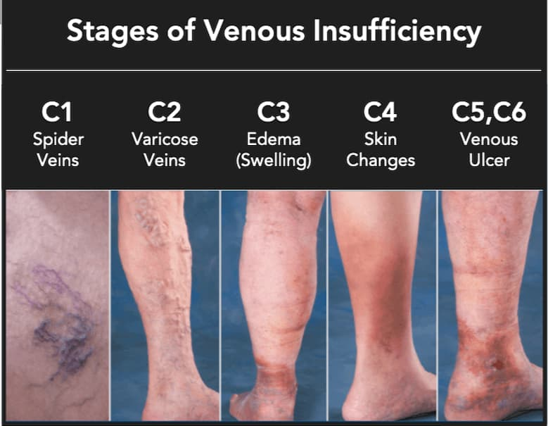

**Fig 3: Stages of venous insufficiency**

**CONCLUSION**

This case report underscores the significance of early recognition and intervention in managing varicose veins, even in younger male patients, which is relatively less common in routine clinical practice. Although traditionally regarded as a disease predominantly affecting older individuals and women, this case reflects the shifting epidemiological trend, where occupational risk factors, particularly prolonged standing, play a pivotal role in pathogenesis, irrespective of age or gender. The clinical presentation of progressive tortuous swellings, localized pain, recent bleeding, and skin discoloration represented an evolving chronic venous disease spectrum within the CEAP C2–C4 stage. The timely use of 2D Color Doppler proved essential in confirming the diagnosis by delineating the superficial venous reflux and ruling out deeper venous involvement. This case reinforces the role of non-invasive vascular imaging as the gold standard in both diagnostic confirmation and therapeutic planning. Importantly, there were no signs of thrombosis, ulceration, or systemic abnormalities, making the patient an ideal candidate for conservative management. The pharmacological strategy employed—comprising anti-inflammatory agents (Ibuprofen + Paracetamol), proteolytic enzymes (Trypsin-Chymotrypsin), antibiotics (Cefixime), antioxidants (Lycopene, Vitamin C), and supportive medications (Pantoprazole and Ondansetron)—was scientifically grounded, symptom-targeted, and well tolerated. The inclusion of enzyme therapy and antioxidants reflects a modern therapeutic approach aimed not only at symptomatic relief but also at enhancing vascular healing and reducing oxidative stress, which is increasingly recognized in chronic venous pathophysiology. In the absence of complications necessitating surgical intervention, conservative pharmacological therapy remains an effective and practical strategy for early to moderate varicose veins, especially in resource-limited settings or in patients unwilling or unfit for invasive procedures. Furthermore, lifestyle advice regarding leg elevation, reduced standing time, use of compression stockings, and regular follow-up formed the cornerstone of long-term management and relapse prevention. In conclusion, this case exemplifies how early diagnosis, appropriate use of Doppler ultrasonography, tailored pharmacological management, and structured patient education can together prevent the progression of varicose veins to more severe forms of chronic venous insufficiency. It highlights the importance of viewing varicose veins as a clinical continuum requiring multidisciplinary and staged management rather than merely a cosmetic concern. The success of this conservative approach further reaffirms that evidence-based, individualized non-surgical therapy can provide significant clinical benefits when initiated at the appropriate stage.

**REFERENCES**

1] Robertson L, Evans CJ, Fowkes FG. Epidemiology of chronic venous disease. Phlebology. 2008,23(3):103–111. Raju S, Neglén P. Chronic venous insufficiency and varicose veins.

2]3N Engl J Med. 2009,360(22):2319–27. Beebe-Dimmer JL, Pfeifer JR, Engle JS, Schottenfeld D.

3]The epidemiology of chronic venous insufficiency and varicose veins. Ann Epidemiol. 2005,15(3):175–84. Labropoulos N, Giannoukas AD.

4]Duplex evaluation of venous insufficiency. Semin Vasc Surg. 2005,18(1):5–9. Eberhardt RT, Raffetto JD. Chronic venous insufficiency. Circulation. 2014,130(4):333–46. Gloviczki P, Comerota AJ, Dalsing MC, et al.

5]The care of patients with varicose veins and associated chronic venous diseases: clinical practice guidelines. J Vasc Surg. 2011,53(5 Suppl):2S–48S.

6]Nicolaides AN. Investigation of chronic venous insufficiency: a consensus statement. Circulation. 2000,102(20):E126–63. Bergan JJ, Schmid-Schönbein GW, Smith PD, et al.

7]Chronic venous disease. N Engl J Med. 2006,355(5):488–98. Chakraborty S, Mazumdar A, Barma J, Pal D.

8]Therapeutic role of proteolytic enzymes in chronic venous disorders. Int J Surg. 2015,13:45–49. El-Sayed HF, Nasr FA, Khalil FA.

9]Oxidative stress and antioxidant status in patients with chronic venous insufficiency. J Vasc Surg. 2016,64(3):664–9.