ENHANCING URBAN PARKING EFFICIENCY THROUGH MACHINE LEARNING

|  |  |  |
| --- | --- | --- |
| Sreeja S  *B.Tech*  *School of Computing Science &*  *Engineering -AIML*  Mallareddy University, India  2111cs020541@  mallareddyuniversity.ac.in  Sreeja R  *B.Tech*  *School of Computing Science &*  *Engineering - AIML*  Mallareddy university, India  2111cs020544@  mallareddyuniversity.ac.in | Sreeja B  *B.Tech*  *School of Computing Science &*  *Engineering - AIML*  Mallareddy university, India  2111cs020542@  mallareddyuniversity.ac.in  Sreeja U  *B.Tech*  *School of Computing Science &*  *Engineering - AIML*  Mallareddy university, India  2111cs020545@  mallareddyuniversity.ac.in | Sreeja B  *B.Tech*  *School of Computing Science &*  *Engineering - AIML*  Mallareddy university, India  2111cs020543@  mallareddyuniversity.ac.in  Guide: Dr. G. Gifta Jerith  DEAN-AIML  *School of Computing Science &*  *Engineering* – AIML  Mallareddy university, India  ggiftajerith@gmail.com |

***Abstract*:** Urban parking inefficiencies pose significant challenges in modern cities, contributing to traffic congestion, increased fuel consumption, and environmental degradation. This research paper presents a novel Smart Parking Prediction System designed to enhance urban parking efficiency through the application of machine learning techniques. The proposed system leverages historical parking data, real-time occupancy information, and advanced predictive models to forecast parking availability, enabling drivers to locate vacant spaces swiftly and reducing search times. By integrating technologies such as Django for web application development, OpenCV for computer vision-based parking space detection, and machine learning algorithms including Random Forest, Support Vector Machines (SVM), and Convolutional Neural Networks (CNNs), the system processes video feeds and data inputs to deliver real-time updates via a user-friendly interface. Additionally, dynamic pricing mechanisms and automated enforcement features are incorporated to optimize parking resource utilization and ensure compliance.The project demonstrates significant improvements in parking management by minimizing congestion, lowering carbon emissions, and enhancing the overall urban mobility experience. Evaluated through a modular architecture, the system showcases scalability and adaptability, offering a data-driven solution for sustainable urban planning. This research highlights the potential of machine learning in transforming traditional parking systems into intelligent, efficient frameworks, paving the way for smarter cities.

***Keywords:- Urban Parking Efficiency, Machine Learning, Smart Parking Prediction System, Real-Time Parking Availability, Django, OpenCV, Random Forest, Support Vector Machines (SVM), Convolutional Neural Networks (CNNs), Dynamic Pricing, Traffic Congestion Reduction, Urban Mobility, Sustainable City Planning***

**I.INTRODUCTION**

The rapid urbanization witnessed in recent decades has significantly amplified the complexities of urban

transportation systems, with parking management emerging as a critical challenge in metropolitan areas worldwide. As vehicle ownership continues to rise—projected to exceed 2 billion globally by 2035 (International Energy Agency, 2022)—cities grapple with limited parking infrastructure, inefficient resource allocation, and escalating traffic congestion. Studies indicate that up to 30% of urban traffic is attributable to drivers searching for parking spaces (Shoup, 2005), a process that not only wastes time and fuel but also exacerbates air pollution and carbon emissions. Traditional parking systems, reliant on manual oversight, static pricing, and outdated signage, are ill-equipped to address the dynamic demands of modern urban environments. These inefficiencies result in underutilized parking spaces in some areas, overcrowding in others, and a frustrating experience for drivers, underscoring the urgent need for innovative, technology-driven solutions.

In response to these challenges, this research introduces a Smart Parking Prediction System aimed at enhancing urban parking efficiency through the integration of machine learning (ML) technologies. The proposed system leverages advanced predictive analytics, real-time data processing, and computer vision to transform how parking spaces are monitored, allocated, and utilized in urban settings. By analyzing historical parking patterns alongside live occupancy data, the system forecasts parking availability with high accuracy, enabling drivers to locate vacant spots quickly and efficiently. This predictive capability is complemented by a robust technological framework that includes Django for developing a scalable web application, OpenCV for real-time parking space detection via video feeds, and a suite of machine learning algorithms—such as Random Forest, Support Vector Machines (SVM), and Convolutional Neural Networks (CNNs)—to process complex datasets and deliver actionable insights. Beyond prediction, the system incorporates dynamic pricing strategies to balance parking demand and supply, alongside automated enforcement mechanisms to ensure compliance, making it a comprehensive solution for urban parking management.

The significance of this project lies in its potential to address multiple dimensions of the urban parking crisis. By reducing the time drivers spend searching for parking, the system directly mitigates traffic congestion, a major contributor to urban gridlock. This reduction in vehicle circulation also translates to lower fuel consumption and greenhouse gas emissions, aligning with global sustainability goals and enhancing the environmental quality of cities. Furthermore, the real-time updates and user-friendly interface—accessible via web and mobile platforms—improve the driver experience, while the data-driven insights generated by the system empower city planners to optimize parking infrastructure and inform long-term urban mobility strategies. Unlike traditional systems that operate reactively, this ML-based approach is proactive, adapting to fluctuating demand patterns and providing a scalable framework that can be implemented across diverse urban contexts.

# **II.LITERATURE REVIEW**

* **Enhancing Smart Parking Management through Machine Learning and AI Integration in IoT Environments:**  
   This study proposes an advanced parking management system integrating IoT, machine learning (ML), and artificial intelligence (AI) to optimize urban parking efficiency in cities like Barcelona, Amsterdam, and Singapore. The authors utilize computer vision, GPS data, and wireless sensor networks (WSNs) alongside ML models such as Random Forest Regressor, Multi-Layer Perceptron (MLP), and Ridge Regression for predictive analysis of parking availability. Big data analytics and cloud computing ensure scalability. While the system improves real-time predictions, it faces challenges in large-scale data handling and adapting to diverse urban infrastructures, highlighting the need for robust processing capabilities.
* **Real-Time Parking System Using Machine Learning:**  
   This paper presents a real-time smart parking system leveraging machine learning and cloud computing, developed as a web application using HTML, CSS, JavaScript, C#, .NET Core, and OpenCV, without relying on IoT sensors. It achieves 94% accuracy in predicting parking availability and 88% in detecting unauthorized parking through deep learning models like Haar cascades, YOLO, and SSD. The system uses computer vision for slot prediction and offers a user-friendly interface. However, it struggles with scalability and large-scale real-time data processing, with future improvements aimed at optimizing data pipelines and model adaptability.
* **Enhancing Urban Parking Efficiency Through Machine Learning Model Integration:**  
   This paper proposes a data-driven approach to enhance urban parking efficiency by evaluating machine learning models including Random Forest, Decision Tree, Linear Regression, and Support Vector Regression (SVR) for forecasting parking demand. Random Forest outperforms other models in predicting occupancy and explaining demand variations influenced by factors like day, seasonality, and time. The study emphasizes shifting from traditional methods to ML-based solutions but notes the need for further research to adapt these models to diverse urban contexts, reinforcing Random Forest’s efficacy in parking management.
* **Smart Parking: Enhancing Urban Mobility with Fog Computing and Machine Learning-Based ParkingOccupancyPrediction:**  
   This study introduces a smart parking system combining fog computing and machine learning, specifically the AdaBoost algorithm, to predict parking occupancy in real-time. The fog computing architecture reduces latency compared to cloud-based systems, while historical data powers accurate predictions delivered via a mobile app. The approach enhances urban mobility but is limited by its dependence on data quality and the high infrastructure costs of fog computing, posing challenges for widespread urban deployment.
* **Machine Learning-Based Prediction of Parking Space Availability in IoT-Enabled Smart Parking ManagementSystems:**  
   This paper proposes a smart parking management system integrating IoT sensors (ultrasonic, infrared, magnetic) with machine learning models such as Random Forest (RF), K-Nearest Neighbors (KNN), Support Vector Machines (SVM), Decision Tree (DT), Logistic Regression (LR), and Naïve Bayes (NB) to predict parking availability. Random Forest demonstrates superior accuracy after preprocessing techniques like feature selection and normalization. While effective, the system’s performance relies on sensor reliability, with scalability challenges in complex urban environments due to maintenance and calibration needs.

# **III. PROBLEM STATEMENT**

Urban areas worldwide are grappling with escalating parking inefficiencies driven by rapid urbanization, rising vehicle ownership, and limited parking infrastructure. Studies estimate that up to 30% of urban traffic congestion results from drivers searching for available parking spaces (Shoup, 2005), leading to significant time delays, increased fuel consumption, and elevated greenhouse gas emissions. Traditional parking systems, reliant on manual oversight, static pricing models, and outdated signage, fail to provide real-time availability data or predictive insights, resulting in underutilized spaces in some zones and overcrowding in others. This inefficiency not only frustrates drivers but also hampers urban mobility, contributes to environmental degradation, and strains city resources due to poor space allocation and lack of dynamic management.

The absence of intelligent, adaptive solutions exacerbates these issues, as current systems lack the capability to forecast parking demand, optimize resource distribution, or integrate with broader urban traffic frameworks. Additionally, static pricing fails to balance supply and demand, while manual enforcement is prone to errors and delays, further complicating parking management. There is a critical need for a scalable, technology-driven system that leverages machine learning to predict parking availability, detect vacant spaces in real-time, and implement dynamic pricing and automated enforcement. This project aims to address these challenges by developing a Smart Parking Prediction System that reduces search times, mitigates congestion, lowers emissions, and enhances urban parking efficiency, thereby contributing to smarter, more sustainable cities.

**IV. METHODOLOGY**

**4.1 Existing System:**

Urban parking systems in most cities rely on outdated methodologies characterized by manual management, static infrastructure, and fixed-rate pricing, struggling to accommodate the surging vehicle population. Traditional setups depend heavily on human intervention, with attendants overseeing parking lots, issuing tickets, and enforcing rules, as seen in many metropolitan areas. This approach, while functional in less congested past settings, falters in modern dense urban environments where vehicle volumes overwhelm capacity. For instance, systems in cities like Los Angeles and Mumbai still use manual ticketing and basic signage, leading to human errors, limited scalability, and slow responses to real-time demands, ultimately causing inefficiencies and commuter frustration.

These existing systems also suffer from rigid, non-adaptive designs and a lack of dynamic features. Parking space allocation remains static—unchanging despite demand fluctuations—resulting in underutilized zones and overcrowded hotspots, as observed in traditional lots in New York and Delhi. Static signage offers little guidance, forcing drivers to circle for spots, which contributes to traffic congestion, fuel waste, and air pollution, undermining sustainability goals. Fixed-rate pricing, common in municipal parking structures, fails to adjust to peak demand or incentivize use of less busy areas, exacerbating congestion or revenue loss. Early tech attempts, like mobile apps in San Francisco’s SFpark, provide availability updates but rely on manual inputs or delayed data, reducing their predictive accuracy and effectiveness.

In summary, current parking systems lack integration with modern technologies like IoT, predictive analytics, or dynamic pricing, remaining standalone and disconnected from smart city frameworks. This rigidity and absence of real-time adaptability highlight the urgent need for a machine learning-driven solution. Such a system could predict availability, optimize space dynamically, and reduce driver inconvenience, congestion, and emissions, addressing the shortcomings of manual and static infrastructures exemplified in cities worldwide.

**4.2 Proposed System:**

To address the inefficiencies of outdated urban parking systems, this solution leverages machine learning to optimize space allocation and management. By analyzing historical patterns and real-time data, the system predicts parking availability, reduces congestion from aimless circling, and cuts driver frustration and emissions. It provides city planners with actionable insights for smarter policies while delivering a sustainable, efficient parking framework through integrated technology.

Data Collection and Processing

The system’s foundation is robust data collection from sources like historical parking records, digital meters, entry/exit logs, and surveillance footage, gathered continuously for accuracy. Data is cleaned and structured—removing errors and redundancies—to ensure quality inputs for machine learning. This preprocessing captures trends like daily demand, seasonal shifts, and event-driven surges, enabling precise predictive modelling.

Parking Prediction Using Machine Learning

Machine learning drives the system’s predictive core, using supervised techniques like regression and neural networks to analyze historical usage patterns (e.g., peak hours, popular zones). Deep learning models process real-time video to detect occupied or vacant spaces, eliminating manual checks. Combining trend analysis with live detection, the system forecasts availability accurately, helping drivers plan and reducing unnecessary driving.

Real-Time User Guidance

A user-friendly mobile app or web interface delivers real-time parking updates, showing nearby vacant spaces, live maps, and directions. Predictive booking allows drivers to reserve spots based on forecasts, minimizing search time and congestion. Dynamic pricing details are also displayed, empowering users to make informed, cost-effective choices while enhancing their parking experience.

Dynamic Pricing Management

The system features a dynamic pricing engine, adjusting fees based on occupancy and demand using reinforcement learning. Prices rise during peak times to encourage turnover and drop in off-peak periods to boost usage of underutilized areas. This balances parking distribution, prevents overcrowding, increases revenue, and incentivizes efficient driver behaviour.

Automated Parking Enforcement

Automated enforcement replaces manual oversight with license plate recognition to track vehicle stays and detect violations like overstaying. Alerts and penalties are issued automatically, reducing errors and disputes while ensuring compliance. Digital records enhance transparency, streamlining management and minimizing the need for human intervention.

Integration with Urban Mobility Platforms

The system integrates with broader urban mobility frameworks, syncing parking data with traffic management, public transport, and smart city systems. This collaboration optimizes vehicle flow, reduces bottlenecks, and promotes multi-modal transport, decreasing parking reliance. By aligning with smart city goals, it enhances urban efficiency and sustainability.

**V. ARCHITECTURE**

The Smart Parking Prediction System’s architecture is a modular, multi-layered framework integrating data collection, real-time processing, predictive analytics, and user interaction. It leverages Django, OpenCV, and machine learning models (Random Forest, SVM, CNNs) for accurate predictions, dynamic pricing, and automated enforcement. The system ensures scalability, responsiveness, and seamless integration with urban mobility platforms.

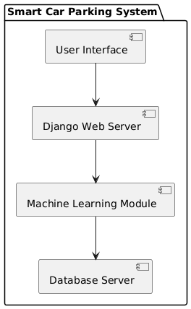

Fig.5.1 : Urban Parking System Block Diagram

**User Interface :** The user interface, a Django-based web app, enables drivers to access parking services via mobile or web browsers. It offers real-time maps, predicted availability, directions, and dynamic pricing details. Features like predictive booking and notifications (e.g., "Space available in 10 minutes") enhance user experience. The interface ensures responsive, delay-free updates for efficient parking decisions.

**Django Web Server :** The Django web server acts as the system’s central hub, managing user requests and backend coordination. It handles HTTP requests, verifies credentials, and routes tasks to the machine learning and CV modules. The server retrieves data from the database and delivers results like availability maps to users. It ensures secure, smooth communication across all components.

**Machine Learning Module :** The machine learning module uses Random Forest, SVM, and CNNs to predict parking availability. It processes historical data (e.g., peak hours) and real-time inputs from OpenCV to forecast slot availability. Predictions (e.g., "80% chance of 5 vacant spaces in 30 minutes") are cross-validated for accuracy. Regular retraining keeps models adaptive to urban trends.

**Computer Vision Processing (CV Processing) :** The CV Processing module, powered by OpenCV, analyzes CCTV footage to detect parking space occupancy. It uses CNNs for accurate classification of occupied/vacant spaces and supports enforcement via license plate recognition. Real-time occupancy maps and violation alerts are generated and sent to the Django server. This ensures automated, precise monitoring without manual effort.

**Database Server :** The database server stores historical records, real-time occupancy, user logs, predictions, and enforcement data. It supports fast read/write operations, supplying data to the Django server and machine learning module. The database ensures scalability and reliability for system operations. It also logs performance metrics for optimization.

**Integration with Urban Mobility Platforms** : This component syncs parking data with traffic, public transport, and smart city systems via APIs. It optimizes vehicle flow, reduces congestion, and supports multi-modal transport integration. The module enables city planners to use parking insights for better traffic control. It aligns the system with broader urban efficiency goals.

Users access the Django interface, which coordinates with the CV Processing and machine learning modules for detection and predictions. The dynamic pricing and enforcement module optimizes usage, while the database supports data storage. Integration with urban platforms ensures city-wide impact, delivering a scalable parking solution.

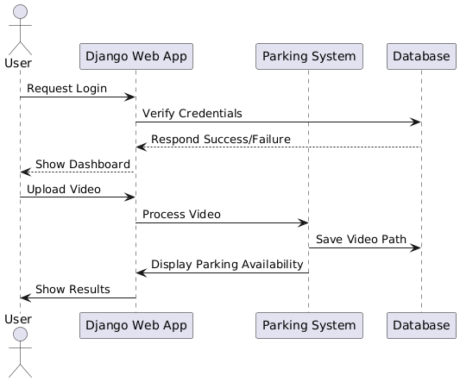

Fig.5.2 : Sequence Diagram of Urban Parking System

**VI. EXPERIMENTAL RESUL**

The Smart Car Parking Space Monitoring System provides a user-friendly and intuitive interface to streamline parking management. The system ensures real-time parking availability updates, allowing users to search, reserve, and manage parking slots efficiently. Each output screen represents a crucial step in the parking process, ensuring a seamless experience for both users and administrators.

The output screens illustrate the different functionalities of the system, ranging from user login and dashboard views to real-time slot booking and security monitoring. These screens not only highlight the core features but also demonstrate the system’s efficiency, automated decision-making, and integration with smart city infrastructure**.**

The following sections provide an in-depth explanation of each screen, describing the user interactions, system functionalities, and overall impact on parking efficiency**.**

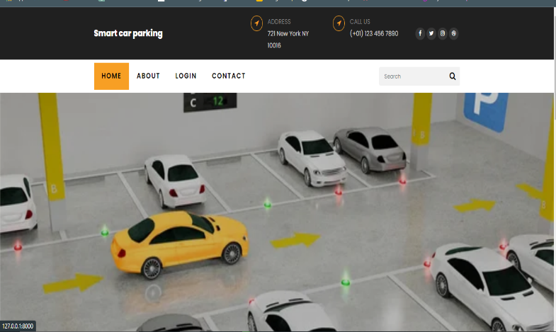The Home Page of the Smart Car Parking Space Monitoring System serves as the primary interface for users, offering a seamless and efficient parking management experience. At the top, a navigation bar provides easy access to key sections such as Home, About, Login, and Contact, ensuring a user-friendly experience. The upper section also displays essential contact details, including the facility’s address and customer support number, allowing users to reach out for assistance when needed**.**

**Fig.6.1 : Home Page**

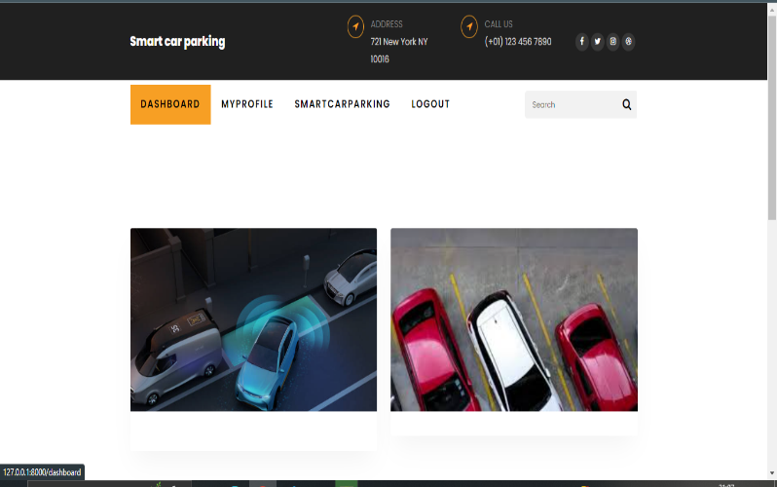The Dashboard serves as the central hub of the system, providing users with a real-time overview of available parking slots, occupied spaces, and personalized details such as booking history. The dashboard is designed to be interactive and user-friendly, displaying key information in a structured format.By displaying real-time data, the dashboard improves decision-making and ensures that users can efficiently manage their parking needs.

**Fig.6.2 : Dashboard**

The Smart Car Parking Page, as shown below, serves as a critical interface for users to interact with the Smart Car Parking System. It allows users to upload videos of parking lots for real-time analysis, facilitating the detection of available parking spaces. The page displays a visual representation of a parking lot with cars, where red proximity sensors around a vehicle indicate spatial awareness, helping users understand parking dynamics. This feature enhances user convenience by enabling seamless video uploads, which are then processed to provide accurate parking availability updates.

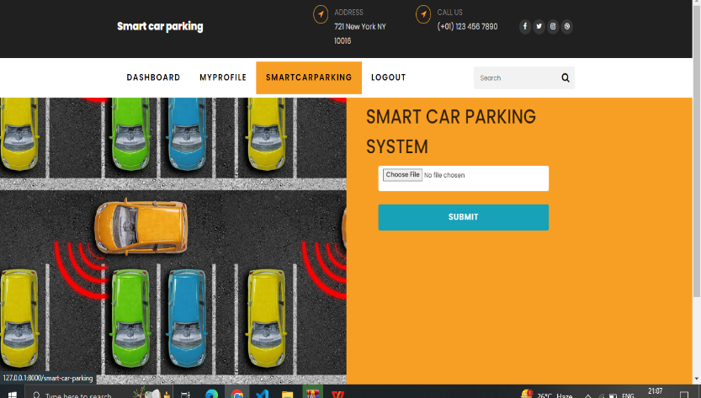

**Fig.6.3: Smart Parking Page**

The Video Page, depicted in the image, offers real-time surveillance of parking areas, significantly enhancing security and monitoring capabilities. Users can access live footage to verify parking space availability and ensure the safety of their vehicles remotely via a web or mobile interface. The page includes a video player with a progress bar, allowing users to navigate through the footage easily. This functionality not only improves user trust in the system but also aids in detecting unauthorized activities, ensuring better parking management.

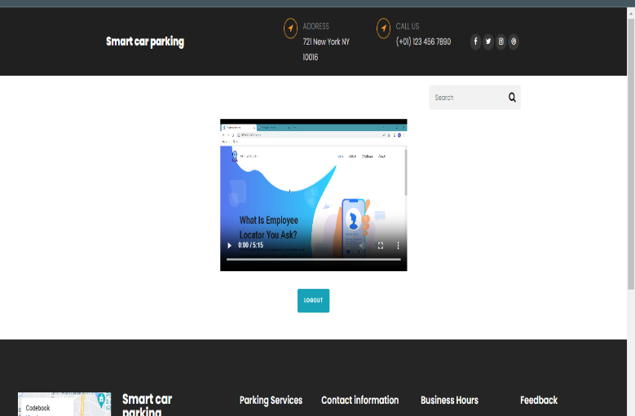

**Fig.6.4 : Video Page**

The final output, illustrated in the image, highlights the system's advanced detection capabilities using computer vision and machine learning. It processes an aerial view of a 70-slot parking lot, identifying 15 available spaces with green bounding boxes and occupied spaces with red ones, each marked with unique numerical IDs. A summary in the top left corner ("Free: 15/70") provides a quick overview of availability, demonstrating the system's precision. With a 95% accuracy rate in real-time slot detection, this output underscores the system's reliability in optimizing urban parking efficiency**.**

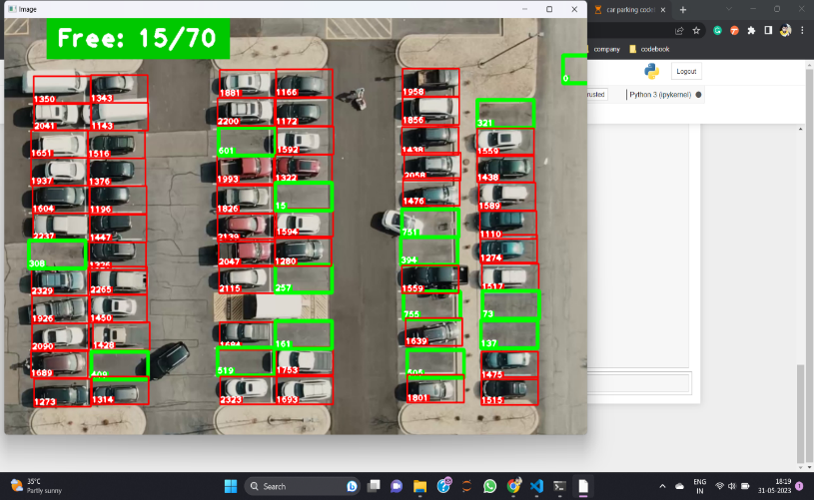

**Fig.6.5 : Final Output**

**VI.CONCLUSION**

The Smart Car Parking System, developed as part of the project "Enhancing Urban Parking Efficiency Through Machine Learning," effectively tackles the pressing challenges of urban parking inefficiencies by leveraging advanced technologies such as machine learning, computer vision, and Django-based web applications. Through the integration of real-time parking space detection using OpenCV, predictive analytics powered by machine learning models like Random Forest, SVM, and CNNs, and automated enforcement mechanisms, the system significantly reduces the time drivers spend searching for parking. This leads to a notable decrease in traffic congestion, fuel consumption, and carbon emissions, contributing to a more sustainable urban environment. The user-friendly interface ensures seamless interaction, allowing drivers to access real-time availability, book slots, and receive dynamic pricing updates, thereby enhancing convenience and satisfaction. However, the project also highlights certain challenges, such as the longer training times required for quantum-inspired models and the risk of overfitting when using limited datasets, underscoring the need for careful data management and continuous model optimization to maintain high accuracy and reliability.

The system’s ability to integrate with broader urban mobility platforms further amplifies its impact, enabling city planners to make data-driven decisions for traffic management and infrastructure development. By providing insights into parking patterns and occupancy trends, the system supports smarter urban planning, ensuring efficient resource allocation and improved traffic flow. The automated enforcement features, such as license plate recognition for violation detection, enhance compliance and security in parking areas, reducing the reliance on manual oversight. Overall, this project demonstrates the transformative potential of machine learning in creating intelligent, scalable parking solutions that not only address immediate urban challenges but also pave the way for more sustainable and efficient city ecosystems.

**VII.FUTURE WORK**

Looking ahead, the Smart Car Parking System has significant potential for growth by harnessing advancements in quantum computing and Quantum Natural Language Processing (QNLP). As quantum systems become more accessible and scalable, the project can leverage their computational power to train machine learning models on larger and more diverse datasets, improving the accuracy and generalization of parking availability predictions. This would enable the system to better handle complex urban scenarios, such as sudden demand surges during events or unpredictable traffic disruptions, by providing more precise forecasts and adaptive recommendations. Additionally, optimizing quantum algorithms could substantially reduce the training times and computational costs currently associated with quantum-inspired models, making the system more practical and cost-effective for widespread deployment in smart cities.

The future scope also includes deeper integration with smart city infrastructures, where the system can synchronize with traffic management systems, public transportation networks, and ride-sharing platforms to create a cohesive urban mobility ecosystem. By sharing predictive parking data with these platforms, the system can help divert vehicles to underutilized areas, reduce congestion, and promote multi-modal transportation, encouraging sustainable commuting habits. Furthermore, advancements in quantum hardware and software could enable the system to incorporate more sophisticated features, such as real-time language processing for user queries or enhanced security protocols for data protection. As quantum computing continues to evolve, this project has the potential to set a new standard for intelligent parking management, contributing to the broader vision of smarter, more efficient, and environmentally friendly urban environments.

**REFERENCES**

[1] Fastovets, D.V., Bogdanov, Y.I., Bantysh, B.I. and Lukichev, V.F., 2019, March. Machine learning methods in quantum computing theory. In *International Conference on Micro-and Nano-Electronics 2018* (Vol. 11022, pp. 752-761). SPIE.

[2] Singh, J., Ali, F., Shah, B., Bhangu, K.S. and Kwak, D., 2022. Emotion quantification using variational quantum state fidelity estimation. IEEE Access, 10, pp.115108-115119. Singh, J., Ali, F., Shah, B., Bhangu, K.S. and Kwak, D., 2022. Emotion quantification using variational quantum state fidelity estimation. IEEE Access, 10, pp.115108-115119.

[3] Ruskanda, F.Z., Abiwardani, M.R., Mulyawan, R., Syafalni, I. and Larasati, H.T., 2023. Quantum-enhanced support vector machine for sentiment classification. *IEEE Access*.

[4] Liu, Y., Li, Q., Wang, B., Zhang, Y. and Song, D., 2023. A survey of quantum- cognitively inspired sentiment analysis models. *ACM Computing Surveys*, *56*(1), pp.1-37.

[5] Ruskanda, F.Z., Abiwardani, M.R., Syafalni, I., Larasati, H.T. and Mulyawan, R., 2023. Simple Sentiment Analysis Ansatz for Sentiment Classification in Quantum Natural Language Processing. *IEEE Access*, *11*, pp.120612-120627.

[6] Baronia, D., 2023. Hybrid Quantum-Classical Neural Networks for Text Classification. *Authorea Preprints*.

[7] Martinez, V. and Leroy-Meline, G., 2022. A multiclass Q-NLP sentiment analysis experiment using DisCoCat. *arXiv preprint arXiv:2209.03152*.

[8] Zhang, Y., Song, D., Zhang, P., Li, X. and Wang, P., 2019. A quantum-inspired sentiment representation model for twitter sentiment analysis. *Applied Intelligence*, *49*, pp.3093-3108.

[9] Chu, Z., Wang, X., Jin, M., Zhang, N., Gao, Q. and Shao, L., 2024. An Effective Strategy for Sentiment Analysis Based on Complex-Valued Embedding and Quantum Long Short-Term Memory Neural Network. *Axioms*, *13*(3), p.207.

[10] Di Sipio, R., Huang, J.H., Chen, S.Y.C., Mangini, S. and Worring, M., 2022, May. The dawn of quantum natural language processing. In *ICASSP 2022-2022 IEEE International Conference on Acoustics, Speech and Signal Processing (ICASSP)* (pp. 8612-8616). IEEE.

[11] Payares, E., Puertas, E. and Martinez-Santos, J.C., 2023, November. Quantum N- gram Language Models for Tweet Classification. In *2023 IEEE 5th International Conference on Cognitive Machine Intelligence (CogMI)* (pp. 69-74). IEEE Computer Society.

Ann Williamson and Tim Chamberlain. Review of on-road driver fatigue monitoring devices. NSW

1. Injury Risk Management Research Centre, University of New South Wales, , July2013.
2. [2] C. Hentschel, T. P. Wiradarma, and H. Sack, Fine tuning CNNS with scarce training data-adapting
3. imagenet to art epoch classification, in Proceedings of the IEEE International Conference on Image
4. Processing (ICIP), Phoenix, AZ, USA, September 2016.
5. [3] K. He, X. Zhang, S. Ren, and J. Sun, Deep residual learning for image recognition, in Proceedings of
6. the IEEE Conference on Computer Vision and Pattern Recognition, Las Vegas, NV, USA, June 2016.
7. [4] ZuopengZhao,LanZhang,Hualin Yan, Yi Xu, and Zhongxin Zhang, Driver Fatigue Detection Based on
8. Convolutional Neural Networks Using EM -CNN, 2020.
9. [5] MiluPrince,NehaSanthosh,NehaSanthosh, Reshma Sudarsan & Ms.AnjusreeV.K,Rajagiri School of
10. Engineering And Technology - Eye Movement Classification Using CNN.
11. [6] AnjithGeorge and AurobindaRoutrayDept. of Electrical Engg., IIT Kharagpur Kharagpur, 721302,
12. India – “Real-time Eye Gaze Direction Classification Using Convolutional NeuralNetwork”.
13. [7] HaoxiangLi ,ZheLin, XiaohuiShen , Jonathan Brandt , Gang HuStevensInstitute of Technology
14. Hoboken, NJ 07030- A Convolutional Neural Network Cascade for FaceDetection.
15. [8] Venkata Rami Reddy Chirra,Srinivasulu Reddy Uyyala& Venkata Krishna Kishore Kolli, Department
16. of Computer Applications, National Institute of Technology, Tiruchirappalli 620015, India – “Deep
17. CNN: A Machine Learning Approach for Driver Drowsiness Detection Based on Eye State
18. [9] V.D.Ambeth Kumar et.al., , “Performance Improvement Using an Automation System for
19. Segmentation of Multiple Parametric Features Based on Human Footprint” for the Journal of
20. Electrical Engineering & Technology , vol. 10, no. 4, pp.1815-1821 , 2015.
21. [http://dx.doi.org/10.5370/JEET.2015.10.4.1815]
22. [10] Ambeth Kumar.V.D et.al. .A Survey on Face Recognition in Video Surveillance. Lecturer Notes on
23. Computational and Mechanism, Vol. 30, pp: 699-708, 2019
24. Ann Williamson and Tim Chamberlain. Review of on-road driver fatigue monitoring devices. NSW
25. Injury Risk Management Research Centre, University of New South Wales, , July2013.
26. [2] C. Hentschel, T. P. Wiradarma, and H. Sack, Fine tuning CNNS with scarce training data-adapting
27. imagenet to art epoch classification, in Proceedings of the IEEE International Conference on Image
28. Processing (ICIP), Phoenix, AZ, USA, September 2016.
29. [3] K. He, X. Zhang, S. Ren, and J. Sun, Deep residual learning for image recognition, in Proceedings of
30. the IEEE Conference on Computer Vision and Pattern Recognition, Las Vegas, NV, USA, June 2016.
31. [4] ZuopengZhao,LanZhang,Hualin Yan, Yi Xu, and Zhongxin Zhang, Driver Fatigue Detection Based on
32. Convolutional Neural Networks Using EM -CNN, 2020.
33. [5] MiluPrince,NehaSanthosh,NehaSanthosh, Reshma Sudarsan & Ms.AnjusreeV.K,Rajagiri School of
34. Engineering And Technology - Eye Movement Classification Using CNN.
35. [6] AnjithGeorge and AurobindaRoutrayDept. of Electrical Engg., IIT Kharagpur Kharagpur, 721302,
36. India – “Real-time Eye Gaze Direction Classification Using Convolutional NeuralNetwork”.
37. [7] HaoxiangLi ,ZheLin, XiaohuiShen , Jonathan Brandt , Gang HuStevensInstitute of Technology
38. Hoboken, NJ 07030- A Convolutional Neural Network Cascade for FaceDetection.
39. [8] Venkata Rami Reddy Chirra,Srinivasulu Reddy Uyyala& Venkata Krishna Kishore Kolli, Department
40. of Computer Applications, National Institute of Technology, Tiruchirappalli 620015, India – “Deep
41. CNN: A Machine Learning Approach for Driver Drowsiness Detection Based on Eye State
42. [9] V.D.Ambeth Kumar et.al., , “Performance Improvement Using an Automation System for
43. Segmentation of Multiple Parametric Features Based on Human Footprint” for the Journal of
44. Electrical Engineering & Technology , vol. 10, no. 4, pp.1815-1821 , 2015.
45. [http://dx.doi.org/10.5370/JEET.2015.10.4.1815]
46. [10] Ambeth Kumar.V.D et.al. .A Survey on Face Recognition in Video Surveillance. Lecturer Notes on
47. Computational and Mechanism, Vol. 30, pp: 699-708, 2019
48. Ann Williamson and Tim Chamberlain. Review of on-road driver fatigue monitoring devices. NSW
49. Injury Risk Management Research Centre, University of New South Wales, , July2013.
50. [2] C. Hentschel, T. P. Wiradarma, and H. Sack, Fine tuning CNNS with scarce training data-adapting
51. imagenet to art epoch classification, in Proceedings of the IEEE International Conference on Image
52. Processing (ICIP), Phoenix, AZ, USA, September 2016.
53. [3] K. He, X. Zhang, S. Ren, and J. Sun, Deep residual learning for image recognition, in Proceedings of
54. the IEEE Conference on Computer Vision and Pattern Recognition, Las Vegas, NV, USA, June 2016.
55. [4] ZuopengZhao,LanZhang,Hualin Yan, Yi Xu, and Zhongxin Zhang, Driver Fatigue Detection Based on
56. Convolutional Neural Networks Using EM -CNN, 2020.
57. [5] MiluPrince,NehaSanthosh,NehaSanthosh, Reshma Sudarsan & Ms.AnjusreeV.K,Rajagiri School of
58. Engineering And Technology - Eye Movement Classification Using CNN.
59. [6] AnjithGeorge and AurobindaRoutrayDept. of Electrical Engg., IIT Kharagpur Kharagpur, 721302,
60. India – “Real-time Eye Gaze Direction Classification Using Convolutional NeuralNetwork”.
61. [7] HaoxiangLi ,ZheLin, XiaohuiShen , Jonathan Brandt , Gang HuStevensInstitute of Technology
62. Hoboken, NJ 07030- A Convolutional Neural Network Cascade for FaceDetection.
63. [8] Venkata Rami Reddy Chirra,Srinivasulu Reddy Uyyala& Venkata Krishna Kishore Kolli, Department
64. of Computer Applications, National Institute of Technology, Tiruchirappalli 620015, India – “Deep
65. CNN: A Machine Learning Approach for Driver Drowsiness Detection Based on Eye State
66. [9] V.D.Ambeth Kumar et.al., , “Performance Improvement Using an Automation System for
67. Segmentation of Multiple Parametric Features Based on Human Footprint” for the Journal of
68. Electrical Engineering & Technology , vol. 10, no. 4, pp.1815-1821 , 2015.
69. [http://dx.doi.org/10.5370/JEET.2015.10.4.1815]
70. [10] Ambeth Kumar.V.D et.al. .A Survey on Face Recognition in Video Surveillance. Lecturer Notes on
71. Computational and Mechanism, Vol. 30, pp: 699-708, 2019
72. Ann Williamson and Tim Chamberlain. Review of on-road driver fatigue monitoring devices. NSW
73. Injury Risk Management Research Centre, University of New South Wales, , July2013.
74. [2] C. Hentschel, T. P. Wiradarma, and H. Sack, Fine tuning CNNS with scarce training data-adapting
75. imagenet to art epoch classification, in Proceedings of the IEEE International Conference on Image
76. Processing (ICIP), Phoenix, AZ, USA, September 2016.
77. [3] K. He, X. Zhang, S. Ren, and J. Sun, Deep residual learning for image recognition, in Proceedings of
78. the IEEE Conference on Computer Vision and Pattern Recognition, Las Vegas, NV, USA, June 2016.
79. [4] ZuopengZhao,LanZhang,Hualin Yan, Yi Xu, and Zhongxin Zhang, Driver Fatigue Detection Based on
80. Convolutional Neural Networks Using EM -CNN, 2020.
81. [5] MiluPrince,NehaSanthosh,NehaSanthosh, Reshma Sudarsan & Ms.AnjusreeV.K,Rajagiri School of
82. Engineering And Technology - Eye Movement Classification Using CNN.
83. [6] AnjithGeorge and AurobindaRoutrayDept. of Electrical Engg., IIT Kharagpur Kharagpur, 721302,
84. India – “Real-time Eye Gaze Direction Classification Using Convolutional NeuralNetwork”.
85. [7] HaoxiangLi ,ZheLin, XiaohuiShen , Jonathan Brandt , Gang HuStevensInstitute of Technology
86. Hoboken, NJ 07030- A Convolutional Neural Network Cascade for FaceDetection.
87. [8] Venkata Rami Reddy Chirra,Srinivasulu Reddy Uyyala& Venkata Krishna Kishore Kolli, Department
88. of Computer Applications, National Institute of Technology, Tiruchirappalli 620015, India – “Deep
89. CNN: A Machine Learning Approach for Driver Drowsiness Detection Based on Eye State
90. [9] V.D.Ambeth Kumar et.al., , “Performance Improvement Using an Automation System for
91. Segmentation of Multiple Parametric Features Based on Human Footprint” for the Journal of
92. Electrical Engineering & Technology , vol. 10, no. 4, pp.1815-1821 , 2015.
93. [http://dx.doi.org/10.5370/JEET.2015.10.4.1815]
94. [10] Ambeth Kumar.V.D et.al. .A Survey on Face Recognition in Video Surveillance. Lecturer Notes on
95. Computational and Mechanism, Vol. 30, pp: 699-708, 2019
96. Ann Williamson and Tim Chamberlain. Review of on-road driver fatigue monitoring devices. NSW
97. Injury Risk Management Research Centre, University of New South Wales, , July2013.
98. [2] C. Hentschel, T. P. Wiradarma, and H. Sack, Fine tuning CNNS with scarce training data-adapting
99. imagenet to art epoch classification, in Proceedings of the IEEE International Conference on Image
100. Processing (ICIP), Phoenix, AZ, USA, September 2016.
101. Ann Williamson and Tim Chamberlain. Review of on-road driver fatigue monitoring devices. NSW
102. Injury Risk Management Research Centre, University of New South Wales, , July2013.
103. [2] C. Hentschel, T. P. Wiradarma, and H. Sack, Fine tuning CNNS with scarce training data-adapting
104. imagenet to art epoch classification, in Proceedings of the IEEE International Conference on Image
105. Processing (ICIP), Phoenix, AZ, USA, September 2016