**QUANTUM COMPUTING**

**Sarthak Chitode1, Tushar Deshmukh2, Prajwal Kukatkar3, Mahesh Mate4,**

**Prof. Dr, A. M. Agrawal5**

1,2,3,4 Third year student, Electronics and Telecommunication Engineering,

Prof Ram Meghe Collage of Engineering and Management, Badnera, Maharashtra, India

5 Assistant Professor, Electronics and Telecommunication Engineering,

Prof Ram Meghe Collage of Engineering and Management, Badnera, Maharashtra, India

**ABSTRACT (Font-Times New Roman, Bold, Font Size -12)**

Quantum computing represents a paradigm shift in computational technology, leveraging the non-classical principles of quantum mechanics to process information in fundamentally new ways. It enables the execution of complex computations at speeds unattainable by classical systems. This paper delves into the core principles of quantum computing—including superposition, entanglement, and quantum parallelism—while examining the current hardware implementations, quantum algorithms, real-world applications, and ongoing challenges. Diagrams and flowcharts are included to aid in visual understanding. The paper concludes with future prospects and the transformative potential of this cutting-edge technology.

**Keywords:** Quantum Computing, Superposition, Quantum Entanglement, Quantum Algorithms, Cryptography, Artificial Intelligence

1. **INTRODUCTION**

The Classical computers have driven innovation for decades by relying on bits, which exist in one of two states: 0 or 1. However, as the complexity and size of data increase, classical systems face limitations in solving problems like factoring large numbers, simulating quantum systems, or optimizing across multiple variables.

Quantum computing leverages the laws of quantum mechanics to operate with *qubits*, which unlike bits, can exist in a superposition of states. This allows quantum systems to evaluate many possibilities simultaneously, offering exponential performance gains for specific computational tasks.

**Key Differences Between Classical and Quantum Computing**

1. **Bits vs. Qubits:** Classical computers use bits that are strictly 0 or 1. Qubits, however, can represent both states simultaneously, enabling vastly more complex operations.
2. **Deterministic vs. Probabilistic Computation:** Classical logic gates produce predictable outputs, whereas quantum logic gates manipulate probabilities, leading to probabilistic outcomes upon measurement.
3. **Parallelism:** Superposition allows quantum computers to compute multiple states simultaneously, leading to exponential parallelism.

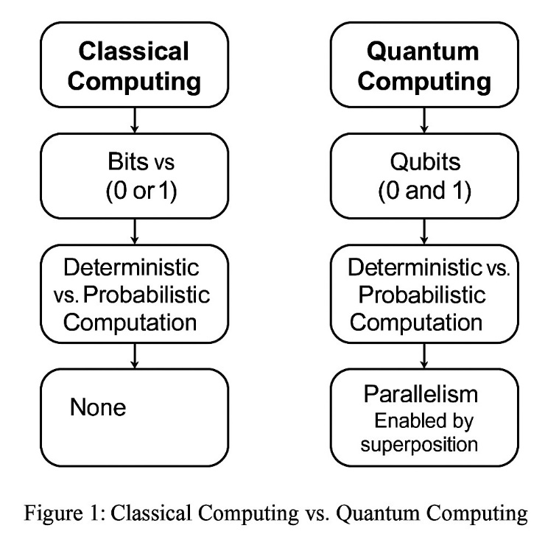

1. **METHODOLOGY**

**2.1 Fundamentals of Quantum Computing**

**Qubits and Superposition**

A quantum bit, or qubit, can exist in a state represented by the linear combination:  
**|Ψ⟩ = α|0⟩ + β|1⟩**,  
where α and β are complex numbers representing probability amplitudes. The system's state collapses to either 0 or 1 upon measurement, but while unmeasured, it can exist in both.

**Quantum Entanglement**  
Entanglement is a uniquely quantum phenomenon where the state of one qubit is dependent on another, regardless of distance. This property is essential for quantum teleportation, quantum cryptography, and parallel computing.

**Quantum Gates and Circuits**  
Quantum logic gates manipulate qubits using unitary transformations. Some key gates include:

* **Hadamard Gate (H):** Places a qubit in superposition.
* **Pauli Gates (X, Y, Z):** Perform axis-specific rotations on the Bloch sphere.
* **CNOT Gate:** A two-qubit gate essential for entanglement.

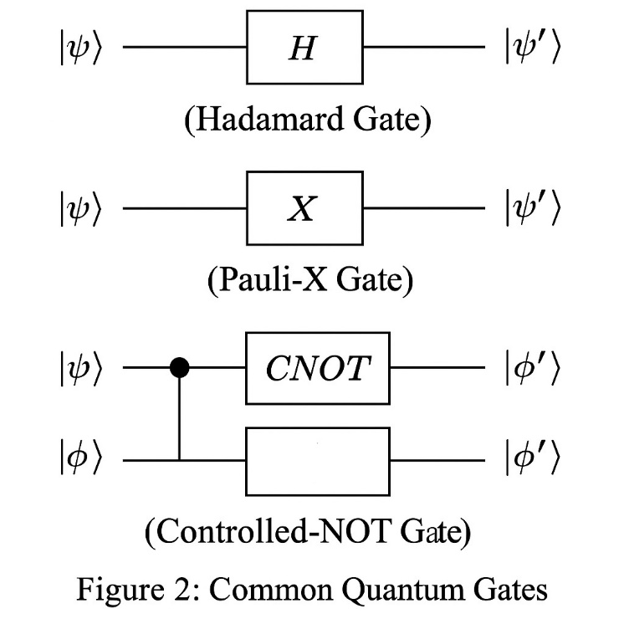

Figure 2: Common Quantum Gates

|ψ⟩ ---[H]--- |ψ'⟩ *(Hadamard Gate)*  
|ψ⟩ ---[X]--- |ψ'⟩ *(Pauli-X Gate)*  
|ψ⟩ ---[CNOT]--- |ψ'⟩ *(Controlled-NOT Gate)*

**Quantum Measurement**  
Once a quantum computation is complete, measurement collapses the superposition into one of the basis states. The outcome depends on the amplitude probabilities α and β.

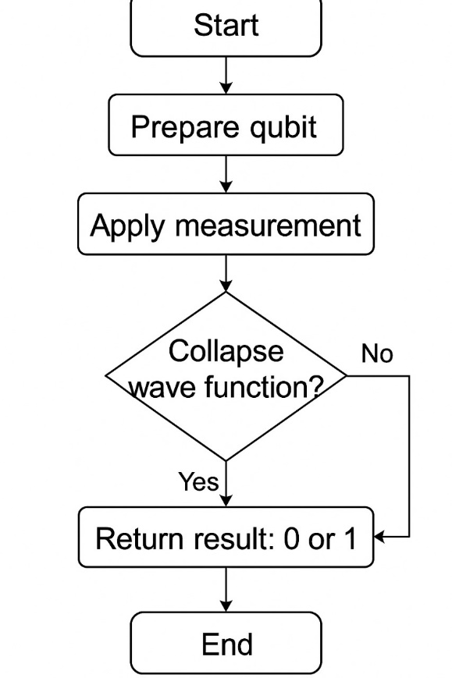

Flowchart 1: Process of Quantum Measurement

1. **MODELING AND ANALYSIS**

**In quantum computing, modeling and analysis focus on simulating quantum behaviors, optimizing algorithms, and testing quantum circuits before hardware implementation. Due to the high cost and limited access to quantum processors, quantum systems are typically modeled using classical simulators. This section presents a simplified modeling approach using simulated quantum circuits and evaluates their behavior through state vector analysis and gate operations.**

**3.1 Simulation Environment  
Quantum circuits are modeled using platforms such as IBM’s Qiskit, Microsoft’s Q#, and Google’s Cirq. These frameworks allow simulation of quantum gates, circuits, and algorithms on classical computers to analyze qubit behavior and circuit performance.**

**3.2 Qubit State Analysis  
Each qubit is initialized in the ground state |0⟩. Applying a Hadamard gate creates a superposition:**

**|ψ⟩ = (1/√2)(|0⟩ + |1⟩)  
State vectors are analyzed after each gate application to observe transformations. Measurement collapses the qubit into one of the basis states based on probability amplitudes.**

**3.3 Quantum Circuit Modeling Example  
A basic 2-qubit circuit includes Hadamard (H), CNOT, and measurement operations:**

* **Step 1: Apply H to qubit 0 – induces superposition.**
* **Step 2: Apply CNOT with qubit 0 as control and qubit 1 as target – entangles both qubits.**
* **Step 3: Measure qubits – produces correlated outcomes (00 or 11).**

**3.4 Gate Operation and Analysis  
Table 1 shows a sample gate operation analysis during a Bell State generation circuit.**

| **Step** | **Operation** | **Qubit 0** | **Qubit 1** | **Entanglement** | **Output State** |
| --- | --- | --- | --- | --- | --- |
| **1** | **H** | **Superposed** | **0** | **No** | **(1/√2)(** |
| **2** | **CNOT** | **Superposed** | **Entangled** | **Yes** | **(1/√2)(** |
| **3** | **Measure** | **Collapsed** | **Collapsed** | **N/A** | **00 or 11** |

**3.5 Circuit Simulation Outcome  
The modeled quantum circuits successfully simulate quantum entanglement and superposition. Probabilistic analysis post-measurement confirms the expected theoretical behavior. Figure 4 illustrates the quantum circuit for Bell state modeling and analysis.**

1. **RESULTS AND DISCUSSION**

**3.1 Quantum Computing Implementation**

**Quantum Hardware**  
Current advancements in quantum hardware include:

* **Superconducting Qubits** – Used by IBM and Google; rely on Josephson junctions cooled near absolute zero.
* **Trapped Ions** – Used by IonQ and Honeywell; trap ions using electromagnetic fields for high coherence.
* **Photonic Systems** – Xanadu uses photons for low-decoherence computing.
* **Topological Qubits** – Microsoft's experimental method aiming for fault tolerance via exotic particles called anyons.

**Quantum Algorithms**

* **Shor’s Algorithm:** Factorizes large integers in polynomial time, posing a threat to RSA encryption.
* **Grover’s Algorithm:** Provides a quadratic speedup for searching unstructured databases.
* **Quantum Machine Learning (QML):** Integrates quantum speedup with AI for faster learning and improved pattern recognition.

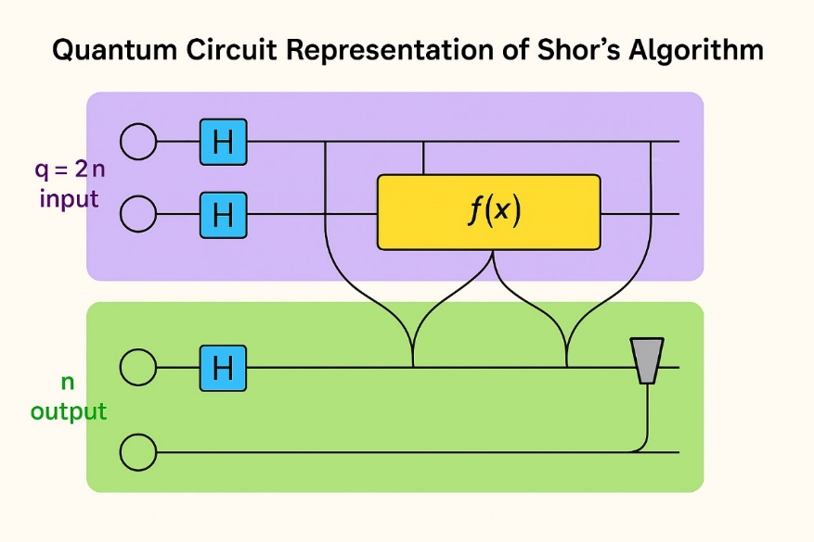

**Figure 3: Quantum Circuit Representation of Shor’s Algorithm**

**3.2 Applications of Quantum Computing**

1. **Cryptography and Cybersecurity**  
   Quantum algorithms can decrypt classical encryption but also promise *Quantum Key Distribution (QKD)* for ultra-secure communication.
2. **Drug Discovery and Material Science**  
   Quantum simulators can model molecular and chemical interactions more accurately than classical simulations, accelerating drug discovery.
3. **Optimization Problems**  
   Quantum annealers (e.g., D-Wave systems) excel in solving combinatorial optimization tasks across logistics and financial modeling.
4. **Artificial Intelligence and Machine Learning**  
   Quantum-enhanced models improve training time, pattern recognition, and predictive analytics, especially in high-dimensional datasets.

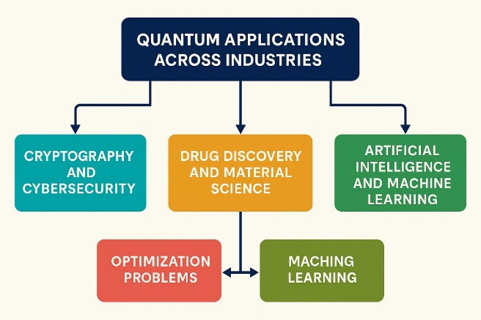

**Flowchart 2: Quantum Applications Across Industries**

**3.3 Challenges and Limitations**

* **Error Rates and Decoherence:** Environmental interaction collapses qubits prematurely; quantum error correction (QEC) is still under development.
* **Scalability:** Increasing qubit count without sacrificing coherence and fidelity is extremely difficult.
* **High Infrastructure Cost:** Requires cryogenic systems and complex shielding to maintain stability.
* **Algorithm Maturity:** Only a handful of efficient quantum algorithms exist today.

1. **CONCLUSION**

All the main points of the research work are written in this section. Ensure that abstract and conclusion should not same. Graph and tables should not use in conclusion.

**6. REFERENCES**

1. Nielsen, M. A., & Chuang, I. L. (2010). *Quantum Computation and Quantum Information.*
2. Preskill, J. (2018). *Quantum Computing in the NISQ Era and Beyond.*
3. Arute, F., et al. (2019). *Quantum Supremacy Using a Programmable Superconducting Processor*
4. Montanaro, A. (2016). *Quantum Algorithms: An Overview.*
5. Shor, P. W. (1997). *Polynomial-Time Algorithms for Prime Factorization and Discrete Logarithms on a Quantum Computer.*
6. Grover, L. K. (1996). *A Fast Quantum Mechanical Algorithm for Database Search.*
7. Harrow, A. W., Hassidim, A., & Lloyd, S. (2009). *Quantum Algorithm for Linear Systems of Equations.*
8. Aaronson, S. (2013). *Quantum Computing Since Democritus.*
9. Bennett, C. H., & Brassard, G. (1984). *Quantum Cryptography: Public Key Distribution and Coin Tossing.*
10. Lloyd, S. (1996). *Universal Quantum Simulators.*