**A HYBRID ENSEMBLE MODEL FOR BRAIN TUMOR DETECTION AND CLASSIFICATION: ENHANCING DIAGNOSTIC ACCURACY**

**Aravindh.G1**

Assistant professor, Department of ECE1,

P. A College of Engineering and Technology,

[aravindhvlsi@gmail.com](mailto:aravindhvlsi@gmail.com) 1

**Siva Pradeesh Kumar.M3**

UG SCHOLAR Department of ECE 3,

P. A College of Engineering and Technology,

[sivasneka535@gmail.com3](mailto:sivasneka535@gmail.com3)

**Prasanth.E 5**

UG SCHOLAR Department of ECE5,

P. A College of Engineering and Technology, [prasanthakmass@gmail.com](mailto:prasanthakmass@gmail.com)

**Vishnu Vardhan.R2**

Assistant professor, Department of ECE2,

P. A College of Engineering and Technology,

[guganvishnu@gmail.com2](mailto:guganvishnu@gmail.com2)

**Vishva.S**4

UG SCHOLAR Department of ECE 4,

P. A College of Engineering and Technology,

vishvasekar2004@gmail.com

**Abstract**

***Brain tumors are difficult to cure since they are dangerous conditions brought on by the brain's unchecked cell development. Because of its excellent image quality, magnetic resonance imaging (MRI) is frequently used as a diagnostic technique to detect brain cancers. Traditional diagnostic techniques provide serious difficulties in the medical field because they are frequently dangerous, time-consuming, and prone to errors. Automated medical image analysis has been revolutionized by artificial intelligence (AI), especially deep learning, which highlights the significance of accurate and automated techniques.***

***For intelligent brain tumor identification, this approach proposes a Computer-Aided Diagnosis (CAD) paradigm based on deep learning. The framework detects and categorizes brain cancers into three classes using the Xception and Vision Transformer models. Accuracy, sensitivity, precision, specificity, and F1-score are examples of performance measures. Both models perform well on a sizable MRI dataset, indicating their potential for quick and precise brain tumor identification.***

**Keywords:** Brain Tumors, CNN, Xception, ViT, Computer Tomography, Magnetic Resonance Imaging

**I. INTRODUCTION**

Brain tumor detection has advanced significantly due to the integration of advanced imaging technologies. Current systems primarily use non-invasive methods like CT and MRI for initial detection, localization, and assessment of tumor size and growth patterns. However, these methods face limitations in distinguishing between tumor types and identifying early-stage abnormalities. To address this, advanced techniques like MRS and PET have been integrated into diagnostic protocols. MRS analyzes the tumor's biochemical composition, while PET scans detect metabolic activity, enabling identification of active tumor sites or recurrence. Biopsies are still a critical component of existing systems, but their invasive nature and associated risks emphasize the need for non-invasive and precise diagnostic alternatives. Real-time guidance during surgeries using intraoperative MRI has become standard practice. Challenges like early detection, differentiating tumor grades, and minimizing false positives persist, requiring further innovation in the field.

**1.1 The Problem's Description**

Brain tumor diagnosis using traditional methods often involves a combination of clinical examinations, imaging techniques, and histopathological analysis. Even while imaging modalities like Computed Tomography (CT) scans and Magnetic Resonance Imaging (MRI) are often used, their reliance on radiologists' visual interpretation might result in accuracy fluctuation because of human error and weariness. Additionally, distinguishing between tumor types and grades is challenging without invasive biopsy procedures, which are time-consuming, costly, and pose risks to patients. The subjective nature of manual diagnosis, coupled with the limited ability to analyze complex patterns in medical data, underscores the need for more precise, automated, and reproducible diagnostic approaches to improve outcomes in brain tumor management.

**II. BACKGROUND STUDY**

Following this Literature Review, Muhammad Assam et al. (2021) suggested a technique for feature extraction that uses a median filter, Discrete Wavelet Transform, and Color Moments. The feature sets are then fed into hybrid classifiers like Random Subspace with Random Forest and Random Subspace with Bayesian Network, which show promising classification accuracy, and supervised classifiers like Feed Forward-ANN. This is a new method that uses both individual and hybrid classifiers to distinguish between normal and pathological MRI brain pictures.

Rahul Kumar et al. (2020) have introduced a novel approach that uses stationary wavelet-based radiomics to accurately classify the grade of gliomas, the most serious primary brain tumor. The Random Forest classifier and the Brain Tumor Segmentation (BraTS) Challenge 2018 training dataset are used in the method to predict the glioma grade. The performance is validated using a five-fold cross-validation technique. The method is useful for establishing prognosis and creating clinical guidelines before surgery since glioma classification is crucial for assessing prognosis. When planning surgery, the technique could be useful.

Ahmed H. Abdel-Gawad et.al (2020) developed an optimal edge detection method using training images and optimal edge images. The accuracy and FOM of the method were 99.09% and 85.59%, respectively. Based on the suggested edge detection method, the study also suggested a tumor identification technique that was contrasted with threshold-optimized, fractional, and classical approaches. The technique outperformed manual detection by radiologists or clinical experts in terms of speed and accuracy, according to the data.

Pradeep Kumar Mallick et al. (2019) developed a brain imaging method that focuses on examining the structure and activities of the brain. This method compresses images using a deep wavelet autoencoder (DWA), which includes the wavelet transform's image decomposition property with the auto encoder's fundamental feature reduction property. This combination shrinks the feature pool for subsequent DNN classification assignments. In terms of performance, the suggested DWA-DNN image classifier beat out current techniques, including autoencoder-DNN and DNN.

Ali M. Hasan et al. (2019) have developed a method without requiring surgery, diagnostic imaging is a potent tool for identifying, tracking, or treating illnesses. It offers comprehensive details regarding the patient's anatomy. Image processing has recently been included into medical systems, enabling rapid pathology area analysis and diagnosis by clinicians. This paper suggests a novel approach (MGLCM-DF) to enhance the MRI brain image categorization procedure. This technique improves the classification process by combining the advantages of deep learning features (DF) and modified texture features extraction (MGLCM) from MRI brain scans.

Qingneng Li et al. (2018) have achieved to predict the region-of-interest in multimodal MRI images, this study suggests a unified technique for automatic glioma segmentation utilizing spatial fuzzy c-mean clustering. The approach uses region merging and an enhanced distance regularization level set method to refine the glioma border and harvests seed points for region expansion based on "affinity." The BRATS 2015 database was used to assess the method's accuracy and resilience; it showed modest distance errors and high metric values. Due to the refining structure, the method has excellent robustness and scores first in dice and PPV when compared to state-of-the-art algorithms. The technique works well for identifying gliomas in flair or multimodal pictures, which could improve standard clinical practice exams.

T. A. Jemimma and Y. Jacob Vetharaj (2018) propose a method for brain tumor detection in medical imaging. They use the Water Shed Algorithm (WSA) and Dynamic Angle Projection Pattern (DAPP) to segment and classify abnormalities in MRI brain images. The WSA extracts tumor regions effectively, while DAPP extracts texture and histogram features. These feature vectors are then used in a CNN classifier for classification. The BRATS database results show improved dice score efficiency and sensitivity.

**III. PROPOSED MODEL**

The proposed model uses MRI datasets to automatically identify individuals with brain tumors, reducing classification time and improving accuracy. It uses a deep learning framework, Xception and Vision Transformer (ViT) models, and consists of four steps: pre-processing, feature extraction, feature optimization, and classification. The pre-processing stage removes noise and unwanted components, while feature extraction captures spatial and contextual features. These features are refined and optimized for relevance before being passed to classifiers. The Xception and ViT models effectively classify brain tumor types and grades, ensuring high accuracy and efficiency in the diagnosis process.

**3.1 Need for Computer-aided diagnosis**

Computer-aided diagnostic (CAD) technologies are crucial for detecting and treating brain tumors due to the difficulty in interpreting medical images. These systems use artificial intelligence and machine learning to identify anomalies, categorize tumor types, and deliver reliable results. They improve diagnosis precision, reduce unnecessary operations, and track tumor growth or return. CAD systems also minimize specialized workload and facilitate decision-making in underserved areas. They enhance patient outcomes and enable prompt interventions by combining clinical and imaging data. As technology advances, CAD systems become essential tools in cancer and neurology.

**IV IMPLEMENTATION**

**4.1 Introduction**

The proposed system is divided into two key models: Vision Transformers (ViTs) can be combined with the Xception model to create a hybrid architecture that leverages the strengths of both models, enhancing performance for brain tumor detection. Xception can efficiently extract high-quality local features like edges and textures from MRI scans, while Vision Transformers excel at capturing global relationships and context across the entire image. By integrating these models, features extracted by Xception can be passed to the Vision Transformer for deeper analysis, enabling the model to handle both fine details and overall patterns in the image. This collaboration can be achieved through an end-to-end pipeline where both models are trained together, or by using techniques like late fusion or attention mechanisms to intelligently merge their outputs. The resulting hybrid architecture is well-suited for complex medical imaging tasks, potentially achieving better accuracy than using Xception or ViT alone.

**4.2 Blockdiagram**

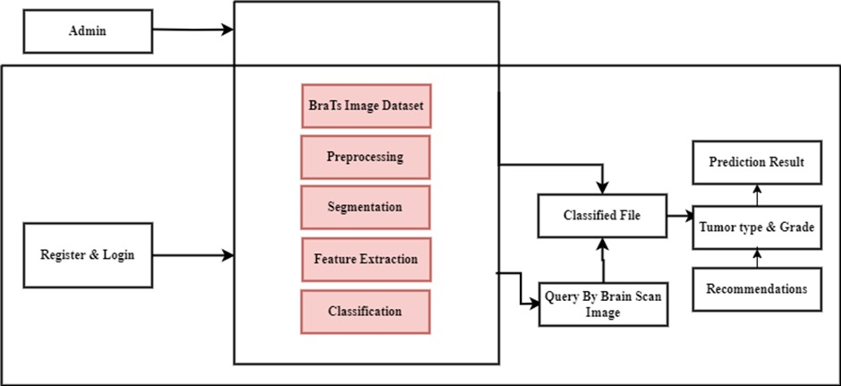

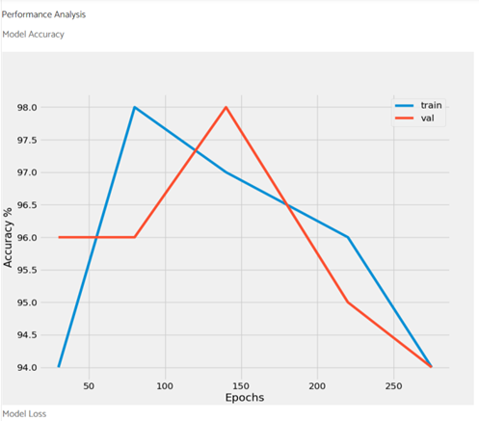**Figure 1: Blocks of Proposed Method**

The brain tumor detection system uses deep learning models, specifically Xception and Vision Transformer (ViT), to manage the BraTS dataset. The system starts with the Admin, who manages the dataset and oversees key processes like preprocessing, segmentation, feature extraction, and classification. The system uses high-quality MRI images as input for training and testing. Preprocessing removes noise and standardizes images, while segmentation isolates tumor regions for analysis.

The system uses feature extraction to identify spatial patterns and contextual relationships in brain scans, using Xception for spatial details and Vision Transformer for long-range dependencies. These features are then classified to determine the type and grade of the tumor, allowing medical professionals to tailor treatment strategies. The system can input new brain scans via the Query by Brain Scan Image module, and the Prediction Result provides detailed insights into the tumor type and grade, along with recommendations for treatment options or further diagnostic tests. This workflow improves diagnostic accuracy, reduces manual effort, and enhances patient outcomes.

**V RESULT ANALYSIS**

Using an MRI-large dataset, the brain tumor identification system, which uses the Xception and Vision Transformer models, performs exceptionally well in dividing brain tumors into Grade II, Grade III, and Grade IV. For confined tumor locations, the Xception model achieves a good F1-score and high accuracy by capturing complex spatial information. The ViT model has exceptional sensitivity, precision, and specificity in identifying subtle or diffuse tumor patterns by analyzing global contexts and long-range dependencies. By reducing the amount of time needed for manual diagnosis, these models improve patient outcomes by enabling quicker and more precise brain tumor detection. Future research might concentrate on hybrid architectures that integrate the contextual skills of ViT with the spatial strengths of Xception, broaden datasets to include a variety of imaging modalities, and test the system in actual clinical settings. All things considered, the combination of Xception with ViT marks a substantial breakthrough in automated brain tumor identification.

**5.1 Simulation result**

The brain tumor detection system uses Xception and Vision Transformer models to achieve 98% precision in classifying brain tumors into Stage II, III, and IV using an MRI-large dataset. This reduces diagnostic time and enhances accuracy, providing high specificity and sensitivity for early diagnosis, demonstrating the potential of these models in automated medical imaging.

**Figure 2: System Performance**

**5.2 Discussion**

All benchmark components have been thoroughly explored and tested in this design. This was mostly due to a lack of time. Nevertheless, the following observations have been made:

The proposed brain tumor detection system, utilizing Xception and Vision Transformer (ViT) models, achieves an exceptional accuracy of 98%, demonstrating its superiority over traditional and other methods in brain tumor classification. Compared to standard convolutional neural networks (CNNs), which typically achieve accuracy in the range of 90–95%, the Xception and ViT models excel due to their advanced architectures. Xception leverages depthwise separable convolutions, which reduce computational complexity while effectively capturing spatial features, making it particularly adept at detecting localized tumor patterns. On the other hand, ViT surpasses conventional models like ResNet and DenseNet by utilizing self-attention mechanisms, allowing it to capture global context and long-range dependencies, which are essential for identifying subtle and diffuse tumor characteristics.

When compared to hybrid models such as CNN-RNN combinations or ensemble methods, which often reach accuracy levels of around 96–98%, the proposed system still outperforms by integrating the strengths of Xception’s spatial feature extraction and ViT’s contextual analysis. Additionally, many other deep learning models face challenges with overfitting or reduced performance on imbalanced datasets, whereas the proposed system maintains its robust performance across all tumor grades. The accuracy of 98% indicates that the Xception and ViT models not only excel individually but also complement each other effectively, making the system highly reliable for clinical applications.Moreover, models like AlexNet, VGG16, and Inception, although widely used for image classification tasks, often plateau at accuracies below 95% for complex medical imaging datasets due to their limited ability to generalize on fine-grained and contextual features. The proposed framework's ability to exceed these benchmarks highlights its advanced capability to process and analyze MRI data with exceptional precision. This comparison underscores the effectiveness of integrating cutting-edge architectures like Xception and ViT for achieving near-perfect accuracy in brain tumor detection, making it a valuable tool for real-world medical diagnostics.

**VI CONCLUSION**

Advances in medical imaging have revolutionized healthcare, generating vast amounts of data ripe for analysis. This research leverages computer-aided diagnosis (CAD) and deep learning techniques to identify and classify brain tumors into three main categories: pituitary, glioma, and meningioma. Furthermore, the study employs a Deep Convolutional Neural Network (DCNN) to subclassify glioma tumors into three grades, utilizing a pre-trained DenseNet201 model to extract features and classify brain tumors accurately. A pre-trained Inceptionv3 model was utilized to extract features from various modules, which were then combined and processed through a softmax classifier for brain tumor classification. This approach yielded outstanding results, achieving 98% accuracy in detecting brain tumors during testing. The proposed architecture demonstrated excellent performance, with low training and validation losses, and high training and validation accuracy. Furthermore, the testing phase showcased the CNN architecture's exceptional ability to accurately detect and localize brain tumors, highlighting the potential of portable EM imaging equipment.