# VEHICLE SERVICE AUTOMATION

# Prof. Megha Garud*1, Pratik Lagad*2, Avishkar Kedar*3, Prafull Chavhan*4, Aditya Dhanawade*5

*1,2,3,4,5Computer Engineering, Zeal College of Polytechnic,

Pune, Maharashtra, India.

# ABSTRACT

# The Vehicle Service Automation App is a mobile application developed using Android Studio and Firebase with the aim of transforming the traditional vehicle service industry into a digital, automated, and user-friendly ecosystem. The application caters to two primary stakeholders: vehicle owners (users) and service providers (admins/garage owners). Users can easily register, locate nearby service centers using map-based integration, book services, track real-time progress and provide feedback. On the other hand, service providers can manage bookings, update service statuses, monitor customer interactions, and analyze feedback and history — all in real time.

# The integration of Firebase ensures a robust backend for authentication, cloud data storage, and notification delivery. By reducing the dependency on manual communication and paperwork, this system aims to streamline operations, reduce service delays, and provide a smooth, reliable experience for users and service centers alike. The inclusion of AI features like chatbot support further enhances user engagement and query resolution. This digital solution is particularly crucial in urban environments where time efficiency and real-time information are key to customer satisfaction.

# INTRODUCTION

The growing number of vehicles on the road has led to an increasing demand for efficient and organized vehicle servicing systems. Traditional approaches to vehicle maintenance are often inefficient, involving long wait times, unclear service tracking, and limited communication between customers and service providers. Customers are frequently unaware of the service progress and have to rely on repeated follow-ups, which reduces transparency and satisfaction.

To address these challenges, we propose the **Vehicle Service Automation App**, a comprehensive mobile platform developed using Java/Kotlin in Android Studio and powered by Firebase as the backend. The app digitizes the entire servicing workflow — from booking a vehicle service to providing feedback after service completion. It empowers users with complete visibility over their vehicle servicing status, location-based service discovery and history tracking.

Simultaneously, it equips garage owners and admins with the tools necessary to manage service requests, track service timelines, update service progress, manage customer data, and interact with users efficiently. The integration of Firebase's real-time database and cloud messaging services ensures smooth synchronization of data, instant updates, and reliable system performance.

# LITERATURE REVIEW

**I In [1] Paper Title: Vehicle Service Automation**

**Authors:** Swarali Degaonkar, Manasi Khillare, Gauri Markandey, Ketki Kerkar, Dr. Aarti Agarkar

**Published in:** IJARSCT, Vol. 3, Issue 1, Aug 2023

**Key Contributions:**

* Developed a web application for vehicle service center discovery and booking.
* Integrated Firebase for backend services, authentication, and hosting.
* Implemented a recommendation system based on user location, reviews, and ratings.
* Enabled Stripe payment gateway for online service payments.

**Limitations:**

* Platform is English-only, requiring users to understand the language.
* Limited to Pune city; lacks wider geographical coverage.
* Supports only two-wheelers and four-wheelers.
* Assumes users are digitally literate.

**In [2] 2. Paper Title:** Mobile Application for Automobile Service and Repair

**Authors:** Sumit Chandra, A.N. Kshirsagar, Kartiki Bhos, Sumedh Borkar

**Published in:** JETIR, Vol. 10, Issue 5, May 2023

**Key Contributions:**

* Android application for locating and booking nearby garages using GPS & Google Maps.
* Integrated with Firebase Firestore for data storage and user authentication.
* Includes digital billing system, allowing online payments via UPI/cards.
* Provides emergency contact, chatbot support, and 24x7 helpdesk.
* Features like online parts store, second-hand vehicle listings, and garage location tracking.

**Limitations:**

* Coverage limited to areas with registered garages.
* Lacks integrated towing services unless offered by garages.
* Highly dependent on internet and GPS availability.
* No multi-language support.
* Security/privacy aspects are not well-detailed.

**In [3] Vehicle Service System (IRJET, 2021):**

**Authors:** Vigyani Singh, Saurav Shinde, Prachi Khedlekar, Prof. Nisha Patil

**Key Contributions:**

* Developed a web-based vehicle service system.
* Features included spot booking, auto-calculation of service time and charges, FAQs, and real-time navigation to service centers.
* Identified the issue of customers wasting time in searching for service slots.

**Limitations:**

* Web-based only; lacks a dedicated mobile application.
* Limited real-time tracking capabilities.
* No integration with automated reminders and notifications.

**In [4] Gaadizo Vehicle Service System (Online Reference):**

**Developed by:** Vikas Mitra

**Key Contributions:**

* Provided multi-location service bookings.
* Ensured genuine spare parts and service warranty.
* Implemented service tracking and automated customer notifications.

**Limitations:**

* Primarily available in metro cities.
* No provision for small-scale service centers.
* No offline mode support.

1. **OBJECTIVE**

The primary objective of the Vehicle Service Automation App is to create a seamless digital platform that connects vehicle owners with nearby service providers, enhancing convenience, transparency, and efficiency in the vehicle maintenance process. The app aims to allow users to easily register, book services, track real-time service progress, and provide feedback after service completion. For service providers or admins, the objective is to offer tools for managing customer requests, updating service statuses, accessing user profiles, and maintaining a history of services provided. By leveraging Firebase for real-time database management, authentication, and notifications, the system ensures a smooth and synchronized user experience while reducing manual effort, communication gaps, and operational delays typically faced in traditional service workflows.

# PROPOSED SYSTEM

(Figure 1: Proposed System Diagram)

The proposed **Vehicle Service Automation App** is designed to bridge the gap between vehicle owners and service centers through a smart, real-time mobile platform.

The **proposed Vehicle Service Automation App** aims to digitize and simplify the entire vehicle servicing process by offering a dual-interface mobile application—one for customers and another for garage owners. The user side allows customers to register, log in, and book vehicle services from nearby garages based on their preferences. Customers can track the status of their service in real time, manage their personal and vehicle details, and provide feedback after service completion. Google Maps integration helps users locate nearby service centers, while Firebase Cloud Messaging ensures they receive instant updates about booking status, service progress, and completion.

On the admin side, garage owners can register and log in to manage their operations efficiently. They can list various services offered, set prices, view upcoming and ongoing bookings, and update the status of each service request. The admin dashboard also allows access to customer profiles and service history to deliver better service. Additionally, the system uses Firebase Realtime Database to store all critical data such as user info, booking records, and feedback, while Firebase Authentication ensures secure login for both users and admins. This centralized and real-time approach reduces manual work, improves service transparency, and enhances overall user satisfaction.

# DATA FLOW DIAGRAM

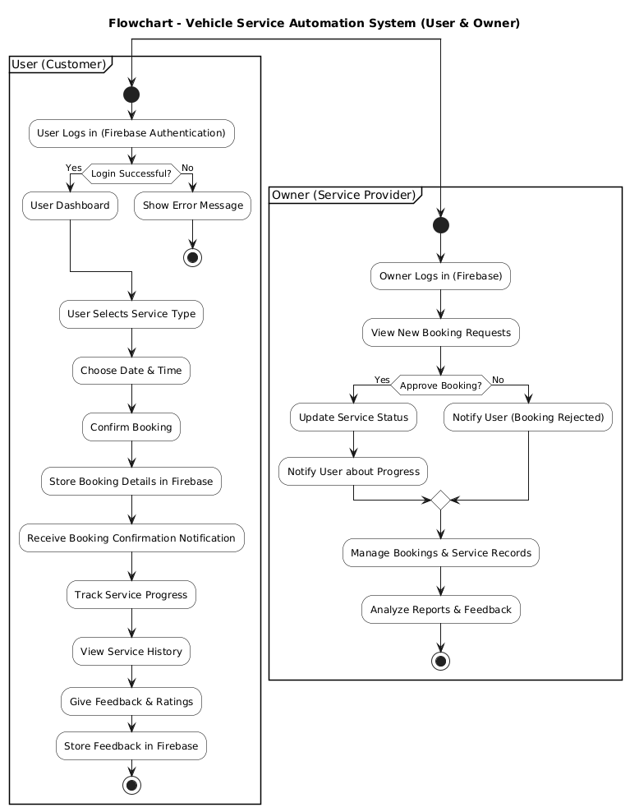

# USE-CASE DIAGRAM

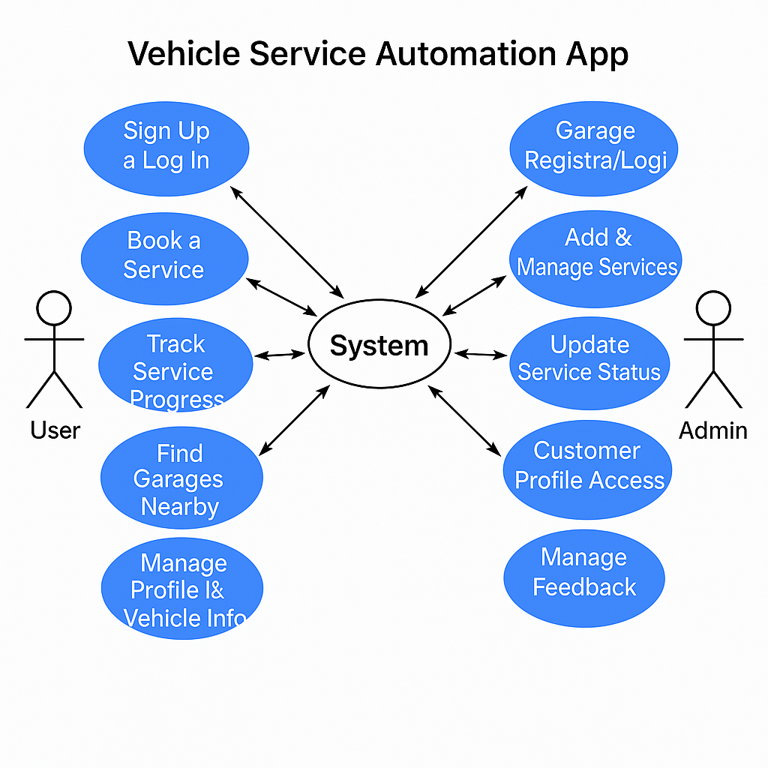

(Figure 6: **Use Case Diagram**)

This is a **Use Case Diagram** for a **Vehicle Service Automation**  App. It visually represents the interactions between different actors (users and Admin) and the system’s functionalities.

### ****Explanation:****

**👤 User (Customer) Side Functionalities:**

1. **Sign Up & Log In** – Users can register/login through Firebase Authentication.
2. **Book a Service** – Select garage, service type, and date; system stores this in Firebase.
3. **Track Service Progress** – View real-time updates pulled from service status in Firebase.
4. **Find Garages Nearby** – Google Maps API integration helps locate service centers.
5. **Feedback System** – After service, users can rate and review, which is stored and passed to Admin.

**🛠️ Admin (Garage Owner) Side Functionalities:**

1. **Garage Registration/Login** – Admins securely access the system via Firebase.
2. **Add & Manage Services** – List types of services and edit pricing/availability.
3. **Update Service Status** – Change service status (Pending → In Progress → Completed) and notify users.
4. **Customer Profile Access** – View user and vehicle details for personalized service.
5. **Feedback Dashboard** – Review user feedback to assess and improve service quality.

# FEATURES AND WORKING

The Vehicle Service Automation App allows users to book and track vehicle services in real time, manage profiles, and locate nearby garages using maps. Garage owners can manage bookings, update service status, and view customer details. Powered by Firebase and Google Maps, the app ensures smooth communication and efficient service handling.

1. The Vehicle Service Automation App provides secure login functionality for both users and garage owners. Users can register using their email and password, allowing them to book and track services seamlessly. Garage owners (admins) have a separate login panel where they can register and access their dashboard to manage bookings and services. Both user and admin authentications are handled securely through Firebase Authentication, ensuring protected access and role-based control within the system.

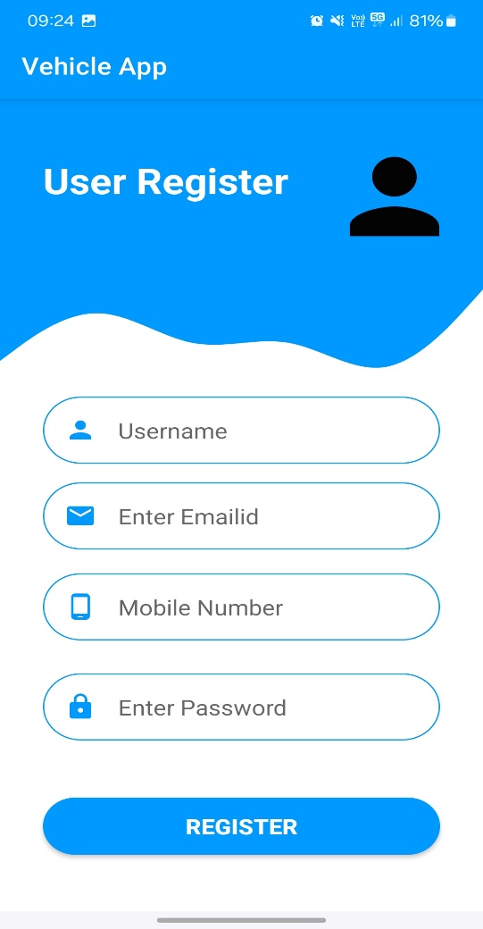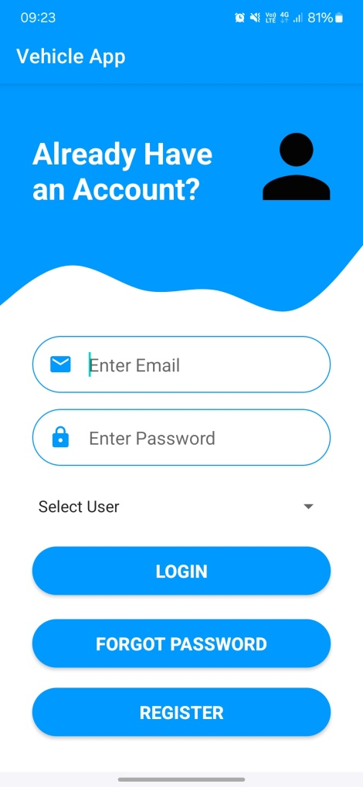

(Figure 1: Login & Register Page)

1. The **Vehicle App** is a user-friendly mobile application designed to help users manage their vehicle information with ease. The main dashboard welcomes users with a message highlighting the importance of car health and features a clean interface with quick navigation options. It includes engaging visuals that promote smooth and safe driving. The user profile section allows users to view and update their personal details, such as name, mobile number, address, and car registration number, along with a profile picture and an easy-to-use update button—all contributing to a seamless and personalized user experience.

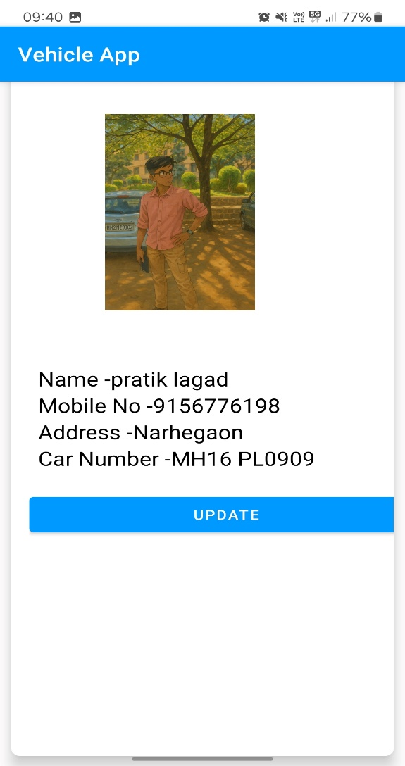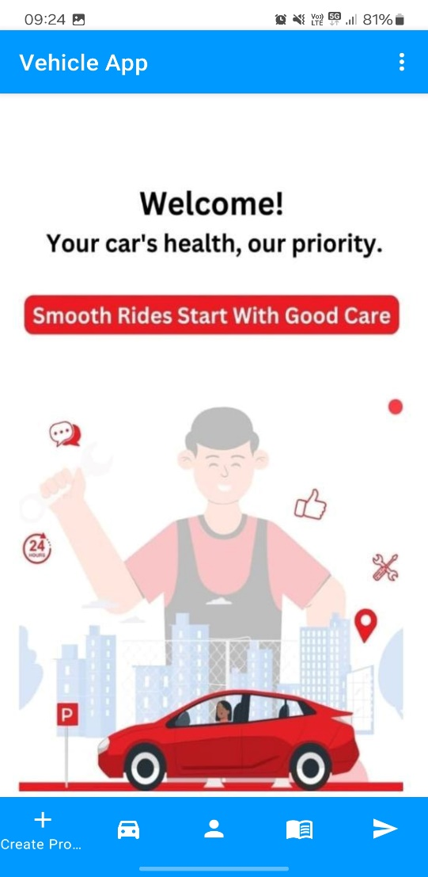

(Figure 3: User dashboard & User Profile)

1. The app allows users to book vehicle services by selecting a preferred garage, service type, and date. The booking details are fetched from Firebase, and the request is stored with the status marked as "Pending" until processed by the admin. Additionally, users can view nearby garages using an interactive map, where the Google Maps API displays service center locations based on the user's current location or search query, making it easy to choose the most convenient garage**.**

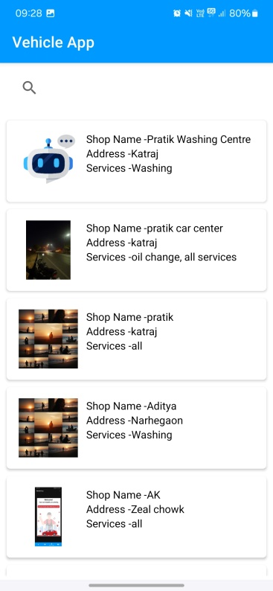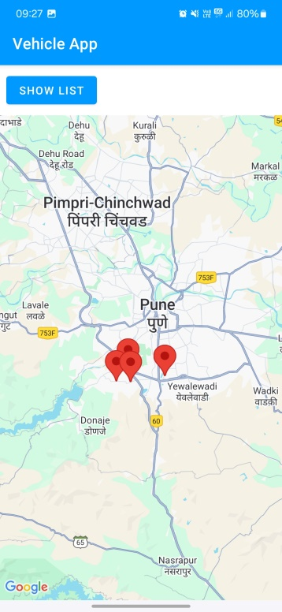

(Figure 3: Book Vehicle Service & View Nearby Garages (Map Integration) )

1. 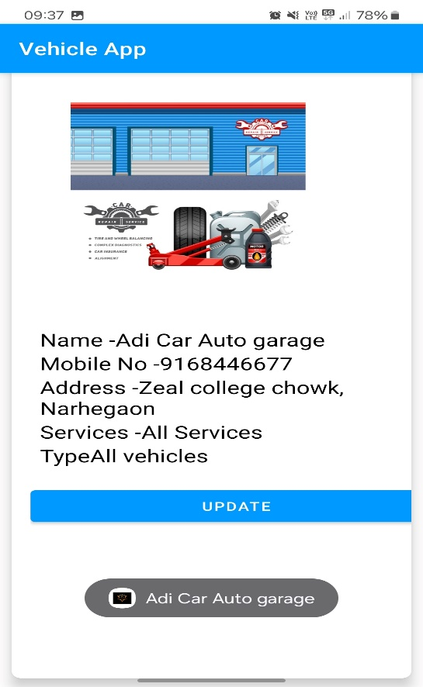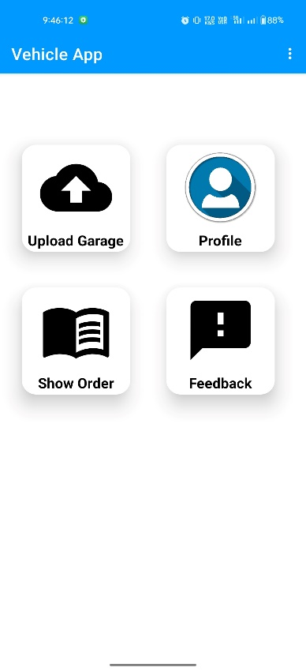The **Admin Dashboard** of the Vehicle App provides easy access to key features such as uploading garage details, viewing orders, giving feedback, and managing the user profile. The **Admin Profile** section displays detailed garage information including the name, contact number, address, and the types of services offered for all vehicles, with an option to update these details.

(Figure 4: Owner Dashboard & Vehicle Details & View Service History)

1. When a user sends a service request in the Vehicle App, the details appear in the admin dashboard under "Show Orders." If the admin wants to accept the booking, they can click the "Send" button, which automatically sends a "Booking Confirm" message to the customer.

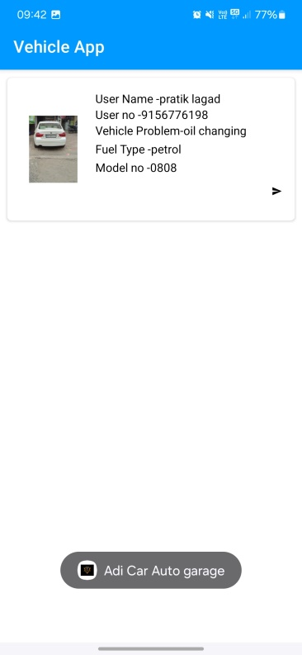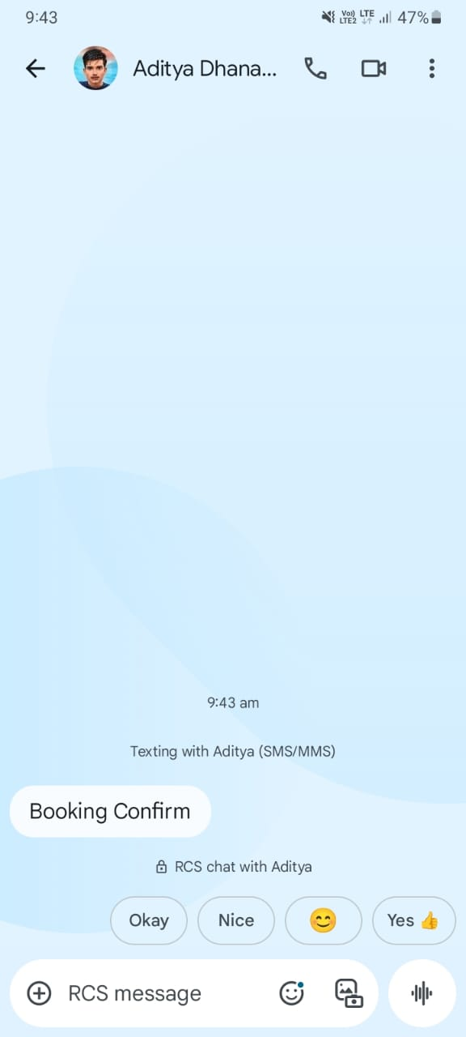

(Figure 5: Booking confirmation & Admin Dashboard )

# FUTURE SCOPE

The Vehicle Service Automation App has the potential for significant future enhancements to improve user experience and expand functionality. One major scope is the integration of **AI-powered service recommendations** based on vehicle history, usage patterns, and predictive maintenance. This would help users get timely alerts and reduce unexpected breakdowns. Additionally, **vehicle pickup and drop scheduling** can be added to offer a fully contactless service experience, especially useful for busy users.

In the future, the system can support **multi-vendor garages**, allowing users to compare services, prices, and ratings before booking. Implementing **subscription-based service plans** and a **loyalty rewards system** would further increase user retention and satisfaction. Real-time **chat support or AI chatbots** can enhance customer support, and **integration with spare parts inventory** would make it easier for garages to manage stock and for users to request specific parts during service bookings. Expansion of the platform to a **web portal** or **cross-platform app** would also broaden user accessibility and reach.

# CONCLUSION

The Vehicle Service Automation App effectively bridges the gap between vehicle owners and service providers by digitizing and streamlining the entire service process. From booking a service to tracking its progress and providing feedback, the app enhances user convenience while offering garage owners powerful tools to manage their operations. By leveraging Firebase for authentication, real-time database management, and push notifications, the system ensures fast, secure, and scalable performance.

Overall, this solution not only modernizes the traditional vehicle service model but also lays a strong foundation for future innovations such as AI recommendations, contactless scheduling, and multi-vendor support. It contributes to improving customer satisfaction and operational efficiency, marking a significant step forward in automotive service management.

# REFERENCES

1]Swarali Degaonkar1, Manasi Khillare2, Gauri Markandey3, Ketki Kerkar4, Dr. Aarti Agarkar5, Vehicle

Service Automation, International Journal of Advanced Research in Science, Communication and

Technology (IJARSCT), Volume 3, Issue 1, August 2023.

2] Sumit Chandra1, A.N. Kshirsagar2, Kartiki Bhos3, Sumedh Borkar4, Mobile Application For

Automobile Service And Repair, Journal of Emerging Technologies and Innovative Research (JETIR),

Volume 10, Issue 5, JETIR May 2023.

3] Vigyani Singh1, Saurav Shinde2 ,Prachi Khedlekar3 , Prof. Nisha Patil4, Vehicle Service System,

International Research Journal of Engineering and Technology (IRJET) e-ISSN: 2395-0056 Volume: 08

Issue: 06 | June 2021.

4] https://ijarsct.co.in/Paper12495