FitPose Using Machine Learning And Tensorflow

Ekta Verma Kanchan DIxit *CSE Department* *CSE Department*

*ABES Engineering College* Ghaziabad, *ABES Engineering College* Ghaziabad, India India ekta.21b0101110@abes.ac.in tokanchandixit@gmail.com

***Abstract*— FitPose is a real-time posture correction application that makes exercises more effective and safe by combining PoseNet and JavaScript. It assists users in performing workouts with ideal alignment by detecting posture problems and delivering corrective feedback based on an analysis of key body areas. For people of all fitness levels, the strategy offers a simple solution to reduce the risk of injury while increasing training efficacy.   
  
FitPose is a lightweight, user-friendly application for real-time posture analysis that includes insights from existing pose estimation frameworks and posture correction procedures. It focuses on identifying common posture anomalies like slouching or misaligned joints and gives simple solutions like "straighten your back" and "adjust your stance." FitPose, which incorporates insights from advanced posture estimation techniques, provides practical advice via visual and audible feedback. This research focuses on the system's architecture, approach, and potential applications in posture correction, fitness, and rehabilitation.**

**Keywords— Pose estimation, posture correction, real-time feedback, PoseNet, exercise safety, JavaScript, fitness technology, body alignment, injury prevention, rehabilitation.**

# I. INTRODUCTION

Maintaining physical health, boosting exercise efficacy, and avoiding injuries all need optimal body positioning. Improper exercise postures can cause a variety of concerns, including joint pain, muscle strains, and decreased workout efficacy. To address these issues, modern technologies like as pose estimation have shown to be excellent tools for assisting people in maintaining optimal postures while participating in physical activities.

FitPose is a real-time posture correction system that utilizes PoseNet, a cutting-edge pose estimation machine learning model. This tool uses spatial analysis of significant bodily features to assess users' workout postures and provides fast feedback to assist them take corrective action, such as"straighten your back" or "adjust your arm position.

FitPose aims to improve workout safety. effectiveness by offering real-time teaching, which makes it particularly Maintaining physical health, boosting exercise efficacy, and avoiding injuries all need optimal body positioning. Improper exercise postures can cause a variety of concerns,

including joint pain, muscle strains, and decreased workout efficacy. To address these issues, modern technologies like as pose estimation have shown to be excellent tools for assisting people in maintaining optimal postures while participating in physical activities.

FitPose is a real-time posture correction system that utilizes PoseNet, a cutting-edge pose estimation machine learning model. FitPose, which uses only a camera, integrates cutting-edge computer vision techniques to deliver quick, personalized recommendations, as opposed to traditional posture analysis tools that rely on wearables or pre-recorded data. This technique provides access to posture correction, ensuring that users can perform exercises without the requirement for specific equipment in any setting. The approach is designed to assess various types of exercise, such as strength training and yoga, highlighting their adaptability and usefulness in today's fitness routines.

FitPose addresses difficulties such as dynamic movement detection and feedback generation, advancing the rapidly growing field of real-time fitness technology. This paper presents the system's design, techniques, and potential applications for increasing exercise efficiency and safety.

# II. LITERATURE REVIEW

Pose estimate technology has improved tremendously, particularly in the areas of rehabilitation and fitness. OpenPose is a popular solution that uses a multi-stage convolutional neural network (CNN) to track and detect 18 critical body regions in real time. This paradigm's usefulness has been proved through fitness routines and other human posture analysis applications. It is an important component of many posture correction systems because of its ability to pinpoint accurate body joint locations. PoseNet is another common model for real-time posture applications, as it is lighter than OpenPose and better suited to devices with limited computing power. PoseNet is a common solution for systems. FitPose is popular because it is simple to use and fast, allowing for seamless integration into web-based applications.

Many posture correction technologies now emphasize real-time posture feedback. The benefits of combining pose estimation with deep learning techniques like as Graph Convolution Networks (GCN) have been demonstrated by systems such as Form Check, which can identify posture flaws and provide suggestions on how to correct them. This device gives the user visual feedback on their posture while tracking the movements of the human body during workouts such as lunges and squats. It can identify significant postural anomalies, such as misplaced knees or backs, and make modifications to improve form. Accurate pose identification, paired with real-time feedback, is critical for avoiding injuries and improving workout performance.

Aside from these technologies, 3D posture estimation systems are an important field of development. 3D pose estimation addresses concerns such as depth ambiguity, whereas 2D pose recognition models such as OpenPose and PoseNet can give enough accuracy for a variety of tasks. For example, MediaPipe posture addresses depth-related issues by combining optimization methodologies with 2D posture assessment. This allows us to perceive human location in three dimensions with better precision and detail. MediaPipe Pose is particularly useful in more complex motions that require 3D analysis for proper posture correction.

Furthermore, machine learning techniques are critical for enhancing posture correction systems. For example, dynamic temporal warping (DTW) algorithms help to match crucial point sequences from many video frames, enabling for more exact tracking of posture changes over time. Body size, camera angles, and movement speed are just a few of the variables that these models can account for, ensuring that input is accurate even in dynamic and unpredictable situations. When these algorithms are paired with position estimation, posture correction systems become more reliable and adaptable, capable of handling a wider range of workouts and motions.​

Important Additions to the of Existing Literature:

1. **PoseNet:** PoseNet uses various phases to determine 17 essential locations. A lightweight solution for real-time applications.
2. **FeedBack Systems:** When making intuitive corrections, visual feedback is required. GCN is integrated into systems like Form Check to evaluate and adjust postures.
3. **3D Pose Estimation:**  MediaPipe Pose uses optimization approaches to overcome depth ambiguities.
4. **Practical Applications:** Promotes proper workout form, which helps to avoid injuries. provides important feedback for recovery activities.

Finally, new breakthroughs in pose estimation, real-time feedback mechanisms, and machine learning algorithms have resulted in more efficient posture correction systems. Tools such as OpenPose and PoseNet, as well as methodologies like GCN and DTW, serve as the foundation for real-time posture correction applications. These systems have shown considerable promise for improving exercise performance, minimizing injuries, and providing users

with individualized remedial input. FitPose builds on these advances by offering a simple, approachable posture correction solution that takes use of current technologies to optimize training and recovery.

# III. MATERIAL AND METHODS

The FitPose system uses PoseNet and JavaScript to provide real-time feedback on posture adjustments. Pose estimation, posture analysis, and feedback generation are the system's primary components. PoseNet examines input pictures or video frames to detect key body points such as joints and limbs. FitPose uses a pose estimation model to recognize the user's posture and identify deviations from normal form. Once the important places have been located, the system uses algorithms to assess alignment and make modifications.

The FitPose program runs on a web platform and uses JavaScript to manage processing and user interface. The technology uses the device's camera to collect real-time video of the user exercising. PoseNet is used to process the collected video frame by frame and extract the body important points. This information is then evaluated to detect posture issues, such as incorrect joint angles or misalignment of body parts. Feedback is offered in the form of visual and written advice, guiding users on how to improve their posture and alignment. This technology democratizes analytics by increasing interactivity and automating operations, allowing a bigger audience to make full use of their data.

To record video input, the system requires a simple webcam or camera. Because the application is developed on a web platform, it can be accessed without the necessity of specialized equipment. The feedback loop operates by processing video frames in real time, analyzing the user's posture, and generating corrective actions based on the pose analysis. This strategy ensures that FitPose will operate in a number of contexts, including at-home workouts and gym sessions.

The suggested system's technique includes a number of important elements:

1. **Pose Estimation:**

PoseNet, a deep learning network, is used to identify critical body points in images and video frames. PoseNet's real-time performance ensures fast feedback for posture adjustments.

1. **Posture Analysis:**

To determine the accuracy of posture, the system evaluates the indicated body locations. Deviations from correct form are discovered using specified standards such as body alignment and joint angles.

1. **Mechanism of Feedback:**

Real-time corrective advice, such as "straighten your back" or "adjust your stance," is available in both text and graphic formats. JavaScript is utilized to enable smooth interaction and integration.

FitPose combines position estimation, real-time video processing, and feedback production to provide a full posture correction solution. The system is designed to work on most webcam-enabled devices, providing users with accessibility and convenience while they try to improve their exercise form.

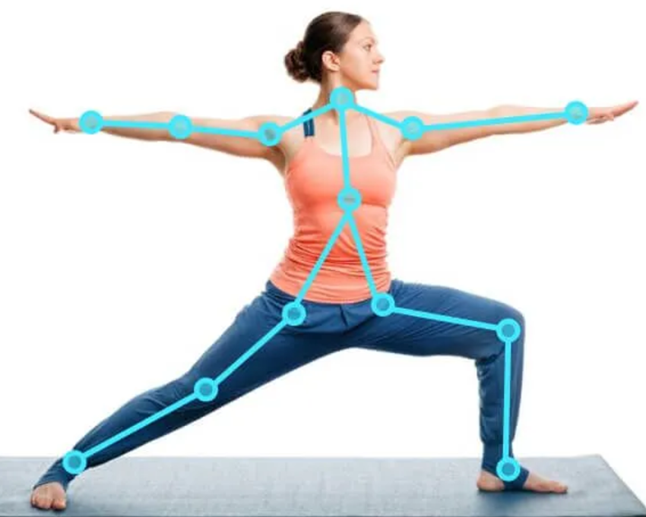

Fig 1.1 Real-time pose estimation for accurate posture tracking in fitness and yoga.

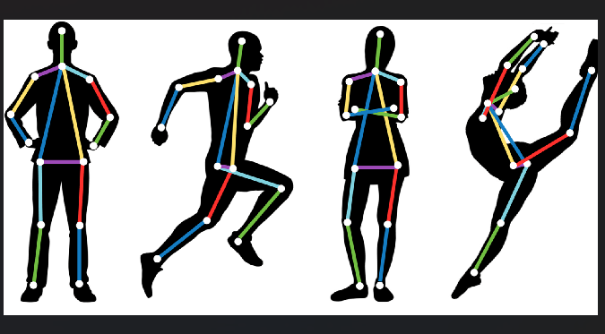 *Fig 1.2* Illustration of human pose estimation with keypoints and skeleton overlays for various body movements.

## System architecture

## 

FitPose's architecture is built around the successful integration of machine learning models, specifically PoseNet and TensorFlow, to deliver precise and instantaneous posture correction. Using a camera and a computer, the system is simplified to observe user movements, identify poor posture, and provide relevant feedback.

The major component, PoseNet, employs machine learning to identify important body landmarks such as the knees, hips, shoulders, and elbows. TensorFlow-based algorithms look at these key locations to evaluate posture and find deviations from optimal workout routines. FitPose detects errors such as slouching, improper arm angles, and misaligned joints and

delivers corrective feedback by comparing the user's detected position to pre-defined templates.

Accessibility and simplicity are prioritized in the architecture. Users only need a browser that supports TensorFlow.js and a simple camera. The entire method, from pose estimation to feedback production, takes place in real time and does not require expensive hardware. This ensures that FitPose is compatible with a wide range of devices, such as laptops, tablets, and smartphones.

Accessibility and simplicity are prioritized in the architecture. Users only need a browser that supports TensorFlow.js and a simple camera. The entire method, from pose estimation to feedback production, takes place in real time and does not require expensive hardware. This ensures that FitPose is compatible with a wide range of devices, such as laptops, tablets, and smartphones.

FitPose's system design integrates computer vision, machine learning, and human interaction to accurately analyze and correct workout postures in real time. An explanation of the architecture is provided below:

1. **Input Module:**

The input module's goal is to record the user's physical activities.

Camera: Any standard webcam or smartphone camera with RGB video capturing capabilities. In order to ensure clarity and proper alignment for posture estimation, the video preprocessor processes input frames.

User Interface: Helps users position themselves properly within the camera's range of vision for the best results.

1. **Pose Estimation Module:**

Estimating Pose The module's purpose is to identify essential body landmarks and determine the user's posture in real time.   
Technology: Use PoseNet or a similar algorithm to estimate human poses accurately.

Procedure: A skeletal model is created by mapping essential body locations such as the knees, elbows, and shoulders.   
Adjusts crucial point data to account for various camera angles and body sizes.

1. **Posture Analysis and Feedback Module:**

Posture Posture Evaluation and Input The module's purpose is to evaluate the detected pose, identify poor posture, and make corrective recommendations.

Parts: Pose analysis compares the user's primary points and angles to previously set templates for good posture.   
Detects deviations in body alignment by geometric computations.   
Feedback generation: provides suggestions (e.g., "Lower your shoulders" or "Stretch your back"). delivers both textual and visual feedback.

Algorithms: Includes machine learning models for error categorization and threshold-based detection of key angles.

1. **Query for the Feedback Display Module**

Feedback Display Module Giving them remedial guidance in real time is the aim.

Characteristics:

Overlay live video to highlight problematic areas (e.g., a slouching back or incorrect arm position). either text-based or audio-based corrective cues.

1. **Integration of Machine Learning Models**

Goal of Machine Learning Model Integration: Enhances the system's ability to adapt to various user situations and exercises.

Models Employed:

PoseNet: For real-time pose detection.

Customised classifiers: trained to identify specific types of physical activity.

1. **Module for Data Management and Reporting**

Data management and reporting Monitoring user performance over time is the aim of the module.

Features: Keeps track of posture analysis results.

produces session reports that provide information on characteristics like exercise duration, recommended enhancements, and posture accuracy. Reports can be exported for fitness trainers or personal usage.

1. **Needs for Hardware and Software**

Hardware and Software Requirements

Hardware: Camera (either a standard webcam or smartphone).

technological equipment, like a laptop, smartphone, or desktop computer with middling specs.

Software: The FitPose program was developed using PoseNet, JavaScript and TensorFlow.js .

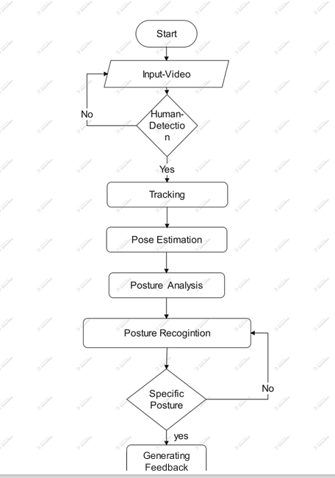

*Flowchart of methodology*

## V. Implementation

FitPose is a web-based application that instantly corrects posture using PoseNet and JavaScript. The solution works seamlessly on devices with cameras, guaranteeing accessibility and user-friendliness. The following are the steps that comprise the implementation process:

1. **Analysis and Estimation of Posture:**

PoseNet examines each video frame to pinpoint key body parts, such as the elbows, shoulders, hips, and knees. PoseNet uses the coordinates of these significant locations to build a skeleton model of the user. The system evaluates joint angles and the distances between significant locations. Deviations from an ideal posture are identified by comparing the user's skeletal data to established posture norms for certain exercises.

1. **Error Fixing and Feedback Production:**

JavaScript is used by the technology to deliver corrective feedback in real time. Textual recommendations like "straighten your back" and visual overlays on the video, like different colours for bad and good posture, are examples of feedback.

The feedback is tailored to treat specific posture issues and offers specific growth techniques.

Users may rapidly adjust their posture by following the advice, which will improve their training technique and reduce their chance of injury.

1. **Flowchart and Workflow:**

The following are the steps in the system workflow:

1. Users can submit a video or begin a live feed from their camera for posture analysis.
2. PoseNet processes the video frame by frame to identify key body parts like joints and limbs.
3. The algorithm calculates joint angles and positions based on the key points that PoseNet collected.
4. The algorithm calculates joint angles and positions based on the key points that PoseNet collected.
5. To find deviations from ideal posture, calculated angles and positions are compared to preset criteria for certain tasks.
6. The technology provides corrective feedback through visual overlays on the video (such as a skeleton model) and written directions (such as "straighten your back").
7. Users adjust their posture in response to information to guarantee proper alignment during exercises.
8. Posture correction at the end of the session improves workout technique and reduces the risk of injury.

FitPose provides easily accessible, real-time posture correction thanks to this procedure, which encourages safer and more efficient physical activity.

1. **Results and Discussion**

The application FitPose demonstrated promising results in accurately detecting and correcting postural faults during exercise. Using PoseNet, the system was able to identify key body parts, such as the knees, hips, and shoulders, enabling precise joint angle and position calculations. This made it simpler to recognise postural errors including slouching and misaligned limbs.

Outcomes:

1. **Pose Estimation Accuracy:** PoseNet fully recognised key body sites, enabling precise joint angle calculations. The technology handled dynamic motions in exercises like lunges and squats with minimal lag.
2. **Real-Time Feedback:** Because feedback, which included visual overlays and auditory prompts, was delivered rapidly, users were able to instantly modify their posture.

Users claimed improved understanding of postural errors as a result of the evident visual changes.

1. **Accessibility:** The lightweight nature of the JavaScript implementation ensures compatibility with common devices such as laptops and smartphones without requiring additional hardware.
2. **Error Identification:** Common posture errors such as slouching or misaligned joints were correctly identified, and users were assisted in improving their form in following attempts by the corrective recommendations.

Improvements:

PoseNet's robustness and adaptability to a range of user scenarios can be increased by adding more datasets for training. This will also address pose detection limitations in challenging situations, such as occlusions, dim lighting, or unusual camera angles. Additionally, real-time performance can be further enhanced by optimising the processing pipeline to better handle high-resolution inputs.

Voice-guided feedback may be incorporated into future updates to make the system more interactive and user-friendly. Greater precision would result from support for numerous cameras, which would allow for a more in-depth analysis of complex movements. By including dedicated modes for yoga, rehabilitation, or office ergonomics, the application's utility might be expanded. FitPose may prove to be an essential tool for enhancing posture and fitness thanks to its machine learning-based personalisation features, which offer tailored feedback according to user profiles.

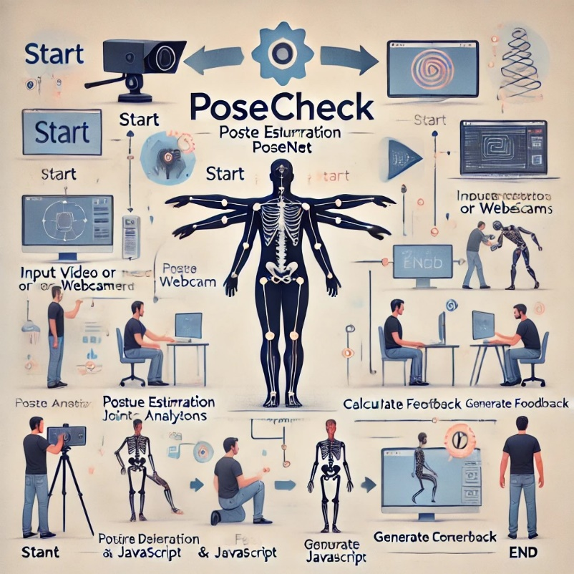

*Fig. 2.1 Flowchart illustrating the workflow of FitPose.*

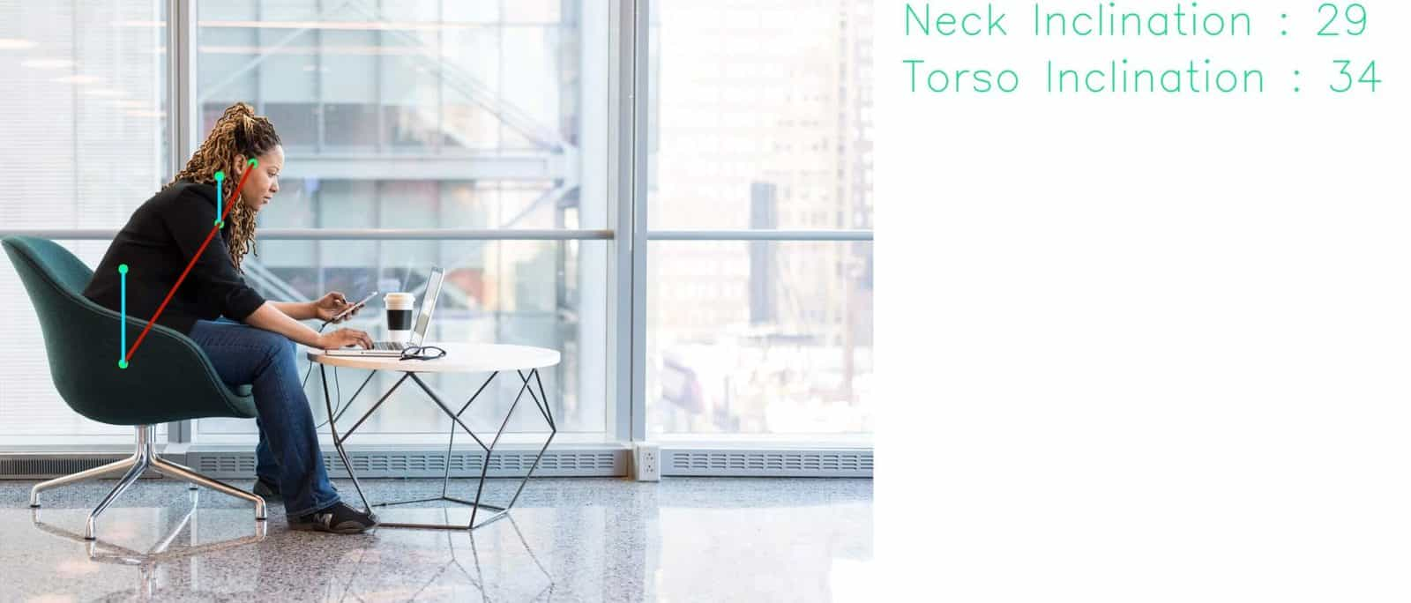

*Fig 2.2 Body Posture Detection & Analysis System*

## VI. Conclusion

FitPose is a great real-time posture correction application that combines JavaScript and PoseNet to detect and fix postural mistakes made during exercises. By providing users with clear visual and written feedback, the technology helps users improve their form, reduce their risk of injury, and boost the effectiveness of their workouts.

**A. Effective Posture Correction**

FitPose efficiently detects and corrects postural issues using JavaScript and PoseNet. The technology allows users to instantly change their form because it provides real-time feedback.

1. **Accessibility and Usability**

The web-based approach is lightweight and does not require additional hardware, ensuring compatibility with ordinary devices.

1. **Benefits for Users**

Users reported significant improvements in postural awareness and workout efficiency, which reduced the risk of injury.

1. **Scalability**

FitPose is a versatile tool that may be applied to a number of domains, including fitness, rehabilitation, and workplace ergonomics.

1. **Future Prospects**

FitPose could evolve into a comprehensive posture correction and injury prevention system with additional features like voice-guided feedback, support for multiple cameras, and personalised suggestions.

The project shows how posture assessment technology can be applied to a number of domains, including rehabilitation, fitness, and ergonomics. With future features like voice-guided feedback, multi-camera compatibility, and personalised recommendations, FitPose has a lot of promise to become a comprehensive tool for improving posture and fitness.

# REFERENCES

1. Kolla, M., Varma, P., & Tondanoorthy, D., “*Form Check: Exercise Posture Correction Application*,” *Journal of Electrical Systems*, 20-4s (2024): 25-33.
2. Kim, J.-W., Choi, J.-Y., Ha, E.-J., & Choi, J.-H., “*Human Pose Estimation Using MediaPipe Pose and Optimization Method Based on a Humanoid Model*,” *Applied Sciences*, 13 (2023): 2700.
3. Kanase, R. R., Kumavat, A. N., Sinalkar, R. D., & Somani, S., “*Pose Estimation and Correcting Exercise Posture*,” *ITM Web of Conferences*, 40, 03031 (2021).
4. Jiang, X., Hu, Z., Wang, S., Zhang, Y., "A Survey on Artificial Intelligence in Posture Recognition," Computer Modeling in Engineering & Sciences, vol. 137, no. 1, pp. 36-51, 2023​
5. M. Buttenschoen, G. M. Morris, and C. M. Deane, "PoseBusters: AI-based docking methods fail to generate physically valid poses or generalize to novel sequences," Chemical Science, vol. 15, no. 3130, pp. 3130–3139, 2024.
6. Munea, T. L., Jembre, Y. Z., Weldegebriel, H. T., Chen, L., Huang, C., & Yang, C. (2020)., “The progress of human pose estimation: A survey and taxonomy of models applied in 2D human pose estimation,” *IEEE Access, 8*, 133330–133348.
7. Redmon, J., Divvala, S., Girshick, R., & Farhadi, A. (2016)., “You only look once: Unified, real-time object detection,” In *Proceedings of the IEEE Conference on Computer Vision and Pattern Recognition* (pp. 779–788).
8. Zhang, S., Tong, H., Xu, J., & Maciejewski, R. (2019)., “Graph convolutional networks: A comprehensive review,” *Computational Social Networks, 6*(1), 1–23.
9. Xu, J., Yu, Z., Ni, B., Yang, J., Yang, X., & Zhang, W. (2020)., “Deep kinematics analysis for monocular 3D human pose estimation,” In *Proceedings of the IEEE/CVF Conference on Computer Vision and Pattern Recognition* (pp. 899–908).
10. Bazarevsky, V., & Grishchenko, I. (2020)., “On-Device, Real-Time Body Pose Tracking with MediaPipe BlazePose,” *Google Research*.
11. Pavlakos, G., Zhou, X., Derpanis, K. G., & Daniilidis, K. (2017)., “Coarse-to-fine volumetric prediction for single-image 3D human pose,” In *Proceedings of the IEEE Conference on Computer Vision and Pattern Recognition* (pp. 7025–7034).
12. Wei, S., Ramakrishna, V., Kanade, T., & Sheikh, Y. (2016)., “Convolutional Pose Machines,” In *2016 IEEE Conference on Computer Vision and Pattern Recognition* (pp. 4724–4732).
13. Bogo, F., Kanazawa, A., Lassner, C., Gehler, P., Romero, J., & Black, M. J. (2016)., “Keep it SMPL: Automatic estimation of 3D human pose and shape from a single image,” In *Proceedings of the European Conference on Computer Vision* (pp. 561–578).
14. Newell, A., Yang, K., & Deng, J. (2016)., “Stacked hourglass networks for human pose estimation,” In *Proceedings of the European Conference on Computer Vision* (pp. 483–499).
15. Kocabas, M., Athanasiou, N., & Black, M. J. (2020)., “Vibe: Video inference for human body pose and shape estimation,” In *Proceedings of the IEEE/CVF Conference on Computer Vision and Pattern Recognition* (pp. 5253–5263).