**Abstract:**

Blockchain technology initially created for digital transaction and it is describe as the decentralised distributed ledger for recording transactions and record and for tracing. In recent years, Blockchain technology is growing worldwide in various fields including pharmaceutical industry. The global pharmaceutical industry faces various challenges over the decades. According to WHO nearly 10.5% drugs are found to be substandard or fake. These problems arises due to the poor monitoring and supply chain management. Pharmaceutical Industry faces the issues such as drug counterfeiting, poor supply chain management, improper data management, etc. Blockchain offers the potential solution to these issues by securing data, tracing of drug supply chain from the manufacturing to the drug distribution. This study explores the potential application of Blockchain technology in Pharmaceutical by identifying the current trends, issues in the Pharmaceutical industry. Study also identifies the limitations of Blockchain such as scalability issues, implementation issue, etc. and challenges of Blockchain in pharmaceutical industry after implementation. The future implication by disrupting the traditional intermediates and also by implementing the Blockchain with AI and IoT also addressed.

**Key words:** Blockchain,, Supply Chain Management, Counterfeit drug, Data integrity.

**Introduction**

The international pharmaceutical drug market suffers from $200 billion in fake, substandard, counterfeit, and gray medicines annually. Research has revealed a range of pharmaceutical products, medications, agricultural goods, healthcare products, and medical devices that are being counterfeited across different countries, highlighting the susceptibility of the entire drug supply chain to such criminal activities. Meanwhile, the healthcare industry is actively seeking improvements in its supply chain management [1]. Many issues plague the traditional pharmaceutical supply chain, such as product shipment that has expired, lack of trust, tracking products, and lack of transparency. However, to produce and distribute drugs, the pharmaceutical industry needs to keep accurate records of the source of raw materials. The application of Blockchain technology in the pharmaceutical business has been highlighted as a potential solution to protect against the distribution of counterfeit drugs, given its qualities, namely its capacity to provide decentralization, transparency, trust, anonymity, and stability. Blockchain technology has the potential to track the provenance of medications, their transportation, and the acquisition of raw ingredients. Additionally, Blockchain technology lowers the number of middle men in the pharmaceutical process, which lowers prices and boosts security[2]

**Literature Review:**

1. **Gaurav Kumar Badhotiya *et.al* (2021**) **‘Investigation and assessment of blockchain technology adoption in the pharmaceutical supply chain’**: The global pharmaceutical industry has faced significant challenges over the past decade, particularly with counterfeit drugs, operational inefficiencies, and cold chain logistics for vaccines and medicines. Blockchain technology offers potential solutions to these issues by securely tracking product authenticity from production to consumption, preventing financial losses. This study explores the integration of blockchain into the pharmaceutical supply chain, enhancing transparency, trust, and security in transactions. The adoption and implementation of blockchain to address these supply chain challenges are discussed.

1. **Mark Gaynor *et.al* (2024)** **‘Blockchain applications in the pharmaceutical industry’**: In recent years, blockchain technology has made great strides in diverse industries but has fallen behind within the pharmaceutical industry. The pharmaceutical industry is complex and would benefit greatly from the distributed database and emphasis of information privacy promoted by blockchain technology. This paper identifies the potential best application for blockchain technology in the United States pharmaceutical industry by identifying current trends, companies exploring the possibilities of blockchain technology, and industry concerns with opportunities for improvement.

1. **Pathak R** ***et.al* (2023)** **‘Tackling counterfeit drugs: The challenges and possibilities’** : Counterfeit drugs, which are fraudulently manufactured or packaged with incorrect ingredients or dosages, have become a global issue. According to the World Health Organization, nearly 10.5% of medications worldwide are substandard or fake. While developing countries are major targets for drug counterfeiting, fake drugs are also reaching developed nations like the USA, Canada, and Europe. Counterfeiting leads to economic losses and contributes to patient morbidity and mortality. The COVID-19 pandemic further increased the demand for certain medicines, amplifying the production of substandard drugs. This review highlights the current trends and global impact of drug counterfeiting, measures for prevention, and the role of stakeholders in combating this problem.
2. **Kuyoro A *et.al.* (2020) ‘Blockchain technology: An overview and areas of application.’:** Blockchain is considered to be an emerging technology and was introduced through bitcoin. Blockchain can be described as a distributed ledger technology capable of recording safe and continuous transactions between parties. Attempts have been made toadapt the technologytoother fields of implementation, outside finance, so that the interesting characteristics of blockchain could benefit other sectors and use cases. Blockchain is now regarded as a general-purpose technology that has discovered applications in various sectors and applications, such as identity management, conflict resolution, contract management, supply chain management, insurance and healthcare, to name a few. This paper presents an overview of blockchain technology and its application areas.
3. **Ghadge A** ***et.al* (2023)** **‘Blockchain implementation in pharmaceutical supply chains: A review and conceptual framework.’:** This study explores the potential of Blockchain technology in pharmaceutical supply chains (PSC) and aims to build a conceptual framework for its implementation. Through a systematic review of 65 interdisciplinary articles published between 2010 and 2021, the research identifies key developments, drivers, barriers, and applications of Blockchain in PSC. Thematic analysis highlights its use in addressing drug counterfeiting, recalls, patient privacy, regulations, and clinical trials. Despite slow adoption, Blockchain research in PSC has accelerated since the Covid-19 pandemic. The proposed framework offers valuable insights for producers, regulators, and governments to implement Blockchain in the pharmaceutical industry.
4. **Islam I** ***et.al* (2024)** **‘A Blockchain-based medicine production and distribution framework to prevent medicine counterfeit.’ :** This research addresses the growing issue of medicine counterfeiting, particularly in developing countries like Bangladesh. It outlines factors contributing to counterfeit drugs and proposes a blockchain-based framework to prevent this issue. Through content analysis and interviews with key personnel in Bangladesh's medicine manufacturing and distribution system, use cases for tackling counterfeiting identified. A blockchain solution developed based on these findings, and its prototype evaluated. The proposed framework found to be secure, scalable, customer-oriented, and practical compared to other solutions.

**Blockchain**

The concept of Blockchain was first introduced by Stuart Haber and W.Scott Stornetta while they were trying to build a system in which document timestamps could not be modified. This was later implemented in the year 2008 by Satoshi Nakamoto. Blockchain can be defined as a growing list of records called blocks, which are linked and stored using cryptography**[3]**. Many organizations have defined Blockchain technology in different ways. Coinbase, the bulkiest cryptocurrency exchange across the globe, has established the Blockchain as “A distributed, public ledger that contains the history of every bitcoin transaction”. The Oxford dictionary bestows a familiar definition stated as “A digital ledger in which transactions made in bitcoin or another cryptocurrency are recorded chronologically and publicly". Another description is given by Sultan *et,al*., which narrates a very general definition of Blockchain technology as “A decentralized database containing sequential, cryptographically linked blocks of digitally signed asset transactions, governed by a consensus model” Blockchain uses the concept of a ledge1r which may be seen as a database to maintain the records or a list of transactions. Blockchain is a network of blocks (nodes) that connect to one another following some topology rather than being connected with a central server. It has the potential to store the transactions in the ledger effectively and confirm transparency, security, and auditability[4].

**Components of Blockchain:**

* 1. Block
  2. Genesis block
  3. Chain and height
  4. Nonce
  5. Nodes
  6. Cryptographic hash function
  7. Ledger
  8. Distributed peer to peer network
  9. Asymmetric key cryptography
  10. Smart contract
  11. Concensus mechanism

1. **Block**: Block in the Blockchain technology is the decentralized nodes/miners equipped with the databases, and it contains the digital piece of information. Blocks are linked together containing the hash value of the previous block into the current block. In general, block structure can be visualized into two parts: block header and a list of transactions.

Block headers consist of following information:

* + Version number indicates the version number of the block and uses 4 bytes for its representation.
  + Previous block hash is a pointer between the previous and current block and uses 32 bytes.
  + Timestamp uses 4 bytes and stores the time of the creation of the block.
  + Merkle tree is represented by 32 bytes and is a hash of every transaction that takes place in a block
  + Nonce also uses 4 bytes and computes the different hashes.

List of transactions includes the no of transaction that occurred.

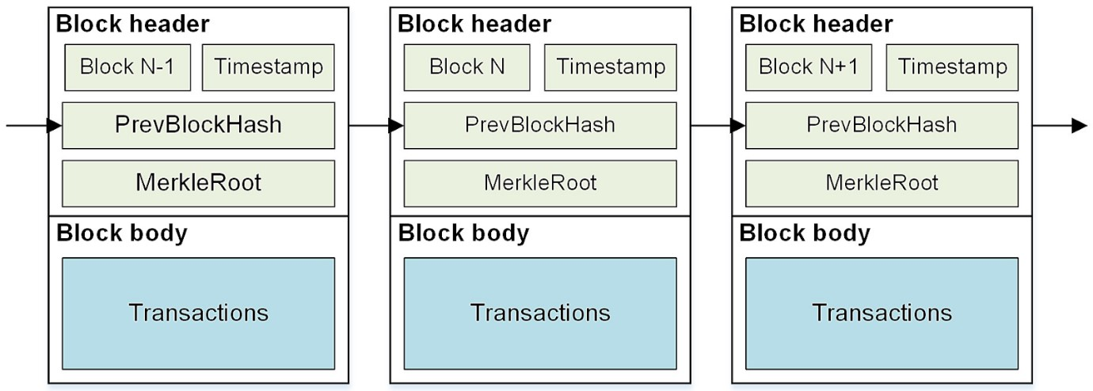

**Fig.1 Structure of block[7].**

1. **Genesis Block**: In a Blockchain, genesis block is consider as a foundered block because it is the first block in chain. The Block height of the first block is always zero, and no block precedes the genesis block. Every block which is part of a Blockchain comprises of a Block Header along with Transaction Counter, and Transactions.

1. **Chain and Height:** In Blockchain technology, the chain is a virtual string that connects the miners in the accrescent set of blocks with hashes. The chain keeps growing as and when a new block is append. Blocks in the chain are generally indicated by their block height in the chain which is nothing but a sequence number starting from zero

(0).

The height of a block is define as the number of blocks in the chain between the genesis block and the given block (for which height is to be calculated).

1. **Nonce:** A nonce, an abridgment for “number only used once” is a one-time code in cryptography. It is a number appended to the hashed (encrypted) block in a Blockchain. When it is rehash, it ensures the difficulty level of antagonism. The Nonce is the number for which Blockchain miners solve a complex problem. It is also associated with the timestamp to limit its lifetime; that is why if one performs duplicate transactions , even then a different Nonce is required.

1. **User/node and Miner:** A computationally advanced node that tries to solve a complex problem (which requires high computation power) to retrace a new block which is recognized as a miner. The miners can work alone or in a collective routine to find the solution to the given mathematical problem[4].

1. **Cryptographic hash function:** An important component of Blockchain technology is the use of cryptographic hash functions for many operations.

Hashing is a method of applying a cryptographic hash function to data, which calculates a relatively unique output for an input of nearly any size. It allows individuals to independently take input data, hash that data, and derive the same result – proving that there was no change in the data. Even the smallest change to the input will result in a completely different output digest. Cryptographic hash functions are used for many tasks, such as : -

* Address derivation
* Creating unique identifiers.
* Securing the block data – a publishing node will hash the block data, creating a digest that will be stored within the block header.
* Securing the block header – a publishing node will hash the block header.

1. **Ledger:** A ledger is a grouping of transactions. Pen and paper ledgers have been used to keep account of the transaction of commodities and services for centuries. Ledgers are now held digitally, frequently in massive databases owned and operated by a centralized trustworthy third party (the ledger's owner) on behalf of a community of users. These centralized ownership ledgers can be deployed either centrally or distributed. There is considerable interest in researching the possibility of distributed ledger ownership. Blockchain technology supports this approach by utilizing both distributed ownership and a distributed physical design [5].

1. **Distributed Peer 2 Peer Network:** P2P network design is the fundamental building component of the Blockchain technique. With the approval of this regulation, we can no longer rely on a server, which is a primary source of decision-making. The user must have total faith on networks and hope that they don't have a backdoor that allows them to secretly view or alter the reports. It is also important to hope that they do not cease operations and disable their servers. Instead of utilizing a server, the nodes—which include tablets, routers, and other devices—interact and share data with one another directly, disseminating all of the data throughout every node in the grid. The Blockchain will be replicate across all nodes in the network, making it impossible for anyone to alter any value within the chain.

1. **Asymmetric-Key Cryptography:** A pair of keys—a public key and a private key— that are mathematically connected to one another are used in asymmetric key cryptography. The process's security is maintained when the public key is disclosed, but the data's cryptographic protection depends on the private key's continued secrecy. Despite the two keys being related, it is impossible to efficiently determine the private key from the public key. A public key can be used to decrypt data that has been encrypted using a private key. Alternatively, one can use a public key for encryption and a private key for decryption[5].

1. **Smart contract:** In 1997, Szabo coined the phrase "smart contract," referring to a legal agreement that combines user consent and computer protocols to enforce its provisions. Embedded in computer code that is controlled by the Blockchain, a smart contract is a self-enforcing agreement—one that is up held by the parties involved.

Computer protocols control it, allowing a trustworthy transaction to be completed without the involvement of other parties. Trackable and irreversible transactions are carried out using the Smart Contract. The three main parts of a smart contract are an account balance, a storage file, and some code. To start a transaction on the Blockchain, a node can generate it. Once it has been entered, the lines of code cannot be changed[4].

1. **Consensus mechanism :-** The protocols known as consensus mechanisms make sure that every node in the Blockchain is in sync with every other node. Before adding the transaction to the Blockchain, it verifies that it is authentic. There are a lots of consensus techniques available now. Nonetheless, a few well-known and widely used Blockchain consensus techniques are Ripple, Tendermint, Proof of Work (PoW), Proof of Stake (PoS), and Delegated PoS.

The first and most often used consensus method is PoW[4].

**Proof of work (PoW)** - According to this technique, a node known as a miner verifies each new transaction (block) made on the network. When combining a random number with the data contained in a block, miners utilize the hashing method. If the hash value produced falls within the allowed range, the miner will receive reward points, and all other miners will cease working on that block.

**Proof of stake (PoS)** - Their share of coins on the network serves as the basis for this algorithm. A node which have more coins will have the opportunity to validate the block

[7].

**How it works:-**

A Blockchain is an electronic concept for data storage; Figure 2 illustrates how the Blockchain operates. Since information is organize into blocks, the squares can be referred to as information squares; when the squares are bound together, the information blocks become permanent, meaning that once the squares are fixed together, the information cannot be altered significantly. A Blockchain transaction must first go through a number of important steps. The working mechanism of the Blockchain as shown in Figure 2. When a transaction is made on the Blockchain and authentication is needed, a block containing the transaction's information is created, sent to each node or participant in the Blockchain, and the nodes validate the transaction. If the newly created

node's information is incorrect or altered, it will not match other node blocks in the Blockchain, which will cause the validation to fail and prevent the transaction from being record. If, however, the validation is successful, the transaction is completed. Additionally, every node within that specific Blockchain network will receive the updates. The Blockchain is then update with the block. The nodes are rewarded, typically with cryptocurrency, for their Proof of Work[8].

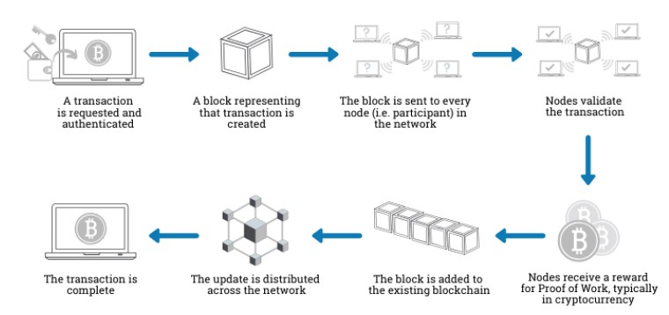

**Fig.2 How it works [8].**

**Types of Blockchain:-**

Experts classified Blockchain Technology into following types-

* Public Blockchain • Private Blockchain
* Hybrid Blockchain
* Consortium Blockchain

1. **Public Blockchain :-** Public Blockchain technology is major type of Blockchain which is open and decentralized, with computer networks accessible to anyone interested in transactions. Transaction rewards are distributed based on validation, and two types of Proof-of-Work and Proof-of-Stake models are used.

Some of the examples of this type of Blockchain are- Bitcoin, Etherium.

1. **Private Blockchain :**- Private Blockchain are restricted and not open to everyone, it also has a features of access. This kind of Blockchain is limited to closed systems and networks, which are typically helpful in businesses and organizations where membership is restricted to specific individuals. This kind of Blockchain has appropriate accessibility, authorizations, permissions, and security. Private Blockchain are only accessible to approved nodes, preventing outsiders from accessing transaction-related data. Eg. Vechain and Mediledger are the private blockchain used by pharmaceutical industry like Pfizer.

1. **Hybrid Blockchain :-** Hybrid Blockchain, which combine public and private Blockchain, provide greater control and help achieve higher goals. Hybrid Blockchain combines controlled and decentralized systems. Although not open, it offers integrity, transparency, and security. Hybrid Blockchain offer maximal customisation through both permission-based and permission-less systems. Blockchain technologies allow users to access specific areas while keeping the remainder secure through ledger records.

1. **Consortium Blockchain :-** Consortium Blockchain is another type of semidecentralized type of Blockchain, and this type of Blockchain is able in the organization of managing the Blockchain network. This type of Blockchain is able in doing activities even from a single organization. Here Blockchain is able in exchange information or do the mining and are being used in the areas such as banks, government organizations, etc. Some of the examples of this type of consortium are Energy Web Foundation, R3, etc.

|  |  |  |  |  |
| --- | --- | --- | --- | --- |
|  | **Public** | **Private** | **Hybrid** | **Consortium** |
| **Type** | **Permissionless** | **Permissioned** | **Both** | **Permissioned** |
| **Control** | **No control by**  **any authority** | **Control by a central authority** | **Control by a central authority** | **Control by a multiple central authority** |
| **Advantage** | **Independent Transparency** | **Performance**  **Partially**  **Secure** | **Performance**  **Security** | **Security**  **performance** |
| **examples** | **Bitcoin,**  **etherium** | **Hyperledger**  **Mediledger** | **XRP token** | **Web**  **foundation,**  **R3** |

**Table1. Types of Blockchain**

**Key Characteristics of Blockchain Technology**

**Decentralized**: It is a network-connected database system with open access control. The information on various devices can be accessed, tracked, stored and updated.

**Transparent**: Blockchain information recorded and stored is transparent to prospective customers, which can be readily update further. Blockchain's transparent nature could definitely avoid altering or stolen information.

**Immutable**: Once stored, the records become permanently reserved and cannot be easily modify without controlling more than 51 percent of the node at the same time.

**Autonomy**: The Blockchain system is independent and autonomous, which means that each node on the Blockchain system can safely access, transfer, store and update the data, making it reliable and free from any external interference.

**Open Source:** The Blockchain technology is develop in a manner that offers opensource access to all network linked. This inimitable versatility enables anyone not only to openly inspects the documents, but also to create multiple applications that are imminent [9].

**How Blockchain is useful in Pharmaceutical Industry**

The pharmaceutical sector uses Blockchain technology in two different ways**:**

**1. monitoring** and **2. management**. These sections show various components and functions used in implementation strategies. Nevertheless, when integrated, they promote industry best practices and a possible Blockchain technology foundation for the pharmaceutical sector[10].

Pharmaceutical

industry

Monitoring

Drug

Authenticity

Prescriptions

Management

Inventory

Data

Management

**Fig.3 Use of Blockchain**

**Monitoring**

Drug

Authenticity

Prevent

Counterfeits

Supply Chain

Prescriptions

Interactions

Doctors

Shipping

**Monitoring:**

The pharmaceutical industry’s ability to monitor goods and products is essential. Many stakeholders are involved in the delivery of one specific product to any individual consumer. However, given the industry’s multifaceted nature, there is a deficiency in authenticating products and preventing prescription misuse [10].

Further analysis of potential applications for monitoring pharmaceutical products includes:

1. **Prescription monitoring**: A medical prescription is a handwritten document by a physician for a patient based on the patient’s symptoms or disease. Patients and pharmacists frequently misread the name of a medication on a prescription due to the doctor’s illegible handwriting. Historically, this procedure involved physically transferring a piece of paper with a handwritten order to another service. For instance, it can be inconvenient for patients to seek medical care when using traditional medical information systems such as the classic Electronic Medical Records (EMRs) or the Hospital Information System (HIS), in which a large amount of medical data is stored in a centralized database at each medical institution. Doctors cannot accurately and adequately analyze patients’ illnesses in hospitals due to a lack of complete diagnosis, traceability, and treatment information **(21)**. The misuse and abuse of prescription medications, particularly high-value or addictive ones, pose significant concerns. Historically, it has been difficult to track and monitor these cases across providers, health systems, and states.

By operating on a Blockchain, all health providers can access essential medical information, including prior prescribed medications. Using permission rights, the Blockchain will track in real-time who is accessing and viewing all records of an individual while performing regular audits to ensure patient data safety in the case of unauthorized access[10]. As a result, the EP system was developed to address these problems. E-prescription is a way for the patient, the doctor, the pharmacist, the government, and the health insurance company to send and receive prescription information through an electronic device. By integrating information about a patient’s diagnosis and prescriptions, prescription systems enable healthcare practitioners, such as physicians, to establish digital records regarding a patient’s health state. Compared to paper-based prescriptions, it provides more effective communication and fewer inconsistencies. EP enables the parties concerned to provide a safe, effective, and highquality service. Furthermore, EP systems facilitate communication between a doctor and a pharmacist when reviewing a prescription prior to distribution. Electronic prescriptions are expected to prevent drug errors resulting from paper prescriptions. Moreover, it improves the poor service quality associated with paper prescriptions by reducing the work required to sort related documentation. Importantly, giving each patient a medical history and traceability will improve patient safety during medication administration.

Public–private partnerships, like Pharma Ledger, leverage Blockchain technology to address this concern by providing consumers with more information and eliminating the need for printed warnings, information and instructions. PharmaLedger collaborated with its stakeholders to create a secure electronic Product Information (ePI) solution that instantly allows anyone with a smartphone to scan medical packaging and receive information regarding the use of a product. In real-time, the ePI system can continuously update information from a manufacturer, preventing the continuous spread of out-ofdate information in the ePI[10]**.**

It mainly involves 3 nodes

* + **Healthcare provider**: represents the physician or hospital responsible for creating or updating patient medical information and prescriptions. Medical professionals might review the patient’s records in an emergency to learn more about his condition and the medications given to help with the diagnosis. Additionally, the physician has access to the patient’s medication history. If a valid prescription for the same medication exists, the doctor cannot prescribe a new one. This prevents numerous physicians from prescribing the same drug to patients within the same period.
  + **Pharmacist**: This group of users ensures the effective and secure use of medicines. Once the prescription reaches the pharmacy, the pharmacist ensures that it is filled while considering any potential drug interactions with current treatments. To achieve this, the pharmacist consults the patient’s medical history and then signs the prescription, preventing the reuse of a previously filled prescription. Its role in the system are
    - Check the prescription ID and quantity ordered by the patient
    - Deliver the medication once the patient’s purchase order has been completed.
  + **Patient:** The third node who can access all the information whether the medication given by the pharmacist are true with respect to the physician suggested medicine[21].

MedRec Blockchain Health Records System: The **MIT Media Lab** and the **Beth Israel Deaconess Medical Center** piloted a blockchain-based system MedRec to process electronic healthcare records. The solution enables secure access to blockchain medical records for patients, care providers, hospitals, specialist private clinics, regional urgent care centers, and insurance companies. The system alerts the patients when data transactions are initiated and lets them control third-party access to their personal health records [29].

**Limitations:-**

* 1. **Data Privacy**: While Blockchain enhances transparency, privacy concerns persist. Striking the right balance between transparent data sharing and patient privacy is an ongoing challenge. Patients hesitate to share their personal information publically however it is the major challenge of Blockchain in the prescription monitoring
  2. **Resistance to change:** Traditional medical information systems such as the classic Electronic Medical Records (EMRs) or the Hospital Information System (HIS) are easy to use however healthcare’s are cautious about adopting new technologies due to potential disruptions. Addressing concerns and demonstrating the value of Blockchain is crucial for widespread adoption.
  3. **Technological Complexity:** Integrating Blockchain into existing systems requires technical expertise and resource allocation. Overcoming this hurdle demands collaboration between tech specialists and pharmaceutical

professionals**.**

* 1. **Implementation cost:** Implementation of Blockchain in healthcare is major challenge as it is not cost effective to use this technology in healthcare it requires high cost with high energy to operate[22]**.**

1. **Drug authenticity:** In Pharmaceutical industry the delivery of authentic drug is crucial part of the industry as the drug that delivers by pharmaceutical industry directly affect the human health. However the drug authenticity majorly affects by two problems **1) counterfeiting, 2) supply chain management**

**1) Counterfeit drug:** Counterfeit medication/drugs are manufactured and sold out with the intention of misleading consumers about their origin, authenticity, or efficacy. The product may contain insufficient active ingredients. Drug counterfeiting has been a longstanding crime throughout human history. Since then, the issue of counterfeit and inferior pharmaceuticals has grown uncontrolled. The World Health Organization (WHO) first addressed the global issue of medicine counterfeiting. In 2017, the WHO reported that 10.5% of medicines worldwide were poor or fraudulent. Figure 4 shows the global impact of counterfeit pharmaceuticals. Drug counterfeiting has a big financial impact. Counterfeit pharmaceuticals have a global impact not just financially but also as a crime against humanity, transforming life-saving medicines into deadly poisons. Fake drugs kill over 1 million people year, according to the WHO. Another report claims that the illegal market for drugs has increased by more than 400% at the end of 2021[11].

.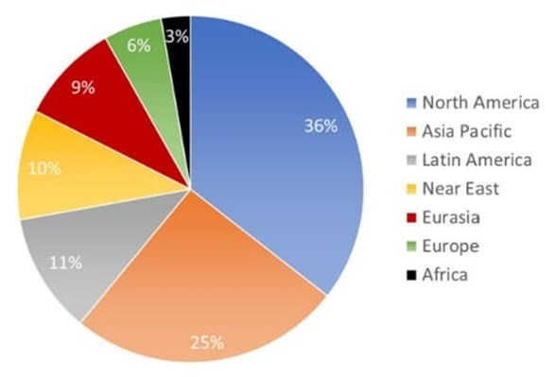

**Fig 4 percentage of counterfeiting incident with respect to seven region of world [11].**

The healthcare supply chain faces significant obstacles due to asymmetric information and a lack of openness among many entities. . Due to inadequate coordination and teamwork, this could cause delays. Furthermore, it could lead to inconsistencies in records since each stakeholder only believes data that belongs to them without reaching an agreement with other supply chain participants, which could result in inconsistent [13].

For the prevention of counterfeit drugs, pharmaceutical industry need an efficient supply chain management system, and the best available solution to develop a perfect SCM system is the Blockchain technology. Transparency is the key characteristics of Blockchain which is mainly helpful in the transparent information sharing in the supply chain of pharmaceutical industry. Blockchain technology is recommended for pharmaceutical supply chain management due to its security benefits also. Another key characteristics is immutability in which the Blockchain technology prevents individual users from changing data and transactions, increasing confidence and eliminating bias in traditional supply chain systems. Blockchain technology also enables anonymous exchange of digital assets without the need for trust between participants or third parties. The SCM system is the most effective way to track a product's travel across the supply chain. When a product changes ownership, a new transaction is published the Blockchain which helps in preventing scam. Storing a product's history allows for easy identification of its origins and milestones. This technique will enhance transparency in the pharmaceutical supply chain and allow everyone to track the product where the product is travelling from where the ownership of product gets change and where it delivers [14].

**2) Supply chain management:** Pharmaceutical supply chain network is the mechanism by which manufactured medication are distributed among patients. However the supply chain is complex and consist of various stage. A primary supply chain mainly consist of many entities like manufacturer, supplier, distributor, wholesaler, retailers. Pharma companies manage complex supply chains as it involves interacting with many numbers of suppliers contributing ingredients and components for drug production. The Pharma supply chain industry needs to ensure the utmost safety precautions to transport goods, as any negligence of safety measures may lead to a fatal outcome. Digitalization and online sale of pharmaceutical products have opened doors to the production of counterfeit drugs, diminished quality, untraced transport of drugs, and customers’ absence in the entire supply chain process. The reason for the diminished quality of drugs will discovered at a very later stage in a supply chain process, which results in a product or financial loss for the entities within the supply chain. Furthermore, lack of transparency and cross-supply chain communication failure increases the problems faced which forces every single operating entity in the supply chain to work using information from a localized point of view [18].

The USA's Food and Drug Administration (FDA) is a regulatory organization that oversees the pharmaceutical supply chains (PSC) and is in charge of monitoring the efficacy, safety, and quality of medications. The USA's Food and Drug Administration (FDA) is a regulatory organization that oversees the pharmaceutical supply chains (PSC) and is in charge of monitoring the efficacy, safety, and quality of medications [19].

Blockchain is an innovative technology to record transaction information as immutable and timestamped blocks. The transparency properties of Blockchain facilitate the regulatory procedure of the system. Each block is authorized by the digital signature of the owner to ensure the data is valid and tamper-proof. . Moreover, data related to medicine must be distributed and ensured the secure and smooth delivery of drugs to each participant in the medicine production and distribution system. So, Blockchain technology was adopted to propose a framework involving the participants in medicine production and distribution systems to prevent drug counterfeiting. The framework focuses on ensuring the smooth delivery of drugs between each participant, from the manufacturer to the customer. Fig. 5 depicts the proposed Blockchain based framework involving the medicine production and distribution system. Each participant is refer as a ‘node’. Each node will have a separate account in the system, and all the accounts can be accessed using personal access credentials.

There are four types of nodes in this framework:

* **Manufacturer**: The manufacturer will produce medicine and take orders from the next node. The manufacturer account can add a new block in the Blockchain for adding a medicine using a digital identifier. Adding a new medicine involves ‘Medicine Production Information’ like medicine ID, medicine info, manufacturer info,batch number, package number, manufacturing date, and expiring date. The medicine can be tracked until it is sold using the identifier (medicine ID).

* **Distributor**: The distributor can view the product list provided by a manufacturer and buy any drug. The distributor can again sell it to the next node by adding transaction information. The distributor can add a new block by updating the ‘Medicine Distribution Information’ of medicine by inserting information related to the distributor or retailer information.

* **Retailer**: The retailer buys medicine from the distributor and sells it to the customer. The account will also be able to add transaction information about selling medicine. Retailers can change the medicine information by providing the ‘Medicine Sales Information.

* **Consumer**: The customer buys medicine from the retailer shop. This account can input the code given on the medicine to know the movement across the distribution.

The distributor can store information about the medicine ID, information about the next and previous node, and the delivery time of the medicine. Each node can fetch data up to the current status of the medicine from the Blockchain. So, the whole journey of medicine is visible from any node at any time. The hash value is used to validate the event of reception by the node. All nodes can remotely access the Blockchain using the internet. When a node confirms the information to store, the system will create a new block (n+1) and broadcast the block to all nodes over the network.

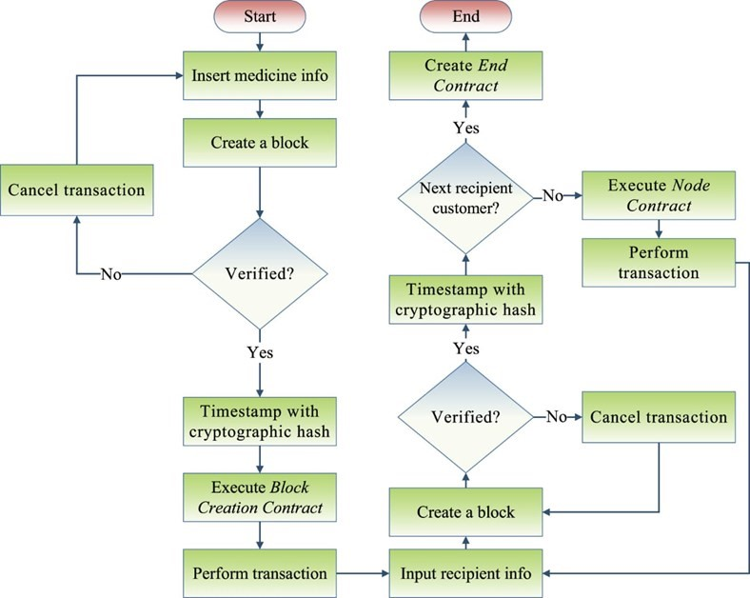

**Fig 5 Workflow of Blockchain based freamework**

The workflow of the system is discuss through a use case of the data stored over the Blockchain in this framework involving a total four nodes: one manufacturer, one distributor, one retailer, and one customer, respectively, which is depict in Fig. 6. Each user is assign a unique user and account to access the system. At each node, a new block will be create with updated information and tagged with a timestamp. A medicine can traced anytime while moving from the manufacturer to the customer. A digital code will used with every medicine package as a data pointer. The codes will printed on the package while manufacturing. After manufacturing, the manufacturer creates a new block for adding a medicine. The block has detailed medical information like name, generic name, batch name, production date, expired date, form, address, dosage, batch no, package no, and status. The address contains the address of the manufacturer, indicating the current location of the medicine. Moreover, the status field is ‘at manufacturer’ as it is not been sold yet. A hash value is calculated of the data in the block as ‘Hash’ while ‘Timestamp’ contains the time of creating the block, and the ‘UserID’ shows the ID of the user who created the block. When the manufacturer wants to sell the medicine to a distributor, he inserts the distributor information (Name, address) along with medicine info in another block. After the transaction, medicine information will updated. Then, the address shows the new location of the medicine, and the previous block is link with this block by storing the previous hash in it. To sell the same medicine to a retailer, the distributor updates the new address with the retailer’s address. The new block contains a link to the previous block by the ‘Previous Hash’. The ‘Timestamp’ contains the time of the creation of the block. When a customer buys the medicine from the retailer, the retailer creates a new block for the event by updating the status as ‘SOLD’, the address of the customer (not mandatory). The new hash will be stored the ‘Hash’, and a link will created with the previous block [20].

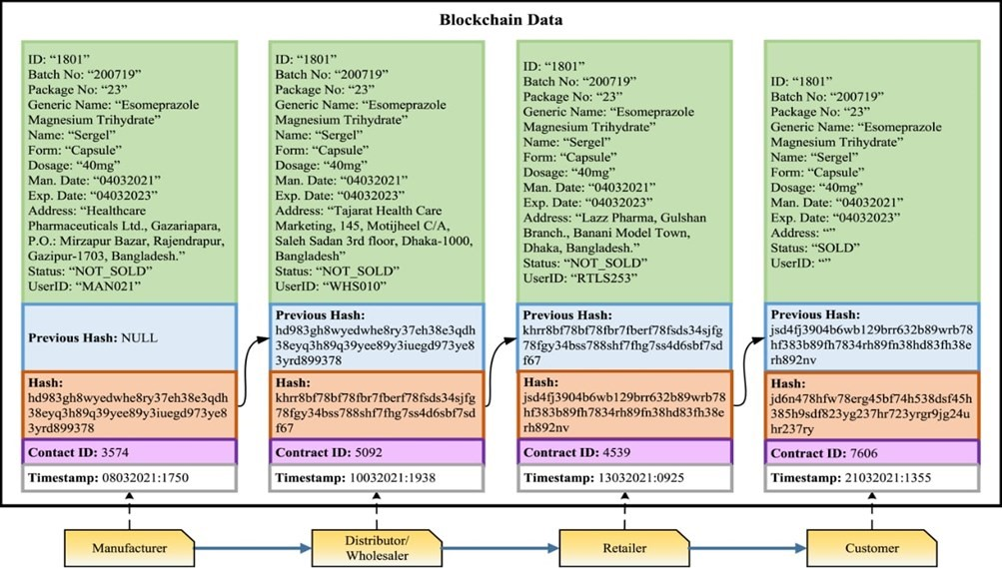

**Fig 6 Use case of framework.**

Pfizer uses the MediLedger blockchain project to create a closed ecosystem and track drugs to every last detail. The system also ensures that there is no counterfeit. Overall, Pfizer is already utilizing the technology and successfully reaping benefits from it [30]. The first solution in production from MediLedger is a product verification system that makes it easier to verify that a returned drug is authentic — a common, but difficult process [31].

**Limitations:-**

1. **Technological Complexity:** Integrating Blockchain into existing systems requires technical expertise and resource allocation. It requires high skills professionals to implement this into pharmaceutical industry. Overcoming this hurdle demands collaboration between tech specialists and pharmaceutical professionals**.**
2. **Resistance to Change:** The pharmaceutical industry is traditionally cautious about adopting new technologies due to potential disruptions. Addressing concerns and demonstrating the value of Blockchain is crucial for widespread adoption**.**
3. **Interoperability:** Interoperability is defined as a mass adoption of business software and platforms across multiple organizations to provide efficient integration strategies. It serves as a means for users of different platforms and software’s to interact and conduct meaningful businesses seamlessly. The existing drug traceability solutions such as serialization, bar codes, RFID tags, and e-pedigree as well as Blockchain-based solutions and platforms lack full interoperability as there are no standardized solutions to make integration, adaptability and implementation easier.
4. **Implementation cost:** Designing the perfect Blockchain application is not an easy task, it requires high cost to implement info pharmaceuticals, also it requires high energy to operate since majority of the existing solutions are under development.

**Management:**

Pharmaceutical industry generates enormous amount of data, which includes the data related to drug product, manufacturing information, results of test, overall stock related data, etc. The management of data in pharmaceutical industry includes: **1) Inventory**

**management 2) Data management**

1. **Inventory management:** Pharmaceutical inventory management is the complex management which include the data related to overall product information management from distribution of product to the recall of product whenever necessary i.e. balancing of product stocks throughout the system. Pharmaceutical inventory management is challenging for hospitals, clinics, and doctors' offices. Accurate inventory records enable management to make informed decisions regarding ordering, availability, and matching with physical inventory. Reducing inventory shrinkage can result in annual cost savings of millions. Without a dedicated inventory management system, lead times might cause costly shortages. Managing inventories when demand fluctuates greatly is difficult. This year's epidemic taught the medical profession valuable lessons. Ensuring an adequate supply of life-saving drugs is crucial, even when infection rates rise substantially, as seen during the Covid-19 pandemic. In the United States, the rate of prescription recalls remains high. According to the United States Food and Drug Administration (FDA), in 2023 alone, there were over 1,500 recalled products in medical devices, biologics, and drugs. The currently using traditional system are-
   * **Barcode scanning** - For logging physical inventory counts and describing medications, including any important warnings or instructions.
   * **Lot Tracking** - It is possible to trace any tainted product forward and backward.
   * **Tracking expiration dates** - reduce waste and ensure patients are receiving active medications.
   * **Automate Purchase Orders** - Automatically place orders with suppliers based on reorder points.

Issues related to use these technologies are : Inability to update inventory in real time, absence of historical data, and there is always a challenge to analyze inventory level. Manually documenting patient records consumes a lot of your time. A strong inventory system can assist balance supply and demand for pharmaceuticals in the healthcare industry [23].

The implementation of Blockchain technology can effectively track the distribution of medications and identify patients impacted by the recall through an indisputable record system, enabling targeted alerts to only those individuals who received the recalled product. The decentralization of Blockchain promotes the ability for multiple actors to form a network displaying the status of drug supplies at pharmacies. This collaboration can efficiently improve patient outcomes. In 2019, WakeMed Health and Indiana University Health piloted a program in collaboration with Good Shepard Pharmacy, called RemediChain. RemediChain focused on product tracking to address inventory shortages of high-value goods. Currently, they accept donated medications and match them to patients who are in immediate need. In real time, they can verify products and produce urgent sales with the hopes of relieving pharmaceutical waste. Since implementation, RemediChain estimates they have prevented $17 million worth of pharmaceutical product waste [10].

1. **Data management:** Data management includes various data related to clinical trials, pharmaceutical products, product quality information etc. however in related to the data management accurate data must be there. Data integrity (DI) is the assurance of data records that are complete,accurate, intact, and maintained within the original circumstance,including their connectivity to relevant data records and focuses toprevent unwanted changes to the required information [16]. Data integrity is an important part of the pharmaceutical quality management system that guarantees that medicines produced are of the desired quality, which relies on product quality. Data integrity gives the assurance that records i.e. electronic and paper records are precise, intact, accurate and well maintained in their original form and aims to prevent fabrication of information [15].

In recent years, there has been a significant increase in the number and types of data integrity issues that have been cite in regulatory inspections. There were many uncovered serious cases on DI related problems. Companies often have DI issues, which are hazardous to the company's long-term prospects and a demoralizing effect on the company culture. Managing data is challenging in the pharmaceutical industry, especially when a firm's growth was emerging on a volume of data at a rapid rate. Organizations expect that pharmaceutical organizations have to hold exact records and every single data will be accessible to controllers. There are many chances of getting corrupted results if there is no proper measures are taken to ensure the safety of data. Errors of DI generally arise from human error, uncooperative operating procedures, data transfers, defects in software and physical negotiation to devices.

Common issues of data integrity Data management and archiving

* + - * Ability to edit data/delete methods
      * Lack of backups/protection of records from loss
      * Failure to retain raw data/complete data as generated
      * Incomplete files/records of data acquired
      * No backup or backups that overwritten earlier data
      * Hybrid systems of both paper/electronic record [16].

To overcome this issue the Blockchain technology is the one of the way to overcome those challenges. As it is a decentralized record of digital events, with validation by the participants occurring before it is recorded making manipulation of previously verified transactions including data entry or movement very hard, and cannot be deleted. Blockchain has three main ways to ensure data security. Firstly, it has a hash function, which identifies blocks, and calculation of hashes involves the previous block’s hash. Secondly, it has a peer-to-peer network to verify before it added to the current Blockchain as a legitimate block, removing the need for an authorized person for approval of transaction. Once a block is added, it is added to all the copies of the verified Blockchain across the entire network, hence remaining in the system indefinitely. Thirdly, as only pre-approved participants can participate in adding new blocks, the identity of the node adding the block would be documented which ensures data attributability. Furthermore, by using Blockchain-utilizing smart contracts, DI can be enforced using Blockchain technology to ensure all components of the contract are meet before transactions such as approvals occur. Companies such as BlockVerify and One Network Enterprises have started to employ Blockchain to maintain DI in the pharmaceutical market[17] .

Due to its characteristics features it makes the Blockchain technology more useful in data integrity issue in the pharmaceutical insustry. The characteristic features such as immutability, transparent, tamper-proof, decentralised, peer to peer network makes it useful in the data integrity in pharmaceutical industry[19] .

**Limitations:-**

* 1. **Scalability** remains challenging for Blockchain networks, particularly in pharmaceutical industries with high transaction volumes. Ensuring that Blockchain platforms can handle large-scale data processing efficiently is crucial for their effectiveness.
  2. **Data Privacy**: While Blockchain enhances transparency, privacy concerns persist. Striking the right balance between transparent data sharing and patient privacy is an ongoing challenge.
  3. **Technological Complexity:** Integrating Blockchain into existing systems requires technical expertise and resource allocation. It requires high skills professionals to implement this into pharmaceutical industry.

**Challenges of Blockchain:**

* + **Technological or technical threats**
  + **Social threats**
  + **Organisational threats**

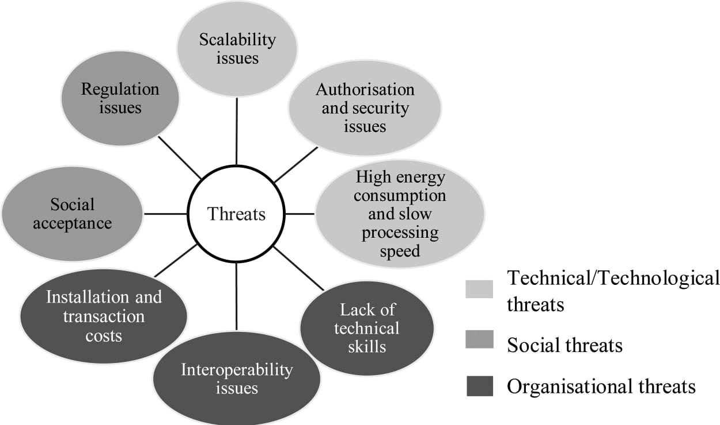

**Fig.7 Threats of Blockchain [24].**

**1) Technological or technical threats:** This is one of the major challenge of implementing Blockchain although it has lot of perks still it has many technological perks. It includes scalability issue, security and privacy issue, high energy consumption.

* + 1. **Scalability:** The scalability issue of Blockchain technology was related to the limited rate of processing transactions executed per second in the network. As network grows with high number of ransaction or data records it often need to maintain efficiency and spped of network[24].
    2. **Security and privacy issue:** The current secure communication architectures of EHR disregard users or patients’ privacy, such as the exchanging system revealing all the data without the permission of owners or noise in the data requester summary.

Because of the transparency and openness feature of Blockchain makes it difficult to maintain the privacy of patient data record which affects the security as the information is not secure when it comes to the openness feature[25].

* + 1. **High energy consumption:** Implementation of Blockchainn requires high energy to operate the entire system. Verification of data to add a block in Blockchain requires high energy as well as high computational power.

1. **Social threats**: Major challenge faced in the adoption of Blockchain technology was the societal acceptance. It includes regulation challenges and social acceptance.

* 1. **Regulatory challenges:** The deployment of Blockchain technology in the pharmaceutical industry faces major regulatory challenges. The sector is under to rigorous scrutiny from regulatory organisations around the world, which attempt to assure pharmaceutical safety, efficacy and quality. Integrating a new technology such as Blockchain necessitates conforming to and, in certain circumstances, altering current legislation to fit this creative approach. Regulatory authorities must establish clear rules and guidelines for Blockchain implementation. This involves difficulties like recordkeeping, compliance and auditability. Regulatory compliance will necessitate open communication between industry stakeholders, technology specialists and regulatory bodies [26].
  2. **Social acceptance:** The pharmaceutical industry is traditionally cautious about adopting new technologies due to potential disruptions. Majority of industries are afraid to adopt the new technologies like Blockchain in the industry due to it lack of awareness in the environment [22].

1. **Organizational threats:** Organizational threats include limitations related to the organizations by the use of Blockchain. It includes installation and installation costs, lack of technical skills, interoperability issue.
   * 1. **Installation costs:** Implementation of Blockchain in healthcare and pharmaceuticals is major challenge as it is not cost effective to use this technology it requires high cost to implement this technology.
     2. **Technical skills:** Integrating Blockchain into existing systems requires technical expertise and resource allocation. Lacking essential technical skills and IT professionals who are experts in operating the technology makes it difficult to implement this technology [22].
     3. **Interoperability issue**: Interoperability as one of the major issues of Blockchain implementation in the area of healthcare and pharmaceuticals. The lack of trust between parties and limited open standards that cause difficulties for a comprehensive exchange of health information between healthcare organisations [24].

**Future direction:** The future of Blockchain in the pharmaceutical industry looks very bright, with exciting developments on the way. As technology progresses, we’re going to see big changes in how the pharmaceutical industry operates and sets its standards with respect to Blockchain. By utilizing into the pharmaceuticals the industry will grow rapidly without any loss of product. Blockchain technology has the potential to transform the pharmaceutical industry by making it efficient, secure and transparent. It improves authenticity, tracking, data integrity and reducing counterfeiting risks. The future implications of blockchain in the industry by disrupting traditional ways are mention below:

**Potential future implications for the industry: disrupting traditional intermediaries**

**Impact on intermediaries:** Blockchain’s distributed ledger architecture has the potential to reshape the roles of traditional pharmaceutical intermediaries. Intermediaries have historically played an important role in checking and confirming transactions, assuring compliance and validating data integrity. However, with Blockchain, the necessity for third-party interference may be greatly reduced.

**Smart contracts:** Smart contracts are revolutionizing the pharmaceutical industry by automating regulatory compliance, quality assurance, and financial transactions. These self-executing contracts ensure adherence to standards, speeding up processes, minimizing errors, and enhancing product quality and patient safety. Automated payments further streamline operations, reducing conflicts through secure, preset conditions. This innovation drives efficiency, reliability, and compliance across the supply chain.

**Decentralised applications (dApps):** Decentralized applications (dApps) are transforming the pharmaceutical industry by providing transparency and security without a central authority. These Blockchain-based applications facilitate secure communication among producers, distributors, and regulatory bodies, allowing realtime validation of interactions. This transparency enhances the integrity of medications throughout their lifecycle and fosters trust among stakeholders. By minimizing the risk of counterfeit drugs and ensuring adherence to quality and safety standards, dApps are revolutionizing supply chain processes, ultimately benefiting the patients and the broader healthcare ecosystem [26].

**Blockchain with AI:** Combining Blockchain and artificial intelligence (AI) can significantly enhance healthcare data analytics by addressing challenges related to data quality, accessibility, and security. Blockchain enables real-time tracking of data changes, allowing for quicker decision-making through AI-driven analytics. This integration improves data quality and resolves integration issues, leading to more accurate analytical results. By leveraging the strengths of both technologies, the convergence of Blockchain and AI has the potential to revolutionize the healthcare sector, driving efficiency and better outcomes in patient care [27].

**Blockchain with IoT:** Integrating Blockchain and IoT in supply chain management enhances risk understanding and information continuity among stakeholders. This combination facilitates effective data transfer and global tracking of products. IoT, as a digital fusion, plays a crucial role in connecting various devices to the physical and digital realms, enabling comprehensive visibility and control. Addressing challenges in information flow will be vital for improving supply chain efficiency and resilience. Together, Blockchain and IoT represent a transformative approach for the future of supply chain management in this industry [28].

**Establishing Blockchain policies:** Establishing stringent policies is crucial for the widespread adoption of Blockchain technology in healthcare. Effective policies should balance between restrictive and permissive approaches, ensuring they align with government regulations and industry goals. Flexibility is essential, allowing for adjustments based on emerging lessons and the evolving technological landscape. Without well-defined standard policies at the national level, the immense potential of Blockchain in healthcare may remain unrealized. Comprehensive and adaptable regulations will facilitate innovation while ensuring compliance and security across the industry [27].

**Conclusion:** Blockchain Technology is decentralized database that has so many applications along the world. The use of bockchain technology in pharmaceutical industry offers a transformative solution to the industry. The key characteristics of blockchain such as transparency, accountability, trust, decentralized nature, security provides the pharmaceutical industry with wide range of benefits and build trust among them. By studying various applications of blockchain in pharmaceuticals such as drug monitoring and data management it helps to tract the real time event occurring during the process and to manage the recorded data. Along with the applications it has various disadvantages such as implementation costs and resistance to change from traditional way into advanced technology and other the major challenge is because of the transparency nature there is possibility of the leakage personal information of patients from health record management. The implementation of blockchain in pharmaceutical gives wide range of future benefits with the applications such as data management, electronic prescription record, etc but it will also face major problems by integrating the blockchain in related to leakage of privacy in the type of private blockchain.

**References:**

1. Badhotiya GK, Sharma VP, Prakash S, Kalluri V, Singh R. Investigation and assessment of blockchain technology adoption in the pharmaceutical supply chain. *Mater Today Proc*. 2021;46(20):10776-10777.

<https://doi.org/10.1016/j.matpr.2021.01.673>

1. Zakari N, Al-Razgan M, Alsaadi A, Alshareef H, Al Saigh H, Alashaikh L, Alharbi M, Alomar R, Alotaibi S. Blockchain technology in the pharmaceutical industry: A systematic review. *PeerJ Comput Sci*. 2022;8 <http://doi.org/10.7717/peerj-cs.840>
2. Gururaj HL, Athreya AM, Kumar AA, Holla AM, Nagarajath SM, Kumar VR. Blockchain: A new era of technology. In: Shrivastava G, Le D-N,

Sharma K, editors. Cryptocurrencies and blockchain technology 2020

May.p. 7-10. doi: 10.1002/9781119621201.ch1.

<https://www.researchgate.net/publication/341593490>

1. Singh SK. Blockchain technology: Introduction, integration and security issues with IoT. 1st ed. arXiv.org; 2022.
2. Anish A, Ashwiny Selshiya M, Immaculate Shyla S. A review on the types and components of Blockchain technology. *Int J Adv Res Sci Comput*

*Technol*. 2021;2(1):1-10. <https://doi.org/10.48175/568>

1. [https://www.cryptoblogs.io/what-is-block-in-Blockchain](https://www.cryptoblogs.io/what-is-block-in-blockchain)

1. Sri PSG, Bhaskari DL. A study on Blockchain technology. *Int J Eng Technol*. 2018; 7(2.7):420. <https://doi.org/10.14419/ijet.v7i2.7.10757>
2. Chowdhury MU, Suchana K, Alam SME, Khan MM. Blockchain application in banking system. *J Softw Eng Appl*. 2021; 14:298-311.

<https://doi.org/10.4236/jsea.2021.147018>

1. Kuyoro A, Aleburu D, Olujimi A, Akingbile A. *Int J Comput Technol*. 2020;7 (3).
2. Gaynor M, Gillespie K, Roe A, Crannage E, Tuttle-Newhall JE. Blockchain applications in the pharmaceutical industry. *Blockchain Healthc Today*.

Year; 7298. https://doi.org/10.30953/bhty.v7.298

1. Pathak R, Gaur V, Sankrityayan H, Gogtay J. Tackling counterfeit drugs: The challenges and possibilities. *Pharm Med*. 2023; 37(4):281–287. <https://doi.org/10.1007/s40290-023-00468-w>
2. Kapoor D, Vyas RB, Dadarwal D. An overview on pharmaceutical supply chain: A next step towards good manufacturing practice. *Drug Des Intell*

*Prop Int J*. 2018; 1(2) <https://doi.org/10.32474/DDIPIJ.2018.01.000107>

1. Omar IA, Debe M, Jayaraman R, Salah K, Omar M, Arshad J. Blockchainbased supply chain traceability for COVID-19 personal protective equipment. *Comput Ind Eng*. 2022; 1

<https://doi.org/10.1016/j.cie.2022.107995>

1. Haq I, Muselemu E. Blockchain technology in the pharmaceutical industry to prevent counterfeit drugs. *Int J Comput Appl*. 2018;180 (25):1-6. Available from: <https://doi.org/10.5120/ijca2018917403>
2. Badamane M, James R, Das S, Kumari A, Rekdal M, Kulyadi GP. A recent regulatory update on consequences of data integrity issues and its management in the pharmaceutical scenario. *Indian Journal on Pharmaceutical Education Research*.2021;55(2Suppl):616-618

<https://doi.org/10.5530/ijper.55.2s.134>

1. Vignesh M, Ganesh GNK. Current status, challenges and preventive strategies to overcome data integrity issues in the pharmaceutical industry. *International journal ofAppliedPharmaceuticals*.2020;12(6):19-20. <https://doi.org/10.22159/ijap.2020.v12i6.39427>
2. Tay SC, Chan LW. Pharmaceutical data integrity : isssues, challenges and proposed solutions for manufacturing and inspectors. GaBl J. 2020;9(4):17-

82. <https://doi.org/10.5639/gabij.2020.0904.028>

1. Abdallah S, Nizamuddin N. Blockchain-based solution for pharma supply chain

industry.*ComputIndEng*.2023;177,108997.[https://doi.org/10.1016/j.cie.202](https://doi.org/10.1016/j.cie.2023.108997)

[3.108997](https://doi.org/10.1016/j.cie.2023.108997)

1. Ghadge A, Bourlakis M, Kamble S, Seuring S. Blockchain implementation in pharmaceutical supply chains: A review and conceptual framework. *International Journal of Production Research*.2023;61(19):6633–6635.

<https://doi.org/10.1080/00207543.2022.2125595>

1. Islam I, Islam MN. A Blockchain-based medicine production and distribution framework to prevent medicine counterfeit. *J King Saud Univ*

*Comput Inf Sci*. 2024;36:101851.

<https://doi.org/10.1016/j.jksuci.2023.101851>

1. Bounab R, Zarour K, Guelib B, Bouazza A. A Blockchain based approach for e-prescription system security and traceability. *CEUR Workshop Proc*.

2023;3616. <http://ceur-ws.org/Vol-3616>

1. [https://www.qualifyze.com/resources/blog/the-role-of-Blockchaintechnology-in-pharma/](https://www.qualifyze.com/resources/blog/the-role-of-blockchain-technology-in-pharma/)
2. Shetty T, Shetty C, Shah I, Rao R. Inventory management in pharmaceutical industry. *Int Res J Eng Technol*. 2021;8:1419-20.
3. Abu-elezz I, Hassan A, Nazeemudeen A, Househ M, Abd-alrazaq A. The benefits and threats of Blockchain technology in healthcare: A scoping review. *International Journal of Medical Information*.2020

Oct;142:104246. <https://doi.org/10.1016/j.ijmedinf.2020.104246>

1. Hussien HM, Yasin SM, Udzir SNI, Zaidan AA, Zaidan BB. A systematic review for enabling the development of Blockchain technology in healthcare applications: taxonomy, substantial analysis, motivations, challenges, recommendations, and future direction. *J Med Syst*. 2019;43:320 <https://doi.org/10.1007/s10916-019-144>
2. Pareek V, Saran D, Sharma L, Jakhar P, Kumar S. Blockchain technology in pharmaceutical industry: A review of recent research articles on PubMed. *Scriptamed*. 2022;55:47100. <https://doi.org/10.5937/scriptamed55-47100>
3. Yaqoob I, Salah K, Jayaraman R, Al-Hammadi Y. Blockchain for healthcare data management: opportunities, challenges, and future recommendations.

*NeuralComputerApplications*.2022;34(7). [https://doi.org/10.1007/s00521-](https://doi.org/10.1007/s00521-020-05519-w)

[020-05519-w](https://doi.org/10.1007/s00521-020-05519-w)

1. Premkumar A, Srimathi C. Application of Blockchain and IoT towards pharmaceutical industry. In: Proceedings of the 2020 6th International

Conference on Advanced Computing&Communication Systems

(ICACCS); 2020;: <https://doi.org/978-1-7281-5197-7/20>

1. [https://www.scnsoft.com/healthcare/blockchain-for-personal-healthrecords#:~:text=The%20MIT%20Media%20Lab%20and,to%20their%20p ersonal%20health%20records](https://www.scnsoft.com/healthcare/blockchain-for-personal-health-records#:~:text=The%20MIT%20Media%20Lab%20and,to%20their%20personal%20health%20records)
2. [https://venusremedies.com/blog/blockchain.](https://venusremedies.com/blog/blockchain)
3. [https://hbr.org/2020/05/why-big-pharma-is-betting-on-blockchain.](https://hbr.org/2020/05/why-big-pharma-is-betting-on-blockchain)