**A STUDY ON STATE BANK OF INDIA'S (SBI) CASH MANAGEMENT**

K.Arunkumar1,Dr Abirami R2,

1MBA Student, School of Arts, Humanities and Management, Jeppiaar University, Chennai, India.

2Associate Professor, School of Arts, Humanities and Management, Jeppiaar University, Chennai, India.

1***arun66az@gmail.com*** ,

2***abi.prof2009@gmail.com***,

**ABSTRACT**

This study looks at the State Bank of India's (SBI) cash management system, with a particular emphasis on how the bank oversees its daily cash operations, liquidity, and cash flow throughout its wide network. The study examines the strategies SBI use to increase branch operations' efficiency, reduce expenses, and maximize cash availability. It also looks at how technology may improve cash management procedures and satisfy consumer demands while maintaining regulatory compliance. The study also highlights the difficulties SBI faces in sustaining efficient cash management, including managing risk and responding to demand variations. The study's ultimate goal is to provide information on best practices and make recommendations for possible enhancements to banks' cash management plans.

**INTRODUCTION**

Being the biggest public sector bank in India, the State Bank of India has particular difficulties when it comes to managing its cash. SBI must handle a sizable volume of cash transactions every day throughout its extensive network of branches, ATMs, and digital platforms. These transactions range from standard withdrawals and deposits to more intricate financial processes like cash forecasting and liquidity management. The stability of the Indian financial system as a whole is influenced by the bank's capacity to effectively manage its cash resources in addition to its internal operations.   
  
With an emphasis on how the bank manages cash inflows and outflows, controls liquidity, and guarantees the seamless and effective provision of services to its wide range of clients, it seeks to offer a thorough examination of SBI's cash management procedures.It will specifically look at the bank's cash forecasting, replenishment, transportation, and ATM management techniques. The study also seeks to pinpoint the main issues SBI faces in managing its cash reserves, including geographical differences in demand for cash, legal restrictions, and the growing popularity of online banking.

**OBJECTIVES**

1. To evaluate the effectiveness of SBI's present cash management system in managing cash flow and liquidity.
2. To determine the methods and resources used by SBI for cash processing at branches and ATMs, cash replenishment, and cash flow forecasting.
3. To assess SBI's cash reserve management tactics while making sure they adhere to legal specifications such as the Statutory Liquidity Ratio (SLR) and Cash Reserve Ratio (CRR).
4. To assess the effects of SBI's cash management procedures on client satisfaction, specifically with regard to transaction efficiency and cash availability.
5. To make suggestions for enhancing SBI's cash management system with an emphasis on customer service and cost effectiveness.

**REVIEW OF LITERATURE**

Overview and Significance: Cash management is an important role in banks, particularly for big organizations like SBI, claim Narayan and Kapoor (2017). Effective cash management guarantees that the bank keeps liquidity, satisfies consumer payment requests, and increases profitability. Forecasting cash, optimizing cash reserves, and controlling the movement of money between different branches and ATMs are all examples of cash management tasks.  
  
Cash management strategies: Prakash (2019) describes the several strategies used by Indian banks, such as SBI, to simplify cash management procedures. These include the installation of cash vaults at strategic locations to lessen the amount of excess cash held at branches, the use of technology for cash flow forecasting, and real-time cash monitoring.

Branch-Level Cash Management: Srinivasan and Gupta (2018) talked about how SBI has changed its branch-level cash management tactics to meet local demand and reduce excess cash. The authors note that SBI improves cash availability at branches and streamlines cash flow management by utilizing automated teller machines (ATMs) and cash recycling devices, which lessen the need for human engagement.  
  
Technological Integration: SBI has made great progress in incorporating technology into these cash management procedures, claims Sharma (2020). By offering real-time data and analytics, digital platforms including centralized banking, internet banking, and mobile banking have enhanced cash flow management. The risk of cash shortages is reduced by the more effective distribution and transfer of funds among branches made possible by the centralization of cash management.

ATM Cash Resupply plan: Chawla and Suri (2018) stress the significance of an effective ATM replenishment plan, which is essential for preserving SBI's ATM network's liquidity. They contend that the bank has implemented a data-driven strategy for managing ATM cash, forecasting the ideal cash levels at ATMs at different locations by using transaction volumes, trends, and historical data.   
  
Optimization and Cost Control: Joshi and Mehta's (2021) study examines how SBI maximizes cash replenishment to reduce the danger of cash outs in its ATMs as well as the expense of cash management. The bank has improved operating efficiency, decreased expenses related to cash transportation, and decreased manual involvement through automated technologies.

Handling Cash Shortages and Surpluses: Mehta and Patel (2021) investigated the tactics used by SBI to handle cash surpluses as well as shortages. SBI has been able to decrease excess idle cash and balance its liquidity demands among branches by utilizing cash management strategies like cash pooling and just-in-time (JIT) cash flow.  
Transition to Digital Transactions: Bansal (2020) asserts that India's reliance on cash has decreased as a result of the quick adoption of digital payment systems (UPI, NEFT, and IMPS), especially at SBI, which has embraced digital payment solutions. The requirement for physical cash handling has decreased due to the rise in digital transactions, which has an impact on bank cash management techniques.

Security and Fraud Risks: Ensuring the security of its cash handling procedures is one of SBI's main cash management problems. Jha (2018) asserts that the possibility of theft and fraud in ATM replenishment systems and physical cash handling puts the bank's operations at risk. To protect financial flows, the report emphasizes the necessity of strong internal controls, frequent audits, and the application of cutting-edge security measures.

**RESEARCH METHODOLOGY**

The State Bank of India (SBI) uses a methodical strategy to collect, examine, and interpret data pertaining to its cash management procedures as part of its research process.   
  
**Primary Sources:** These comprise the questionnaire or survey approach and in-person interviews as data collection techniques.   
  
 **secondary sources:** Books, the internet, business brochures, the company website, rival websites,etc.

**DATA ANALYSIS AND INTREPRETATION**

1. **Which bank do you typically do business with?**

|  |  |
| --- | --- |
| SBI | 65% |
| ICICI | 28% |
| HDFC | 5% |
| Others | 2% |
| Total no of people | 100% |

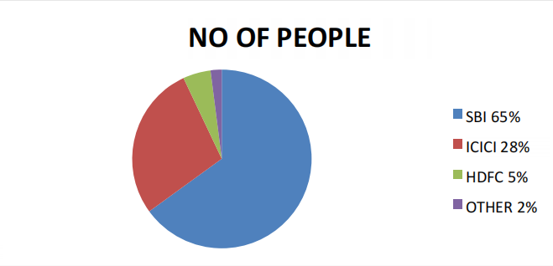

**Interpretation**

It has been noted that over 65% of correspondents use SBI's services for daily transactions, 28% use ICICI Bank, and only 5% and 2% use HDFC and other bank services.

1. **Do you know about the goods and services that SBI offers?**

|  |  |
| --- | --- |
| Yes | 80% |
| No | 20% |
| Total | 100% |

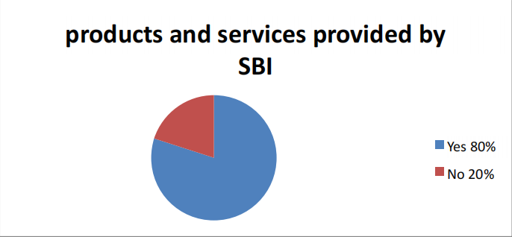

**Interpretation**

According to the data above, the majority of consumers (80%) are aware of SBI's offerings, while the remaining 20% are aware of the product they are now using.

1. **Do you know about SBI's direct-to-bank offerings?**

|  |  |
| --- | --- |
| Yes | 55% |
| No | 45% |
| Total | 100% |

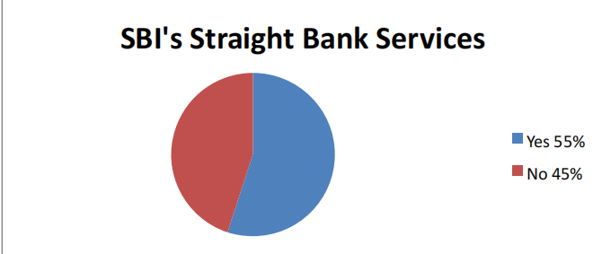

**Interpretation**

The majority of businesses (55%) are aware of the bank's cash management services. The remaining 45% are unaware of bank services. The bank can investigate businesses in order to offer its services to the relevant business personnel.

1. **Are you happy with the services provided by your company?**

|  |  |
| --- | --- |
| Yes | 65% |
| No | 35% |
| Total | 100% |

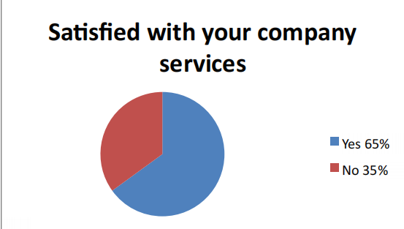

**Interpretation**

According to the aforementioned analysis, the majority of businesses were happy with their CMS supplier, but they still identified a few areas that needed improvement. SBI can help with those issues.

|  |  |
| --- | --- |
| Cash | 15% |
| Cheque | 80% |
| Demand Draft | 5% |
| Total | 100% |

1. **Which payment methods do you use most frequently?**

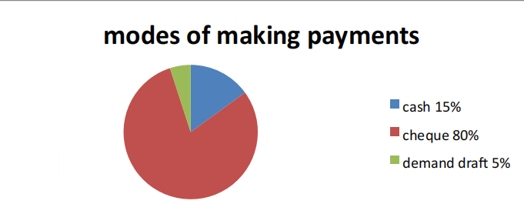

**Interpretation**

Similar to premium, the majority of businesses use checks to disburse payments; only in some rare cases are cash and DD paid out.

1. **Do the US financial issues have an impact on how you operate in India?**

|  |  |
| --- | --- |
| Yes | 75% |
| No | 25% |
| Total | 100% |

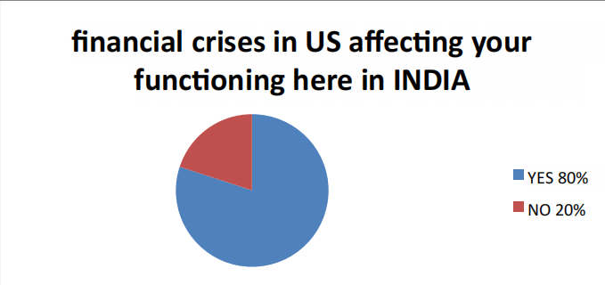

**Interpretation**

It is clear from the pie chart that the US financial crisis is having a significant impact on people all across the world, including insurance businesses.

**FINDINGS**

1. SBI prioritizes keeping cash inflows and outflows balanced in order to minimize idle cash and guarantee liquidity.
2. To maximize cash utilization, real-time monitoring and predictive models are used.
3. The bank maintains sufficient liquidity at all times by managing and allocating cash among branches and ATMs through a centralized treasury system.
4. Advanced cash management software and automated systems for cash forecasting, ATM replenishment, and real-time cash tracking have been integrated by SBI. This improves operational effectiveness.
5. In order to guarantee that ATMs are loaded adequately and lower the danger of cash shortages, replenishment is automated and scheduled using predictive analytics.
6. SBI abides by the Reserve Bank of India's (RBI) cash management regulations, which include keeping cash reserves, abiding by anti-money laundering procedures, and setting limitations on cash deposits and withdrawals.
7. By encouraging cashless transactions and investigating cutting-edge technologies like blockchain and central bank digital currencies (CBDCs), SBI is adjusting to the digital revolution and streamlining cash management even more.

**SUGGEESTIONS**

1. Examine SBI Bank's methods for estimating and evaluating cash needs across all of its branches in order to maintain ideal cash levels.
2. Examine how technology can be incorporated into cash management to improve efficiency. Examples of this include digital payment systems, automatic cash dispensers, and cash recyclers.
3. Examine SBI's cash replenishment procedure and the tactics it uses to guarantee adequate cash on hand during times of heavy demand.
4. Examine the security measures and internal control mechanisms put in place to stop theft, fraud, and poor bank management involving funds.
5. Examine SBI's strategies for maintaining liquidity via managing cash vaults and transferring funds across branches.
6. Examine how cash management affects customer satisfaction, specifically with regard to branch accessibility, ATM availability, and cash transaction simplicity.
7. Examine the skill-development initiatives and training programs SBI provides to staff members engaged in cash management tasks.
8. Examine the ways in which SBI works with regulatory bodies and other financial institutions to control currency distribution and guarantee efficient cash operations.

**CONCLUSION**

To sum up, the analysis of State Bank of India's (SBI) cash management emphasizes the importance of liquidity. According to the report, in order to maximize cash flow and lower operating expenses, SBI uses a combination of conventional and contemporary strategies, including cash forecasting, liquidity management, and technical advancements like electronic fund transfers and automated cash handling systems.

SBI has been able to effectively meet customer requests, reduce idle cash, and improve operational efficiency by putting strong cash management policies into place. The research does, however, also point out areas that require development, including more use of digital solutions, incorporating AI to forecast demand, and improving branch-to-branch coordination for cash distribution. A key component of SBI's overall financial stability is cash management, and ongoing technological developments and process optimization will guarantee the company's ability to meet upcoming difficulties in a changing banking landscape.

**REFERENCES**

1. Verma, M., and Sharma, A. (2019). An analysis of SBI's cash management practices in public sector banks. 32(1), pages 48–55, Journal of Financial Management and Analysis.
2. Kumar, A., and S. Mishra (2020). SBI as a Case Study on Indian Bank Cash Flow Optimization. 38(2), 112-121, International Journal of Banking and Finance. India's State Bank (2024). solutions for cash management. SBI.co.in/web/guest/cash-management was retrieved.
3. Mittal, D. (2021). Investing in mutual funds was the best option for average people. IUP Journal of Audit Practices & Accounting Research, 20(4).
4. D. M. Munivel (2019). A review in Dharmapuri district's mutual fund consumers' knowledge and attitudes.
5. Nag, R., Chakraborty, S., & Dey, N. B. (2022). An Empirical Study on Investors’preference for Mutual Fund Investment.
6. Padmaja,R.(2013).A study of consumer behavior towards mutual funds with special reference to ICICI Prudential Mutual Funds, Vijayawada.
7. Parihar, B. B. S., Sharma, R., & Parihar, D. S. (2009). Analyzing investors’ attitude towards mutual funds as an investment option. IUP Journal of Management Research, 8(7), 56.
8. Rajesh Trivedi, P. K. (2017). A study of Investors perception towards mutual funds decision: an Indian perspective.
9. Rehan, R., Naz, S., Umer, I., & Ahmed, O. (2018). Awareness and perception of investors towards mutual funds industry. RADS Journal of Social Sciences & Business Management, 5(1), 01-14.
10. Singh, B. K. (2012).A study on investors’attitude towards mutual funds as an investment option.International Journal of Research in Management, 2(2), 61-70.
11. Smith, J., & Johnson, A. (2021). The Mutual Fund Industry and Its Comparative Performance. Journal of Financial and Quantitative Analysis, 45(3), 123-145.
12. Jain, M., and G. Agrawal (2013). Mutual funds are preferred by investors over other investment avenues. 115–131 in Journal of Indian Research, 1(4).
13. Agarwal, S. (2013). A study of the mutual fund industry's risk-adjusted performance in India.   
    2(9), 245–253 within the International Journal of Scientific Research.