AI WITH ADAS

***(Artificial Intelligence with Advanced Driver Assistance System)***

Shivam Bhardwaj Abhay Walia Rishabh Jain

Department of AIML Department of AIML Department of AIML

Bachelor of Technology Bachelor of Technology Bachelor of Technology

Delhi, India Delhi, India Delhi, India

[Shivmbr01@gmail.com](mailto:Shivmbr01@gmail.com) [waliaabhay2004@gmail.com](mailto:waliaabhay2004@gmail.com) [jainrishabh062@gmail.com](mailto:jainrishabh062@gmail.com)

Corresponding Author email-id: [jainrishabh062@gmail.com](mailto:jainrishabh062@gmail.com)

**Abstract -** Advanced Driver Assistance Systems (ADAS) represent a transformative leap in automotive technology, designed to enhance driver safety, improve driving comfort, and reduce human error. These systems utilize a combination of sensors, cameras, radar, and artificial intelligence to assist with vehicle operation and decision-making in real-time. Common features of ADAS include lane-keeping assistance, adaptive cruise control, automatic emergency braking, parking assistance, and collision avoidance systems. Issues such as sensor obstructions, system malfunctions, over-reliance on technology, and limited functionality under adverse weather conditions remain concerns.

**Keywords** - self - driving cars, artificial intelligence, sensor, mal function, adaptive cru control, CNN.

# Introduction

Advanced driver assistance systems (ADASs) are a group of electronic technologies that assist drivers in driving and parking functions. Through a safe human–machine interface, ADASs increase car and road safety. They use automated technology, such as sensors and cameras, to detect nearby obstacles or driver errors, and respond or issue alerts accordingly. They can enable various levels of autonomous driving, depending on the features installed in the car.

ADASs use a variety of sensors such as cameras, radar, lidar, and a combination of these, to detect objects and conditions around the vehicle. The sensors send data to a computing system, which then analyze the data and determines the best course of action based on the algorithmic design. For instance, if a camera detects a pedestrian in the vehicle’s path, the computing system may trigger the ADAS to sound an alarm or apply the brake

The chronicles of ADAS date back to the 1970s with the development of the first anti-lock braking system (ABS). Following a slow and steady evolution, additional features such as the lane departure warning system (LDWS) and electronic stability control (ESC) emerged in the 1990s. In recent years, there has been a rapid development of numerous ADASs, with new functionalities being introduced every other day and becoming increasingly prevalent in modern vehicles, as they offer a variety of safety features that aid in preventing accidents, relying on the aforementioned variety of sensors that have made the ADAS a potential system with which to significantly reduce the number of traffic accidents and fatalities.

various features of ADASs, as shown in [Figure 1,](https://www.mdpi.com/1424-8220/24/1/249#fig_body_display_sensors-24-00249-f001) are a crucial part of the development of autonomous driving;

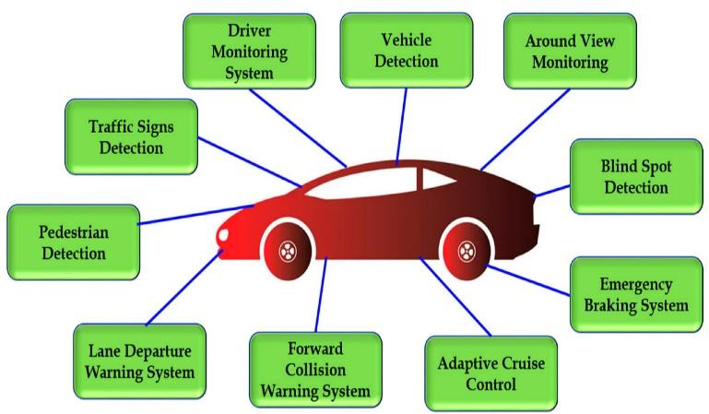

Figure 1.

The basic functionalities of ADASs are object detection, recognition, and tracking. Numerous algorithms allow vehicles to detect and recognize—in other words, to identify and then track—other objects on the road, such as vehicles, pedestrians, cyclists, traffic signs, lanes, probable obstacles on the road, and more; warn the driver of potential hazards; and/or take evasive action automatically.

# The Scope of ADASs:

ADASs perform a variety of tasks using object detection, recognition, and tracking algorithms which are deemed as falling within the scope of ADASs; namely, (i) vehicle detection, (ii) pedestrian detection, (iii) traffic signs detection (TSD), (iv) driver monitoring system (DMS), (v) lane departure warning system (LDWS), (vi) forward collision warning system (FCWS), (vii) blind-spot detection (BSD), (viii) emergency braking system (EBS), (ix) adaptive cruise control (ACC), and (x) around view monitoring (AVM).

These are some of the most important of the many ADAS features that rely on detection, recognition, and tracking algorithms. These algorithms are constantly being improved as the demand for safer vehicles continues to grow.

# Problem of Statement

## Malfunction of Adaptive Cruise Control (ACC)

Adaptive Cruise Control (ACC) is an Advanced Driver Assistance System (ADAS) designed to automatically adjust a vehicle's speed to maintain a safe following distance from

vehicles ahead. While ACC offers numerous benefits, including enhanced safety and reduced driver fatigue, it is susceptible to malfunctions that can compromise its effectiveness and create potentially hazardous situations. Understanding the causes and implications of these malfunctions is crucial for improving the reliability and safety of ACC systems.

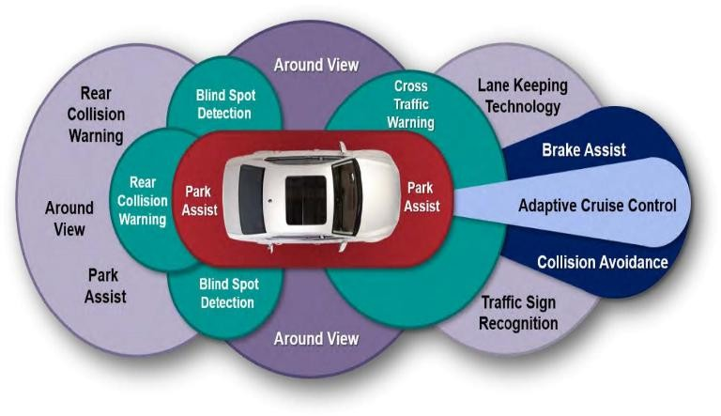

Figure 2.

Adaptive Cruise Control (ACC) is a key component of **Advanced Driver Assistance Systems (ADAS)**, designed to enhance vehicle safety and driver convenience. It builds on traditional cruise control by using sensors and control logic to automatically adjust the vehicle’s speed based on the traffic ahead.

# ADAS Algorithms: Traditional vs. Deep Learning

There are two main types of algorithms used in ADASs: traditional algorithms and DL algorithms. In this section, we discuss the advantages and disadvantages of traditional and DL algorithms for ADASs and also some of the challenges involved in developing and deploying ADASs.

### Traditional Algorithms

Traditional methods for malfunction of adaptive cruise control are typically the most common type of algorithms used in ADASs, based on hand-crafted, rule-based features, and heuristics designed to capture the distinctive characteristics of different objects. That is, a feature for detecting vehicles might be the presence of four wheels and a windshield. This means that these algorithms use a set of pre-defined rules to determine what objects are present in the environment and how to respond to them. For instance, a traditional lane-keeping algorithm might use a rule that says, ‘If the vehicle is drifting out of its lane, then turn the steering wheel in the opposite direction’ or ‘a rule might state that if a vehicle is detected in the vehicle’s blind spot, then the driver should be warned’.

Traditional methods are less complex than DL algorithms, making them easier to develop, and are very effective in certain cases, but they are difficult to generalize to new objects or situations because they are limited by the rules that are hard- coded into them. If a new object, obstacle, or hazard is not covered by a rule, then the algorithm may not be able to detect it. Some of the basic traditional methods-based algorithms.

using a variety of sensors. The algorithm is trained to associate specific patterns in the data with specific objects or hazards. DL algorithms are generally more complex than traditional algorithms, but they can achieve higher accuracy as they are not limited by hand-crafted rules, they can learn to detect objects and hazards not covered by any rules, and they are also able to handle challenging conditions, such as occlusion or low lighting, more effectively. Some of the standard DL method- based algorithms.

## Role of Deep Learning in ACC

Deep learning techniques, particularly those based on **convolutional neural networks (CNNs)**, **recurrent neural networks (RNNs)**, and **reinforcement learning (RL)**, have been incorporated into ACC to provide enhanced decision- making capabilities. Below are key areas where deep learning is applied:

# Methodology for Developing Adaptive Cruise Control (ACC) Systems

The development of an Adaptive Cruise Control (ACC) system involves several stages, from sensor fusion and data acquisition to the design of algorithms and real-time decision-making. Below is a breakdown of the typical methodology used for implementing ACC, with a focus on integrating deep learning techniques for enhanced performance.

### Sensor Selection and Data Acquisition

Before any algorithmic work can begin, the first step is to gather data from the vehicle's surrounding environment. ACC systems depend heavily on sensors for detecting objects, monitoring vehicle speed, and maintaining safe following distances. The sensors typically used include:

**Radar**: Measures the relative distance and speed of surrounding objects, often used for long-range detection.

**Cameras**: Provide visual data for recognizing road signs, lane markings, and nearby vehicles. Cameras are essential for detecting objects that radar might miss.

**Lidar (optional)**: Provides detailed 3D mapping of the surroundings to identify obstacles.

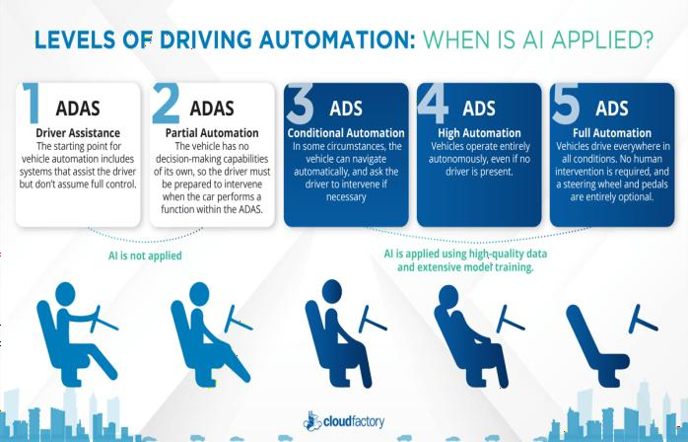**Ultrasonic Sensors**: Typically used for short-range detection, such as in parking assistance, to detect nearby objects.

### Deep Learning Algorithms

Inspired by the human brain, DL methods for object detection, recognition, and tracking use artificial neural networks (ANNs) to learn the features that are important for identifying different objects. They are composed of layers of interconnected nodes. Each node performs a simple calculation, and the output of each

### Data Collection

Figure 3.

node is used as the input to the next node.

DL algorithms can learn to detect objects, obstacles, and hazards from large datasets of labeled data usually collected

The data gathered from these sensors are then processed in real- time to detect the positions and speeds of vehicles in front. This

data must be fused into a comprehensive understanding of the environment, which is essential for effective decision-making.

### Preprocessing and Sensor Fusion

The raw sensor data can often be noisy and fragmented. To improve the quality of information and ensure consistency, **sensor fusion** is applied. This involves combining data from multiple sensors to create a unified and reliable representation of the environment.

### Sensor Fusion Techniques:

**Kalman Filters**: Used to combine noisy sensor data (e.g., radar and camera data) and estimate the real position of an object in space.

**Particle Filters**: Often used when the object’s movement is non-linear or if the sensors provide uncertain data.

**Deep Learning Models**: In modern systems, convolutional neural networks (CNNs) can be trained for **feature extraction** from camera data, and the outputs can be integrated with radar data for a more precise fusion.

The goal of sensor fusion is to produce a robust **environmental map** that allows the ACC system to:

Track the position of surrounding vehicles.

Estimate the distance, speed, and trajectory of objects ahead. Identify static and moving obstacles.

### Trajectory Prediction and Object Detection

Once the sensor data is fused and processed, the next step is to **predict the future behavior** of the surrounding vehicles. This allows the ACC system to anticipate the actions of other vehicles and adjust speed accordingly.

### Techniques Used:

**Object Detection**: Deep learning techniques, such as **Convolutional Neural Networks (CNNs)**, are used to detect and classify objects (other vehicles, pedestrians, road signs, etc.) in the environment. These networks can detect both static and moving objects.

**Trajectory Prediction**: Recurrent Neural Networks (RNNs), particularly **Long Short-Term Memory (LSTM)** networks, are well-suited for trajectory prediction. LSTMs take sequential data as input, allowing the ACC system to predict the future positions of vehicles ahead based on their past movement.

### Decision Making and Control

With the trajectory prediction in place, the next step is **decision making**—the heart of the ACC system. This step involves calculating the desired speed and acceleration to maintain a safe following distance, avoid collisions, and maintain smooth driving.

### Safe Following Distance

ACC systems must calculate and maintain a safe distance from the vehicle in front. The typical following distance is adjusted based on the current speed and road conditions. For example: At higher speeds, the system increases the following distance. At lower speeds (e.g., in stop-and-go traffic), the system may reduce the following distance.

### Adaptive Speed Control

The ACC system continuously adjusts the vehicle's speed to match the detected environment. The following factors are considered:

**Relative Speed**: The system adjusts the vehicle's speed based on the relative speed of surrounding vehicles.

**Road Curvature**: The system should be able to detect road curves and adjust speed accordingly, especially in combination with **GPS and map data**.

**Traffic Conditions**: Real-time traffic conditions and detected obstacles may require rapid deceleration, stopping, or lane changes.

To achieve these decisions in real-time, **Reinforcement Learning (RL)** has emerged as a popular technique. In RL, the system continuously learns the optimal actions (accelerate, brake, maintain speed) based on rewards/penalties for safe or unsafe behavior. This allows ACC systems to dynamically adapt to various traffic situations.

### Control Algorithms

Once the decision-making process is complete, the next step is **executing control commands** to adjust the vehicle’s speed. The control system typically uses:

**PID Controllers**: To adjust speed and throttle inputs based on the distance to the leading vehicle.

**Model Predictive Control (MPC)**: More advanced systems may use MPC, which involves predicting future states of the system and choosing control inputs that optimize performance while respecting constraints like comfort and safety.

The ACC system communicates with the car’s **throttle**, **brakes**, and **steering** to execute these decisions:

**Throttle control** adjusts the vehicle's speed.

**Braking** reduces speed when necessary to maintain a safe distance or slow down quickly.

**Lane-keeping** (when integrated) makes subtle steering adjustments.

### Testing and Validation

Before an ACC system is deployed in real-world conditions, extensive **simulation** and **on-road testing** are performed. This involves:

**Simulation Testing**: Virtual environments are used to simulate various road conditions, traffic scenarios, and weather conditions (e.g., heavy rain, snow, fog). Deep learning models can be trained using simulated data to ensure robustness.

**Real-World Testing**: ACC systems are validated in real-world traffic conditions, ensuring that they perform effectively in edge cases, such as sudden lane merges, erratic driving behavior from other vehicles, and challenging weather.

The testing phase also focuses on **safety validation**, making sure that the system’s interventions (e.g., braking) are timely and do not cause discomfort to passengers or lead to unintended accidents.

### Continuous Learning and Improvement

Once deployed, the ACC system continues to gather real-world data, allowing for continuous improvement:

**Over-the-Air Updates**: Software updates can improve decision-making algorithms and sensor fusion methods.

**Feedback Loops**: The system can learn from past driving data (using machine learning models) to continuously optimize its behavior based on new scenarios and edge cases.

### Conclusion

Developing an Adaptive Cruise Control (ACC) system is a complex, multi-faceted process that requires effective integration of various technologies, including sensor fusion, deep learning, control systems, and real-time decision-making. The methodology follows a structured approach:

1. **Data Acquisition** (from radar, cameras, etc.),
2. **Sensor Fusion** (combining data from multiple sensors),
3. **Deep Learning** (for object detection and trajectory prediction),
4. **Decision Making** (ensuring safe and efficient speed control),
5. **Control** (executing speed adjustments and maintaining safety),

### Testing and Validation, and

1. **Continuous Learning** (ensuring adaptive improvements over time).

As ACC systems evolve, they increasingly leverage deep learning and reinforcement learning for better decision-making and adaptability in complex driving environments, paving the way for more autonomous driving systems.

# Acknowledgement

I/We would like to express my sincere gratitude to all those who supported and guided me throughout the completion of this project on **Advanced Driver Assistance Systems (ADAS)**.

First and foremost, I/We extend my heartfelt thanks to my project guide, **[Rishabh Jain (Assistant Professor)]**, for their invaluable insights, continuous encouragement, and constructive feedback at every stage of the project. Their guidance was instrumental in shaping this work to its final form.

I am also grateful to the faculty and staff of the **[Department AI&ML (Artificial Intelligence & Machine Learning)]**, [**Dr. Akhilesh Das Gupta Institute of Professional Studies/(Guru Gobind Singh Indraprastha University)]**, for providing the necessary resources and a supportive learning environment. Special thanks to **[Dr. Ankit Verma (HOD, AI&ML Depart.)]** for access to tools and simulation equipment that greatly enhanced the research and development phases of the project. I/We would also like to acknowledge the contributions of my peers and teammates for their cooperation and valuable discussions, which enriched the learning experience.

Finally, I/We express my deep appreciation to my family and friends for their constant encouragement, understanding, and moral support throughout this journey.

This project has not only deepened my technical understanding of modern automotive systems but also reinforced the importance of collaboration and innovation in solving real- world problems.

**[Shivam Bhardwaj, Abhay Walia]**

**[Dr. Akhilesh Das Gupta Institute of Professional Studies]**

# References

1. <https://www.mdpi.com/2622978>
2. [https://www.researchgate.net/publication/321364551_Revie](https://www.researchgate.net/publication/321364551_Review_of_advanced_driver_assistance_systems_ADAS) [w_of_advanced_driver_assistance_systems_ADAS](https://www.researchgate.net/publication/321364551_Review_of_advanced_driver_assistance_systems_ADAS)
3. [https://www.sciencedirect.com/science/article/pii/S2352146](https://www.sciencedirect.com/science/article/pii/S2352146516302460) [516302460](https://www.sciencedirect.com/science/article/pii/S2352146516302460)
4. [https://www.researchgate.net/publication/379832878_Advan](https://www.researchgate.net/publication/379832878_Advance_Driver_Assistance_Systems_ADAS) [ce_Driver_Assistance_Systems_ADAS](https://www.researchgate.net/publication/379832878_Advance_Driver_Assistance_Systems_ADAS)
5. <https://ieeexplore.ieee.org/document/10192617>
6. [https://etrr.springeropen.com/articles/10.1186/s12544-024-](https://etrr.springeropen.com/articles/10.1186/s12544-024-00654-0) [00654-0](https://etrr.springeropen.com/articles/10.1186/s12544-024-00654-0)
7. <https://www.youtube.com/watch?v=lU4Drli6s9g>
8. [https://www.sitime.com/applications/automotive-adas-](https://www.sitime.com/applications/automotive-adas-computer) [computer](https://www.sitime.com/applications/automotive-adas-computer)